The physiological and behavioral effects of carbon dioxide on Drosophila melanogaster larvae

NICOLAS H. BADRE, M. ELISABETH MARTIN and ROBIN L. COOPER

Department of Biology
University of Kentucky
Lexington, KY 40506-0225

Abbreviated Title: Carbon dioxide & Drosophila larva

Key words: Heart, CNS, Neuromuscular junction, glutamate receptors, acidic

Figures: 8
Table: 1
Abstract: 239 words

Correspondence should be addressed to:
Dr. Robin L. Cooper
Dept. of Biology
University of Kentucky, Lexington, KY 40506-0225
Phone: 859-257-5050
Fax: 859-257-1717
Email: RLCOOP1@pop.uky.edu
Acknowledgments
Appreciation is given to Dr. Kert Viele (Dept. Statistics, Univ. of KY) for statistical analysis. Support was provided by a G. Ribble Fellowship for undergraduate studies in the Department of Biology at the University of Kentucky and NSF-REU (MEM), the University of Kentucky Undergraduate Research Program (NHB), and in part by NSF grant IBN-0131459 (RLC & KV).
ABSTRACT
Adult and larval insects are rapidly anesthetized by carbon dioxide (CO₂) however the mechanisms have not been addressed. In this study we use larval Drosophila to investigate the actions of CO₂ to explain the behavioral effects of rapid immobilization and cardiac arrest with acute exposure to CO₂. To determine if the central nervous system (CNS) is required studies were performed with and without the CNS. The effects of low pH induced by exposure to CO₂ was also examined. An acidic saline increases the heart rate in contrast to saline containing CO₂. Synaptic transmission at the skeletal neuromuscular junction (NMJ) is blocked by CO₂ but not by low pH. The site of action is postsynaptic by a decreased sensitivity to glutamate, the neurotransmitter at Drosophila NMJs. The CNS remains active in synaptic transmission when exposed to CO₂ which is in contrast to the synapses at the NMJ. In summary, the effects of CO₂ are directly mediated on the heart to stop it and at skeletal NMJs by a reduced sensitivity to glutamate, the released neurotransmitter, from the motor nerve terminals. The rapid behavioral and physiological effects cannot be accounted for by action on the CNS within the larvae nor by a pH effect indirectly induced by CO₂. The glutamate receptors in the D. melanogaster preparation are similar in function to ionotropic glutamate receptors in vertebrates which could account for the observational phenomena of CO₂ not yet explained mechanistically in vertebrates.

Key words: Heart, CNS, Neuromuscular junction, glutamate receptors, acidic
INTRODUCTION
It is common practice to "anesthetize" insects with exposure to high concentrations of carbon dioxide (CO₂). Adults as well as larval forms typically respond very rapidly (i.e., a few seconds) to CO₂ exposure in becoming paralyzed and non-responsive to sensory stimuli. As in mammals, CO₂ affects the physiology of insects in the same manner in relation to pH changes: a decrease in body fluid acidity resulting in physiological response to the formed protons (CO₂ + H₂O ↔ H₂CO₃ ↔ HCO₃⁻ + H⁺, Stone and Koopowitz, 1974). This reaction within living organisms is rapidly catalyzed by carbonic anhydrase and is likely the primary reason that intracellular pH quickly drops upon exposure of CO₂ (Baker and Honerjäger, 1978). In vertebrates, CO₂ had previously been used as an anesthesia (Eisele et al., 1967) which was likely what spurred an interest in its cellular actions. As with other anesthetics, CO₂ can form hydrate crystals which is thought to distort integral membrane proteins (Miller, 1961; Pauling, 1961; Sillans and Biston, 1979). The hydrate form of CO₂ is H₂CO₃. The hydrate and cellular pH are assumed to be the primary mechanism of action on cells for CO₂. However, Sillans and Biston (1979) proposed in insects that CO₂ might have direct actions on neural function which then altered bodily functions, such as heart rate, to produce its anesthetic nature.
Recently CO₂ sensory receptors have been localized on the surface of adult insects and have been anatomically and physiologically characterized (see review by Stange and Stowe, 1999). In the Australian adult fruit fly, Bactrocera tryoni, olfactory receptors were shown to respond to CO₂ as recorded by electroantennograms (Hull and Cribb, 2001). The behavioral responses and monitored electrophysiological observations in the adult insects are associated with olfactory cues in relationship to locate food resources. At low concentrations CO₂ can be an attractant to insects. It has been suggested that in the nectar-feeding moth, Manduca sexta, the CO₂ released from recently opened flowers is an attractant which improves foraging efficiency (Guerenstein et al., 2004). Such attractiveness to CO₂ by insects is also known to be a key for blood sucking insects to find their hosts (Barrozo and Lazzari, 2004; Eiras and Jepson, 1991; Lehane, 1991; Núñez, 1982; Warnes and Finlayson, 1985; Wiesinger, 1956). The responsiveness to CO₂ in insects has also been shown to be related to circadian rhythms (Barrozo et al., 2004).
The olfactory neural responses have not been linked to the anesthetic behavioral actions of CO₂ in insects but instead as a chemo-attractant. However at some level the positive chemo-attractant of CO₂ is outweighed by its anesthetic actions. Recently it was proposed, but not conclusively demonstrated, that CO₂ given off by stressed adult Drosophila produces an avoidance behavior for adult Drosophila (Suh et al., 2004). Many researchers using insect models commonly expose the animals to CO₂ for sorting or identifying mutations and then perform behavioral and physiological assays. We feel it is important to know how CO₂ is working mechanistically which could influence such studies. In this report, we focus on the anesthetic actions of CO₂ and the behavioral as well as physiological mechanisms for its actions in the fruit fly Drosophila melanogaster. Since Sillans and Biston (1979) proposed a likely neural response to explain the rapid actions of CO₂ in reducing heart rate and contractility in the silkworm, Bombyx mori, larvae, we also examined the direct actions of CO₂ on D. melanogaster larvae hearts, but with and without an intact nervous system. When larvae are anesthetized by CO₂ they do not respond to mechanical sensory stimulation. In order to address why larvae do not respond, we examined the effect of CO₂ on intrinsic CNS motor commands by recording from motor axons. To account for the rapid paralytic nature of CO₂ we examined not only CNS activity but also direct action at the glutamate-ergic neuromuscular junction of body wall skeletal muscles. Since exposure of physiological saline to CO₂ results in a rapid drop of pH, the direct actions of low pH without CO₂ were also assessed in these physiological assays.
This work has previously appeared only in abstract form (Badre et al., 2004).

METHODS
The common ‘wild-type’ laboratory strain of Drosophila melanogaster, Canton S, was used in these studies. The methods used to stage fly larvae have been described previously (Campos-Ortega and Hartenstein, 1985; Li et al., 2001, 2002). Larvae at the beginning of the “wandering” phase of the third instar were used in these experiments. The general dissection technique and HL3 saline content have been previously reported (Cooper and Neckameyer, 1999).

Whole animal behavioral effect to CO₂
These tests were performed by injecting 100% CO₂ in a sealed 53 mm diameter glass Petri dish with an apple juice agar layer on the bottom. These tests were controlled by conducting trials without the injection of any gas and another set of trials in which 100% N₂ was injected. The N₂ control was used to examine if the effects were specific to CO₂ and/or hypoxia.
The behavioral responses were viewed with the aid of a microscope (adjustable zoom 0.67 to 4.5; World Precision Instrument) fitted with a 10X eye objective. In addition, the animals were recorded on to VHS tape by a microscope mounted camera (Mintron, MTV; World Precision Instrument).

Body Wall Movements (BWM)
The time at which the BWM stopped, when the animals were exposed to a gas, was recorded. The CO₂ was injected in the sealed container for 10 minutes. The BWMs were counted for the first and last two minutes during the exposure period.

Heart Rate (HR) measures
The same microscopic method as for behavioral movements was used to record HR but with the exception of a 2x base objective to obtain a higher resolution of the heart and trachea. The movements of the trachea or heart were used for direct counts. The flow of CO₂ was selectively varied over the surface of the animal to determine where the animal was responsive to CO₂ by monitoring the rapid reduction of HR. The HR was also used to examine the direct effects of various salines exposed to the deinnervated and innervated hearts in semi-intact animals. The HR was also used in parallel with BWMs for correlation in the effects on body paralysis and HR.
The time in which the HR stop during the exposure to CO₂ was recorded. The rate in which cardiac activity recovered was also measured after the removal of the gas. With visual inspection one can readily observe the heart beating or the trachea movements as a consequence of the heart pulling on the ligament attachments (Figure 1A). The movement of is trachea are commonly used to monitor Drosophila larval heart rate because of the clear contrast of the structures (Dasari and Cooper, 2004b; Miller, 1985; Johnson et al., 1997; Nichols et al., 1999; White et al., 1992). To test if the animal required a CNS to elicit the responses to CO₂ a Guillotine test was utilized. Larvae were taped in order to carefully direct the flow of gases to the spiracles while the anterior (head) end of the animal was rapidly cut off. The HL3 saline was placed over the transection of the body while the heart was monitored.
Heart rate was also monitored in exposed hearts by pinning or gluing the animal on their dorsal surface and making a longitudinal cut along the length of the animal (Figure 1B). This dissection technique has been used to directly assay pharmacological agents on the heart of Drosophila larvae (Gu and Singh, 1995). The internal organs are carefully blown to one side by use of flowing saline directly at organs from a pipette, which allows one to remove the organs not of interest. Care is taken not to damage segmental nerves or the central nervous system (the larval brain). With this approach the heart is readily observed along the length of the semi-intact larvae. While monitoring the heart the segmental nerves were transected or the CNS was removed. With this type of heart exposure various composition of salines were exchanged rapidly over the heart. The exposure to different salines was tested with or without an intact CNS.
To assay the effects of low pH on HR the exposed heart was monitored without the CNS intact. The heart beat was recorded by counting for two intervals of five min in normal pH 7.2 saline (HL3). After the first five min the saline was flushed out and reapplied. After this initial ten min, the saline was flushed out and pH 6.0 saline was added. Recordings were obtained again for two intervals of five minutes with a flushing out and reapplying a pH 6.0 saline after the first 5 min. This experiment was repeated on a new set of larvae using pH 5.0 saline. Before every trial the pH of the solutions was adjusted to ensure accurate pH values. During these saline trials, the saline remained aerated by agitation of solution with the use of a repetitively injecting saline through a 21 gauge needle into a beaker.
To quantify HR either direct observations were used or VHS obtained images were analyzed by a photodiode. In the cases in which the photodiode was used, the detector (model 276-142, Radio Shack, USA) was placed in the back of a black plastic 35mm film canister and the open end was held over the region on the monitor screen in which the heart and caudal end of the larvae was magnified. The output of the photodiode was amplified by an impedance amplifier. The impedance detectors (UFI, model 2991) allowed HR to be monitored as a measure of dynamic change in the light path across the photodiode during each heart contraction. These signals were recorded on-line to a PowerMac 9500 via a MacLab/4s interface (ADInstruments). Events were measured and calibrated with the MacLab Chart software version 3.5.6 (ADInstruments, Australia) with an acquisition rate set at 4kHz. The HR was determined by direct measures with a window discriminator which measured a running average of an instantaneous events. The values were then converted to beats per minute (BPM). Similar procedures in the use of an impedance amplifier were used as described in earlier studies for obtaining heart rates and respiratory rates in crayfish (Li et al., 2000; Listerman et al., 2000; Schapker et al., 2002) and movements in Drosophila larvae (Cooper and Cooper, 2004).

Neuromuscular physiology
The recording arrangement was essentially the same as previously described (Neckameyer and Cooper, 1998; Stewart et al., 1994). Intracellular recordings in muscles were made with 30-60MΩ resistance, 3M KCl-filled microelectrodes. The combined amplitudes of the excitatory postsynaptic potentials (EPSP) elicited by Is and Ib motor nerve terminals in the various segments of muscle m6 was monitored. Intracellular responses were recorded with a 1 X LU head stage and an Axoclamp 2A amplifier. Stimulation of segmental nerve roots was provided by suction electrodes (Cooper and Neckameyer, 1999). The stimulator (S-88, Grass) output was passed through a stimulus isolation unit in order to alter polarity and gain (SIU5, Grass). Electrical signals were recorded on-line to a PowerMac 9500 and G4 Mac via a MacLab/4s interface. All events were measured and calibrated with the MacLab Scope software 3.5.4 version. All experiments were performed at room temperature (21-22ºC).
Three conditions were tested and analyzed for comparison. The conditions were: (1) normal saline at pH 7.2 switched to a saline of pH 6.0, (2) normal saline at pH 7.2 switched to a saline of pH 5.0 and, (3) normal saline at pH 7.2 switched to a saline of pH 5.0 and a saturated CO₂ content.
To test if CO₂ was directly altering sensitivity of the postsynaptic muscle to the motor terminal transmitter, glutamate, the NMJs were exposed to exogenously applied glutamate (1mM) while recording EPSPs every 2 seconds. The resting membrane potential of the muscle was also monitored throughout these trials. The paradigm was to expose to the NMJ to CO₂ and then a combined solution of saturated CO₂ and glutamate. The paradigm to test for saline at a pH 5.0 consisted of first monitoring EPSP responses in normal saline and after switching to a saline at pH 5.0 followed by a saline at pH 5.0 containing glutamate. Preparations exposed to exogenous glutamate alone were used for comparisons in sensitivity to glutamate.

CNS-Motor unit physiology
The intrinsic motor unit activity of the CNS was monitored using the 3rd instar larvae of Drosophila melanogaster by recording from distally transected nerves as previously described (Cooper and Neckameyer, 1999). The motor nerves fire in bursts in the filleted dissected preparations which account for the rhythmic body wall contractions commonly observed in a filleted preparation.
Five preparations were examined for each experimental condition as stated above for effects at the neuromuscular junction. The number and duration of burst over time were counted and compared.

Statistics
The behavioral responses to air, CO₂, and N₂ were compared by an ANOVA of repeated measures as well as non-parametric tests. The effects of CO₂ and acidic environment on heart rate were compared by an ANOVA followed by the Tukey test of multiple comparisons. The non-parametric analysis were performed with a rank sum Wilcoxon test or a sign test for paired-sample data.
RESULTS
The effects of CO₂ on the Physical Behavior
In our effort to identify particular characteristics of the larval response to carbon dioxide, we designated several terms to quantify the behavioral responses (Figure 2A). 'Shell position' designates larvae in a curved position. 'Elongated position' designates larvae that are flaccid and longer than usual. 'Contracted position' designated larvae that had returned to their normal shape after being in elongated position. These responses were noted during and after direct exposure of the spiracles in larvae to a 100% CO₂ for 5 min followed by clean air exposure. It should be noted that in less than 1 min the animals are already fully anesthetized and unresponsive to mechanical sensory stimulation by prodding or pinching of the animal with tweezers. When CO₂ is removed the animals first go into a contracted state for a short while prior to initiating locomotion. The recovery of locomotion is rapid. The animals reach full locomotion recovery by 10 min. Control larvae were not significantly different in BWM as the CO₂ exposed larvae after 10 min of recovery.

The effects of CO₂ on the Body Wall Movements (BWM)
The degree of slowing in locomotion for larvae over time during exposure to CO₂, N₂ and still air is shown in Figure 3. The mean time for body wall movement to cease during CO₂ is 40 sec (±3 sec for SEM, n=5,) whereas during exposure to N₂ the larvae show no decrease movement for this period of exposure. The larvae do have a gradual reduction in BWMs over time for N₂ and even after 10 min the animals are still crawling at a good rate. For a 10 min exposure of 100 % N₂ the mean BWM over the first 2 min (Figure 3A, n=15) and minutes 8 through 10 were used for this assessment (Figure 3B, n=15). Thus, the hypoxic environment during CO₂ exposure does not explain the rapid reduction in BWM. There is a significant reduction in BWM for CO₂ exposure as compared to N₂ and air and the rate of BWM decreases faster over time for CO₂ than N₂ exposures. Both CO₂ and N₂ substantially reduces BWM as compared to air exposure.The original experimental design is similar to a repeated measures ANOVA. In this case, however, it is not appropriate to use an ANOVA for the analysis. CO₂, by design, puts the animals to sleep, resulting in activity readings of 0 at the last time point. An ANOVA assumes that all the observations have
equal variances. This assumption is therefore violated for the CO₂ group,
and would thus call into question the Analysis of Variance results.
Fortunately, the data are sufficiently strongly separated that less
statistically powerful tests still produce significant results, even when
adjusted for multiple comparisons. The Kruskal Wallis test (a nonparametric
alternative to an ANOVA, also a generalization of the Wilcoxon-Mann-Whitney
test) rejects the hypothesis the medians are equal (p<10⁻⁸) for the 2 minute time
point and rejects the hypothesis the medians are equal (p<10⁻⁸) for the
last time point as well. Pairwise comparisons using the Kruskal Wallis test
result in all groups being different from each other (p<0.00001 for all
six pairwise comparisons). We are also interested in the increase/decrease
of activity over time. Taking the differences between the last time point
and the first 2 miniutes, the median differences are different between the three gases (Kruskal Wallis p<10⁻⁶). Pairwise comparison resulting in all pairs of
gases being concluded have different medians as well (p<0.0003 for each
pairwise comparison, n=15 in each group). All common methods for adjusting sizes of tests based on multiple testing (Bonferroni, etc.) would find these p-values significant for all tests performed.

The posterior end is the most sensitive to CO₂
Directed flow of CO₂ over the head and tail regions of the larval body was performed to determine where the larvae are most sensitive to induce a paralysis in body movement. The CO₂ was projected through the tip of a plastic needle (MicroFil 28AWG; World Precision Instruments) to prevent rapid diffusion back over the animal. Figure 4A depicts the schematic view of the body regions exposed to CO₂ and N₂ airstreams. The same approach was repeated on a different group of larvae with N₂ as a control assay. It was clearly observed in each animal tested that the body would cease to have coordinated contractions for locomotion and that the heart would stop within a minute after CO₂ exposure directed at the caudal end of the animal (5 out of 5 animals; p<0.05, non-parametric analysis sign test for paired-sample data).
In carefully assessing if the spiracles were sensitive to the CO₂, they were covered with Vaseline or with super glue and the tests was repeated. In the conditions with the spiracles blocked the larvae continued to move their body for several minutes. These test were performed with the larvae on double stick tape so that its movements are limited and directed flow could be precise.
The decrease in HR was also used as a bioindex to test for bodily location in sensitivity to CO₂ since HR is rapidly affected by environmental CO₂. The only region that elicited a fast decrease in HR is the region of the spiracles. If the spiracles are blocked in any way the animal does not respond to the CO₂. Instead it responds similar as when the larva are enclosed in a chamber and it is flooded with N₂. Thus, they become hypoxic and respond slowly as if exposed to N₂ if the spiracles are blocked (5 out of 5 animals; p<0.05, non-parametric analysis sign test for paired-sample data).
Since the larvae are very sensitive to the presence of CO₂ directed at their spiracles and the responses are so rapid (seconds to a minute) in slowing down body wall contractions as well as heart rate, we postulated that the effects might well be mediated by sensory neurons within the spiracles and when actively elicited a sensory neuron relays the signal to the CNS to produce a motor command to the heart to stop it. In addition, we assumed that the putative CO₂ sensory nerve resulted in a quiescence in the activity the motor neurons innervating skeletal muscles of the body wall. Thus, within the CNS the net result was to inhibit motor commands of the skeletal muscles as well as possible mediate a inhibitor motor response to the heart. This idea is supported by previous studies on larvae of the Bombyx mori in which it was postulated that since the body wall muscles ceased at the same time the heart stopped the entire response is neural mediated (Sillans and Biston, 1979).
To test the hypotheses a paradigm was developed which we refer to as the Guillotine test. This test examined if the animal required a CNS to elicit the responses to CO₂. Larvae were taped down as before for the direct flow tests, but prior to exposure the anterior (head) end of the animal was rapidly cut off. The spiracles were then exposed to CO₂. Upon cutting the head of the larva off the caudal aspect of the heart remained active and beating. The heart would continue to beat for up to 10 min in this manner. If saline (HL3) was placed over the transection of the body the heart would remain active for 20 min or more. However, if the spiracles are exposed to CO₂ as with the directed flow test mentioned above, the heart would cease beating within seconds to a minute (5 out of 5 animals; p<0.05, non-parametric analysis sign test for paired-sample data). The rapidity of the effects and regional sensitivity of the spiracles to CO₂ were no different than for intact larvae. Thus, the Guillotine test clearly indicated that the larvae do not require the larval brain to relay a signal monitoring exposure to CO₂. After performing the Guillotine test the anterior part of the larvae was dissected to insure the larvae brain was completely transected from segmental nerves in the caudal half.

Semi- intact preparation for direct exposure of the heart
To alter the pH of the solution bathing the heart without an intact CNS, the larvae were pinned on their dorsal side and dissected on the ventral side (Figure 4B). The bathing solution initially applied was HL3 adjusted to a pH of 7.2 for the dissection and then the CNS was removed. The basal HR is relatively lower in these conditions compared to the fully intact preparation (see Table 1). Perhaps the dissection is traumatic resulting in a lowered rate and/or the HL3 saline is not optimal for maintaining the physiological state of the myogenic pacemaker cells within the heart. Even with a lowered HR in the dissected preparations, exposure of the spiracles to CO₂ still causes the HR to stop within a minute (5 out of 5 animals; p<0.05, non-parametric analysis sign test for paired-sample data). In this experimental procedure the spiracles have to be left intact and exposed out of the bathing saline.

Specific receptors for CO₂
To disprove the hypotheses that the effect of CO₂ in reducing the HR is due to the conversion of the hemolymph (or saline) to an acidic solution which then directly reduces the HR, we examined acidity and CO₂ independently on isolated hearts. The three pH values tested were 7.2, 6.0, and 5.0 of the HL3 saline adjusted with HCl. HL3 has been demonstrated to be superior to the previously used older versions of non-physiological derived salines (Ball et al., 2003; Macleod et al., 2002; Stewart et al.,1994). pH 7.2 was used since this is the pH normally used for physiologic measures for neuromuscular studies in Drosophila larvae. pH 5.0 value was used because when the HL3 saline is bubbled with 100% CO₂ for at least 20 min the final pH of the solution is 5.0. The change is rapid (<2 min) from 7.2 to 5.0 upon bubbling CO₂, but the return to 7.2 takes 15 to 20 min or longer. Thus, when examining the effect of returning from a saline saturated with CO₂ to normal saline the bath was exchanged instead of waiting for the CO₂ in saline to reach equilibrium with the air. pH 6.0 saline was used as a general measure between pHs 7.2 and 5.0 and for obtaining a pH response curve.

(i) The effect of an acidic environment on HR
The mean HR was assessed for each minute within 5 to 10 minutes in a dissected larvae without a CNS and exposed to normal saline (pH 7.2) in order to obtain a basal rate. The saline was then changed to one with a pH at 6.0 or 5.0 or HL3 at pH 7.2 to serve as a sham. Since each animal had a different basal rate at rest the absolute difference is used to asses the effects of the acidic environment among preparations. As shown in Figure 5, pH of 6.0 increases HR on average by 30 beats per minute. The change is rapid and prolonged. Within the first minute the rate has increased and reached the maximum increase. The increase in HR is maintained for at least another 10 minutes and in some cases as long as 30 minutes if the saline bath is refreshed.
Exposure to pH 5.0 after animals had been exposed to pH 7.2 was even more dramatic in increasing the HR as compared to pH 6.0. On average the increase was 60 beats per minute for the pH 5.0 exposure (Figure 5). As with pH 6.0, the effect of pH 5.0 in increasing HR lasts for several minutes. The effect of exchanging the bathing media also has an effect on HR. This could be due to stimulation of the heart by rapid movement of ions over the pacemaker cells on the heart. Since sham runs showed an increase in HR the effects of the sham experiments were used for comparison to the salines adjusted to pH 6.0 and 5.0. Compared to sham, only the saline at pH 5.0 showed a significant difference (p<0.05, Student's t-test between sham and pH 7.2 to pH 5.0; F-Statistic=3.6, p<0.05 for ANOVA of the 3 conditions. The post-ANOVA Tukey multiple comparisons test showed no significant difference among the groups).

(ii) Acidity vs. CO₂ on HR
Once the effect of an acidic saline environment was noted to increase HR, we examined the direct effect of CO₂ while the preparation was bathed in an acidic saline of pH 5.0. With a rapidly beating of the heart, induced from the acidic environment, CO₂ was directed at the intact spiracles as shown in Figure 4B. Within 30 sec to a min the heart stopped (5 out of 5 animals; p<0.05, non-parametric analysis sign test for paired-sample data).
In a second series of experiments, the bath surrounding the exposed heart was changed from pH 7.2 to pH 5.0. A 5 min period was used before the saline was exchanged to pH 5.0 and saturated with dissolved CO₂. As previously shown, a change from pH 7.2 to 5.0 increased the HR, but when the saline was subsequently changed to one saturated with CO₂ at pH 5.0 the HR decreased immediately and stopped within 30 sec (5 out of 5 animals; p<0.05, non-parametric analysis sign test for paired-sample data).
Neuromuscular physiology
To address the mechanism of why larvae become rapidly paralyzed and flaccid by exposure to CO₂, the skeletal neuromuscular junction was examined for alterations in evoked synaptic responses. One possibility tested was the effect on the motor nerve remaining excitable in the presence of CO₂. Likewise the postsynaptic muscle may become unresponsive to the evoked glutamate released from the motor nerve terminal. Since the dissolving of CO₂ within the saline drops pH, the effects of pH needed to be addressed separately from CO₂.
The typical body wall muscle examined physiologically in Drosophila larvae is the segmental longitudinal muscle named muscle 6 (m6, Figure 6). The Is and Ib motor nerve terminals innervate muscle 6 of the 3rd instar Drosophila larva (Fig. 6B). These terminals have different morphology and physiology; though they can be recruited separately or in unison (Atwood et al., 1993; Kurdyak et al., 1994; Li et al., 2002). The induced depolarization in the muscle are graded, non-spiking and glutamatergic (Fig. 6C) (Stewart et al., 1994).
The combined Is and Ib EPSP amplitude was measured over time during exposure to normal HL3 saline, followed by saline adjusted to pH 5.0 and subsequently to pH 5.0 saline, saturated with CO₂. In each preparation the resting membrane potential of the muscle fiber was reduced (less negative) by the exposure of the acidic saline. Simultaneously the EPSP amplitude decreased, but could still be observed. However, when the saline at pH 5.0 with dissolved CO₂ was exposed to the NMJ, the resting membrane potential did not change any further, but the evoked EPSP gradually became smaller and faded out all together within two to three min. The further reduction could not be accounted for by the pH, but rather was due to direct actions of CO₂. A typical response is illustrated for one preparation (Figure 6D). Exposure to CO₂ resulted in a complete attenuation of the EPSP in five out of five preparations within 1 min (5 out of 5 animals; p<0.05, non-parametric analysis sign test for paired-sample data). The effect of the acidic environment was also tested. Percent change in the EPSP amplitude was determined for each preparation for the transition from pH 7.2 to pH 5.0 saline. A mean of the EPSP amplitude for the minute preceding the change and a minute after the saline change was used to calculate the percent change. The absolute values in the EPSP amplitudes varied among preparations so a percent change was used (Figure 6E).
The result of a gradual reduction in the EPSP amplitude suggest that the motor nerve remained viable to electrical stimulation and that the reduction in synaptic transmission was not due to a rapid failure to evoked action potentials. Likely other mechanisms must account for the effect of CO₂. Such possibilities could be that synaptic transmission is reduced due to alterations in calcium influx and/or a compromised vesicle fusion process or even perhaps that the postsynaptic cell became unresponsive to evoked glutamate release. In order to examine if the muscle cell remained responsive to glutamate, exogenous glutamate (1 mM) was applied in saline (pH 5.0) containing dissolved CO₂ following a pre-exposure of the NMJ to saline (pH 5.0) containing dissolved CO₂. Since the EPSPs are already reduced by exposure to CO₂ the reduction in the resting membrane potential (RP) was used as an assay for sensitivity to exogenous glutamate. In preparations not exposed to CO₂ but to saline at pH 5.0 and subsequently exposed to saline at pH 5.0 containing glutamate, the resting membrane potential rapidly depolarizes to approximately 0 mV within 1 min and as expected the EPSP amplitude attenuates to the baseline (5 out of 5 animals; p<0.05, non-parametric analysis sign test for paired-sample data). The pH of 5.0 alone accounts for some depolarization of the resting membrane potential, but neither the absence of the EPSP nor for the RP rising to zero in the presence of glutamate. The average percent change of the RP from normal pH 7.2 saline to pH 5.0 is shown in Figure 7 (A, B) (n=5). The subsequent exposure to saline (pH 5.0) with glutamate resulted in the RP proceeded rapidly to zero potential. In a different set of preparations the change from saline (pH 7.2) to saline saturated with CO₂ resulted in an initial transitory slow depolarization of a small amount. With a subsequent exposure of saline saturated with CO₂ and glutamate resulted in another small depolarization but not as drastic as glutamate in the absence of CO₂. The emphasis here is the percent change in RP from pH 5.0 to pH 5.0 & glutamate and the percent change in RP from saline with CO₂ to saline with CO₂ & glutamate which is compared in the first two bars in Figure 7B (p<0.5, Student's t-test). These results clearly demonstrate that CO₂ blocks the responsiveness of the muscle to exogenously applied glutamate. This likely explains the reduced EPSP amplitude to endogenously evoked glutamate release as well as unresponsiveness to exogenously applied glutamate.

CNS-Motor unit physiology
In addition to the direct effect of CO₂ at the NMJ, it was of interest to know if the motor command from the central nervous system was also silenced. When preparations are pinned out in the arrangement used in this study, motor unit activity remains in the segmental nerves that drives the skeletal muscles (Figure 8A)(Cooper and Neckameyer, 1999). This is readily observed in segmental waves of contraction by pinching the caudal end of the preparation or by electrically stimulating the sensory neurons within the segmental nerves (Dasari and Cooper, 2004a). We used preparations that were robust in motor nerve bursts to examine the effect of saline saturated with CO₂ or saline at pH 5 (Figure 8A). The bursting activity was not silenced by the presence of CO₂ as for the synaptic transmission at the NMJ. The electrical activity was recorded within 1 or 2 segmental nerves that were distally transected. Thus, only descending motor activity was being monitored. The activity was recorded over a period of 5 min in normal pH 7.2 HL3 saline followed by either an exchange with saline at pH 5.0 or saline saturated with CO₂. The number of bursts were counted within the 5 min. In five preparations, the exposure to CO₂ did not result in a consistent response. Two increased and three decreased; however with exposure to pH 5.0 saline (n=5) there was a consistent decrease in bursting frequency (Figure 8B; 5 out of 5 animals; p<0.05, non-parametric analysis sign test for paired-sample data). The significance of these results is that the presence of CO₂ did not cause the CNS to shut down as for the NMJ within the time frame behavioral changes normally occur.
Discussion
In this study it was demonstrated that the larval Drosophila rapidly (<1 minute) respond to the presence of high CO₂ in their environment. The spiracles need to be intact and functional for the rapid response to occur. Behaviorally the animals twist and become flaccid within 1 to 2 minutes of exposure of CO₂ which is not observed for N₂, thus this rapid behavior is not elicited by an hypoxic response. In intact larvae the heart parallels the whole body response in that it also rapidly responds and stops. The effects on the heart appear to be directly mediated by CO₂. Since saturating the physiological saline with CO₂ results in a reduction of the pH to 5.0 the effects of saline at pH 5 were also directly assessed. An acidic saline increases the HR in contrast to saline containing CO₂. CO₂ rapidly blocks synaptic transmission at the skeletal NMJ which was not observed within the same time period for saline adjusted to pH 5. The loss of evoked synaptic responsiveness appears to be due to a decrease in the postsynaptic glutamate receptors responding to released glutamate, since NMJ exposed to CO₂ were not responsive to exogenously applied glutamate. In contrast to the NMJ, the central nervous system did not shut down synaptic transmission that drives the intrinsic drive of the motor nerves when exposed to CO₂ containing saline. Low pH saline decreased intrinsic central activity within the same time period that responsiveness for CO₂ was observed in relation to behavior, heart rate, and NMJ actions. In summary, the effects of CO₂ are directly mediated on the heart to stop it and at skeletal NMJs by a reduced sensitivity to released neurotransmitter from the motor nerve terminals. The rapid behavioral and physiological effects can not be accounted for by action on the central nervous system within the larvae.
The type of salines used in the past for conducting physiological experiments in larval Drosophila have varied depending on the need. However the saline termed HL3 (hemolymph like) is based on ion concentrations determined by ion-sensitive electrodes from larval hemolymph. The HL3 preserves synaptic transmission at neuromuscular junctions as well as muscular function and integrity better than the commonly used three solutions: Schneider’s (Schneider and Blumenthal, 1978), Shields and Sang or also termed M3 (Shields and Sang, 1977) and standard (Jan and Jan, 1976) medium (Ball et al., 2003; Stewart et al., 1994). Presumably the rapid reduction in the amplitude of synaptic responses for larval NMJs is due to glutamate-receptor activation and/or desensitization when Schneider’s and M3 medium are used as a consequence of exposure to the high levels of glutamate and other amino acids contained in the media (Ball et al., 2003; Stewart et al., 1994). Slight modifications of the HL3 saline, termed HL6, have been used for calcium imaging of motor nerve terminals which might be better for long-term physiological studies (Ball et al., 2003; Macleod et al., 2002).
The above salines mentioned have not been examined for effects on HR but to some extent it is known that depending on the ionic composition wide differences in the rate occur for in situ exposed hearts. A pH at 7.1 produces a steady beat (Papaefthimiou and Theophilidis, 2001) and salines with higher potassium content produce a higher beat frequency (Gu and Singh, 1995). There is no previous report on the effects of HL3 saline on heart rate in larval Drosophila. We found that dissecting intact larvae from the ventral aspect, as outlined in the Methods, and exposing the heart to HL3 at pH of 7.2 produced a substantially lower rate than for intact larvae. However, if the pH of the HL3 saline is reduced to 7.0 the rate is more robust and consistent. Our concern in this study centered on the fact that HL3 saline saturated with CO₂ produced a pH of 5.0. This drop in pH is likely due to the bicarbonate buffer used in HL3. Thus, the physiological examinations performed in this study controlled for the pH effect separate from the effect induced by CO₂. The physiological responses of heart rate, synaptic transmission at the NMJ and intrinsic activity of the CNS to lower pH alone were strikingly different to that of CO₂. Thus, the effects could not be simply due to a lower pH during CO₂ exposure in the intact animal. One concern we had was in shifting the reaction (CO₂ + H₂O ↔ H₂CO₃ ↔ HCO₃⁻ + H⁺↔ CO₃²⁻ + 2H⁺) toward H⁺ that CO₃²⁻ might have had resulted in a calcium carbonate precipitate (CO₃Ca). This would effectively have reduced free [Ca²⁺] in the bath and reduce synaptic transmission. Since neural activity was not significantly decreased within the CNS for low pH and/or CO₂ exposure, it does not appear that the effect at the skeletal NMJ can be explained by a reduction in free calcium ions within the bath. Likewise, no precipitation was observed within the CO₂ containing saline.
There are known effects of protons on the function of some types of glutamate receptors which could account for part of the reduced EPSP amplitudes at the Drosophila NMJ since they are also glutamate-ergic. It has been demonstrated in cerebellar neurons that NMDA (N-methyl-d-aspartate) receptors are selectively, as compared to AMPA (aminomethylphosphonic acid) and kinate glutamate receptors, inhibited by protons even within a physiological pH range (Traynelis and Cull-Candy, 1990). This implied that even within a normal physiological state the receptors are not fully responsive. In rat cerebral cortex low pH reduces the blocking effect of glutamate and glycine for the binding of an open channel blocker (MK-801). This suggest that protons reduce the effect of glutamate and glycine from binding to the NMDA receptor thus allowing MK-801 to bind. As a result the calcium influx through the NMDA receptors could be reduced (Liu and Euler, 1999). Spreading neural depression in the hippocampal slice, experimentally induced by low pH and raised CO₂, was reduced and suggested to be due to compromised NMDA receptor function by protons (Tong and Chester, 2000). Such actions of protons on the NMDA receptor have been explained structurally by induced mutations within the NR1 subunit of the NMDA receptor. There is a proton-sensitive region on an extracellular end of one transmembrane domain that possibly regulates receptor gating (Low et al., 2003). Even in highly modified glutamate receptors there are proton effects. The delta 2 receptors that are similar in structure to the NMDA glutamate receptor subtype, but are not responsive to glutamate, showed a reduced current in acidic conditions (Williams et al., 2003). The effects we observed at the Drosophila NMJ for pH 5.0 saline do not explain the results obtained for CO₂ exposure of fully attenuating the EPSP since the saline at pH 5.0 by itself did not block evoked responses. The acidic saline alone did result in some depolarization of the muscle membrane and possibly for the small (<1 um diameter) nerve terminals; however, a substantial EPSP amplitude remained. Exposure to CO₂ after exposure to saline at pH 5.0 did not result in any further depolarization of the muscle membrane, but the presence of CO₂ did block the effect of exogenously applied glutamate. This reduction in sensitivity was selective to CO₂ exposure since glutamate in the presence of an acidic saline without CO₂ produced the expected result of fully depolarizing the membrane to approximately zero. The reversal potential for the glutamate receptor in locust muscle is –2.5mV (Patlak et al., 1979) which is in accordance to the effect of exposing the Drosophila NMJ to saline containing glutamate (1 mM). These results imply that protons are not blocking the effect of glutamate but CO₂ is through some unknown mechanism. It is plausible that CO₂ diffuses into the muscle resulting in even greater decreases in pH than outside the cell, since carbonic anhydrase should be present within the muscle cell. If protons have an action on the cytoplasmic side of glutamate ionotropic channel then the conditions tested with lower extracelluar pH saline cannot rule out the effects of pH on the inner side of the glutamate ligand-gated ion channel.
The lack in the ability of protons to block the evoked glutamate response at the Drosophila NMJ is not surprising given that the glutamate receptors at the NMJ are not of the NMDA subtype, but rather of the quisqualate type as reported for other insect models of skeletal NMJs (Anderson et al. 1976; Bhatt et al., 2004; Cull-Candy and Parker, 1983; Gration et al., 1981; Patlak et al., 1979). In the arthropod cousin, the crayfish, the glutamate receptors at the NMJs are also a quisqualate type which exhibit rapid sodium conductance (Dudel et al.,1992; Shinozake and Ishida, 1981). Surprisingly, only recently have the glutamate receptors at the Drosophila NMJ been investigated with a wide range of agonists and antagonists to classify their pharmacological profile (Bhatt et al., 2004). In vertebrates the glutamate receptors are defined in relation to NMDA sensitivity and ion flux characteristics. The NMDA sensitive receptors are glutamate-gated ion channels whereas the non-NMDA receptors, such as the quisqualate activated receptors, are metabotropic. However, at the insect and crayfish NMJ the glutamate-gated ion channels are most prominently activated by quisqualate and they are ionotropic (Bhatt et al., 2004; Cull-Candy and Parker, 1983; Gration et al., 1981; Shinozaki and Ishida, 1981; Shinozaki and Shibuya, 1974). Thus, one would expect some similarity in function of insect NMJ glutamate receptors with vertebrate ionotropic NMDA receptors.
A feasible explanation for CO₂ blocking glutamate receptors at the NMJ might be related to its hydrate form, H₂CO₃. Since hydrate crystals have been proposed to alter integral membrane proteins (Miller, 1961; Pauling, 1961; Sillans and Biston, 1979) this remains a possibility. Perhaps analogs of H₂CO₃ that remain stable at a given pH could resolve this issue. It is unlikely that CO₂ blocks the receptor directly since it is lipid permeable, unless perhaps it could be trapped within the channel pore and cannot diffuse through the protein structure. As far as we are aware there is no precedence for this type of action for a lipid soluble gas working directly on ion channels, but it might be worthy of investigation at a single channel/receptor level.
The blockage of glutamate receptors at the NMJ explains the behavioral effect of reduced locomotion and relaxation of the body; however, this is unrelated to the rapid reduction and subsequent quiescence of the myogenic heart in the larvae exposed to CO₂. We have demonstrated the effect is not due to pH since an increase in HR occurs when the heart is bathed in saline at pH 5.0. In addition, we showed by the guillotine paradigm as well as in carefully dissected and reduced preparations of skeletal muscle, cuticle and heart that CO₂ has direct actions on the heart independent of the nervous system. The experiments performed in our study address the postulation posed by Sillans and Biston (1979) in that the anesthetic nature and reduction of HR by CO₂ was via neural function. However, the question remains as to the mechanism of action of CO₂ on the heart. Since there does not even appear to be focal contractions, we postulate the action must be directly on the pacemaker cells in preventing the spread of electrical depolarization. As with the NMJ, possible CO₂ might have an action directly on ion flux through channels, but given that CO₂ did not dampen the intrinsic motor neuron activity from the CNS would suggest there are selective actions on ion channels of the heart. Since the spread of electrical activity in the heart is via electrical junctions, CO₂ potentially might block gap junctions. This could also explain the lack of focal contractions. This phenomenon remains to be examined. Perhaps other invertebrate preparations that conduct electrical signals via gap junctions, such as the lateral giant axon to the motor neuron in the crayfish ventral nerve cord, could be used to address this postulate.
The phenomena and mechanisms of action reported in this study have broader implications such that instead of using toxic insecticides which have residual effects on transported produce (fruits etc.) gassing with 100% CO₂ for 30 min will cause Drosophila larvae to die. We did not investigate actions on embryos and adults, but perhaps they would even be more susceptible to dying with CO₂ exposure due to size or lack of conditioning to hypoxia that likely occurs with instars adapted to burrowing in food.
In the recent study by Suh et al., (2004) is was shown that adult Drosophila when agitated give off an increase in CO₂. This is expected for an increase in cellular metabolism. The interesting issue is that they postulate the CO₂ produced is the cue for the avoidance behavior in newly introduced adults. If this postulate holds true, the mechanism of action for an avoidance might well be a paralytic action as compared to actively avoiding the stress chamber.
To investigate if the actions we report in Drosophila larvae are a commonality in other invertebrates with similar NMJ physiologic profiles (i.e. quisqualate sensitive glutamate-ergic NMJs) but with differences in heart regulation (i.e., neurogenic) we started using a crayfish model (Cooper et al, 1995; Listerman et al., 2000).
References

Anderson, C.R., Cull-Candy, S.G., Miledi, R., 1976. Glutamate and quisqualate noise in voltage-clamped locust muscle fibres. Nature. 261,151-153.

Atwood, H.L., Govind, C.K., Wu, C.F., 1993. Differential ultrastructure of synaptic terminals on ventral longitudinal abdominal muscles in Drosophila larvae. J. Neurobiol. 24, 1008-1024.

Badre, N., Martin, M.E., Bradacs, H., Cooper, R.L., 2004. The Effects of CO₂ on Drosophila larvae: Possible neural components. Abstracts for the Society for Neuroscience. (Abstr.).

Baker, P.F., Honerjager, P., 1978. Influence of carbon dioxide on level of ionized calcium in squid axons. Nature. 273(5658), 160-161.

Ball, R., Xing, B., Bonner, P., Shearer, J., Cooper, R.L., 2003. Long-term maintenance of neuromuscular junction activity in cultured Drosophila larvae. Comp. Biochem. Physiol. 134, 247-255.

Barrozo, R.B., Lazzari, C.R., 2004. The response of the blood-sucking bug Triatoma infestans to carbon dioxide and other host odours. Chem. Senses. 29, 319-329.

Barrozo, R.B., Minoli, S.A., Lazzari, C.R., 2004. Circadian rhythm of behavioral responsiveness to carbon dioxide in the blood-sucking bug Triatoma infestans (Heteroptera: Reduviidae). J. Insect Physiol., 50, 249-254.

Bhatt, D., Dasari, S., Brewer, L.D., Cooper, R.L., 2004. Characterization of Glutamate receptors at the Drosophila Neuromuscular Junction. Abstracts for the Society for Neuroscience. (Abstr.).

Campos-Ortega, J.A., Hartenstein, V., 1985. The embryonic development of Drosophila melanogaster. 1st ed. Spring-Verlag, Berlin.

Cooper, A.-S., Cooper, R.L., 2004. Monitoring activity of Drosophila larvae: Impedance & video microscopy measures. Drosophila Infor. Ser. 87, pp.TBA.

Cooper, R.L., Marin, L., Atwood, H.L., 1995. Synaptic differentiation of a single motor neuron: conjoint definition of transmitter release, presynaptic calcium signals, and ultrastructure. J. Neurosci. 15, 4209-4222

Cooper, R.L., Neckameyer, W.S., 1999. Dopaminergic neuromodulation of motor neuron activity and neuromuscular function in Drosophila melanogaster. Comp. Biochem. Physiol. 122, 199-210.

Cull-Candy, S.G., Parker, I., 1983. Experimental approaches used to examine single glutamate-receptor ion channels in locust muscle fibers. In: Sakmann, B., Neher, E. (Eds.), Single-Channel Recording. Plenum Press, New York, pp. 389-400.

Dasari, S., Cooper, R.L., 2004a. Modulation of sensory to motor circuits by serotonin, octopamine, and dopamine in semi-intact Drosophila larva. Neurosci. Res. 48, 221-227.

Dasari, S., Cooper, R.L., 2004b. Monitoring heart rate in Drosophila larvae by various approaches. Drosophila Infor. Ser. 87, pp.TBA.

Dudel, J., Franke, C., Hatt, H.,1992. Rapid activation and desensitization of transmitter-liganded receptor channels by pulses of agonists. 3rd ed. Plenum Press, New York, pp. 207-260.

Eiras, A.E., Jepson, P.C., 1991. Host location by Aedes aegypti (Diptera: Cullicidae): a wind tunnel study of chemical cues. Bull. Entomological Res. 81, 151-160.

Eisele, J.H., Eger, E., Muallem, M., 1967. Narcotic properties of carbon dioxide in the dog. Anesthesiology. 28, 856-865.

Gration, K.A., Lambert, J.J., Ramsey, R.L., Rand, R.P., Usherwood, P.N., 1981. Agonist potency determination by patch clamp analysis of single glutamate receptors. Brain Res. 230, 400-405.

Gu, G.G., Singh, S., 1995. Pharmacological analysis of heartbeat in Drosophila. J. Neurobiol. 28, 269-280.

Guerenstein, P.G., Yepez, A., Van Haren, J., Williams, D.G., Hildebrand, J.G., 2004. Floral CO(2) emission may indicate food abundance to nectar-feeding moths. Naturwissenschaften. 91, 329-333.

Hull, C.D., Cribb, B.W., 2001. Olfaction in the Queensland fruit fly, Bactrocera tryoni. II: Response spectra and temporal encoding characteristics of the carbon dioxide receptors. J. Chem Ecol. 27, 889-906.

Jan, L.Y., Jan, Y.N., 1976. Properties of the larval neuromuscular junction in Drosophila melanogaster. J. Physiol. 262, 189-214.

Johnson, E., Ringo, J., Dowse, H., 1997. Modulation of Drosophila heart beat by neurotransmitters. J. Comp. Physiol. 167, 89-97.

Kurdyak, P., Atwood, H.L., Stewart, B.A., Wu, C.F., 1994. Differential physiology and morphology of motor axons to ventral longitudinal muscle in larval Drosophila. J. Comp. Neurol. 350, 463-472.

Lehane, M.J., 1991. Biology of blood-sucking insects. Harper Collins Academic, London.
Li, H., Listerman, L., Doshi, D., Cooper, R.L., 2000. Use of heart rate to measure intrinsic state of blind cave crayfish during social interactions. Comp. Biochem. Physiol. A 127, 55-70.

Li, H., Harrison, D., Jones, G., Jones, D., Cooper, R.L., 2001. Alterations in development, behavior, and physiology in Drosophila larva that have reduced ecdysone production. J. Neurophysiol. 85, 98-104.

Li, H., Peng, X., Cooper, R.L., 2002. Development of Drosophila larval neuromuscular junctions: Maintaining synaptic strength. Neurosci. 115, 505-513.

Listerman, L., Deskins, J., Bradacs, H., Cooper, R.L., 2000. Measures of heart rate during social interactions in crayfish and effects of 5-HT. Comp. Biochem. Physiol. A 125, 251-264

Liu, Y., von Euler, G., 1999. Na+, K+ and Ca2+ antagonize the glutamate- and glycine-induced decrease of [3H]MK-801 binding observed in the presence of Mg2+ at low pH. Neurochem. Int. 34, 291-301.

Low, C.M., Lyuboslavsky, P., French, A., Le, P., Wyatte, K., Thiel, W.H., Marchan, E.M., Igarashi, K., Kashiwagi, K., Gernert, K., Williams, K., Traynelis, S.F., Zheng, F., 2003. Molecular determinants of proton-sensitive N-methyl-D-aspartate receptor gating. Mol. Pharmacol. 63, 1212-1222.

Macleod, G.T., Hegström-Wojtowicz, M., Charloton, M.P., Atwood, H.L., 2002. Fast calcium signals in Drosophila motor neuron terminals. J. Neurophysiol. 88, 2659-2663.

Mandal, L., Banerjee, U., Hartenstein, V., 2004. Evidence for a fruit fly hemangioblast and similarities between lymph-gland hematopoiesis in fruit fly and mammal aorta-gonadal-mesonephros mesoderm. Nat. Genet. 36, 1019-1023.

Miller, S.L., 1961. A theory of gaseous anesthetics. Proc. Natl. Acad. Sci. USA. 47, 1515-1524.

Miller, T. A., 1985. Structure and physiology of the circulatory system. In: Kerkut, G.A., Gilbert, L.I. (Eds.), Comprehensive Insect Physiology, Biochemistry and Pharmacology. Pergamon Press, Oxford. pp, 289-353.

Neckameyer, W.S., Cooper, R.L., 1998. GABA transporters in Drosophila melanogaster: developmental expression, behavior, and physiology. Invert. Neurosci. 3, 279-294.

Nichols, R., Kaminski, S., Walling, E., Zornik, E., 1999. Regulating the activity of a cardioacceleratory peptide. Peptides. 20,1153–1158

Núñez, J.A., 1982. Food source orientation and activity in Rhodnius prolixus. Bulletin Insect Entomological Res. 72, 253-262.

Pauling, L., 1961. A molecular theory of general anesthesia. Science. 134,15-21.

Papaefthimiou, C., Theophilidis, G., 2001. An in vitro method for recording the electrical activity of the isolated heart of the adult Drosophila melanogaster. In Vitro Cell Dev. Biol. Anim. 7, 445-449.

Patlak, J.B., Gration, K.A., Usherwood, P,N., 1979. Single glutamate-activated channels in locust muscle. Nature. 5705, 643-645.

Ponzielli, R., Astier, M., Chartier, A., Gallet, A., Therond, P., Semeriva, M., 2002. Heart tube patterning in Drosophila requires integration of axial and segmental information provided by the Bithorax Complex genes and hedgehog signaling. Development 19, 4509-4521.

Rizki, T.M., 1978. The circulatory system and associated cells and tissues. In: Ashburner, M., Wright, T. (Eds.), The Genetics and Biology of Drosophila. Vol. 2a. Academic Press, New York. pp, 397–452.

Schneider, I., Blumenthal, A., 1978. Drosophila cell and tissue culture. In: Ashburner, M., Wright, T.R.F. (Eds.), Biology and Genetics of Drosophila. vol. 2B. Academic Press, New York. pp, 266 - 315.

Schapker, H., Breithaupt, T., Shuranova, Z., Burmistrov, Y., Cooper, R.L., 2002. Heart rate and ventilatory correlative measures in crayfish during environmental disturbances & social interactions. Comp. Biochem. Physiol. A 131, 397-407.

Shields, G., Sang, J.H., 1977. Improved medium for culture of Drosophila embryonic cells. Drosophila Information Service. 52,161.

Shinozaki, H., Ishida, M., 1981. Quisqualate action on the crayfish neuromuscular junction. J. Pharmacobiodyn. 4, 42-48.

Shinozaki, H., Shibuya, I., 1974. A new potent excitant, quisqualic acid: effects on crayfish neuromuscular junction. Neuropharmacol. 13, 665-672.

Sillans, D., Biston, J., 1979. Studies on the anesthetic mechanism of carbon dioxide by using Bombyx mori larvae. Biochimie. 61(2),153-156.

Stange, G., Stowe, S., 1999. Carbon-dioxide sensing structures in terrestrial arthropods. Microsc. Res. Tech. 47, 416-427.
Stewart, B.A., Atwood, H.L., Renger, J.J., Wang, J., Wu, C.F.,1994. Improved stability of Drosophila larval neuromuscular preparation in haemolymph-like physiological solutions. J. Comp. Physiol. A 175, 179-191.

Stone, G.C., Koopowitz, H., 1974. Mechanisms of action of CO₂ on the visual response of Galleria mellonella. J. Insect Physiol. 20, 485-496.

Suh, G.S., Wong, A.M., Hergarden, A.C., Wang, J.W., Simon, A.F., Benzer, S., Axel, R., Anderson, D.J., 2004. A single population of olfactory sensory neurons mediates an innate avoidance behaviour in Drosophila. Nature. 431(7010), 854-859.

Tong, C.K., Chesler, M., 2000. Modulation of spreading depression by changes in extracellular pH. J. Neurophysiol. 84(5), 2449-2457.

Traynelis, S.F., Cull-Candy, S.G., 1990. Proton inhibition of N-methyl-D-aspartate receptors in cerebellar neurons. Nature. 345(6273), 347-350.

Warnes, M.L., Finlayson, L.H., 1985. Responses of the stable fly, Stomoxys calcitrans (L.) (Diptera: Muscidae), to carbon dioxide and host odours. II Orientation. Bull. Entomological Res. 75, 717-727.
White, L.A., Ringo, J.M., Dowse, H.B., 1992. Effects of deuterium oxide and temperature on heart rate in Drosophila melanogaster. J. Comp. Physiol. B. 162(3), 278-283.

Wiesinger, D., 1956. Die Bedeutung der Umweltfaktoren fϋr den Saugakt von Triatoma infestans. Acta Tropica. 13, 97-141.

Williams, K., Dattilo, M., Sabado, T.N., Kashiwagi, K., Igarashi, K., 2003. Pharmacology of delta2 glutamate receptors: effects of pentamidine and protons. J. Pharmacol. Exp. Ther. 305(2), 740-748.
Figure Legends
Figure 1. Description of the intact and in situ approach to monitoring heart rate. Dorsal viewing of the caudal end of the animal allows one to readily observe the heart beating. The movement of trachea via the heart pulling on the attachments is also commonly used (A). To apply compounds directly on the heart with or without the CNS intact, the heart can be exposed by pinning the dorsal surface of the animal down and approaching the heart by a ventral dissection (B). For illustrative purposes the tissues were fixed and photographed. The CNS and roots in B were pulled to one side in order to view the aorta. Not the lymph nodes (LN) that line the outer edges of the aorta (AR) and heart (H) allow one to readily see the longitudinal boundary of the heart and aorta. (Nomenclature after- Mandal et al., 2004; Ponzielli et al., 2002). Sp, spiracles; Tr, trachea.

Figure 2. Assessing behavior effects of CO₂ on whole larvae. When larvae are exposed to 100% CO₂ the animals contract and bend which was deemed a 'Shell position'. This is followed by whole body relaxation and elongation, thus termed 'Elongated position'. In this state the larvae are non-responsive to sensory stimuli such as pinching. When the CO₂ is removed and the animal is exposed to air they will contract there longitudinal muscles. This state we termed 'Contracted position'.

Figure 3. The effects of CO₂ on the Body Wall Movements (BWM) were examined. To examine the effects of hypoxia due to 100% CO₂ exposure, a 100% N₂ was used as a control. Animals exposed to ambient air were also used as a reference. Even after 10 min of exposure to air or N₂ the larvae did not stop in their locomotion. The mean rate (± SEM) of BWMs over a 10 min period was assessed for the first 2 min (A) and the last 2 min (B). There is a significant decrease in BWMs for CO₂ as compared to N₂ exposure and air at both time points (n=15 for each group). Taking the differences between the last time point
and the first 2 miniutes, the median differences are different between the three gases (Kruskal Wallis p<10⁻⁶). Pairwise comparison resulting in all pairs of
gases being concluded have different medians as well (p<0.0003 for each
pairwise comparison).

Figure 4. Testing the regional sensitivity of the body to CO₂. The regions of the body exposed to CO₂ and N₂ are noted in A. The larvae were filleted open and pinned with the dorsal side down so that the spiracles could be exposed to directed CO₂ or to N₂. Thus, the heart tube and spiracles are able to be observed. The preparation was covered with HL3 saline. The larval brain could be present or not.

Figure 5. Effects induced by pH on the HR of larvae without the CNS. The bathing solution was either exchanged with saline adjusted to pH 5.0 (n=5) or pH 6 (n=5) or sham HL3 at pH 7.2 (n=10) and a mean (± SEM) HR for the next 5 min was obtained. The statistical differences among treatments were assessed by means of an ANOVA (p<0.05) followed by a Tukey pair-wise comparison. Compared to sham, only the saline at pH 5.0 showed a significant difference (p<0.05, Student's t-test between sham and pH 7.2 to pH 5.0; F-Statistic=3.6, p<0.05 for ANOVA of the 3 conditions. The post-ANOVA Tukey multiple comparisons test showed no significant difference among the groups). The sham was used since exchanging the saline resulted in a 20% increase on average, however some preparations showed a minor alteration in HR for the sham exchange.

Figure 6. The effect of CO₂ on skeletal neuromuscular junction. Schematic diagram of the dissected Drosophila larva preparation (A). The preparation is pinned at the four corners to keep the preparation taut. The ventral abdominal muscle, m6 in segment 3, was used in this study. The various segmental nerves are transected from the CNS to avoid muscle movement. The 3rd segmental nerve is pulled into a stimulating suction electrode. (B) Muscle 6 (m6) and muscle 7 (m7) is shown along with the two nerve terminals, Ib and Is. The terminals are schematically depicted. (C) Intracellular recordings obtained from m6 (arrow shown in B is the location used) are illustrated when either one of the axons that give rise to the Ib or Is terminal are individually stimulated or when they are stimulated together (Ib & Is). The combined Is and Ib EPSP amplitude was measured over time during exposure to normal HL3 saline, followed by saline adjusted to pH of 5.0 and subsequently to saline adjusted to pH 5.0 and saturated with CO₂ (D). Exposure to CO₂ resulted in a complete attenuation of the EPSP in five out of five preparations within 1 minute without any further change in resting membrane potential to that observed during the pH of 5.0 saline (p<0.05, non-parametric analysis sign test for paired-sample data). The average percent change in the EPSP amplitude as a result of exchanging the saline from 7.2 to 5.0 is shown in E (n=5, ±SEM).

Figure 7. Sensitivity to glutamate is reduced at the NMJ when exposed to CO₂. Preparations were exposed to HL3 saline at pH 7.2 then to pH 5.0 and subsequently exposed to saline at pH 5.0 but containing glutamate (1 mM) (A1). To test the effect of CO₂ on glutamate exposure the RP was monitored in saline at pH 7.2 for 5 minutes then to saline saturated with CO₂ and subsequently exposed to saline saturated with CO₂ but containing glutamate (1 mM) (A2). The mean percent change for exposure to the stimuli is shown in B. The mean percent change from saline at pH 7.2 to saline at pH 5.0 was significant (B, n=5, ±SEM; 5 out of 5 animals; p<0.05, non-parametric analysis sign test for paired-sample data). The change from saline at pH 7.2 to one containing CO₂ is also significant (B, n=5, ±SEM; 5 out of 5 animals; p<0.05, non-parametric analysis sign test for paired-sample data). The main point is the percent change in A1 (pH 5.0 to pH 5.0 & glutamate) and the percent change in A2 (saline with CO₂ to saline with CO₂ & glutamate) which is compared in the first two bars in B (p<0.5, Student's t-test). Thus, CO₂ blocks the responsiveness of the muscle to exogenously applied glutamate.

Figure 8. Effects of pH and CO₂ on central motor command of motor neurons. The intrinsic motor unit activity driven from the CNS as measured from extracellular recoding of a segmental nerve before adding an acid saline is shown for a representative preparation (A). The activity pattern is altered when the saline is exchanged from one at pH 7.2 to one at 5.0. The rate of bursting decreased in five out of five preparations (p<0.05, non-parametric analysis sign test for paired-sample data). Saline saturated with CO₂ did not result in any significant alteration in bursting frequency. The mean percent difference (± SEM) from saline at pH 7.2 with either condition (pH 5.0 or saline saturated with CO₂) is shown (B).
Table 1: The effect of exposure to acidic conditions on the larval heart rate. Beats per minute are listed for an average of 5 minutes in each condition. Sham controls show that changing the saline bath results in an increase in heart rate. An acidic environment is stimulatory to the heart. The CNS connections were removed in these measures. All observations were obtained directly on the heart and not from the aorta. There n=10 for sham and n=5 for the other two conditions.
Table 1:

Sham pH 6.0 effect pH 5.0 effect
________________ ___________ ____________
pH 7.2 pH 7.2 prior pH 6.0 prior pH 5.0
______ _____ ____ ____ ___ ______
18 29 30 61 0 51
0 0 0 15 48 160
5 6 4 10 73 130
89 98 82 148 162 224
0 0 78 90 73 89
0 0
46 75
20 95
133 185
78 90

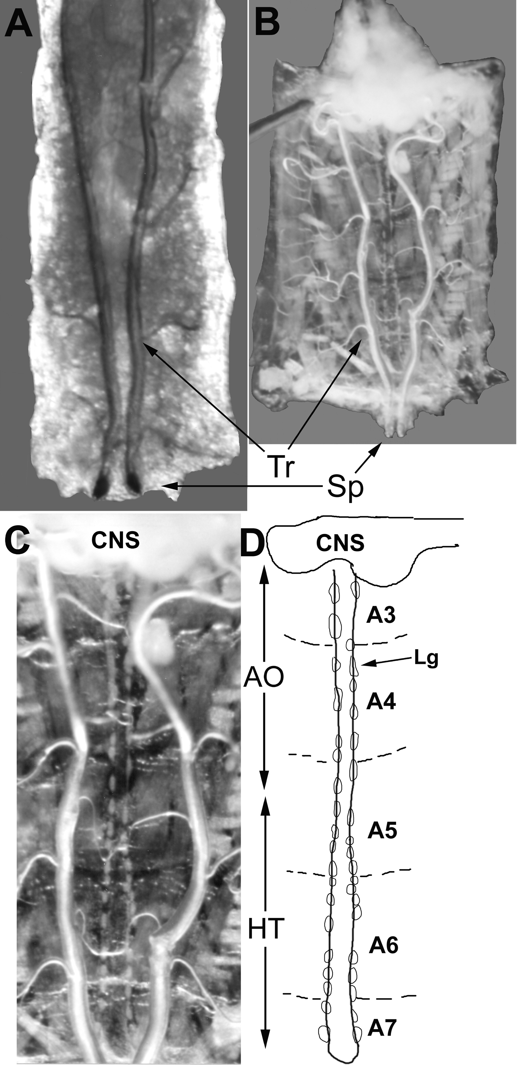
Figure 1
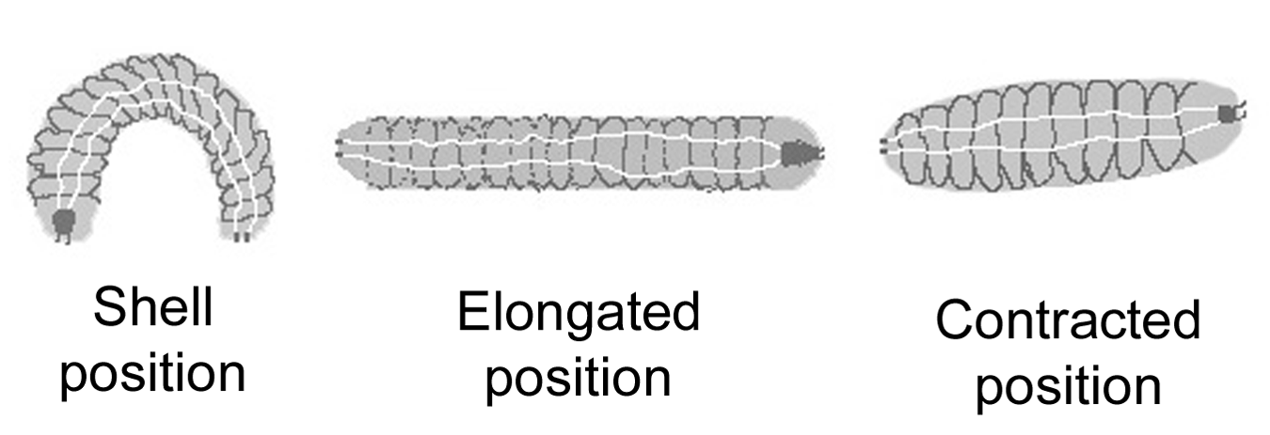
Figure 2
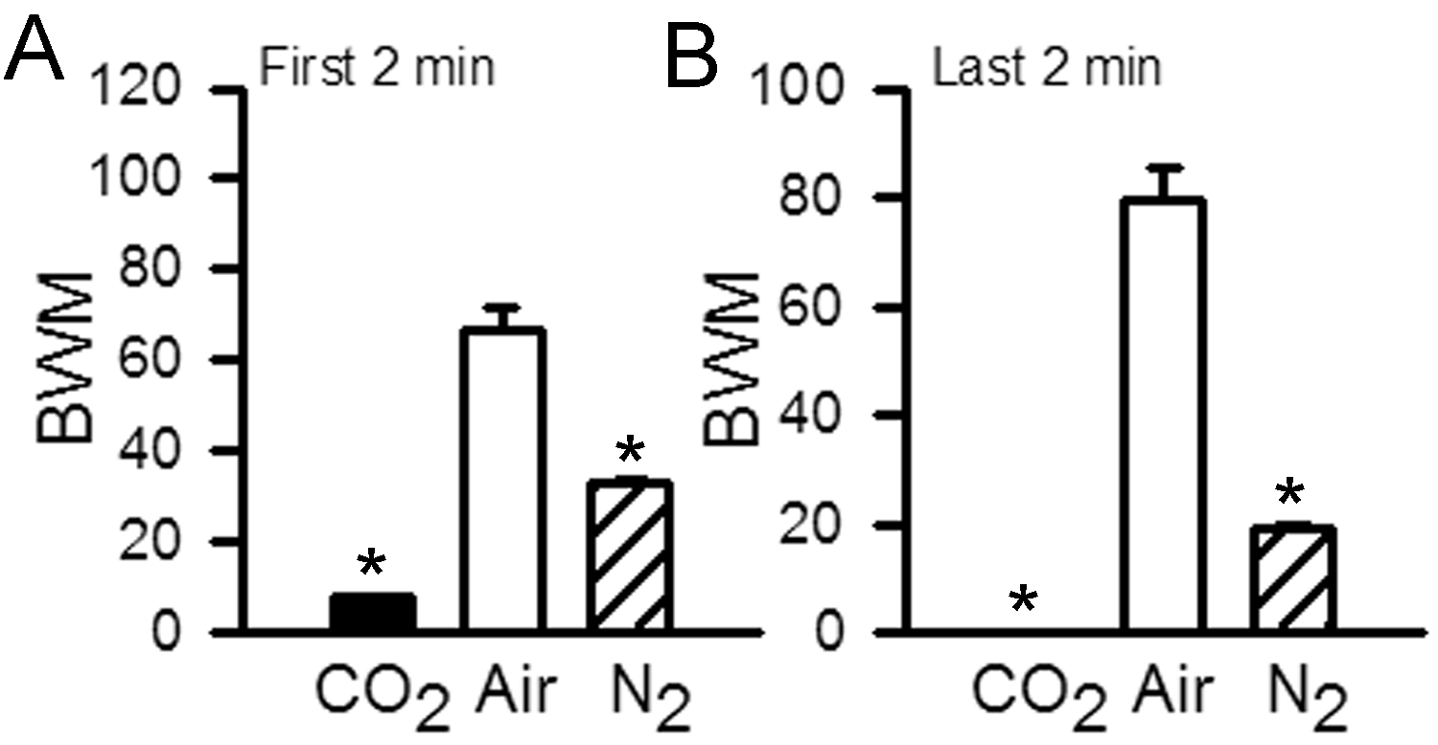
Figure 3
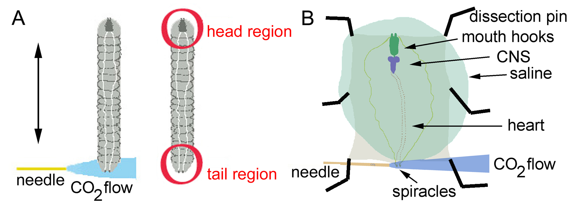
Figure 4
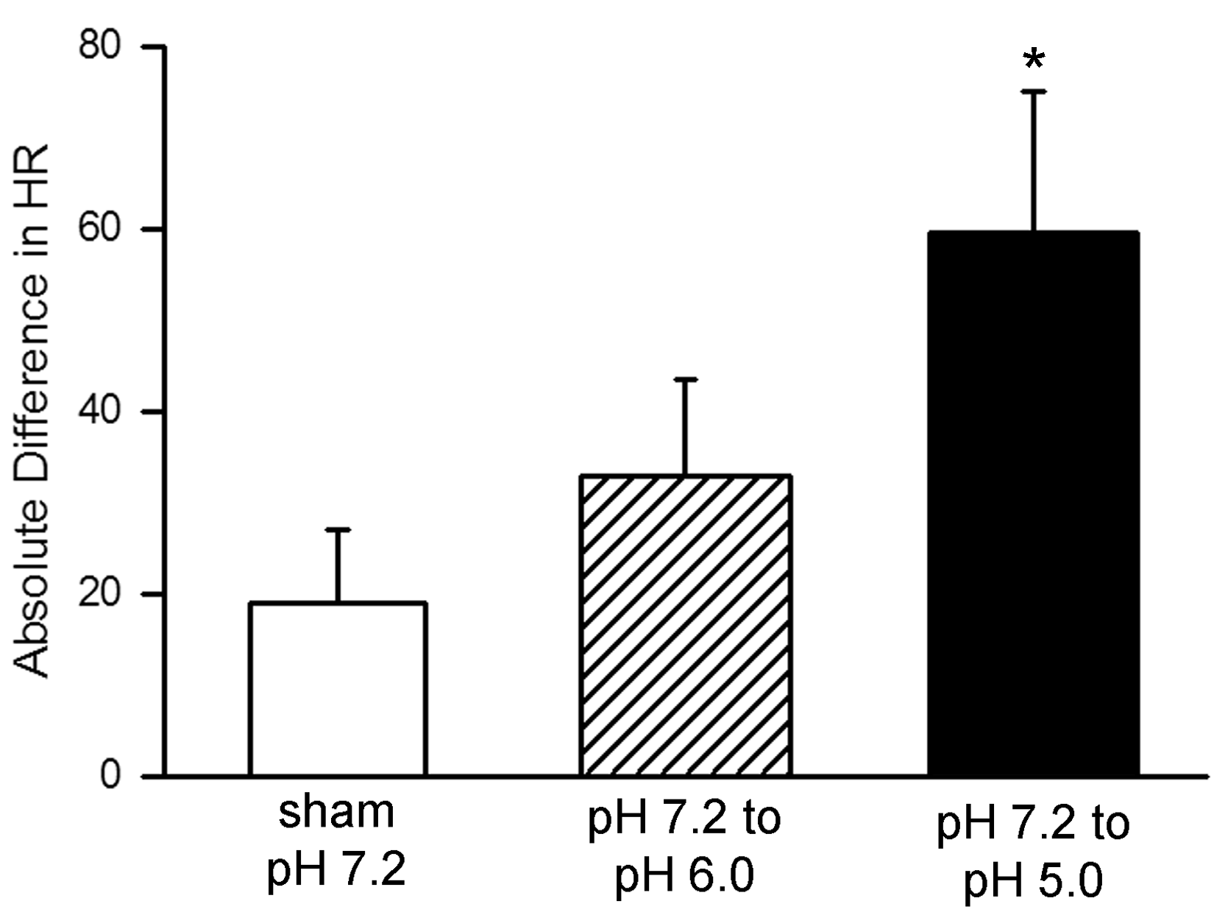
Figure 5
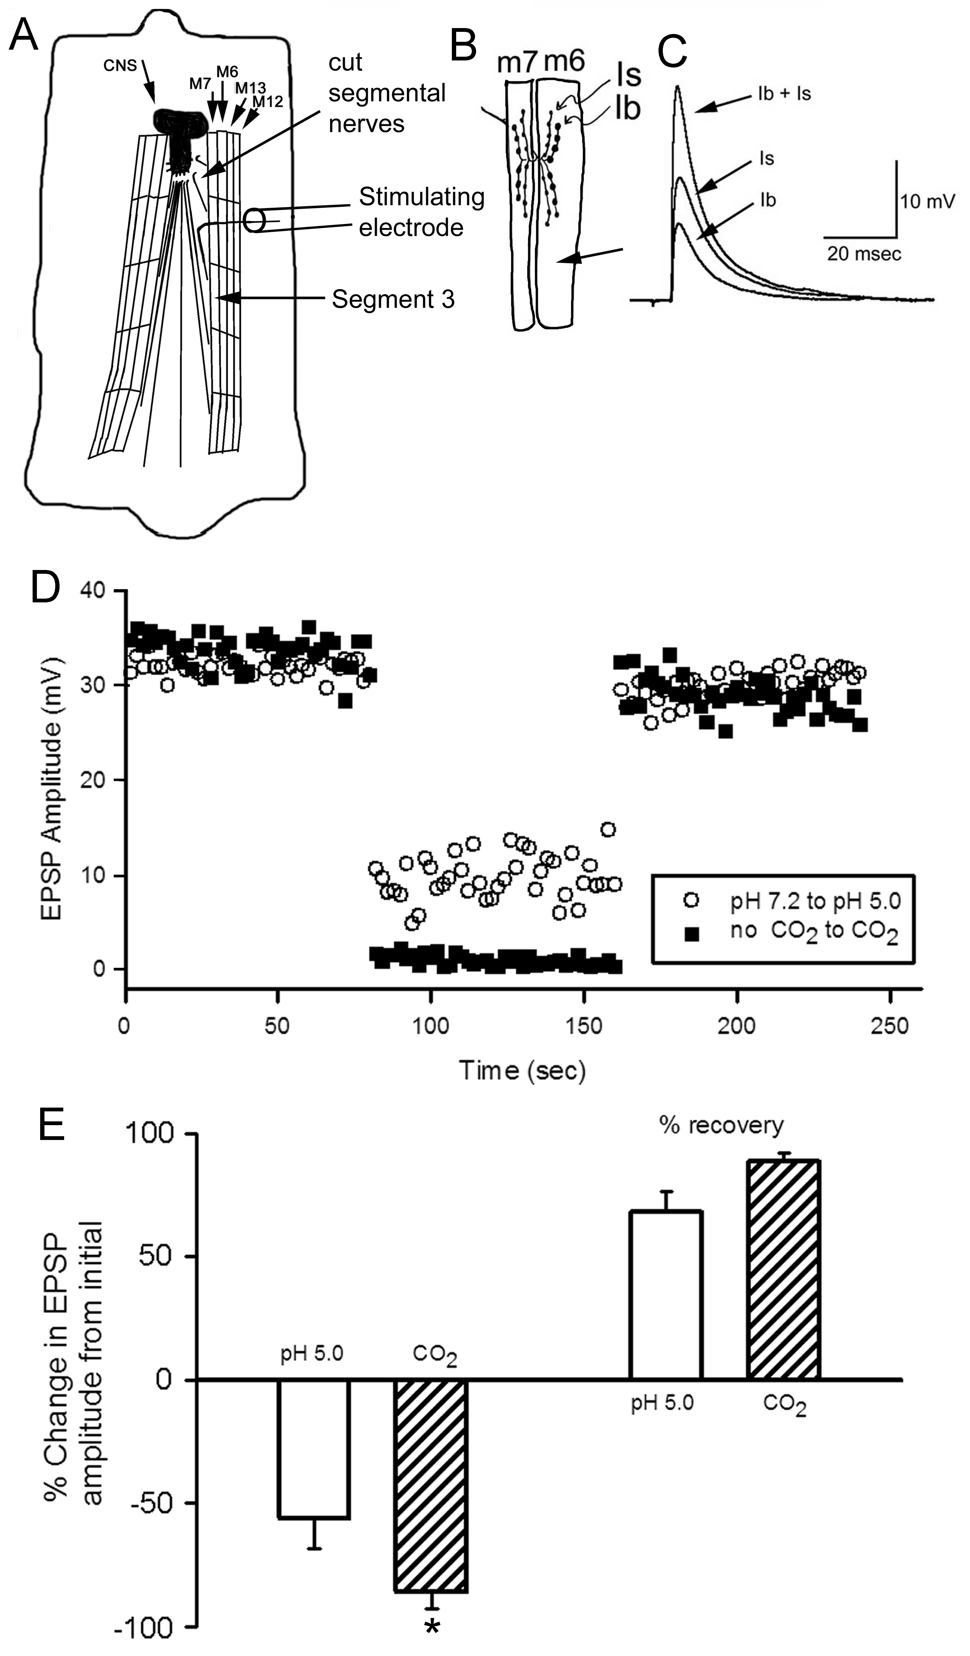
Figure 6
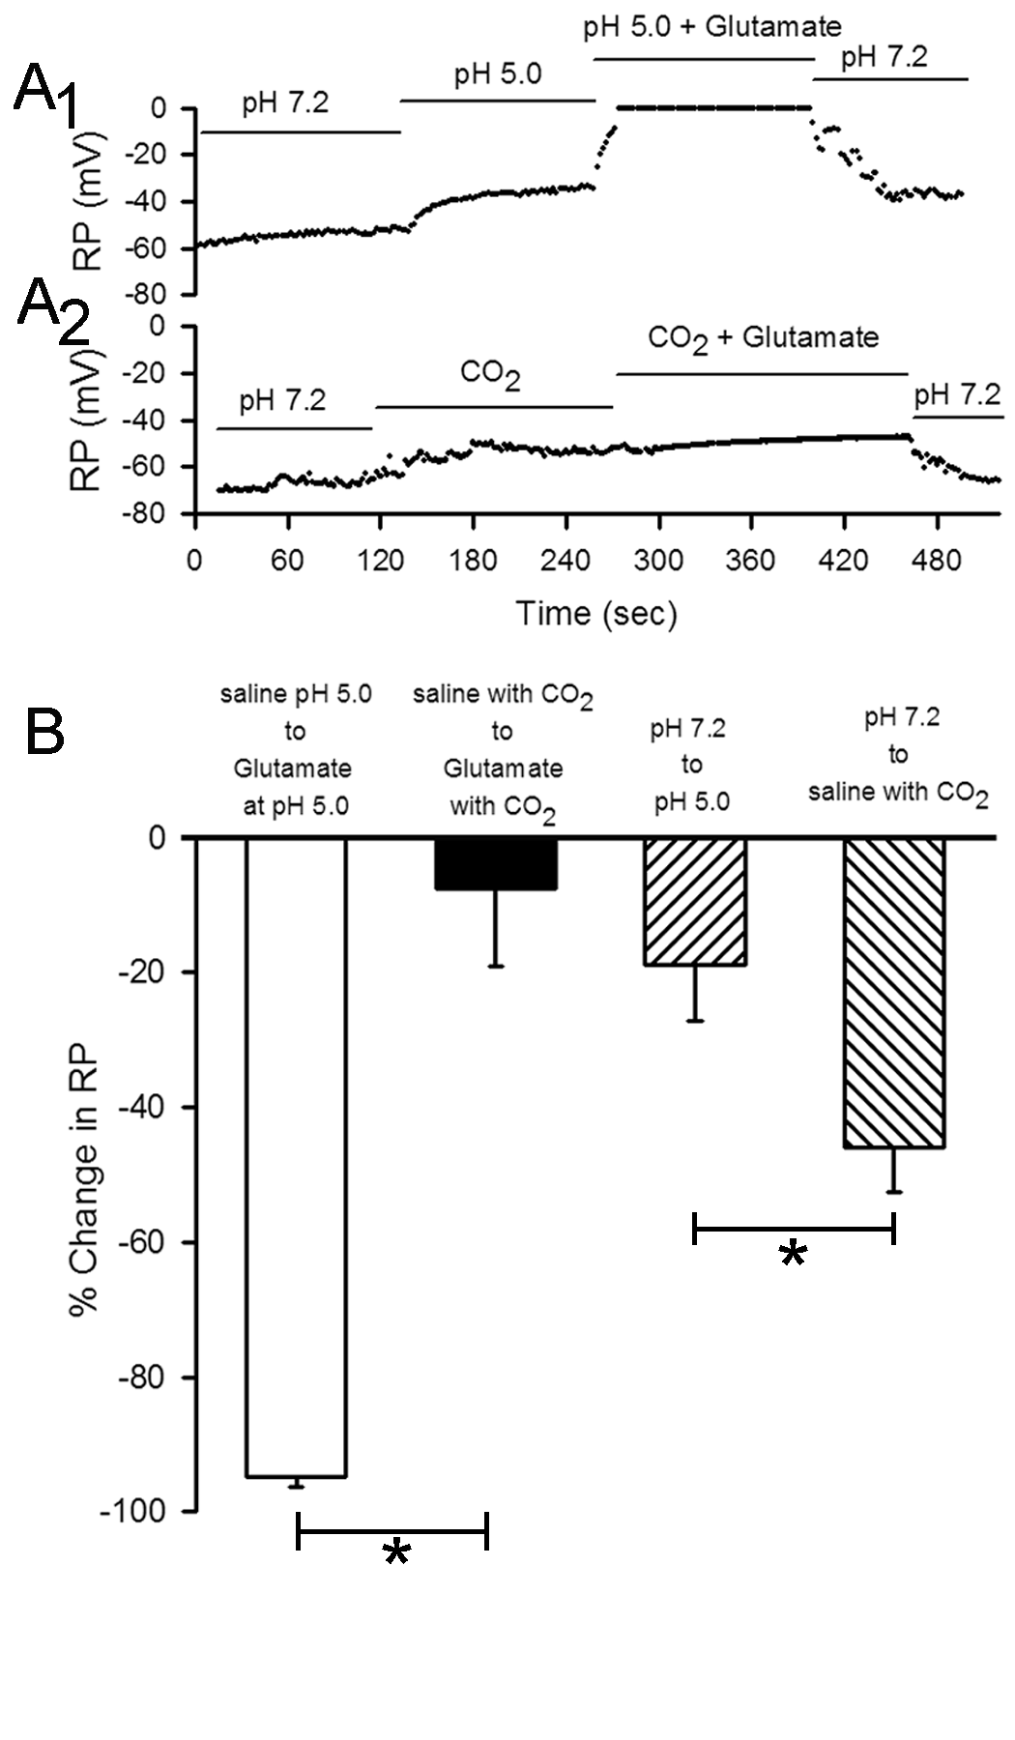
Figure 7
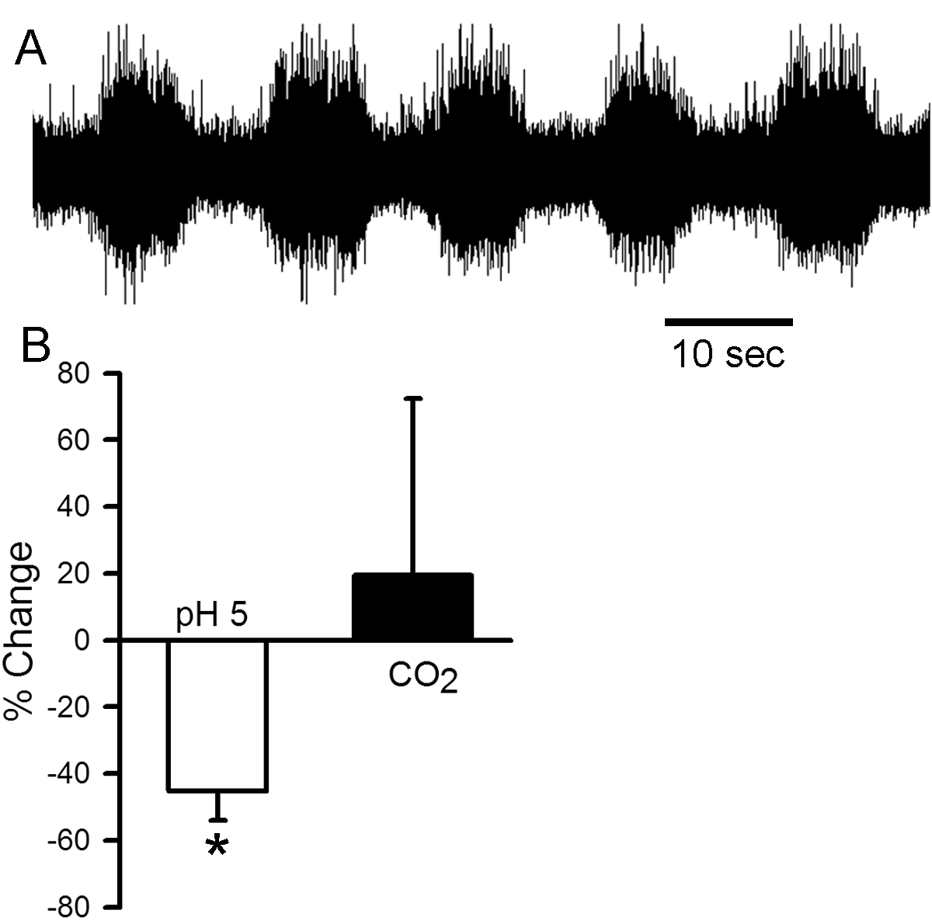
Figure 8

