Robin Cooper, Dept of Biology, University of KY.
Also posted on www site: http://www.as.uky.edu/Biology/faculty/cooper/TFC/workshopsummer2007.htm

PROJECT 1: Increased levels of atmospheric CO2 on crayfish
PROJECT 2: Phytoplankton blooms and the effects on crayfish

________________________________________________________________

PROJECT 1: Increased levels of atmospheric CO2 on crayfish

Overall Objective –monitor behavioral and physiological responses due to current environmental issues with a simple model organism of KY (i.e., crayfish). Monitor behaviors, heart rate, ventilation rate, responses to environmental cues, and selective pressure in crayfish within this experimental inquiry based module.

I. INTRODUCTION FOR CLASSROOM PROJECTS

1. Carbon Dioxide Concentrations in the Atmosphere (Facts for students- could ask them how to measure this over years then present the ice core data)

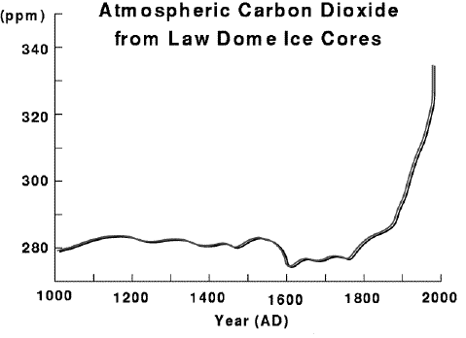
A closer look at the carbon dioxide changes within the last thousand years can be seen in the graphic on the left. The concentrations of carbon dioxide in the atmosphere, were measured in the bubbles from an Antarctic ice core from Law Dome near Australia's Casey Station. The Law Dome ice core is at a location where the snow accumulation is much higher than at Vostok. Thus, the time scale for the Law Dome core is expanded and it can provide us with more detailed information about recent climate changes.

Concentrations of carbon dioxide measured in the air bubbles trapped in the ice are shown in Antarctic ice core from Law Dome near Australia's Casey Station.

Concentration of Carbon Dioxide from trapped air measurements for the DE08 ice core near the summit of Law Dome, Antarctica. (Data measured by CSIRO Division of Atmospheric Research from ice cores supplied by Australian Antarctic Division). Dr. T.H. Jacka, Glaciology Program,Antarctic Cooperative Research Centre and Australian Antarctic Division.

QUES. a: Explain what is significant about the change in carbon dioxide concentration with time as viewed in the graphic?

QUES. b: What energy consuming and carbon dioxide producing events were taking place in most of the Northern Hemisphere at the time, (1850, 1900 and years following), of the dramatic increase in the carbon dioxide concentration?

(ref http://www.elmhurst.edu/~chm/vchembook/globalwarmA3.html)

2. What contributes to CO2 rising in the atmosphere? (Inquiry based time)

What Are Greenhouse Gases?
Many chemical compounds found in the Earth’s atmosphere act as “greenhouse gases.” These gases allow sunlight to enter the atmosphere freely. When sunlight strikes the Earth’s surface, some of it is reflected back towards space as infrared radiation (heat). Greenhouse gases absorb this infrared radiation and trap the heat in the atmosphere. Over time, the amount of energy sent from the sun to the Earth’s surface should be about the same as the amount of energy radiated back into space, leaving the temperature of the Earth’s surface roughly constant.

Many gases exhibit these “greenhouse” properties. Some of them occur in nature (water vapor, carbon dioxide, methane, and nitrous oxide), while others are exclusively human-made (like gases used for aerosols).

Why Are Atmospheric Levels Increasing?

Levels of several important greenhouse gases have increased by about 25 percent since large-scale industrialization began around 150 years ago (Figure 1). During the past 20 years, about three-quarters of human-made carbon dioxide emissions were from burning fossil fuels.

Figure 1. Trends in Atmospheric Concentrations and Anthropogenic Emissions of Carbon Dioxide
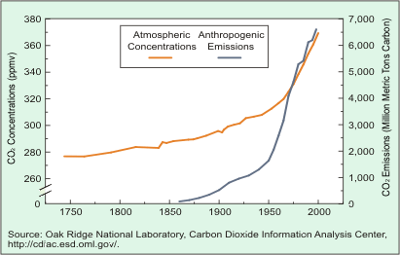
Figure 1 is a line graph showing the trends in atmospheric concentrations and anthropogenic emissions of carbon dioxide.

Concentrations of carbon dioxide in the atmosphere are naturally regulated by numerous processes collectively known as the “carbon cycle” (Figure 2). The movement (“flux”) of carbon between the atmosphere and the land and oceans is dominated by natural processes, such as plant photosynthesis. While these natural processes can absorb some of the net 6.1 billion metric tons of anthropogenic carbon dioxide emissions produced each year (measured in carbon equivalent terms), an estimated 3.2 billion metric tons is added to the atmosphere annually. The Earth’s positive imbalance between emissions and absorption results in the continuing growth in greenhouse gases in the atmosphere.

Figure 2. Global Carbon Cycle (Billion Metric Tons Carbon)
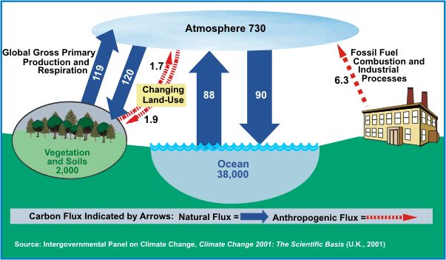
Figure 2 is a flow diagram showing the global carbon cycle.

What Effect Do Greenhouse Gases Have on Climate Change?

Given the natural variability of the Earth’s climate, it is difficult to determine the extent of change that humans cause. In computer-based models, rising concentrations of greenhouse gases generally produce an increase in the average temperature of the Earth. Rising temperatures may, in turn, produce changes in weather, sea levels, and land use patterns, commonly referred to as “climate change.”

Assessments generally suggest that the Earth’s climate has warmed over the past century and that human activity affecting the atmosphere is likely an important driving factor. A National Research Council study dated May 2001 stated, “Greenhouse gases are accumulating in Earth’s atmosphere as a result of human activities, causing surface air temperatures and sub-surface ocean temperatures to rise. Temperatures are, in fact, rising. The changes observed over the last several decades are likely mostly due to human activities, but we cannot rule out that some significant part of these changes is also a reflection of natural variability.”

However, there is uncertainty in how the climate system varies naturally and reacts to emissions of greenhouse gases. Making progress in reducing uncertainties in projections of future climate will require better awareness and understanding of the buildup of greenhouse gases in the atmosphere and the behavior of the climate system.

What Are the Sources of Greenhouse Gases?

In the U.S., our greenhouse gas emissions come mostly from energy use. These are driven largely by economic growth, fuel used for electricity generation, and weather patterns affecting heating and cooling needs. Energy-related carbon dioxide emissions, resulting from petroleum and natural gas, represent 82 percent of total U.S. human-made greenhouse gas emissions (Figure 3). The connection between energy use and carbon dioxide emissions is explored in the box on the reverse side (Figure 4).

Figure 3. U.S. Anthropogenic Greenhouse Gas Emissions by Gas, 2001
(Million Metric Tons of Carbon Equivalent)
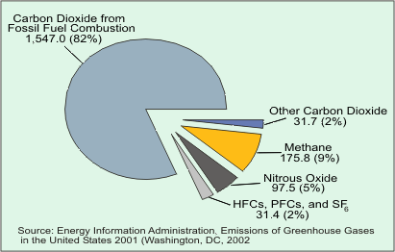
Figure 3 is a pie chart showing the anthropogenic greenhouse gas emissions in the U.S. by gas type.

Figure 4. U.S. Primary Energy Consumption and Carbon Dioxide Emissions, 2001
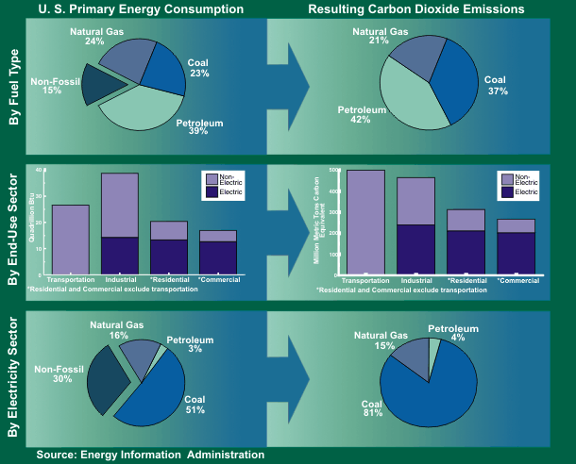
Figure 4 is a charting of the U.S. primary energy consumption with the resulting carbon dioxide emissions. For more detailed information about this chart, please call the National Energy Information Center at (202)586-8800.

Another greenhouse gas, methane, comes from landfills, coal mines, oil and gas operations, and agriculture; it represents 9 percent of total emissions. Nitrous oxide (5 percent of total emissions), meanwhile, is emitted from burning fossil fuels and through the use of certain fertilizers and industrial processes. Human-made gases (2 percent of total emissions) are released as byproducts of industrial processes and through leakage.

What Is the Prospect for Future Emissions?

World carbon dioxide emissions are expected to increase by 1.9 percent annually between 2001 and 2025 (Figure 5). Much of the increase in these emissions is expected to occur in the developing world where emerging economies, such as China and India, fuel economic development with fossil energy. Developing countries’ emissions are expected to grow above the world average at 2.7 percent annually between 2001 and 2025; and surpass emissions of industrialized countries near 2018.

Figure 5. World Carbon Dioxide Emissions by Region, 2001-2025
(Million Metric Tons of Carbon Equivalent)

Figure 5 is a line graph showing world carbon dioxide emissions by region from 2001-2025.

The U.S. produces about 25 percent of global carbon dioxide emissions from burning fossil fuels; primarily because our economy is the largest in the world and we meet 85 percent of our energy needs through burning fossil fuels. The U.S. is projected to lower its carbon intensity by 25 percent from 2001 to 2025, and remain below the world average (Figure 6).

Figure 6. Carbon Intensity by Region, 2001-2025
(Metric Tons of Carbon Equivalent per Million $1997)

Figure 6 is also a line graph showing carbon intensity by region from 2001-2025.

(ref http://www.eia.doe.gov/oiaf/1605/ggccebro/chapter1.html)
National Energy Information Center (NEIC)
Energy Information Administration, EI-30
Forrestal Building, Room 1E-226
Washington, DC 2058
Telephone: (202) 586-8800 FAX: (202) 586-0727
E-Mail: infoctr@eia.doe.gov
For more information, see EIA's Environmental Web Site:
http://www.eia.doe.gov/environment.html

3. What kind of impact would this have on animals ? Lets use a model animal in KY, say a crayfish.

Higher level of CO2 in air would also impact the KY streams. High limestone (CaHCO3) is similar to the ocean with HCO3 serving as a buffer balance. This could also change pH (acidly levels) of the water and have a direct pH effect of crayfish.

Other factors which could effect CO2 levels in water ? (Inquiry based- could be tested in classroom)

Lot of detritus decaying in the stream or in stagnate water will produce CO2 and layers within the water (or layers of mud) in which crayfish live. Recall crayfish burrow in mud banks as well as within the pond or stream.

Air contains only 0.035 % carbon dioxide by volume; however, CO₂ is nearly 30 times as soluble in water as oxygen. Carbon dioxide moves across the air-water interface according to the same physical process that affect the dissolving of oxygen. Both temperature and pressure affect the diffusion rate measured by dissolved CO₂ instruments. Accuracy and diffusion range are typically measured in parts per thousand or parts per million. (http://sensors-transducers.globalspec.com/Industrial-Directory/co2_detector)

Carbon dioxide (CO2) is present in water as a dissolved gas, like oxygen. High CO2 can stress and even kill fish. It also forms carbonic acid, which lowers the pH. this can be tested with Carbon Dioxide Test Kit. LaMotte Limnological Water Test Outfit. (http://www.lamotte.com/pages/edu/ind-kits/carbdiox.html) Testing takes 2 minutes. 0 to 50 mg/liter.

II. METHODS

Field studies
Survey streams around local vicinities in urban settings as compared to rural areas without run off. For example, Tates Creek stream in Lexington, as compared to streams out by KY river (Woodford) or even more remote more pristine places in the state. Look in stagnate pools on horse farms or other farms for crayfish. Might use crayfish bait traps. If possible where there is substantial run off over limestone. Set up a grid of several meters and count all the crayfish in and under rocks etc. Take notes on water environment and what is upstream. Compare data sets. Also take water samples for CO2 analysis.
Measure the CO2 and pH levels. Save water sample for nitrate sample in future experiments of algae bloom.
Collect crayfish from various sites and house in the class room. Use bottle drinking water.

Lab studies
Examine crayfish behaviors and take notes.
(a) For isolated crayfish held in small tanks: test tail flip response, response to food, response to shadow. Can monitor antennules flicks for response to orders in large crayfish. If one has Vernier LabPro (Vernier Software & Technology, 13979 SW Millikan Way, Beaverton, OR, 97005-2886, USA)
equipment can be used to measure heart rate (high school kids only).

(b) For grouped crayfish: Examine social interactions. Fighting, dominate and submissive behaviors.

Now in these lab held crayfish one can experiment with them and study the effects of dissolved CO2 in the water.

What happened if there is a rapid change as compared to a gradual change ? Drastic effects can be induced by adding HCO3 (baking soda) or Alka-Seltzer tablets (more than just CO2) and more gradual changes can be induced by adding small amounts of baking soda over a period of days or weeks.
Reexamine the behaviors initially studied. Does one see the same responses ? Make sure to run control experiments with groups of crayfish not exposed to CO2 but held for the same duration in the tanks.
Correlate effects observed with direct measures of dissolved CO2 and pH of the water.

III. ANTICIPATED RESULTS/ DATA PROCESSING

Have students list out possible outcome ahead of time. Have them make postulations and after initial studies are done then hypothesis based on the outcomes of the earlier tested predictions.
Graphs over time related to behaviors in pre exposure to CO2 and then compared to either rapid or gradual CO2 exposure. Recall controls need to be examined as well.
Compared data over time (dynamic measures as compared to one time static observations). This is a very important concept as humans today look at fossils or medical records and draw conclusions based on static measures.

IV. LEARNING OBJECTIVES (KY CORE CONTENT)

If monitor Heart rate:

(1) To highlight various types of experiments that students could design on their own for experimental inquiry. (AP Biology- “Science as a Process”, NSES- “Science Inquiry”)

(2) To convey an understanding in the regulation of heart rate and highlight similarities and differences between vertebrates and invertebrates. (AP Biology- “Unity in Diversity”).

(3) To allow students to ask further questions based on experiences with invertebrate models and to develop experimental designs for further research. (AP Biology-“Science as a Process”).

(4) To give students further experience with technological advancements and collection and manipulation of data using Vanier probes. (AP Biology-“Science, Technology, and Society”).

If measuring Physiology/Behaviors (Core Content Connections- need to check with David Helm FCPS):

SC-06-3.4.1

Students will describe the relationship between cells, tissues and organs in order to explain their function in multicellular organisms. With the effects of CO2 on whole animal

Examination of cells, tissues and organs reveals that each type has a distinct structure and set of functions that serve the organism for behaviors.
DOK 3

SC-06-3.5.2
Students will understand that regulation of an organism’s internal environment involves sensing the internal environment and changing physiological activities to keep conditions within the range required to survive. Maintaining a stable internal environment is essential for an organism’s survival.

SC-08-4.6.5
Students will:
Explain the effects of change to any component of the ecosystem.
DOK

______________________________________________________________________

PROJECT 2: Algal blooms resulting in decrease oxygen content: Effects of crayfish

I. INTRODUCTION FOR CLASSROOM PROJECTS

"Persistent suds were once commonly found in lakes and streams whose run-off contained phosphate-based detergents. Phosphorus is a limiting factor in lakes. Botkin and Keller (1998) define a limiting factor as the single requirement in the least supply in comparison to the need of an organism. If this factor becomes abundant, excess growth of an organism, or group of organisms, that require that factor will occur. If the organism is an alga, we call this excess growth an algal boom. Algal booms are often caused by a phenomenon called cultural eutrophication. This is described as the over nourishment (or increase in a limiting factor or nutrient) of aquatic ecosystems with plant nutrients because of human activities (Miller, 2000).
Algal blooms can lead to a decrease in the dissolved oxygen level in a lake. This decrease in oxygen occurs when algae reproduce so much that they form a thick mat. This results in a decrease in the amount of sunlight that reaches the photosynthetic organisms under the mat during the day. This decreases the amount of photosynthesis and subsequently the amount of oxygen produced by photosynthesis. Benthic photosynthetic organisms may die if too little sunlight reaches them. Dead organic matter becomes a food source for decomposers; this increases the amount of cellular respiration. Cellular respiration requires oxygen and this reduces the dissolved oxygen in the body of water. Therefore, the amount of dissolved oxygen is decreased two ways. The first is due to the decrease in photosynthesis and the second is due to the increase in cellular respiration." (ref http://www.ed.mtu.edu/esmis/id153.htm).

"The nutrient cycle for a natural pond, lake, or slow moving river starts with the plants (either simple, one-celled algae to more advance multi-celled flowering plants such as eel grass) and their ability to photosynthesize. This process uses carbon dioxide (CO2) and water (H2O) with energy from sunlight to form sugar (C6H12O6) and oxygen gas (O2). During photosynthesis oxygen dissolves in the water and is then available to aquatic plants, animals, and bacteria that all require it for respiration. Respiration is the opposite chemical reaction, where plants and animals take in oxygen and break down sugar to get energy for life and release water and carbon dioxide.
Animals eat plants and other animals and produce waste products as they live and die. The waste products and dead plants and animals sink to the bottom of the body of water. This muck, called detritus, breaks down with the help of bacteria and bottom feeders to produce nutrients. The more nutrients there are and the more available they become, the faster the plants, especially the algae, grow. This may be okay during the day when they can photosynthesize to produce enough oxygen to support the larger biomass of plants and animals, but not at night when no oxygen is being produced. When the biomass is too large for the dissolved oxygen supply, plants and animals die. As their bodies decompose, there is a surge of more bacterial activity and even more oxygen is required. Nothing can live in these waters—they are called dead zones. " (http://www.sky-bolt.com/pond.htm)

"The water quality of a river is only as good as the quality of the watershed that feeds into it. The properties of the water itself can be altered by very small amounts of added materials. Surface water, especially, are easily changed. There can be silt brought in by flooding, algae blooms caused by the combination of an increase nutrient supply and sunlight, or the leaching of minerals from soil or decomposing forest litter.
It is also important to remember that water quality changes over time. Sample analysis is only good for the time that the sample was taken. Man’s influence on surface water quality can be seen by deforestation, which can cause an increase in soil erosion, agrochemical pollution, and heavy metal pollution.
There are several easy and simple tests that can quickly assess the overall abiotic quality of a water sample. The first important preliminary test is measuring pH. Small changes in pH, 0.3 units or less, can be associated with relatively large changes in water quality (Renn, 1970). Metal solubilities and biological processes will then be affected. A change in pH can be the first clue in tracking down a serious water quality problem. Surface water usually has a pH of 6.0 to 8.5.
Water polluted from wastewater sources will contain phosphorus in ranges greater than .1 ppm. Increase in phosphorous concentrations will cause a rapid growth of algae in the water. As the algae dies and decomposes, the oxygen concentration will fall, adversely affecting fish populations.
Conductivity of a water sample can be used to determine the ion concentration in the sample. The ability of a solution to conduct an electric current increases with an increasing concentration of ions. There is a direct relationship between conductivity and total dissolved solids. So a high conductivity reading may indicate an environmental problem. Total dissolved solids usually are regulated at levels below 1100mg/L.
Water samples can easily be analyzed for pH, carbon dioxide, phosphorus concentrations, hardness and conductivity. The analysis can indicate the general “health” of the water system. Streams or rivers whose water samples show spikes in concentrations can then be revisited for the point source pollution." (http://www.woodrow.org/teachers/esi/2001/CostaRica/la_selva3/aquatic_sys/)

And from the Southwest Florida Water Management District, Brian Nelson gives a lesson in aquatic life:

"Free-floating (planktonic) and attached (periphytic) algae species are common and very important components of both freshwater and marine habitats. Algae, along with plants, are primary producers. They are able to utilize sunlight to make food (photosynthesis) and are the basis of the food chain for all aquatic organisms from zooplankton to shrimp and crayfish to largemouth bass and sea trout.

"Water bodies are often classified based on their productivity or ability to grow aquatic plants and/or algae, which is based on the amount of nutrients nitrogen and phosphorus (fertilizer) in the water. Oligitrophic lakes have few nutrients. They are characterized by small amounts of plants and algae, clear water, and little sedimentation or muck on the bottom. Eutrophic lakes are characterized by high levels of nutrients, abundant plant and/or algae populations, green water, and lots of sediment or muck on the bottom.

"As lakes age, they become more eutrophic as nutrients from their watershed are washed into the lake. This is a natural process that takes place over thousands of years. However, the process can be greatly accelerated by storm water runoff, the discharge of sewage, excessive use of fertilizer and other man-induced alterations within their watersheds. This process is called cultural eutrophication. This process can also affect estuarine areas such as Tampa Bay.

"Excessive algal populations that are common on eutrophic waters are considered detrimental for numerous reasons. They reduce water clarity, shading out more beneficial submerged plants that provide necessary food and habitat for fish, waterfowl, manatees and other aquatic life. In extreme cases, excessive algal populations can reduce dissolved oxygen levels in the water to a point where fish kills occur. These occurrences where algae becomes super-abundant are often referred to as algae blooms.

"Cultural eutrophication has impacted many freshwater and estuarine waters within our district and throughout Florida. For this reason, the water management districts, the Florida Department of Environmental Protection and other agencies have enacted educational, regulatory, restoration and protection programs to restore and protect water quality."

So it's a possibility that algal blooms could be a problem and affect the fish you're after, but there haven't been many documented cases of people getting sick from this.

Last year, the Centers for Disease Control issued this statement: "PEAS [possible estuary-associated syndrome] is not infectious and has not been associated with eating fish or shellfish caught in waters where pfiesteria has been found. However, persons should avoid areas with large numbers of diseased, dying, or dead fish and should promptly report the event to the state's environmental or natural resource agency."

PEAS symptoms include headache, skin rash, sensation of burning skin, eye irritation, upper respiratory irritation, muscle cramps, and gastrointestinal symptoms, the CDC said. (ref http://www.ecofloridamag.com/askeditor_algal_bloom.htm)

The inquiry based studies can be in the field as well as in the classroom. This project can be tied to Project 1 related to CO2.

II. METHODS

II. METHODS

Field studies
Survey streams around local vicinities in urban settings as compared to rural areas without run off. For example, Tates Creek stream in Lexington, as compared to streams out by KY river (Woodford) or even more remote more pristine places in the state. Look in stagnate pools on horse farms or other farms for crayfish. Might use crayfish bait traps. If possible where there is substantial run off over agriculture and farms. Set up a grid of several meters and count all the crayfish in and under rocks etc. Take notes on water environment and what is upstream. Compare data sets. Also take water samples for O2, phosphate and nitrate analysis.
Measure the O2, phosphate and nitrate analysis as well as pH levels. Save water sample for experiments of algae bloom examination.
Collect crayfish from various sites and house in the class room. Use bottle drinking water.

Lab studies
Examine crayfish behaviors and take notes.
(a) For isolated crayfish held in small tanks: test tail flip response, response to food, response to shadow. Can monitor antennules flicks for response to orders in large crayfish. If one has Vernier LabPro (Vernier Software & Technology, 13979 SW Millikan Way, Beaverton, OR, 97005-2886, USA)
equipment can be used to measure heart rate (high school kids only).

(b) For grouped crayfish: Examine social interactions. Fighting, dominate and submissive behaviors.

Now in these lab held crayfish one can experiment with them and study the effects of an induced algae bloom. Use growth lights and algae. Also can add rich food sources such as fish food.
What happened if there is a rapid change as compared to a gradual change ? Drastic effects can be induced by adding pre-incubated algae and more gradual changes can be induced by adding small amounts of algae or reduced lighting to grow the algae over a period of days or weeks.
Reexamine the behaviors initially studied. Does one see the same responses ? Make sure to run control experiments with groups of crayfish not exposed to algae but held for the same duration in the tanks.
Correlate effects observed with direct measures of dissolved O2, phosphate, nitrate analysis and pH of the water.

O2 & algae measure:
Vanier dissolved oxygen probes will be used to determine dissolved oxygen concentration. In order to determine the dry mass, the sides of the bottle will be scraped using a metal scoop. Students will swirl the water for 20 seconds. They will then wait twenty seconds to allow the sediment, essentially sand, to settle. Students will label and then determine the mass of empty containers. A 100 mL sample of each set-up is measured using a graduated cylinder and is poured into the appropriate 250 mL beaker. The water will be evaporated using the fan in the fume hood. The mass of the algae will be determined by subtracting the mass of the empty beaker from the final mass of the beaker and algae. (http://www.ed.mtu.edu/esmis/id153.htm)
Other compounds that can be measured (Phosphate and Nitrates):
LaMotte Limnological Water Test Outfit. (http://www.lamotte.com/pages/edu/ind-kits/nitrphos.html). For nitrate & phosphate: The kit #3119 uses one comparator that contains both nitrate and phosphate standards. The phosphate method in kit #3119 is an ascorbic acid reduction.

III. ANTICIPATED RESULTS/ DATA PROCESSING

Have students list out possible outcome ahead of time. Have them make postulations and after initial studies are done then hypothesis based on the outcomes of the earlier tested predictions.
Graphs over time related to behaviors in pre exposure to CO2 and then compared to either rapid or gradual algae exposure. Recall controls need to be examined as well.
Compared data over time (dynamic measures as compared to one time static observations). This is a very important concept as humans today look at fossils or medical records and draw conclusions based on static measures.

IV. LEARNING OBJECTIVES (KY CORE CONTENT)

If monitor Heart rate:

(1) To highlight various types of experiments that students could design on their own for experimental inquiry. (AP Biology- “Science as a Process”, NSES- “Science Inquiry”)

(2) To convey an understanding in the regulation of heart rate and highlight similarities and differences between vertebrates and invertebrates. (AP Biology- “Unity in Diversity”).

(3) To allow students to ask further questions based on experiences with invertebrate models and to develop experimental designs for further research. (AP Biology-“Science as a Process”).

(4) To give students further experience with technological advancements and collection and manipulation of data using Vanier probes. (AP Biology-“Science, Technology, and Society”).

If measuring Physiology/Behaviors (Core Content Connections- need to check with David Helm FCPS):

SC-06-3.4.1

Students will describe the relationship between cells, tissues and organs in order to explain their function in multicellular organisms. With the effects of CO2 on whole animal

Examination of cells, tissues and organs reveals that each type has a distinct structure and set of functions that serve the organism for behaviors.
DOK 3

SC-06-3.5.2
Students will understand that regulation of an organism’s internal environment involves sensing the internal environment and changing physiological activities to keep conditions within the range required to survive. Maintaining a stable internal environment is essential for an organism’s survival.

SC-08-4.6.5
Students will:
Explain the effects of change to any component of the ecosystem.
DOK

REFERENCES CITED (more to add)

Bodkin, Daniel B. and Edward A. Keller. 1998. Environmental Science: Earth As A Living Planet. 2nd ed. New York: John Wiley & Sons, Inc.

Michigan Department of Education. Michigan Curriculum Framework. [Online]Available http://cdp.mde.state.mi.us/MCF/search.html. Wednesday, August 8, 2001

Li, H., Listerman, R., Doshi, D., Cooper, R.L., 2000. Heart rate measures in blind cave crayfish during environmental disturbances and social interactions. Comparative Biochemistry and Physiology, 127A, 55-70.

Listerman, R., Deskins, J., Bradacs, H., Cooper, R.L., 2000. Measures of heart rate during social interactions in crayfish and effects of 5-HT. Comparative Biochemistry and Physiology 125A, 251-263.

Miller, G. Tyler Jr. 2000. Living in the Environment. 11th ed. Pacific Grove, CA. Brooks/Cole
Publishing.

Renn, C. R. 1970. Investigating Water Problems. LaMotte Company, Chestertown, Maryland.

Schapker, H., Breithaupt, T., Shuranova, Z., Burmistrov, Y., Cooper, R.L., 2002. Heart and ventilatory measures in crayfish during environmental disturbances and social interactions. Comp. Biochem. Physiol., 131A, 397-407.

Wilkens, J.L., Mercier, A.J., Evans, J., 1985. Cardiac and ventilatory responses to stress and to neurohormonal modulators by the shore crab Carcinus maenas. Comp. Biochem. Physiol. C, 82, 337-343.

