Preparations with animals (Brine Shrimp and Crayfish)
As for the initial experiments on pH and CO2 content next one is to examine the effect on Brine shrimp and crayfish.
The effect of Brine Shrimp is to measure their mobility and survival in water that has not been gassed with CO2 and in water that has CO2. The crayfish experiments are to monitor heart rate and behavior while exposed to CO2 and or low pH.
Approach 1: Baking soda and vinegar method with phenol red-Brine Shrimp
Here the monitoring of pH with a meter can be used to determine the effects of pH and CO2 on Brine Shrimp survival and behavior.
- Take 50 mls of solution place in beaker or container. Place plastic seal warp over top. Poke 2 holes in plastic about the diameter of a soda straw.
- Place plastic tube in solution.
- After the apparatus is connected add 5 grams of HCO3 and inject 10 ml of vinegar to one flask and collect CO2 bubbles in the phenol red containing fresh water.
- Take some of the water (2 ml) that was not exposed to the CO2 and some (2 ml) that was with the CO2. Place the different solutions in small dishes.
- To control for the effect of pH, take the starting solution and add HCl until the same pH is obtained.
- Add about the same amount of Brine shrimp. Examine about every 10 minutes. Be sure to maintain the lighting about the same for both containers as the shrimp behavior depends on the light.
- Every 10 minutes count how many shrimp are moving and swimming around in each of the containers. After 30 minutes is there any major difference that is noticeable between the dishes in relation to Brine Shrimp behavior?
- The pH of the solution should be taken to compare pH with behavior for repeated trials.
- If one has a CO2 monitoring ability then use the CO2 assay.
- Graph (line and scatter plot) % of Brine shrimp moving (swimming) in each container over time.

Approach 2: Baking soda and vinegar method with phenol red- Crayfish and their Heart Rate.
- Take 50 mls of solution place in beaker or container. Place plastic seal warp over top. Poke 2 holes in plastic about the diameter of a soda straw.
- Place plastic tube in solution.
- Placed wired crayfish in phenol red containing fresh water (recall this is the crayfish pond water not tap water that is made up with Phenol Red).
- Record HR of crayfish for 2 minutes before starting the CO2 exposure.
- After the apparatus is connected add 20 grams of HCO3 and inject 20 ml of vinegar to one flask and collect CO2 bubbles in the phenol red containing fresh water with a crayfish (75 mls).
- Take recordings of HR every 10 minutes for 1 minute. Repeat for 40 minutes.
- To control for the effect of pH, take the starting solution and add HCl until the same pH is obtained. Exchange this solution for one with baseline conditions. Remember to collect HR data prior to changing the solution and then every 10 minutes after changing solutions.
- Note- see write up how to wire up crayfish. Wire the crayfish up 1 day in advance if possible and test the HR signals.

METHODS for wiring up crayfish to record Heart Rate (HR):

The supplies consist of the following items:
1. Crayfish (obtained from various biological suppliers or fish farms)
2. Vernier LabPro (Vernier Software & Technology, 13979 SW Millikan Way, Beaverton, OR, 97005-2886, USA)
3. The human ECG module sold separately or together with the LabPro (same company that sells the LabPro)
4. Two meters of coated stainless steel wire (diameter 0.005 inches and with the coating 0.008 inches; A-M systems, Inc., Carlsburg, WA).
5. A TI-83PLUS or TI-86 with the LabPro software installed. USB port required for data transfer from LabPro to computer or can go directly to computer.
6. Dissecting scalpel blade
7. Super Glue (cyanoacrylate ester and accelerator can be obtained at most craft stores such as HobbyTown USA)
The same procedures are described in an earlier study for obtaining heart rates (Listerman et al., 2000) with the exception of insulated stainless steel wires(diameter 0.005 inches and with the coating 0.008 inches; A-M systems, Inc., Carlsburg, WA). The tips of the wires to be placed in the animal are stripped of the insulation by using a fire from a match. Only about 1/8 of an inch is required to be stripped. These ends are bent 90 degrees to aid in holding them in the animal while glue them in place (Figure 1).

The crayfish is wrapped in moist towels with its chelipeds wrapped well and forced against its body underside. The tail is tucked under the animal and wrapped with a paper towel to keep the animal from tail flipping while placing the recording leads into the animal.

The tips are to be placed under the dorsal carapace directly over the heart to record the heart rate. These two wires were placed to span the heart in a rostral-caudal arrangement to insure an accurate measure during each contraction. A third wire is placed under the cuticle in the rostral area of the thoracic chamber to serve as a ground. Wires were inserted through holes drilled in the carapace and cemented in place with cyanoacrylate ester and accelerator (HobbyTown USA, Lexington, KY). The use of this rapid drying glue reduced handling stress of the animals which is known to have an effect on heart rate (Wilkens et al.,1985; Listerman et al., 2000).

To make the smallest hole possible for less loose of blood (hemolymph) a sharp pointed scalpel blade (a #11 blade) is used. The scalpel is turned around and around slowly on the location where the holes are desired. Just as one is about through the carapace poke a small needle through the depression made by the scalpel blade until a little bit of hemolymph appears. Another person will then need to place the bent lead into the hole and with a slight pull to one side to keep the wire taut. Before placing the super glue over the hole with the wire in it dab of any remaining hemolymph. Repeat same procedure for the other two wires. (Figure 2A, B).

**Caution- Do NOT make the holes over the gill chambers since that fluid in the gill chamber is the same as the external aquaria water. Do not push the wires too deep into the animal as the ends will hit through the heart and other vital organs. If too much super glue gets into the holes, which are in the thoracic cavity, the crayfish will die so use only a small amount. If the holes were made too big then modeling clay can be used to seal the hole and reduce the bleeding until the wires are placed in the holes and glued in place.

Secure the other end of the wire to a the alligator clips placing for the red and green leads which should span the heart and the black lead attach to the wire placed in the anterior part of the thoracic above the heart (Figure 2B).

Turn on the calculator or start the software on a computer for the LabPro. Change the setting to acquire 200 points/sec and to acquire for 60 seconds of data. The data should look close to that shown in Figure 3. The waveforms will vary depending on the location of the leads to the heart. The point here is that the beats per minute can be determined from the recordings.

References
Li, H., Listerman, R., Doshi, D., Cooper, R.L., 2000. Heart rate measures in blind cave crayfish during environmental disturbances and social interactions. Comparative Biochemistry and Physiology, 127A, 55-70.
Listerman, R., Deskins, J., Bradacs, H., Cooper, R.L., 2000. Measures of heart rate during social interactions in crayfish and effects of 5-HT. Comparative Biochemistry and Physiology 125A, 251-263.
McMahon, B.R., 1995. Integrated neural and neurohormonal control of respiratory and circulatory function in crustaceans: Is there evidence for an >autonomic= control system? Verh. Dtsch. Zool. Ges., 88.2, 87-101.
Schapker, H., Breithaupt, T., Shuranova, Z., Burmistrov, Y., Cooper, R.L., 2002. Heart and ventilatory measures in crayfish during environmental disturbances and social interactions. Comp. Biochem. Physiol., 131A, 397-407.
Wilkens, J.L., Mercier, A.J., Evans, J., 1985. Cardiac and ventilatory responses to stress and to neurohormonal modulators by the shore crab Carcinus maenas. Comp. Biochem. Physiol. C, 82, 337-343.

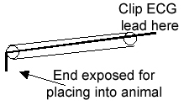

Figure 1: Wire with insulation for use with ECG.

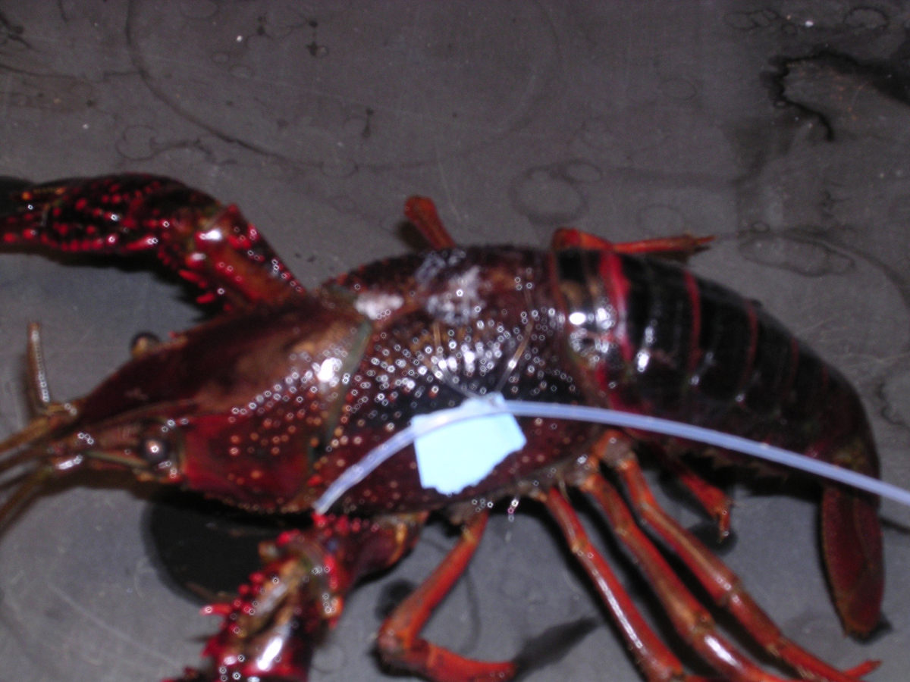
Figure 2A: Intact crayfish wired for recordings

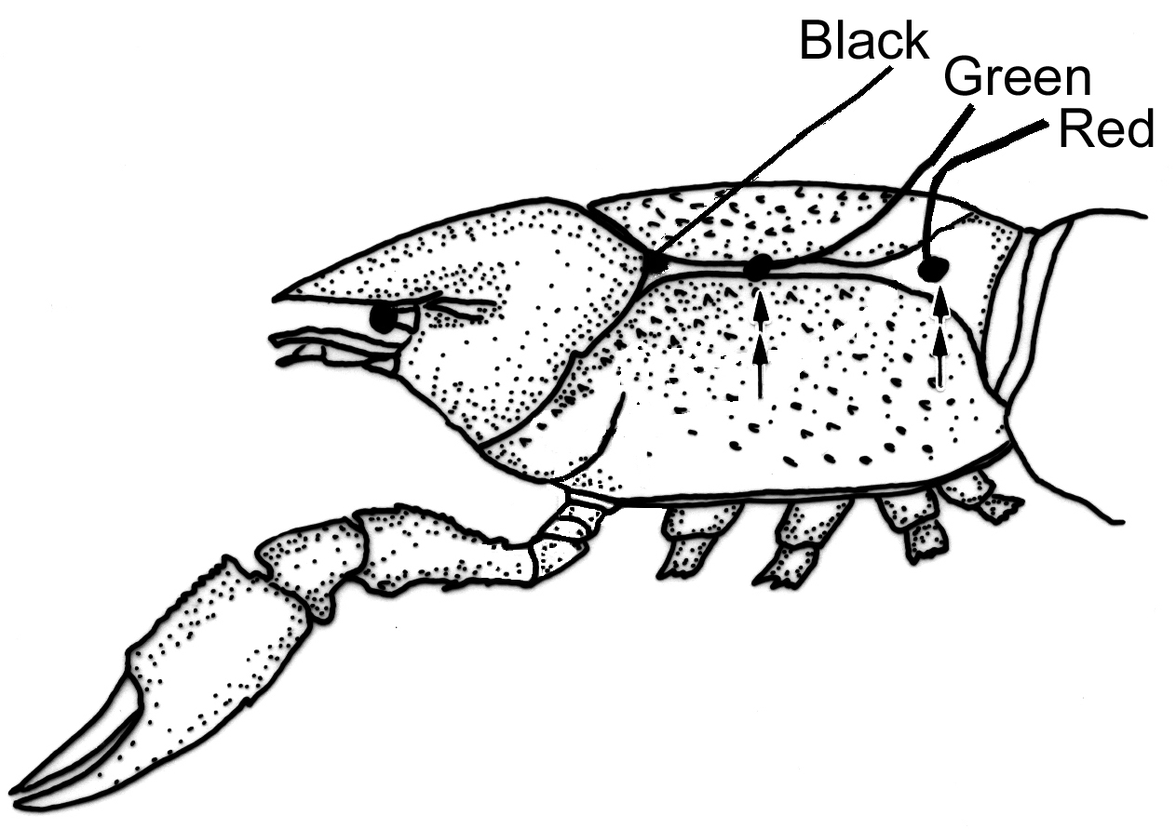
Figure 2B: A schematic in the placement of the wires
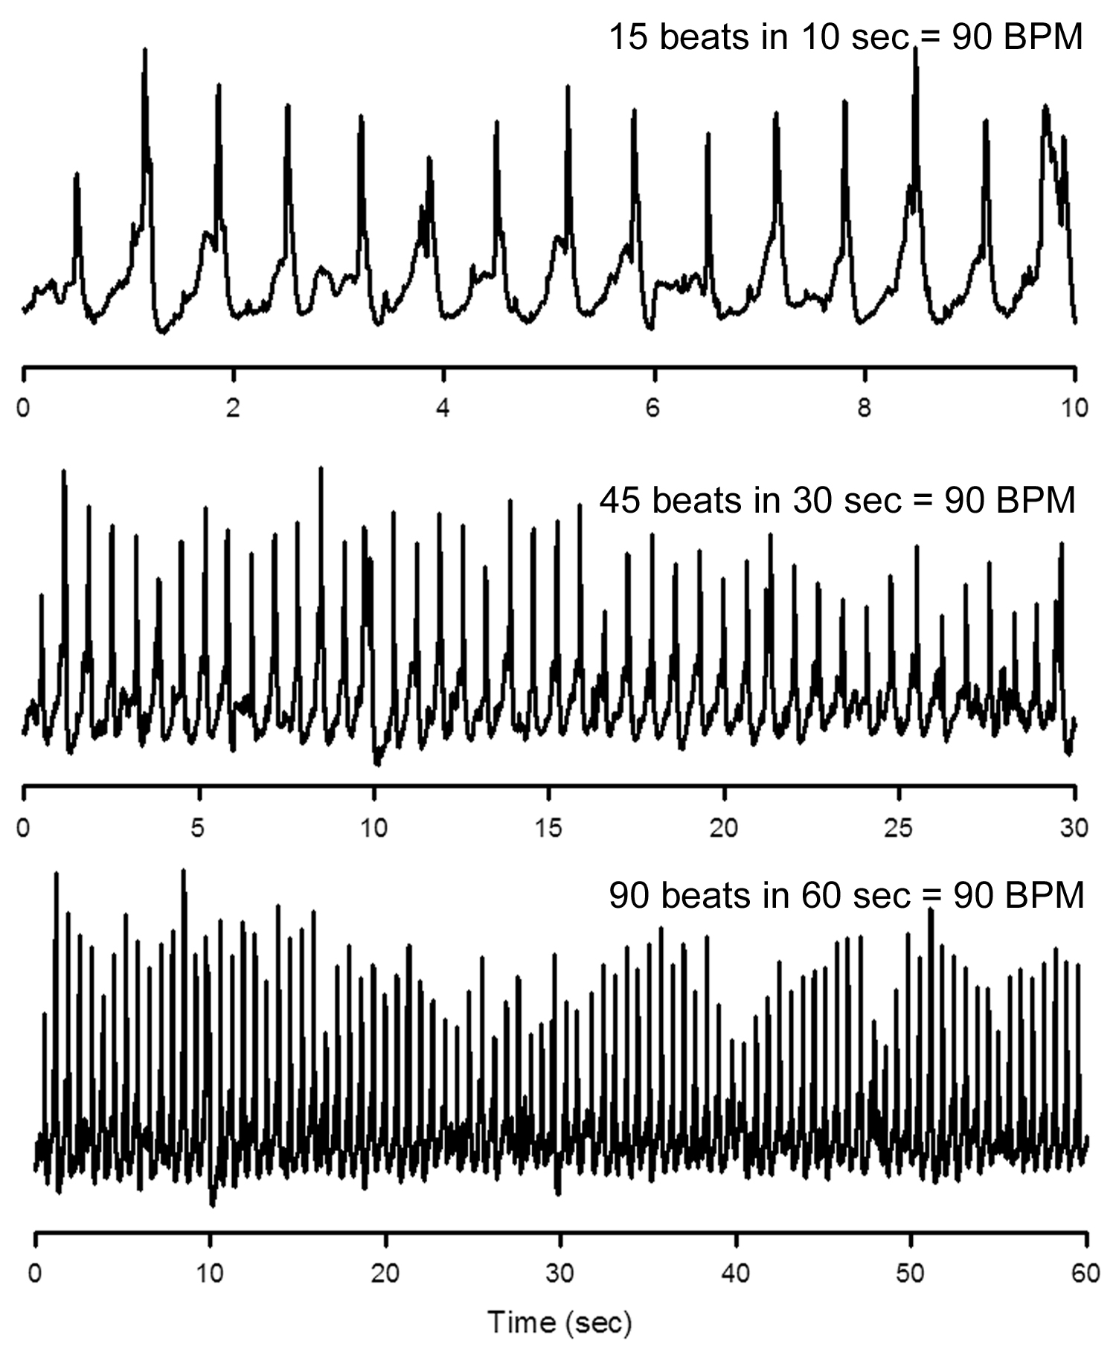
Figure 3: 10 seconds, 30 seconds and 1 minute time scales shown.

