Exercise in Biology and Geometry
Background Information:
You will learn how to use basic geometry principals to solve problems that scientists face. Imagine that you are a scientist that was sent two specimens that were the same in shape, size, and are paper-thin. Unfortunately the two specimens were already sectioned, and had different width slices. One cell specimen was sliced into 3 slices that were 1 cm in width. The second specimen was sliced into 4 slices that were 0.75 cm (or ¾ cm) in width. You, as a scientist, are to determine what the original structure (i.e., size and shape) of the cell was and to find which technique of sectioning is best to approximate the real area of the specimen (on one side).
To view the sections, you shine a light from the side of the sections to view a shadow on a 2-D plane (Figure A and B). Figure A shows a flat triangle in the box that will be sectioned. Figure B shows a slice (#2 section) taken out of the box and a light projecting the image on to the wall behind.
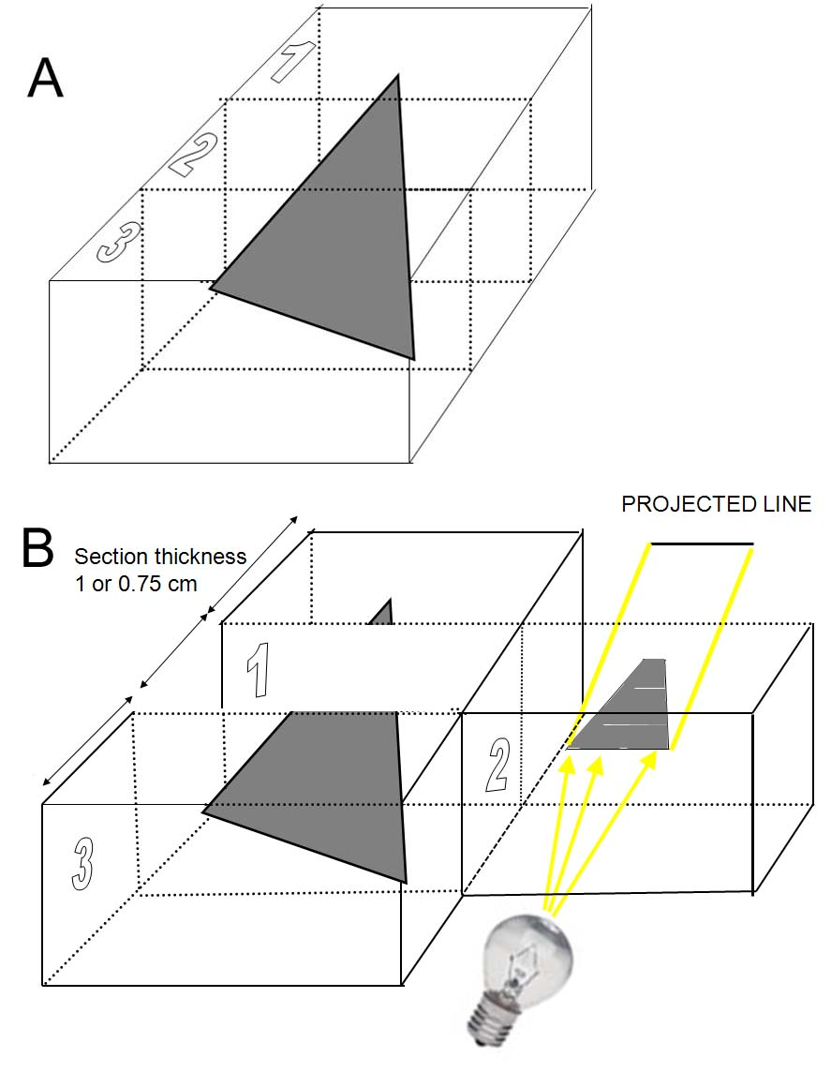

Par
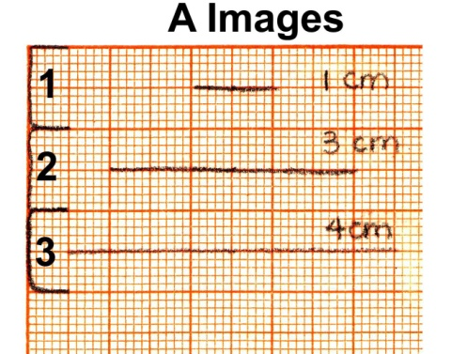 Specimen 1
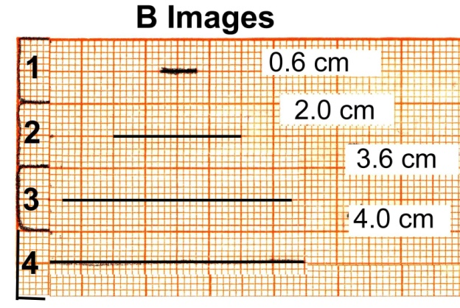 Specimen 2
Draw the estimated shape of the specimens determined from the sections shown above for specimens 1 (projected A images) and 2 (projected B images). Specimen A is sectioned into 3 slices and specimen B is sectioned into 4 slices. The 3 slices are 1 cm in width and the 4 slices are 0.75 cm (or ¾ cm) in width.
The section that is projected is the width of a section. For example:
If there were 2 sections that were projected (see below Figure 1.0A), you would draw the specimen as shown (top view- looking down).
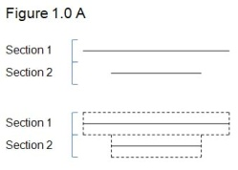
After you have drawn specimens A and B, calculate the area of the specimens.
Specimen A: Specimen B:
Section 1: Section 1:
Section 2: Section 2:
Section 3: Section 3:
Total Area: Section 4:
Total Area:
Part 1.1: Difference between the Two Techniques
Calculate the difference between the two areas from the two techniques.
Difference:

Part 2.0: Determining the Area with an Edited Version of the Sections
In part 1.0, you drew the specimens as sort of a stair-step view. Usually for a cell specimen the projected sections would not cover the whole section. To fix this problem, draw a new picture for specimens A and B where the projected image does not cover the whole section width but ½ its width to correct for the large stair step between sections. On average with random sections this would occur as ¼ the width between sections. For example:
If you were given the same slices as in part 1.0, the edited version would be drawn as shown. To draw the edited version, find the middle point between sections 1 and 2 and draw 2 lines (C). Draw this line C halfway between the first sections to the second section. Line C will stop at the beginning of the last section and line B will be the estimated end of the specimen. The last section can not be averaged for the stair-step effect because if there was a longer projected section in the last section, then the original projected section would be longer.
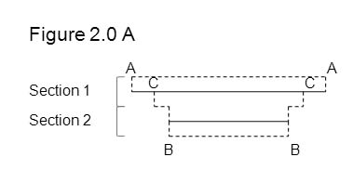
After drawing an edited version for both specimens A and B (as seen in a top view above), calculate the area.
Specimen A Area:
Specimen B Area:
Part 2.1: Difference between the Two Edited Techniques
Calculate the difference between the two edited techniques.
Difference:
Part 2.2: Comparing the Difference between the Edited Techniques to the First Technique
Calculate the difference in area for specimen A and B from part 1.0 to part 2.0.
Difference for Specimen A:
Difference for Specimen B:
Part 3.0: Determining the Area with a More Realistic Edited Version of the End Sections
In part 2.0, you determined the area when the projected sections went to the edge of the section. In reality not all specimens go to the edge of the sections. Redraw specimens A and B with another technique. For example:
Take the same drawing done in part 2.0 and take off half of the width in the end sections (step 1). Then draw a line down a fourth (1/4) of the way from the projected section (step 2), and go to the edge of the second projected section (step 3). This corrects for end sections as well as the large stair step effect on average.
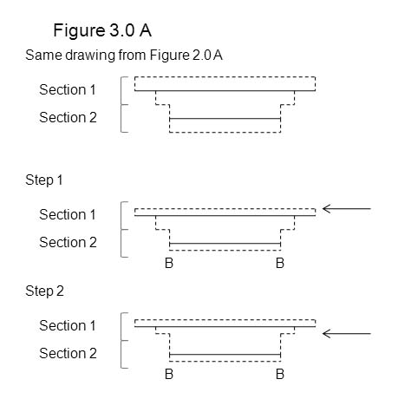

After drawing the new edited version for both specimens A and B, calculate the area.
Specimen A Area:
Specimen B Area:
Part 3.1: Difference between the Two New Edited Techniques
Calculate the difference in area between specimen A and B.
Difference:
Part 3.2: Compare the Difference Between the New Edited Techniques to the First Edited Techniques.
Calculate the difference in area between specimens A and B from part 3.0 to 2.0.
Difference for Specimen A:
Difference for Specimen B:
Part 3.3: Compare the Difference Between the New Edited Techniques to the First Techniques.
Calculate the difference in area for specimen A and B from part 3.0 to part 1.0.
Difference for Specimen A:
Difference for Specimen B:
Part 4.0: Calculating the Real Area of the Two Specimen
The specimens were actually shaped as triangles. Calculate the two areas for both specimens A and B from the figures given of the true structure.
Specimen A Area:
Specimen B Area:
Part 4.1: Comparing the Three Techniques to Find Area in Relation to the True Area
 | Specimen A | Specimen B
Area from part 1.0
Area from part 2.0
Area from part 3.0
True Area
Place a checkmark next to the technique that is most similar to the real area.
Questions:
- Which specimen (A or B) had the largest measurement of error, and why?

- Which specimen (A or B) had the least measurement of error, and why?

- How could a laboratory worker reduce the error measurement before slicing a specimen?

- How could a laboratory worker estimate the appearance of a specimen if only receiving the sections of the specimen?

Teacher’s notes
What the students should obtain from part 1.0
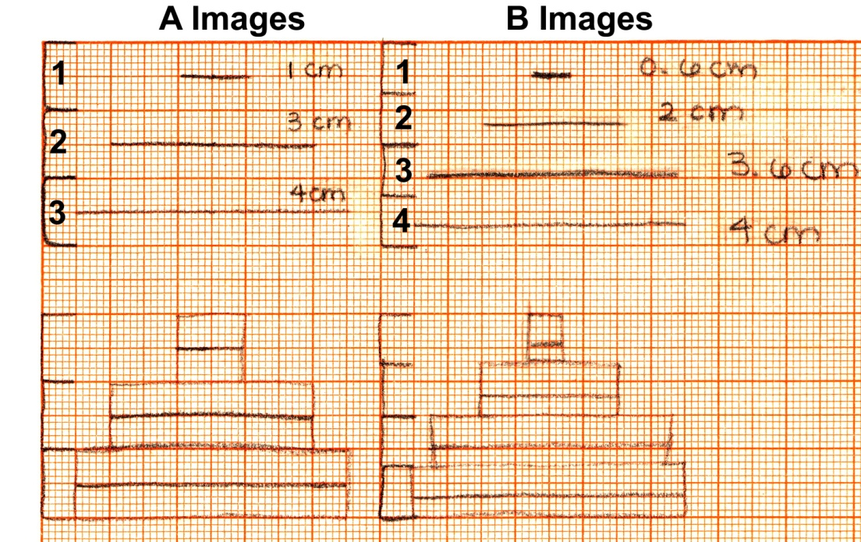
The common view might be as shown looking down from the top as in the bottom half of this figure. But is this really the way to show it from sections with varying thickness when a block of wax or resin is the same height for each section?

The true structures of the objects used for this problem are shown below. Students can calculate the true area and determine how much their estimates are off. Top view looking down.
