Exercise in Biology and Geometry Part 2
Background Information
Imagine you are a scientist that is sent two specimens that have a 3-D configuration. The two specimens have the same size, volume, shape, and are 1 cm in height. The only difference between the two specimens is that one has 3 sections that are 1 cm in width and the other has 4 sections that are 0.75 cm (or ¾ cm) in width. The specimens were sent to you already sectioned. You are to determine which technique is best used to approximate the real volume of the specimen.
To view the sections, you shine a light from the side of the sections to view a shadow on a 2-D plane (Figure A and B).

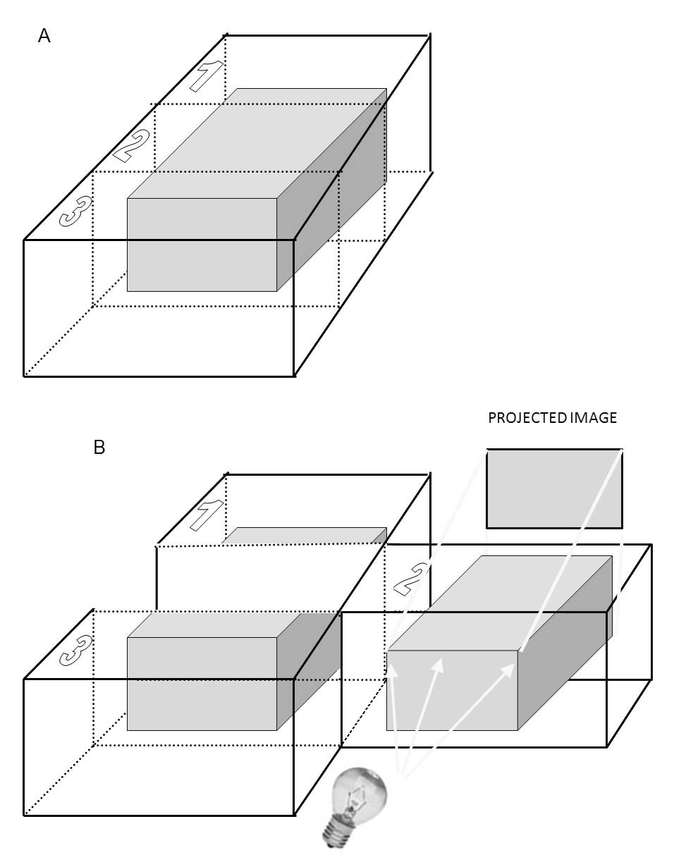

The sections you see below are the projected images of both specimen A and B . Specimen A is sectioned into 3 slices and specimen B is sectioned into 4 slices. The only difference between the two specimens is that one has 3 sections that are 1 cm in width and the other has 4 sections that are 0.75 cm (or ¾ cm) in width. The specimens were sent to you already sectioned.
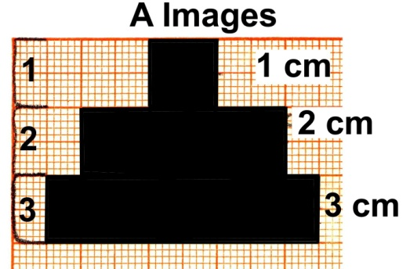

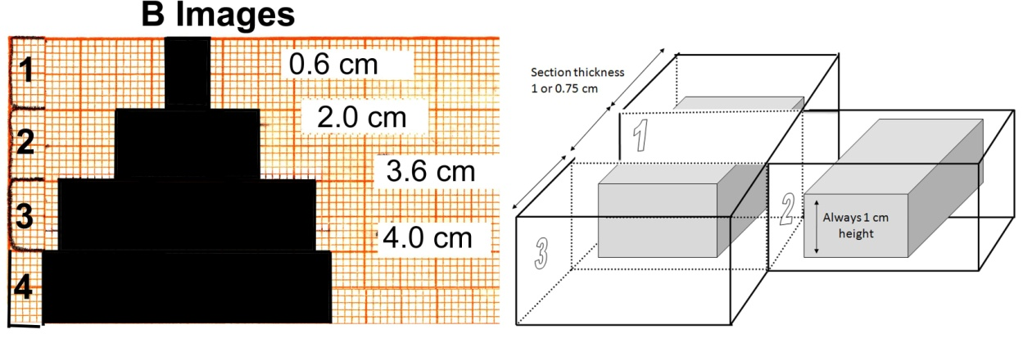
Part 1.0: Determining the Volume from the Sections
Draw the estimated shape of the specimens determined from the rectangular sections shown above. The section that is projected is the length of a section. For example, if there were 2 sections that were projected (below), you would draw the specimen as shown.
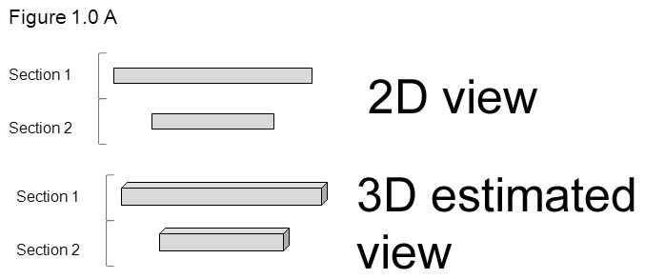

After you have drawn specimens A and B, calculate the volume of the specimens (Note: V=length × width × height, height=1 cm).
Specimen A: Specimen B:
Section 1: Section 1:
Section 2: Section 2:
Section 3: Section 3:
Total Volume: Section 4:
Total Volume:
Part 1.1: Difference between the Two Techniques
Calculate the difference between the two volumes from the two techniques.
Difference:
Part 2.0: Determining the Area with an Edited Version of the Sections
In part 1.0, you drew the specimens as sort of a stair-step view. Usually for a cell specimen the projected sections would not cover the whole section. To fix this problem, draw a new picture for specimens A and B where the projected image does not cover the whole section width but ½ its width to correct for the large stair step between sections. On average with random sections this would occur as ¼ the width between sections. For example:
If you were given the same slices as in part 1.0, the edited version would be drawn as shown. To draw the edited version, draw lines (A) on the half way point on surface A and C. Then draw a line to match the same length of the next smaller section. The smallest section is left alone because if any changes were made, the projected image would have been altered.
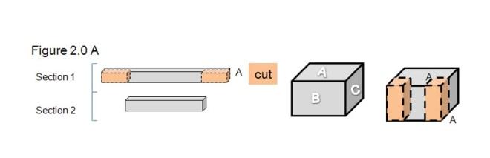

After drawing an edited version for both specimens A and B, calculate the volume.
Specimen A: Specimen B:
Section 1: Section 1:
Section 2: Section 2:
Section 3: Section 3:
Total Volume: Section 4:
Total Volume:
Part 2.1: Difference between the Two Edited Techniques
Calculate the difference between the two edited techniques.
Difference:
Part 2.2: Comparing the Difference between the Edited Techniques to the First Technique
Calculate the difference in volume for specimen A and B from part 1.0 to part 2.0.
Difference for Specimen A:
Difference for Specimen B:
Part 3.0: Determining the Volume with a More Realistic Edited Version of the End Sections
In part 2.0, you determined the volume when the projected sections went to the edge of the section. In reality not all specimens go to the edge of the sections. Redraw specimens A and B with another technique. For example:
Take the same drawing done in part 2.0 and take off half of the width in the end sections. To do this draw line (B) down a fourth (1/4) of the way from surface A and C (step 1). Then on the smallest section draw a line a fourth (1/4) at the end of that section (step 2). The highlighted parts of the sections are the parts that will be removed. This method corrects for end sections as well as the large stair step effect on average.
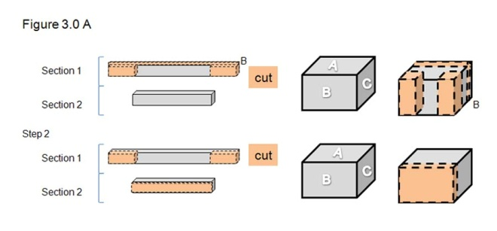

After drawing the new edited version for both specimens A and B, calculate the volume.
Specimen A: Specimen B:
Section 1: Section 1:
Section 2: Section 2:
Section 3: Section 3:
Total Volume: Section 4:
Total Volume:
Part 3.1: Difference between the Two New Edited Techniques
Calculate the difference in volume between specimen A and B.
Difference:
Part 3.2: Compare the Difference Between the New Edited Techniques to the First Edited Techniques.
Calculate the difference in volume between specimens A and B from part 3.0 to 2.0.
Difference for Specimen A:
Difference for Specimen B:
Part 3.3: Compare the Difference Between the New Edited Techniques to the First Techniques.
Calculate the difference in volume for specimen A and B from part 3.0 to part 1.0.
Difference for Specimen A:
Difference for Specimen B:
Part 4.0: Calculating the Real Volume of the Two Specimen
The specimens were actually shaped as triangles. Calculate the two volumes for both specimens A and B from the figures given of the true structure. (Note: Volume of a Triangular Prism=1/2 × length × height × width)
Specimen A Area:
Specimen B Area:
Part 4.1: Comparing the Three Techniques to Find Volume in Relation to the True Volume
 | Specimen A | Specimen B
Volume from part 1.0
Volume from part 2.0
Volume from part 3.0
Volume Area
Place a checkmark next to the technique that is most similar to the real volume.
Questions:
- Which specimen (A or B) had the largest measurement of error, and why?

- Which specimen (A or B) had the least measurement of error, and why?

- Are the measurements of volume error consistent with the measurements of area error considering the different number of sections?

