Preparation
Sea water:
0.5 cups/1 gallon (US). Use Instant Ocean from any pet store.
(0.5 cup/1 gallon)(1 gallon/3.78 liter)(236 milliliters of sea salt/1 cup)=31.21 ml of salt/liter
So for each liter add 31 ml (by volume) of dry salt to almost a liter of water. Dissolve the salt then fill up to 1 liter. Ph the solution to 8.0 the best you can with NaOH (1 or 2 N).
Then add 10 mg of Phenol red dye for each liter of water made.
(Phenol red is not good to ingest or get on your body. USE gloves if need be. It is an estrogenic compound and toxic at high concentrations.)
Fresh water:
Take deionized water (Spring water for drinking or ones clothes iron) or if you have to you can use tap water.
Measure a liter. Adjust pH to 8.00 the best you can with NaOH (1 or 2 N).
Then add 10 mg of Phenol red dye for each liter of water made.
(Phenol red is not good to ingest or get on your body. USE gloves if need be. It is a estrogenic compound and toxic at high concentrations.)
Place water in sealed container and store in the refrigerator until ready to use. Let warm to room temp prior to using for controlling for temperature.

Experiments
Approach 1: Straw and breath method
- Take 50 mls of solution place in beaker or container. Place plastic seal warp over top. Poke 2 holes in plastic about the diameter of a soda straw.
- Set timer for count up.
- Place straw in solution (fresh water). Count how many breaths or time with continue blowing into straw until solution turns yellow. Repeat for next solution (Sea water).
- Compare time or number of breaths blowing into solution until it turned yellow.

Approach 2: Baking soda and vinegar method with phenol red
- Take 50 mls of solution place in beaker or container. Place plastic seal warp over top. Poke 2 holes in plastic about the diameter of a soda straw.
- Place plastic tube in solution.
- After the apparatus is connected add 5 grams of HCO3 and inject 10 ml of vinegar to one flask and collect CO2 bubbles in the phenol red containing fresh water or salt water (50 mls) containing flask. Watch if 5 grams HCO3 and 10 mls of vinegar are enough to convert the sea water to a low pH as for the fresh water.
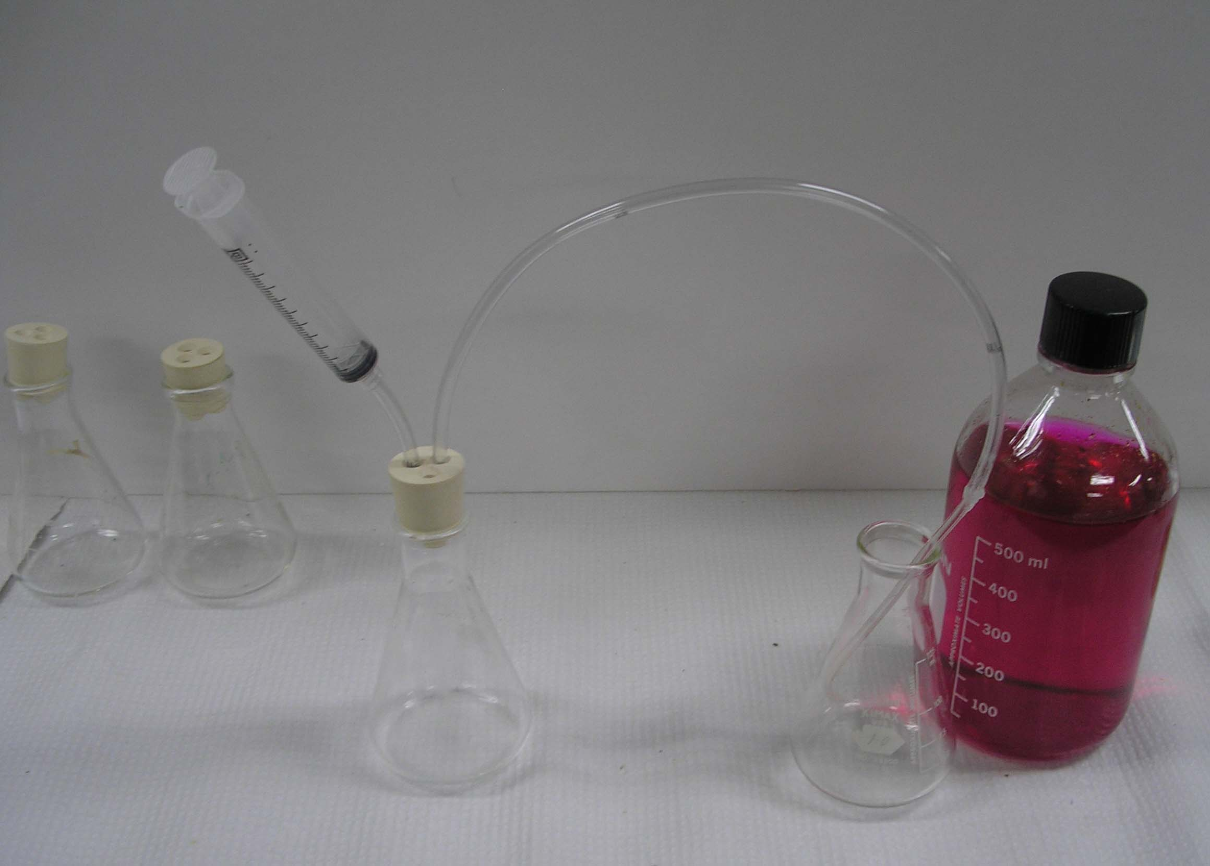

Approach 3: Baking soda and vinegar method with phenol red and pH meter.
Here the monitoring of pH with a meter demonstrates that the color indicator has a limit which is not as informative as using a pH meter to more accurately monitor pH in these experiments.

- Take 50 mls of solution place in beaker or container. Place plastic seal warp over top. Poke 2 holes in plastic about the diameter of a soda straw.
- Place plastic tube in solution.
- After the apparatus is connected add 5 grams of HCO3 and inject 10 ml of vinegar to one flask and collect CO2 bubbles in the phenol red containing fresh water or salt water (50 mls) containing flask. Watch if 5 grams HCO3 and 10 mls of vinegar are enough to convert the sea water to a low pH as for the fresh water. Make sure the pH electrode is in the solution.
- Record the pH values over time (every 1 minute) and stop after 8 to 10 minutes as the changes should stop occurring.

Approach 4: Baking soda and vinegar method with phenol red , pH meter and HCO3 added to fresh water.
- Take 50 mls of solution place in beaker or container. Place plastic seal warp over top. Poke 2 holes in plastic about the diameter of a soda straw.
- Place plastic tube in solution.
- After the apparatus is connected add 5 grams of HCO3 and inject 10 ml of vinegar to one flask and collect CO2 bubbles in the phenol red containing fresh water or salt water containing flask.
- * Add 0.5 grams of the HCO3 to fresh water with phenol red
- Watch if 5 grams HCO3 and 10 mls of vinegar are enough to convert the fresh water with HCO3 to a low pH as for the sea water used in Approach 2 or 3 above. Make sure the pH electrode is in the solution.
- Record the pH values over time (every 1 minute) and stop after 8 to 10 minutes as the changes should stop occurring.
- *Repeat experiments but now add 0.1 grams of the NaHCO3 to fresh water with phenol red.
- Use 10 grams of baking soda this time with the same 10 mls of vinegar.
- Does the phenol red change color? Not quit to the yellow as fresh water without HCO3. So now wash out the phenol red flask and repeat again with 10 grams of baking soda with 10 mls of vinegar. Keep the phenol red solution from the last run. You are to repeat the experiment in the same solution.
- Does the phenol red start to appear yellow?
- One could determine how much backing soda it would take to convert the phenol red to the same yellow color as before. The point here is that a small amount of buffer (NaHCO3) to fresh water can prevent the acidification induced by the CO2. How much buffer do you think the sea water has ? Also it is the ability of the water to dissolve CO2 and react with it to prevent acidification based on the addition of CO2.
- One could repeat these experiments with using HCl (so many drops of 1 M) added to the phenol red solutions instead of CO2 to determine the differences in buffering in sea water, fresh water and fresh water with NaHCO3 instead of using CO2.

