Electroencephalography
In this experiment, you will examine an electroencephalogram (EEG) and explore the electrical activity of the brain. You will record an electroencephalogram from a volunteer, look at interfering signals, and examine the effects of visual activity on alpha brain waves.

Written by staff of ADInstruments.

Background
The cerebral cortex contains huge numbers of neurons. Activity of these neurons is to some extent synchronized in regular firing rhythms. These are referred to as brain waves. Electrodes placed in pairs on the scalp can pick up variations in electrical potential that derive from this underlying cortical activity. The recording of the electrical activity is called an electroencephalogram (EEG). EEG signals are affected by the state of arousal of the cerebral cortex and show characteristic changes in different stages of sleep. EEG signals are also affected by stimulation from the external environment and brain waves can become entrained to external stimuli. Electroencephalography is used, among other things, in the diagnosis of epilepsy and the diagnosis of brain death.

Recording the EEG
EEG recording is technically difficult, mainly because of the small size of the voltage signals, which are typically 50 µV peak-to-peak. The signals are small because the recording electrodes are separated from the brain's surface by the scalp, the skull, and a layer of cerebrospinal fluid. A specially designed amplifier, such as the Bio Amp built into the PowerLab, is essential to record EEGs. It is also important to use electrodes made of the right material and to connect them properly. Even with these precautions, recordings may be spoiled by a range of unwanted interfering influences, known as artifacts.
In this laboratory you will record EEG activity with two electrodes: a frontal electrode on the forehead, and an occipital electrode on the scalp at the back of the head. A third (ground or earth) electrode is also attached, to reduce electrical interference. In clinical EEG, it is usual to record many channels of activity from multiple recording electrodes placed in an array over the head.

Origins of the EEG signals
The EEG results from slow changes in the membrane potentials of cortical neurons, especially the excitatory and inhibitory post-synaptic potentials (EPSPs and IPSPs). Very little contribution normally comes from action potentials propagated along nerve axons. As with the ECG, the EEG reflects the algebraic sum of the electrical potential changes occurring from large populations of cells. Therefore, large amplitude waves require the synchronous activity of a large number of neurons. The rhythmic events that these waves reflect often arise in the thalamus whose activity is in turn affected by a variety of inputs including structures in the brainstem reticular formation.

Components of the EEG waveform
The EEG waveform contains component waves of different frequencies. These can be extracted and provide information about different brain activities. The types of brain waves are:
- alpha (between 8 to 13 Hz; average amplitudes of 30 to 50 µV peak-to-peak) which will be studied in this experiment. Alpha rhythm is seen when the eyes are closed and the volunteer relaxed. It is abolished by eye opening and by mental effort such as doing calculations or concentrating on an idea. It is thus thought to indicate the degree of cortical activation. The greater the activation, the lower the alpha activity. Alpha waves are strongest over the occipital (back of the head) cortex and also over the frontal cortex.
- beta (13 to 30 Hz; <20 µV peak-to-peak) which are prominent in alert individuals with their eyes open. The beta rhythm may be absent or reduced in areas of cortical damage and can be accentuated by sedative-hypnotic drugs such as benzodiazepines and barbiturates.
- theta (4 and 8 Hz; <30 µV peak-to-peak) which are seen in awake children but not adults. The theta rhythm is normal during sleep at all ages. However, some researchers separate this frequency band into two components, low theta (4 - 5.45 Hz) activity that they correlate with decreased arousal and increased drowsiness, and high theta (6 - 7.45 Hz) activity that it is claimed is enhanced during tasks involving working memory.
- delta (0.5 and 4 Hz; up to 100 - 200 µV peak-to-peak) which is the dominant rhythm in sleep stages three and four but not seen in conscious adults. The delta rhythm tends to have the highest amplitude of any of the component EEG waves. EEG artifacts caused by movements of jaw and neck muscles can produce waves in the same frequency band.
- gamma (30 and 50 Hz). Most people recognize gamma rhythm, but its importance is controversial. It may be associated with higher mental activity, including perception and consciousness and it disappears under general anesthesia. One suggestion is that the gamma rhythm reflects the mental activity involved in integrating various aspects of an object (color, shape, movement, etc) to form a coherent picture. Interestingly, recent research has shown that gamma waves are enhanced in Buddhist monks during meditation and are absent in schizophrenics.
It is not presently possible to relate the EEG waves to specific underlying neuronal activities. In general, the more active the brain the higher the frequency and the lower the amplitude of the EEG. Conversely, the more inactive the brain the lower the frequency and the higher the amplitude of the signal.

Required Equipment
- LabChart software
- PowerLab Data Acquisition Unit
- 5 Lead Shielded Bio Amp Cable
- EEG Flat Electrodes
- Electrode Paste
- Abrasive Gel or Abrasive Pad
- Alcohol Swabs
- Ballpoint pen
- Medical tape
- Elastic bandage

Procedure

Equipment Setup and Electrode Attachment
- Make sure the PowerLab is turned off and the USB cable is connected to the computer.
- Connect the 5 Lead Shielded Bio Amp Cable to the Bio Amp Connector on the front panel of the PowerLab (Figure 1). The hardware needs to be connected before you open the settings file.
- Attach the leads of the EEG Flat Electrodes to the Earth, CH1 NEG and POS pins closest to the labeled side on the Bio Amp Cable. Channel 1 “positive” will lead to the inion (the bump on the back of the head above the neck) and Channel 1 “negative” will lead to the forehead. Channel 2 will be empty and the Earth will lead to the temple. Refer to Figure 1 for proper placement, but do not attach them to the volunteer. Follow the color scheme on the Bio Amp Cable.
- Remove any jewelry from the volunteer’s face, ears, and neck. Use a ballpoint pen to mark a small cross on the skin on the back of the head, forehead, and temple. Use Figure 1 as a guide. Abrade the skin with Abrasive Gel or Pad. This is important as abrasion helps reduce the skin’s resistance.
- After abrasion, clean the area with an alcohol swab to remove the dead skin cells. While the skin is drying, scoop Electrode Paste into the EEG Flat Electrodes. When the skin is dry stick the electrodes to the skin (Figure 1). Immediately hold the electrodes and wires in place with the medical tape. Make sure the tape firmly holds the electrodes against the head. Use the elastic bandage to wrap tightly around the head. This will help the electrodes maintain good contact with the skin.
- Have the volunteer lie in a comfortable position on their back, with their head turned so that none of the electrodes are disturbed or compressed.
- Check that all three electrodes are properly connected to the volunteer and the Bio Amp Cable before proceeding. Turn on the PowerLab.
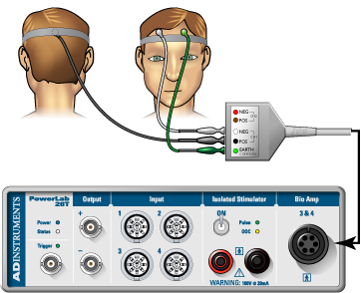
Figure 1. Equipment Setup for PowerLab 26T

Exercise 1: Recognizing Artifacts
In this exercise, you will learn to recognize some of the artifacts that can appear on an EEG.

- Launch LabChart and open the settings file “EEG Settings” from the Experiments tab in the Welcome Center. It will be located in the folder for this experiment.
- Select Bio Amp from the EEG Channel Function pop-up menu. It should be the only channel visible. Make sure the settings are as follows: Range 200 µV, High Pass 0.5 Hz, and Low Pass 50 Hz.
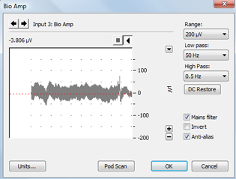
Figure 2. Bio Amp Dialog

- Start recording. Add a comment “blinking,” and have the volunteer blink repeatedly. Stop recording after 10 seconds.
- Repeat step 3, this time, have the volunteer make eye movements. Add a comment “eye movements.” Have the volunteer gaze up-and-down and left-and-right in a repeated pattern. Make sure the volunteer’s head is still and only the eyes move.
- Repeat step 3, this time, have the volunteer make head movements. Add a comment “head movements.” Have the volunteer gently move his/her head in a repeated pattern.
- Save your data, and open a new file with the same settings.

Exercise 2: Alpha Waves in the EEG
In this exercise, you will examine the effects of relaxation and eye movement on alpha waves in the EEG.

- Make sure the volunteer is relaxed and comfortable. Have the volunteer close his/her eyes and remain quiet. Keep noise to a minimum and keep all distractions away from the volunteer.

- Start recording. Record for 30 seconds. Prepare a comment with “open;” do not enter it yet.

- Tell the volunteer to open both eyes. Immediately press Return/Enter to add the comment. Record with the volunteer’s eyes open for 10 seconds. Do not stop recording.

- Prepare a comment with “shut.” When the 10 seconds are complete, tell the volunteer to close both eyes. Immediately press Return/Enter to add the comment.

- Repeat steps 3 and 4 twice, to give you three sets of results. Save your data.

Analysis

Exercise 1: Recognizing Artifacts
- Examine the vertical scale at the left of the Chart View, and note the positions corresponding to +50 µV and –50 µV. True EEG signals rarely exceed these limits.
- Examine the entire data trace and Autoscale, if necessary. There may be some large signals outside the ±75 µV range. Such large signals are artifacts.

Exercise 2: Alpha Waves in the EEG
- Examine the entire data trace. Use the View Buttons to change the horizontal compression to see data with eyes open and shut. Make a data selection that includes some data from both eyes open and eyes shut conditions. View this selection in Zoom View. This should make it easier to see the alpha wave activity (Figure 3). Now Autoscale, if necessary.
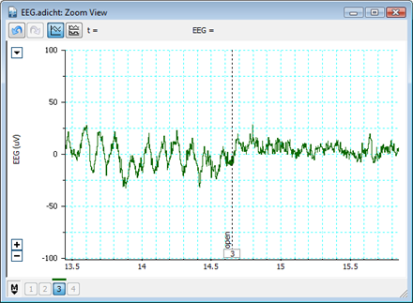
Figure 3. EEG signal with eyes shut and open. Note alpha waves during eyes shut.
- In Chart View scroll through the parts of the recording that were made with the volunteer’s eyes shut to look for alpha waves. Use the View Buttons to change the horizontal compression if necessary. The alpha waves can be recognized by their amplitude (usually 30 to 50 µV peak-to-peak, although it can be quite variable) and their frequency. Each cycle of an alpha wave should last approximately 0.1 s.
Note: If you cannot find brain activity that matches the alpha rhythm, re-attach the electrodes and repeat this exercise.
- Use the Marker and Waveform Cursor to measure the amplitude of the alpha waves. Place the Marker at the lowest point of the wave and move the Waveform Cursor to the peak of the wave. Measure the amplitudes of five waves from when the volunteer’s eyes were closed. Record the values in Table 1 of the Data Notebook.
- Now measure wave amplitudes when the volunteer’s eyes were open. Record these values in Table 2 of the Data Notebook.
The amplitude of the waves is affected by the quality of the EEG signal. Therefore, it is useful to examine the frequency and power of the wave activity. Spectral analysis can be used to examine these features of a signal. Before examining your EEG signal you will complete a short tutorial on Spectral Analysis.

Spectral Analysis Tutorial
A spectrum is a representation of data based on the frequency distribution of its component sine waves. Spectra indicate the strength of the various frequencies in a time-varying waveform. Spectrum View allows you to observe the frequency distribution of data that might not otherwise be easily seen. For example, it could be used to break down an EEG waveform into its various components: beta waves, alpha waves, theta waves and delta waves. A mathematical technique known as the Fast Fourier Transform is applied to the raw data. The results of this analysis can be displayed as a plot of the power (vertical axis) of different frequencies (horizontal axis) relative to each other in the input signal. This is called a Power Spectrum Density (PSD) plot. The data can also be displayed as 3-dimensional color plot of spectral power, frequency, and time called a Spectrogram.

- Open the Welcome Center and in the Experiments tab browse the “EEG Spectral Analysis Tutorial.” It will be in the Settings folder for this experiment. Open this file.
- Examine the Chart View. Use the View Buttons to view each block. You should see five blocks of data. The first record is a slowly oscillating sine wave
- Open Spectrum view by clicking on the Spectrum View button in the Toolbar (Figure 4).
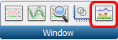
Figure 4. Spectrum View Toolbar button
- Click the Smart Tile button in the LabChart Toolbar to display both windows in full screen mode.
- In Chart View Select the first record by double clicking in the Time axis. This will perform a spectral analysis for this record and displays the result in the Spectrum view. Adjust the horizontal scaling of plots to view the results:
  - Set the horizontal scaling for the Power Spectrum Density (PSD) plot to 50 Hz (Figure 5). Use the horizontal scroll bar to display the 0 Hz to 50 Hz region of the plot.
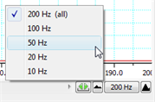
Figure 5. Spectrum PSD Scale
  - Set the horizontal scaling for the Spectrogram to 50:1.
- Examine the PSD plot and then the first section of the Spectrogram. Expand the vertical axes if necessary. Use the waveform cursor to identify the frequency in Hertz (Hz) of the peak in the PSD plot and the band in the Spectrogram. Values are displayed at the top of each plot.
  - What is the frequency in Hertz (Hz) of this sine wave?
- Select the second record and again view the result in the Spectrum view.
  - What is the frequency in Hertz (Hz) of this second sine wave?
- Select the third record and again view the result in the Spectrum view. You should now see two prominent peaks (PSD plot) and bands (Spectrogram) in the result.
  - Are these two peaks/bands the same as for the first two records?
- Select the fourth record and again view the result in the Spectrum view.
  - Is there any regular signal within this record?
- In Chart View compare the signal amplitudes of the fourth and fifth records. Note that the fifth record has lower amplitude compared with the fourth record.
- Select the fourth record again. In the Spectrum view examine the PSD plot. Move the Waveform Cursor to the prominent peak.
- What is the frequency (Hz) of this signal?

- What is the power (mV²) of this signal?
- Select the fifth record and examine the PSD plot. Move the Waveform Cursor to the peak.
- What is the frequency (Hz) of this signal?

- What is the power (mV²) of this signal?
- Examine the Spectrogram. Note that the band corresponding to the signal’s frequency appears to missing. This is because the power of the signal is small compared with the previous four records. Expand the scale on the right hand side of the Spectrogram by setting the scale closer to the power of the signal (e.g., 0 to 0.004 V²) (Figure 6). Note that the band is now visible at the expected frequency.
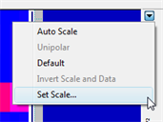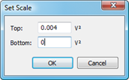
Figure 6. Spectrogram Drop-down Menu and Set Scale Dialog
- The fifth record is the same signal as the fourth record, except that the quality of the raw signal has been affected. Compare your features (amplitude, power, frequency) of the fourth and fifth record.
- How has the quality of the signal affected the wave features?

Exercise 2: Alpha Waves in the EEG contd.
Now you will use Spectral Analysis to examine the EEG you recorded.

- Use the View Buttons to change the horizontal compression to 10:1 (Figure 7).
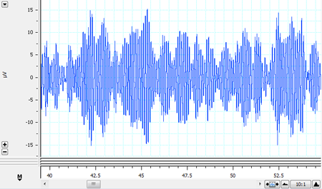
Figure 7. Alpha Waves with 10:1 Compression

- Find the part of the recording when the volunteer had his/her eyes shut. Click-and-drag across this part of the data trace to select it. From the Window menu, select Spectrum. In the Spectrum View choose Selected (Figure 8).
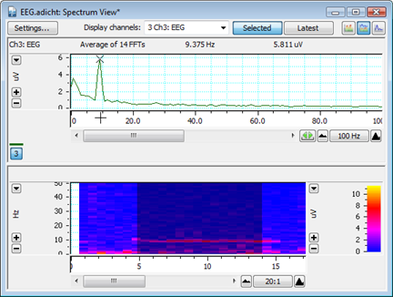
Figure 8. Spectrum of an EEG
- Alpha activity shows up in the PSD plot as a clear peak in the 8-12 Hz range. Then print the PSD plot.
- Alpha activity shows up in the Spectrogram as a band of color in the 8-12 Hz range. If you cannot see the alpha activity as a clear peak in the 8-12 Hz range, scale the horizontal and vertical axes. Note that Spectrogram displays all the recorded data and that the selection you have made is highlighted in a darker blue color.
- Make a data selection of several seconds from when the volunteer had their eyes open. Select Spectrum. Note that in the PSD plot the peak in the alpha activity range of 8-12 Hz is small or absent and in the Spectrogram the band of color in the alpha activity range of 8-12 Hz is weak or absent. Print the PSD plot.
- In the Spectrogram scale the horizontal axis so that all the data is visible. Note the presence and absence of the band of color in the alpha activity range of 8-12 Hz which correspond with the eyes shut and eyes open conditions. Print the Spectrogram.

Data Notebook

Table 1. Alpha Waves
Amplitude
Wave #1

Wave #2

Wave #3

Wave #4

Wave #5

Table 2. Absence of Alpha Waves
Amplitude
Wave #1

Wave #2

Wave #3

Wave #4

Wave #5

Study Questions

- How does the human anatomy make it difficult to record an electroencephalogram, or EEG?

- What are common causes of the artifacts you recorded in Exercise 1? Name at least three causes.

- In Exercise 2, under what conditions did you see alpha waves more clearly?

- What are alpha waves thought to indicate?

- Look at your Spectral Analysis from when the volunteer had their eyes closed. At what range do you have the greatest peak? What type of brain waves does the Spectral Analysis suggest is active?

- Look at your Spectral Analysis from when the volunteer had their eyes open. At what range do you have the greatest peak? What type of brain waves does the Spectral Analysis suggest is active?

Copyright © 2010 ADInstruments Pty Ltd. All rights reserved.

PowerLab® and LabChart® are registered trademarks of ADInstruments Pty Ltd. The names of specific recording units, such as PowerLab 8/30, are trademarks of ADInstruments Pty Ltd. Chart and Scope (application programs) are trademarks of ADInstruments Pty Ltd.

www.ADInstruments.com

