NAME_______________________
BIO 350 EXAM #3 SUMMER 2009
(2 points each for multiple choice)

1. The primary force driving fluids to leak from capillaries in skeletal muscle (on the arterial side of the capillary) into the interstitial tissue is:
A. hydrostatic pressure of the blood
B. hydrostatic pressure of the lymph
C. colloid pressure of the blood

2. Compared to fetal hemoglobin, adult hemoglobin has:
A. has no Fe molecules
B. same oxygen affinity
C. more heme groups
D. lower oxygen affinity
E. both B and A are correct

3. The greatest cross-sectional surface area for the blood to flow past is which of the following regions of the circulation ?
A. aorta
B. arteries
C. capillaries
D. veins
E. vena cava (region right before the atrium)

4. A condition, such as elephantiasis, where severe edema occurs is most closely associated with which of the following ?
A. low hydrostatic pressure in the veins
B. very high colloid osmotic pressure in the capillary
C. blockage of the lymphatic system so lymph can not flow
D. an over production of NO locally producing vasodilatation
E. active use of skeletal muscle inhibiting lymph flow

5. The region of the circulation with the least hydrostatic pressure is
A. aorta
B. arteries
C. capillaries
D. veins
E. vena cave (region right before the atrium)

6. The carotid bodies are primarily related to which of the following functions ?
A. monitoring pH in the blood
B. monitoring the hydrostatic pressure in the blood
C. to block perfusion of the nasal passage ways in the human nose
D. none of the above

7. The mammalian systemic circulation (mark the correct answer)______________________:
A. receives more blood than the pulmonary circulation.
B. is a high pressure system compared to the pulmonary circulation.
C. receives blood from the left ventricle.
D. Both B and C are correct.
E. All the above are correct

8. In you, a typical mammal, the left half of the heart pumps blood through the __________and the right half pumps blood through the __________ circulation.

A. systemic: pulmonary
B. systolic: semilunar
C. diastolic: systolic
D. kidneys: liver
E. pulmonary: systemic

9. When the ventricles relax in the human heart a substantial amount of blood will back flow from the main arteries to refill the ventricles so they can pump it back out again.
A. True B. False

10. The main pacemaker of the mammalian heart is normally the _________.
A. The SA node
B. The AV node
C. The Purkinje system
D. The bundle of His
E. none of the above since it is purely neurogenic

11. One of the pronounced cardiovascular responses to diving among birds and mammals is bradycardia (slowing down of the heart rate) during the physical contact with the cold water.
A. True B. False
12. Invertebrates with a open circulatory system can have arteries from the heart to direct blood to particular regions of the body.
The statement above is-
A. True B. False

13. The majority of the blood volume is stored in the ______________ when you are in a relaxed state.
A. arteries
B. pulmonary veins
C. pulmonary arteries
D. systemic veins
E. heart

14. which of the flowing blood vessels have the thickest wall ?
A. veins
B. capillaries
C. aorta
D. pulmonary veins
E. arterioles

15. Which one of the lower vertebrates have two completely separated atria and two completely separated ventricles ?
A. turtles
B. salamanders
C. lungfish
D. crocodiles
- Frogs

16. Thyroid hormones are:
A. produced from serotonin
B. inhibited in production by TSH
C. a type of neurohormone
D. made in the thyroid gland

17. Which of the following hormone(s) is(are) secreted by the hypothalamus?
A. thyroid-stimulating hormone (TSH)
B. adrenal corticotropic hormone (ACTH)
C. gonadotropin-releasing hormone (GnRH)
D. follicle-stimulating hormone (FSH)
E. All of the above are correct

18. During the follicular phase of the ovarian (menstrual) cycle:
A. estrogen levels predominate
B. progesterone levels predominate
C. estrogen and progesterone levels are elevated
D. estrogen and progesterone levels are low
E. none of the above apply

19. The production of nitric oxide (NO) from endothelial cells is one mechanism to promote relation of smooth muscle cells.
(A) True (B) False

20. Which factor reduces hemoglobin’s oxygen affinity?
A. decreasing CO₂
B. increasing pH
C. increasing temperature

21. The figure below illustrates the changes in pressure in the left atrium, ventricle, and aorta over the time of 1 heart beat. Choose the answer which best describes what is occurring at point Z (marked on the graph)
- the aortic valve has opened
- the atrioventricular valve has opened
- the blood in the aorta is back flowing into the ventricle
- the blood pressure is building up in the ventricle and is not flowing
- None of the above are true

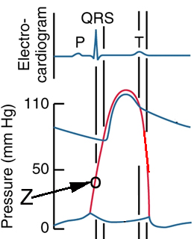

22. Which of the following forms a exchange systems with the environment is most effective (example - for a fish gill) ?
A. Counter current
B. Concurrent
23. Which of the following vertebrates utilize parabronchi instead of alveoli for gas exchange?
A. frogs
B. salamanders
C. snakes
D. crocodiles
E. birds
24. The sigmoid oxygen dissociation curve of hemoglobin is due to:
A. it’s binding of oxygen and carbon dioxide
B. it’s oxygen reservoir
C. subunit cooperativity
D. Bohr’s shift
E. the root effect

25. Carbon dioxide is transported in the blood mostly:
A. as molecular CO₂
B. as carbonate ion
C. bound to hemoglobin
D. as carbonic acid
E. as bicarbonate ion
26. In the figure on the right, which curve has the highest oxygen affinity?
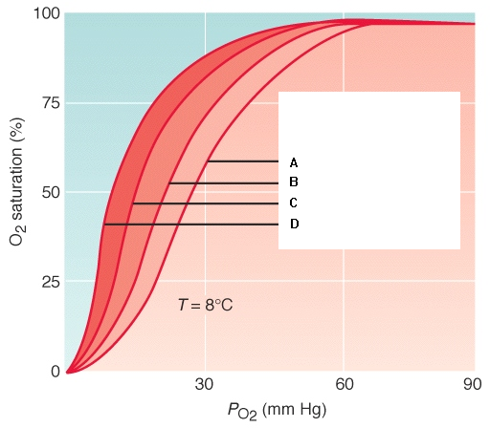
A. curve A
B. curve B
C. curve C
D. curve D

27. Which hormone is involved in the milk-ejection reflex during nursing in mammals?
A. oxytocin
B. prolactin PRL
C. estradiol
D. parathyroid hormone
E. thyroxine
28. The least resistance (friction) to blood flow occurs during:
A. turbulent flow
B. pulsatile laminar flow
C. laminar flow
D. pulsatile turbulent flow
E. reverse flow
29. The plateau phase of a cardiac muscle action potential is characterized by:
A. lacking a stable resting potential
B. elevated Na⁺ flux
C. elevated K⁺ flux
D. elevated Ca²⁺ flux
E. none of the above
30. Which of the following hormones binds to receptors inside the cell?
A. luteinizing hormone
B. insulin
C. triiodothyronine
D. parathyroid hormone
E. antidiuretic hormone (arginine vasotocin)
31.Which vertebrate group may have a “caudal heart” located in the tail region which aids in returning deoxygenated blood to the heart.
A. bony fish
B. sharks
C. salamanders
D. snakes
E. crocodilians

32. Which of the following endocrine glands is a modified sympathetic ganglia?
A. adrenal cortex
B. adrenal medulla
C. pars nervosa
D. parafollicular cells
E. islets of Langerhans

33. In insects, the hormones involved in metamorphosis are:
A. ecdysone and juvenile hormone
B. juvenile hormone and vitellin
C. allostatin and allotropin
D. precocenes and vetellogenin
E. ecdysone and allotropin

34. The Frank-Starling mechanism illustrates the relation between:
A. pulmonary resistance and stroke volume
B. filing pressure and stroke volume
C. atrial mean pressure and cardiac work
D. impulse velocity and ventricular contraction
E. distensibility of the ventricular wall and cardiac work

35. The surge in Luteinizing hormone (LH) on day 14 of the menstrual cycle is caused by:
A. estrogen stimulating release of LH
B. Follicle-stimulating hormone stimulating release of LH
C. progesterone stimulating release of gonadotropin releasing hormone
D. Follicle-stimulating hormone stimulating release of gonadotropin releasing hormone
E. progesterone stimulating release of LH

36. During early pregnancy, which hormone rescues (stimulates the survival of) the corpus luteum?
A. chorionic gonadotropin
B. luteinizing hormone
C. progesterone
D. estradiol
E. prolactin

37. Which of the following capillary types is the least porous?
A. Continuous
B. Sinusoidal
C. Fenestrated
D. splenic
E. hepatic

38. Which of the Following can act as a second or even third messenger?
A. calcium
B. adenylate cyclase
C. guanylate cyclase
D. Phospholipase C
E. G-protein
(24pts) *****Short answers and or Essay questions (LOOK AT THE POINTS FOR EACH QUESTION- determine the extant of information needed)

1. (2 points) Explain the significance and reasons of having a compliant (i.e., elastic) aorta with blood flow to the systemic tissues.

2. (2 points) Why is it that mountain climbers that go to the top of Mount Everest use compressed air? Under what conditions could they reach the top without compressed air tanks?

3. During strenuous exercise there is an increase in blood flow to the working muscles.
(5 points total for this question)
A. Where is this blood being mobilized from and how (2 point).
B. What local factor(s) (in the working muscle) promotes and increases blood flow to the working muscle or increases O2 delivery to the tissue. (1 points)
C. What role does the nervous system play in promoting the blood flow to working muscles
(2 points).

4. (5 points) What function does having carbonic anhydrase located within the RBC have on gas exchange in the tissue of exercising skeletal muscle ? (Diagrams must be explained well to get points).

5. (2 points) With the following words construct a short paragraph that is logical in its physiological content.
Use each word “ diving seal” “trained” “ heart rate” “PO2” “pH” “oxygen debt”

6. (4 points) What is the rational of why a steroid hormone would have prolonged action on a target cell as compared to peptide hormone ? Why would it be possible for even a peptide hormone to possible have prolonged action on one type of cell but a fast and short lived response on another cell?

7. (4 points) How are calcium levels regulated in the blood, which then is important for bone growth and turn over ? (list mechanisms and names of compounds used in this process. Clear informative diagrams can also be used)

