**An Expert Opinion: Crayfish Metabolism and Oxygen Requirements**

**Melody Danley1**

## 1 Department of Biology, University of KY, Lexington, KY 40506-0225

**PURPOSE**

The purpose of these experiments is to gather data and to prepare an expert opinion related to a mock community-driven lawsuit. In these activities, one will learn the purpose of conducting as well as proper techniques for conducting closed-respirometry metabolic experiments. You will also be applying metabolic calculations to the collected data to better identify absolute and mass-specific trends within the data.

1. **INTRODUCTION**

**1.2 Case History of the Bayou Black Fish Kill**

In October of 2010, the citizens of Southern Town, Louisiana were greeted to a disturbing site; floating along the surface of the local bayou, Bayou Black, were hundreds of dead fish. Most of the fish were large (500 g or more), but some small fishes were also observed, and many different species of fish were visibly dead. Concerned, Southern Town citizens called the local LA Fish and Wildlife office to report the fish kill episode. A state wildlife officer came out to the bayou to conduct an on-site investigation. An outline of the initial water quality findings are indicated in the table below (Table 1).

Table 1. Results of the on-site investigation of the Bayou Black Fish Kill (Oct 2010). The estimated time/date of the fish kill event was October 3, 2010. The first report came in at 6:30 AM.

|  |  |
| --- | --- |
| Water Quality Parameter | Average + standard deviation from samples collected  at 3 different locations in the affected area |
| Dissolved oxygen (mg/L) | 1.21 + 0.53 |
| [1]pH | 4.9 + 0.2 |
| Water temperature (oC) | 21.9 + 0.8 |
| Color of the water1 | 3 + 0 |
| Any other notable observations | High level of algal growth in water, and strong odor of “cucumbers” often associated with excess nitrogen and algal blooms |

The total number of fish floating dead along the surface was approximately 789 individuals. It was estimated that at least an equal number of additional organisms were likely dead, but below the surface and not immediately visible. A major fish kill is one where more than 1000 fish in a 1.6 km of a stream are killed (Meyer 1990). Based on the initial on-site investigation, the officer believed the animals likely died from hypoxia, or extremely low oxygen dissolved concentrations, due to a sudden surge of nutrients followed by rapid algal growth. While green algae photosynthesize during the day, producing oxygen as a metabolic byproduct, they respire at night, vigorously consuming oxygen, when light is no longer available. During this time, they can rapidly deplete the water of oxygen.

To verify this hypothesis, additional water samples were collected and taken back to the LA Fish and Wildlife Service’s office for analysis. Samples of the rotting animal carcasses were also collected and taken to the State’s Aquatic Animal Disease Diagnostic Laboratory in Baton Rouge, LA for processing. Results of the water samples showed unusually high concentrations of ammonium nitrate, the type of nitrogen commonly used in commercial farming operations. No other abnormal chemical readings were detected. Results from the disease lab failed to identify any notable pathogens, other than a few low-virulent, opportunistic species that likely infected the fish after they had already died.

A few days after the fish kill episode, a local farming company brought their fertilizer-sprayer into town for repairs. This particular company had already been fined for a number of point-source environmental violations, including dumping hazardous wastes into the local bayou, Bayou Black, which borders the back edge of the company’s property. It was just upstream from the site of the current fish kill. The company had also been cited for operating hazardous equipment in a dangerous manner. This time, their sprayer had literally exploded, or so it appeared. Based on the location of the farm relative to the fish kill site, the LA Fish and Wildlife Office believed this particular company was at fault. In response, the LAFW Service pressed charges against the company for a total of $1 million in retribution to the state for the economic losses (fishing and tourism losses), as well as $400,000 to remediate (clean-up and restock) the kill site. As part of the lawsuit, however, the LAFW Service must demonstrate that the fish kill was a “Major Fish Kill”. Since only 789 individuals were observed floating along the surface, and the minimum number of individuals killed for a major fish kill is 1000, the State needs expert testimony to prove additional organisms likely died from the event.

**1.2 Your Expert Opinion**

You will need to conduct an experiment on the oxygen requirements of a bottom dwelling species (one that would not have floated to the surface) commonly found in Bayou Black, and present that information in a written, scientific report format to a tripanel of judges overseeing the Bayou Black case. The judges are Ms. Wu, Mr. Harpole, and Mrs. Holsinger. You only need to address your report to one of the judges. In your report, you should provide sufficient background information about the metabolic demands of a bottom dwelling species, as well as provide methods, results, and discussion from your own independent research (class results). The basic information about how to conduction such oxygen consumption studies follows. Remember, your job here is not to decide for the court whether or not the farming company is guilty. Your job is to provide unbiased information and results (through your “opinion”) to the court, about the metabolic demands of a bottom dwelling species, and the likelihood of such animals surviving in a hypoxic environment.

1. **MATERIALS AND METHODS**
   1. ***Materials***

|  |  |
| --- | --- |
| **Item** | **Needed Per Group** |
| Vernier LabPro Interface with cables | 1 |
| Closed respirometry chamber with lid/probes | 2 |
| Size 00 or 000 rubber stoppers | 2 |
| Stir plates | 2 |
| Stir bars | 2 |
| Circular wire mesh | 2 |
| Graduated cylinder, 500-mL | 1 |
| Erlenmeyer flask, 250-mL or 500-mL | 1 |
| Turkey baster | 1 |
| 10-mL pipette | 1 |
| Sodium sulfite calibration solution (100-mL bottle) | 2 |
| Dual aerator with tubing | 1 |
| Absorptive lab mats, blue/white | 2 |
| Liquid waste bottle (1-L) | 1 |

* 1. **Equipment and Software Set-up**

1. To obtain oxygen consumption data, first plug in the power cord to the Vernier LabPro unit, then plug the other end into a power strip or outlet. A few seconds after the unit is powered up, it will beep several times; this is normal. If it does not beep, check the cables to ensure they are plugged in correctly, and check the power source to ensure power is running to the unit. Next, plug in the data cable into the Vernier LabPro unit, then plug the other end (USB end) into the computer. NOTE: Do not plug the USB end into the monitor – be sure it is plugged into a port directly on the CPU.
2. Remove the lids from the respirometry chambers. Take the respiratory chambers and the Erlenmeyer flask to the large black reservoir tank. Use the beaker next to the reservoir tank to obtain the conditioned tank water. Dip the beaker into the reservoir to fill the beaker, the pour the conditioned water into each respirometry chamber. Fill each chamber and the flask with the conditioned water, leaving about one inch of space at the top of each container. NOTE: Do not dip the respirometry chambers or flask directly into the reservoir since this can contaminate the water in the reservoir tank. Return the water-filled containers to your workstation.
3. Place a lab mat beneath each stir plate to absorb any spilled water.
4. Next, place the respirometry chambers onto the stir plates, one per plate. Center the chambers onto each stir plate. Set the flask aside for now.
5. If the wire mesh and stir bars are not in the chambers, they should be inserted at this time. Place one stir bar into each respirometry chamber and let it sink to the bottom. Next, insert the wire mesh. The mesh should be folded down around the edges, so that it creates a low platform for the crayfish to rest on, without interfering with the action of the stir bar at the bottom of the chamber (Figure 1).
6. Turn on the stir function of the stir plate to medium-low (about 3 to 4 on the Corning brand dials). If the stir bar is not moving, or if it is jumping around, reposition the chamber onto the middle of the plate and adjust the knob until the bar is stirring the water with a steady, slow pace. If your stir plate has both stir and heat options, be sure to use the correct knob!
7. To set-up the data collection software, open the LoggerPro software on your computer. There is a short-cut for this software on the desktop. As the software boots up, it will search for the corresponding hardware, and should automatically recognize the LabPro unit, and the temperature and dissolved oxygen probes (4 total). If does not recognize all the equipment, check to ensure the cables from the probes and the LabPro unit are all plugged in correctly, and that the cable running from the LabPro unit is plugged into the CPU (not the monitor).
8. Allow the software to run for at least 10 minutes to warn-up the oxygen probes. Do not attempt to calibrate the electrodes until they are warmed up.

**2.3 Calibrating the oxygen electrodes**

1. Before beginning the calibration, record the current barometric pressure and temperature from the extra computer set up with the gas pressure sensor and temperature probe. Record the pressure and temperature below (Table 2). Next, use the table in Appendix 1 to determine the correct dissolved oxygen concentration (mg/L) in air-saturated distilled water. Record the concentration (mg/L) in Table 2 below.

Table 2. Oxygen saturation calculation given the barometric pressure and

temperature. If a barometric pressure recording is unavailable, it can be estimated from the elevation, using any number of conversion tables available online.

|  |  |
| --- | --- |
| Temperature (oC) |  |
| Barometric Pressure (mmHg) |  |
| Oxygen saturation (mg/L) |  |

1. Complete a two-point calibration of the oxygen probes to maximize the accuracy of the probes. A two-point calibration sets the readings of the probe relative to two points, a zero-point reading (no oxygen present) and a maximum/saturation point (which was calculated in the previous step). Within the LoggerPro software, select “Experiment,” from the tabs at the top of the window, then select “calibrate now” from the drop-down menu that appears. Remove each probe from the chamber water. Gently blot the tips dry, taking care not to scratch the delicate membrane on the tip of each electrode.
2. Place the tip of each probe into the sodium sulfite calibration solution. Note: Ensure air bubbles are stuck to the bottle of the electrodes, since this will give an inaccurate reading through the probe. If any air bubbles are seen, gently tap the side of the electrode to dislodge the bubbles. Allow the reading to stabilize for about 1 minute. Typical readings for the zero point reading are in the 0.2 to 0.5 V range. Once the reading has stabilized, type 0 (the known value, in mg/L) into the edit box, then click “keep.”
3. Remove each probe from the sulfite solution, rinse with distilled water, and gently blot dry. Do not place the probes back into water.
4. Obtain the small white calibration bottle that goes with probe. Remove the lid. Use a clean disposable pipette to add a thin layer of distilled water (¼ inch) to the bottom of the bottle. Next, place a piece of parafilm over the surface of the bottle. Poke a hole into the surface of the parafilm, then gently insert the oxygen probe into the bottle through the whole, to a depth of about 1/2 inch. Be careful not to scratch the end of the probe (membrane covered) when inserting the probe through the parafilm. Also, be sure the probe does not contact the water/become wet. The end of the probe should be “hanging” in the air of the container. Again, allow the reading to stabilize for about 1 minute. Typical readings for the saturation point are about 2.0 V. Once the reading has stabilized, type the calculated oxygen saturation value from Table 2 above (the known value, in mg/L) into the edit box, then click “keep.”
5. Rinse the tip of each probe, then place the probes back into the respiratory chambers (Figure 1).

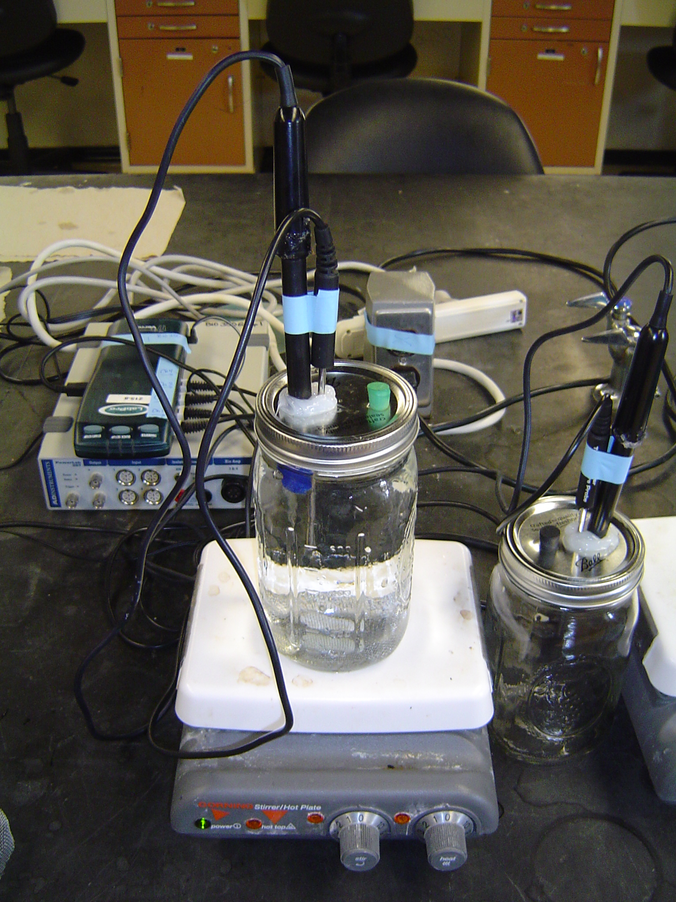

Rubber Stopper

Wire mesh above a stir bar

Temperature probe

Oxygen probe

**Figure 1.**  Closed respirometry chamber with oxygen and temperature probes. A piece of wire mesh was placed at the bottom of the chamber and edges folded under, to create a platform for the organism to be held above the stir bar. The stir bar, below the wire mesh, is set to slowly rotate to ensure water within the chamber remains homogenized, and to ensure the water moves continuously past the tip of the oxygen probe.

* 1. **Respirometry Chamber Set-up and Data Collection**

1. Obtain two crayfish of different sizes from the stock tank. These crayfish have been fasted for 48-72 hours. To account for the consumption of oxygen by microorganisms and the electrode itself, at least two control chambers (without crayfish) should be run simultaneously per section. If you are running a control chamber at your workstation, you will only need one crayfish.
2. Gently blot each crayfish with paper towels to remove excess water, then use the digital balance to obtain the weight of each crayfish. Record the weight below (Table 3).
3. Return the crayfish to your workstation, and place one crayfish into each respirometry chamber. Place the lid/probes back onto each chamber. Secure the lids into place. If necessary, stabilize the cords from the probes to the sides of the chambers with tape to prevent the chambers from tipping over. Loosely cover the sides of each chamber with paper to help the crayfish settle down and minimize visual stimulation. There is a large roll of butcher paper near the back of the classroom that can be used to obtain paper to cover the chambers.
4. Next, remove the rubber stoppers from the lids of each chamber, and insert the aerator tubing to maintain dissolved oxygen concentrations during the acclimation period. Again, tape or secure the tubing in place to ensure the chambers do not tip over, and that the tubing does not slip out.
5. Acclimate the crayfish to the respirometry chambers for a minimum of 15 minutes, or a maximum of 30 minutes before beginning the data collection. It is important that the crayfish be quiescent and displaying minimal activity levels to obtain accurate standard metabolic rates.
6. While the crayfish are acclimating, set-up the software for the experimental recordings. Along the tabs at the top of the window, select “Experiment,” then select “data collection” from the pull down menu options. Set the data collection interval for a minimum of 35 minutes. Set the sampling rate to collect 4 samples per minute.
7. After the acclimation period, remove the aerator tubing from each chamber. Use the turkey baster and the conditioned water in the flask to top off the chamber with water. It is important that no air pockets or bubbles be left in the chamber, since these can serve as a source to replace oxygen used up in the water and can negatively affect your data. Water should spill out of the chamber and onto the surface of the lid. Replace the rubber stopper into the lid. Leave a thin layer of water on the top of the lid; this will prevent air from directly contacting the water within the chamber through any possible cracks or openings.

**2.5 Data Collection and Calculations**

1. To begin data collection, click on the green “Collect” icon near the top of the screen. Allow the software to collect data for the next 35 minutes.
2. During the collection period, quantify the activity of the crayfish using the space below, at least once every five minutes. Since oxygen consumption rates are directly related to metabolic activity, the more active the crayfish are, the more oxygen that is likely to be consumed.

Table 3. Crayfish weights and oxygen consumption

|  |  |  |  |  |  |
| --- | --- | --- | --- | --- | --- |
| Crayfish | Treatment | Weight (g) | Average O2 consumed mg/L  (first 2 min) | Average O2  consumed mg/L  (last 2 min) | Chamber Volume L  (water only) |
| 1 |  |  |  |  |  |
| 2 |  |  |  |  |  |
| 3 |  |  |  |  |  |
| 4 |  |  |  |  |  |

Notes about crayfish activity during data collection

1. Use the information from Table 3 to calculate the absolute oxygen consumption rates and the mass-specific oxygen consumption rates for the crayfish. The units for the absolute oxygen consumption rates are mg of oxygen consumed per hour, or mg/h. Absolute oxygen consumption rates reflect the whole organism oxygen consumption rates. The units for the mass specific oxygen consumption rates should be in mg of oxygen consumed per gram of body weight per hour, or mg/g/h. Insert your results into Table 4.

Table 4. Mass-specific oxygen consumption rates.

|  |  |  |  |  |
| --- | --- | --- | --- | --- |
| **Crayfish** | **Treatment** | **Weight (g)** | **Absolute oxygen consumption rate**  **(mg/h)** | **Mass-specific**  **oxygen consumption rate (mg/g/h)** |
| 1 |  |  |  |  |
| 2 |  |  |  |  |
| 3 |  |  |  |  |
| 4 |  |  |  |  |

1. After collection of the data is complete, the volume of water in the respirometry chamber should be measured and recorded in Table 3. Measurements can be done in one of two ways. First, the water can be carefully poured into a graduated cylinder appropriate for the volume of water in the chamber. Be sure not to spill any of the water. As an alternative, the volume of water can be weighed on a scale (take the difference of the weight of the chamber with and without water). The conversion from mass to volume for water is 1 g = 1 mL.

**2.6 Post-experimental Clean-up**

1. Return the crayfish to the post-experiment tank (do not mix these crayfish with the unused ones). The respiratory chamber must be thoroughly cleaned to remove any potential microbial growth by cleaning it in the glassware cleaner, and then rinsed twice with distilled water to remove all soap residue (the soap can be toxic to the crayfish). Set them upside down on some paper towels to dry. Finally, rinse the ends of the oxygen probes with distilled water, carefully replace the blue protective caps over the ends, and rest them on their sides (with lids) on the countertops. Pour any water waste down the drain, and if soiled, toss the absorptive sheets into the trash.

**Alternate Procedures / Extensions:**

1. *Changes in oxygen consumption as a function of temperature can be studied by acclimating a group of crayfish at least 3 degrees (oC) higher or lower than their typical water temperature. Crayfish should be acclimated at least 3 days in advance, or at least one day per temperature unit change.*

1. *Changes in the metabolic requirements of crayfish at different activity levels can also be investigated by having one group of crayfish serve as the undisturbed control group, and a second set serve as the active group. The active group can be prodded every 30 seconds during the measuring period by removing the rubber stopper, and inserting a glass rod through the spill hole to invoke a tail flip or defensive posturing response.*

**REFERENCES**

Meyer, F. P., and L. A. Barclay. 1990. Field Manual for the Investigation of Fish Kills. Resource Publication No. 177. U.S. Department of the Interior, Fish and Wildlife Service. Washington D. C.

Appendix 1. Dissolved oxygen concentration (mg/L) in air-saturated distilled water (0 salinity) based on temperature (oC) and barometric pressure (mmHg).



1. Color of the water is scaled: 1= very clear to a bottom depth of 2 feet; 2 = somewhat cloudy/murky but still visible to bottom depth of 2 feet; or 3 = not visible to a bottom depth of 2 feet.