**The Human Body – The Circulatory System**

**Middle School**

**Connections to New Generation Science Framework**

*LS1.A: Structure and Function* (By end of grade 8) (abbreviated): Within cells, special structures are responsible for particular functions, and the cell membrane forms the boundary that controls what enters and leaves the cell. In multicellular organisms, the body is a system of multiple interacting sub-systems. The subsystems are groups of cells that work together to form tissues or organs that are specialized for particular body functions.

*PS1.A: Structure and properties of matter* (By end of grade 8) (abbreviated): All substances are made from some 100 different types of atoms, which combine with one another in various ways. Atoms form molecules that range in size from two to thousands of atoms. Pure substances are made from a single type of atom or molecule; each pure substance has characteristic physical and chemical properties (for any bulk quantity) under given conditions) that can be used to identify it.

*PS2.A: Forces and Motion* (By end of grade 8) (abbreviated): For any pair of interacting objects, the force exerted by the first object on the second object is equal in strength to the force that the second object exerts on the first but in the opposite directions(Newton’s third law). The motion of an object is determined by the sum of the forces acting on it; if the total force on the objet is not zero, its motion will change. The greater the mass of the objet, the grater the force needed to achieve the same change in motion.

Cross Cutting Concepts:

* *Cause and effect: Mechanism and explanation.*  Events have a causes, and sometimes simple, sometimes multifaceted. A major activity of science is investigating and explaining causal relationships and the mechanisms by which they are mediated. Such mechanisms can then be tested across given contexts and used to predict and explain events in new contexts.
* *Scale, proportion, and quantity.* In considering phenomena, it is critical to recognize what is relevant at different measures of size, time, and energy and to recognize how changes in scale, proportion, or quantity affect a system’s structure or performance.
* *Systems and models*. Defining the system under study—specify-tools for understanding and testing ideas that are applicable throughout science and engineering.
* Energy and matter: Flows, cycles, and conservation. Tracking fluxes of energy and matter into, out of, and within systems helps one understand the systems’ possibilities and limitations.
* *Structure and function*. The way in which an object or living thing is shaped and its substructure determine many of its properties and functions.

**Scientific Engineering Practices**

* Asking questions (for science) and defining problems (for engineering)
* Deveop9ng and using models
* Planning and carrying out investigations
* Analyzing and interpreting data
* Using mathematics and computational thinking
* Constructing explanations (for science) and designing solutions (for engineering)
* Engaging in argument from evidence
* Obtaining, evaluating, and communicating information

**Kentucky Standards (Program of Studies, Core Concept for Assessment)**

Standards Included:

SC-6-UD-S-3

Students will describe and represent (e.g. construct a chart, diagram, or graphic organizer) relationships between and among levels of organization for structure and function, including cells, tissues, organs, organ systems, organisms (e.g., bacteria, protists, fungi, plants, animals) and ecosystems

# **SC-06-3.4.1**

# **Students will describe the relationship between cells, tissues and organs in order to explain their function in multicellular organisms.**

**Specialized cells perform specialized functions in multicellular organisms. Groups of specialized cells cooperate to form tissues. Different tissues are, in turn, grouped together to form larger functional units called organs. Examination of cells, tissues and organs reveals that each type has a distinct structure and set of functions that serve the organism.**

**DOK 3**

**PL-6-PW-S-PPH2**

Students will explore and analyze how an individuals behaviors and choices of diet, exercise and rest affect the body

**PL-6-PW-S-PPH3**

Students will analyze various communication methods and barriers for expressing health information and ideas

**PL-06-1.1.6**

Students will describe how individual behavior choices and habits relating to diet, exercise, rest, and other choices (e.g., tobacco, alcohol, illegal drugs) affect body systems (e.g., circulatory, respiratory, digestive).

DOK 2

**Big Idea - Human Body Systems**

Living systems have the following level of organization—cells, tissues, organs, and organ systems. The complexity and number of fundamental units change in extended hierarchies of organization. Within these systems, interactions between components occur. Furthermore, systems at different levels of organization can manifest different properties and functions.

The human body has a set of systems which regulate the internal environment and strive to give our cells the necessary conditions they need to function. These systems are made up of organs; each organ system functions in the human body and works in cooperation with other systems to benefit the entire organism.

Lifestyle choices, environmental factors, and genetics can cause abnormalities to occur during embryonic development as well as later in life. Human activities such as smoking, consumption of alcohol and the use of drugs lead to a variety of adverse conditions within the human body and interfere with the efficient operation of the systems of the body. Technology and medical advances can help us understand how the human body functions and allow us to make informed decisions regarding our health.

This lesson introduces the circulatory system and gives an overview of its many functions. Students will be introduced to the parts of the heart and will learn how to calculate their target heart rates. Students will learn about cholesterol and the effects it has on the heart and cardiovascular system. Finally, the culminating project will be to complete a foldable or a newsletter on the 4 components of blood and their functions.

*Day 1-*Engage:

Ask:

* What is the main organ of the circulatory system? (heart)
* Do you recall from the muscular system which type of muscle the heart is made of? (cardiac)
* Can you remember any facts about the cardiac muscle? (it is striated, it reacts quickly, and it DOES NOT tire quickly)
* Can anyone guess approximately how many times your heart beats each minute? (70-100)
* Does your heart rate change? If so, give an example. (Yes, it speeds up when working hard or when excited.)
* What sound do you think your heart makes and what causes the sound? (The lub-dub sound comes from the valves of the heart opening and closing.)

Visit the website - [**http://www.kidshealth.org/kid/closet/movies/how\_the\_body\_works\_interim.html**](http://www.kidshealth.org/kid/closet/movies/how_the_body_works_interim.html)

* It gives an overview video for each human body system. Show the short video clips on the circulatory system.

Activity - The following will show students how hard the heart actually works: *They should discover how difficult it is and how hard the heart works to continuously pump blood throughout the body.*

1. Give each student or student pair a flexible ball that can be squeezed with their hands. (A tennis ball may be a little too hard for the whole minute.)
2. When you say GO, the task will be to squeeze the ball with 2 hands the same number of times the heart beats in one minute, approximately 80. Time the students for one minute and allow the partner to count for the person squeezing.
3. Allow the other partner the same opportunity.
4. Discuss after the activity:
   1. Was it hard to squeeze the ball continually for one whole minute?
   2. Would you be able to do that all day?
   3. Does the heart ever get tired and stop?

Explanation of Activity: The force needed to squeeze a tennis ball is about the same force that the heart exerts to pump blood through the body. Your hands got tired from squeezing because they are skeletal muscles. Skeletal muscles tire quickly whereas cardiac muscle does not. Cardiac muscle has to work 24 hours every day of every week. Your heart does not take a break when you rest or sleep, but the beats per minute may slow down to a resting rate.

If you want to elaborate on physical fitness levels each student can find their target heart rate using the formula below.

(220-age) x .65 = 65% fitness level

(220-age) x .85 = 85% fitness level

In order to be considered physically fit you must reach your target heart rate for 30 consecutive minutes, 3 days a week. The top formula calculates your heart rate at a 65% fitness level and the bottom formula calculates your heart rate at an 85% fitness level. You can briefly discuss the idea that as you become more physically fit your resting heart rate can decrease over time due to the fact that it doesn’t have to work as hard.

Ask students to predict how a non-athletic person’s heart rate would compare to an athletic person’s. (The athletic person’s heart rate would be lower because it is used to working hard during the exercise.)

The following activity will allow students to investigate their heart and respiration rate.

Students will participate in a Harvard step test. They will be asked to take their heart and breathing rate for 20 seconds after completing 3 different activities. They can then use the information collected to create a graph (Attachment 1).

*Day 2*

Explore:

Show the following video called the Bloodmobile:

<http://www2.fi.edu/exhibits/permanent/resources/heartsongMed.mpg> -- (video)

or <http://www.dave-logan.com/animation/bloodmobile/> -- (song)

While the video is playing ask students to write down as least 5 facts about circulation or the circulatory system. Ask them to try to determine why some of the ambulances are blue and some are red. (Red signifies arteries carrying oxygen-rich blood, while blue signifies veins carrying oxygen-poor blood.)

Visit the following websites to introduce facts about the heart and circulation:

Cut to the heart website - <http://www.pbs.org/wgbh/nova/heart/>

This website covers the following topics:

Pioneers of heart surgery

Map of the human heart

The following site allows students to perform an interactive electric heart transplant. You can lead the class through it as an introduction to the parts of the heart. The site gives you directions at the bottom of the screen. It introduces students to the parts of the heart, utensils used during surgery and what can happen to the heart if it beats improperly.

<http://www.pbs.org/wgbh/nova/eheart/transplantwave.html>

Following the investigation, introduce the parts of heart (Attachment 2). The main idea to introduce is that there are four main chambers of the heart. The upper two chambers are called atria (singular “atrium”), and the lower two chambers are the ventricles. Each chamber has a right and a left. Ask students to use text or resources to try to label the major parts of the heart and the vessels attached. If you feel it is necessary, you can also have them label the 4 main types of valves. Check for accuracy at the end of the activity.

Answers: 1.valve 2.right atrium 3.valves 4.right ventricle 5.aorta 6. left atrium

7.valve 8. left ventricle 9. septum

To show how the heart actually pumps blood you can visit-

<http://www.pbs.org/wgbh/nova/heart/heartmap.html>

This website labels the parts of the heart and the valves.

If you would like to give an online quiz or a review on the parts of the heart, the following website has in interactive quiz. On the left side of the screen there is a choice option for cardiovascular. Once opened it offers a variety of quizzes on different ability levels.

WebAnatomy (quizzes)- [**http://msjensen.education.umn.edu/webanatomy/**](http://msjensen.education.umn.edu/webanatomy/)

Students can choose to take a self or timed test to check their knowledge.

Visit - <http://www.unitedstreaming.com/>

Search for the following video- Heart Attack (24:00)

This video shows the muscles, arteries and vessels that keep the heart working. It introduces the term cholesterol and discuses the effects that cholesterol has on the heart and cardiovascular system.

*Day 3*

Explain:

Introduce the 4 components of blood - red blood cells, white blood cells, platelets, and plasma. Instruct students to fill out the brace map with each component, listing facts or details beside each component. You may pass the information to them verbally or they can use the text to research the components. Along the bottom, ask students to include a picture of the component (Attachment 3).

Background information: All blood is produced in marrow, which is found inside bones. Marrow is full of nutrients and all 4 components of blood. An average of 2.6 million red blood cells are produced each second by the bone marrow to replace blood cells that are worn out and destroyed by the liver.

Red blood cells carry oxygen; they can be dark red (oxygen-poor) or bright red (oxygen- rich). Please stress to students that blood is NEVER blue; this is a huge misconception. Red blood cells carry hemoglobin, which is an iron-containing protein that contains oxygen. They are disc shaped with a pinched center. This allows it to bend and squeeze through capillaries.

White blood cells fight infection. They are larger in size than red blood cells, but they are fewer in number. The body produces several different types of white blood cells. The body increases production of white blood cells when infections enter the body.

Platelets are cell fragments that help the blood to clot at a wound site. They are shaped somewhat like plates. Like the red and white blood cells, platelets are produced in bone marrow. Hemophiliacs lack a sufficient number of platelets; therefore they are considered free bleeders because their blood does not clot as easily as in other people.

Plasma is the fluid portion of blood. It makes up 55% of blood and is a straw-(yellow) colored liquid. About 95% of it is made of water.

Visit the website Blood Journey: <http://www.pbs.org/wnet/redgold/journey/index.html>

This site covers several main topics about circulation

Phase 2- Creation of blood covers -What is blood made of? and How is blood

produced?

Phase 3- Donation

Phase 4- Blood Banks

You can use these as a reference or a student information site.

Ask the following questions:

Is everyone’s blood the same? (no)

What are the differences? (different types and clotting ability)

What are the different types of blood? (A, B, AB, O)

Information on blood types:

O- the most abundant - 45% of population has it, called the universal donor

because anyone can receive O blood.

A- 2nd most common - 40% of population has it

B- 3rd most common - 11% of population has it

AB- rarest type- 4% of population has it, called the universal recipient because

this blood type can receive O, A and B type blood for transfusion.

Visit - <http://www.unitedstreaming.com/>

Search the following video - Greatest Discoveries with Bill Nye Medicine.

Under “segments,” show “Blood Circulation” (2:51) and “Blood Transfusions” (2:08). “Circulation” shows an overview of the circulatory system and the major functions. “Transfusion” shows the different blood types and explains what happens if two non-compatible types are mixed together.

*Day 4*

Elaborate:

Ask the following questions:

What are some illness or diseases that can occur within the heart or circulatory system?

(stroke, heart attack, high blood pressure)

What lifestyle choices can lead to heart disease or heart attacks?

(eating too many foods high in saturated fat, using tobacco products, poor exercise habits, obesity, or genetics)

If a doctor tells you that you are at risk for heart disease, what can be done to reverse the effects?

(Eat less saturated fats, minimize salt intake, exercise, lose weight, change your diet.)

The Discovery Health website listed below offers an overview of each system. Under the organs and systems given, it lists terms along with diseases and disorders. Each animated clip is about 1-2 minutes long. These clips can reinforce terminology discussed or introduce illnesses that can occur within the circulatory system.

**Discovery Health - <http://health.discovery.com/tools/blausen/blausen.html>**

Investigate what types of things can damage the heart and the effects that smoking and drug and alcohol abuse have on it.

**Treating a Sick Heart:** [**http://www.pbs.org/wgbh/nova/heart/treating.html**](http://www.pbs.org/wgbh/nova/heart/treating.html)

Most students may associate that heart disease can be caused by poor diet, sedentary lifestyles or obesity, but it also can be caused by abuse of alcohol, drugs or tobacco products. The following is useful research taken from the website listed below it.

*Heart failure is also associated with untreated hypertension, alcohol abuse, and drug abuse (primarily cocaine and amphetamines) at any age. Hyperthyroidism and various abnormalities of the heart valves (particularly aortic and mitral) are among the other disorders that can cause heart failure. In addition, viral infection or inflammation of the heart (myocarditis) or primary heart muscle disease (cardiomyopathy), and in rare instances, extreme vitamin deficiencies, can result in heart failure.*

<http://www.pbs.org/wgbh/nova/heart/treating.html>

The following website shows several clips of damaged hearts and the effect that heart disease has on its physical characteristics.

Troubled Hearts website - <http://www.pbs.org/wgbh/nova/heart/troubled.html>

Evaluate:

Pass out the information on the folded project (Attachment 4). The students will create a project on the 4 components of blood. Each component will include a description along with a graphic. The center will include a description of a cardiovascular disease.

For a follow up students can visit the following website –

Test your blood I.Q.- <http://www.pbs.org/wnet/redgold/php/bloodquiz.php>

*Day 5, Day 6*

Extension 1:

The task is for students to use Microsoft Publisher to create an informational newsletter. The audience will be people who are trying to learn more about what the circulatory system does and how it works. Examples of a target audience would be patients at a doctor’s office or people visiting a health fair.

The newsletter must provide important circulatory information but must also be interesting and visually appealing.

Make your newsletter more interesting and authentic by including any of the following fillers: statistics, graphs, healthy heart tips, workout routines, nutritional facts, patient questions with doctor answers, jokes, comics or advice.

The informational newsletter will cover the four components of blood.

For each component you must include information on:

* Its shape
* Its life span (if it has one)
* Its color
* What it is made of
* Its function or purpose within the body
* You must also include a picture of each component.

In addition to the four components of blood, you must also research four diseases that affect the circulatory system.

Create four articles, one for each disease and include the following information:

Name the disease and define or tell about it.

How does it affect the body?

What are the signs or symptoms?

What is the treatment, cure or ways it can be prevented?

Name \_\_\_\_\_\_\_\_\_\_\_\_\_\_\_\_\_\_\_\_\_\_\_\_\_\_\_\_\_\_\_\_ Date \_\_\_\_\_\_\_\_\_\_\_\_\_

Complete each task below. Record your data

on the table. Put the number of beats and breaths

you get when counting for 10 seconds in the first

column. In the second column, put the number

that will be graphed. (your 10 seconds number

multiplied times 6 to get the whole minute).

1. Take your resting heart rate for 10 seconds.

2. Take your resting breathing rate for 10 seconds.

(only count the number of times you inhale)

3. Walk up and down steps or a chair for three

consecutive minutes. Stop and calculate #4 & 5.

4. Take your active heart rate for 10 seconds.

5. Take your active breathing rate for 10 seconds.

(only count the number of times you inhale)

6. Rest for 2 minutes and calculate # 7 & 8.

7. Take your resting heart rate for 10 seconds.

8. Take your resting breathing rate for 10 seconds.

(only count the number of times you inhale)

9. Create a double line graph for the results, make sure to use the

number you calculated for one minute. Include your data for the

breathing and heart rate. Each axis must be accurately labeled.

|  |  |  |
| --- | --- | --- |
|  | # @ # to  10 sec graph | |
| resting heart rate |  |  |
| resting breathing rate |  |  |
|  |  |  |
| after walking heart rate |  |  |
| after walking breathing rate |  |  |
|  |  |  |
| resting heart rate |  |  |
| resting breathing rate |  |  |

|  |  |  |  |  |  |  |  |  |  |  |  |  |  |  |  |  |  |  |  |  |  |  |  |  |  |  |  |  |  |
| --- | --- | --- | --- | --- | --- | --- | --- | --- | --- | --- | --- | --- | --- | --- | --- | --- | --- | --- | --- | --- | --- | --- | --- | --- | --- | --- | --- | --- | --- |
|  |  |  |  |  |  |  |  |  |  |  |  |  |  |  |  |  |  |  |  |  |  |  |  |  |  |  |  |  |  |
|  |  |  |  |  |  |  |  |  |  |  |  |  |  |  |  |  |  |  |  |  |  |  |  |  |  |  |  |  |  |
|  |  |  |  |  |  |  |  |  |  |  |  |  |  |  |  |  |  |  |  |  |  |  |  |  |  |  |  |  |  |
|  |  |  |  |  |  |  |  |  |  |  |  |  |  |  |  |  |  |  |  |  |  |  |  |  |  |  |  |  |  |
|  |  |  |  |  |  |  |  |  |  |  |  |  |  |  |  |  |  |  |  |  |  |  |  |  |  |  |  |  |  |
|  |  |  |  |  |  |  |  |  |  |  |  |  |  |  |  |  |  |  |  |  |  |  |  |  |  |  |  |  |  |
|  |  |  |  |  |  |  |  |  |  |  |  |  |  |  |  |  |  |  |  |  |  |  |  |  |  |  |  |  |  |
|  |  |  |  |  |  |  |  |  |  |  |  |  |  |  |  |  |  |  |  |  |  |  |  |  |  |  |  |  |  |
|  |  |  |  |  |  |  |  |  |  |  |  |  |  |  |  |  |  |  |  |  |  |  |  |  |  |  |  |  |  |
|  |  |  |  |  |  |  |  |  |  |  |  |  |  |  |  |  |  |  |  |  |  |  |  |  |  |  |  |  |  |
|  |  |  |  |  |  |  |  |  |  |  |  |  |  |  |  |  |  |  |  |  |  |  |  |  |  |  |  |  |  |
|  |  |  |  |  |  |  |  |  |  |  |  |  |  |  |  |  |  |  |  |  |  |  |  |  |  |  |  |  |  |
|  |  |  |  |  |  |  |  |  |  |  |  |  |  |  |  |  |  |  |  |  |  |  |  |  |  |  |  |  |  |
|  |  |  |  |  |  |  |  |  |  |  |  |  |  |  |  |  |  |  |  |  |  |  |  |  |  |  |  |  |  |
| (**Attachment 1**) |  |  |  |  |  |  |  |  |  |  |  |  |  |  |  |  |  |  |  |  |  |  |  |  |  |  |  |  |  |

Key:

heart rate

breathing rate

# Name \_\_\_\_\_\_\_\_\_\_\_\_\_\_\_\_\_\_\_\_\_\_\_

Use the words below to label the diagram of the human heart. One word will be used twice.

Left ventricle right ventricle left atrium right atrium septum valve aorta valves

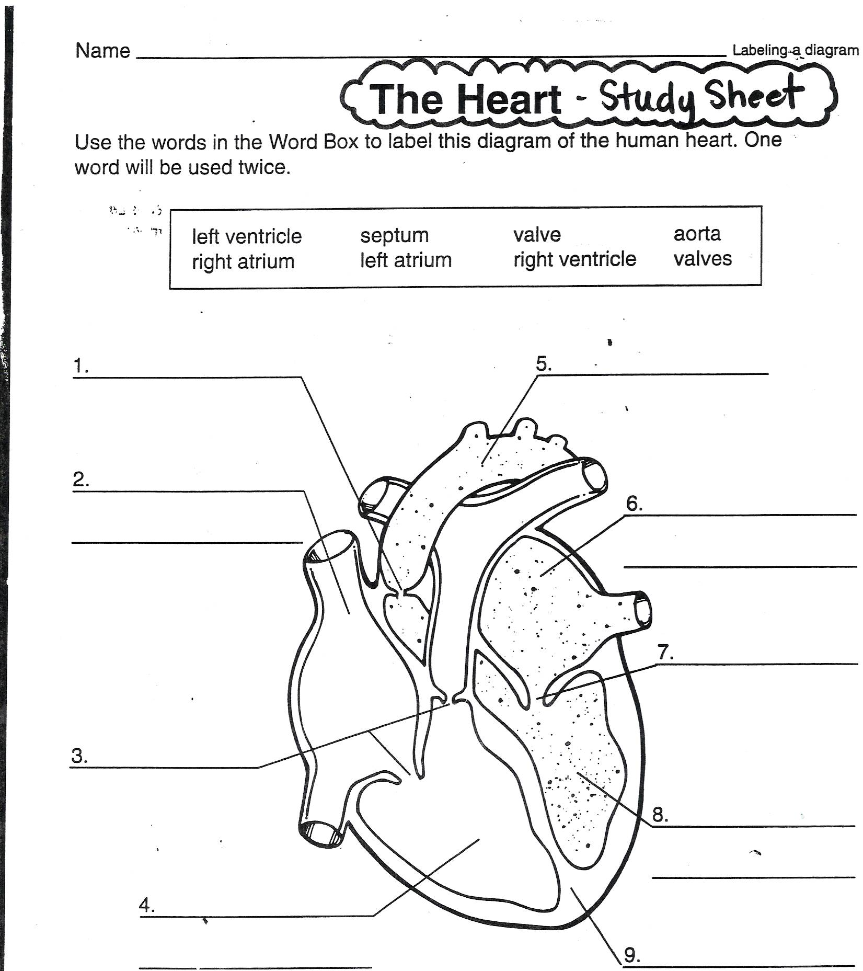

(Attachment 2)

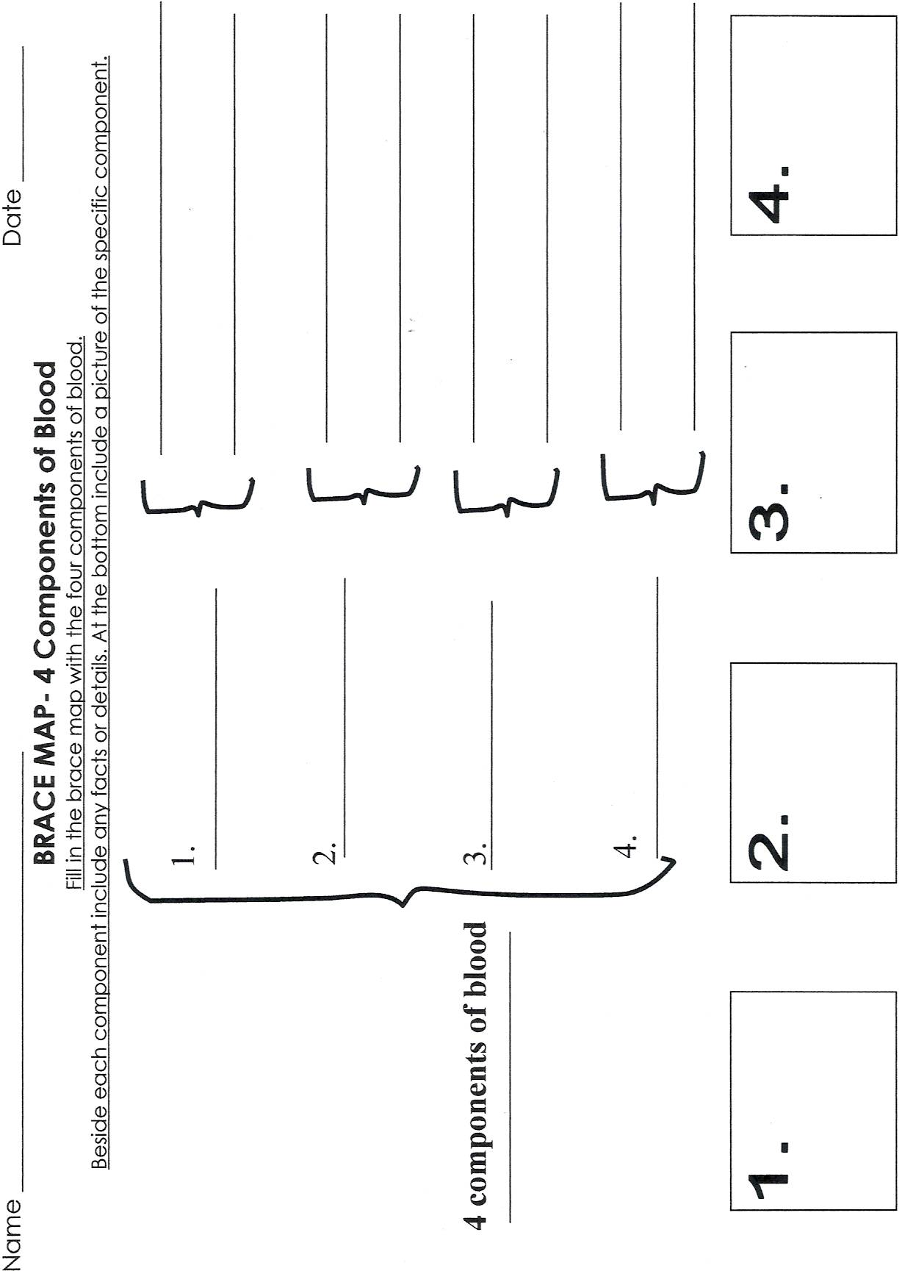

IN00364_IN00364_Components of Blood- 4 Folded Display

Use a piece of paper to make the following envelope fold.

1. Fold a sheet of paper to form a square. Cut off the leftover piece at the bottom.

2. Open the square and fold it the opposite way- so there is a “X” of folded lines.

3. Open the fold back to a square. Fold each corner towards the center of the

square until it meets the center of the X.

PE06259_

You will be constructing a display illustrating and explaining the 4 components that make up blood. A title must appear on the outside cover. Your name and date will be on the back side. Each of the 4 folds will be used to explain one component of blood.

On the outside folds you should creatively write one component per fold. A picture (drawn or printed out) should also be included with each component. It can be a picture of the particular blood component or any picture related to circulation.

When you open the fold, there should be a 3-sentence minimum description of the term along with its function and any interesting facts. Inserted inside all the folds should be a square piece of paper with one disease that affects the circulatory system or cardiovascular system. The disease should be defined, explaining how people get it and also how it is treated or cured.

**Rubric:**

Title \_\_\_\_\_ 4 components \_\_\_\_\_\_ definition of components \_\_\_\_\_ 3 sent. length \_\_\_\_\_

Extra Credit \_\_\_\_ 4 pictures \_\_\_\_\_\_ creativity \_\_\_\_\_\_\_ effort \_\_\_\_\_\_

Disease \_\_\_\_\_\_ how you get it \_\_\_\_\_\_\_\_ treatment \_\_\_\_\_\_ grammar/spelling\_\_\_\_\_\_\_

explained or cure

(Attachment 4) Foldable diagram adapted from Dina Zike’s Big Book of Science