IDENTIFIABLE NEURONS IN THE CENTRAL
NERVOUS SYSTEM OF A LEECH

By

Josh Titlow¹, Zana R. Majeed^{1,2}, John G. Nicholls³ and Robin L. Cooper¹
¹Department of Biology, University of Kentucky, Lexington, KY 40506, USA;
²Department of Biology, College of Sci, Univ. of Salahaddin, Erbil, Iraq;
³Department of Neurobiology and Cognitive Neuroscience, SISSA, Trieste 34136,
Italy

1. PURPOSE

The purpose is to investigate various types of identifiable neurons and their characteristic electrophysiological and anatomical properties.

2. PREPARATION

Leech (Hirudo medicinalis)

3. INTRODUCTION

The leech preparation is useful for investigating the function of identifiable primary neurons within the animal's central nervous system (CNS). A most valuable feature of leech neurons is that the shape of their action potentials and biophysical properties are characteristic for a given cell type (eg sensory, motor, neurosecretory and interneurons). Moreover neurons can be removed from the animal and cultured in a suitable medium in which the cells maintain their electrical characteristics for as long as 45 days (Fuchs et al., 1981; Ready and Nicholls, 1979).
A distinct advantage of the leech ganglion for learning how to make electrophysiological recordings is that cells are characteristiacally and reliably arranged in the ganglion in a pattern that allows identification of distinct cell types from ganglion to ganglion and from animal to animal The unique locations and morphology of neurons in leech ganglia were noted by Retzius as early as 1891 (Blackshaw, 1981). Knowledge of the identity and function of a neuron offers advantageous for investigating neural circuits and for making experiments with a given cell type. Due to the relatively large somata of the neurons within a ganglion they are visible with a dissecting microscope; the somata can be selectively impaled with microelectrodes for recording their electrical properties.

Several types of ionic currents have been identified that give rise to the various shapes of the characteristic action potentials in the various neurons (Drapeau and Sanchez-Armass, 1989; García et al., 1990; Cooper et al., 1992; Liu and Nicholls, 1989). From investigations in the pattern of innervation and branching of individual neurons within the CNS, the synaptic connections have been reproduced in culture with identified neurons (Ready and Nicholls, 1979; Fernández-de-Miguel, et al., 1992). Studies in the leech ganglia have provided insight into the developmental of functional circuits that can be measured with electrophysiology as well as with whole animal behavior studies. The leech CNS has also served as a valuable preparation for investigating mechanisms involved with neuronal repair and regeneration in the whole animal and in culture (Briggman, Kristan, 2008; Macagno et al., 1985; Becker and Macagno, 1992; Drapeau and Sanchez-Armass, 1989; García et al., 1990; Cooper et al., 1992; Marin-Burgin et al., 2008).
The ganglia are clearly divided into regions marked by large glia cell compartments. These are glial packets can be readily identified in the dissecting microscope or by injection of dyes (Deitmer et al., 1999; Kuffler and Nicholls, 1966; Kuffler and Potter, 1964). The physiological function of glial cells was relatively unknown in animals until studies carried out by Kuffler and Nicholls, (1966) demonstrated that when neurons in the leech ganglion were activated, the electrical potential of the large glial cells was altered. The explanation model was then proposed that these large glial cells could take up the extracellular K⁺ ions that increased due to the activity of the neurons. Thus, the neighboring neurons would be protectedfrom the rise in In mammalian brains it is a daunting task to explain behavior in terms of the properties and connections of individual identified neurons In principle one can hope that the study of less complex systems such as the leech could help to define basic mechanisms used in higher animals . The connections that are used which underlie a swim pattern (Kristan, 1983; Bradfuehrer and Friesen, 1986) and the rhythmicity of the heart (Arbas, and Calabrese, 1987) have been well characterized in the leech. The ability of some leech neurons to form both electrical and chemical communication is intriguing. Some connections are bidirectional while others are unidirectional chemically but bidirectionally electrically (Liu and Nicholls, 1989). Understanding the synaptic connections within the animal as well as recreating the same type of connections in a culture dish are powerful tools for investigations into synaptogenesis (Ching, 1995; Kristan et al., 2000; Todd et al., 2010) as well as pharmacological profiling of synapses (Li and Burrell, 2009 ).

4. METHODS
4.1 Materials
- Scissors (1)
- Forceps , one fine and 1 course (2)
- One pair of fine iris scissors (1)
- Silver Wire for ground wire (1)
- Microscope (1)
- Intracellular electrode Probe (1)
- Large Petri dish with Sylgard on the bottom for leech dissection (1)
- Small Petri dish with Sylgard on the bottom for ganglion in isolation (1)
- Saline Solution (1)
- Bleach (Small Amount, Use for the tip of the silver wire to build Ag-Cl)
- Glass Pipette (1), to remove and add solutions
- Syringe (1)
- Amplifier/Acquisition System (1)
- Faraday Cage (1)
- Desktop/Laptop (1)
- Fine dissection pins (10)
- Large insect pins for dissecting leech
- Leech Hirudo medicinalis
- Fiber optic lamp
- Mirror that can be tilted under a stand
18. Raised preparation stand with a glass bottom
19. Lamp to shine onto mirror
20. Micromanipulators
21. Dissecting microscope with 100x magnification
25. Squirt bottle for leech saline (need during leech dissection)
26. Dissection tools

4.2 Preparation/Dissection:

4.2.1Solution
Leech Ringer's solution:
Buffer Stock solution Tris 0.2M (24.2g) & Maleic acid (23.2g)
Final solution mM
NaCl 115.0 (6.716 gram/1 L)
CaCl₂ 1.8 (0.264 gram/1 L)
KCl 4.0 (0.298 gram/1 L)
Add Tris/Maleic acid (50.0 ml) of stock for every 1000 ml of saline to be made. Dissolve salts in 800 ml of H2O, pH to 7.4 with 5N NaOH, fill to 1 Liter.

4.2.2. Dissection

The animal usually secretes slimy mucus from the skin. It is better to quickly deal with the animal and get it pinned dorsal side down with large pins placed in the head and tail regions as well as along the lateral aspects of the body wall (see Figure 1). If the animal is stretched longitudinally it will be easier to remove the ventral nerve cord.

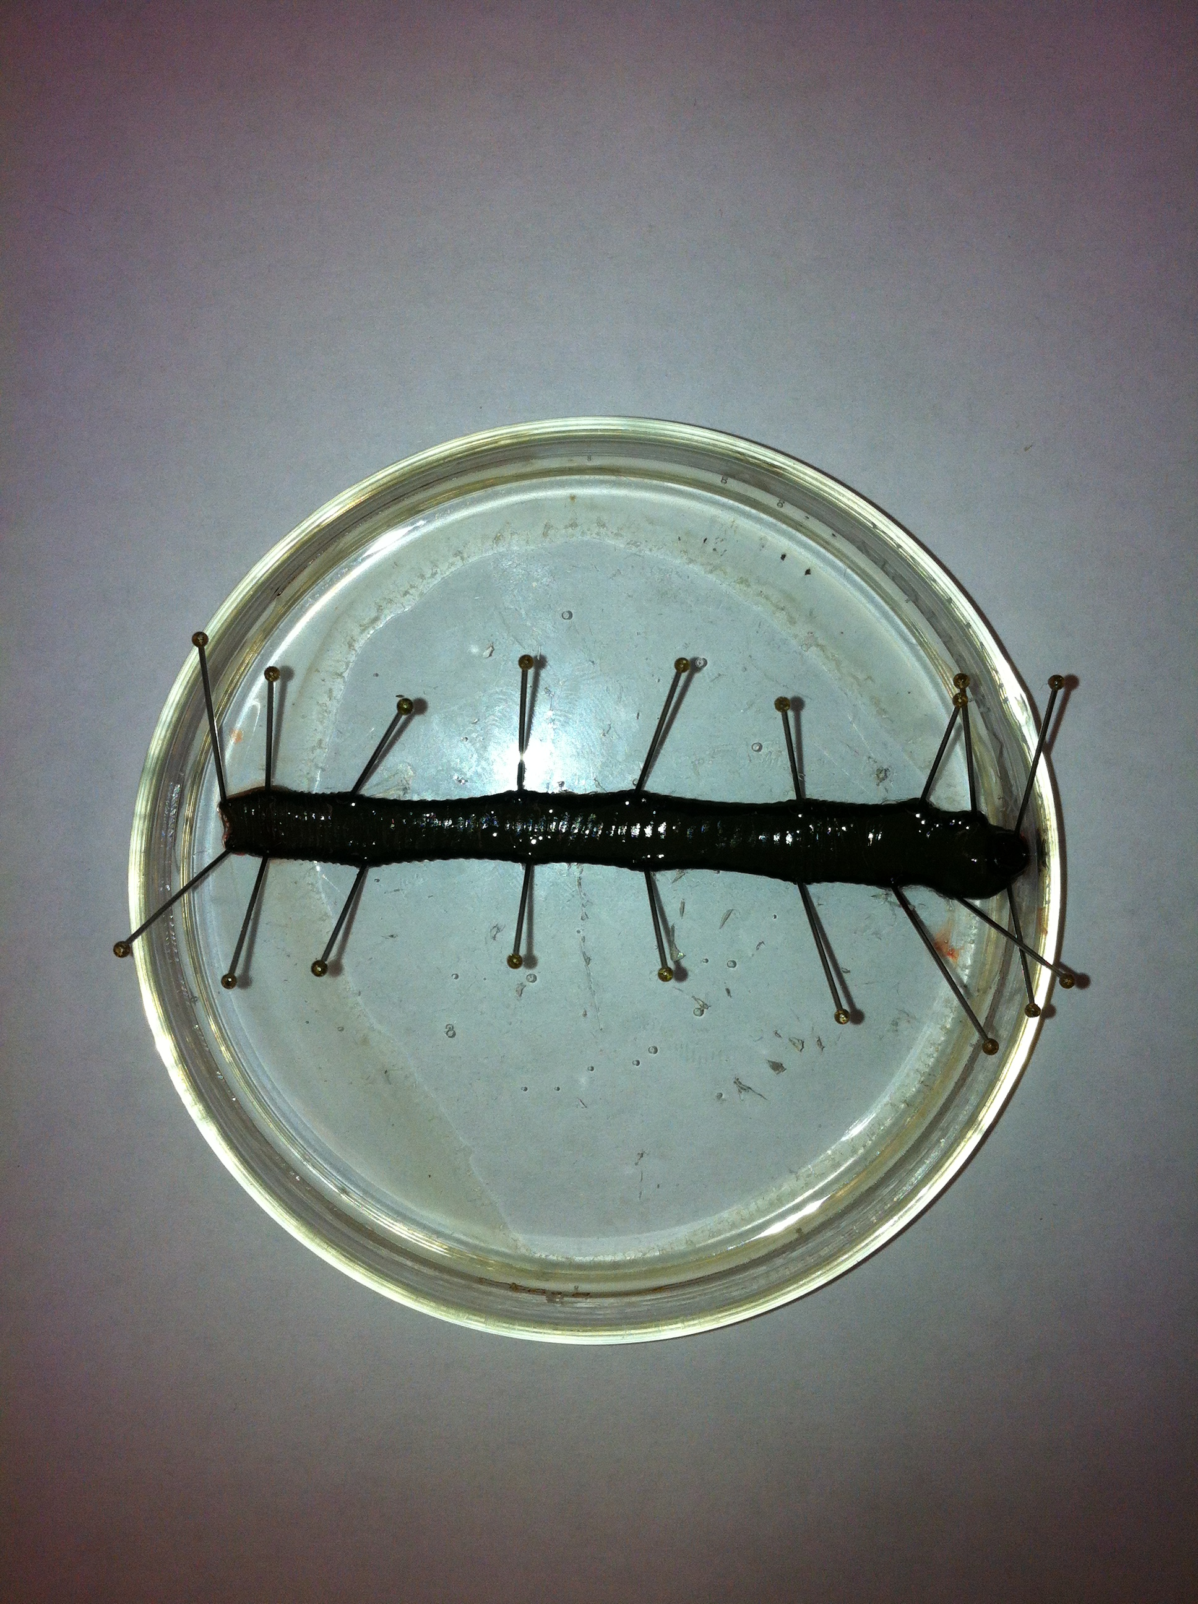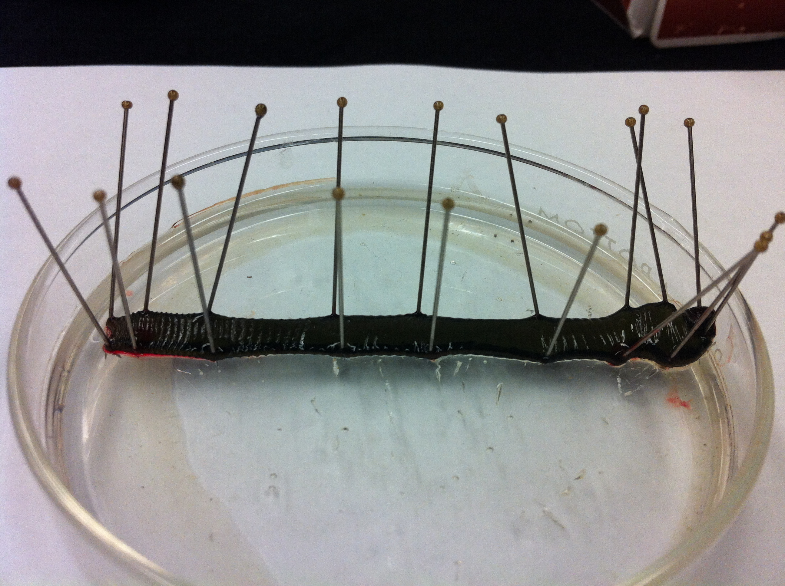
Figure 1: Leech pinned out along the sides and fully stretched. (Dorsal view, Top panel; side view, Bottom panel)

With #10 or #11 size scalpel make a longitudinal incision, with very shallow cuts, in the ventral midline. About the middle 2/3rd of the ventral cut is shown in Figure 2.Try not to cut through the black stocking (the ventral blood vessel) until the animal is fully opened and the black stocking is stretched without kinks. This black stocking runs the length of the animal along the ventral midline. The VNC is contained inside of this blood vessel.

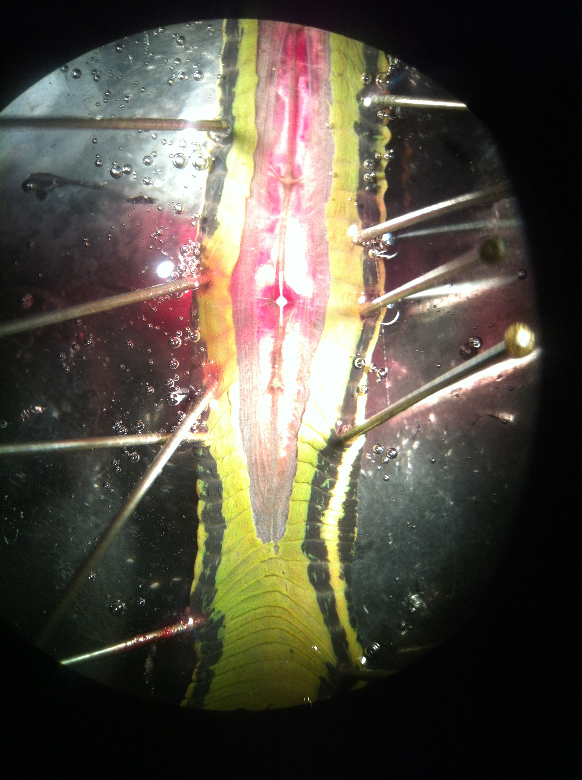
Figure 2: The ventral side of the animal is opened with the VNC containing the white ganglia readily seen. This is after the black stocking was carefully opened to expose the VNC.

After the skin has been cut the full length of the animal, the fine iris scissors should be used to nick the black stocking (Figure 3). Slip one blade of the fine iris scissors under the stocking and slightly raise the blade to pull up on the stocking. Cut the stocking the length of the ventral nerve cord while trying not to cut the nerve roots or the connectives between ganglia. Next the ventral nerve cord has to be removed by cutting the roots more distally then where the blood vessel joins the roots. The blood vessel (stocking) around the roots has to be cut free. Repeat this process for each ganglion along the length of the ventral nerve cord. The last ganglion in the head and tail do not have to be used as the arrangement of the neurons are not in the same arrangement as the other segmental ganglia.

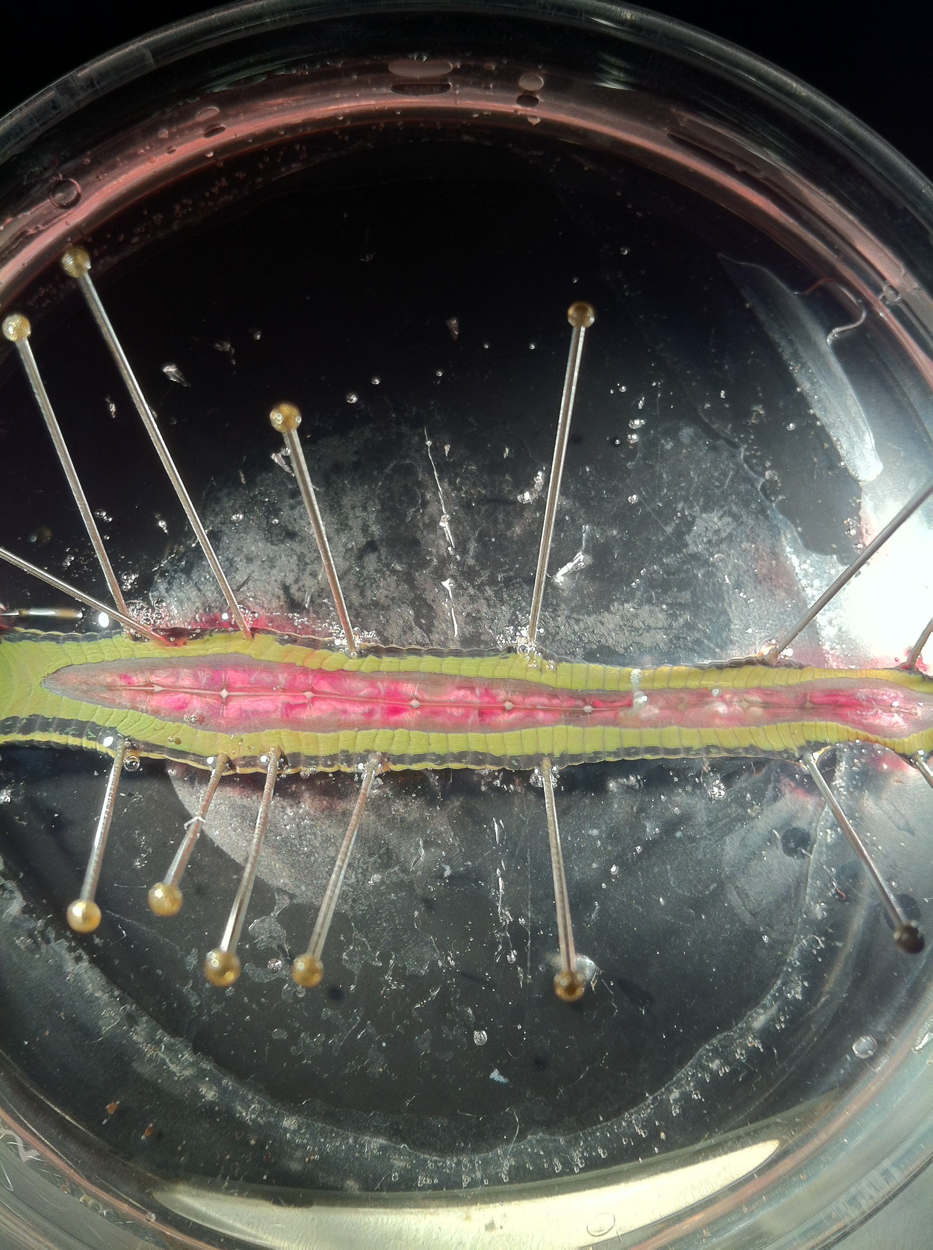
Figure 3: Exposing the ventral nerve cord (VNC). Top panel illustrates the careful cutting away of the stocking with one edge of the scissors within the stocking while cutting along the length of the VNC. The bottom panel illustrates the VNC exposed with the black stocking cut along the length of the animal.

The ventral nerve cord (CNS) should be transferred to the smaller Petri dish and cut into sections of 1 or a few ganglia in length. The ganglia or the single ganglion needs to be pinned taut. Pin the connectives and the roots so the ganglion glial sheath is stretched over the neuron to prevent the neuron cell bodies from moving around when impaling through the glial sheath and into the neuron of interest. It is important to try not to damage the neurons in the roots or connectives with the pins as later in the experiment the roots and connectives will be sucked into a suction electrode to stimulate the axons of neurons to record electrical activities. The pins can be placed through the black stocking for the roots and in the middle of the two connectives to minimize damage of the axons (Figure 4).

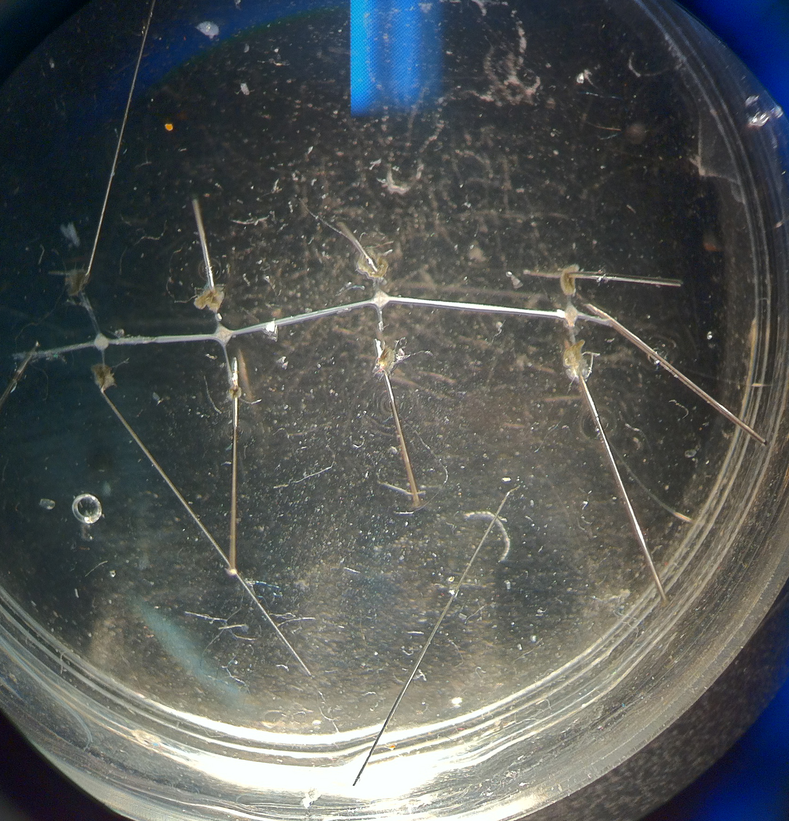
Figure 4: With fine pins stretch out the roots and connectives so the ganglia are taut and flat.

4.2.3 Cell identification anatomically
See that the arrangement of neurons matches the typical arrangement as shown in Figure 5 (Schematically shown in Figure 6). If it does not match then potentially the preparation is pinned dorsal side up. The two large Retzius cells in the middle of the ganglion should be observed.
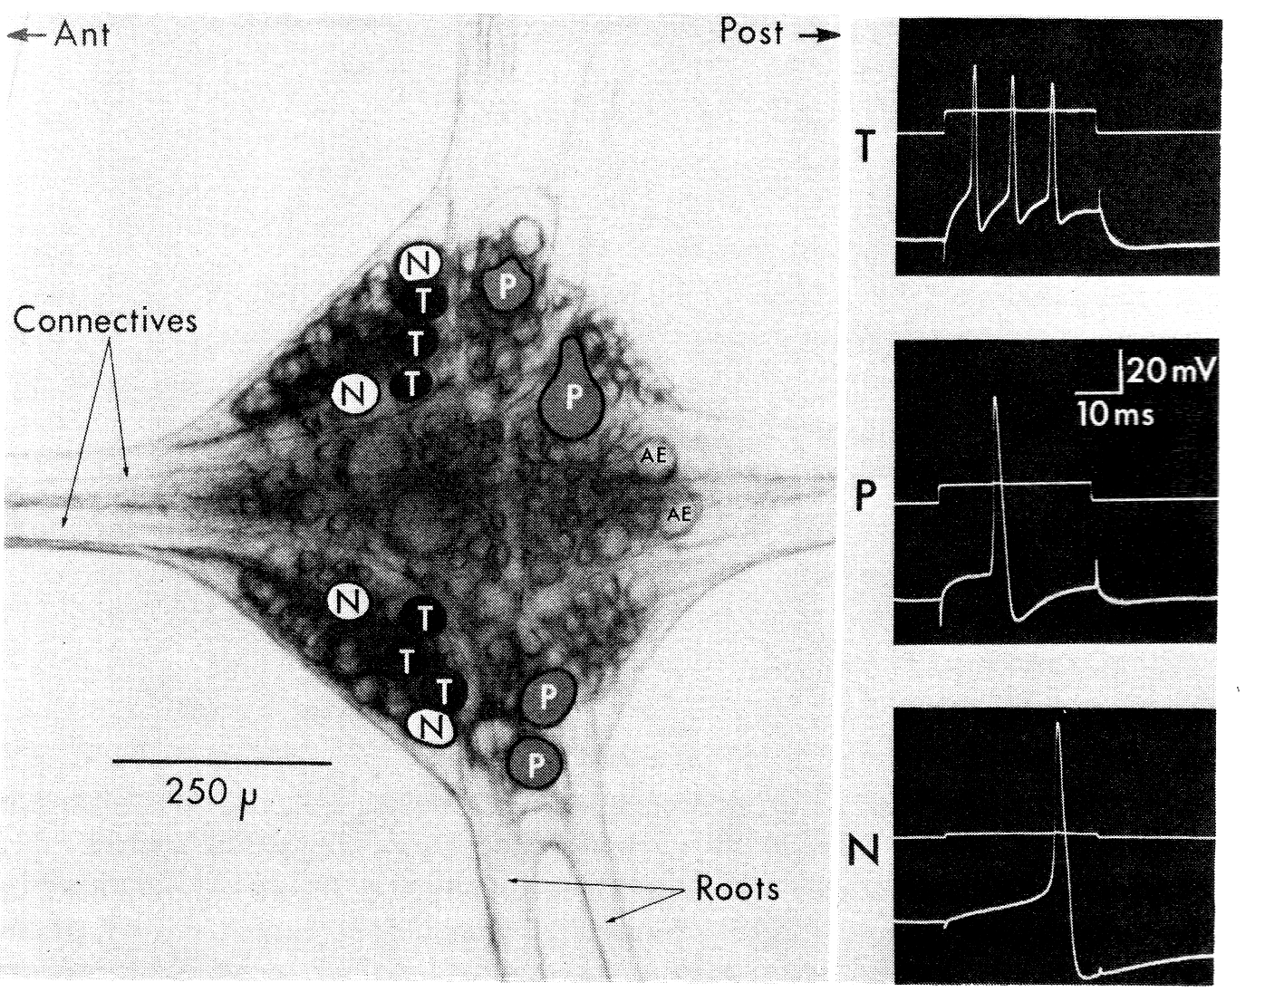
Figure 5: the arrangement of neurons and the evoked action potentials for some of the sensory neurons (from Blackshaw, 1981 modified from Nicholls and Baylor, 1968).

Figure 6: Schematic of ganglion illustrating the large Retzius (R) cells close to the mid region of the ganglion. The touch (T), pressure (P), nociceptive (N) sensory neurons as well as the annulus erector (AE) motor neuron are labeled in the approximant locations and relative sizes as seen from a ventral view of the ganglion.

4.2.4 Intracellular identification of neuronal types

From a ventral view, one is now able to obtain an intracellular recording of the Rz neurons. Afterwards, impale the known sensory T, P and N neurons and measure the resting membrane potential (RP) and electrical signals. To clearly visualize the neuronal cell bodies one may have to change the saline level and adjust the mirror to obtain the best light intensity.

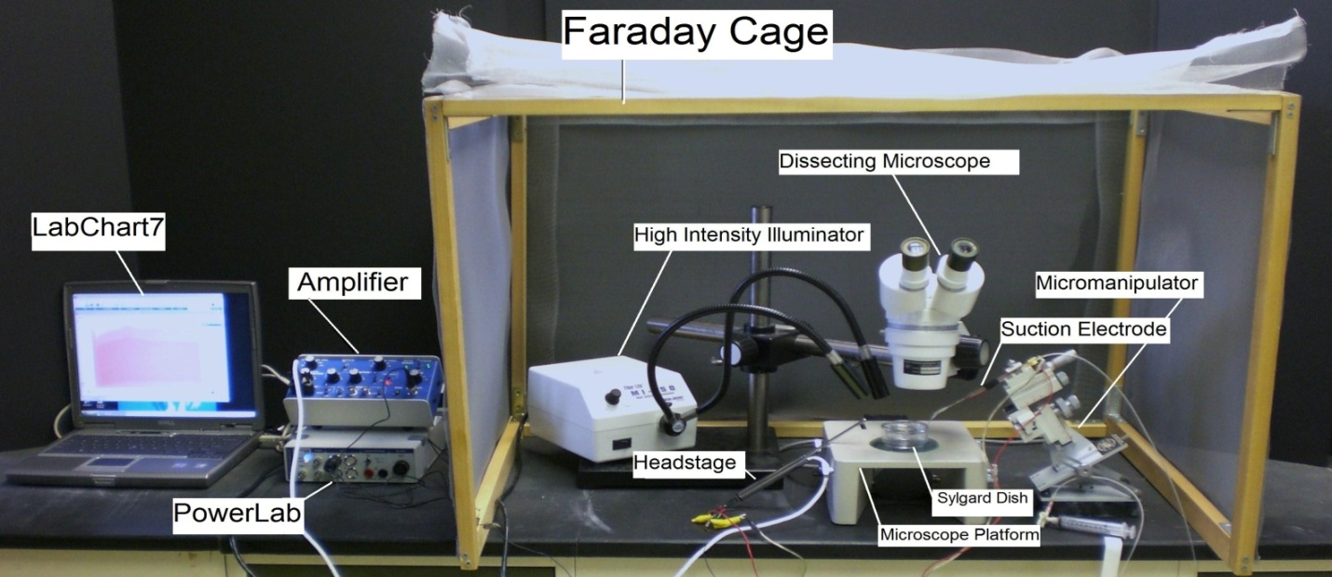

Figure 7: Overall setup of the recording equipment.

The Petri dish with preparation should be placed under the microscope and secured with wax at the bottom of the dish to prevent movement.

The specimen dish with preparation should be placed under the microscope and secured with wax or clay on the sides of the dish to prevent movement. One might find using a tilt mirror of use under the preparation to shine light up through the preparation (Figure 7).

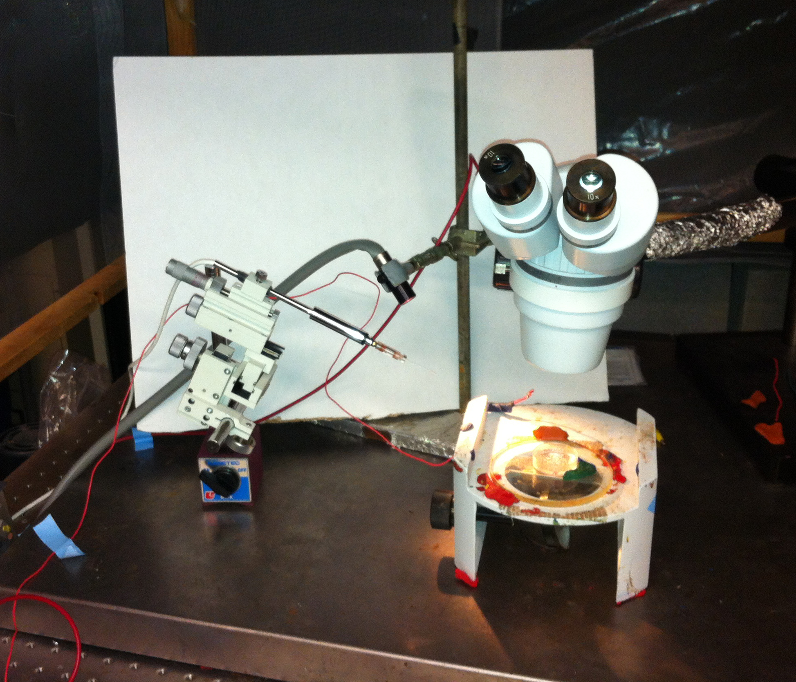

Figure 8: Placement of the preparation under the microscope with the intracellular head stage mounted on a micromanipulator

Two wires each with a short length of silver wire attached to one end should be obtained. The silver wire should be dipped into a small amount of bleach for about 20 minutes to obtain an Ag-Cl₂ coating. Wash the wire with distilled water before using. A glass intracellular pipette should be obtained and carefully backfilled with a long needle attached to a syringe filled with a 3M KCl or 3M K-acetate solution (Figure 9). The pipette should be turned down (with the opening facing the floor) and filled with solution. This will ensure that any excess KCl will drip out the back of the electrode. Be sure no KCl runs along the glass pipette that will enter the saline bath. Turn the pipette upright when finished filling with potassium chloride or potassium acetate solution. The silver wire can then be placed into the pipette (Figure 10). Care should be made not to break the electrode tip. Another wire is attached to the Faraday cage or into ground directly on the intracellular amplifier. A wire should also be placed from the Faraday cage to the ground portion of the AD converter Powerlab. The head stage is connected to the “input-probe” on acquisition/amplifier (Powerlab).

Figure 9: Filling microelectrode

Figure 10: Microelectrode and holder

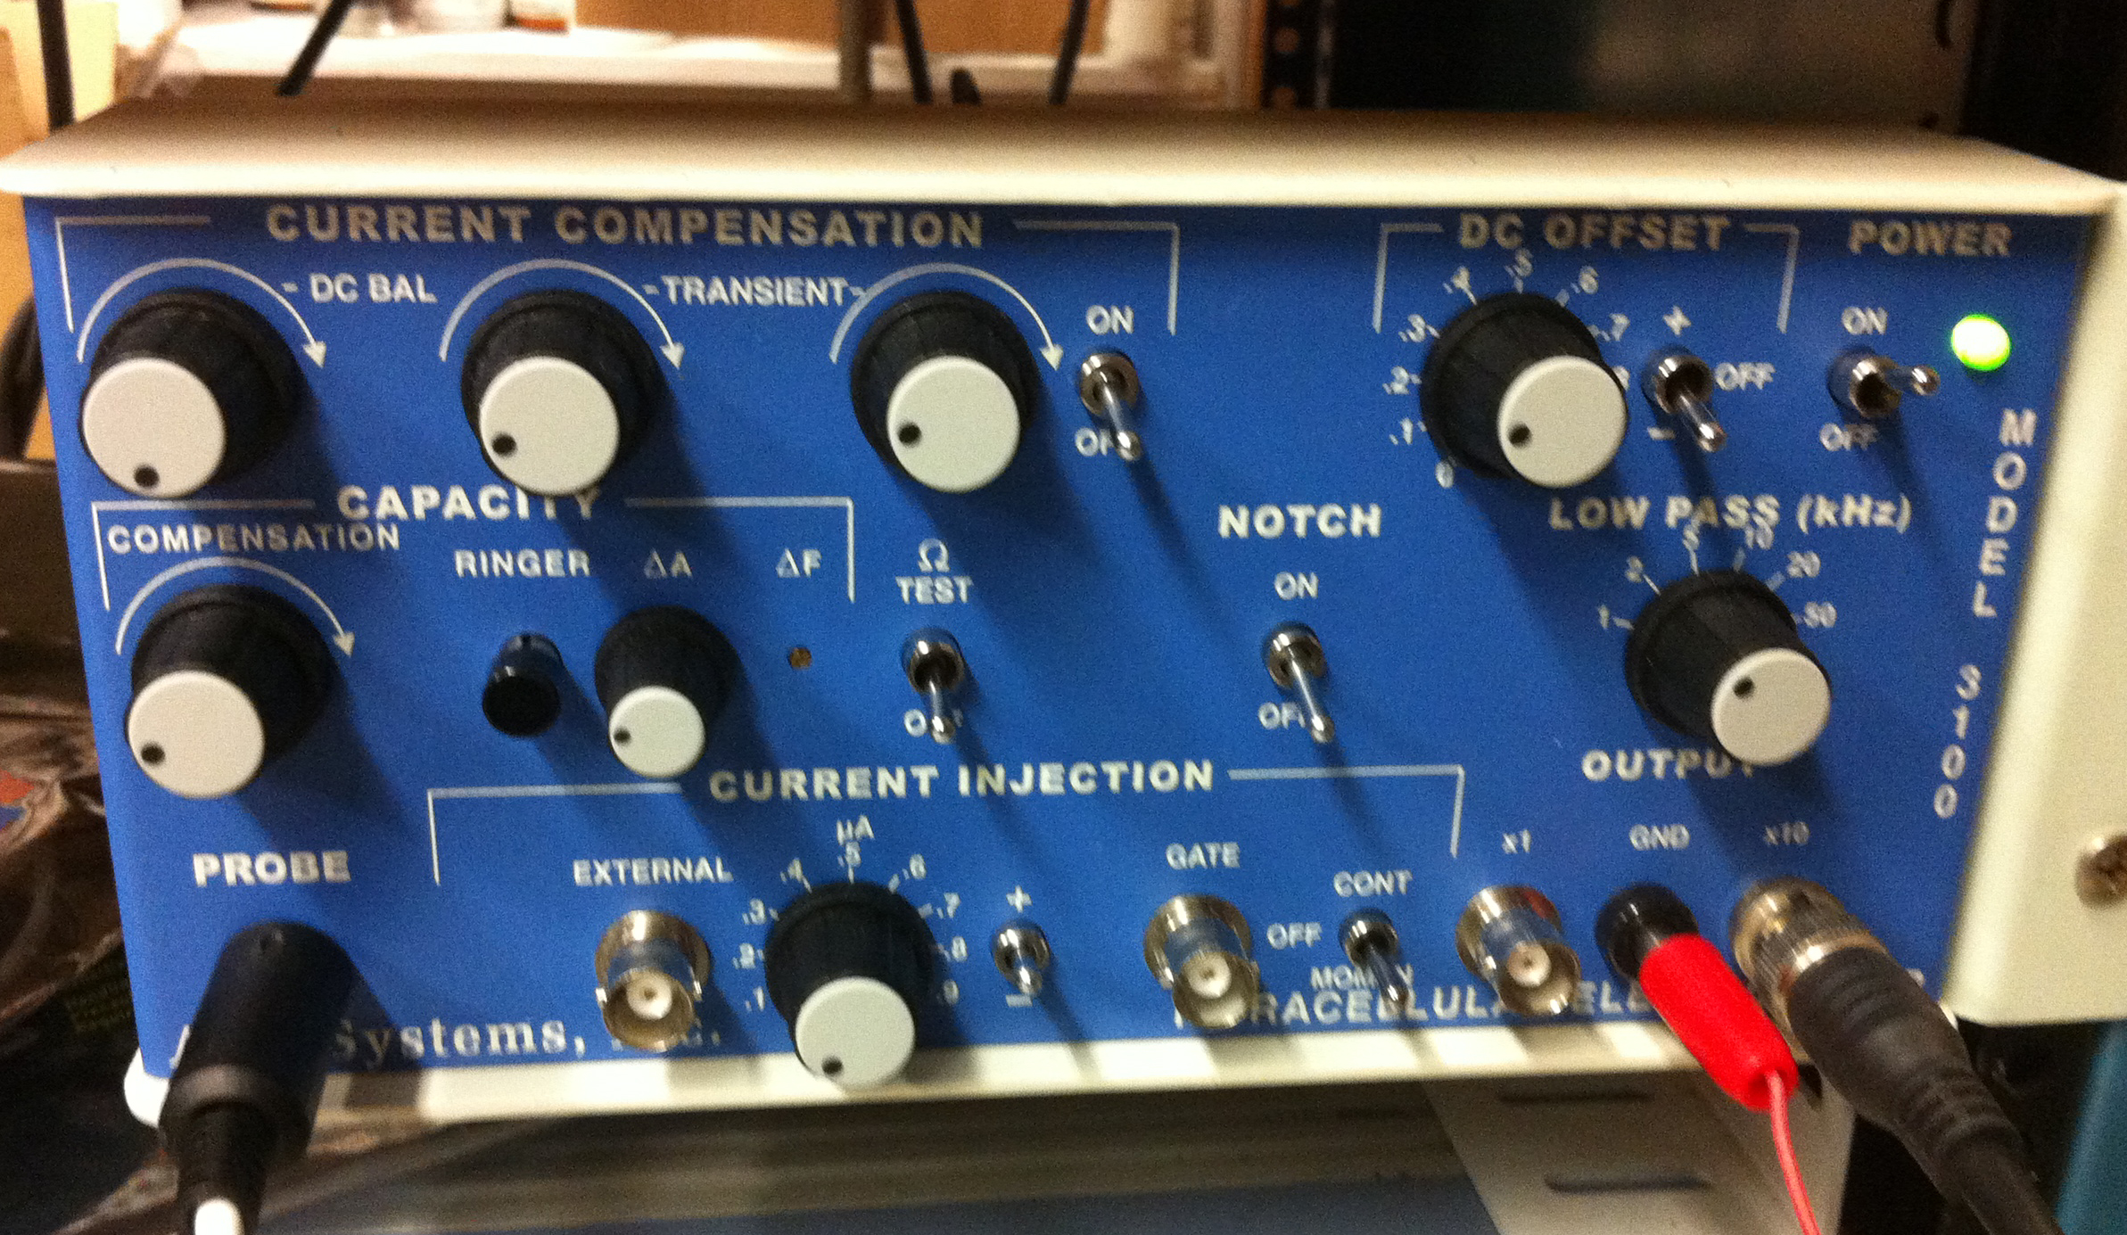
Figure 11: Front face of the intracellular amplifier used during the intracellular membrane potential recordings. The “Ω TEST” switch used to test electrode resistance is center left. The DC offset knob is in the upper right corner, and should be turned counter clockwise to start. The ground wire is placed in the “GND” pin jack opening. The amplifier in this set-up amplifies the signal by 10X.

Software Set-up
Be sure your amplifier and PowerLab units are on before opening the software.

Open the LabChart software. Adjust the chart to display only one channel by clicking “Setup”, then “Channel settings.” Under “Channel settings,” change number of channels to one. Click “OK.”

At the top of the chart, left hand corner, cycles per second should be 2K. Set volts (y-axis) to around 1V.

Click on “Channel 1” on the right hand portion of the screen. Click “Input Amplifier” and that the following settings are selected:

Single ended | OFF
Differential | Checked
AC-Coupled | OFF
Anti-alias | Checked
Invert | OFF

Amplifier Set-up
The amplifier output cable should be plugged into channel one. The following settings should be used with the intracellular amplifier (see Figure 11 for reference):

Current Comp.(3 knobs) | counter clockwise
Capacity Comp. | counter clockwise, OFF
Capacity Amp (ΔA) | counter clockwise
DC Offset knob | Varies (see part 16 below)
Low Pass knob | 50 kHz
Notch | OFF
Current Injection | 0 µA
ΩTEST | OFF

CHECK THE RESISTANCE OF YOUR ELECTRODE.

To measure the resistance, place the tip of the glass electrode into the saline bath. Make sure a ground wire is also in the saline bath. While recording, the Ω TEST switch should be turned on and then off several times (Figure 12).

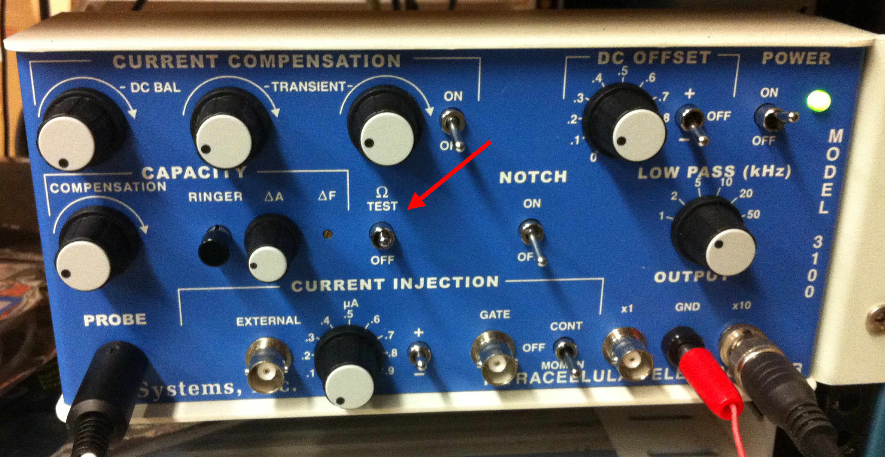

Figure 12: Front face of the intracellular amplifier with the “Ω TEST” switch in the on position.

The amplitude (mV) of the resulting changes should be measured. To measure the amplitude changes in the trace, place the marker on the steady base line and then move the cursor to the peak amplitude. The trace might be condensed so use the “zoom function” under the “window” menu. Then move the “M” at the bottom left to base line and the cursor over the peak response (Figure 13). Then the delta value will display at the top in mV. In the figure it is 222.7 mV.
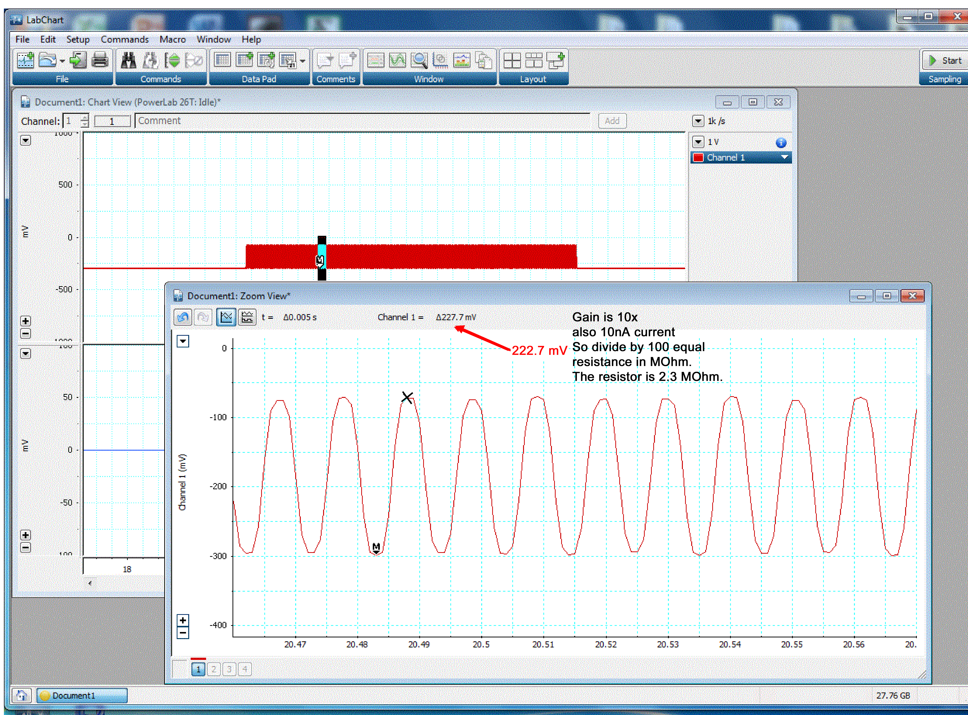

Figure 13: Traces of the responses for measuring electrode resistance.

As a measure of the electrode resistance, the voltage should be divided by the current, which is 10 nA (ie., R=V/I, or Ohm’s law). The resulting value is the resistance of your glass electrode. Recall the BNC output of the intracellular amplifier is connected to a 10X output. Thus, divide by 100 to obtain the correct electrode resistance.

Electrode Resistance (MΩ) = ____________________

The resistance should be within 20 to 60 MegaOhms. Low (<20) and high resistance (>100) are not acceptable. Troubleshoot as necessary to bring your electrode’s resistance within the acceptable range.

Set the gain in your software to 1 or 5 V/div. Begin recording by pressing “start” at the bottom of the screen. Use the DC offset knob on the amplifier to adjust the recording trace to zero before inserting the electrode into the tissue. This sets your extracellular voltage to zero. This is the difference from the glass microelectrode to the ground wire which should be both in the saline.

Record potentials
Carefully place the tip of the electrode over the cell of interest and gently lower the tip until a dimple is seen in the glial sheath. One might very carefully tap the electrode holder or manipulator so that the electrode tip “pops” into the cell of interest. Since there are at least two of the same cell types (Rz, T, P, N) try to obtain the resting membrane potential from the same cell type.

cell | RP (mV) | Notes
Rz1
Rz2
T1
T2
P1
P2
N1
N2

Record the resting membrane potentials in the table and draw or take notes on the shape of the action potentials that might occur after poking into the cell. Some cells can be stimulated to fire by either stimulation the axons in the roots or the connectives. The responses recorded in the cell bodies may be from directly stimulating the axon of that cell or be a result of synaptic activity on to the recorded cell (Figure 14).

Figure 14: Electrical responses obtained in a RZ and T cell depicting the synaptic responses and an action potential.

The amplifier also allows one to stimulate through the recording electrode. In order to do this operation the BNC output from the Powerlab should be connected to the external BNC connection under the “current injection” heading. The chart software requires the settings to be established for delivering the pulses of the desired duration. The amount of current can be controlled by the knob on the intracellular amplifier. The AD power lab setting will drive the amount of current. The current settings on the intracellular amplifier are added to the value given by the setting in the software from the chart stimulator panel. The “gate” BNC connection tells the machine when to give the stimulus through the intracellular electrode.

Amplifier Set-up for current injection and recording potentials
The amplifier output cable should be plugged into channel one. The following settings should be used with the intracellular amplifier (see Figure 12 for reference):

Current Comp.(3 knobs) | counter clockwise
Capacity Comp. | counter clockwise, OFF
Capacity Amp (ΔA) | counter clockwise
DC Offset knob | Varies (see part 16 below)
Low Pass knob | 50 kHz
Notch | OFF
Current Injection | 0 µA
ΩTEST | OFF
Current injection µA | 0
Toggle switch for current injection + or - | +
Toggle switch for current injection | “CONT” for continuous

Software set up to stimulate through the intracellular amplifier and microelectrode

The PowerLab system (PowerLab interface from AD Instruments, Australia) will serve as the stimulating voltage source in this experiment.

Connect the Stimulator BNC cable to Output portals on the PowerLab as follows: BNC to the positive Output portal and then to the External current injection BNC connection (Figure 15 and 16).

Figure15: Power lab with BNC output and input connections from the intracellular amplifer shown.

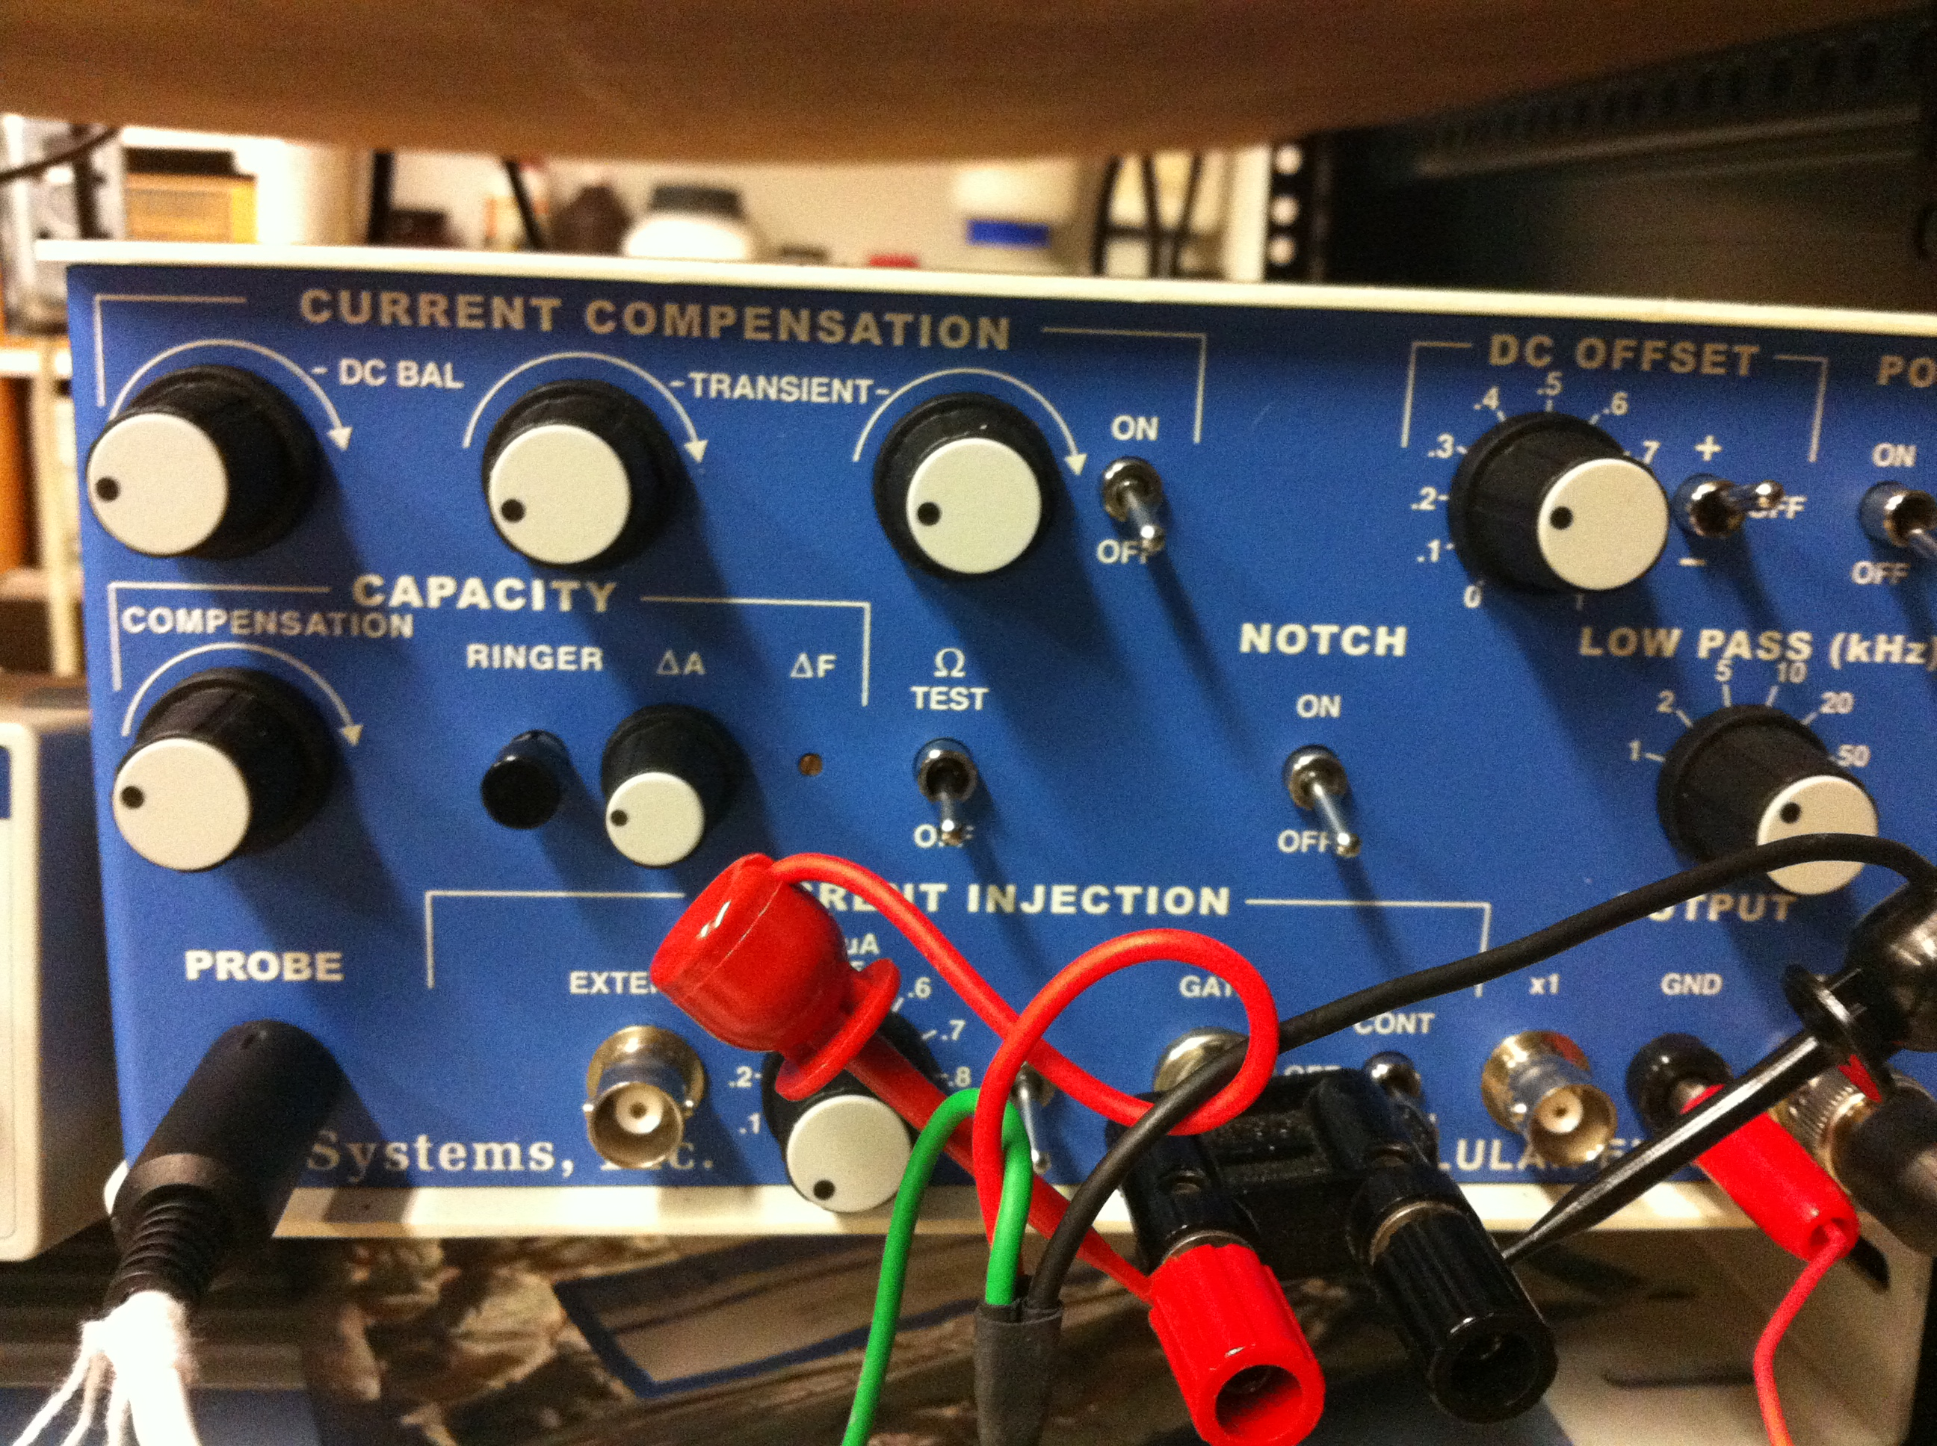

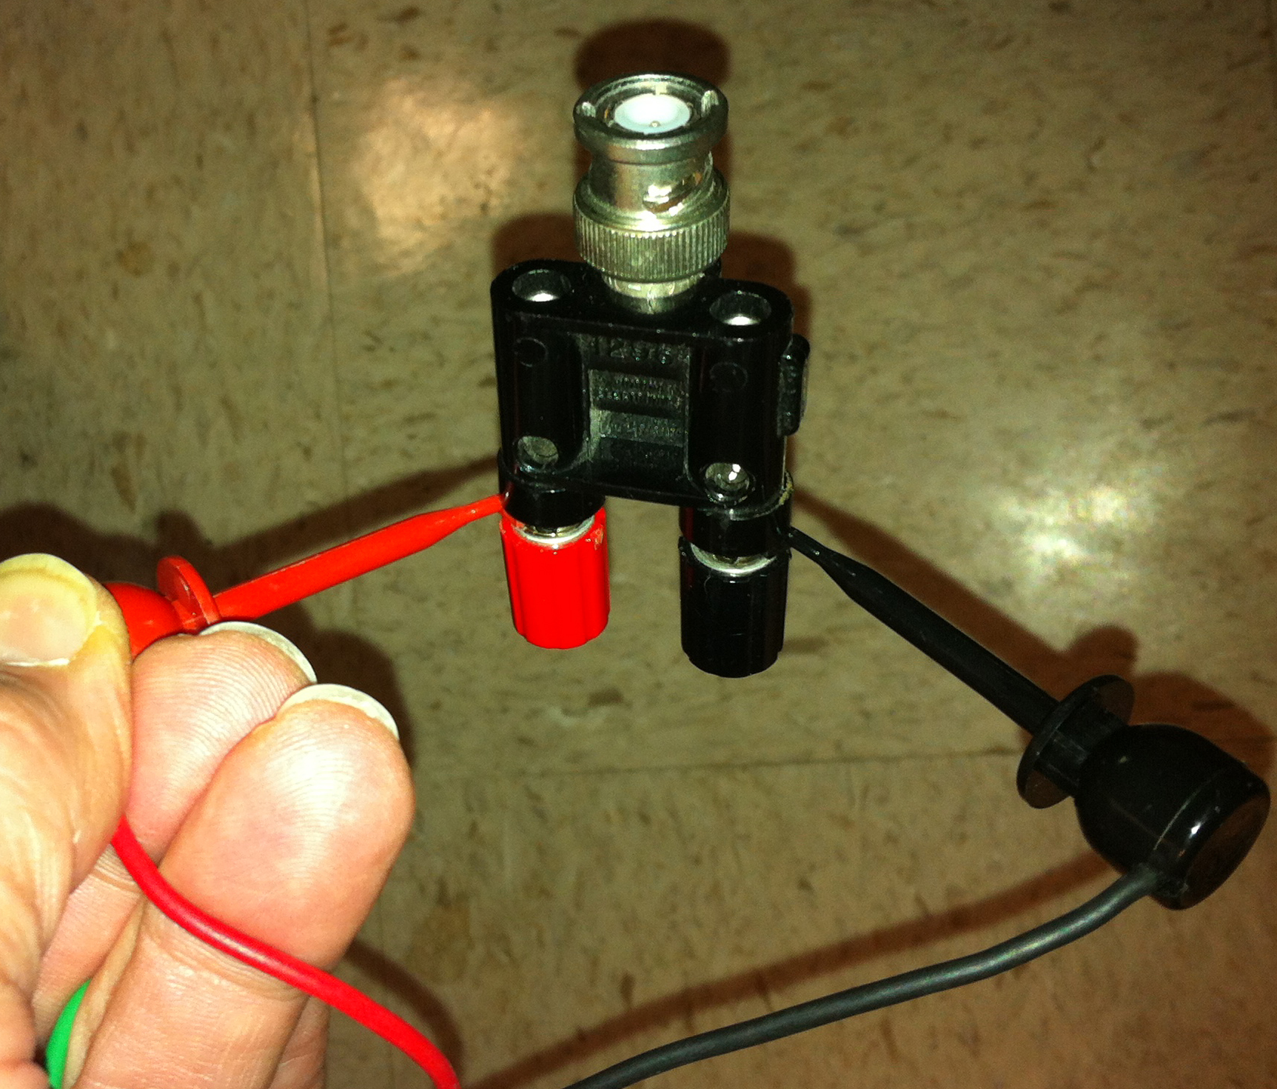
Figure 16: Intracellular amplifier with BNC output from power lab connected to “gate” current injection (Top panel). The stimulating wires from the PowerLab can be connected with a BNC to two lead inputs as shown in bottom panel. Current injection knob is turned off or to zero. Current injection toggle switch to + and current injection toggle to “off” until reday to start injections. The BNC output is connected to the 10X output. The input connections from the intracellular headstage is connected to the PROBE input.

Next, it is necessary to change the power output, frequency, and pulse duration of the PowerLab. In order to do this, select “Setup,” and then “Stimulator Panel.” Short pulses and small voltages to start off with are required for the first portion of the experiment, so adjust the amplitude to 0.01 V. Set the frequency (0.5 Hz) and pulse duration (0.04s).

A window will appear with multiple recording channels. Select “Setup” at the top and click on “Channel Settings.” In the bottom left corner of the window, decrease the Number of Channels to 2; on Channel 1and 2, change the Range to 1V.

Next, it is necessary to change the power output, frequency, and pulse duration of the PowerLab. In order to do this, select “Setup,” and then go to “Stimulator”. Select “marker channel” as Channel 2 (Figure 17). This way one can tell when the stimulus is given. Note: Keep “Stimulus isolation” off in this window.

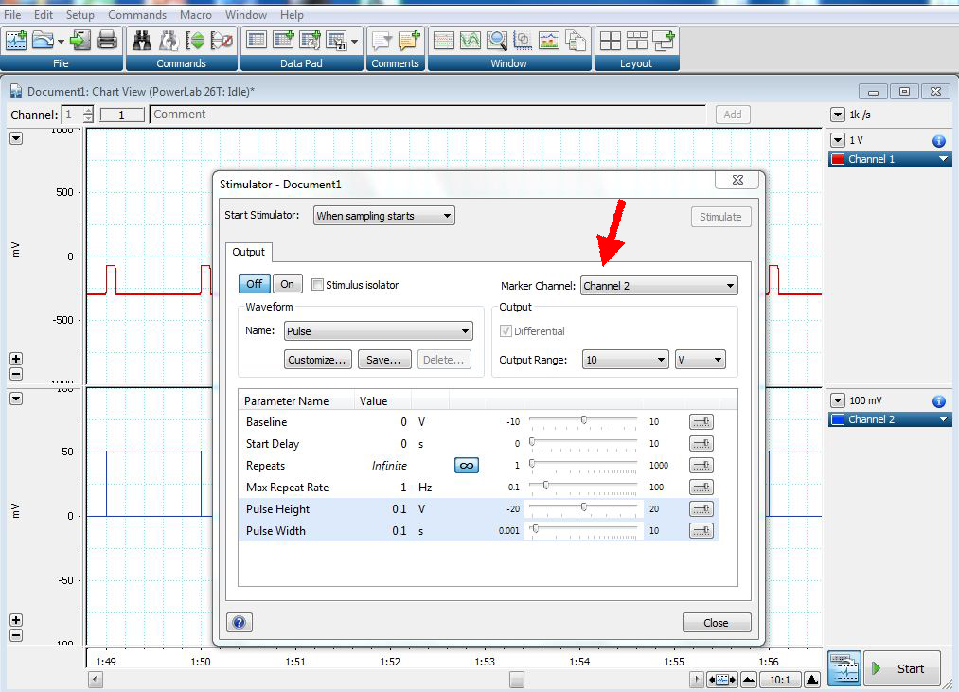
Figure 17: Stimulator menu to show how to set the stimulation parameters.

Next click “Setup,” and then go to “Stimulator Panel.” Short pulses and small voltages to start off with are required for the first portion of the experiment, so adjust the amplitude to 0.5 V; this will give a range of 1.0 V (the PowerLab will emit a voltage fluctuating between positive and negative 0.5 V). Set the frequency (0.5 Hz) and pulse duration (0.01s) (Figure 18).

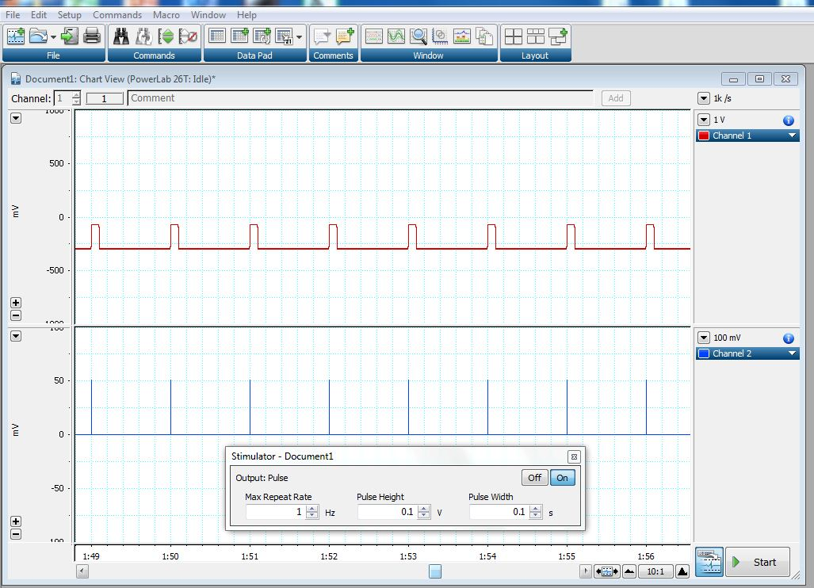
Figure 18: Stimulator panel menu to show how to set the stimulation parameters.

The stimulus intensity can be varied from positive to negative by placing a negative sign in front of the value in the “pulse height”. Also the value can be increased or decreased to recruit a nerve bundle with a suction electrode. As an example, a 2.3 megaohm resister is connected across the ground wire and the recording silver wire in the electrode holder and the stimulation was changed from 0.1 to 0.01V (Figure 19).

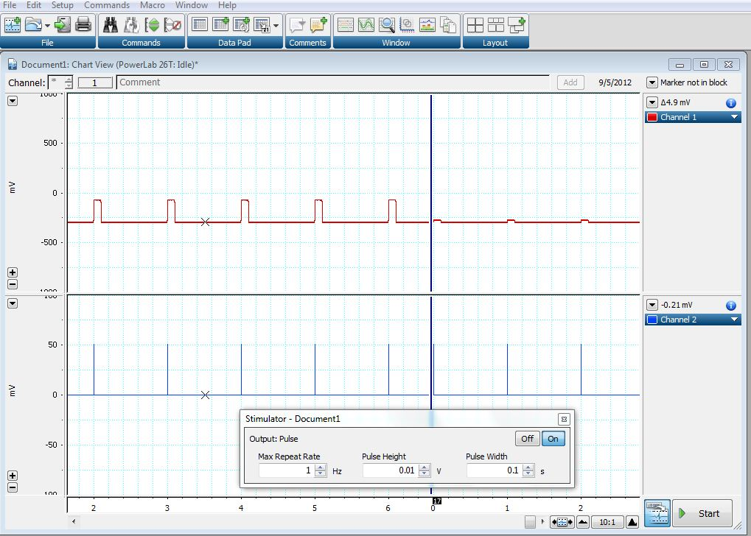
Figure 19: Stimulator panel menu to show the effect of altering the stimulus intensity 0.1 to 0.01V.

One might obtain a response as shown in Figure 20 with the current injection pulse shown and the evoked APs as a result of the current injection.

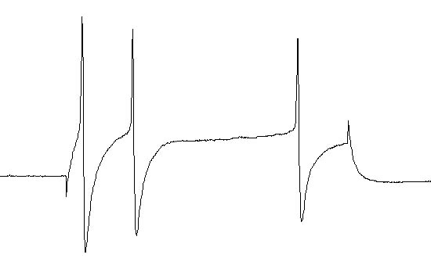
Figure 20: Current injection induced action potentials

2.2.5 Intracellular identification of neuronal types with stimulation of roots and or connectives

The cells that are used for recording the resting membrane potentials (RPs, mV) and used for injecting current to fire action potentials can also be used while stimulating a root or a connective. These neurons have processes that go out a root to monitor the sensory fields in the skin but also some of the neurons have processes that send information to the next ganglion through the connectives.
In this experimental design it is best to place the suction electrode close to the root or connective that is to be stimulated and then poke a cell body of a neuron of interest (T, P, N or Rz neuron) to determine if it can be stimulated. If no response is obtained after trying various stimulus strengths and changing polarity of stimulation then move the stimulating suction electrode to another root or connective and repeat trying to stimulate the neuron.
Keep good notes in your lab notebook of which roots and connectives were stimulated as well as the type of cell one is recorded from.

In order to stimulate the roots and connectives the suction electrode has to be employed and software settings should be changed for driving the stimulus.

Power lab set up for stimulating the nerve roots/connectives
Place the suction electrode with use of the micromanipulator directly over a root or connective (Figure 21). Gently pull on the syringe (negative pressure) to draw the nerve bundle into the electrode.

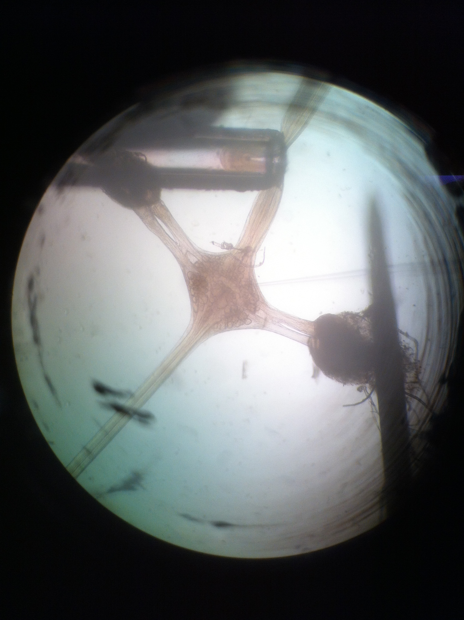

Figure 21: Leech ganglion with suction electrode pulling a section of the connective into the lumen for stimulation.

The PowerLab system (PowerLab interface from AD Instruments, Australia) will serve as the stimulating voltage source in this experiment.

Attach the PowerLab’s USB cable to the computer. Make sure PowerLab is on and open the LabChart program from the desktop.

Select “New File.”

A window will appear with multiple recording channels. Select “Setup” at the top and click on “Channel Settings.” In the bottom left corner of the window, decrease the Number of Channels to 2; on Channel 1, change the Range to 1V. Channel 2 to 100mV.

Connect the Stimulator cable with the two mini-hook leads to the Output portals on the PowerLab as follows: attach the red connector cable to the positive Output portal and the black connector cable to the negative Output portal (Figure 15) and the stimulating crimp leads attached to the suction electrode leads (Figure 22).

Figure 22: The suction electrode leads are connected to the stimulating leads.

Next, it is necessary to change the power output, frequency, and pulse duration of the PowerLab. In order to do this, select “Setup,” and then go to “Stimulator”. Select marker channel as Channel 2 (Figure 23). This way one can tell when the stimulus is given. Note: Keep “Stimulus isolation” off in this window.

Figure 23: Stimulator menu to show how to set the stimulation parameters.

Next select “Setup,” and then go to “Stimulator Panel.” Short pulses and small voltages to start off with are required for the first portion of the experiment, so adjust the amplitude to 0.5 V; this will give a range of 1.0 V (the PowerLab will emit a voltage fluctuating between positive and negative 0.5 V). Set the frequency (0.5 Hz) and pulse duration (0.01s) (Figure 24).

Figure 24: Stimulator panel menu to show how to set the stimulation parameters.

The stimulus intensity can be varied from positive to negative by placing a negative sign in front of the value in the “pulse height”. Also the value can be increased or decreased to recruit a nerve bundle with a suction electrode. As an example, a 2.3 megaOhm resister is connected across the ground wire and the recording silver wire in the electrode holder and the stimulation was changed from 0.1 to 0.01V (Figure 25).

Figure 25: Stimulator panel menu to show the effect of altering the stimulus intensity 0.1 to 0.01V.

5. RESULTS

For the laboratory write up report your finding in the charts provided and your interpretations of the findings. Report on the findings from stimulating through the intracellular electrode as well as stimulating the roots and connectives with the extracellular suction electrode to evoke action potentials.

6. DISCUSSION

These sets of experiments were to teach the fundamental principles of intracellular recordings from identifiable neurons and to recognize the characteristic shapes of electrical signals that can arise from these particular neuronal types. One might now ask themselves why the action potentials have the shapes they do and why the threshold for recruiting the action potentials varied depending on the cell type. Other questions to comtemplate are: (1) Why do some roots or connectives but not others result in evoking an action potential in a particular cell? (2) Why did some neurons give rise to a series of action potentials with the same intracellular current pulse while others only produced a single action potential ? (3) Is one able to record activity from a sensory neuron (T, P or N) and stimulate the associated receptive field on the skin to map the skin area innervated by a neuron ? (4) If the neurons were dye filled would the anatomy be correlative to the physiological parameters that were measured ?

There is a rich history of investigations using the leech model for neurophysiological investigations and still an active area of research is ongoing in addressing questions of the development in the neural circuitry and gene regulation during development as well as during synaptic repair and regeneration (Friesen et al., 2011; Jellies and Kueh, 2012; Lamb and Calabrese,. 2011; Meriaux et al., 2011; Mladinic et al., 2009; Mullins and Friesen 2012; Ngu et al., 2007; Urazaev et al., 2007; Weisblat and Kuo, 2009).

References

Arbas, E.A. and Calabrese, R.L. 1987. Slow oscillations of membrane potential in interneurons that control heartbeat in the medicinal leech. J. Neurosci. 7:3953-3960.

Becker, T. and Macagno, E.R. 1992. CNS control of a critical period for peripheral induction of central neurons in the leech. Dev. 116:427-434.

Briggman K.L., Kristan W.B. Jr. (2008) Multifunctional pattern generating circuits. Annu. Rev. Neurosci. 31:271-294.

Blackshaw, S.E. 1981. Sensory cells and motor neurons. In: Neurobiology of the leech. Eds. K.J. Muller, J.G. Nicholls and G.S. Stent. Cold Spring Harbor Laboratory. pp. 51-78.

Bradfuehrer, P.D., and Friesen, W.C., 1986. From stimulation to undulation: a neuronal pathway for the control of swimming in the leech. Science 234:1002-1004.

Cooper, R.L., Fernández-de-Miguel, F., Adams, W.B. and Nicholls, J.G. 1992. Synapse formation inhibits expression of calcium currents in purely postsynaptic cells. Pro. R. Soc. (Lond.) B. 249:217-222.

Ching, S. (1995) Synaptogenesis between identified neurons, Thesis. Department of Biology, McGill University, 1995

Deitmer, J. W., Rose, C. R., Munsch, T., Schmidt, J., Nett, W., Schneider, H.-P. and Lohr, C. (1999), Leech giant glial cell: functional role in a simple nervous system. Glia, 28: 175–182.

Kristan, W.B., 1983, The neurobiology of swimming in the leech Trends Neurosci. 6:84-88.

Kristan WB Jr, Eisenhart FJ, Johnson LA, French KA. (2000). Development of neuronal circuits and behaviors in the medicinal leech. Brain Res Bull. 2000 Nov 15;53(5):561-70. Review.

Fernández-de-Miguel, F., Cooper, R.L. and Adams, W.B. (1992) Synaptogenesis and calcium current distribution in cultured leech neurons. Proceedings of the Royal Society (London) B. 247:215-221

Friesen WO, Mullins OJ, Xiao R, Hackett JT. Positive feedback loops sustain repeating bursts in neuronal circuits.J Biol Phys. 2011 Jun;37(3):317-45. Epub 2010 Dec 16.

Fuchs PA, Nicholls JG, Ready DF. (1981) Membrane properties and selective connexions of identified leech neurones in culture. J Physiol. 1981 316:203-23.

Garcia, U., Grumbacher-Reinert, S., Bookman, R. and Reuter, H. 1990, Distribution of Na⁺ and K⁺ currents in soma, axons and growth cones of leech Retzius neurones in culture. J. Exp. Biol. 150:1-17.

Jellies J, Kueh D. Centrally patterned rhythmic activity integrated by a peripheral circuit linking multiple oscillators.J Comp Physiol A Neuroethol Sens Neural Behav Physiol. 2012 Aug;198(8):567-82. Epub 2012 May 11.

Kristan, W.B., 1983, The neurobiology of swimming in the leech. Trends Neurosci. 6:84-88.

Kuffler SW, Nicholls JG. 1966. The physiology of neuroglial cells. Ergeb Physiol 57:1–90.

Kuffler, S.W., Nicholls, J.G. and Martin, A.R. 1984. A simple nervous system: the leech. Chapter 17 of "From Neuron to Brain", Sinauer, Sunderland, M.A.

Kuffler SW, Potter DD. 1964. Glia in the leech central nervous system: physiological properties and neuron–glia relationship. J Neurophysiol 27:290–320.

Lamb DG, Calabrese RL. Neural circuits controlling behavior and autonomic functions in medicinal leeches.Neural Syst Circuits. 2011 Sep 28;1(1):13.

Li Q, Burrell BD. (2009) Two forms of long-term depression in a polysynaptic pathway in the leech CNS: one NMDA receptor-dependent and the other cannabinoid-dependent. Comp Physiol A Neuroethol Sens Neural Behav Physiol. 195(9):831-41.

Liu, Y. and Nicholls, J. G. 1989, Steps in the development of chemical and electrical synapses by pairs of identified leech neurons in culture. Proc. R. Soc. (Lond) B. 236:253-268.

Macagno, E.R., Muller, K.J. and DeRiemer, S.A. 1985. Regeneration of axons and synaptic connections by touch sensory neurons in the leech central nervous system. J. Neurosci. 5:2510-2521.

Marin-Burgin A., Kristan W.B. Jr., French K.A. (2008) From synapses to behavior: Development of a sensory-motor circuit in the leech. Special issue of Dev. Neurobiology 68:779-787.

Meriaux C, Arafah K, Tasiemski A, Wisztorski M, Bruand J, Boidin-Wichlacz C, Desmons A, Debois D, Laprévote O, Brunelle A, Gaasterland T, Macagno E, Fournier I, Salzet M. Multiple changes in peptide and lipid expression associated with regeneration in the nervous system of the medicinal leech. PLoS One. 2011 Apr 22;6(4):e18359.

Mladinic M, Muller KJ, Nicholls JG. (2009) Central nervous system regeneration: from leech to opossum.J Physiol. 2009 Jun 15;587(Pt 12):2775-82. Review.

Mullins OJ, Friesen WO. The brain matters: effects of descending signals on motor control.J Neurophysiol. 2012 May;107(10):2730-41. Epub 2012 Feb 29.

Nicholls, J.G., 1987, "The Search for connections: studies of regeneration in nervous system of the Leech", Sinauer, Sunderland, M.A.)

Nicholls, J.G. and Baylor, D.A. 1968. Specific modalities and receptive fields of sensory neurons in CNS of the leech. J. Neurophysiol. 31:740-756.

Ngu EM, Sahley CL, Muller KJ. Reduced axon sprouting after treatment that diminishes microglia accumulation at lesions in the leech CNS.J Comp Neurol. 2007 Jul 1;503(1):101-9.

Ready, D. F. & Nicholls, J. (1979). Identified neurones isolated from leech CNS make selective connections in culture. Nature 281, 67-69.

Retzius, G. 1981. Biologishe Untersuchungen, neue Folge II. Samson & Wallin, Stockholm.

Stewart, R.R., Nicholls, J.G. and Adams, W.B. 1989, Na⁺, K⁺ and Ca²⁺ currents in identified leech neurons in culture. J. Exp. Biol. 141:1-20.

Stuart, A.E. 1970. Physiological and morphological properties of motoneurones in the central nervous system of the leech. J. Physiol. (Lond.) 209:627-646.

Todd KL, Kristan WB Jr, French KA. (2010) Gap junction expression is required for normal chemical synapse formation. J Neurosci. 2010 Nov 10;30(45):15277-85.

Urazaev AK, Arganda S, Muller KJ, Sahley CL.Lasting changes in a network of interneurons after synapse regeneration and delayed recovery of sensitization.Neuroscience. 2007 Dec 19;150(4):915-25. Epub 2007 Oct 5.

Yau, K.W., 1976. Receptive fields, geometry and conduction block of sensory neurons in the CNS of the leech. J. Physiol. (Lond.) 263:513-538

Weisblat DA, Kuo DH. Helobdella (leech): a model for developmental studies. Cold Spring Harb Protoc. 2009 Apr;2009(4):pdb.emo121.

