Name:
BIO350
EXAM #2 Summer 2009 Cooper
MULTIPLE CHOICE (2 points each)
1. The potassium channels that are primarily responsible for repolarization of the plasma membrane of an axon after the initiation of an action potential are activated by
a) cold temperature
b) epinephrine
c) cAMP
d) membrane depolarization
e) membrane hyperpolarization

2. The general structure of the hair cells of the lateral line in lower vertebrates, like frogs and fish, are essentially the same kind of hair cells in the receptor structure as our auditory receptors.
A) True B) False
3. Which of the following body part has the largest representation in the somato-sensory cortex in a human brain ?
A) the knee
B) the hip
C) the shoulder
D) the face
E) the back of the lower leg
4. Which cell types are primarily used for non-color vision in the human eye?
a) cones b) rods c) ommatidium

5. When light stimulates a sensory cell in the invertebrate ommatidium, it will depolarize.
a) true b) false
6. The parasympathetic nervous system normally decreases motility of the gastrointestinal tract.
(A) True (B) False
7. The semicircular canals of the vertebrate inner ear are primarily responsible for which of the following functions?
a. equilibrium
b. static position of the head
c. hearing
d. K⁺ balance of the body

8. A physician friend of yours is telling you about a patient with a head injury who suddenly had osmoregulation problems. What portion of the brain was probably injured?
A) sensory cortex
B) cerebrum
C) cerebellum
D) hypothalamus
E) pineal gland

9. At which site on the figure below of the spinal cord and sensory cells are the majority of the cell bodies located for motor neurons?

10. In general, slow oxidative (Type I) muscle fibers have _____________ numbers of mitochondria than fast glycolytic (Type IIb).
(A) greater (B) fewer

11. Although we often assume that our sense organs are reporting a complete picture of the world to our brains, in fact the world is full of stimuli (very low frequency sound, cosmic rays, electrical fields, etc.) that our sense organs cannot detect. This situation is best characterized as a failure of our sense organs to __________ these stimuli.
A) inhibit
B) intercept
C) transduce
D) transceive
E) none of the above
12. During Long Term Depression (LTD) there is _________ at postsynaptic membrane. (according to your text book)
a) An increase in AMPA receptors
b) A decrease in AMPA receptors
c) An increase in NMDA receptors
d) A decrease in NMDA receptors

13. If you could isolate and electrically stimulate the olfactory nerve of a conscious patient, that person would be expected to perceive ________ as a result of that stimulation.
a. light
b. tingling
c. heat
d. pain
e. smell

14. Statocysts are sensory organs used to perceive

a. consciousness, or state of being.

b. an organism's orientation to the gravitational pull.

c. surface hardness.
d. none of the above.

15. Vincent Van Gogh, the nineteenth -century French painter, one night cut off his own ear. The local physician, Dr. Felix Ray, examined Van Gogh the day he cut a part of his ear off. The Doctor's interview and notes to relatives by Van Gogh stated that he suffered from dizziness and nausea a disease associated with "Ménière's disease". Later Van Gogh died by his own inflictions. What is the likely association of this disease with what you covered in this class?
A. A hyperactive sympathetic nervous system
B. A build up of fluid in the inner ear
C. A lack of skeletal muscle control by reflexes in the spinal cord
D. A lack of cerebellum
E. A broken ear drum from load sounds
16. Presynaptic inhibition by inhibitory innervation is possible at invertebrate synapses associated at the neuromuscular junction.
A. True B. False

17. A weight lifter when picking up a set of very heavy weights first undergoes isometric contraction when trying to lift the weight then isotonic contraction when the weights start to be lifted off the floor.
A. True B. False

18. In cardiac muscle, the calcium that is used for muscle contraction comes from
A. ECF
B. SR
C. mitochondria
D. A, B, and C
E. A and B

19. In relation to the two point discrimination that you performed in recitation, this showed that ...... (choose the best answer).
A. receptive fields in the arm are smaller and have some overlap as compared to the
finger tips.
B. there are more neurons dedicated to sensory perception in the finger tips than for the
same given area on the arm.
C. the sensory ending on the finger tip are more sensitive to touch than those are your
arm.
D. the ability to sense the two stimuli as touch depends on visual signals over your
whole body.
E. the concept of receptive fields does not exists for touch reception but only for vision.

20.The "blind spot" in the human retina is due to which of the following?

a. a high density of cones

b. the lack of rods being present in that part of the retina

c. where the optic nerve exits the retina

d. it is due to the corpus luteum blocking the light path

e. pupil does not allow light to pass
21. Whether a synapse is excitatory or inhibitory depends on the
A). type of neurotransmitter.
B). presynaptic axon terminal.
C). size of the synapse.
D). nature of the postsynaptic receptors.
E). concentration of neurotransmitter in the synaptic space.

22. The rational for the observed physiological responses in the muscle fiber in this type of experiment is most likely due to: (see graph below)

A. The muscle cell became much more responsive to the neurotransmitter by the time the
2nd stimulus arrived.
B. The free calcium in the presynaptic nerve terminal did not have time to be buffered or to get back to the resting value before the 2nd stimulus arrived and added to the free calcium causing a much greater concentration which increased the probability of transmitter release.
C. The 1st action potential caused the membrane resistance to increase in the nerve terminal that by the 2nd stimulus arrived more calcium channels opened up and resulting in a great influx of calcium presynaptically.
D. The pressure within the nerve terminal from the 1st stimulus is so great that is forces more vesicles out of the terminal on the 2nd stimulus.
E. The mechanisms to account for this have not been determined yet.

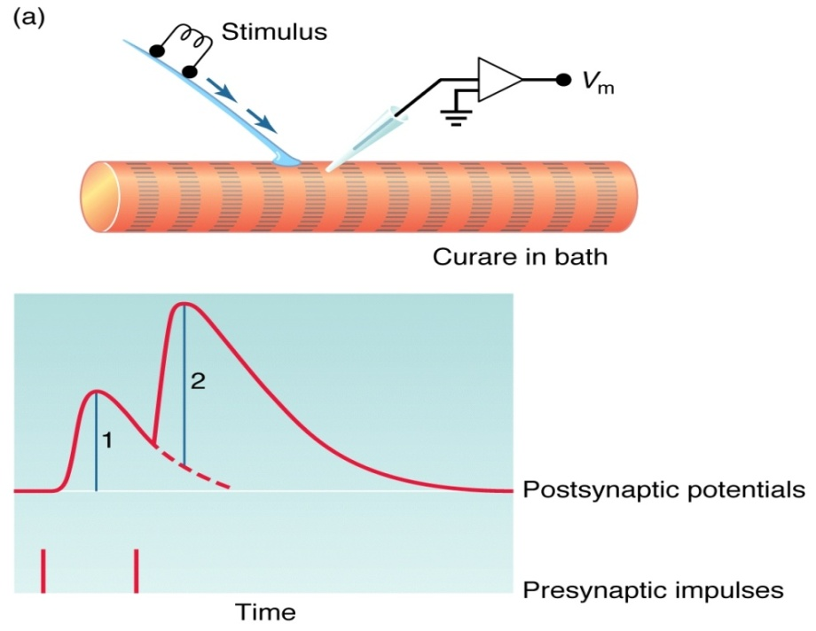
23. The reason a Shaker muscle can contact so fast is that..... (Choose best answer)
A. the myosin heads keep binding to actin since the binding sites are always
exposed.
B. the sarcoplasmic reticulum can take up calcium quickly so that the muscle does \
not go into tetanus and keep contracting with each neural impulse.
C. the sarcoplasmic reticulum dose not take up calcium rapidly there is no delay
between binding and unbinding of the myosin heads for repetitive contractions.
D. There is no known mechanism yet that can explain the reason why the Shaker
muscle contracts so fast.

24. In singing birds, like the zebra finch example in your text book, it was determined that neurons within the central nervous system can respond to hormones like testosterone in adults birds to enhance the production of the bird song.
A) True B) False

25. In class we discussed grooming behavior of male to females in Montane voles and Prairie voles. The Prairie voles groom more than Montane voles. What was the main reason for the difference between these animals that is thought to account for the difference?

a. Female Montane voles give off a Skunk like smell.
b. Female Prairie voles give off attractant chemical cues.
c. Male Prairie voles have more arginine vasopressin receptors.
d. Male Prairie voles have more testosterone production.
e. Male Prairie voles have more testosterone receptors.

SHORT Answer (each worth 2 points)

26. (2 points) List or write out three differences between slow and fast muscle fibers. Clearly state which type of muscle you are describing.

27. (2 points) The pioneering work of Hubel and Weisel showed developmental timing of the visual neuronal circuits in cats and monkeys had an impact for human infants. Please explain and why does it matter for infant as compared to adults?

28. (2 points) What is meant by the dark current in the vertebrate rods and cones of the retina?

29. (2 points) What does the figure below indicate about animal behavior in relation to what we covered in this class?
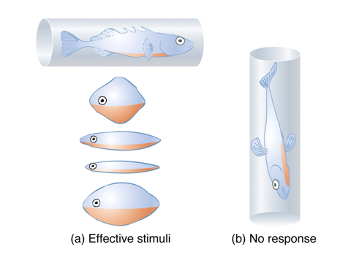

30. (2pts) What is meant by sensory adaptation and discuss how this process occurs ?

31. (2pts) Rigor mortis can be explained by what in muscles post mortem?

32. (2pts) How is it that we have the ability to "taste with our tongue" or "smell with our nose" different types of chemicals ?

33. (2pts) Why is Ca2+ needed for vertebrate skeletal muscle to contract ? (What key role is Ca2+ used for within the muscle cell in the process of muscle contraction ?)

34. (2pts) Acetylcholinesterase is the enzyme that degrades acetylcholine. What effect on nerve transmission would occur following the administration of a chemical that inhibited acetylcholinesterase?

ESSAY QUESTIONS

1. (5 Points) List and described three ways presynaptically and 3 ways postsynaptically that (6 total) that the postsynaptic signal (signal or multiquantal) could be variable in such ways as “rise time”, “amplitude”, and “duration” of response that is subthreshold.

2. (5 points) Compare and contrast the sympathetic and parasympathetic divisions of the autonomic nervous system by answering the following points: How do they differ anatomically? How do they differ functionally and biochemically?

3. (5 points) Draw a sarcomere and label the components. List the bands A, I, and H clearly and state which one or ones will be altered in length during muscle contraction within a physiological range of muscle contraction.
4. (4 points) Explain how the muscle receptor organ (MRO) of the crayfish abdomen is analogous to the limb proprioception in humans. Explain functionality. So how do these MROs respond to dynamic movements and static positions?

5. (4 points) Explain what is Lateral Inhibition and how researchers know this is important in sensory systems?

6. (2 points) Why does red muscle look red and why does white muscle look white?

7. (2 points) Describe 2 interesting scientific discoveries that were made using the leech as a model organism.
8. (5 points) List and describe the steps involved from an action potential reaching the nerve terminal at a VERTEBRATE (like your skeletal muscle) motor neuron to the point of a muscle starting to contract. (start with a diagram)

BONUS
1. (1 point) The hominid skulls shown in the figure having varying brain size from the older fossils to modern man. What part of the brain do you think increased in size to correspond to the increase in skull size and what function is associated with this part of the brain?

2. (1 point) In the article handed out in class (Schurr and Payne, 2007. Research done at Univ of Louisville, KY) the science is about pyruvate and lactate and neuronal activity. State the major finding of the research. (The take home message).

3. (1 point) There was an article posted on your class www page (next to the homework problems) but not handed out in class about muscle fatigue. State the major finding of the research. (The take home message). The work was about why muscles feel sore and why they fatigue. What was the mechanism proposed?

