NAME_________________________
BIO 350 FINAL EXAM Summer 2009

Matching (1 point for each)
You can if need be use an answer more than once.

___ 1. “A” band
___ 2. Absolute refractory period
___ 3. Acclimatization
___ 4. Accommodation
___ 5. Adrenal medulla
___ 6. Anatomic dead space
___ 7. Antidiuretic hormone
___ 8. Aortic body
___ 9. Atrioventricular node
___ 10. Bohr effect
___ 11. Calcitonin
___ 12. Chylomicrons
___ 13. Countercurrent heat exchanger
___ 14. Diabetes mellitus
___ 15. Emulsification
___ 16. Excitatory postsynaptic potential (EPSP)
___ 17. Follicular phase
___ 18. Fovea
___ 19. Frank-Starling mechanism
___ 20. Glomerular filtrate rate
___ 21. Hemolymph
___ 22. Hypothyroidism
___ 23. Inositol trisphosphate
___ 24. Juxtaglomerular apparatus
___ 25. Length constant
___ 26. Omasum
___ 27. Ommmatidium
___ 28. Parathyroid hormone
___ 29. Pepsinogen
___ 30. Pheromone
___ 31. Proximal tubule
___ 32. Surfactant
___ 33. Tetanus
___ 34. Transcription
___ 35. Uricotelic
___ 36. Vasa recta
___ 37. Vital capacity

Multiple choice (2 points each)

1. Which of the following enter the duodenum ?
(A) Pancreatic secretions
(B) Bile
(C) Gastric (stomach) contents
(D) both (A) and (B) above are correct
(E) all three (A), (B) and (C) above are correct.

2. The primary site of absorption in the digestive system is the
(A) stomach
(B) small intestine
(C) colon
(D) esophagus
(E) mouth

3. The brush border (microvilli) of the small intestine epithelial cells is responsible for digestion and absorption of food substances by which of the following mechanisms ?

(A) These microvilli are impermeable to products of digestion.
(B) By supplying digestive enzymes and specific carriers for membrane
transport.
(C) These microvilli only secrete substances and have no role in
absorption.
(D) By breaking food particles into smaller sizes by “brushing” action.

4. Which of the following breakfasts would result in the most bile to be released into the intestine ?
(A) Toast, orange juice, and coffee
(B) Black coffee
(C) Fried eggs, bacon from a fatty pig, hash browns (fried potatoes in oil).
(D) A bowl of cereal with skim milk
(E) Boiled egg, toast, and juice

5. Which part of the digestive system has the lowest pH ?
(A) esophagus
(B) stomach
(C) pancreas
(D) small intestine
(E) large intestine

6. The parasympathetic system normally increases motility of the gastrointestinal tract.
(A) True (B) False

7. If a mammal is put in a very cold room 32 F (or 0 C) which of the following statement(s) is (are) likely to be true within the first 20 minutes ?
(i) The blood vessels in the skin would tend to vasodilate
(ii) Metabolism would likely increase.
(iii) oxygen consumption would tend to increase
(iv) ATP production within skeletal muscle cells would tend to decrease
(v) Shivering would not likely occur

A. only (i) is correct
B. only (iv) is correct
C. both (ii) and (iii) would occur
D. both (ii) and (v) are likely true
E. none of the choices are likely to occur

8. The fact that large mammals typically have higher basal metabolic rate than smaller animals has been explained as follows:
a. their larger size means they have more surface area for losing heat so they require more metabolic energy to stay warm.
b. their larger size makes them less susceptible to predation, so they don't
have to use energy to escape from predators.
c. their greater weight makes them less inclined to move, so they expend
less energy in locomotion.
d. their lower surface to volume ratio means they lose a lower percentage
of their energy to the environment.
e. None of the above.

9. Which of the following secretes pepsinogen, which in turn initiates protein digestion?
a. Chief cells
b. Mucous cells
c. Parietal cells
d. G cells

10. Control of gastric secretion in response to seeing food relates to what digestive phase?
a. Cephalic phase
b. Gastric phase
c. Intestinal phase
d. All of the above

11. (2 points) What is the RQ for the complete metabolism of glucose ?

1, 5, 10, or a 100

12. There are many mutations in humans for producing ion channels in membranes. Some are so deadly that a developing fetus will stop in development and die, which likely results in a failed pregnancy in the sense of carrying the baby to term (i.e. delivery). Other mutations are not so deadly since they may only decrease the function of the channel but operates with a decreased efficacy and still allows the fetus to get by for development into a baby and grow into a child. Which of the following might be possible outcomes for such a child?

A) Plays soccer and finds himself the slowest on the team for running.
B) Scores poorly on learning exams like a math test in school.
C) Has memory problems.
D) does not perceive sensory information like touch on the skin as well as other
kids.
E) all the above (A-D) are possible.

13. There are many (1,000's) of genetic mutations in humans as well as other animals and plants. Some mutations, for example might cause the eyes not to develop at all. Now if this occurred for a crayfish was living in a cave, such as early in historical time for cave crayfish and the crayfish was never to get out of the cave, would such a mutation be detrimental for this animal that only lives in a cave?

A) YES-likely bad if living the rest of its life in a cave
B) No- this mutation would not result in the harm of the animal if living in a cave.
In fact it might save metabolic needs for other organs such as olfaction to function better or save energy for skeletal muscles to use.

14. The reason a Shaker muscle can contact so fast is that..... (Choose best answer)
A. the myosin heads keep binding to actin since the binding sites are
always exposed.
B. the sarcoplasmic reticulum can take up calcium quickly so that the
muscle does not go into tetanus and keep contracting with each
neural impulse.
C. the sarcoplasmic reticulum dose not take up calcium rapidly there is no
delay between binding and unbinding of the myosin heads for
repetitive contractions.
D. There is no known mechanism yet that can explain the reason why the
Shaker muscle contracts so fast.

15. The main driving force causing glomerular filtration is:
A. osmotic pressure of plasma colloids promoting filtration
B. hydrostatic pressure of the blood
C. peristaltic contractions of the nephron
D. gravity
E. both A and B are correct

16. Marine birds maintain osmotic balance by:
A. highly evolved and efficient uriniferous tubules.
B. excretion of a concentrated salt solution from glands located above the orbit of the eye.
C. excretion of brine from salt glands located on their tongue.
D. concentrating their urine as it passes through the cloaca.
E. the production of extremely salty sweat from glands under their wings.

17. Which segment of the nephron reabsorbs the most components from the filtrate?
A. proximal convoluted tubule
B. descending thick limb of loop of Henle
C. ascending thick limb of loop of Henle
D. distal convoluted tubule
E. collecting duct

18. Antidiuretic hormone (ADH)
A. decreases filtration in the glomerulus
B. increases water reabsorption in the proximal convoluted tubules
C. increases water permeability of the collecting ducts
D. decreases water permeability of the collecting ducts
E. increases ion transport in the distal convoluted tubules
19. Which of the three following nitrogenous waste products eliminates the least amount of nitrogen atoms per molecule ?
A. Ammonia
B. Uric acid
C. Urea
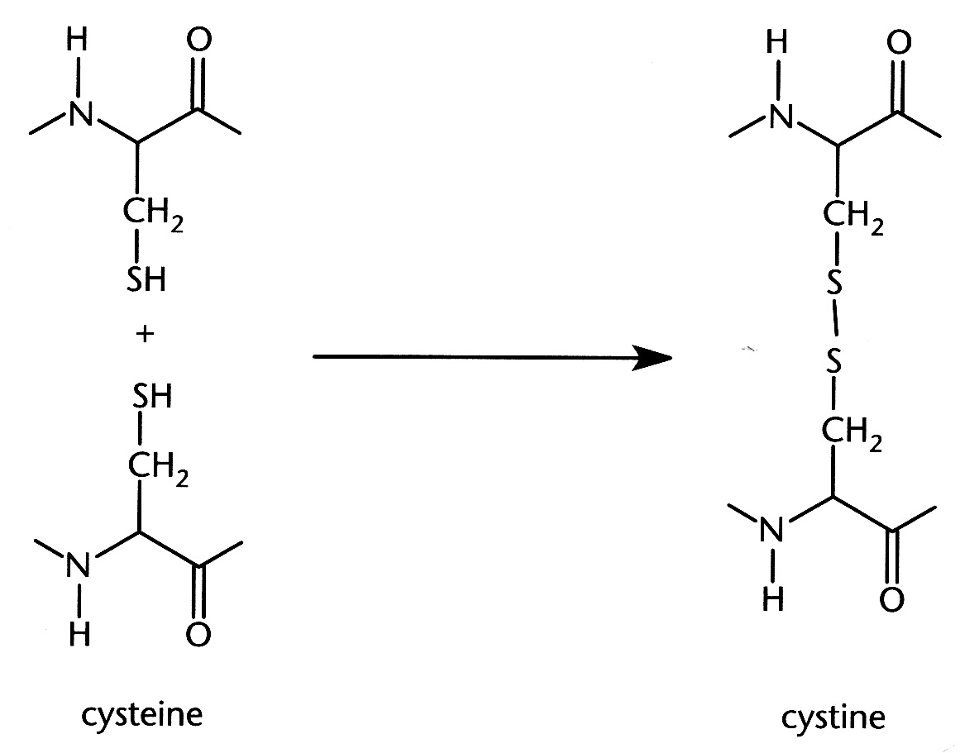
20. The diagram below depicts a common bond formed between two nearby cysteine amino acids within a protein. The two cysteine molecules become oxidized to form cystine. The bond formed between them, consisting of two covalently bonded sulfur atoms, would most likely play a role in a protein's
A. primary structure
B. tertiary structure
C. quaternary structure

21. Over secretion of gastric HCl can be treated by severing the vagus (X cranial nerve) nerve in a procedure called a vagotomy, which reduces parasympathetic activity. Which of the following effects is most likely to be caused by a vagotomy ?
A. decreased heart rate
B. decreased gastric motility
C. decrease in retention of food in the GI system
22. Sarcomere shortening in muscle fibrils requires
A. the rapid influx of Na+ ions into the cytoplasm after release from
sarcoplasmic reticulum.
B. T-tubule shortening after calcium ion release by the sarcoplasmic
reticulum.
C. ATP release from the sarcoplasmic reticulum and subsequent myosin
attachment to actin filaments.
D. conformational modifications of the tropomyosin-troponin complex
within the muscle fibers.
E. an increase in the transcription of muscle regulatory proteins such as
troponin and actin.

23. Cholecystokinin (CCK) is a hormone that stimulates
A. bile production
B. release of pancreatic enzymes
C. contraction of the gallbladder
D. both A and B
E. both B and C

24. Which of the following is the correct sequence of events in photo-transduction in a vertebrate rod cell in the retina?
A. Light directly activates the sodium channels to open allowing the rod to become
depolarized.
B. Light activates rhodopsin by photo-isomerization, which results in activation of
phosphodiesterase that hydrolyzes cyclic GMP to plain GMP. This results in
opening of the sodium channel and depolarization of the rod cell.
C. Light activates rhodopsin by photo-isomerization, which results in activation of phosphodiesterase that hydrolyzes cyclic GMP to plain GMP. This results in closing of the sodium channel and hyperpolarization of the rod cell.
D. Light will activate the dark current by OPENING sodium channels causing the cell to
depolarize
E. Light stimulates the sodium/potassium pump to pump sodium out of the cell causing the cell to hyperpolarize.

25. In general, slow oxidative (Type I) muscle fibers have _____________ numbers of mitochondria than fast glycolytic (Type IIb).
(A) greater (B) fewer
26. Which of the following statements best describes aspects muscle contraction?
A. That calcium ions have no role in the development of muscle tension.
B. That ATP is needed for muscle relaxation.
C. Calcium around the Troponin C is needed for the muscle to relax after a contraction.
D. That ATP is needed for initiation of muscle contraction from a resting state.

27. Which of the following definitions would best describe the concept of homeostasis in relation to animal function?
A) Regulation of biological events by positive feedback
B) The ability of animals to control their immediate external environment
C) The ability of animals not to regulate any internal functions
D) Process involved in the maintenance of constancy of the internal milieu (or
environment) of the body

28. Increasing the degree of saturation of the lipid tails (i.e., the hydrophobic region) for lipids in a membrane, will result in the membrane having an increase in its fluidity.
A) True B) False

29. In the complete metabolism of one glucose molecule, in the presence of oxygen, most ATP molecules are produced in which one of the following series of reactions or cycles listed
A) Citric-acid cycle & ETC (electron transport chain)
B) Glycolysis
C) The steps of ‘A’ and ‘B’ above both produce the same amount of ATP therefore they are equal

30. With respect to cellular metabolism (mark the correct answer)
A) Citric-acid cycle (or sometimes called the TCA or Krebs cycle) takes place in the
cytosol.
B) Glycolysis requires oxygen for the reactions to take place.
C) The Citric-acid cycle and the electron transport chain reactions only take place under anaerobic conditions.
D) The reactions of the electron transport chain take place in the mitochondria
E) The reactions for the Citric-acid cycle take place in the nucleus.

31. Urine produced by the Malpighian tubules flows into which of the following structure?
A. Bladder
B. gastrointestinal tract (hind gut)
C. Ureter
D. Interstitial space
E. Vasa Recta

32. (1 point multiple choice answer) In relation to development of an action potential in a mammalian neuron, depolarization of a neuronal axon membrane to a voltage more positive than threshold causes:
A. all voltage-gated Na channels to open simultaneously, thus allowing Na to enter the axon, and depolarize the membrane.
B. some voltage-gated Na channels to open, thus allowing some Na to enter the axon; this further depolarizes the membrane, causing other voltage-gated Cl channels to open.
C. some voltage-gated Na channels to increase their selectivity for K ions so that there is a net increase in gNa relative to gK.
D. some voltage-gated Na channels to increase their single channel conductance, allowing Na to enter the axon and depolarize the membrane.
E. all voltage-gated Na channels to open simultaneous and inactivation of voltage gated K channels, thereby moving the membrane potential toward ENa and away from EK.

Bonus questions:
1. (1 point) A biopsy of the neuromuscular junction from a patient who was bitten by a black widow spider provides the following information: (1) the postsynaptic nerve terminals respond normally to ACh injected into the synaptic cleft, and (2) neither presynaptic depolarization nor high external Ca can elicit EPSP’s (or EJPs) or muscle contraction. Based on this information, the molecular action of the black widow toxin is MOST likely to:
A. block the postsynaptic ACh receptor.
B. prevent miniature epp’s from combining into a normal epp’s.
C. block K permeation through the ACh receptor so that this channel becomes highly Na selective.
D. block ACh-esterase within the synaptic cleft.
E. does not allow the vesicles in the presynaptic terminals to fuse normally in order to release Ach.

2, (1 point) Lambert-Eaton Syndrome is an autoimmune disease in which the number of pre-synaptic neuronal voltage-dependent Ca⁺⁺ channels is decreased. Given this information, you would predict that a patient with Lambert-Eaton Syndrome should exhibit:
A. over-stimulation of skeletal muscle resulting in tetanus.
B. supra-threshold EPP’s.
C. reductions of acetylcholine receptor density.
D. reduced amplitude of the muscle end plate potential (EPP).
E. reduced amplitude of miniature end plate potentials (MEPP’s).

3. (1 point) Why is it such a problem if we kill out the bacteria in our intestines with strong antibiotics? (one reason not to self medicate unless you really know what you are doing).

4. (1 point) You might find this question crude or inappropriate but it is a medical issue and is relevant to the concepts we learned in this course so deal with it. It is also mentioned in the Freshman (high school level) biology book Campbell. This is a form of myotonia.

What logical mechanism do you propose is the cause for the phenomenon when a human male (or a female) reaches an sexual orgasm and he (she) obtains severe skeletal muscle cramping (like a Charlie Horse) in his (her) skeletal muscles in their legs or even other skeletal muscles of the body ?

