Workshop Thursday, June 21, 2018
Understanding acute deep tissue injury of motor units
Robin L. Cooper – University of Kentucky
This workshop highlights a neurophysiology teaching exercise in synaptic transmission at neuromuscular junctions in relation to a practical problem. The exercise is left open ended in several ways so instructors and students can modify to tackle new questions. This is an ideal exercise as a course-based undergraduate research experience (CURE) to address an authentic research question. The research hypothesis we will promote for this workshop is that muscle injury would relate to a similar degree of the K⁺ concentration in muscle which would affect surrounding health cells as examined by direct application of saline containing K⁺. Crayfish motor units will be used as the experimental model. The theme is to determine the consequences of damaged muscle influencing surrounding healthy muscle and neuronal function. The preparations are well known for student neurophysiology experimentation but novel to use for investigating consequences of tissue injury. This module lends itself for inquiry, team discussion, self-paced learning and focuses on authentic scientific research. The research questions on this topic are based on understanding the physiological problems with deep tissue injury of skeletal muscle and/or neurons. Primary skeletal muscle damage can produce secondary effects which can increase the spread of the initial damage zone. This can be caused by the additive effects of intracellular contents, particularly free K⁺, released from crushed muscle cells. Consideration in the exposure time and effects of restoring normal [K⁺]_{o} on the health of skeletal muscle and synaptic transmission has not been fully addressed. The synaptic responses return slower than recovery of skeletal muscle potential. Students can develop variations to the experimental preparation presented in this exercise. This educational module can also help establish other animal models which may lead to better treatment and assessment of deep tissue injury (DTI) in urgent care centers for mammals.
Category: Instructional Methods, Physiology

Note: This exercise is now in press and should appear on line by the time the ABLE 2018 workshop begins. Journal of Young Investigators at https://www.jyi.org/
A copy of the submitted manuscript is being provided but minor changes may appear on the online version from editing of the galley proofs.
There is also a web site built for ABLE 2018 for the workshops presented on my web page:
http://web.as.uky.edu/Biology/faculty/cooper/Teacher%20training.htm
Citation: Thenappan, A., Dupont-Versteegden, E.E. and Cooper, R.L. (2018). An educational model for understanding acute deep tissue injury of motor units: Common lab exercises with a new twist (In Press, Journal of Young Investigators).

Binder Materials:
- a thorough introduction that provides sufficient background for those who might not be familiar with the material
- the student lab exercise
- instructor notes
- preparation instructions
- an equipment and materials list
- information about sources and suppliers for materials
- student evaluation feedback on the lab (if possible)

An educational model for understanding acute deep tissue injury of motor units: Common lab exercises with a new twist

Ashwatha Thenappan^{1,3, 4}, Esther E. Dupont-Versteegden^{2,3}, and Robin L. Cooper^{1,3}
¹Department of Biology, University of Kentucky, Lexington, KY 40506-0225; ²Division of Physical Therapy, Dept. Rehabilitation Sciences; College Health Sciences, University of Kentucky 900 S. Limestone, Lexington, KY 40536-0200; ³Center of Muscle Biology; ⁴Boonshoft School of Medicine, Wright State University, 3640 Colonel Glenn Hwy.,Dayton, OH 45435

Robin Cooper: RLCOOP1@uky.edu
Ashwatha Thenappan: ashwatha ashthenappan@gmail.com
Esther E. Dupont-Versteegden: eedupo2@email.uky.edu

Abstract

This laboratory procedure highlights a neurophysiology exercise in synaptic transmission at neuromuscular junctions in relation to a practical problem. The exercise is left open ended in several ways so instructors and students can modify it to tackle new questions. This is an ideal exercise as a course-based undergraduate research experience (CURE) to address authentic research questions. The research hypothesis is that muscle injury would result in a pathological increase in K⁺ concentration in muscle which would similarly affect surrounding healthy cells as examined by direct application of saline containing K⁺. Physiology exercises commonly study effects of extracelluar K⁺ on resting membrane potential. However, the novelty in this exercise is to put it in context with cellular injury in conjunction with other factors related to injury. Crayfish motor units were used as the experimental model. The theme is to determine the consequences of damaged muscle influencing surrounding healthy muscle and neuronal function. The research questions on this topic are based on understanding the physiological problems with deep tissue injury of skeletal muscle and/or neurons. Primary skeletal muscle damage can produce secondary effects which can increase the spread of the initial damage zone. This can be caused by the additive effects of intracellular contents, particularly free K⁺, released from crushed muscle cells. Consideration in the exposure time and effects of restoring normal [K⁺]_{o} on the health of skeletal muscle and synaptic transmission has not been fully addressed. The synaptic responses return slower than recovery of skeletal muscle potential. Students can develop variations to the experimental preparation presented in this exercise. This educational module can also help establish other animal models which may lead to better treatment and assessment of deep tissue injury in urgent care centers for mammals.

Keywords: Electrophysiology, neuromuscular junction, physiology, neurobiology, cell injury, CURE
Running head: Acute deep tissue injury of motor units
Introduction

We have designed this university level student laboratory exercise around the theme of deep tissue injuries (DTIs) and related pathological consequences. We used an invertebrate crayfish model which has a long history for college level teaching of neurophysiological principles.
To stimulate interest in the growing number of undergraduate allied health focused students, the theme of this laboratory exercise is focused around a medical problem a physician may face when attempting to rehabilitate from a tissue injury to prevent further muscle/cellular damage due to the spread of the initial injury (Brancaccio et al., 2010; Cintra-Francischinelli et al., 2010). The spread of indirect tissue damage from a direct injury is a common occurrence with DTIs.
As an exercise for this student lead research project, they can assume a relative large mass of tissue is injured (i.e., skeletal muscle) by either blunt force trauma of external object and/or with pressure injury from the internal skeleton. The testable hypothesis is that damaged muscle can cause altered function of healthy muscle and neurons and that rapid removal in intracellular constituents (i.e., K⁺ and amino acids) from injured muscle will help prevent the spread of tissue damage. Thus, this treatment can help promote a faster recovery from the initial DTI insult. Students can develop variations to the experimental preparations presented in this lab exercise. The preparations presented are of two types of muscle fibers (slow and fast). These preparations are well known for student neurophysiology experimentation but novel for use for investigating an injury topic on muscle and nerve function.
Crayfish preparations are commonly used for undergraduate and graduate classes to teach basic neurophysiological measures (Johnson et al., 2014). The crayfish abdominal extensor muscle preparation is used to demonstrate effects on resting membrane potential with ion substitution in saline and is a good preparation for demonstrating synaptic responses for different types of motor units. Some muscles in crustaceans are selectively innervated by either a phasic or a tonic motor neuron, although some single fibers can be innervated by both phasic and tonic excitatory motor neurons, such as for extensor muscle in the crayfish walking legs (Fig. 1A) (Atwood, 1976; see movie explanation in Wu and Cooper, 2010) and most other limb muscles (Wiersma, 1961a). By selectively stimulating phasic and tonic motor neurons, physiological differences in the EPSPs may be measured. Phasic motor neurons produce rapid twitching of muscle fibers and evoke EPSPs on the order of 10–40 mV. The phasic response can depress rapidly with 5–10-Hz trains of stimulation. The tonic motor neurons give rise to smaller EPSPs that can be facilitated in the presence of a higher frequency (10–50 Hz) of stimulation. Structurally, the presynaptic phasic and tonic terminals at the NMJs are fundamentally different (Atwood and Cooper, 1996a, b; Bradacs et al., 1997; Cooper et al., 1998). The topic of muscle phenotype can be presented to the students as well as investigating if different types of motor units are affected differently by cytoplasm spillage of a DTI.
Using scenarios related to practical issues to help unravel complex biological systems provides students with authentic context in which to learn and apply scientific concepts. Doing so can also help students develop and apply scientific practices (Coll et al., 2005). Using models to explore and construct scientific explanations also promotes metacognitive thinking, communication skills, and creates opportunities for students to participate in the development of scientific knowledge (Gilbert et al., 2000). These approaches are hallmarks in student retention and understanding of novel concepts. The points of this exercise are to learn to answer questions such as: What is DTI? How does excess K⁺ affect neuron function? How is this going to be looked at in the crayfish? Why is this a good model to address DTIs in other animals?

Learning objectives:
1. Students will learn about physiological conditions of membrane potential.

2. Students will learn terminology and meaning of the terms related to membrane potential (depolarization, hyperpolarization, resting membrane potential, voltage gated channels, passive leak channels, permeability)

3. Students will learn the meaning and how to use the Nernst Equation and Goldman Hodgkin Katz equation.

4. Students will learn the general differences in ionic concentrations across cells and how they are maintained by pumps, exchangers and other transport mechanisms.

Student Outline

The spread and causes of deep tissue injuries (DTIs) are multifactorial and can involve a complex series of events. The causes in progressive problems from an initial injury may arise from many different issues: bone/muscle interface deformation, ischemia, ischemic reperfusion injury, impaired lymph drainage, alteration in interstitial fluid flow, alteration in capillary wall permeability- edema, and inflammatory changes conducive to apoptosis (Honaker et al., 2013). Since there are many different primary causes in the progression of DTI one might indeed expect the treatments to be varied. This laboratory exercise covers an inquiry based approach in researching the mechanisms behind the growing area of tissue damage beyond the initial site of injury. In the case of mammals, the general treatments for DTI are wide ranging but usually have one of the following or a mix of options: increasing blood flow with movement, apply heat, apply cold, use of medications such as anti-inflammatory compounds (non-steroidal anti-inflammatory drugs, NSAIDs) for blocking prostaglandins production, and use of steroids such as glucocorticoids to reduce swelling. Basically, the current recommendations follow accepted standard of care for treating pressure ulcers (Honaker et al., 2013). These include repositioning schedules, support surfaces, topical dressing application, and nutritional support. At this time, there are limited treatment options identified in the literature for DTI (Honaker et al., 2013), one of which is low-frequency ultrasound treatment (Suchkova et al., 2002). For a discussion point after conducting this laboratory exercise the students can discuss if additional treatments could be possible for DTI and incorporate clinicians for the discussion. Some points could be on perfusing the injury site with physiological saline and filtering the effluent of toxic agents (somewhat analogous to the performance of peritoneal dialysis). A similar potential treatment was discussed with a vascular surgeon as a plausible measure to undertake for such injuries. It was brought to our attention by this surgeon that an option for regional chemotherapy, for example to a leg, is that the leg may be selectively perfused with a toxic agent by cannulating the arterial inflow and draining the venous outflow during treatment (to prevent the toxic effluent from damaging other tissues in the body during chemotherapy treatment).

Given that a good deal of research and effort in monitoring various cellular factors such as cytokines and free radical formation has taken place with treatment of DTIs, one might have thought that interstitial potassium [K⁺]_{o} levels would have been measured in such studies. The measure of free K⁺ ion levels appears to be lacking in studies of DTI and in various treatment protocols. It has been known since the 1930’s that taking the fluid from damaged skin tissue causes sensory neurons to stop responding (Feng, 1933). Also, it is well known that increasing the K⁺ concentration in a saline Ringer solution 10 times the normal will result in cell death in muscle (Kuo et al., 2005). The balance of Na⁺ and K⁺ across the membrane is maintained by the Na-K ATPase pump under physiological conditions (Skou, 1965, 1998). Potassium can also move through potassium “leak” channels while a cell is in its resting state. Due to the high abundance of potassium leak channels, a cell membrane at rest is more permeable to potassium than to other ions. Thus, the cell’s resting membrane potential is closer to the equilibrium potential for potassium than that for other ions. The resting membrane potential depends upon the potassium equilibrium potential so if [K⁺]_{o} rises so will the resting membrane potential. As early as 1902, Bernstein was dealing with the issues of a resting potential in the axon of a squid in relation to intra- and extra-cellular ion concentrations and permeability. Subsequent studies demonstrated that a rise in extracellular K⁺ ions from activity of cells (neurons) could influence the resting membrane potential in neighboring cells that were not initially electrical active. This results in a depolarization of the surrounding cells (Baylor and Nicholls, 1969; Frankenhaeuser and Hodgkin, 1956; Orkand 1966). The depolarization in the surrounding cells in these cases is due to small changes in the extracellular [K⁺]_{o} levels. When cells remain depolarized various biophysical properties can occur such as the opening of voltage gated ion channels or if the depolarization occurs slowly then inactivation of voltage gated sodium channels will occur in a graded fashion and thus altering the threshold level for exciting a cell. This would result in a cell not being as electrically excitable or developing a complete depolarizing block.
The crayfish abdominal extensor muscle preparation in this protocol is used to demonstrate effects on resting membrane potential with ion substitution in saline and is a good preparation for demonstrating synaptic responses for different types of motor units. Some muscles in crustaceans are selectively innervated by either a phasic or a tonic motor neuron, although some single fibers can be innervated by both phasic and tonic excitatory motor neurons, such as for extensor muscle in the crayfish walking legs (Fig.1. A) (Atwood, 1976; Wu and Cooper, 2010) and most other limb muscles (Wiersma, 1961a). By selectively stimulating phasic and tonic motor neurons, physiological differences in the EPSPs may be measured. Phasic motor neurons produce rapid twitching of muscle fibers and evoke EPSPs on the order of 10–40 mV. The phasic response can depress rapidly with 5–10-Hz trains of stimulation. The tonic motor neurons give rise to smaller EPSPs that can be facilitated in the presence of a higher frequency (10–50 Hz) of stimulation. Structurally, the presynaptic phasic and tonic terminals at the NMJs are fundamentally different (Atwood and Cooper, 1996a, b; Bradacs et al., 1997; Cooper et al., 1998).
In this relatively robust crayfish abdominal preparation, both tonic and phasic responses are easily recorded and examined for facilitation and/or depression of the synaptic responses with varied stimulation paradigms. With these preparations, students will be able to recognize generalities of the phasic and tonic synaptic responses by stimulating a nerve bundle and assess the effects of a solution composed of various [K⁺]_{o} or a solution obtained from damaged skeletal muscle.

Materials

Each item per set up. 2 to 3 students per setup is ideal

Scissors (1 fine for muscle and nerves, 1 course for cutting cuticle)
Forceps (#5)
Silver Wire for ground wire
Dissecting microscope (final magnification at least 30X)
Electrode Probe for intracellular recordings
Stimulator to use with the suction electrodes
Petri Dish with Sylgard on the bottom
Normal saline crayfish saline.
Potassium Solutions: 5.4mM (normal saline), 10, 20, 40, 80, 100 mM
Bleach (Small Amount, Use for the tip of the silver wire to build Ag-Cl)
Glass Pipette to remove and add solutions
Syringe
Amplifier/Acquisition System
Faraday Cage
Desktop/Laptop
Four strong dissection pins
Crayfish

Notes for the Instructor

Methods for measuring resting membrane potential and synaptic responses

This exercise is narrated on line via YOUTUBE by Ashwatha Thenappan for visualization of the dissection and recording procedures. Additional material is also presented on line related to effects of raised extracellular K⁺ on sensory neurons which is not covered in the exercises highlighted below. Please see:
Part 1: Resting membrane potentials with varied K⁺ and muscle juice.
https://www.youtube.com/watch?v=f7YySz7Rz9Q
Parts 2 & 3: Sensory stimulation and motor nerve recording; Synaptic responses at NMJ.
https://www.youtube.com/watch?v=mrRFVcrwJhA

Preparation and dissection
Crayfish approximately 6-10 cm in body length are best to use to obtain a large enough abdomen for ease in experimentation. For invertebrate species an IACUC animal use protocol approval is not generally required in the USA. However, best practice in reducing any potential pain or discomfort is followed. Before the laboratory begins a group discussion on animal care should be provided. In implementing the lab we instructed students to rapidly place a crayfish in an ice slurry for 5 to 10 minutes to quickly reduce neural function. Afterwards, the anterior part of the cephalothorax, which contains the brain, should be rapidly cut away from the body.
The protocol for exposing the deep abdominal preparation is described in several studies and in protocols for educational purposes (Baierlein et al., 2011; Johnson et al., 2014; Parfitt, 2002; Sohn et al., 2000; Wyttenbach et al., 1999). There are two main types of muscles and motor unit groups to examine. The deep extensor lateral (DEL1) or the more lateral deep extensor muscle bundles (DEL2) for phasic muscle and the superficial extensor lateral (SEL) for a tonic muscle phenotype and their associated motor nerve innervation (Sohn et al., 2000; Pilgrim and Wiersma, 1963).
Part of the exercise that we implemented focused on determining the [K⁺]_{i} which would likely spill out of a damaged muscle or what would be the extracellular [K⁺]_{o} in the crayfish hemolymph or for a mammal with a massive DTI injury for a given amount of muscle tissue. The students were to research values for [K⁺]_{i} related to skeletal muscles in different animal preparations and calculate dilutions for systemic blood/hemolymph volumes.
We bathed dissected preparations in a standard crayfish saline, modified from Van Harreveld’s solution (1936), which is made with (mM): 205 NaCl, 5.3 KCl, 13.5 CaCl₂, 2H₂O, 2.45 MgCl₂, 6H₂O, 5 HEPES and adjusted to pH 7.4 with HCl. All the materials for conducting these experiments are listed in Table 1.

Intracellular recordings of resting membrane potentials

After students secure the preparation in the dissecting dish and remove damaged muscle fibers, a sharp electrode (20 to 40 MegaOhms resistance) filled with KCl (3M) is used to measure membrane potentials. An agar bridge (1.5% agar in normal crayfish saline) is used to keep the electrical potentials from fluctuating when the saline is exchanged. The agar bridge can be made with a standard plastic Eppendorf pipette tips (200 uL) using the small tip opening to be placed in the saline.
In our class, we divided groups of students into two sets in order to complete the exercise in one 3 hour laboratory period. One group monitored the longitudinal muscles (DEL1 or DEL2- PHASIC muscles) and the other group the medial muscle (SEL- TONIC muscle) of the preparation (Fig.1 B, C; Fig 2). Students obtained an average resting membrane potential (RP) value from 3 different fibers within the muscle group they were focusing on.

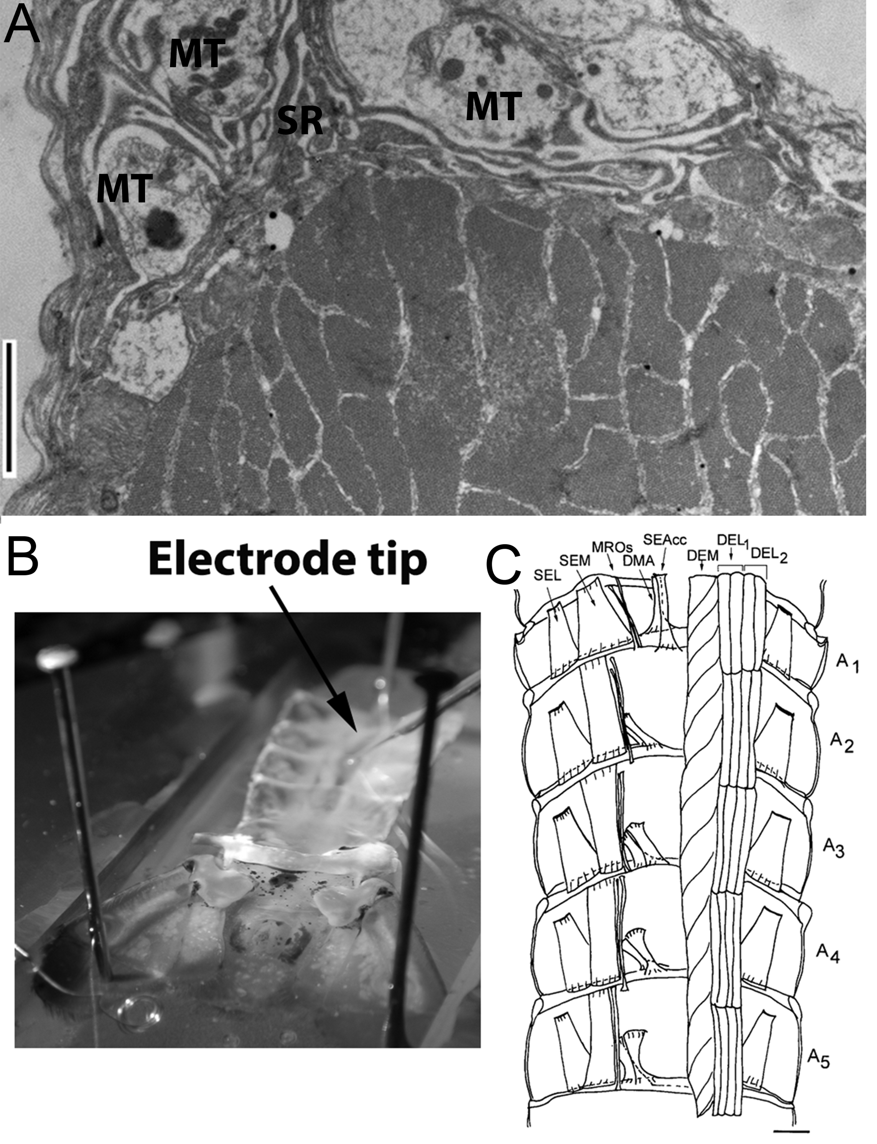
Figure 1: (A) Cross section of crustacean skeletal muscle. Note the close association of the muscle fibers within the muscle bundle and the neighboring motor nerve terminals (MT). The subsynaptic reticulum (SR) at the neuromuscular junction is a complex enfolding of the basal lamina of the muscle. (Scale bar: 2 µm). (B) Insertion of electrode into the muscle. The pinned out preparation with an intracellular electrode ready to penetrate a DEL muscle. (C) Schematic drawing from a ventral view of the dorsal part of the crayfish abdomen showing the extensor musculature of each segment. The abbreviations are: deep extensor medial (DEM), deep extensor lateral group1 (DEL1) and deep extensor lateral group2 (DEL2). A representative EPSP is shown for the DEL1 muscle (Scale bar = 2.35 mm) (part C modified from Sohn et al., 2000).

Prior to exchanging the bathing solutions we had the students discuss the following questions to have mindset of the rationale for values in ionic concentrations of the salts to use. A damaged muscle will spill out the internal contents of ions to neighboring cells.
What is the [Na⁺]_{i} of cells ?
How does this alter RP?
How would low [Na⁺]_{o} and high [K⁺]_{o} alter the RP ?.

The rationale of lowering the low [Na⁺]_{o} is that it would be diluted if the intracellular fluid of a large muscle is now spilling out into the smaller volume of extracellular space among healthy fibers. In reducing the NaCl in the saline, the osmolarity can be maintained by replacing it with the same molarity of with choline chloride. We used two different salines with the various amounts of NaCl and choline chloride for these experiments (Table 1).

Table 1: Composition of Saline with Reduced [Na⁺]_{o} and Compensated with Choline Chloride
100% Na+ 66.66% Na⁺ 33.33% Na⁺
(Normal Saline)
__________________________________________________________
NaCl 205 mM 136.65 mM 68.32 mM
Choline Chloride NA 68.3 mM 136.53 mM

After obtaining an average RP in normal saline, the electrode should be removed from the muscle fiber and the bathing solution changed to the next saline to be examined and obtain new values of membrane potential. Data for our experiments is compiled in Table 3. In describing the results, the Nernst and Goldman Hodgkin Katz equations can be discussed to explain the measures that are obtained in this part of the exercise.

E= (RT/nF) ln (PNa[Na+]_{o} + PK [K+]_{o} ) / ( PNa[Na+]_{i} + PK [K+]_{i})

In our experiments, after completing the low [Na⁺]_{out} experiments, the saline was exchange back to the normal crayfish saline in order to use the same preparation for the next series of experiments which used the various [K⁺]_{bath}. The same process for obtaining the RPs between saline exchanges was used as above. The series of [K⁺]_{bath} crayfish saline solutions we used were: 5.4 (control), 20, 60, and 80 mM. The students collected data as shown in Table 2.

Table 2: Results for varying [Na⁺]_{o} (examples provided)

[Na⁺]_{out} (mM) Replicate Membrane potential (mV)
205 1 RP -68 mV sample
205 2
205 3
136.65 1 RP -72mV sample
136.65 2
136.65 3
68.32 1 RP -75 mV sample
68.32 2
68.32 3

The above experiments examined changing one ionic concentration at a time but for the scenario of a DTI for skeletal muscle, or in deep brain region for a mammal, both [K⁺]_{o} and [Na⁺]_{o} would change around the healthy cells because of the damaged cells. In order to examine the effect of both ions changing in the direction which would possibly occur for a DTI we kept [Na⁺]_{o} low and gradually rose the [K⁺]_{o} as shown in Table 3. The preparation was rinsed with normal saline and allowed to regain a normal starting RP. Data collected by students conducting these experiments are shown in Table 4 and Table 5. Tables like these would serve as good template for student to fill in their own measured values.

Table 3: Composition of saline with reduced Na+ and compensated with choline chloride
33.33 %Na⁺ 33.33 %Na⁺ 33.33 %Na⁺
NaCl 68.32 mM 68.32 mM 68.32 mM
Choline Chloride 136.53 mM 136.53 mM 136.53 mM
KCl 20 mM 40 mM 60 mM

Table 4: Plot the results of findings for K⁺ as follows:
[K⁺]_{out} (mM) Replicate Membrane potential (mV)
5.4 1 RP -81.9 mV sample
5.4 2
5.4 3
20 1 RP -66.2 mV sample
20 2
20 3
60 1 RP -31 mV sample
60 2
60 3
80 1 RP -16 mV sample
80 2
80 3

Table 5: Resting membrane potential as if ion leakage of damaged cells occurred

[K⁺]_{out} (mM)
[Na⁺]_{out} 68.32(mM) Replicate Membrane potential (mV)
20 1 RP -72 mV sample
20 2
20 3
40 1 Rp -55 mV sample
40 2
40 3
60 1 Rp -40.3 mV sample
60 2
60 3

In the next series of experiments we asked the students to predict what they would expect to occur to the resting membrane potential when using a defined diluted solution of homogenized skeletal muscle. Afterwards, the students then conducted the measurements and graphed the results. We let the students determine their own dilution of the muscle homogenate to use. A group discussion then took place going over the various assumptions the students made and the results obtained. Various open ended questions on what might be reasons that the predictions did not match the anticipated results took place.
In order to make dilutions of homogenized skeletal muscle, a volume of supernatant of the homogenized crayfish muscle was measured and diluted as determined by the students for testing their predictions. For these experiments, a small dish was used so only small volumes of the homogenized crayfish muscle solution was needed for each preparation. The crayfish muscle is homogenized after measuring the volume in a graded Eppendorf tube. The tissue was homogenized with a small mortar and pistil. The homogenized tissue and solution was added back to an Eppendorf tube to be spun slightly 1000 RPM for 1 min. Earlier attempts with needle aspiration back and forth were problematic, because the needles would clog, so this method was not preferred. Data was compiled as shown in Table 6.

Table 6: Resting membrane potential with muscle juice (¼ dilution, ½ dilution and 100% muscle homogenate)
muscle juice Replicate Membrane potential (mV)
1/4 dilution with normal saline 1 From Rp -77 mV Saline
To Rp -67 mV Muscle Juice
1/4 dilution with normal saline 2
1/4 dilution with normal saline 3
1/2 dilution with normal saline 1 Rp -55 mV Muscle Juice
1/2 dilution with normal saline 2
1/2 dilution with normal saline 3
100 No dilution only supernatant 1 Rp -31 mV Muscle Juice
100 No dilution only supernatant 2
100 No dilution only supernatant
Measures of synaptic excitatory postsynaptic potentials (EPSPs)

For ease in implementing the exercises, we had the students finish with obtaining the resting membrane potentials first and then used new crayfish preparations for examining the effects of the various bathing media on the amplitudes of the EPSPs. In the series of measuring the EPSPs, the students did collect another set of RP values which helped to reinforce the results from earlier set of experiments.
The students quickly learned the phasic muscle fibers will twitch which dislodges the intracellular electrode and movement of the electrode tip in the contracting fiber may also cause artifacts in a recording.
To avoid these problems it is best to stretch the muscle but not to overstretch as this can damage the fibers. In addition, the nerve to DEM muscle can be transected to avoid this muscle from twitching while EPSP measures are made on L1 and L2. The DEM muscle may be used if recordings of the RP in various bathing solutions are to be obtained but this muscle is difficult to keep an impaled intracellular electrode while measuring EPSPs.
To record the EPSPs of the L1 or L2 or the SEL fibers, we found it best to split the abdomen down the midline and pin the preparation in a stretched position. Now two halves can be used. One of the halves is placed in another dish for a lab partner to use or as an extra preparation.
We stimulated the segmental nerve with a standard suction electrode set up and a SD9 ASTRO-MED GRASS stimulator (ASTRO-MED Grass Natus neurology square pulse stimulator, model SD9, Pleasanton, CA). The segmental nerve is readily seen just passing over the SEL and then along the lateral side of the segment where it was transected when cutting off the ventral aspect of the abdomen. See Figure 2 for details and previous reports on methods (Wyttenbach et al., 1999; Sohn et al. 2000; in a video Baierlein et al., 2011; Johnson et al., 2014).

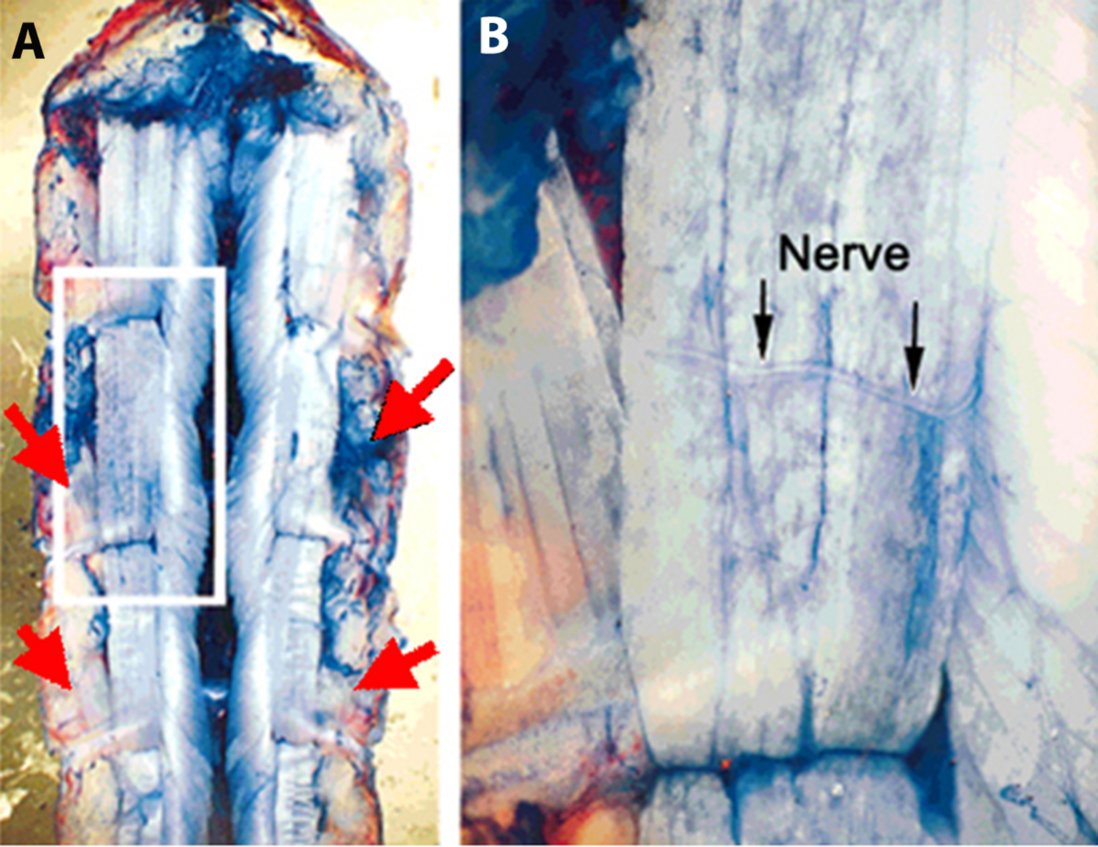
Figure 2: In this methylene blue stained preparation. (A) The segmental nerve approaches the extensor muscle from the lateral-caudal aspect of each segment. The nerve is close to the SEL muscle. The red arrows depict the approximant locations where the segmental nerve can be located. (B) In this enlarge view the motor nerve can be seen on the surface of the DEL muscle and branching as it heads to the DEM muscle (toward the left in the figure).

The twitching of the phasic muscle is easily observed when the nerve is being stimulated. We divided the students again into groups to focus on the phasic or the tonic muscle groups for carrying out these experiments with observing the effects on the synaptic responses. We found that using 0.5 Hz as a stimulating frequency and turning off the stimulation when not needing to collect data prevented the synaptic responses from fatiguing.
It is interesting to note the phasic motor nerve to the DEL1 will cross a segmental boundary to the more caudal segment, and one can measure EPSPs sometimes with less muscle movement in this next segment from the stimulating electrode (Fig. 3). For observing and measuring the EPSPs in the SEL tonic muscle a short train of stimuli maybe needed to facilitate the EPSPs. The SEL muscle is innervated by various motor units, so one needs to increase the voltage until the maximum amplitude in the responses are obtained. We generally started with stimulation frequencies (2-4Hz) while raising the voltage until EPSP responses are observed.

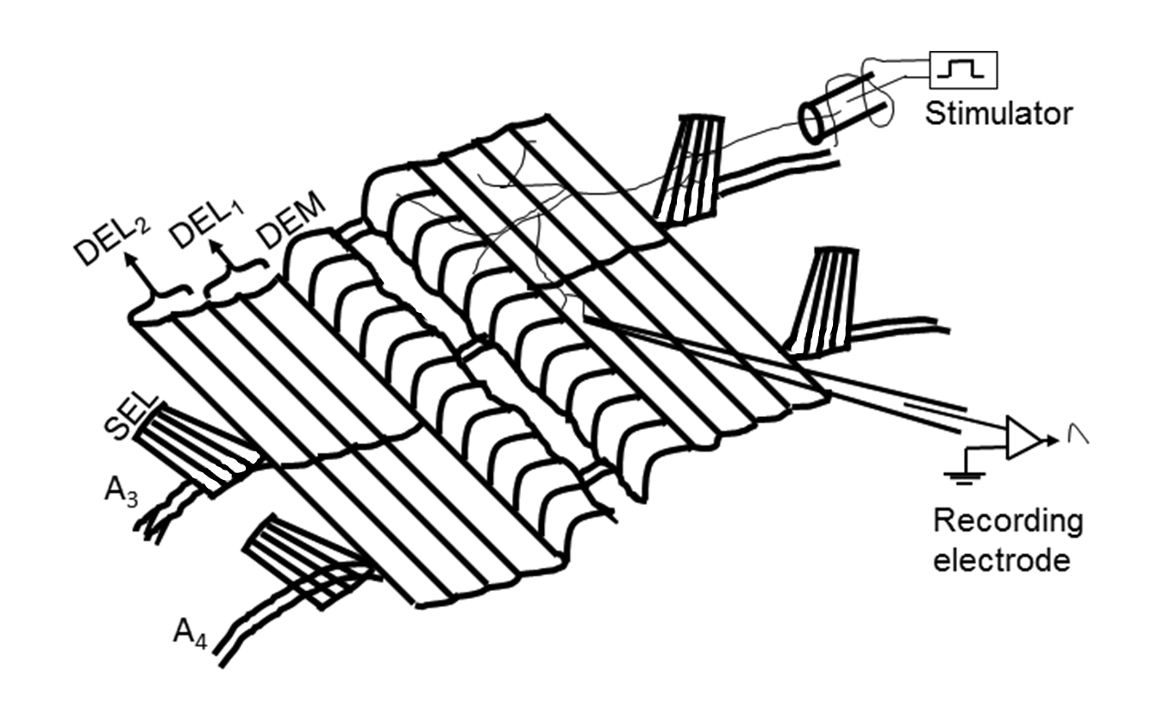
Figure 3: Schematic presentation of crayfish abdomen extensor musculature. Each side of each segment contains deep extensor medial muscle (DEM), deep extensor lateral muscle 1 (DEL1), deep extensor lateral muscle 2 (DEL2), superficial extensor medial muscle (SEM). DEM, DEL1 and DEL2 are phasic muscles whereas SEL is tonic in nature. A3-A4 means abdomen segments. (Drawing made by Dr. Yue Chen Zhu).

We have found it was easier to start with the muscle homogenate experiments and then the combined low [Na⁺]_{o} and varied [K⁺]_{o} experiments as the muscles were able to recover back to normal conditions if the experimental solutions are not left on too long (5 to 10 minutes in each) and exchanging back to normal saline prior to another set of experiments. Since the [K⁺]_{o} is raised to 60 mM in the initial paradigms with monitoring the RP the muscle will likely need a some time to recover (~10 min) with several rapid bath exchanges of normal saline.
To measure the EPSP amplitudes, the height of phasic responses can be directly obtained from the traces. We took an average of 5 or so responses to report a mean value. For the tonic EPSPs, we found that we needed to stimulate for a second or longer to obtain a plateau in the amplitude of the EPSPs. We had the students measure the tonic EPSPs in two fashions: (1) the peak amplitude from the RP and (2) the peak amplitude from the trough between stimuli in case the EPSPs are summating on top of each other. Representative responses are shown in Figure 4 from the SEL with normal saline, 40mM [K⁺]_{o} or muscle homogenate at 1:3 (1 part muscle supernatant to 3 parts normal crayfish saline) followed by a normal saline wash.

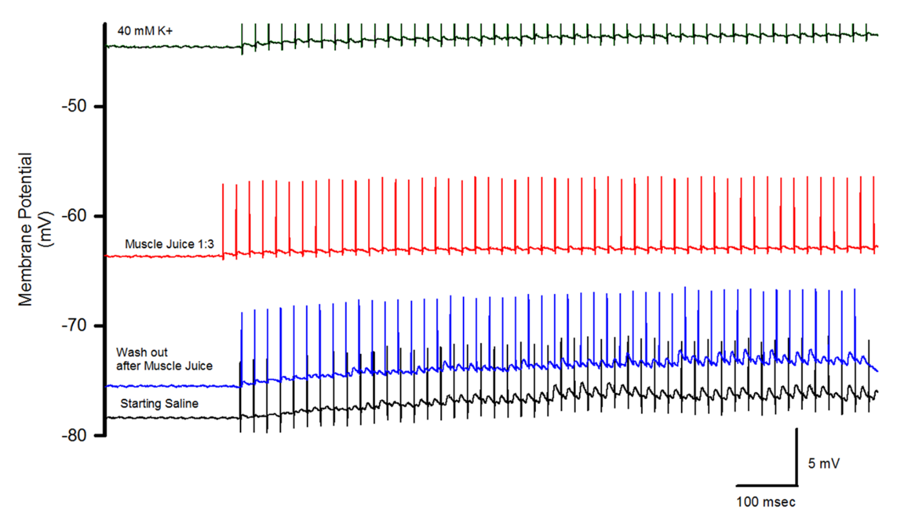
Figure 4: Relationship in size of the EPSPs and membrane potential for muscle juice (1 part muscle juice and 3 parts saline) and 40 mM [K⁺]_{o} from SEL muscle. Note only stimulus artifacts are present with the muscle juice exposure but with 40 mM K⁺ EPSPs are still observed even with a more depolarized resting membrane potential.

Analysis and Results
In our class, the analysis of the data was comprised of having the students plot the measures obtained for the resting membrane potentials at each of the various ionic concentrations they tested. They also plotted the hypothetical values for only altering the [K⁺]_{o} in order to determine if the alteration in [K⁺]_{o} alone could explain the observed results. The graphs for varying [K⁺]_{o} are shown in several publications (Atwood and Parnas1968; Baierlein et al., 2011; Wyttenbach et al., 1999 ) so students will have access to those publications. However, as far as we are aware the novelty for the students is the effects on RP from low [Na⁺]_{o} or the combined alterations in [Na⁺]_{o} and [K⁺]_{o}. Thus, we have not presented a graph in this report as to provide a unique learning experience for a web savvy college students of today who would find the published graphs.
The students can download free graph paper online or even plot on Excel or a graphing program quickly. The tables have sample data entrees from students conducting these exercises. After the student groups completed the graphing analysis various types of questions were poised to the students as follows:
In altering the external level of altered ions, did you expect the same type of alterations in the RP and EPSPs as observed for changing the external level K⁺ concentration alone?
How well did the raised [K⁺]_{o} match the muscle juice dilutions for the RPs and EPSPs?
Were the changes as expected knowing the concentration of [K⁺]_{i} inside of cells (~120 mM)?

Discussion
The approach of using a practical thematic topic to address basic concepts in the driving factors which produces membrane potentials and alterations in synaptic transmission interested the students conducting these experiments. The novelty of using DTI as a theme opened up some new approaches of implementing a common laboratory exercise of only altering the [K⁺] in the bathing media. Lowering the [Na⁺] and raising the [K⁺] mimics closely to the environment induced by a DTI. The additional experiment of using a muscle homogenate directly addressed the type of responses induced by acute cytoplasmic spillage on healthy cells.
With the knowledge gained on the electrochemical gradients of ions in this exercise, the students were able to discuss the actions of injured cells on the neighboring healthy cells. As potential to human health, the students engaged in some of the following questions: what might be a means to reduce the damaging effects with a DTI? What other factors in relation to the muscle contents might need to be considered, which have not been addressed in isolation in these sets of experiments mimicking a DTI? Some students asked family physicians and sought out answers to these questions on their own. A practicing vascular surgeon as well as a certified practicing wound care specialist (certified nurse) were also asked such questions in context of knowing it was for a class project. The standard treatments discussed were to insure IV saline flush to rid the body of the excess K⁺ and protein. The potential for acute renal failure is also monitored due to proteinuria. The main issue to be clinically concerned with is the rising [K⁺]_{o} and thus it is monitored carefully. Students posed what if questions and one of the instructors repeated the question to practicing clinicians: “What would be the procedure for treatment if a large DTI of skeletal muscle occurred for example in the thigh or calf without the skin being compromised?” The answer was the same as the standard clinical protocol mentioned above. “What if the skeletal muscle of injured area could be flushed with an IV saline type of flush but directly inserted around the damaged muscle and a drain catheter could be inserted to remove the excess saline being flushed in along with the cytoplasmic spillage around the healthy cells?” The clinician’s response was, “This sounds like a practical and convincing idea.” The students became ecstatic when the responses were reported back to them. The students conveyed they felt these particular laboratory exercises, which are relatively inexpensive to implement, highlighted the usefulness of model invertebrate preparations to address fundamental questions.
In addition, in reading the literature provided for the exercises the students learned that as early as 1902, Bernstein was dealing with the issues of a resting potential in the axon of a squid. The students were able to see how the early ideas and observations of Berstein (1902) and Nernst (1888) later influenced research in membrane physiology from reading material (See review by Malmivuo and Plonsey, 1995; also available http://www.bem.fi/book/ ). As instructors for such an exercise, one can emphasize that there are still, to this day, breakthroughs being made about ion channel function and properties of biological membranes that are very significant in understanding the cellular physiology, which relate to the function of tissues, organs, and systems (Nicholson and Hrabětová, 2017). It is common in the allied health articles that a topic is discussed, such as hyperkalemia, without stating the mechanism of the physiological consequences. The way the experiments are presented in these exercises will help in this regard. The students will be exposed to how hyperkalemia effects muscle and synaptic transmission in a similar manner from crustaceans to humans. Hyperkalemia in humans can occur in various ways besides with DTIs, such as with medications or with hyperaldosterone production (Braun et al., 2014). Students were so engaged with this laboratory experience, one wrote their lab report with an extra emphasis on how muscle fatigue in humans is also associated with hyperkalemia and altered calcium levels (Cairns et al., 2015).

Additional notes for instructors

This laboratory exercise is built on a commonly used laboratory protocol to measure RP with varying [K⁺]_{o} and measures of EPSPs. Generally, with any physiological lab one needs to ensure the preparations are healthy when starting and that the animals have been maintained in good conditions. Sometimes right after receiving a shipment of crayfish a number will die in 1 or 2 days which is likely from the stress of the transportation. It is a good idea to house the crayfish for a few days prior to using to insure robust physiological preparations.
It is important to see that the students have removed the clumps of damaged muscle attached to the cuticle after the main dissection is completed and to rinse the preparation with fresh normal saline before starting. We used room temperature to maintain the freshly made saline and muscle homogenate. Whereas, if the salines are stored cold and then when the students switch out the saline in the recording dish the temperature will fluctuate and thus alter the RP as well as the amplitude of the EPSPs.
A common mishap with intercellular recordings and glass electrodes is breaking the tip in the dish and spilling out the KCl. If the student notices the break and can quickly change out the solution there may not be too much concern, but this would depend on the situation.
A stimulating suction electrode tip which is too large in diameter, in which the nerve is not snug, results in having to pass larger voltage to activate the nerve. In such a case the stimulus artifact is sometime large and obscures the EPSPs. This can be remedied by placing a Vaseline plug around the nerve and the tip of the suction electrode. One has to be sure not to use scented Vaseline as we found this can kill the nerve.
A topic which an instructor may wish to engage in after such experiments are completed is the neurotransmitter used at these neuromuscular junctions. A unique aspect in crustaceans and insects neuromuscular junctions is that the neurotransmitter is glutamate (while in humans it is acetylcholine). The receptors on the muscle fibers in insects and crustaceans will desensitize with exposure to glutamate. Glutamate receptors on the hippocampal neurons of vertebrates decay with a time constant of 1.2 msec, which is primarily due to the desensitization of the receptors (Clements et al., 1992). Though muscle fibers likely contain 120 mM K⁺, even if it is diluted to an estimated 30 mM K⁺, it did not depolarize the muscle to the same level as saline made to 30 mM K⁺ ; this is likely due to K⁺ still being bound to some the constituents within the homogenized muscle. In addition, the synaptic responses are still able to be measured with a saline containing 30 mM K⁺, but with the estimated muscle juice dilution to 30 mM K⁺ synaptic responses are not able to be obtained. This is most likely due to the amino acids and glutamate, which comes from the homogenized muscle (Abdel-Salam, 2014; Camien et al., 1951; Simpson et al., 1959). Thus, as a follow up experiment to the exercises presented, various concentrations of amino acids can be added to the known saline and investigate the effects on resting membrane potential and on synaptic transmission (Robbins 1959; Thieffry, 1984).

Future experiments

Extensions are readily able to be made in the general experimental paradigm to include effects of temperature and the effects of simulated muscle injury to learn if cooling the muscle or heating it showed different effects of the exposure to muscle juice which relates to the types of treatments humans use for pressure injuries of skeletal muscle (i.e., DTIs). Also pharmacological agents can be applied to see if they would help or worsen the effects of the spilled intracellular constituents on to healthy neighboring cells.
Depending on the severity of a DTI, the blood (hemolymph in the case of an invertebrate) will be tainted with the intracellular constituents of the damaged tissue, and thus expose neural tissue, which can influence its function. In order to examine such pathological conditions, an additional preparation using a crayfish preparation could be presented to the students with the same theme such as with a sensory-CNS-motor nerve circuit (Strawn et al., 2000; Inam et al., 2014; Johnson et al., 2014; Weller et al. 2015).

Student assessment from a freshman class without any prior neurophysiology laboratory experience.

Questions one through five below were given to a freshman class (n=14) of university level students who have not taken a physiology class in college and have not conducted electrophysiological experiments prior to the self-assessment. The questions were given prior to conducting the laboratory exercise and after performing the exercise, with the exception of omitting question number 4 in the survey after experimentation. The general assessment questions were only provided after completing the exercise. The results were not recorded with participant names or coding and the results were not matched for prior and after conducting experiments. Only an aggregate of the data was recorded before and after conducting the experimental exercise.
- What ions are higher in concentration inside the skeletal muscle cytoplasm, when at a resting state, as compared to the extracellular fluid around a skeletal muscle?
- ….Ca²⁺
- ….Na⁺
- ….K⁺
- …. Cl⁻
- ….I am not sure.

- Invertebrates (such as a crayfish) can serve as a model to address some physiological phenomena in relation to mammals?
- True
- False

- Which description below best describes what happens when K+ ions increase (for example from 5 mM to 50mM) in the extracellular fluid around a mammalian skeletal muscle?

A. The resting membrane potential of the muscle will not change.
B. The resting membrane potential of the muscle will hyperpolarize (become more negative).
C. The resting membrane potential of the muscle will depolarize (become more positive).
D. I am not sure.
4. Have you used the Nernst equation or the Goldman-Hodgkin-Katz equation to help in understanding the membrane potential of cells prior to this experiment?
A. Yes
B. No

5. If one damages a small mass of tissue in the central nervous system inside the brain (ie. maybe a blood clot cuts off some oxygen supply for a while and the cells die) what might be the consequences to neighboring healthy cells that did not die from the low oxygen? (short answers)
General assessment questions
On a scale of 1 – 5: (A) Strongly agree, (B) Agree, (C) Neutral, (D) Disagree, (E) Strongly disagree
- This exercise increased my interests in knowing more about how tissue injury can affect whole body health in humans.
- This exercise increased my understanding of the scientific method.
- This exercise helped me to understand the definition of deep tissue injury.
- The videos that accompanied this exercise helped my understanding of topics discussed
- After conducting this exercise, I feel comfortable developing my own hypotheses to address questions related to physiological functions of resting membrane potential of cells.
- After conducting this exercise, I feel confident that I can develop an experiment to test a hypothesis in a quantitative manner
- After conducting this exercise, I feel confident conducting basic data analysis and summarization
- I understand that ionic compounds inside cells that spill out during injury can be related to injury in other cells.
- I feel comfortable developing a muscle fiber electrophysiological recording as part of an experimental study.
- I feel more confident in my note taking abilities, and my ability to summarize general scientific trends

The results of the student self-assessment reveal that there was little understanding of the main concepts prior to conducting the experimental procedure. However, the concepts were well understood after performing the exercise. The answers to the selections before and after the exercise for one through five (omitting question 4 in the post survey) are shown in Figure 6. The responses to the rubric for question 5 are also included. It is important to focus initially on the responses for question 4 which asked if the student had any prior background with the Nernst equation or the Goldman-Hodgkin-Katz equation. The majority (86%) had not had prior exposure to these concepts of resting membrane potential. This helps to illustrate the lack of knowledge in the responses for the pre-test question 1:knowing K⁺ being higher inside cells as compared to the extracellular fluid. However, note the response for question 1 after the exercise. This indicates a large improvement in understanding of this content. The responses for question 2 is not surprising as this particular cohort of students have been working with Drosophila melanogaster (fruit flies) in monitoring heart rate and behaviors related to physiological stressors for 4 weeks prior to this exercise. The responses on the post-test for question 3 showed a large improvement as well after conducting the exercise. What was impressive was the significant improvement in details for the open responses related to question 5. Students had a much more thorough understanding of the concept that when cells are damaged not only is K⁺ spilling out, but also proteins and amino acids, which can alter synaptic transmission.

Figure 6: The results of the participant survey on content questions taken before and after conducting the exercise. The numerical responses are shown for each of the answers. The coded rubric A through E for question five is included (see rubric).The small bars at the 0% are drawn in at the 1% level only for reference to illustrate the pre- and post-responses, but the values are 0%.

The rubric used for assessing open responses for question five was developed prior to reading the responses but was constructed broad enough to capture exemplary responses in the top ranking and a range of response throughout. The rubric used is shown below.

Rubric used for question 5 is as follows:
Question 5: If one damages a small mass of tissue in the central nervous system inside the brain (i.e. maybe a blood clot cuts off some oxygen supply for a while and the cells die) what might be the consequences to neighboring healthy cells that did not die from the low oxygen? (short answers)
A Scientific & in depth response:
- When a nerve cell is damaged and lyses the intracellular constituents will spill out into the extracellular fluid. This will include a higher than normal K+ level and amino acids as well as free proteins. These compounds are not normally high around the outside of the neurons. This can depolarize the neighboring healthy cells and may lead to death of the neighboring healthy cells. The high amino acids and proteins may also interfere with receptors for the neurotransmitters and enzymatic processes.
- Includes scientific justification for selecting correct response and no other extraneous information.
B Scientific, but not in-depth
- The cell debris may harm the neighboring healthy cells. The neighboring healthy cells may include neurons and muscle cells and supportive cells. Maybe the neighboring healthy cells will use the cellular debris as energy sources.
C Partially scientific (scientific fragments) with no non-scientific conceptions
-It is possible the capillaries of circulatory system will take up the dead cell parts. Maybe the dead cell parts will harm the neighboring healthy cells but I am not sure. Tangential response containing no non-scientific conceptions with accompanying correct information
D Partially scientific (non-scientific fragments) with non-scientific conceptions
- Some portion of the answer (either forced-choice or part of written response) is incorrect
- Includes some inaccuracies or conceptual misunderstandings in rationale (e.g., incorrectly states mitochondria will still produce energy while outside the cell in the surrounding fluid to help neighboring healthy cells).
- Rationale may include correct scientific reasoning for some aspects but not directly related to the question.
- May mention, but does not elaborate on the consequences of the intracellular constituents neighboring healthy cells.
E Non-scientific rationale
- Inaccurate or non-scientific justification or use of graphic rather than scientific reasoning to justify response.
- Incorrect explanation
- Illegible/Non-codable/no response
- Response does not make sense

The responses to the general assessment questions are highlighted in Table 7. The response from the participants are very favorable for learning the concepts and the 3-diminsonal learning of practices, crosscutting concepts and disciplinary core ideas (Krajcik, 2015; Achieve Inc., 2013).

Table 7: Results in participant feedback after conducting the exercise. The data represents the questions one through ten of the general assessment questions. The scores are listed as % of total (N=14) for (A) Strongly agree, (B) Agree, (C) Neutral, (D) Disagree, (E) Strongly disagree
1 2 3 4 5 6 7 8 9 10

A 50 21 29 50 14 7 50 79 36 50
B 50 29 57 36 43 43 29 7 43 29
C 0 36 14 7 29 50 14 14 7 21
D 0 14 0 7 14 0 7 0 14 0
E 0 0 0 0 0 0 0 0 0 0

The responses to question 2 with improving understanding the scientific method could be improved by introducing the experimental project more as an investigative approach without informing the students of the experiment but letting them contemplate various way to go about determining the effects of cell damage on healthy neighboring cells. Then guide the students to an approach using the crayfish or a frog skeletal muscle experimental design to address the questions. Likewise, for question 5 the responses would likely be improved by introducing the experiments as hypothesis testing. This was not done with this cohort of students. The students which selected that they disagreed in feeling more comfortable in developing a muscle fiber electrophysiology experiment was likely due to being the first time ever turning knobs on an instrument and running the software for the analysis of the recordings. This cohort was introduced to measuring membrane potential with intracellular recording, new software and the experimental design of altering [K+] as well as muscle injury all in one laboratory setting. Obviously, if this experiment was piggy backed on a lab in a prior week in which they only recorded resting membrane potentials and became familiar with the software, then adding the muscle juice and measuring synaptic potentials in a later laboratory meeting, the students would have been less intimated by instrumentation the second time around.

Feedback from past students in a neurophysiology upper level course

The voluntary feedback by university students who have conducted these laboratory exercise after a school year was completed have been positive and demonstrate they liked the practical nature of the exercises. These students had an entire semester of a neurophysiology laboratory experience.

"This lab provided students the opportunity to utilize their understanding of Potassium’s effect on nerve cell conduction in the crayfish and transmit this to predict the outcome of muscle juice on nerve cell conduction. We were able to apply our knowledge of cells high intracellular Potassium to predict what would occur when muscle juice was applied based on our initial findings with saline Potassium. The practicality of this lab made it extremely effective in enhancing my learning through applied knowledge and skills of neurophysiology."

“The experiment is very helpful for a student to transfer knowledge from text books to real life experience and skills. It allows us to understand the importance of potassium in the resting membrane potential. It deepens our understanding for the Nernst equation, since we can predict different resting membrane potentials by using different potassium concentrations in the Nernst equation. More than that, the experiment also provides a unique perspective on possible clinical scenario on muscle injury as we were testing muscle juice impact on resting potential. Personally, I found this experiment enlightening and inspiring. The math model for resting membrane potential is abstract but it comes to make sense when we practiced them in this animal model and it really encouraged us to think more about its other applications on clinical scenario and basic physiology foundations for organism to be functional.“
“This unique procedure allowed the students to examine the general physiological properties of excitable membranes and the role of a particular ion, Potassium, in altering resting membrane potential. From a physiological standpoint, the study allows one to address the consequences of increasing extracellular cation concentration on neighboring healthy cells. This holds clinical relevance in the case of Deep Tissue Injury, which can progress as intracellular stores from damaged cells are released. Furthermore, the role of increasing extracellular K⁺ concentration on synaptic transmission in surrounding cells, including the potential Na⁺ or Ca²⁺ channel inactivation as a result of altering RP can be assessed. I found this experiment to be particularly useful in enhancing skills that pertain to basic neurophysiological studies. It promotes the importance of animal models in understanding basic principles that may be clinically significant and its practicality allows one to enhance knowledge of the subject matter that corresponds with teachings from the textbook.”
“The lab was helpful in demonstrating how varying extracellular ions affect membrane potentials and synaptic responses. Using damaged muscle as the source of these extracellular ions also helped to exemplify a few of the many abstract concepts of neurophysiology.”

Acknowledgments

Open response feedback by students (Morgen Clayton, Cole Malloy, YueChen Zhu, Jon Christensen) is greatly appreciated. We thank Thomas Schwarcz, MD for the clinically relevant matters related to this topic. Funded by the Department of Biology, University of Kentucky for the development of this laboratory exercise.

References

Abdel-Salam, H.A. (2014). Amino acid composition in the muscles of male and female commercially important crustaceans from Egyptian and Saudi Arabia coasts. Amer. J. Biosci. 2(2), 70-78. doi: 10.11648/j.ajbio.20140202.19

Achieve Inc. (2013). Next generation science standards. Retrieved from http://www.nap.edu/read/18290/

Atwood, H.L. (1976). Organization and synaptic physiology of crustacean neuromuscular systems. Prog. Neurobiol. 7, 291-391.

Atwood, H.L. and Cooper, R.L. (1996a). Assessing ultrastructure of crustacean and insect neuromuscular junctions. J. Neurosci. Meth. 69, 51-58.

Atwood, H.L. and Cooper, R.L. (1996b). Synaptic diversity and differentiation: Crustacean neuromuscular junctions. Invertebrate Neurosci. 1, 291-307.

Atwood, H.L. and Parnas, I. (1968). Recording from the crayfish abdominal extensor muscle preparation with microelectrodes. In: Experiments in physiology and biochemistry (Kerkut GA, ed), pp 307-330. London: Academic Press Inc.

Baierlein, B., Thurow, A.L., Atwood, H.L., and Cooper, R.L. (2011). Membrane Potentials, Synaptic Responses, Neuronal Circuitry, Neuromodulation and Muscle Histology Using the Crayfish: Student Laboratory Exercises. J. Vis. Exp. 47, e2322, doi:10.3791/2322 (2011).

Baylor, D.A. and Nicholls, J.G. (1969). Changes in extracellular potassium concentration produced by neuronal activity in the central nervous system of the leech. J. Physiol. (Lond.) 203, 555-569.

Bernstein, J. (1902). Untersuchungen zur Termodynamik der bioelektrischen Ströme. Pflüger Arch ges. Physiol. 9, 521-562.

Bradacs, H., Cooper, R.L., Msghina, M., and Atwood, H.L. (1997). Differential physiology and morphology of phasic and tonic motor axons in a crayfish limb extensor muscle. J. Exp. Biol. 200, 677-691.

Brancaccio, P., Lippi, G., and Maffulli, N. (2010). Biochemical markers of muscular damage.Clin. Chem. Lab. Med. 48(6), 757-767.

Braun, C.T., Srivastava, D.S., Engelhardt, B.M., Lindner, G., and Exadaktylos, A.K. (2014). Lazy lips: hyperkalemia and acute tetraparesis-a case report from an urban emergency department. Case Rep. Emerg. Med. 2104,160396. doi: 10.1155/2014/160396. PMID:25525527

Cairns, S.P., Leader, J.P., Loiselle, D.S., Higgins, A., Lin, W., and Renaud, J.M. (1985). Extracellular Ca2+-induced force restoration in K+-depressed skeletal muscle of the mouse involves an elevation of [K+]i: implications for fatigue. J. Appl. Physiol. 118(6), 662-674. doi: 10.1152/japplphysiol.00705.2013 PMID: 25571990

Camien, M.N., Sarlet, H., Duchateau, G., and Florkin, M. (1951). Non-protein amino acids in muscle and blood of marine and fresh water Crustacea. J. Biol. Chem. 193, 881-885.

Cintra-Francischinelli, M., Caccin, P., Chiavegato, A., Pizzo, P., Carmignoto, G., Angulo, Y., Lomonte, B., Gutiérrez, J.M., and Montecucco, C. (2010). Bothrops snake myotoxins induce a large efflux of ATP and potassium with spreading of cell damage and pain. Proc. Natl. Acad. Sci. USA. 107(32), 14140-14145.

Clements, J.D., Lester, R.A., Tong, G., Jahr, C.E., and Westbrook, G.L. (1992). The time course of glutamate in the synaptic cleft. Science 258 (5087), 1498-1501.

Coll, R.K., France, B., and Taylor, I. (2005). The role of models/and analogies in science education: Implications from the research. Internatl. J. Sci. Ed. 27(2), 183-198.

Cooper, R.L., Warren, W.M., and Ashby, H.E. (1998). Activity of phasic motor neurons partially transforms the neuronal and muscle phenotype to a tonic-like state. Muscle & Nerve 21, 921-931.

Feng, T.P. (1933). Reversible inexcitability of tactile endings in skin injury. J. Physiol. 79(1), 103–108.

Frankenhaeuser, B. and Hodgkin, A.L. (1956). The after-effects of impulses in the giant nerve fibres of Loligo. J. Physiol. 131, 341-376.

Gilbert, J.K., Boulter, C.J., and Elmer, R. (2000). Positioning models in science education and in design and technology education. In JK Gilbert and CJ Boulter (Eds.), Developing models in science education. Dordrecht, The Netherlands: Kluwer.

Honaker, J.S., Forston, M.R., Davis, E.A., Wiesner, M.M., and Morgan, J.A. (2013). Effects of non contact low-frequency ultrasound on healing of suspected deep tissue injury: a retrospective analysis. Int. Wound J. 10(1), 65-72. doi: 10.1111/j.1742-481X.2012.00944.x.

Inam, Z.S., Nelamangala, S.K., and Lin, J.W. (2014). Application of a spike sorting procedure to analyze recordings in the crayfish ventral superficial flexor preparation: A high resolution approach to the study of neuromodulators on axons and synapses. J. Undergrad. Neurosci. Educ. 12(2), A140-9. eCollection 2014.

Johnson, B.R., Wyttenbach, R.A., and Hoy, R.R. (2014). Cruataceans as model systems for teaching neuroscience: past, present, and future. In: Nervous systems and control of behavior, the natural history of the Crustacea. (Derby C, Thiel M, eds). New York, NY: Oxford University Press.

Krajcik, J. (2015). Three-dimensional instruction. The Science Teacher. 82(8), 50-54.

Kuo, J. J., Siddique, T., Fu, R., and Heckman, C. J. (2005). Increased persistent Na(+) current and its effect on excitability in motoneurones cultured from mutant SOD1 mice. J. Physiol. (London). 563, 843–854.

Malmivuo, J. and Plonsey, R. (1995). Bioelectromagnetism-Principles and Applications of Bioelectric and Biomagnetic Fields. New York: Oxford University Press.

Nernst, W.H. (1888). Zur Kinetik der Lösung befindlichen Körper: Theorie der Diffusion. Z. Phys. Chem. 3, 613-637.

Nicholson, C. and Hrabětová, S. (2017) Brain Extracellular Space: The Final Frontier of Neuroscience. Biophysical J. 113(10), 2133-2142.

Orkand, R.K., Nicholls, J.G., and Kuffler, S.W. (1966). Effect of nerve impulses on the membrane potential of glial cells in the central nervous system of amphibia. J. Neurophysiol. 29(4), 788-806. PMID:5966435.

Parfitt, K. (2002) Designing an effective, affordable laboratory course in neurophysiology crawdad: a cd-rom lab manual for neurophysiology. J. Undergrad. Neurosci. Educ 1(1), R5–R6. PMCID: PMC3592581

Pilgrim, R.L.C. and Wiersma, C.A.G. (1963) Observations on the skeleton and somatic musculature of the abdomen and thorax of Procambarus clarkii (Girard), with notes on the thorax of Panulirus interruptus (Randall) and Astacus. J. Morphol. 113, 453–587.

Robbins, J. (1959). The excitation and inhibition of crustacean muscle by amino acids. J. Physiol. 148(1), 39–50. PMCID: PMC1363107

Simpson, J.W., Allen, K., and Awapara, J. (1959). Free amino acids in some aquatic invertebrates. Biol. Bull. 117(2), 371-381.

Skou, J.C. (1965). Enzymatic basis for active transport of Na+ and K+ across cell membrane. Physiol. Rev. 45, 596-617.

Skou, J.C. (1998) Nobel Lecture. The identification of the sodium pump. Biosci. Rep. 18(4), 155-169.

Sohn, J., Mykles, D.L., and Cooper, R.L. (2000). The anatomical, physiological and biochemical characterization of muscles associated with the articulating membrane in the dorsal surface of the crayfish abdomen. J. Exp. Zool 287, 353-377.

Strawn, J.R., Neckameyer, W.S., and Cooper RL (2000). The effects of 5-HT on sensory neurons, CNS command, and neuromuscular junctions of the crayfish abdominal superficial flexor. Comp. Biochem. Physiol B 127, 533-550.

Suchkova, V.N., Baggs, R.B., Sahni, S.K., and Francis, C.W. (2002). Ultrasound improves tissue perfusion in ischemic tissue through a nitric oxide dependent mechanism. Thromb. Haemost. 88(5), 865-870. PMID:12428107

Thieffry, M. (1984). The effect of calcium ions on the glutamate response and its desensitization in crayfish muscle fibres. J. Physiol. 355, 1469-7793. http://dx.doi.org/10.1113/jphysiol.1984.sp015410

Van Harreveld, A. (1936). A physiological solution for freshwater crustaceans. Proc. Soc. Exp. Biol. Med. 34, 428–432.

Weller, C., Hochhaus, A.M., Wright, T.M. Jr, and Mulloney, B. (2015). A classic improved: minor tweaks yield major benefits in crayfish slow-flexor preparations. J. Undergrad. Neurosci. Educ. 13(2), A74-80. eCollection 2015.

Wiersma, C.A.G. (1961). The neuromuscular system. In, The physiology of Crustacea, Vol 2, ed Waterman TH (Academic, New York), pp 191–240.

Wu, W.H. and Cooper, R.L. (2010). Physiological recordings of high and low output NMJs on the Crayfish leg extensor muscle. J. Vis. Exp. 45, e2319, doi:10.3791/2319 (2010).

Wyttenbach, R.A., Johnson, B.R., and Hoy, R.R. (1999). Crawdad. A CD-ROM Lab manual for neurophysiology. Sinauer Associates, Sunderland, MA ISBN: 0-87893-947-4 CD-ROM

About the Authors

Ashwatha Thenappan is a first year medical student at Boonshoft School of Medicine, Wright State University. She helped to develop this exercise while and undergraduate student at the university of Kentucky working with Dr. Robin Cooper in the Department of Biology. She developed on line video media to help run the exercise for the neurophysiology course (Bio446) at the University of Kentucky. She spent the last year working in rural China as an educational tutor for children and learning more about the Chinese culture.

Dr. Esther E. Dupont-Versteegden graduated from State University Limburg at Maastricht, the Netherlands, with a Bachelor in Science degree in Movement Sciences. In 1995 she received a Doctor of Philosophy degree in Physiology from the University of Texas Health Science Center at San Antonio, Texas. Esther Dupont-Versteegden completed a postdoctoral study in molecular physiology with Dr. Charlotte Peterson at the University of Arkansas for Medical Sciences. In 1999 she became Assistant Professor of Geriatrics at the University of Arkansas for Medical Sciences and in 2006 she accepted a position as Associate Professor in the division of Physical Therapy and the department of Rehabilitation Sciences at the University of Kentucky at Lexington. In 2015 she was promoted to full professor and is currently serving as the Director of the PhD program in Rehabilitation Sciences.

Dr. Robin L. Cooper obtained a dual BS Chemistry and Zoology from Texas Tech Univ. in 1983. He obtained a Ph.D. in 1989 in Physiology from the School of Medicine, Texas Tech Univ. He then went on for postdoctoral training (1989-1992) at the University of Basel, Sch. of Medicine, Basel, Switzerland and a second postdoctoral stent (1992-1996) in the Department of Physiology at the Univ. Toronto, Sch. of Medicine, Toronto, Canada. He then Joined the Dept. of Biology at the University of Kentucky in 1996 and is now professor and director of the undergraduate neuroscience program at the University of Kentucky. He also obtained a BSN in nursing in 2012 and practiced nursing as an RN from 2011 to 2017. He has received several teaching awards: Kentucky Academy of Sciences Excellence in high education teaching, Arts and Sciences Excellence in undergraduate mentoring and, Provost Award for excellence in teaching.

Appendix

Dissection tools: Fine #5 tweezers, fine scissors, knife blade holder, #26002-20 insect pins (all obtained from Fine Science Tools (USA), Inc., 373-G Vintage Park Drive, Foster City, CA 94404-1139).
Sylgard-bottomed glass dish (instructor should pour the Sylgard about 1 to 2 inches deep in a glass dish prior to heating for harden the sylgard). A PowerLab 26T (ADInstruments, Colorado Springs, CO, USA) was interfaced to a computer. The standard software from ADInstruments named Chart or Scope was used to collect data and to perform the data analysis. A model 3000 AC/DC amplifier for intracellular as well as extracellular recordings can be used. For intracellular recordings we use glass capillary tubing (catalogue # 30-31-0 from FHC, Brunswick, ME, 04011, USA).

DATA TABLES
Table 2: Plot the results of your findings for Na+ as follows:

[Na⁺]_{out} (mM) | Replicate | Membrane potential (mV)
205 | 1
205 | 2
205 | 3
136.65 | 1
136.65 | 2
136.65 | 3
68.32 | 1
68.32 | 2
68.32 | 3

Table 4: Plot the results of your findings for K+ as follows:

[K⁺]_{out} (mM) | Replicate | Membrane potential (mV)
5.4 | 1
5.4 | 2
5.4 | 3
20 | 1
20 | 2
20 | 3
60 | 1
60 | 2
60 | 3
80 | 1
80 | 2
80 | 3

Table 5: Resting membrane potential as if ion leakage of damaged cells occurred

[K⁺]_{out} (mM)  [Na⁺]_{out} 68.32(mM) | Replicate | Membrane potential (mV)
20 | 1
20 | 2
20 | 3
40 | 1
40 | 2
40 | 3
60 | 1
60 | 2
60 | 3

Table 6: Resting membrane potential with muscle juice (¼ dilution, ½ dilution and 100% muscle homogenate)

muscle juice | Replicate | Membrane potential (mV)
1/4 dilution with normal saline | 1
1/4 dilution with normal saline | 2
1/4 dilution with normal saline | 3
1/2 dilution with normal saline | 1
1/2 dilution with normal saline | 2
1/2 dilution with normal saline | 3
100 No dilution only supernatant | 1
100 No dilution only supernatant | 2
100 No dilution only supernatant | 3

