Exploring mechanisms in a medical treatment for a disease: A teaching/learning module
Ann S. O'Neil¹, Rebecca M. Krall², Rachael Vascassenno^{3,4} and Robin L. Cooper⁴
¹3000 New Bern Ave. WakeMed Hospital Raleigh, NC 27610, USA
²Rm 105 Taylor Education Bldg, 597 S. Upper St, Department of STEM Education, University of Kentucky, Lexington, KY 40406-0001, USA
³Department of Biology, Eastern Kentucky University, Richmond, KY 40475, USA
⁴675 Rose St., Department of Biology, University of Kentucky, Lexington, KY 40506-0225 USA.
RLCOOP1@uky.edu; Rebecca.krall@uky.edu; Aoneil@wakemed.org; rachael_vascassen@mymail.eku.edu;
Abstract (300 word max)
Many undergraduate students majoring in biological sciences are interested in professions within health care. To spark their interests in learning physiological concepts, this exercise focuses on an active form of health care and a treatment which is not fully understood. Students will learn that medical care is continuously evolving from evidence based practice and scientific understanding. Studying the potential mechanisms of the pharmacological actions on physiological function may lead to developing a more precise mechanistic understanding that can lead to more precise treatments, which students might propose based on their learning. Utilizing the primary research literature, fundamental physiological concepts, and client outcomes from case studies, instructors may construct a teaching and learning module based on the content provided. In this regard, the mystifying actions of how 4-aminopyridine (4-AP) helps to alleviate some of the rigidity and movement of limbs in clients with multiple sclerosis (MS) is explored. It is well established that 4-AP blocks a subset of voltage gated potassium (K⁺) channels, but it is somewhat counterintuitive how this promoted better locomotive movements. The mechanisms of action from clinical doses may be more related to the physiological changes that occur due to the progression of MS or even by actions on other cells besides neurons, leading to secondary actions on neurons. With the use of inexpensive electrophysiological instruments (i.e., Backyard Brains) nerve recordings of invertebrate nerves will be recorded while exposed to 4-AP to directly observe the effects on electrical activity. In this module, multiple physiological concepts are used to construct mechanistic explanations of the phenomenon. The learning objectives are to: (1) cover the basic neurophysiological principles of electrical signals, synaptic transmission, and pharmacological actions of ion channels; (2) demonstrate the disease process of MS, and (3) address scientific literacy developed from a review of research studies on the phenomenon. (now at 300 words)

Introduction (to teacher)

Treatments for various diseases usually involve pharmacological interventions. If the health outcomes are beneficial, they are maintained for treatment and sometimes are examined for other disease states which may not have been originally targeted. In some cases, the medication may be used even without knowing fully the mechanism of action which improves physiological function. However, to potentially design more effective medications and potentially reduce side effects, an understanding of the details in physiological actions need to be understood. Knowing the action of a compound on function in a particular tissue or how the compound may affect cellular processes may not explain fully how the compound is causing the improvement in a complex body involving many systems interacting together. In addition, in a disease state the conditions known or expected for the action can be varied as the compounds may not have been experimentally addressed within a pathological state.

In this report, we highlight an educational module addressing the potential mechanism of how 4-Aminopyridine (4-AP) can be beneficial for some patients with multiple sclerosis (MS). This is an educational module which builds on basic knowledge that is known on how the compound works on cells. Participants are to understand the basics of how neurons are electrically excitable and conduct electrical signals as well as communicate with other cells. The content is to be presented, or by assignments given to the students, addresses the various ion channels and ionic regulation of electrical events as well as the process of chemical synaptic transmission. Then, the module dives deeper than most undergraduate textbooks would cover in the different types of voltage gated potassium (K⁺) channels and how they can modulate the shape of an action potential as well as influence membrane excitability and alter synaptic transmission. It is well established that 4-AP blocks a subset of voltage gated K⁺ channels. This content allows the participants to then draw postulations on how 4-AP can enhance locomotion in some people with MS.

The disease state of MS is addressed and the various effects on the nervous system. Addressing this topic illustrates the complex pathology of the disease and introduces a number of issues in how neurons are altered by the disease which can play a role in how 4-AP may impact physiological function in various cell types.

What is likely to be postulated in the mechanism of action will be addressed in reviewing the primary literature. The controversies in the primary literature are introduced with clinical data and reports from experimental research in animal models.

The latest understanding with sound scientific arguments will be presented in the likelihood of how 4-AP is beneficial in this disease state as well as what is still in question in the understanding.

This exercise teaches the fundamental principles in the scientific process in understanding the basics and building up to more integrated detail as well as integrated information from various sources to make predictions. Then to address those predictions and refute ideas with evidence to then make new predictions. To understand the historical views and how they change over time with more information teaches how the scientific process proceeds and how ideas are refuted with evidence. Lastly, to come to the conclusion that there are still more questions to be addressed and that a complete understanding is hard to obtain and may still require more research.

The set of homework activities can be used as a pre- and post-test survey. One should not expect full answers on the pre-survey; however, after using the educational module one should expect full detailed answers on the post-survey using the same tool.

Introduction to students and protocol

Part 1: Literature based content

This is also explained in a YOUTUBE link https://youtu.be/6s4NK39fEBo

You and your classmate Jane have been studying for your spring semester final exams. Jane tells you that she has been experiencing some clumsiness with tripping over her feet, weakness in her legs, double vision at times, and feeling overall fatigued. She contributes this to staying up late studying and completing projects in school as well as working longer hours at her off campus job. She feels confident that before the fall semester, she will be able to rest and then go back to feeling like how she was before. On the first day of fall semester in physiology class, you notice classmate Jane having more trouble with walking with walking slowly and having trouble going up the steps in the classroom. She appears exhausted upon sitting down next to you and reports she is experiencing more “pins and needles” in her legs but that she is working with her primary care provider to determine the cause of these symptoms. The following week, she comes to you and tells you that she is diagnosed with Multiple Sclerosis.

1. She states she was overwhelmed in the doctor’s appointment and was hoping that you would be able to help her better understand the pathology involved with MS.

2. Due to her difficulty with walking, the provider prescribed her with a medication called Ampyra (dalfampridine) extended release tablets. She is wondering if you can also help her understand how this drug helps with her walking.

Since the diagnosis, she has joined a support group that included members of all ages and different types of MS and has talked to others that have taken Ampyra. She states some of the other members did not demonstrate any improvements in their walking when taking this drug.

1. Basic neuron and excitability and synaptic transmission
-Explain resting membrane potential and how different ion channels and ion permeability alters membrane potential (Nernst and
Goldman-Hodgkin-Katz equation).
-Draw out an axon to explain electrical excitability and electrical conduction. Two types of neurons, a myelinated one and an unmyelinated one.
-Draw out nerve terminal to address chemical synaptic transmission and the process involved related to ionic channels.

2. How various types of K channels are responsible for the shape of the action potential.
-Draw out the shapes and how K channels contribute to the different parts of the AP. (i.e., 4-AP and TEA sensitive K-channels)

3. Address the pharmacology related to the various channel subtypes and how different neurons respond differently to the pharmacological compounds.
-Draw out the shapes and how they are altered by the pharmacological compounds and how the altered shape could have an effect on the voltage-gated
calcium (Ca2+) channel in the presynaptic nerve terminal. Draw how the differences in Ca2+ loading alter chemical synaptic transmission.

4. Detail the clinical appearance of the disease, epidemiology (how many patients affected, age, male/female, Caucasian, etc… ). Explain the mechanism behind MS (destruction of myelin by autoreactive cells that are activated in the periphery, disruption of the BBB). How does the histology help in identifying the with inflammation of MS? How is a diagnosis of MS made via MRI with using McDonald Criteria from 2017?

5. Postulated how 4-AP may benefit MS patients from the basic knowledge addressed above.

6. Address how the pathology of MS may complicate the concepts of how 4-AP may work in the diseased state.

7. Address the concepts presented in the literature and views of in the potential actions of 4-AP in MS as well as the controversies presented in the literature.
8. Address from what you can gather from the latest literature how 4-AP is mechanistically working to improve the symptoms of MS. Directly relate back to the initial case/patient description as noted at the beginning or do so with the next question.
9. From the readings and your knowledge, address why you think only a subset of people with MS benefit from treatments of 4-AP.
10. List what might be as the next research steps required to address how 4-AP might be working to improve MS.

Now watch the attached movie in the link and use the powerpoint slides as well as any reference material provided in the power points and discussion.

The instructor will go over the topics for class discussion in the powerpoint.

Please see this web site and watch the two associated movies clips of one taking the medication mentioned in the introduction for the treatment
https://ampyra.com/real-patient-videos

Part 2: Nerve recording with application of 4-AP
The electrophysiological recordings from a model nerve preparation can be accomplished with various animal models.
- One can use the classic frog sciatic nerve preparation. This preparation is well documented and detailed laboratory procedures can be found online and from educational protocols from companies which sell the associated equipment. Here are some listings:

(A) The general learning objectives and content is presented in protocols already freely available and readily accessible in multiple links.
https://www.adinstruments.com/lt/neuroscience . Then click on "Frog Nerve "
(B). Iworks even presents that lab in video format https://www.youtube.com/watch?v=YUzne-KZ4_4
(C) Biopac manual. https://www.biopac.com/curriculum/a03-frog-sciatic-nerve/
(D) Teaching labs. https://www.medicine.mcgill.ca/physio/vlab/Other_exps/CAP/prep.htm
2. One can also record from a crayfish muscle receptor organ with the necessary equipment. This can be accomplished with high end equipment as well as use of inexpensive equipment but not as sophisticated for data analysis.
See the following for a teaching lab with research grade equipment and a computer to acquire the electrical signals:
Leksrisawat, B., Cooper, A.S., Gilberts, A.B. and Cooper, R.L. (2010) Response properties of muscle receptor organs in the crayfish abdomen: A student laboratory exercise in proprioception. Journal of Visualized Experiments (JoVE). 45: http://www.jove.com/index/details.stp?id=2323 doi:10.3791/2323

Use of Backyard Brains equipment for a lower cost version to record electrical activity but requires one to make a suction electrode, design a dissecting microscope and a simple manipulator in order to move the suction electrode.
See the following: Sensory nerves in a leg of a crab/lobster/crayfish: https://www.youtube.com/watch?v=yIT2rCvIUoo ; Recording nerve activity with a suction electrode & Backyard Brains Part 1of 2: https://youtu.be/LrHXLF96d8Q ;Use of suction electrode to record from nerves in saline with Backyard Brains devices: https://youtu.be/kGMBelEapGk
3. At the ABLE 2022 conference the crab leg proprioceptive nerve was used. This model preparation can also be recorded for a teaching lab with high end equipment and a computer to acquire the electrical signals.
See:
Majeed, Z.R., Titlow, J., Hartman, H.B. and Cooper, R.L. (2013). Proprioception and tension receptors in crab limbs: Student laboratory exercises. Journal of Visualized Experiments (JoVE). (80), e51050, doi:10.3791/51050 http://www.jove.com/video/51050/proprioception-tension-receptors-crab-limbs-student-laboratory

Or with the use of Backyard Brains equipment for a lower cost version to record electrical activity but requires one to make a suction electrode, design a dissecting microscope and a simple manipulator to move the suction electrode.
See the following: Sensory nerves in a leg of a crab/lobster/crayfish: https://www.youtube.com/watch?v=yIT2rCvIUoo ; Recording nerve activity with a suction electrode & Backyard Brains Part 1of 2: https://youtu.be/LrHXLF96d8Q ; Use of suction electrode to record from nerves in saline with Backyard Brains devices: https://youtu.be/kGMBelEapGk

This Youtube movie is specifically designed to accompany the ABLE 2022 protocol presented for the workshop and with the procedures below to expose a nerve of a crab leg to compounds while testing neural activity: https://youtu.be/dnOfB-K3gyo

The following are the steps used to expose the leg nerve from a crab and to record from the whole nerve using suction electrodes and the Spiker box from Backyards Brains.

Procedures used in steps. These are to be accompanied with the movie on YouTube.

- Sylgard coated dish with about ½ to ¾ of an inch thick of sylgard.
- Scalpel and #11 bade
- Cut along the cuticle in each segment to expose nerve
- Pull the proximal leg nerve out of segment.
- Freshly cut nerve and put in a suction electrode
- To insure a tight fit use clear Vaseline (petroleum jelly)
- Make sure saline is covering wire on inside and outside wires.
- Move leg to obtain electrical responses with Spiker Box on IPHONE or IPAD
- Repeat a few times. Save file.
- NOTE: 4-AP is TOXIC TO HUMANS. USE nitrile gloves. Switch saline with saline containing 4-AP and swish around.
- Repeat the joint movements and see if frequency and amplitude are altered.
- Then rinse the preparation with fresh saline without 4-AP a few times while swishing the saline over the nerve.
- Repeat the joint movements and see if the nerve activity and responses are recovered.

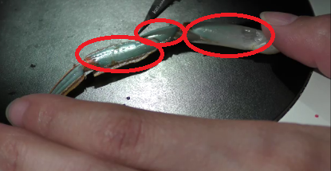
Photos for reference
Figure 1: The three segments in which the cuticle is cut to make windows so the muscles can be seen in order for some to be removed for exposing the leg nerve.
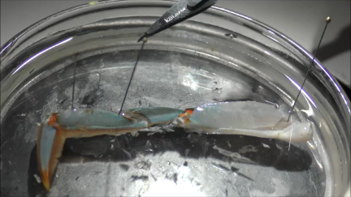
Figure 2: Place pins in the dorsal edge of the cut windows to hold the preparation down.

:

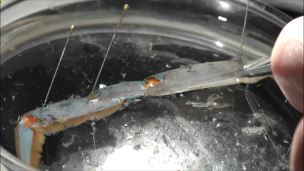

Figure 3: Remove the opener muscle and the muscles on the side the windows were made by cutting the connective tissue holding the tendons (apodemes in arthropods).

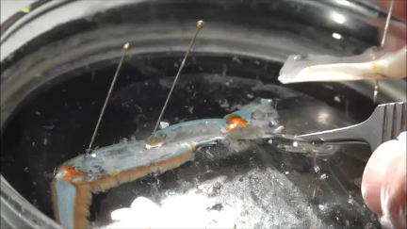
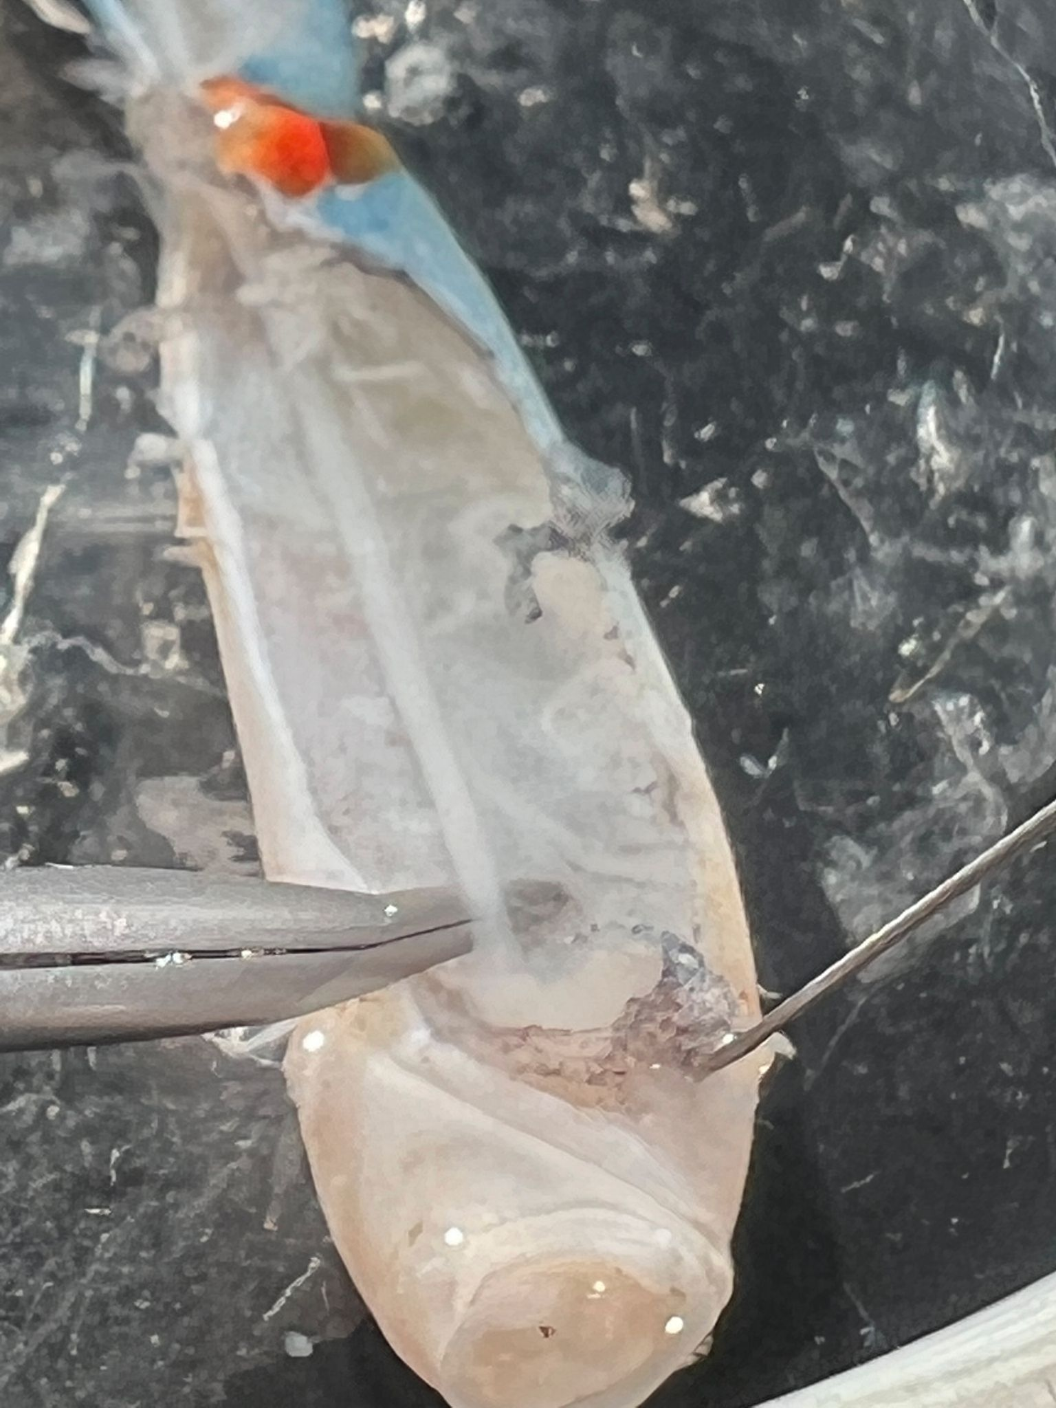
Figure 4: The nerve should now be exposed and can be cut close to the proximal end of the leg. Where the tweezers are shown in the figure.
Figure 5: The nerve can be pushed to one side and the proximal end of this segment can be removed.

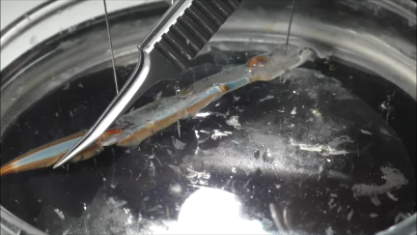

Figure 6: The leg is moved in the dish and re-pinned if it is too long to move the last most distal segment.

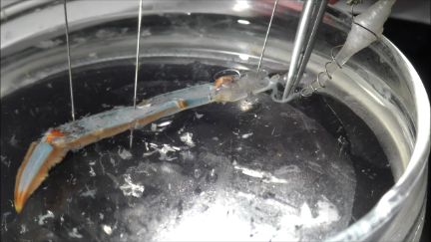
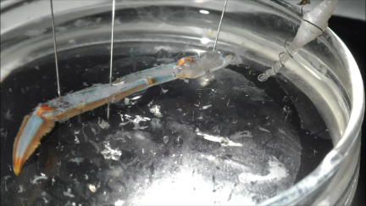
Figure 7: The nerve and suction electrode are moved so that the nerve can be pulled into the suction electrode. The glass dish is also waxed to the table to hold it in place.

Figure 8: The nerve is gentle pushed over toe the suction electrode and pulled into the suction electrode. Prior to pulling the nerve into the suction electrode saline is drawn into the suction above the wire insides the electrode.

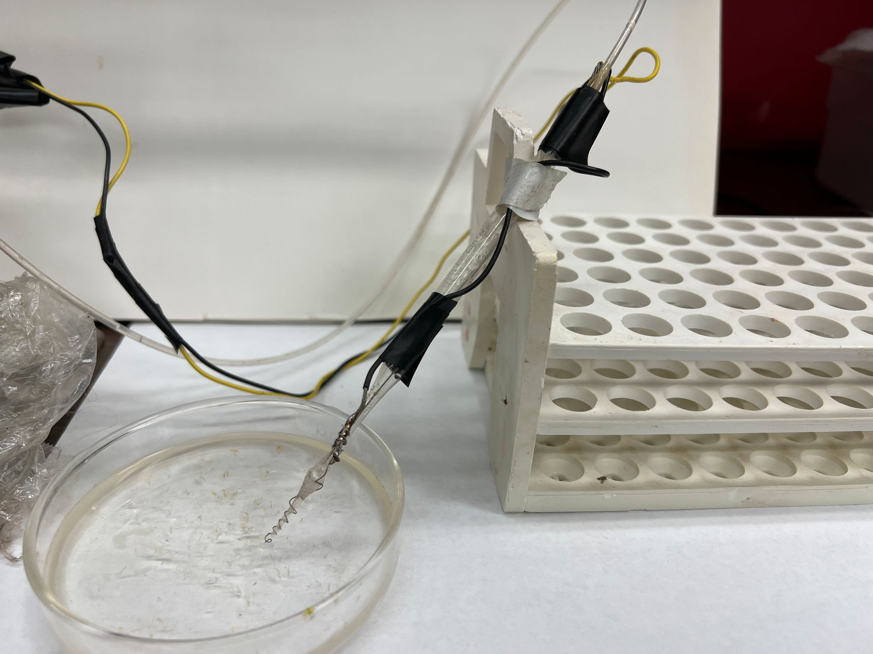
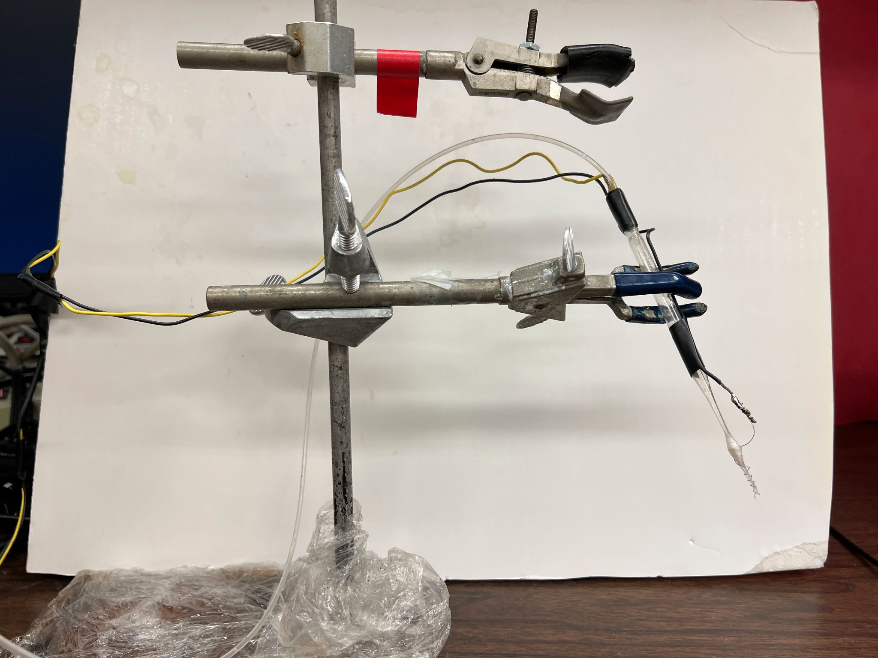
Figure 9: The suction electrode can be held on a clamp and stand to be moved over the dish
Figure 10: The suction electrode can be held basically on any object that can be moved but study enough not to move when conducting the experiments.

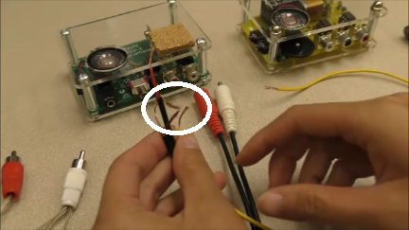
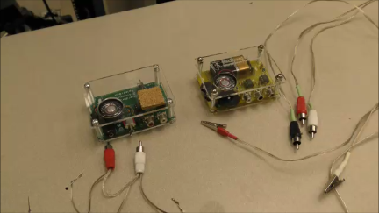
Figure 11: The Backyard brains spiker box (left) or the EMG box (right) can be used to record the electrical activity. The wire leads need to be cut and soldered to the wires on the suction electrode and to a silver wire for a ground wire for the bath.

Figure 12: The Backyard brains spiker box cables are connected in a manner that the wires around the inner core of the two wires are soldered together and to a ground silver wire to be placed in the bath. Each of the two inner core wires are soldered to one lead of the suction electrode so that one wire on the suction electrode will be to only one wire of the core wires.

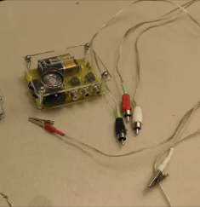
Figure 13: The Backyard brains EMG box cables are cut to remove the alligator clips.

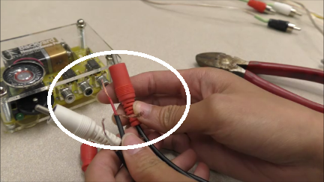

Figure 14: The Backyard brains EMG box cables are connected in a manner that the wires around the inner core of each cable is soldered to one wire. The leads are soldered to one of the wires on the suction electrode or the ground wire. The ground wire was used in these experiments as the lead to the middle port. The outer shielding wire around the inner core wire was not soldered to anything.
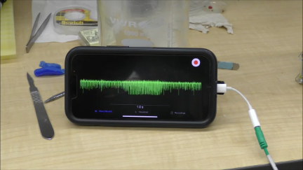
Figure 15: The Backyard brains IPHONE or IPAD AP “Spike Recorder” is used to monitor the activity. Newer IPHONEs need an lighting wire adaptor to connect to the cables provided by Backyard brains.

References

Anderberg L, Aldskogius H, Holtz A. Spinal cord injury--scientific challenges for the unknown future. Ups J Med Sci. 2007;112(3):259-88. doi: 10.3109/2000-1967-200.

Bagchi, B., Al-Sabi, A., Kaza, S., Scholz, D., O'Leary, V. B., Dolly, J. O., & Ovsepian, S. V. (2014). Disruption of myelin leads to ectopic expression of K(V)1.1 channels with abnormal conductivity of optic nerve axons in a cuprizone-induced model of demyelination. PloS one, 9(2), e87736. https://doi.org/10.1371/journal.pone.0087736

Baker MD. 2013. Potential therapeutic mechanism of K+ channel block for MS. Multiple Sclerosis and Related Disorders. 2(4): 270-280.
https://doi.org/10.1016/j.msard.2013.01.005.

Brugarolas P, Sánchez-Rodríguez JE, Tsai HM, Basuli F, Cheng SH, Zhang X, Caprariello AV, Lacroix JJ, Freifelder R, Murali D, DeJesus O, Miller RH, Swenson RE, Chen CT, Herscovitch P, Reich DS, Bezanilla F, Popko B. Development of a PET radioligand for potassium channels to image CNS demyelination. Sci Rep. 2018; 8(1):607. doi: 10.1038/s41598-017-18747-3.

Clay JR. Potassium current in the squid giant axon. Int Rev Neurobiol. 1985;27:363-84. doi: 10.1016/s0074-7742(08)60562-0.

Coggan JS, Bittner S, Stiefel KM, Meuth SG, Prescott SA. Physiological Dynamics in Demyelinating Diseases: Unraveling Complex Relationships through Computer Modeling. International Journal of Molecular Sciences. 2015; 16(9):21215-21236. https://doi.org/10.3390/ijms160921215

Correale J, Gaitán MI, Ysrraelit MC, Fiol MP. Progressive multiple sclerosis: from pathogenic mechanisms to treatment. Brain. 2017; 140(3):527-546. doi: 10.1093/brain/aww258.

de Jong CGHM, Gabius HJ, Baron W. The emerging role of galectins in (re)myelination and its potential for developing new approaches to treat multiple sclerosis. Cell Mol Life Sci. 2020 Apr;77(7):1289-1317. doi: 10.1007/s00018-019-03327-7.

Filippi M, Preziosa P, Langdon D, Lassmann H, Paul F, Rovira À, Schoonheim MM, Solari A, Stankoff B, Rocca MA. Identifying Progression in Multiple Sclerosis: New Perspectives. Ann Neurol. 2020;88(3):438-452. doi: 10.1002/ana.25808.

Hamada MS, Kole MH. Myelin loss and axonal ion channel adaptations associated with gray matter neuronal hyperexcitability. J Neurosci. 2015 35(18):7272-86. doi: 10.1523/JNEUROSCI.4747-14.2015.

Human and animal studies: https://www.ncbi.nlm.nih.gov/pmc/articles/PMC3932769/

Jensen, H. B., Ravnborg, M., Dalgas, U., & Stenager, E. (2014). 4-Aminopyridine for symptomatic treatment of multiple sclerosis: a systematic review. Therapeutic advances in neurological disorders, 7(2), 97–113. https://doi.org/10.1177/1756285613512712

Krishnan AV, Kiernan MC. Sustained-release fampridine and the role of ion channel dysfunction in multiple sclerosis. Mult Scler. 2013 Apr;19(4):385-91. doi: 10.1177/1352458512463769.

Rus H, Pardo CA, Hu L, Darrah E, Cudrici C, Niculescu T, Niculescu F, Mullen KM, Allie R, Guo L, Wulff H, Beeton C, Judge SI, Kerr DA, Knaus HG, Chandy KG, Calabresi PA. The voltage-gated potassium channel Kv1.3 is highly expressed on inflammatory infiltrates in multiple sclerosis brain. Proc Natl Acad Sci USA. 2005;102(31):11094-9. doi: 10.1073/pnas.0501770102.

