Synaptic Responses, Neuronal Circuitry and Neuromodulation Using the Crayfish: Student Laboratory Exercises

By

Alison L. Thurow¹, Brittany Baierlein¹, Harold L. Atwood² and Robin L. Cooper¹

¹Department of Biology, University of KY, Lexington, KY 40506-0225, USA;
²Department of Physiology, University of Toronto,
Toronto, Ontario, M5S 1A8 Canada

ABSTRACT

The purpose of this exercise is to help develop an understanding synaptic transmission. The crayfish abdominal extensor muscles are in groupings with some being tonic (slow) and others phasic (fast) in their biochemical phenotypes, structure as well as the motor neurons that innervate them. We use these muscles as well as the superficial, tonic abdominal flexor muscle to demonstrate properties in synaptic transmission. In addition, we introduce a sensory-CNS-motor neuron-muscle circuit to demonstrate the effect of cuticular sensory stimulation as well as the influence of neromodulators on each aspect within the circuit. With the techniques obtained in this exercise, one can utilize them to answer many questions remaining in other experimental preparations as well as in physiological applications related to medicine and health. We have demonstrated the usefulness of a model invertebrate preparations to address fundamental questions pertinent to all animals.

INTRODUCTION

The abdominal extensor muscle preparation used to demonstrate the resting membrane potential is also ideal for demonstrating induction of synaptic responses at the NMJs from the various muscles. Some muscles in crustaceans are selectively innervated by either a phasic or a tonic motor neuron, although some single fibers can be innervated by both phasic and tonic excitatory motor neurons, such as for extensor muscle in the crayfish walking legs (Atwood, 2008; see JOVE production id#2319-Wu and Cooper, 2010) and most other limb muscles (Wiersma, 1961a). By selectively stimulating phasic and tonic motor neurons, physiological differences in the EPSPs may be measured. Phasic motor neurons produce rapid twitching of muscle fibers and evoke EPSPs on the order of 10–40 mV. The phasic response can depress rapidly with 5–10-Hz trains of stimulation. The tonic motor neurons give rise to smaller EPSPs that can be facilitated in the presence of a higher frequency (10–50 Hz) of stimulation. Structurally, the presynaptic phasic and tonic terminals at the NMJs are different (Atwood and Cooper, 1996; Bradacs et al., 1997; Cooper et al., 1998).

Surprisingly the phenotype of the phasic physiological responses can undergo a transformation to a tonic-like state by electrically conditioning phasic neurons for a few hours daily over 7 days (Cooper et al., 1998; Mercier and Atwood, 1989). Also the sensitivity to neuromodulation of the transformed NMJs is prime for investigating the regulation of receptor expression (Griffis et al., 2000).

In this relatively robust preparation (crayfish abdominal muscles), both tonic and phasic responses are easily recorded and examined for facilitation and/or depression of the synaptic responses with varied stimulation paradigms. With these preparations, students will be able to recognize generalities of the phasic and tonic synaptic responses by stimulating a nerve bundle.

An additional NMJ preparation presented is used for monitoring intrinsic motor activity and sensory stimulus induced motor activity from the CNS. This is the superficial flexor muscle on the ventral side of the crayfish abdomen. This preparation will also be used to monitor the sensory-CNS-motor-muscle circuit and the effects of neuromodulators (Strawn et al., 2000).

In each of the abdominal segment (except the last) there are three functional groups of muscles: (1) those controlling pleopod (swimmerets) movement, (2) three extensor muscles and (3) three flexor muscles. The flexors and extensors are antagonistic groups of muscles which bring about either abdominal flexion or extension by causing rotation about the intersegmental hinges. The phasic musculature occupies most of the volume of the abdomen, while the tonic muscles comprise thin sheets of fibers that span the dorsal (extensors) and ventral (flexors) aspect of each abdominal segment.

In crayfish, the tonic abdominal flexor muscles of crayfish are innervated in each half segment by five motoneurons and by a peripheral inhibitory neuron. The excitatory motoneurons use glutamate as a neurotransmitter. Glutamate depolarizes the muscle fibers by causing an increase in permeability primarily to sodium ions. The inhibitory neurons release gamma-amino butyric acid (GABA), which usually hyperpolarizes the muscle fibers by causing an increase in permeability to chloride ions. In some crustacean muscles (mainly in limbs), the peripheral inhibitory neurons make synaptic contacts with motor neuron terminals as well as with the muscle fibers, and reduce the amount of transmitter released by the motor neuron (presynaptic inhibition) (Dudel and Kuffler, 1961). This phenomenon is not present in the tonic flexor muscles of crayfish.

The ventral nerve cord of crayfish is a bilaterally symmetrical structure running the length of the animal. There is one ganglion per body segment. In the abdomen (6 segments), each ganglion contains several hundred neurons, and each of the two connectives consists of a few thousand axons. The nerve cell bodies form a layer several cell bodies thick on the ventral surface of each ganglion. Immediately above the cell body layer is a fine meshwork of neuronal processes, the neuropile. All synaptic interactions occur here; the cell bodies are devoid of synapses.

Each abdominal ganglion (except the last) has three roots on each side. The first root contains axons of neurons innervating the pleopod musculature and sensory axons; the second root contains axons innervating phasic and tonic extensor musculature and sensory axons; and the third root, which leaves the nerve cord several millimeters caudal to the ganglion, contains axons innervating phasic and tonic flexor musculature. There are two branches of the third root. The deep branch (IIIa) innervates only phasic flexor muscles. The superficial branch of the third root (IIIb) in each half-segment contains six axons, which innervate the tonic flexor muscles.

The neurons innervating the tonic flexor are spontaneously active, unlike the phasic efferent neurons, and in a good preparation, they will continue to fire for many hours after the abdomen has been removed from the animal. For a review of the historical nature of the discoveries made in these abdominal preparations see Atwood (2008). The cell bodies of four of the motor neurons and of the peripheral inhibitory neuron innervating the tonic flexor muscle in any half segment are located in the ganglion of that segment. The cell body of the remaining motor neuron is located in the next caudal ganglion. These neurons may be reliably distinguished from each other on the basis of extracelluarly recorded spike amplitudes. If the tonic flexor muscle from one half segment is removed along with the two ganglia containing the neurons innervating this muscle, five neurons usually show some degree of spontaneous activity. These neurons are numbered on the basis of relative extracellular spike amplitude, in ascending order. f1 to f4 are motoneurons and f5, the largest spontaneously active neuron, is the peripheral flexor inhibitor. f6, the largest motor neuron, is an excitatory motor neuron which is seldom spontaneously active.

The spontaneous nature of tonic motor neuron activity can be modulated by exogenous application of compounds or by providing a sensory stimulus to the cuticle within the same segment that is being monitored for motor nerve activity.

Dissection

To obtain the abdominal extensor preparation the same procedure as described above for examining the resting membrane potentials in relation to extracellular potassium. The difference is to take care of the segmental nerve bundle that runs along the side if the carapace. This nerve will be pulled into a suction electrode which will serve as the stimulating electrode. Stimulate at 1 Hz for monitoring phasic responses. Stimulate with short bursts of pulses 10Hz for 10 to 20 stimuli while monitoring the tonic responses.

The experimental procedures for caring out experiments on the crayfish tonic flexor muscles are different and one needs to leave the ventral nerve cord intact. A preparation consisting of several abdominal segments is made. This is obtained as follows:

1. A crayfish approximately 6-10 cm in body length should be obtained (or a manageable size). Obtain the crayfish by holding it from the back of the head or approximately 2 or 3 centimeters from the back of the eyes. Ensure that the claws of the crayfish or mouth cannot reach the experimenter when handling the crayfish. Dispose of the head and appendages after removing them.

2. Use the scissors to quickly remove the head. Make a clean and quick cut from behind the eyes of the crayfish.

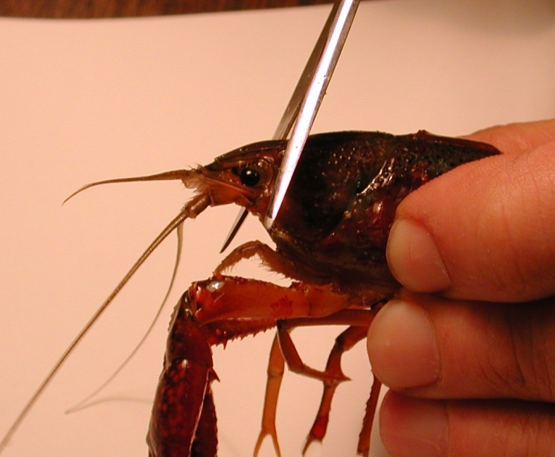
Figure 18: Image shows placement of the cut to remove the head of the crayfish.

The legs and claws of the crayfish can be removed at this point to avoid injury. Stylets on males and swimmerets on both males and females can also be removed (Figure 19 and 20). Next, separate the abdomen from the thorax. Make a cut along the articulating membrane which joins the abdomen and thorax (Figure 20).

3. Save the abdomen portion of the crayfish and dispose of the thorax.

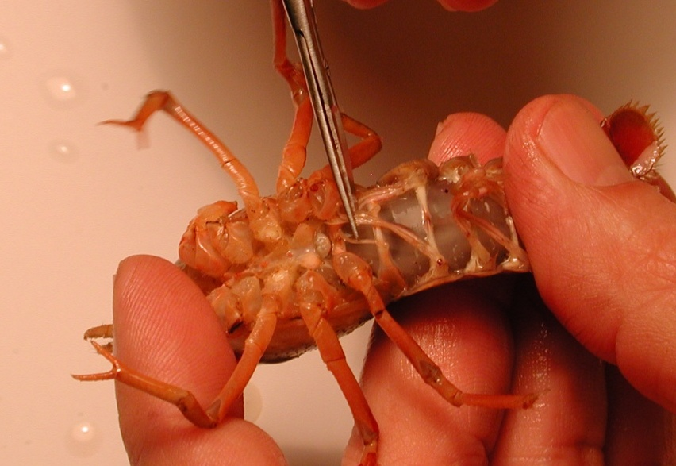
Figure 19: Image shows the placement of the stylets that can be removed from the crayfish.

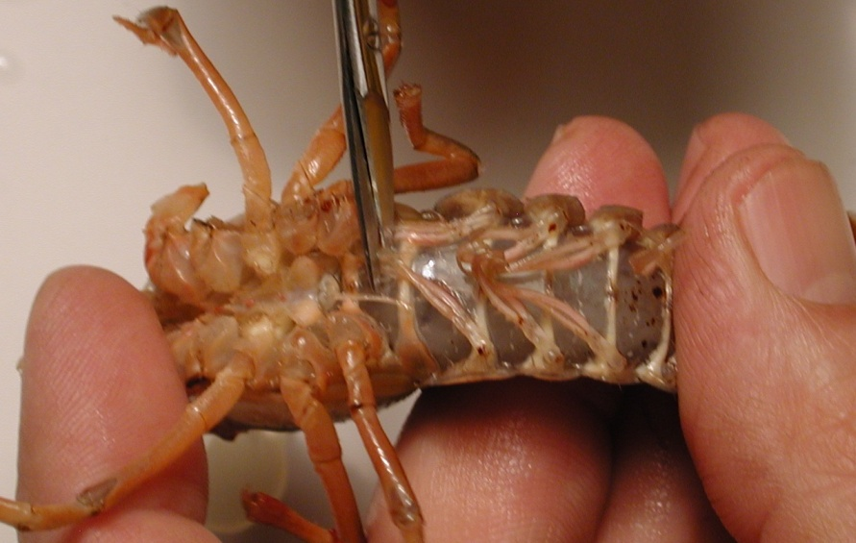
Figure 20: Image shows the placement of the cut to remove the thorax from the abdomen.
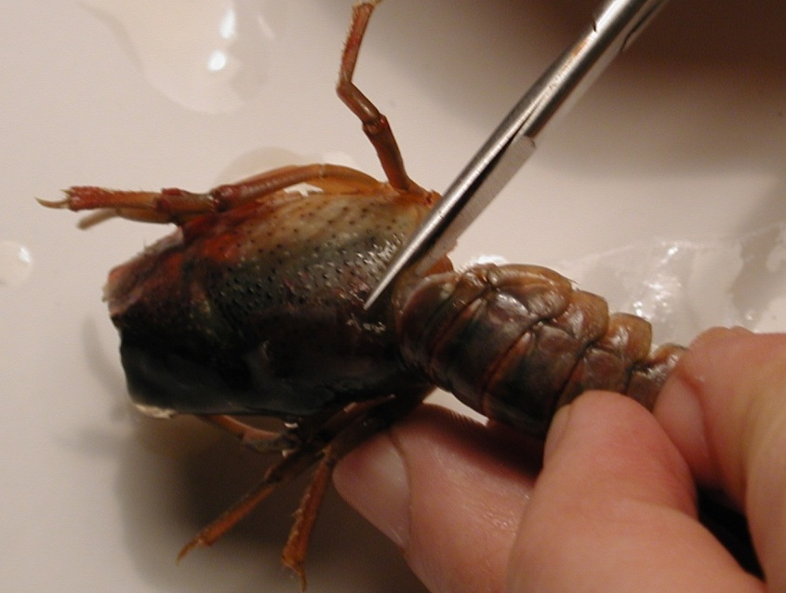
Figure 21: Removal of the thorax from the abdomen. The cut should be made in circular fashion along the line of the joining of the segments.
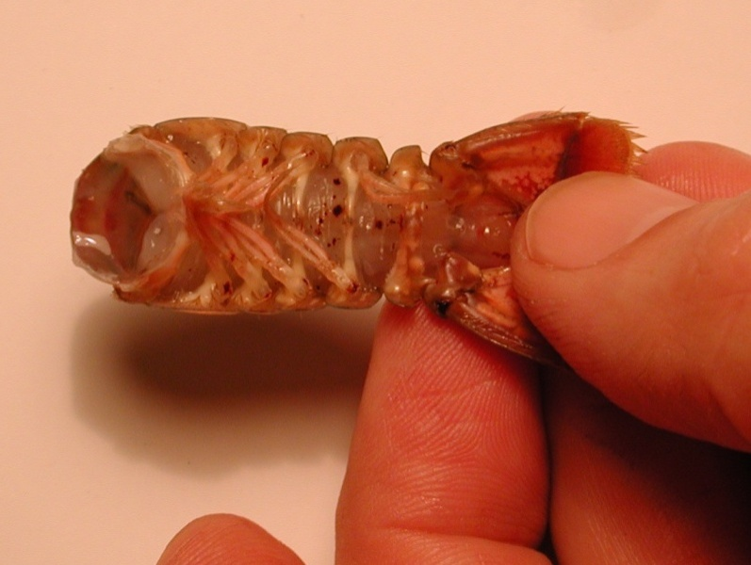

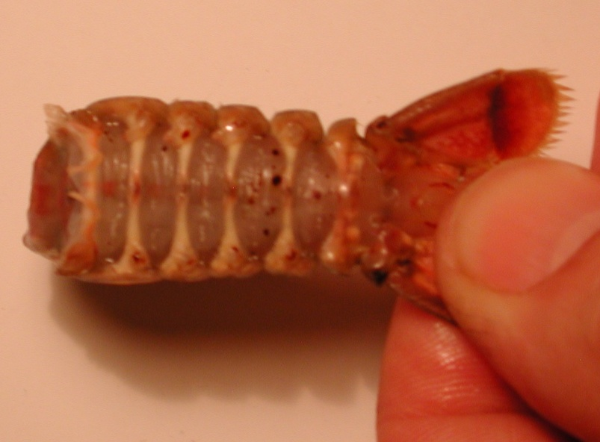
Figure 22: The top image shows the abdomen with appendages. Bottom image shows the removal of the abdominal appendages.

4. Place the isolated tail preparation in saline solution in a large Petri dish. Pin down the tail and upper portion of the preparation to the dish. Make sure the preparation is secure. Use a scalpel to remove a square portion of the ventral side of the preparation between the ribs.

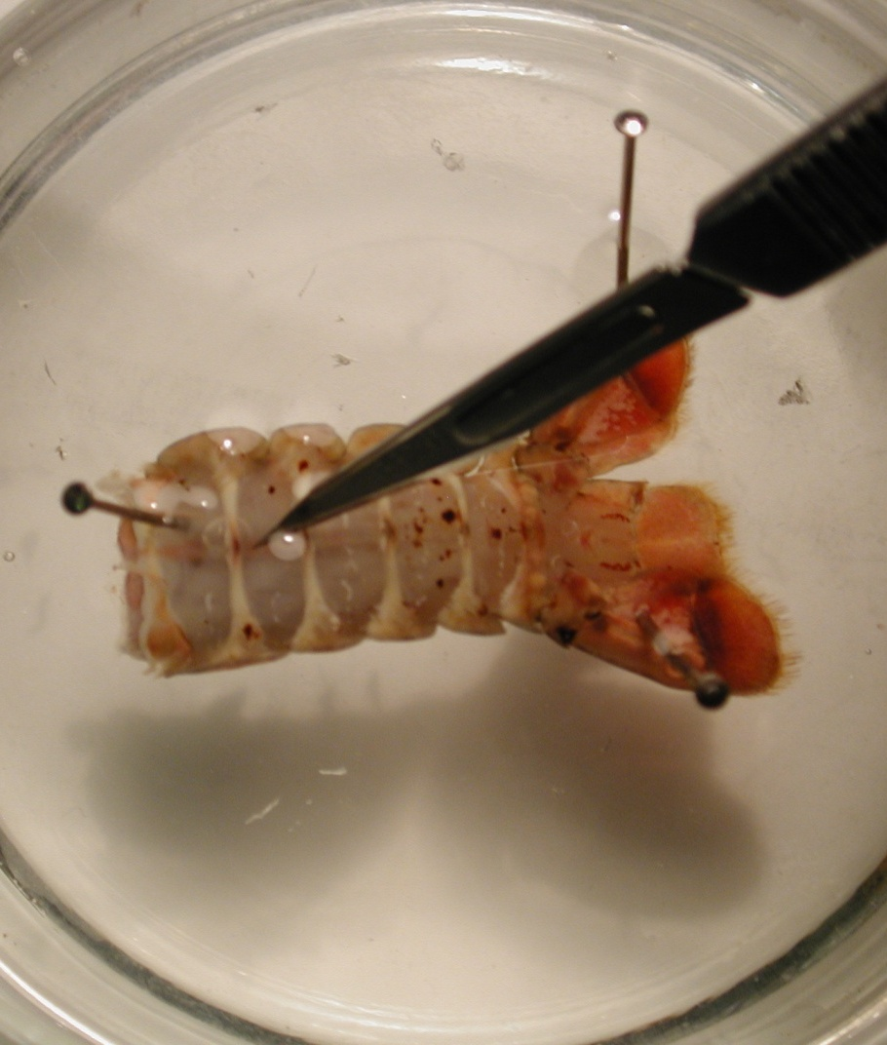
Figure 23: Shows where the cut should be made to remove the ventral potion of the preparation.

- A small cut should be made (can also be done with scissors). A flap should be cut and lifted upward. The flap can then be removed with scissors, exposing the deep flexor muscles. The microscope should be used during this process to ensure precision in removing the ventral portion of the preparation.
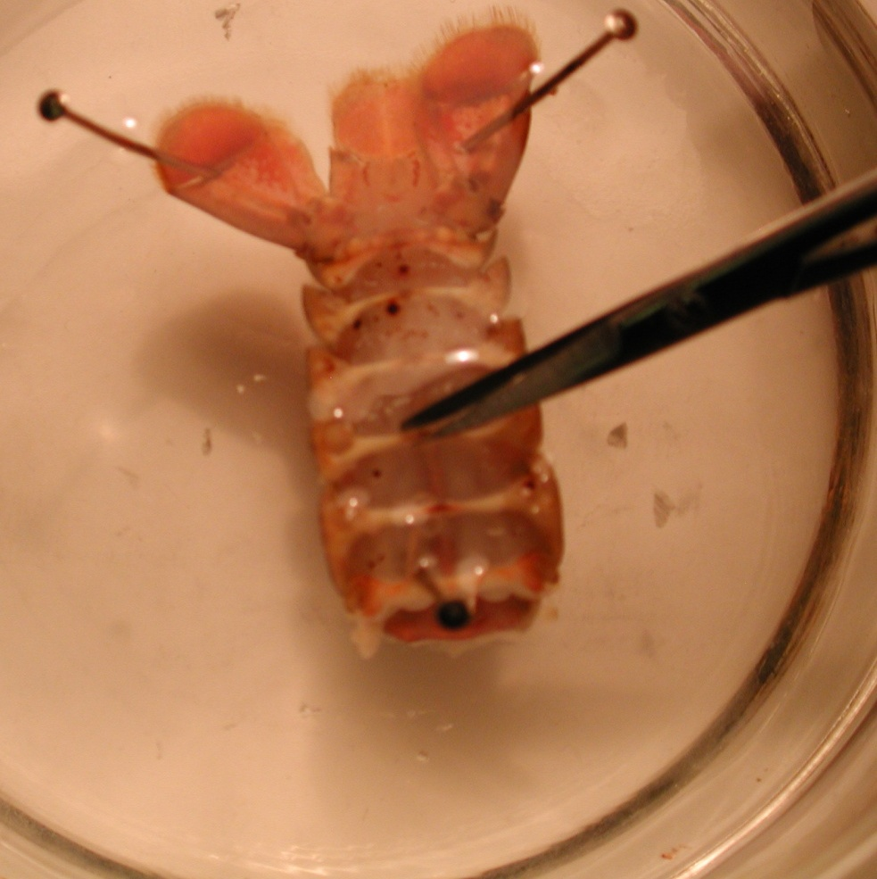
Figure 24: Cutting preparation with scissors to expose muscles.

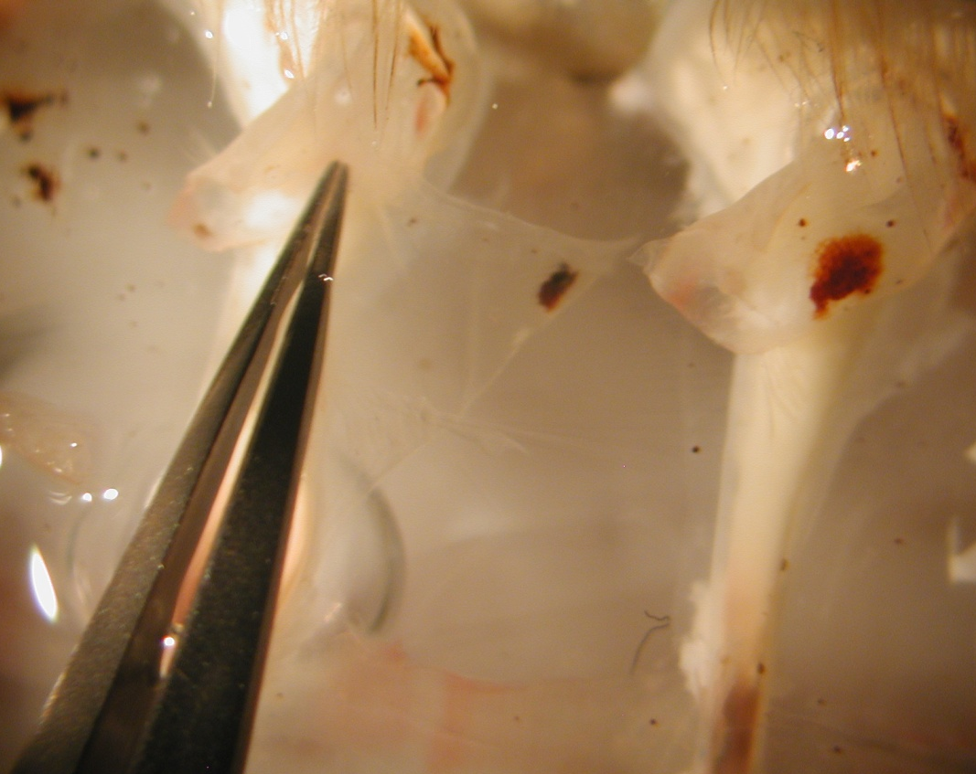

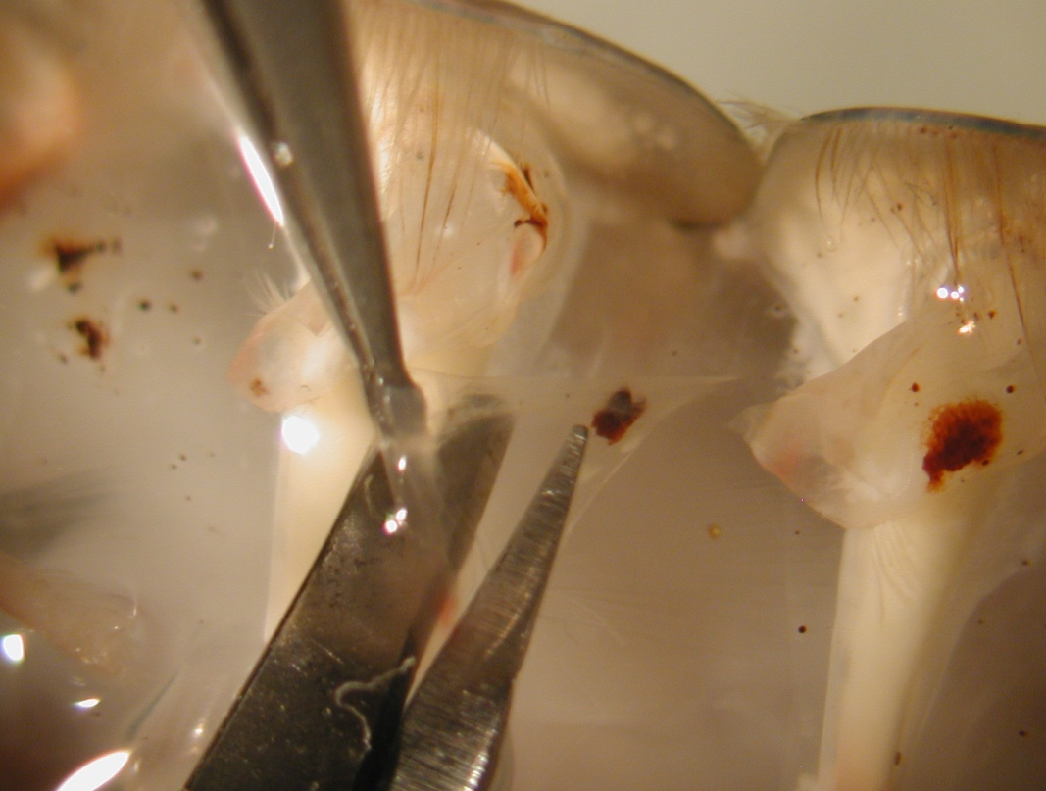
Figure 25: Top image shows the grasping of the flap with forceps. Bottom image shows the removal of the flap from the preparation using the microscope.

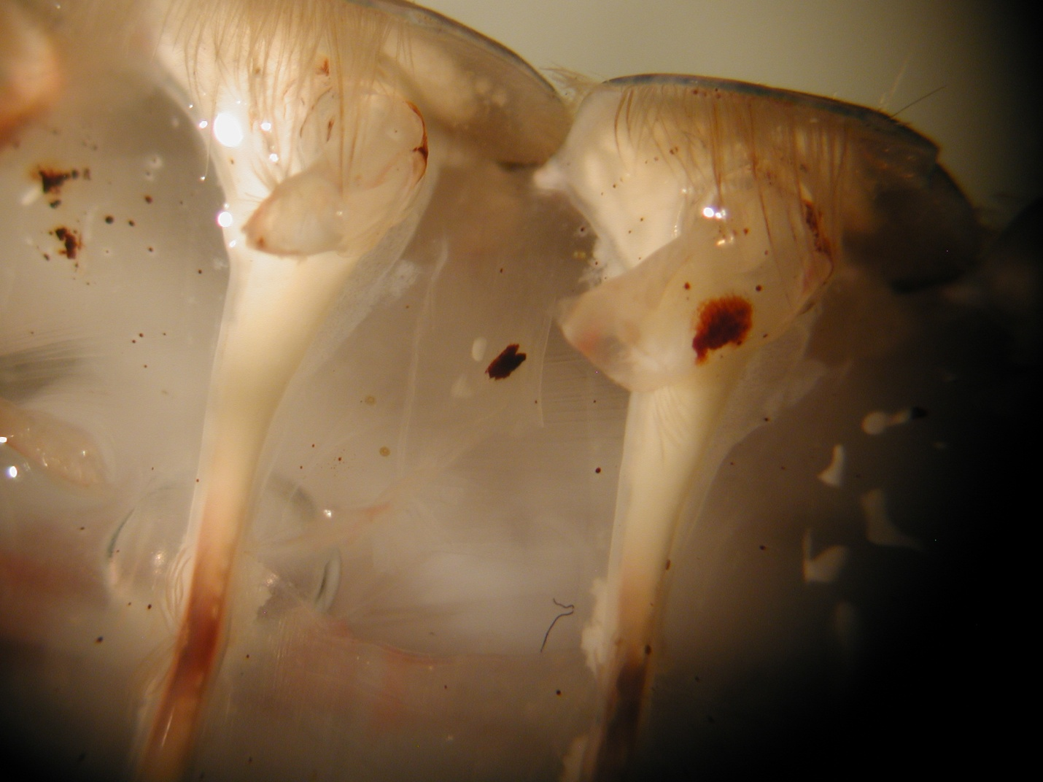
Figure 26: Exposure of the superficial flexor muscles.

5.3) Intracellular Recording:

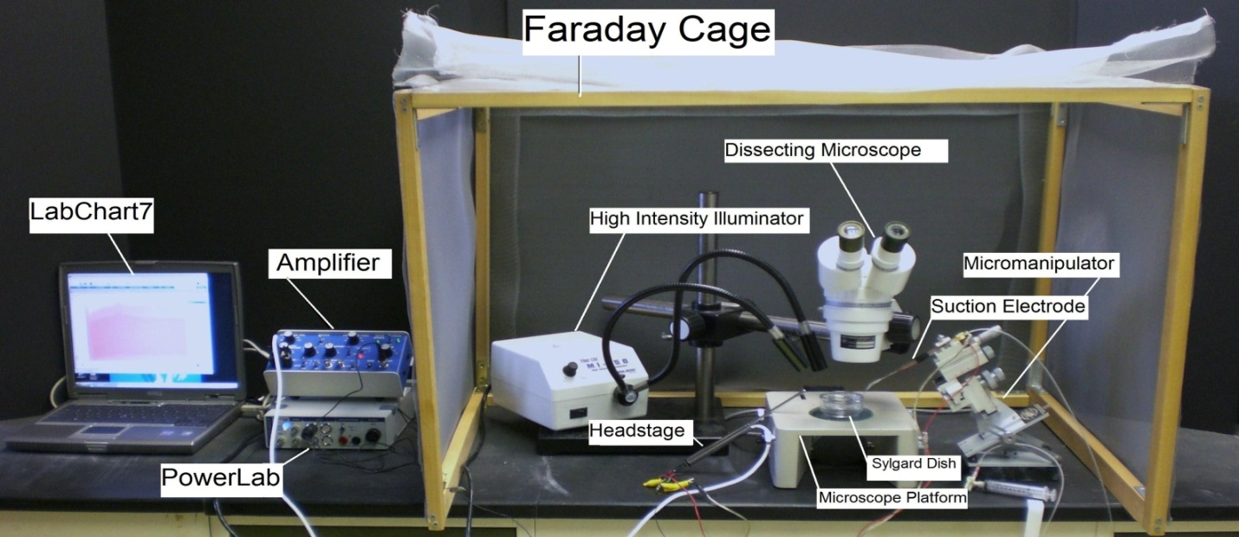
Figure 27: Overall setup of the recording equipment.

1. The Petri dish with preparation should be placed under the microscope and secured with wax at the bottom of the dish to prevent movement.

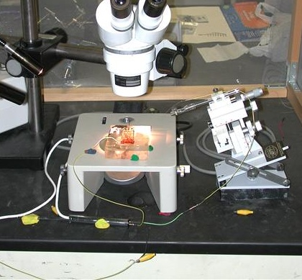
Figure 28: Shows the placement of the preparation under the microscope. Use wax to secure the Petri dish and preparation.

UPDATE 10/16/2010:
We are not using the amplifier and head stage in the movie or in this write up. You will use an upgraded version of the intracellular electrode holder and amplifier. You will be shown in lab during the introduction.

2. Two wires with short length of silver wire attached to one end should be obtained. The silver wire should be dipped into a small amount of bleach for about 20 minutes to obtain a Ag-Cl coating. Wash the wire with water before using. A glass intracellular pipette should be obtained and carefully filled with a KCl (3 M) solution. The pipette should be turned down (with the opening facing the floor) and filled with solution. The latter will ensure that any excess KCl will drip out the back of the electrode. Be sure no KCl runs along the glass pipette that will enter into the saline bath. Turn the pipette upright when finished filling with potassium chloride solution. The silver wire can then be placed into the pipette. The other end is connected to the +(positive) pole on the head stage. The pipette is then secured on the electrode probe. Care should be made not to break the electrode pipette. A third wire attached to the Faraday cage should be placed into the green pole of the head stage. Lastly the Ag wire of the remaining lead should be placed in the bath and the other end attached to the – (negative) pole shown below. A wire should also be placed from the Faraday cage to the ground portion of the AD converter Powerlab. The head stage is connected to the “input-probe” on acquisition/amplifier (Powerlab).
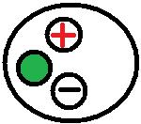
Figure 29: Head stage configuration. The wire connected to the green portion of the head stage is grounded to the amplifier or Faraday cage. The wire connected to the red portion is connected to the electrode wire. The black portion is used to connect to the bathing solution.

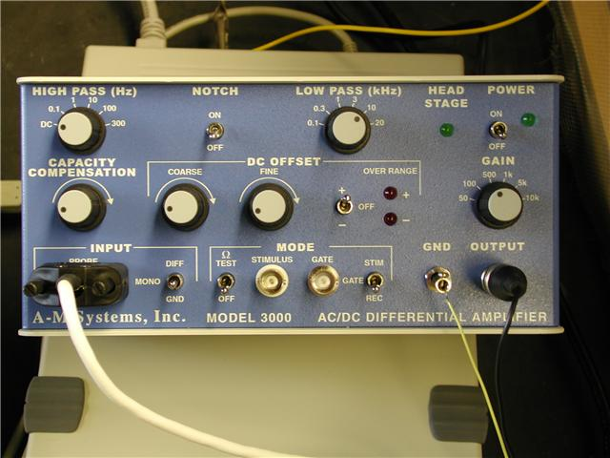
Figure 30: “Test toggle” is in the bottom row to test electrode resistance. The “coarse” knob is also found under DC offset which should be turned counter clock wise. Gain is set to 50, which amplifies signals by a factor of fifty. The ground wire from the head stage is placed in the “GND” pin jack opening.

3. The LabChart software should be opened on the desktop or laptop. Adjust the chart to display only one channel by click “Setup”, then “Channel settings.” Under “Channel settings,” change number of channels to one. Click “OK.” At the top of the chart, left hand corner, cycles per second should be 2K. Set volts (y-axis) to around 200mV to 500mV. Click on “Channel 1” on the right hand portion of the screen. Click “Input Amplifier.” Make sure the following setting is checked:
- Differential

The amplifier output should be in channel one. The following settings should be used with the amplifier:
  - High Pass- DC
  - Notch Filter- OFF
  - Low Pass- 20kHz
  - Capacity Comp.- counterclockwise
  - DC Offset Fine and Course knob- counterclockwise
  - DC Offset (+OFF-)- OFF
  - Gain knob- 50
  - Input (DIFF MONO GND)- Diff
  - MODE(STIM-GATE-REC)- REC
  - ΩTEST- OFF

4. To measure the electrode resistance, the voltage should be divided by the current, which is 2.0 nA. The resulting value is the resistance of the glass electrode. The resistance should be 20 to 60 MegaOhms. Once the resistance has been determined, intracellular recordings can begin. Place the tip of the glass electrode into the saline bath. Make sure a ground wire is also in the saline bath.

To begin recording, press “start” at the bottom of the screen. Make sure the gain is set to 5 V/div. Use the course knob on the amplifier to move the line on the LabChart to zero before inserting the electrode. The toggle knob should be turned on and then off several times in order to test the electrode resistance. Next, the amplitude of the resulting values should be measured. Place one maker the steady base line and then place the second at the peak to obtain the electrode resistance.

5. Use the electrode probe and microscope to insert the electrode into the muscle. Do not penetrate through the muscle. Use microscope and probe settings in order to find the thin layer of muscle fiber and to insert the electrodes into the fibers. The high intensity illuminator can be used as a light source when penetrating the muscle.
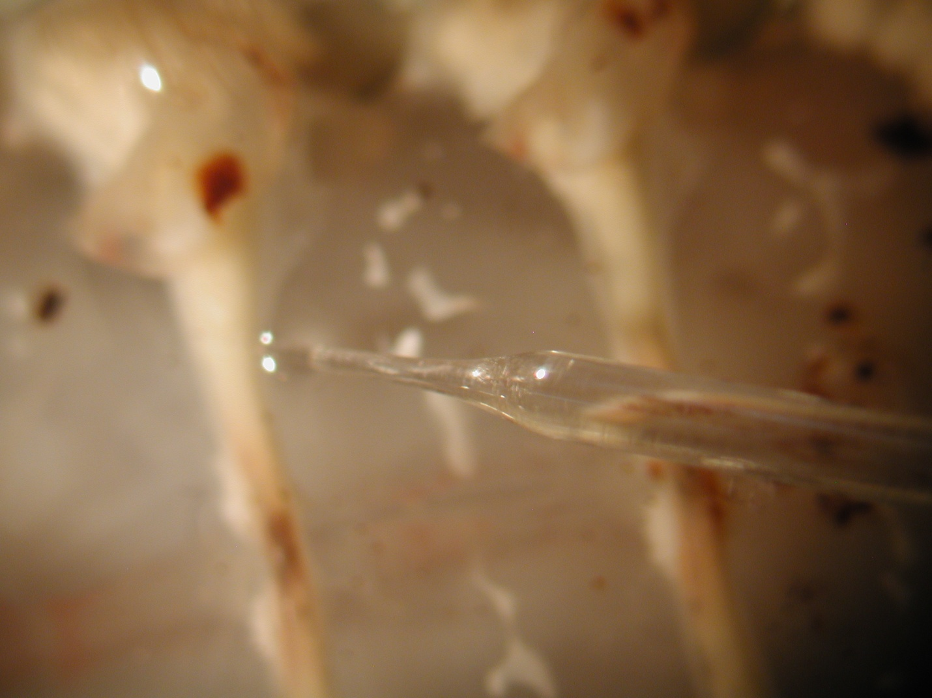
Figure 31: Insertion of electrode into the muscle.

6. Care must be taken to avoid damaging the nerve roots to the superficial muscles.

It is advisable to keep the saline bathing the preparations cool (10-15 degrees Celsius) and well oxygenated while carrying out the experimental procedures. If cooling units are not available replace the saline with fresh, cooled saline regularly. Oxygen gas, or at least air, should be bubbled through the saline.

7. Record the spontaneous activity of the EPSPs. Note the different sizes of the EPSPs and if IPSPs are present.

8. Very carefully take a small paint bush and by hand stimulate along the cuticle edge within the same segment that one is monitoring the spontaneous activity. Note a change in frequency of the responses and if different size EPSPs appear that were not there prior to stimulating the cuticle.

Figure 32: Preparation with stimulating brush and nerve roots. (modified from Strawn et al., 2000)

9. The stimulation can be repeated after carefully exchanging the saline bath with one containing a neuromodulator such as serotonin (1 microM) or saline bubbled with CO₂. Note the effect on the activity profile for a given stimulus. Also note if exchanging the saline back to fresh saline returns the activity to its initial condition.

10. Next, one can monitor neural activity within the sensory-CNS-Motor neuron circuit in various ways. We can use a suction electrode instead of an intracellular electrode (Figure 33) to monitor motor neuron activity. At the tip of the glass suction electrode, plastic tubing is placed which has an opening of the correct size to pull the nerve into the tip. The opening should not be too large, as the nerve would fall out; or too small, because the nerve would be damaged by the pressure of the electrode. The plastic tubing is pulled over a flame and trimmed back to the size needed.

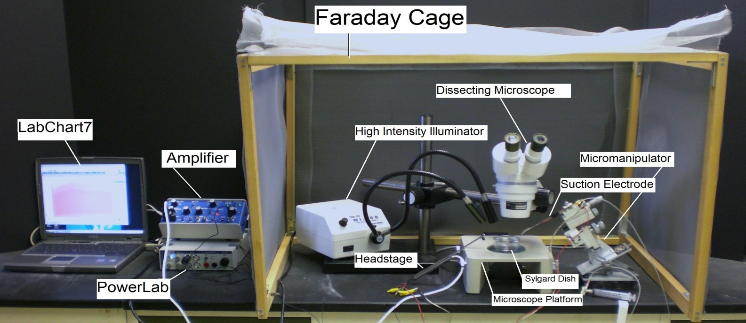

Figure 33: Set up with suction electrode recording arrangement.

Position the micromanipulator in a position where the suction electrode has easy access to the saline bath. Suction up saline until it is in contact with the silver wire inside the suction electrode. Arrange the other wire on the cut-side of suction electrode close to the tip of electrode, so both wires will be in contact with the saline bath.

As for the electrical monitoring connect the AC/ DC Differential Amplifier (amplifier) to the Power Lab 26T. Do this by connecting the proper cord from Input 1 on the PowerLab 26T to the output on the amplifier.
- The amplifier instrument controls should be set to the following settings:
  - High Pass- DC
  - Notch Filter- OFF
  - Low Pass- 20kHz
  - Capacity Comp.- counterclockwise
  - DC Offset Fine and Course knob- counterclockwise
  - DC Offset (+OFF-)- OFF
  - Gain knob- 50
  - Input (DIFF MONO GND)- Diff
  - MODE(STIM-GATE-REC)- REC
  - ΩTEST- OFF

Connect the head stage to the ‘input- probe’ on the amplifier.
Connect the electrical wires from the suction electrode to the head stage. The wires should be connected with the red (positive) at the top left, green (ground) in the middle, black (negative at the bottom. This is indicated in Figure 34. The ground wire can just be put in the saline bath.

Figure 34: Head stage configuration

10. Now connect the USB cord from the PowerLab 26T to the laptop. Ensure that both the amplifier and PowerLab26T are plugged in and turned on before opening LabChart7 on the computer.

11. Open LabChart7.
- The LabChart Welcome Center box will pop open. Close it.
- Click on Setup
- Click on channel settings. Change the number of channels to 1 (bottom left of box) push OK.
- At the top left of the chart set the cycles per second to about 2k. Set the volts (y-axis) to about 500 or 200mv.
- Click on Channel 1 on the right of the chart. Click on Input Amplifier. Ensure that the settings: single-ended, ac coupled, and invert (inverts the signal if needed), and anti-alias, are checked.
- To begin recording press start.

We can record from the branch of the 3rd root that innervates the superficial flexor muscle (branch IIIb) to monitor size of the action potentials with extracellular recording. The extracellular nerve impulses are referred to as ‘spikes’. Recall that there are five excitor motor neurons and one inhibitor motor neuron in this root (Kennedy and Takeda, 1965; Velez and Wyman, 1978). Stimulation of the cuticle with a brush or the exposure of neuromodulators can be utilized (Figure 35). The paintbrush could be used by hand or for consistent stimulation it could be mounted on a micromanipulator to control the amount of pressure and movement.

Figure 35: Activity of the 3rd root before and during cuticular stimulation in saline (top) and in 100 nM 5-HT (bottom). The time during cuticle stimulation is indicated by the bar. Note the enhanced activity before and after stimulation when the preparation is bathed in 5-HT (modified from Strawn et al., 2000).

We can record from the 1st or 2nd roots by making an en passant recording of the nerve; or we can transect the root away from the VNC and record pure sensory input arising from the periphery which would be sending signals into the VNC. Thus, you would record from the transected root leading to the periphery for sensory activity.

The 2nd root contains very large primary afferent axons from the muscle receptor organs (MRO) and smaller axons of efferents to extensor motor neurons (Fields and Kennedy, 1965). There are many sensory axons in the 1st and 2nd roots.
The mechanosensory neurons have direct connections, by electrical synapses with the lateral giant axons (LG) (Krasne 1969; Zucker 1972). Also, mechanosensory neurons are known to excite interneurons via chemical synapses.

To examine how sensory input can influence motor neuron activity, through a sensory-CNS-motor neuron circuit, we can record the synaptic responses in a muscle. Various aspects of the circuit we will use can be examined. For example, we can record from the sensory nerve root alone or the motor root with or without intact sensory input into the VNC To analyze the spike frequency recordings, one can count over a period time in different conditions. The measures can be made prior to brush stimulation and during the brush stimulation for a given amount of time (Figure 35). One can repeat the conditions 5 times and obtain the average percent change in frequency as a measure to make comparisons.

One can also apply exogenous compounds such as serotonin (Strawn et al., 2000) or acetylcholine (Ach), nicotine or glutamate. Various behavioral actions have been described for nicotine in invertebrates. This would suggest the presence of nicotinic receptors (Tsunoyama and Gojobori, 1998). Glutamate is a major excitatory neurotransmitter in most invertebrates at the NMJ and Ach is the major excitatory neurotransmitter within the CNS (Monoghan et al, 1989; Watkins, et al., 1990).

One can try heptanol or CO₂ bubbled saline since it will uncouple the crayfish septate (or gap) junctions within the circuit as Dr. Sonya M. Bierbower (University of Kentucky) has shown in her dissertation research. This action may account for altered whole animal behavior when exposed to high CO₂ in the environment (Bierbower and Cooper, 2010). When you stimulate the cuticle with a brush and drive sensory input and record a response in the motor neurons, note if there is a difference in the activity before and during heptanol or CO₂ exposure. This may or may not suggest gap junctions to have a role in the sensory-CNS-motor neuron circuit.

DISCUSSION

The details provided in the associated movie and text has provided key steps in order to sufficiently record membrane potentials and investigate muscle structure as discussed in the first part of this report. In the second part, the demonstration of how to dissect and record synaptic transmission at the NMJs of phasic and tonic motor units provided an exposure to the potential for these preparations in student run investigative laboratories to teach fundamental concepts in physiology. The exposure to a neural circuit, which can in part, can be used to explain associated intact animal behaviors has potential not only for students to investigate various open ended questions within their laboratory exercise but also for future research in dissecting out neuronal circuits in a well established invertebrate preparation (Kennedy et al., 1969; Antonsen and Edwards, 2003)

These preparations can be used to investigate synaptic facilitation, depression and long-term plasticity. Even within some species of crayfish they show neuronal plasticity depending on the experimental stimulation conditions (Mercier and Atwood, 1989; Cooper et al., 1998) as well as their natural environment. To what extent the ability to alter synaptic efficacy and muscle dynamics serves the animal remains to be investigated. Since crayfish do alter their behavior in relation to seasonal variation and the molt cycle, there are relatively long-term activity differences in their neuromuscular systems. It has been shown that the phasic motor nerve terminals of claw closer muscles exhibit the classic phasic morphology during the winter, but swell and become more varicose along the length of the terminal during the summer months (Lnenicka 1993; Lnenicka and Zhao, 1991).

Some early studies conducted in crayfish lateral giant (LG) interneurons within the ventral nerve cord demonstrated the presence of gap junctions (Johnson, 1924; Watanabe and Grundfest, 1961). It is well known that CO₂ has an effect on electrical communication by uncoupling gap junctions (Arellano et al, 1990). It was recently shown that the nerve cord and communication within the sensory-CNS-motor-muscle circuit, as described in this report, is also sensitive to CO₂ exposure, indicating the presence of gap junctions (Bierbower, 2010; Bierbower and Cooper, 2010)

The phenomena of the spontaneous activity of the 3rd motor root has been a topic since the 1960’s when Eckert (1961) examined if the tonic firing static muscle receptor organ (MRO) within the same or neighboring segment could account for the spontaneous motor drive. In these earlier studies it became apparent that the activity was driven within the ventral nerve cord (VNC) possibly from higher centers (Eckert, 1961; Kennedy and Takeda, 1965a,b; Strawn et al., 2000). Since the presence of CO₂ stopped the spontaneous activity, one can assume somewhere in the drive to the motor neurons there might be gap junctions or even glutamatergic excitatory drive. The NMJs are blocked or present a decreased sensitivity to glutamate in the presence of CO₂, so it is likely that they maybe blocked as well within the CNS (Bierbower, 2010; Bierbower and Cooper, 2010; see also Badre et al., 2005).

The action of various neuromodulators is also readily studied at the various types of NMJs (Cooper and Cooper, 2009; Griffis et al., 2000; Southard et al., 2000; Strawn et al., 2000) presented in addition to the influences on various aspects of the CNS circuitry. It has been suggested that the 5-HT and octopaminergic neurons may function as ‘gain-setters’ in altering the output of neuronal circuits (Ma et al., 1992; Schneider et al., 1996; Hörner et al., 1997; Edwards et al., 2002). Much work remains to be done before we can fully understand the effects of neuromodulators on individual target cells. Given that different neuromodulators may work in concert with one another, analysis of their mixed action is an area for future research (Djokaj et al., 2001). In addition, few studies, particularly in the vertebrates, address the effects of neuromodulators on entire pathways which can regulate a specific behavior. In this sensory-CNS-motor unit preparation one can examine the influence of both sensory input and neuromodulators on the activity of the motor neurons (Kennedy et al., 1969).

Since it has been postulated that 5-HT plays a role in regulating the behavioral state of the crayfish, lobsters, and crabs (Livingstone et al.,1980; Sneddon et al., 2000), several attempts have been made to determine its concentration in the VNC, the hemolymph, and in isolated ganglia of lobsters (Livingstone et al., 1980; Harris-Warrick and Kravitz 1984; Fadool et al., 1988). However, there has been considerable variation in the recorded measurements which eludes a specific dosage and effect relationship to account for behavioral actions.

A crayfish with the claws held in a raised position with the tail tucked under its abdomen was touted as a dominate posture (Livingstone et al., 1980). The state of abdominal flexion in crayfish does not appear to be the posture that dominant crayfish, within a pair, exhibit during the social interactions or while maintaining a dominant hierarchical status (Listerman et al., 2000). Submissive crayfish will even tuck their abdomens under themselves as they cower to an opponent. Such tail tucking is also seen as a defense posture (Listerman et al., 2000). These behaviors have been readily observed in the field and in laboratory settings (Bovbjerg, 1953, 1956; Bruski and Dunham, 1987; Li et al., 2000; Listerman et al., 2000). Interestingly, the behavioral postures noted in lobsters (Livingstone et al., 1980) are reversed for 5-HT and octopamine injections in the Australian crayfish, Cherax destructor (McRae, 1996). Possibly, entirely different responses would be observed in the superficial flexor preparation in the Australian crayfish. In addition, since dominance is generally size related among crayfish, one would expect a very plastic response system for rapidly altered social conditions (Strawn et al., 2000). The plasticity in responsiveness to neuromodulators in invertebrates is an open area of investigation.

REFERENCES

Antonsen, B.L. & Edwards, D.H. Differential dye coupling reveals lateral giant escape circuit in crayfish. J. Comp. Neurol. 466(1), 1-13 (2003).

Arellano, R. O., Rivera, A. & Ramón, F. Protein phosphorylation and hydrogen ions modulate calcium-induced closure of gap junction channels. Biophys. J. 57(2), 363-367 (1990).

Atwood, H. L. γ -aminobutyric acid and crab muscle fibres. Experientia (Basel) 20, 161 163 (1964).

Atwood, H. L. Variation in physiological properties of crustacean motor synapses. Nature 215, 57 58 (1967).

Atwood, H. L. Peripheral inhibition in crustacean muscle. Experimentia 24, 753-763 (1968).

Atwood, H. L. An attempt to account for the diversity of crustacean muscles. Am. Zool. 13, 357-378 (1973).

Atwood, H. L. Organization and synaptic physiology of crustacean neuromuscular systems. Prog. Neurobiol. 7, 291-391 (1976).

Atwood, H. L. Synapses and neurotransmitters. The Biology of Crustacea, vol. 3 (ed. H. L. Atwood and D. C. Sandeman), pp. 105 150. New York: Academic Press, Inc. (1982).

Atwood, H.L. Parallel ‘phasic’ and ‘tonic’ motor systems in the crayfish abdomen.
J. Exp. Biol. 211, 2193-2195 (2008).

Atwood, H.L. & Cooper, R.L. Functional and structural parallels in crustaceans and Drosophila neuromuscular systems. Am. Zool. 35(6), 556- 565 (1995).

Atwood, H.L. & Cooper, R.L. Assessing ultrastructure of crustacean and insect neuromuscular junctions. J. Neurosci. Meth. 69, 51-58 (1996a).

Atwood, H.L. & Cooper, R.L. Synaptic diversity and differentiation: Crustacean neuromuscular junctions. Invertebrate Neurosci. 1, 291-307 (1996b)

Atwood, H.L. & Parnas, I. Recording from the crayfish abdominal extensor muscle preparation with microelectrodes. In: Experiments in physiology and biochemistry (Kerkut GA, ed), pp 307-330. London: Academic (1968).

Badre, N.H., Martin, M.E. & Cooper, R.L. The physiological and behavioral effects of carbon dioxide on Drosophila larvae. Comparative Biochemistry and Physiology A. 140, 363-376 (2005).

Bernstein, J. Untersuchungen zur Termodynamik der bioelektrischen Ströme. Pflüger Arch. ges. Physiol. 9, 521-562 (1902).

Bernstein, J. Elektrobiologie, 215 pp. Viewag, Braunschweig (1912).

Bierbower, S.M. Environmental effects on behavior and physiology in crayfish. PhD disertation under Dr. Robin L. Cooper. Department of Biology, University of Kentucky (2010).

Bierbower, S.M. & Cooper, R.L. The effects of acute carbon dioxide on behavior and physiology in Procambarus clarkii. J. Exp. Zool. In press (2010)

Boistel, J. & Fatt, P. Membrane permeability change during inhibitory transmitter action in crustacean muscle. J. Physiol. (Lond.) 144, 176-191 (1958).

Bovbjerg, R.V. Dominance order in the crayfish Orconectes 6irilis (Hagen). Physiol. Zool. 26, 173–178 (1953).

Bovbjerg, R.V. Some factors affecting aggressive behavior in crayfish. Physiol. Zool. 29, 127–136 (1956).

Bradacs, H., Cooper, R.L., Msghina, M. & Atwood, H.L. Differential physiology and morphology of phasic and tonic motor axons in a crayfish limb extensor muscle. J. Exp. Biol. 200, 677-691 (1997).

Bruski, C.A. & Dunham, D.W. The importance of vision in agonistic communication of the crayfish Orconectes rusticus, I. an analysis of bout dynamics. Behaviour 63, 83–107 (1987).

Burke, W. & Ginsborg, B. L. The electrical properties of the slow muscle fibre membrane. J. Physiol. 132, 586-598 (1956).

Cooper, A.S. & Cooper, R.L. Historical view and demonstration of physiology at the NMJ at the crayfish opener muscle. Journal of Visualized Experiments (JoVE). JoVE. 33. http://www.jove.com/index/details.stp?id=1595; doi: 10.3791/1595 (2009).

Cooper, R.L., Warren, W.M. & Ashby, H.E. Activity of phasic motor neurons partially transforms the neuronal and muscle phenotype to a tonic-like state. Muscle & Nerve 21, 921-931 (1998).

Djokaj, S., Cooper, R.L. & Rathmayer, W. Effects of octopamine, serotonin, and cocktails of the two modulators on synaptic transmission at crustacean neuromuscular junctions. J. Comp. Physiol. A 187(2),145-154 (2001).

Dudel, J. & Kuffler, S. W. Mechanism of facilitation at the crayfish neuromuscular junction. J. Physiol. (Lond.) 155, 540-542 (1961).

Eckert, R. O. Reflex relationships of the abdominal stretch receptors of the crayfish. J. Cell. Comp. Physiol. 57, 149–162 (1961).

Edwards, D.H., Yeh, S.R., Musolf, B.E., Antonsen, B.L. & Krasne, F.B. Metamodulation of the crayfish escape circuit. Brain Behav Evol. 60(6), 360-369 (2002).

Fadool, D.A., Cobb, S.J., Kass-Simon, G. & Brown, P.R. Liquid chromatographic procedures for the analysis of compounds in the serotonergic and octopamine pathways of lobster hemolymph. J. Chromatogr. 452, 491–501 (1988).

Fatt, P. & Katz, B. The electrical properties of crustacean muscle fibers. J. Physiol. 120, 171-204 (1953).

Fields, H.L. & Kennedy, D. Functional role of muscle receptor organs in crayfish. Nature. 206(990), 1235-1237 (1965). PMID: 5879785

Fisher, L. & Florey, E. Modulation of synaptic transmission and excitation-contraction coupling in the opener muscle of the crayfish, Astacus leptodactylus, by 5-hydroxytryptamine and octopamine. J. Exp. Biol. 102, 187–198 (1983).

Freud, S. Über den Bau der Nervenfasern und Nervenzellen beim Flußkrebs. In: Anzeiger Akad. Wiss. Wien (Math.-Naturwiss. Kl.), Bd. 18 (1881), Nr. 28, S. 275f (1881). (see http://artmuseum.binghamton.edu/freudbook/ )

Freud, S. Über den Bau der Nervenfasern und Nervenzellen beim Flußkrebs. In: Sitzungsber. Akad. Wiss. Wien (Math.-Naturwiss. Kl.), 3. Abt., Bd. 85 (1882), S. 9-46. {(On the Structure of the Nerve Fibers and Nerve Cells of the River Crayfish), Sitzungsberichte der Mathematisch-Naturwissenschaftlichen Classe der Kaiserlichen Akademie der Wissenschaften, LXXXV. Band 1882} (see
http://artmuseum.binghamton.edu/freudbook/ )

Goldman, D.E. Potential, impedance, and rectification in membranes. J. Gen. Physiol. 27, 37-60 (1943).

Griffis, B., Bonner, P. & Cooper, R.L. Sensitivity of transformed (phasic to tonic) motor neurons to the neuromodulator 5-HT. Comparative Biochemistry and Physiology A 127, 495-504 (2000).

Grundfest, H. & Reuben, J.P. Neuromuscular synaptic activity in lobster. In: Florey, E. (Ed.), Nervous Inhibition. Pergamon Press, Oxford, pp. 92–104 (1961).

Harris-Warrick, R.M. & Kravitz, E.A. Cellular mechanisms for modulation of posture by octopamine and serotonin in the lobster. J. Neurosci. 4, 1976–1993 (1984).

Hagiwara, S., Chichibu, S. & Naka, K.I. The effects of various ions on resting and spike potentials of barnacle muscle fibers. J. Gen. Physiol. 48, 163-79 (1964). PMID: 14212147

Hille, B. Ionic Channels of Excitable Membranes, 2nd ed., Sinauer Assoc., Sunderland, Mass (1992).

Hodgkin, A.L. & Huxley, A.F. A quantitative description of membrane current and its application to conduction and excitation in nerve. J. Physiol. (Lond.) 117, 500-544 (1952).

Hodgkin, A.L., Huxley, A.F. & Katz, B. Measurement of current-voltage relations in the membrane of the giant axon of Loligo. J. Physiol. (Lond.) 116, 424-48 (1952).

Hodgkin, A.L. & Katz, B. The effect of sodium ions on the electrical activity of the giant axon of the squid. J. Physiol. (Lond.) 108, 37-77 (1949).

Hodgkin, A. L. & Rushton, W. A. H. The electrical constants of a crustacean nerve fibre. Proc. Roy. Soc. 133, 444-479 (1946).

Hörner, M., Weiger, W.A., Edwards, D.H. & Kravitz, E.A. Excitation of identified serotonergic neurons by escape command neurons in lobsters. J. Exp. Biol. 200, 2017–2033 (1997).

Huxley, T.H. The crayfish. C. London: Kegan Paul and Co. (This is a later edition that was not revised from a large paper edition limited to 250 copies published Nov. 29, 1879. (1880). Now available from MIT Press at http://www.mitpress.com)

Johnson, G. E. Giant nerve fibers in crustaceans with special reference to Cambaus and Palaemonetes. J. Comp. Neurol. 36, 323-373 (1924).

Johnston, M. F., Simon, S. A. & Ramon, F. Interaction of anaesthetics with electrical synapses. Nature (Lond) 286, 498-500 (1980).

Katz, B. & Miledi, R. The role of calcium in neuromuscular facilitation. J. Physiol. (Lond.) 195, 481-492 (1968).

Kennedy, D. & Takeda, K. Reflex control of abdominal flexor muscles in the crayfish: the twitch system. J. Exp. Biol. 43, 211–227 (1965a).

Kennedy, D. & Takeda, K. Reflex control of the abdominal flexor in the crayfish: the tonic system. J. Exp. Biol. 43, 229–246 (1965b).

Kennedy, D., Selverston, A. I. & Remler, M.P. Analysis of restricted neural networks. science 164, 1488-1496 (1969).

Krasne, F.B. Excitation and habituation of the crayfish escape reflex: the depolarizing response in lateral giant fibres of the isolated abdomen. J. Exp. Biol. 50(1), 29-46 (1969). PMID: 4304852

Li, H., Listerman, L.R., Doshi, D. & Cooper, R.L. Heart rate measures in blind cave crayfish during environmental disturbances and social interactions. Comp. Biochem. Physiol. 127A, 55–70 (2000).

Listerman, L., Deskins, J., Bradacs, H. & Cooper, R.L. Measures of heart rate during social interactions in crayfish and effects of 5-HT. Comp. Biochem. Physiol. A 125, 251–264 (2000).

Livingstone, M.S., Harris-Warrick, R.M. & Kravitz, E.A. Serotonin and octopamine produce opposite postures in lobsters. Science 208, 76–79 (1980).

Lnenicka, G.A. Seasonal differences in motor terminals. Comp. Biochem. Physiol. 104A, 423–429 (1993).

Lnenicka, G.A. & Zhao, Y. Seasonal differences in the physiology and morphology of crayfish motor terminals. J. Neurobiol. 22, 561–569 (1993).

Ma, P.M., Beltz, B.S. & Kravitz, E.A. Serotonin containing neurons in lobsters: their role as ‘gainsetters’ in postural control mechanisms. J. Neurophysiol. 68, 36–54 (1992).

Malmivuo, J. & Plonsey, R. Bioelectromagnetism-Principles and Applications of Bioelectric and Biomagnetic Fields. New York: Oxford University Press (1995).

McRae, T. On the postural effects induced in female Cherax destructor (Clark) by serotonin and octopamine. Freshwater Crayfish 11, 293–298 (1996).

Mercier, A.J. & Atwood, H.L. Long-term adaptation of a phasic extensor motoneurone in crayfish. J. Exp. Biol. 145, 9–22 (1989).

Monaghan, D. T., Bridges, R. J. & Cotman, C. W. The excitatory amino acid receptors: their classes, pharmacology, and distinct properties in the function of the central nervous system. Annu. Rev. Pharmacol. Toxicol. 29, 365-402 (1989). PMID: 2543272

Moody, W. Gradual increase in the electrical excitability of crayfish slow muscle fibers produced by anoxia or uncouplers of oxidative phosphorylation. J. Comp. Physiol. 125, 327-334 (1978).

Nernst, W.H. Zur Kinetik der Lösung befindlichen Körper: Theorie der Diffusion. Z. Phys. Chem. 3, 613-37 (1888).

Nernst, W.H. Die elektromotorische Wirksamkeit der Ionen. Z. Phys. Chem. 4, 129-81 (1889).

Pilgrim, R.L.C. & Wiersma, C.A.G. Observations on the skeleton and somatic musculature of the abdomen and thorax of Procambarus clarkii (Girard), with notes on the thorax of Panulirus interruptus (Randall) and Astacus. J. Morphol. 113, 453–587 (1963).

Robinson, M.M., Martin, J.M., Atwood, H.L. & Cooper, R.L. Modeling biological membranes with circuit boards and measuring conduction velocity in axons: Student laboratory exercises. In press, Journal of Visualized Experiments (2010).
Schneider, H., Budhiraja, P., Walter, I., Beltz, B.S., Peckol, E. & Kravitz, E.A. Developmental expression of the octopamine phenotype in lobsters. J. Comp. Neurol. 371, 3–14 (1996).

Skou, J. C. The influence of some cations on an adenosine triphosphatase from peripheral nerves. Biochim. Biophys. Acta 1000, 439-446 (1989a). PMID 2550074.

Skou, J. C. The identification of the sodium-pump as the membrane-bound Na+/K+-ATPase: a commentary on ‘The Influence of Some Cations on an Adenosine Triphosphatase from Peripheral Nerves’. Biochim. Biophys. Acta 1000, 435-438 (1989b). PMID 2550073.

Skou, J. C. (1965) Enzymatic basis for active transport of Na+ and K+ across cell membrane. Physiol. Rev. 45, 596-617(1965).

Skou, JC. Nobel Lecture. The identification of the sodium pump. Biosci Rep. 18(4),155-69 (1998).

Sneddon, L.U., Taylor, A.C., Huntingford, F.A. & Watson, D.G. Agonistic behavior and biogenic amines in shore crabs Carcinus maenas. J. Exp. Biol. 203, 537–545 (2000).

Sohn, J., Mykles, D.L. & Cooper, R.L. The anatomical, physiological and biochemical characterization of muscles associated with the articulating membrane in the dorsal surface of the crayfish abdomen. J. Exp. Zool. 287, 353-377 (2000).

Southard, R.C., Haggard, J., Crider, M.E., Whiteheart, S.W. & Cooper, R.L. Influence of serotonin on the kinetics of vesicular release. Brain Res. 871, 16–28 (2000).

Stefani, E. & Steinbach, A. B. Resting potential and electrical properties of frog slow muscle fibers. Effect of different external solutions. J. Physiol. 203, 383-401 (1969).

Strawn, J.R., Neckameyer, W.S. & Cooper, R.L. The effects of 5-HT on sensory neurons, CNS command, and neuromuscular junctions of the crayfish abdominal superficial flexor. Comp. Biochem. Physiol B 127, 533-550 (2000).

Takeuchi, A. & Takeuchi, N. Anion permeability of the inhibitory post-synaptic membrane of the crayfish neuromuscular junction. J. Physiol. (London) 191, 575-590 (1967).

Tsunoyama, T. & Gojobori, S. Evolution of Nicotinic Acetylcholine receptor Subunits. Mol. Biol. Evol. 15(5), 518–527 (1998).

Van Harreveld, A. & Mendelson, M. Glutamate-induced contractions in crustacean muscle. J. Cell Comp. Physiol. 54, 85-94 (1959).

Van Harreveld, A. A physiological solution for freshwater crustaceans. Proc. Soc Exp. Biol. Med. 34, 428-432 (1936).

Van Harreveld, A. & Wiersma, C. A. G. The Triple Innervation of the Crayfish Muscle. Proc. Natl. Acad. Sci. USA 22 (11), 667 (1936).

Vélez, S. J. & Wayman, R. J. Synaptic connectivity in a crayfish neuromuscular system. I. Gradient of innervations and synaptic strength. J. Neurophysiol. 41, 75-84 (1978).

Watanabe, A., & Grundfest, H. Impulse propagation at the septal and commissural junctions of crayfish lateral giant axons. J. Gen. Physiol. 45, 267-308 (1961).

Watkins, J.C. L-Glutamate as a central neurotransmitter: Looking back. Biochemical Society Transactions. 28, 297-310 (2000).

Wine, J. J., Mittenthal, J. E. & Kennedy, D. The structure of tonic flexor motoneurons in crayfish abdominal ganglia. J. Comp. Physiol. 93, 315-335 (1974).

Wu, W.H. & Cooper, R.L. Physiological recordings of high and low output NMJs on the Crayfish leg extensor muscle. In Press, Journal of Visualized Experiments (2010).
Wyttenbach, R.A., Johnson, B.R. & Hoy, R.R. Crawdad. A CD-ROM Lab manual for neurophysiology. Sinauer Associates, Sunderland, MA (1999)
Zucker, R.S. Crayfish escape behavior and central synapses. 3. Electrical junctions and dendrite spikes in fast flexor motoneurons. J. Neurophysiol. 35(5), 638-651 (1972). PMID: 5054508

Zucker, R.S. Crayfish escape behavior and central synapses. II. Physiological mechanisms underlying behavioral habituation. J. Neurophysiol. 35(5), 621-637 (1972). PMID: 5054507

Zucker, R.S. Crayfish escape behavior and central synapses. I. Neural circuit exciting lateral giant fiber. J. Neurophysiol. 35(5), 599-620 (1972). PMID: 5054506

