Effect of Environment and Modulators on Heart Function in Invertebrates: Crustaceans and Drosophila

Rachel C. Holsinger

Sayre School, 194 North Limestone Street, Lexington, KY 40507 (rholsinger@sayreschool.org)

Robin L. Cooper

Department of Biology, University of Kentucky, 675 Rose Street, Lexington, KY 40506-0225 (RLCOOP1@email.uky.edu)

Abstract
Using preserved animals during teacher-led demonstrations and student experimentation may help students appreciate the anatomy of animals but does not allow them to design experiments to develop an understanding of the physiology. The crayfish hindgut allows for easy physiologic recordings through visually monitoring peristaltic activity, which can be used as a bioassay for various peptides, biogenic amines, neurotransmitters and environmental substances. The neurogenic crustacean and the myogenic Drosophila larva hearts clearly show the affect of environmental stimuli (temperature, CO2) and modulators (serotonin, nicotine) that enter the hemolymph. These robust preparations are well suited for training students in physiology and pharmacology.

© 2011 by Rachel C. Holsinger and Robin L. Cooper

Introduction

The goal of our report is to increase the awareness to the potential of this preparation in student-run investigative laboratories that teach fundamental concepts in physiology and pharmacology. These preparations can be used to investigate a number of experimental questions that will lead to a better understanding of the physiological functions. These labs were used for Fall 2010, Summer 2011, and Fall 2012 semesters of Animal Physiology at the University of Kentucky. The labs have been beta tested and videos showing the procedures are available online at
http://web.as.uky.edu/Biology/faculty/cooper/ABLE/LAB-GI.htm
These three experiments can be used with any level of student, ranging from an Anatomy and Physiology high school class to an upper level undergraduate course. Additional levels of these experiments can be performed depending on available equipment such as a dissecting microscope to examine a heart in larval Drosophila when inducing a modulation of pacemaker activity. Also multiple influences in the form of environmental and modulator cocktails are able to provide student individuality in experimentation. These labs are designed to be completed in less than 3 hours with the assumption that students have read the protocol and watched the online videos before coming to class.
Drosophila serve as a good model for physiological function. Although they has an “open” circulatory system, the myogenic nature of the larval heart is comparable to the mammalian heart with pacemakers that drive the heart to pump fluid in a direction to be effective in bathing organs. This dorsal vessel is a continuous tube extending from the last abdominal segment to the dorso-anterior region of the cerebral hemisphere. It is divided into anterior aorta and posterior heart. The heart rate (HR) varies throughout larval stages depending on whole animal activity (feeding and crawling) and the HR tends to slow down during pupation. The larval heart is very susceptible to biogenic amines and peptides depending on the food source. The mechanism of action for neurotransmitters and cardiac modulators on the larval heart has not been described at the cellular level to date.
The ghost shrimp (Palaemonetes genus) is an ideal experimental model for monitoring heart rate, due to the organism’s heterothermic nature and transparent exoskeleton. In addition these organisms are well suited for use in the classroom because they are easily acquired and require little maintenance.

Student Outline
Heart Rate Response To Induced Environmental And Modulators In Freshwater Shrimp

Introduction
The purpose of this exercise is to investigate the effect of various environmental cues on the heart rate of the transparent ghost shrimp, Palaemonetes genus. Heart rate in crustaceans can be altered under many conditions; neurotransmitters, temperature, and chemicals such as stimulants can all have an effect. Neurotransmitters act on the organism’s heart rate through the nervous system in a parasympathetic-like or sympathetic-like manner. This can either cause an increase or decrease in overall heart rate based on the properties of the neurotransmitter in question. The effects of temperature on heart rate are also variable. Lower temperatures tend to decrease the heart rate. Conversely, high temperatures tend to cause an increase in heart rate due to the increase in metabolic activity and higher rate of chemical reactions within the body. Chemical stimulants also increase the heart rate and blood flow. In this experiment, students will become familiar with these effects by subjecting a species of freshwater shrimp to varying environmental conditions- dopamine, serotonin, and cold water.

Preparation
The ghost shrimp is an ideal experimental model for monitoring heart rate, due to the organism’s transparent exoskeleton and low maintenance. Before starting this experiment, become familiar with the shrimp anatomy terms below:

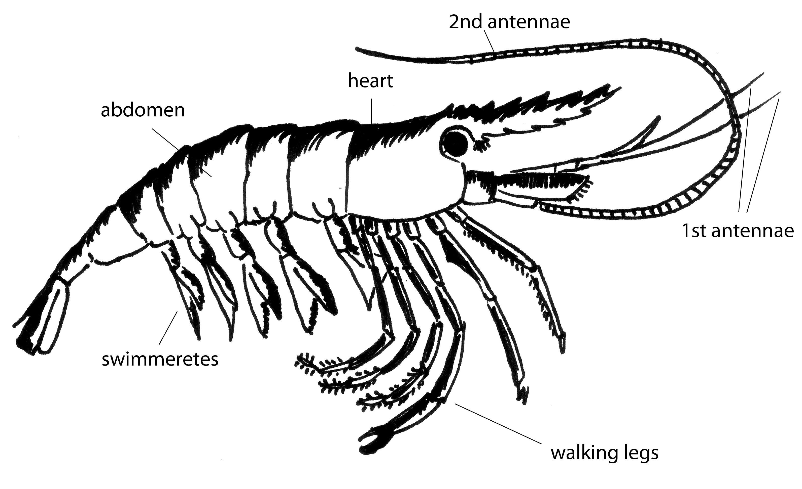
Figure 1: Anatomy of Shrimp

- Dampen a paper towel with distilled water.
- Place the shrimp in the damp paper towel so that the anterior region is wrapped and the animal’s back and tail are free.
- With a second, dry paper towel gently dab the back of the animal in order to dry it for the glue.
- Place a small drop of the glue onto the wooden rod and then adhere it to the animal. Ensure that the stick is glued slightly below the back on the tail so that the apparatus does not hide the heart (see figure 2).
- While holding the rod in place, place a dab of the quick dry compound over the glue to complete the bonding.
- Hold the stick in place for approximately five more seconds or until the rod is sufficiently affixed to the shrimp.
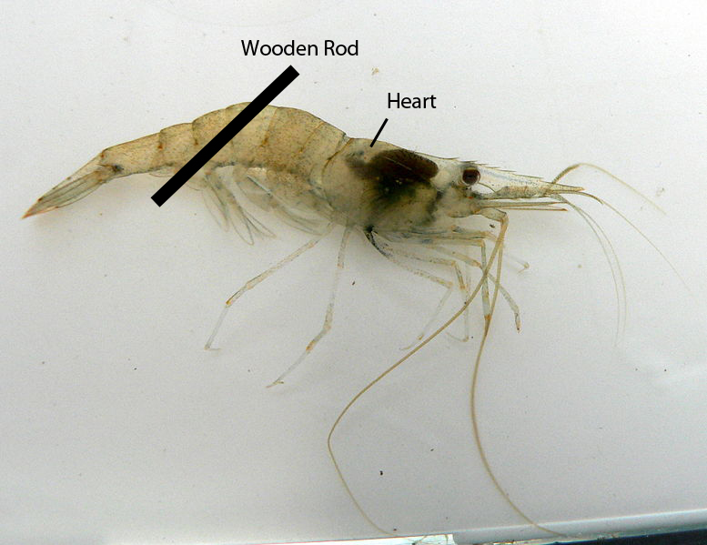

Figure 2. Diagram of wooden rod placement on dorsal side of shrimp.
- Rinse the shrimp and rod of any excess chemicals by dipping it once or twice into the beaker of water.
- Place the shrimp in the grooved Petri dish; ensure that the rod fits securely into both grooves on either side of the dish. This will limit the animal’s movement and will allow for it to be monitored through the microscope. Fill the dish with aerated water and be sure that the level is over the back of the shrimp so that it survives the experiment.

Methods
Exercise 1.
Monitor the heart rate of the shrimp to gain a baseline. To do this, place the shrimp setup under the microscope so that the heart is visible on the back of the animal. Count the number of beats in ten seconds and multiply this number by six to get the beats per minute. To obtain an experimental baseline, do this three times and take the average of the three values and record values in Table 1. Note: It may be beneficial to allow the shrimp to acclimate for approximately five to ten minutes before taking a baseline reading to account for the agitation of the animal.

Exercise 2.
Note: Your teacher will instruct your group to perform either Part A or Part B of Exercise 2 (NOT both). You will then exchange recorded data with a group that used a different chemical stimulus.

- Carefully transport the dish containing the shrimp to the sink and gently pour the contents of the bath out. Make sure that the shrimp is secure and does not fall into the sink. While monitoring the shrimp heart rate through the microscope, fill the bath with the prepared dopamine solution. Take note of the immediate response. After approximately thirty seconds, take note of the number of heart beats in a ten second period. Again, multiply this number by six in order to calculate beats per minute. As in Exercise 1, repeat this process for a total of three times; generate an average beats per minute reading and record it in Table 1.

- Carefully transport the dish containing the shrimp to the sink and gently pour the contents of the bath out. Make sure that the shrimp is secure and does not fall into the sink. While monitoring the shrimp heart rate through the microscope, fill the bath with the prepared serotonin solution. Take note of the immediate response. After approximately thirty seconds, take note of the number of heart beats in a ten second period. Again, multiply this number by six in order to calculate beats per minute. As in Exercise 1, repeat this process for a total of three times; generate an average beats per minute reading and record it in Table 1.

Exercise 3.
Carefully transport the dish containing the shrimp to the collection beaker in the classroom. Gently pour out the solution containing either dopamine or serotonin. Make sure that the shrimp is secure. Rinse the beaker and the shrimp with aerated water to ensure that all of the chemicals have been removed. While monitoring the shrimp heart rate through the microscope, fill the bath with chilled aerated water from the beaker containing the ice. Observe the immediate change. After approximately thirty seconds, take note of the number of heart beats in a ten second period. Again, multiply this number by six in order to calculate beats per minute. As in the previous exercises, repeat this process three times; generate an average beats per minute reading and record it in Table 1. Water Temperature: _______ °C

Exercise 4.
Gently pour out the cold water. Make sure that the shrimp is secure. While monitoring the shrimp heart rate through the microscope, fill the bath with warm aerated water from the beaker. Observe the immediate change. After approximately thirty seconds, take note of the number of heart beats in a ten second period. Again, multiply this number by six in order to calculate beats per minute. As in the previous exercises, repeat this process for a total of three times; generate an average beats per minute reading and record it in Table 1. Water Temperature: _________°C

Results

Table 1
 | Control (beats/min) | Dopamine (beats/min) | Serotonin (beats/min) | Cold Water (beats/min) | Warm Water (beats/min)
Trial 1
Trail 2
Trail 3
Average

In order to compare the effects upon heart rate of the various conditions observed above, plot the average beats/minute of each stimulus below:
Heart Rate (Beats/Min)
Control Dopamine Serotonin Cold Warm
To account for the effects of non-target variable conditions such as experimenter noise or changes in the amount of light over the shrimp with passing shadows, it is important to calculate the percent difference from baseline for each of the stimuli observed before drawing any conclusions about generalized reaction trends.
$$\% Difference= \frac{Absolute differnce (intial-experimental)}{intial}x100$$

 | Dopamine | Serotonin | Cold Temperature | Warm Temperature
Percent Difference

Heart Rate In Drosophila: A Student Laboratory Exercise

Introduction
The Drosophila heart is known to be myogenic (cells initiate contraction, not nerve impulses) in the larval stage and can be studied after being removed or in situ. The myogenic nature of the larval heart is comparable to the mammalian heart as pacemakers drive the rest of the heart to pump fluid in a direction to be effective in bathing organs. The cellular mechanism of action of the neurotransmitters and cardiac modulators in larva have not been described to date as there has not been sufficient understanding of the ionic currents and channel types present in the larval heart that contribute and regulate pacemaker activity (Cooper, et al., 2009). As far as we are aware, there are no reports documenting extracellular or intracellular recordings of myocytes to assess ionic currents to address the mechanistic effects of modulators in larval Drosophila. The larval heart is very susceptible to biogenic amines and peptides, which vary in the hemolymph depending on food source or intrinsic state of the animal (Dasari and Cooper, 2006; Johnson et al. 1997, 2000; Nichols et al. 1999; Zornik et al. 1999). Addressing how endogenous or exogenous compounds influence the heart mechanistically is of interest. Possibly novel insecticides with fewer effects on other organisms can be developed if we gain a better understanding of insect physiology and pharmacology.

Preparation
The Drosophila larva is an ideal experimental model for monitoring heart rate because of the ease of measuring heart rate by counting the movement of the trachea. There are attachments from the heart on the trachea. Before starting this experiment, become familiar with the Drosophila anatomy in Figure 3.

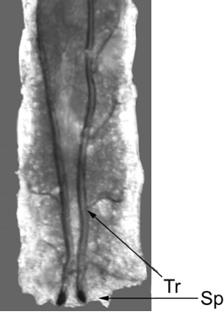
Figure 3. Dorsal view of an intact 3rd instar larva showing trachea (Tr) and spiracles (Sp)

    - Take a clean slide and place a cover slip at one end of it.
    - Put a small dab of superglue at one corner of the cover slip.
    - Locate your Drosophila larva and remove it from the test tube.
    - Place the larva in a Petri dish and rinse it with a small amount of water to remove any excess food.
    - Soak up reaming food with the corner of a small tissue or paper towel.
    - Gently pick up larva with tweezers and place it on your slide on the opposite end from your cover slip.
    - Place the slide under the microscope and adjust your lens on the larva. The larva should be on its stomach with its back facing upwards. You can distinguish between the two sides of the larva because their backs feature two “racing stripes” which are the trachea. The stomach has faint horizontal grooves running along it with very fine black hairs.
    - If the larva is facing the incorrect way, simply turn the right way by gently flipping it over with your tweezers (See figure 4).

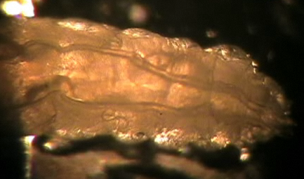
Figure 4: Dorsal view of Larva.

Intact Larvae Protocol
- Restrain the larva to one location using double stick tape on a glass slide and placing the ventral side of the larva to the tape.
- Make sure the black mouth hooks are located near or at the edge of the cover slip and neither they nor the brown spiracles come in contact with the tape.
- Carefully press down on the larva to flatten it out.
- This approach does not work well if the tape gets wet when feeding the larvae. To avoid the tape getting wet use Vaseline (injected out of a small needle around the base of the larvae and around the tape edge). To free the larvae, moisten the tape to loosen the adhesiveness to the animal.

Permanent Restraining Protocol
    - With a new set of tweezers used specifically for glue take a small dab from the drop at the end of your cover slip and place it at the corner of the opposite end. You should use a fractionally amount of glue; just enough to cover the head of the tweezers. Also, make sure you wipe off the ends of your tweezers so that they do not become glued shut.
    - Under the microscope, double check to make sure the larva is still in the correct position. If it has turned over, see step eight.
    - Now, with the tweezers used to handle larva, pick up the larva and place it gently on the fresh patch of glue. Make sure the black mouth hooks are located near or at the edge of the cover slip and neither they nor the brown spiracles come in contact with the glue.
    - Carefully press down on the larva to flatten it out (See Figure 5).

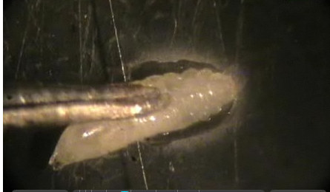
Figure 5: Attached Larva on Cover Slip

Methods

Exercise 1.
Monitor the heart rate of the Drosophila to gain a baseline. Count the number of trachea movements in ten seconds and multiply this number by six to get the beats per minute. To obtain an experimental baseline, do this three times and take the average of the three values and record values in Table 1.

Exercise 2.
Note: Your teacher will instruct your group to perform either Part A or Part B of Exercise 2 (NOT both). You will then exchange recorded data with a group that used a different chemical stimulus.

- While monitoring the Drosophila through the microscope, use a syringe to add dopamine-laced food to the head of the fly. After approximately thirty seconds, count the number of spiracle movements in a ten second period. Multiply this number by six to calculate beats per minute. Repeat this process three times; generate an average beats per minute and record it in Table 1.

- While monitoring the Drosophila through the microscope, use a syringe to add serotonin-laced food to the head of the fly. After approximately thirty seconds, count the number of spiracle movements in a ten second period. Multiply this number by six to calculate beats per minute. Repeat this process three times; generate an average beats per minute and record it in Table 1.

Exercise 3.
Carefully rinse the food off the slide making sure the Drosophila is secure. While monitoring the Drosophila through the microscope, add chilled water from the beaker containing the ice to the slide. After approximately thirty seconds, count the number of spiracle movements in a ten second period. Multiply this number by six to calculate beats per minute. Repeat this process three times; generate an average beats per minute and record it in Table 1. Water Temperature: _______ °C

Exercise 4.
Carefully rinse the food off the slide making sure the Drosophila is secure. While monitoring the Drosophila through the microscope, add warm water from the beaker to the slide. After approximately thirty seconds, count the number of spiracle movements in a ten second period. Multiply this number by six to calculate beats per minute. Repeat this process three times; generate an average beats per minute and record it in Table 1. Water Temperature: _______ °C

Results

 | Control (beats/min) | Dopamine (beats/min) | Serotonin (beats/min) | Cold Water (beats/min) | Warm Water (beats/min)
Trial 1
Trail 2
Trail 3
Average

In order to compare the effects upon heart rate of the various conditions observed above, plot the average beats/minute of each stimulus below:
Heart Rate (Beats/Min)
Control Dopamine Serotonin Cold Warm
To account for the effects of non-target variable conditions such as experimenter noise or changes in the amount of light over the shrimp with passing shadows, it is important to calculate the percent difference from baseline for each of the stimuli observed before drawing any conclusions about generalized reaction trends.
$$\% Difference= \frac{Absolute differnce (intial-experimental)}{intial}x100$$

 | Dopamine | Serotonin | Cold Temperature | Warm Temperature
Percent Difference

Materials

Lab 1 Heart rate response in freshwater shrimp
Per group of 3-4 students
Palaemonetes (Ghost Shrimp)
Small Wooden Rod or Toothpick
Grooved Petri Dish
Light Microscope with Microscope Lights
2 Pins with Curled Ends
Paper Towels
2 Beakers of Distilled, Aerated Water
Beaker of Ice Water
Beaker of Warm Water
1 bath 10 μM 5-HT Solution
1 bath 10 μM Dopamine Solution
Drop of Super Glue (Maxi-Cure)
Drop of Quick Dry (Insta-Set)

Lab 2
Per group of 3-4 students
Drosophila melanogaster (3rd instar larva)
Slide
Cover slip
Tweezers or cotton swabs
Light Microscope with Microscope Lights
Paper Towels
Beaker of Distilled, Aerated Water
Beaker of Ice Water
Beaker of Warm Water
Food laced with 10 μM 5-HT Solution
Food laced with 10 μM Dopamine Solution
Drop of Super Glue (Maxi-Cure) or Double Stick Tape
Vaseline
Needle syringe

Notes

Lab 1 Heart rate response in freshwater shrimp
If students are allergic to shrimp they should wear gloves before handling the ghost shrimp. There are two different techniques for making the grooved petri dish for viewing the shrimp heart. Fill the bottom of a small petri dish with Sylgard (see Notes to Instructor Lab 3 for more information) and cut a groove for the wooden rod perpendicular to a groove to rest the shrimp and enough water to cover (See Figure 10). The other option is to cut or burn two small notches in the wall of a small petri dish to rest the wooden rod and the shrimp will be in the water inside the dish. To find the correct location for gluing the rod hold the shrimp by the tail and it will bend creating a bump on the dorsal side of the organism. Glue should be applied on this bump to make sure that the rod does not cover the heart.
This lab can use many different chemicals including GABA, glutamate, or nicotine. Students could try serial dilutions to see dose response curves. Be sure to have students use hot water last when performing this lab because if it is too hot the shrimp will die.
In our lab we use Maxi-cure glue by Bob Smith Industries purchased from Hobby Lobby. While we were in New Mexico at the ABLE conference we had difficulty finding glue that would dry quickly enough to hold the organisms to the rod. Be sure to try different types of glue on these animals before trying the experiment with your students.
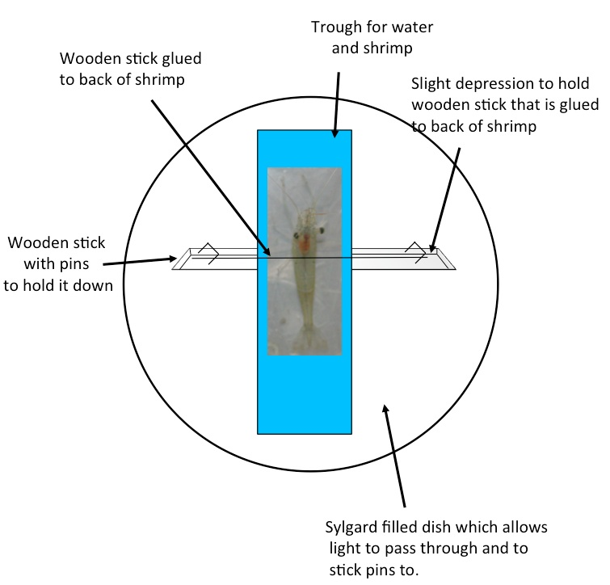
Figure 10: Grooved Petri Dish for viewing Ghost Shrimp

Lab 2
A good means of visualizing an intact beating larval heart is directly with a microscope (adjustable zoom 0.67 to 4.5; World Precision Instrument; Model 501379); however, the larva must remain still enough to count of the contractions. A 2X base objective and tube objective 0.5X is used to gain enough spatial resolution and magnification to cover a 1cm by 0.5 cm rectangle. The ambient temperature is maintained at 20°C. You can use either the Intact Larvae Protocol or the Permanent Restraining Protocol.
Benefits of Intact Larvae Protocol: These approaches could be used to follow an individual larva over extended periods of time if care is used to avoid dehydration. This technique also allows video imaging within a single plane. White light is projected from the underside of the microscope stage with a mirror so that it can be moved accordingly for the best contrast of the heart or the two trachea which move while the heart contracts. These methods can also be used to assess pharmacological agents introduced in the diet or to examine various times in development in mutational lines or with induction of heat shock genes.
Benefits of Permanent Restraining Protocol: If one is not interested in freeing the larvae for experimentation one could use the permanent method of restraining the larva by gluing the animal to a glass slide. With use of super glue method, the animal can eat and even be covered in a moist solution while remaining adhered to the glass cover slip. Make sure students are careful with the glue and they do not to cover spiracles with glue or attach larva to forceps. Try different types of glue before conducting this experiment with your students because some glue will not dry fast enough to adhere the organism to the cover slip before it crawls away.

Acknowledgements
Other contributors to these laboratory exercises were undergraduates from the University of Kentucky: Ann S. Cooper, Bonnie Leksrisawat, Jonathan M. Martin, and Martha M. Robinson‎. For further readings see Cooper et al. (2009, 2011). This laboratory exercise was developed in part due to funding through The Kentucky Non-Public School Commission, Inc. Grant and Department of Biology, University of Kentucky.

Literature Cited
Alexandrowicz, J. S. Zur Kenntnis des sympathischen Nervensystems der Crustaceae. Jena Z. Naturw. 45, 395-444 (1909).
Cooper, A.S. and Cooper, R.L. (2004) Growth of troglobitic (Orconectes australis packardi) and epigean (Oroconectes juvenilis) species of crayfish maintained in laboratory conditions. Journal of Kentucky Academy of Sciences 65(2):108-115.
Cooper, A.S., Leksrisawat, B., Gilberts, A.B., Mercier, A.J. and Cooper, R.L. (2011) Physiological experimentations with the crayfish hindgut. Journal of Visualized Experiments (JoVE). Jove 47: http://www.jove.com/details.php?id=2324 doi: 10.3791/2324.
Cooper, A.S., Rymond, K.E., Ward, M.A., Bocook, E.L. and Cooper, R.L. (2009) Monitoring heart function in larval Drosophila melanogaster for physiological studies. Journal of Visualized Experiments (JoVE). 32: http://www.jove.com/index/details.stp?id=1596.
Dasari, S. & Cooper, R.L. Direct influence of serotonin on the larval heart of Drosophila melanogaster. Journal of Comparative Physiology B 176, 349–357 (2006).
Dircksen, H., Burdzik, S., Sauter, A. & Keller, R. Two orcokinins and the novel octapeptide orcomyotropin in the hindgut of the crayfish Orconectes limosus: identified myostimulatory neuropeptides originating together in neurons of the terminal abdominal ganglion. Journal of Experimental Biology 203, 2807-2818 (2000).
Florey, E. Uber die wirkung von acetylcholin, adrenalin, nor-adrenalin, faktor I und anderen substanzen auf den isolierten enddarm des flusskrebses Cambarus clarkii Girard. Z. Vergl. Physiol. 36, 1-8 (1954).
Florey, E. A new test preparation for bio-assay of Factor I and gamma-aminobutyric acid. Journal of Physiology 156, 1-7 (1961).
Johnson E., Ringo J., & Dowse H. Modulation of Drosophila heartbeat by neurotransmitters. Journal Comparative Physiology B 167, 89-97 (1997).
Johnson E., Ringo J., & Dowse H. Native and heterologous neuropeptides are cardioactive in Drosophila melanogaster. Journal Insect Physiology 1, 1229-1236 (2000).
Kondoh, Y. & Hisada, M. Neuroanatomy of the terminal (sixth abdominal) ganglion of the crayfish, Procambarus clarkii (Girard). Cell and Tissue Research 243, 273-288 (1986).
McRae, T. 1999. Chemical removal of nitrite and chlorinating agents from municipal water supplies used for crayfish and aquarium fin fish culture. Freshwater Crayfish 12:727-732
Mercier, A.J. & Lee, J. Differential effects of neuropeptides on circular and longitudinal muscles of the crayfish hindgut. Peptides 23, 1751-1757 (2002).
Mercier, A.J., Orchard, I. & Schmoeckel, A. Catecholaminergic neurons supplying the hindgut of the crayfish, Procambarus clarkii. Canadian Journal of Zoology 69, 2778-2785 (1991a).
Nichols R., Kaminski S., Walling E., & Zornik E. Regulating the activity of a cardioacceleratory peptide. Peptides 20, 1153-1158 (1999).
Wales, W. Control of mouthparts and gut. In: The Biology of Crustacea, Vol. 4; D.C. Sandeman and H.L. Atwood, eds.; Academic Press Inc., London; pp. 165-191 (1982).
Winlow, W. & Laverack, M.S. The control of hindgut motility in the lobster Homarus gammarus (L.). Analysis of hindgut movements and receptor activity. Marine Behavior and Physiology 1, 1-28 (1972a).
Winlow, W. & Laverack, M.S. The control of hindgut motility in the lobster Homarus gammarus (L.). Motor output. Marine Behavior and Physiology 1, 29-47 (1972b)
Winlow, W. & Laverack, M.S. The control of hindgut motility in the lobster Homarus gammarus (L.). 3. Structure of the sixth abdominal ganglion (6 A.G.) and associated ablation and microelectrode studies. Marine Behavior and Physiology 1, 93-121 (1972c).
Zornik E, Paisley K, & Nichols R. Neural transmitters and a peptide modulate Drosophila heart rate. Peptides 20, 45-51 (1999).

Appendices
Serotonin
For 10 µM:
$$\left(\frac{212.68 grams}{mole}\right)\left(\frac{0.00001 mole}{1 liter}\right)\left(0.5liter\right)=1.0milligrams$$

Dopamine
For 10 µM:
$$\left(\frac{189.64 grams}{mole}\right)\left(\frac{0.00001 mole}{1 liter}\right)\left(0.5liter\right)=0.9milligrams$$

Maintenance of Animals
Food for flies
We suggest using the Standard medium in use at Bloomington Drosophila stock center.
http://flystocks.bio.indiana.edu/Fly_Work/media-recipes/media-recipes.htm

Ghost Shrimp
The Ghost shrimp, obtained from your local pet store, can be held in one aquarium. They can be feed commercial fish food pellets (Aquadine), which is marketed as “shrimp and plankton sticks: sinking mini sticks.” Fragments of cleaned chicken eggshell also should be placed in the containers as a source of calcium. The chloramines of local water must be removed by carbon-based filters for the aquaria water. Bacteria and algae will help to detoxify any ammonium ions, and the water should be aerated for several days before using (Cooper and Cooper 2004; McCrae 1999).

