Muscle Receptor Organs in the Crayfish Abdomen: A Student Laboratory Exercise in Proprioception

By

Bonnie Leksrisawat, Ann S. Cooper and Robin L. Cooper

ABSTRACT

{50 words}
The primary purpose of this experiment is to understand how primary sensory neurons convey information of joint movements and positions as proprioceptive information for an animal. An additional objective of this report is present the anatomy of the preparation by dissection and viewing of neurons under a dissecting microscope.

{150 words}
The primary purpose of this experiment is to demonstrate primary sensory neurons conveying information of joint movements and positions as proprioceptive information for an animal. An additional objective of this experiment is to learn anatomy of the preparation by staining, dissection and viewing of neurons and sensory structures under a dissecting microscope. This is performed by using basic neurophysiological equipment to record the electrical activity from a joint receptor organ and staining techniques. The muscle receptor organ (MRO) system in the crayfish is analogous to the intrafusal muscle spindle in mammals, which aids in serving as a comparative model that is more readily accessible for electrophysiological recordings. In addition, these are identifiable sensory neurons among preparations. The preparation is viable in a minimal saline for hours which is amenable for student laboratory exercises. The MRO is also susceptible to nuromodulation which encourages intriguing questions in the sites of modulatory action and integration of dynamic signals of movements and static position along with a gain that be change in the system.

1) INTRODUCTION
Proprioceptors are neurons that detect joint position, direction, speed, and muscle stretch. Proprioception is a unique sensory modality, because proprioceptors are interoceptors and sense stimuli within the body instead of from the outside world.
In the vertebrate system, it appears that many of the joint and tension receptors are not necessary to detect gross proprioceptive information. The annulospiral and flowerspray (sensory nerve endings) receptors on muscle fibers have been shown by ablation as well as vibratory and anesthetic studies to be the two essential receptor groups needed for proprioception (Burgess et al. for a review, 1982). However, it is notable that there is redundant information gathered by other receptors, such as those in the joints, that are used for fine control of movements. Arthropods like vertebrates have articulated appendages. Therefore, it is not surprising that the proprioceptors described for vertebrates have their counterparts in arthropod limbs and joints

The anatomical arrangement of chordotonal organs in crabs allows the analysis of each individual neuron according to function. In addition, developmental questions can be addressed as the animal grows or when the animal regenerates a limb (Cooper and Govind, 1991; Hartman and Cooper, 1993). Some joint chordotonal organs in crabs contain hundreds of primary sensory neurons (Cooper, 2008) and these neurons monitor aspects in the range fractionation in movements and positions of the joint. A less complex proprioceptive system of monitoring joint movements and positions is the muscle receptor organs (MROs) in the abdomen of crayfish (Eckert, 1961a,b; McCarthy and MacMillan, 1995). The mechanoreceptors in crayfish abdomen MROs transduce a stretch stimulus in the sensory endings, embedded in a muscle, into a graded receptor potential. When potential exceeds a threshold, an action potential will result at the axon base. This is what is defined and known as “the site of spike initiation” in neurobiology. In this system the cell body resides in close apposition to the muscle it monitors. Two distinct types of stretch receptors exist in this sensory system: a slowly-adapting and a rapidly-adapting receptor. The activity is dependent on the strength of the mechanical stretch. The MRO system in the crayfish is analogous to the intrafusal muscle spindle in mammals and the muscles also have efferent control to maintain the taut nature of the muscles as known for intrafusal muscles in mammals.
The muscle spindle sensory neurons in mammals are challenging to investigate electrophysiologically because of the small nature of the sensory endings. It is also difficult to track the location of the cell bodies in the dorsal root ganglion to their peripheral endings. In comparison, the MRO neurons in crayfish are readily accessible for extracellular and intracellular electrodes for long term recordings. The cell bodies of the MRO sensory neurons are relatively large (50–100 µm in diameter). Sensory neurons have also served as a model in addressing how “stretch activated” channels in neurons function, ionic flow, channel distribution, and density of sensory neurons (Brown et al., 1978; Edwards et al., 1981; Erxleben, 1989; Hunt et al., 1978; Purali and Rydqvist, 1992; Rydqvist and Purali, 1991; Rydqvist and Swerup, 1991; Cooper et al., 2003). The integration of the sensory input from the MRO in one segment can influence other adjoining segments (Eckert, 1961a,b). There are a few reports on modulation of the sensory input from the MRO (Pasztor and Macmillan, 1990; Cooper et al., 2003) . Modulation of neural circuits is a rich area for future investigations of basic science and this preparation can serve as a foundation in mammals for future applications, potentially in the spinal cords of vertebrates (Rossignol et al., 2001, 2002; Donnelan, 2009)

1.1) Learning outcomes
In this laboratory experiment, one will dissect a crayfish abdomen and learn the associated anatomy and physiology of the MRO. One will learn how to monitor neuronal activity with extracellular recordings and to use common electrophysiological equipment. One will graph and interrupt the data obtained based on the sensory stimulation provided. The sensory stimulation will range from static positions as well as dynamic movements of the segment being monitored. One will address the concept of in this sensory system and its significance. Sensory adaptation will be observed in a series of experiments. The significance as well as the potential mechanism behind sensory adaption will be addressed by the students.

2) METHODS

2.1) Materials
1. Faraday Cage
2. Micromanipulator
3. Suction Electrode
4. Dissecting Microscope
5. High Intensity Illuminator (light source)
6. Microscope Platform
7. AC/DC Differential Amplifier (A-M Systems Inc. Model 3000)
8. PowerLab 26T (AD Instruments)
9. Head stage
10. LabChart 7 (ADI Instruments, Colorado Springs, CO, USA)
11. Crayfish Saline (mM: 205 NaCl; 5.3 KCl; 13.5 CaCl₂.2H₂O; 2.45 MgCl₂.6H₂O; 5 HEPES adjusted to pH 7.4)
12. Methylene blue: This is made of crayfish saline at a concentration of 0.25%
13. Sylgard coated dishes (Dow Corning, SYLGARD® 184 silicone elastomer kit; Dow Corning Corporation, Midland, MI. USA)
14. Dissecting tools
15. Insect pins

2.2) Setup

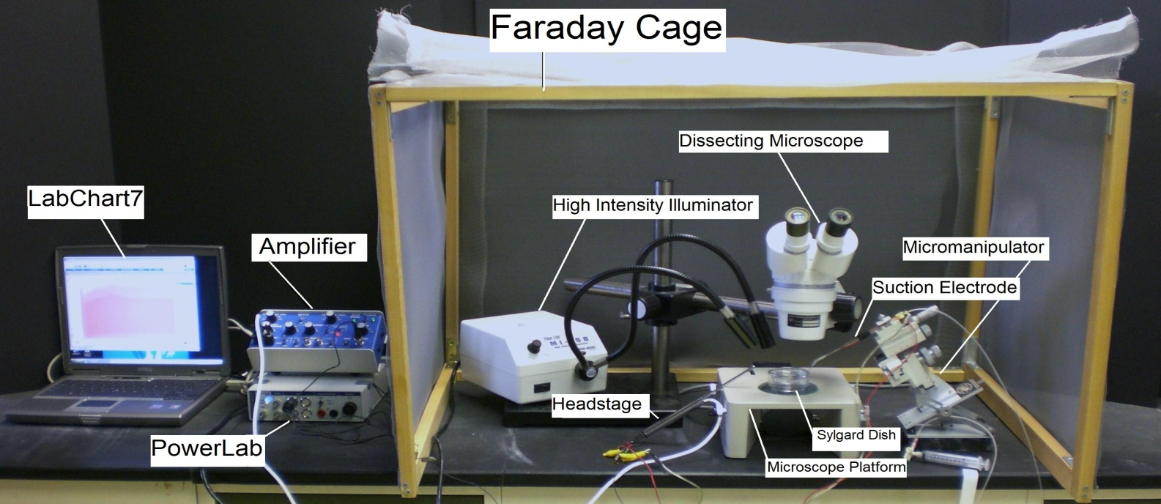
Figure 1: The equipment set up

1. Setup up the Faraday cage. The microscope, high intensity illuminator, micromanipulator, and the saline bath will all be set up inside the cage (The Faraday cage is used to block external electric fields that could interfere with the electrical recording).

2. Setup the microscope in a position where it is overlooking the microscope stage.

3. Position the high intensity illuminator in a convenient position.

4. Prepare a saline bath using crayfish saline in a Sylgard dish and place it under the microscope (this is where the dissected crayfish abdomen will be placed).

5. Position the micromanipulator in a position where the suction electrode has easy access to the saline bath.

6. Suction up saline until it is in contact with the silver wire inside the suction electrode. Arrange the other wire on the cut-side of suction electrode close to the tip of electrode, so both wires will be in contact with the saline bath.

7. Connect the AC/ DC Differential Amplifier (amplifier) to the Power Lab 26T. Do this by connecting the proper cord from Input 1 on the PowerLab 26T to the output on the amplifier.

The settings for the amplifier are as follows:

CONTROL | SETTING
High Pass | DC
Notch Filter | OFF
Low Pass | 20kHz
Capacity Comp. | Counterclockwise
DC Offset Fine and Course knob | Counterclockwise
DC Offset (+OFF) | OFF
Gain knob | 50
Input (DIFF MONO GND) | DIF
MODE(STIM-GATE-REC) | GATE
ΩTEST | OFF

8. Connect the head stage to the ‘input- probe’ on the amplifier.

9. Connect the electrical wires from the suction electrode to the head stage. The wires should be connected with the red (positive) at the top left, green (ground) in the middle, black (negative at the bottom. This is indicated in Figure 2. The ground wire can just be put in the saline bath.

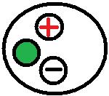
Figure 2: Head stage Configuration

10. Now connect the USB cord from the PowerLab 26T to the laptop. Ensure that both the amplifier and PowerLab26T are plugged in and turned on before opening LabChart7 on the computer.

11. Open LabChart7.

-The LabChart Welcome Center box will pop open. Close it.
- Click on Setup
- Click on channel settings. Change the number of channels to 1 (bottom left of box) push OK.
-At the top right of the chart set the cycles per second to about 4 Kz. Set the volts (y-axis) to about 500 or 200mv.
-Click on Channel 1 on the right of the chart. Click on Input Amplifier. Ensure that the settings: differential, ac coupled, and invert (inverts the signal if needed), anti-alias, and differential are checked.
- To begin recording press start.

2.3) Dissection

- Crayfish (Procamarus clarkii) measuring 6-10 cm in body length should be already placed on ice to anesthetize the animal before dissection begins.

- Hold the anesthetized crayfish from behind the claws with one hand. Quickly, cut from the eye socket to the middle of the head on both sides, and then behead the crayfish (Note: the blood from the preparation will be sticky when it dries, so wash the tools when completed).

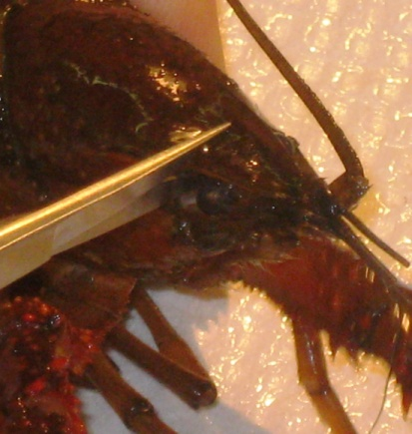
Figure 3: Decapitation of crayfish

- Once the crayfish is beheaded, cut between the thorax and abdomen (tail) on the ventral side. It should be easy to separate the abdomen from the thorax. Note: if the crayfish is male, cut the stylets (male reproductive parts) off before separating the abdomen and thorax. (Shown below in Figure 4A).

Figure 4: Isolation of abdomen

- Place one blade of the scissors inside the abdomen, and with the scissor tips pointing away from the preparation, cut along the lateral border. Repeat on the opposite side.

Figure 5: Longitudinal dissection of abdomen

- Take the back end of the tweezers (#3) and push the muscles and GI tract away from the dorsal side of the preparation. Be sure not to push down on the muscles.

- Cut across (lateral to lateral side) the last rib to remove the ventral side of the tail.
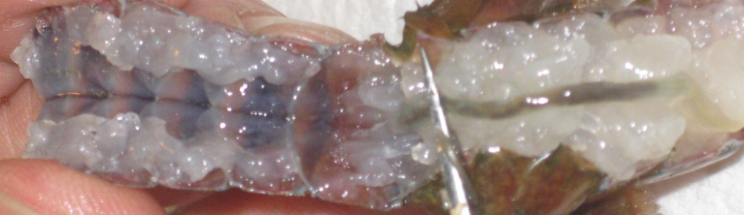
Figure 6: Removal of ventral part of abdomen

- Emerge the preparation in crayfish saline (a modified Van Harreveld's solution).

- Looking at the preparation under the microscope, the deep extensor medial muscle (DEM) can be located by its fibers twisted in a helix, and the deep extensor lateral muscles, with linear fibers can be distinguished (see Appendix Figures 1 & 2). Place two pins in the midsagittal region at the distal part of the abdomen between the DEM muscles on the first and second ribs (Figure 7).

Figure 7: Securing the preparation for recording the nerve containing the sensory MRO nerve.

- The nerve bundles that will be used to record from run along the lateral edge next to the cuticle (Figure 7). (It may be necessary to blow on the preparation or drop saline into the bath using a dropper to locate the nerve by its movement)

Note:
Each abdominal segment has two sets of the rapidly and slowly-adapting MROs on the right and left hemisegments. The associated nerve bundles run along the lateral edge next to the cuticle. This is the nerve bundle that one will be recording from. One will not be able to view the MROs because they are located under the DEL1 and 2 muscles (Appendix Figures 1 & 2). Figure 8 provides an overview of the dissections to be made in order to isolate the abdomen.

Figure 8: Overview of general dissection to isolate abdomen. A, B, and C are the series of steps in dissecting the crayfish.

3) RESULTS

3.1) Recording

Generalized responses obtained from the slowly and rapidly-adapting MROs while stretching and maintaining a stretch are depicted in Figure 9. In this exercise one will be recording from both MROs together as their axons are contained in the same nerve bundle.

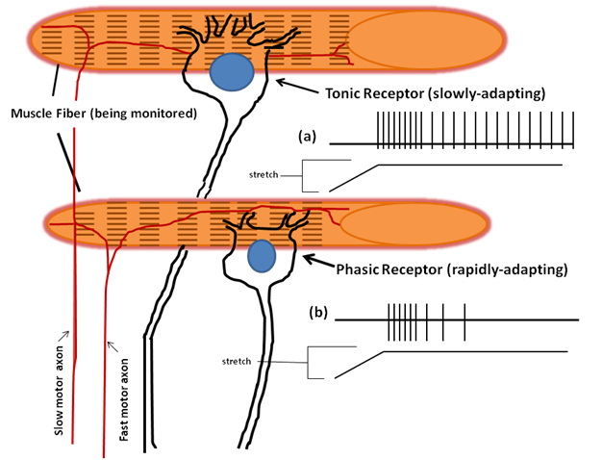
Figure 9: The crayfish has two types of neurons in the MRO. The phasic, which are innervated by fast motor axons, and the tonic which are innervated by slow motor axons. (a) When a tonic receptor is stimulated it slowly adapts to the stimulus and continues a steady firing pattern of action potentials. (b) When a phasic receptor is stimulated it rapidly adapts to the stimulus and fires only a short pattern of action potentials.

The whole nerve which contains motor and sensory neurons is recorded from (Figure 10). However one will only detect the sensory neurons as the motor drive has been severed from the ventral nerve cord of the animal.

Figure 10: The nerve bundle to be sucked up into the recording electrode. (A) The free nerve is shown floating over the dissected abdomen. (B) outlines the nerve bundle and the plastic suction electrode close by the nerve. (C) The segmental nerve is pulled into the suction electrode, which is outlined in blue.

One is now ready to record the electrical responses from the MROs.

- Place the preparation under the dissection scope and prepare the recording set up.

- Electrically ground the bath by placing a silver-chloride ground wire in the bath and the other end to a common ground. Note: sometimes this can cause electrical noise during the recording. If this happens do not ground the bath.

- Use the microscope to find the nerve to be recorded
Note: Look for the segment with the most accessible nerve. The nerve is white, and can be seen by using the pipette to spray saline around the nerve or by lightly blowing on the preparation. This causes the nerve to move around and makes it easier to identify.

- Now that the nerve has been identified place the suction electrode from the micromanipulator directly over the nerve (Figure 10).
- Gently pull on the syringe to draw the nerve into the electrode (one can see the nerve being sucked into the electrode with the use of the microscope).

- Press the start button on Labscope7.

- Using the tweezers gently move the tail of the crayfish up and down at 180$°$, 45$°$, and 90$°$ angles. Notice the difference in the recordings at each different angle. (When changing the position of the angles make sure to note the angle changes with the relevant neuronal activity on the screen. This can be done be using the comment marker in the software.)

- Record the response movements to various static movements in the chart below.
- Hold the crayfish tail at a 45$°$ for fifteen seconds.
- Push stop on the LabChart7 screen. Record the number of action potentials that occurred during the last second recorded.
- Hold the crayfish tail at a 45$°$ for one minute.
- Push stop on the LabChart7 screen. Record the number of action potentials that occurred during the last second recorded.

Explanation: The Lab Chart screen is a moving graph that is in milliVolts (y-axis) vs. seconds (x-axis). It measures how many action potentials occur in a certain amount of time. It also measures the amplitude in volts of each action potential or an extracellular field potential. The amplitude is a relative measure that can be used to determine if different size of extracellular recorded action potentials are present. An action potential recorded by an extracellular field potential is referred to as a “spike”. The farther away from the nerve the smaller the spike will be. The looser the fitting on the suction electrode the smaller the spike will be as the current is lost with the low seal resistance around the nerve bundle and the suction electrode opening.
Table 1: Stationary abdomen (Static spikes firing frequency)
Angle($°)$ | Time of recording | # of Action Potentials in 0.5 seconds at 3 seconds | # of Action potentials in 0.5 seconds at 10 seconds
0$°$ (flat)
45$°$
90$°$

Table 2: Moving then stationary (dynamic spikes firing frequency)
Angle($°)$ | # of Aps in 0.5 sec during movement | Total duration of movement | Total duration of dynamic spikes
0$°$ to 45$°$
45$°$ to 90$°$

Questions to think about while conducting these experiments are: Is there a pattern and consistent response to the extension and flexion movements of the joint? What sort of responses are evoked by pinning or holding the telson at various fixed positions? Is that response consistent when repeated?

Make careful notes of the kinds of responses observed. After you are satisfied with your observations, make permanent records of this activity by saving the data files. Once satisfied with the observations that you have made in segment 3, move on to further recordings from nerves in segments 4 or 5 or on the other side of segment 3 to observe the activity.

One may wish to determine if neuromodulators (octopamine, serotonin, and proctolin) or other compounds or an altered composition in the ionic nature of the saline produces varied responses from those obtained in the defined saline.

3.2) Staining with methylene Blue

One may be able to dissect out the muscle (See appendix) to view the MROs with a staining technique. Take the preparation and pour the crayfish saline out. Place approximately 5 mLs of methylene blue solution into the preparation and gently swirl the dish for a few minutes. Then pour the excess methylene blue into the waste container and pour fresh saline onto the preparation. Now place the dish under the microscope to start dissecting the muscle to view the MROs. Cut the segment along the rib (lateral to midsagittal) by placing one part of the scissors under the muscle and pulling up as you cut along the muscle. Once the DEL 1 and 2 muscles are cut then peel the muscle back and a thin layer of muscle (SEM) should be observed. The MROs are the last two medial fibers lying parallel to the helix muscle. (Draw of use camera on phone).

For student exercises one might wish to have the students answer the following questions:

1. What is an interoceptive receptor?
2. How do interoceptive receptors relate to proprioceptors?
3. Explain sensory adaptation and how it could relate to this lab.
4. What is range fractionation? What does it enable the CNS to do?
5. Is the neuron you recorded a phasic or tonic type neuron? Why?
(Hint: What would you postulate the motor neuron acting would look like in relation to the sensory activity within on intact animal? )
6. On a separate sheet of paper draw a graph of the angle of crayfish tail vs. the frequency of AP.
7. Explain any trend that you might observe in the graph

4) DISCUSSION

The details provided in the associated movie and text have provided key steps in order to sufficiently record the activity in the MRO of the crayfish in situ. One goal of our report is to increase the awareness in the potential for this preparation in student run investigative laboratories to teach fundamental concepts in sensory physiology. The preparations are very robust in viability while being bathed in a minimal saline.

The motor control on the MRO muscles has been identified but the regulation in transmission and the potential of synaptic plasticity as well as efficacy of transmission for the excitatory and inhibitory neurons remains an open area for investigation (Elekes and Florey, 1987a,b; Florey and Florey, 1955; Kuffler, 1954; Kuffler and Eyzaguirre, 1955).

This preparation can be used to investigate a number of experimental conditions as well as the natural range of locomotion within the animal to better understand the biology of the MRO for primary research as well as well as demonstrative purposes. The biophysical properties of these sensory neurons has in part been addressed in their nature of adaptation in the neural activity with a maintained stimulus (Brown et al, 1978; Edwards et al., 1981; Purali, 1997; Rydqvist and Purali,1991; Rydqvist and Swerup, 1991). However, only a few reports address neuromodulation on these sensory receptors and associated muscle fibers (Cooper et al., 2003; Pasztor and Macmillan, 1990). The reports deal with only a few of the many compounds that are known to be present in the hemolymph. Many modulators and cocktails of modulators remain to be examined on the MRO complex (muscles and neurons). Pasztor and Macmillan (1990) did examine the neuromodulators 5-HT and octopamine on the activity of MROs among various crustacean species and noted that there are species differences. They did not examine in detail the long-term influences of these neuromodulators nor the effects on activity at different static positions of the MRO.
This type of preparation can aid in understanding the basis of sensory perception and regulation of neural processing which is important in rehabilitation and disease management for humans with motor unit abnormities (Patel et al., 2009; Rabin et al., 2009; Marino et al., 2010). The various types of input and firing patterns for monitoring joint movements in accessible invertebrate preparations can be used in robotics/prosthesis (Macmillan and Patullo, 2001). There are still many questions awaiting answers in this preparation that can be beneficial in a number of ways.

5) REFERENCES
Alexandrowicz, J.S. Muscle receptor organs in the abdomen of Homarus vulgaris and Palinurus vulgaris. Q. J. Microsc. Sci. 92, 163-199 (1951).

Brown, H.M., Ottoson, D., & Rydqvist, B. Crayfish stretch receptor: An investigation with voltage-clamp and ion-sensitive electrodes. J. Physiol. 284,155–179 (1978).

Burgess, P.R., Wei, J.Y., Clark, F.J. & Simon, J. Signaling of kinesthetic information by peripheral sensory receptors. Ann. Rev. Neurosci. 5,171-187 (1982).

Cooper, R.L. & Govind, C.K. Axon composition of the proprioceptive PD nerve during growth and regeneration of lobster claws. J. Exp. Zool. 260, 181-193 (1991).

Cooper, R.L., Ward, E., Braxton, R., Li, H. & Warren, W.M. The effects of serotonin and ecdysone on primary sensory neurons in crayfish. Microscopy Res. Technique 60, 336-345 (2003).

Donelan, J.M., McVea, D.A. & Pearson, K.G. Force regulation of ankle extensor muscle activity in freely walking cats. J. Neurophysiol. 101(1), 360-371 (2009).

Eckert, R.O. Reflex relationships of the abdominal stretch receptors of the crayfish. I. Feedback inhibition of the receptors. J. Cell. Comp. Physiol. 57, 149–162 (1961a).

Eckert, R.O. Reflex relationships of the abdominal stretch receptors of the crayfish. II. Stretch receptor involvement during the swimming reflex. J. Cell. Comp. Physiol. 57, 163–174 (1961b).

Edwards, C., Ottoson, D., Rydqvist, B. & Swerup, C. The permeability of the transducer membrane of the crayfish stretch receptor to calcium and other divalent cations. Neurosci. 6, 1455–1460 (1981).

Elekes, K. & Florey, E. New types of synaptic connections in crayfish stretch receptor organs: an electron microscopic study. J. Neurocytol. 16, 613–26 (1987a).

Elekes, K. & Florey, E. Immunocytochemical evidence for the GABAergic innervation of the stretch receptor neurons in crayfish. Neurosci. 22, 1111–1122 (1987b).

Erxleben, C. Stretch-activated current through single ion channels in the abdominal stretch receptor organ of the crayfish. J. Gen. Physiol. 94, 1071–1083 (1989).

Fields, H.L. Crustacean abdominal and thoracic muscle receptor organs. In: Mill PJ, editor. Structure and function of proprioceptors in the invertebrates. New York: Chapman & Hall. p 65–114 (1976).

Florey, E. & Florey, E. Microanatomy of the abdominal stretch receptors of the crayfish Astacus fluviatilis L. J. Gen. Physiol. 39, 69-85 (1955).

Hartman, H.B. & Cooper, R.L. Regeneration and molting effects on the proprioceptor organ in the Dungeness crab, Cancer magister. J. Neurobiol. 25, 461-471 (1994).

Hunt, C.C., Wilkerson, R.S. & Fukami, Y. Ionic basis of the receptor potential in primary endings of mammalian muscle spindles. J. Gen. Physiol. 71, 683–698 (1978).

Kuffler, S.W. Mechanisms of activation and motor control of stretch receptors in lobster and crayfish. J. Neurophysiol. 17, 558– 574 (1954).

Kuffler, S.W. & Eyzaguirre, C. Synaptic inhibition in an isolated nerve cell. J. Gen. Physiol. 39, 155–184 (1955).

Macmillan, D.L. & Patullo, B.W. Insights for robotic design from studies of the control of abdominal position in crayfish. Biol. Bull. 200, 201-205 (2001).

Marino, B.F., Stucchi, N., Nava, E., Haggard, P. & Maravita, A. Distorting the visual size of the hand affects hand pre-shaping during grasping. Exp. Brain Res. 202(2),499-505 (2010).

McCarthy, B.J. & MacMillian, D.L. The role of the muscle receptor organ in the control of the abdominal extension in the crayfish Cherax destructor. J. Exp. Biol. 198,2253–2259 (1995).

Mill, P.J. & Lowe, D.A. The fine structure of the PD proprioceptor of Cancer pagurus.I. The receptor strand and the movement sensitive cells. Proc. R. Soc. Lond. B. 184, 179-197 (1973).

Nakajima, Y. & Onodera, K. Membrane properties of the stretch receptor neurons of crayfish with particular reference to mechanisms of sensory adaptation. J. Physiol. 200,161–185 (1969a).

Nakajima, Y. & Takahashi, K. Post-tetanic hyperpolarization and electrogenic Na pump in stretch receptor neurone of crayfish. J. Physiol. 187,105–127 (1966).

Pasztor, V.M. & MacMillan, D.L. The actions of proctolin, octopamine and serotonin on the crustacean proprioceptors show species and neurone specificity. J. Exp. Biol. 152, 485–504 (1990).

Patel, M., Fransson, P.A., Karlberg, M., Malmstrom, E.M. & Magnusson, M. Change of body movement coordination during cervical proprioceptive disturbances with increased age. Gerontol. 56(3), 284-290 (2010).

Patullo, B., Faulkes, Z. & Macmillan, D.L. Muscle receptor organs do not mediate load compensation during body roll and defense response extensions in the crayfish Cherax destructor. J. Exp. Zool. 290(7): 783-790 (2001).

Purali, N. (1997) Mechanisms of adaptation in a mechanoreceptor. A study of mechanical and ionic factors in the crayfish stretch receptors. PhD dissertation, Department of Physiology and Pharmacology, Karolinska Institutet, Stockholm, Sweden.

Purali, N. & Rydqvist, B. Block of potassium outward currents in the crayfish stretch receptor neurons by 4-aminopyridine, tetraethylammonium chloride and some other chemical substances. Acta Physiol. Scand. 146, 67–77 (1992).

Rabin, E., Muratori, L., Svokos, K. & Gordon, A. Tactile/proprioceptive integration during arm localization is intact in individuals with Parkinson's disease. Neurosci. Lett. 470(1), 38-42 (2010).

Rydqvist, B. & Purali, N. Potential-dependent potassium currents in the rapidly adapting stretch receptor neuron of the crayfish. Acta Physiol. Scand. 142, 67–76 (1991).

Rydqvist, B. & Swerup, C. Stimulus-response properties of the slowly adapting stretch receptor neuron of the crayfish. Acta Physiol. Scand. 143, 11–19 (1991).

Rossignol, S. Locomotion and its recovery after spinal injury. Curr. Opin. Neurobiol. 10, 708–716 (2000).

Rossignol, S., Giroux, N., Chau, C., Marcoux, J., Brustein, J. & Reader, T.A. Pharmacological aids to locomotor training after spinal injury in the cat. J. Physiol. 533, 65–74 (2001).

Rossignol, S., Bouyer, L., Barthelemy, D., Langlet, C. & Leblond, H. Recovery of locomotion in the cat following spinal cord lesions. Brain Res. Rev. 40, 257–266 (2002).

Sohn, J., Mykles, D.L. & Cooper, R.L. The anatomical, physiological and biochemical characterization of muscles associated with the articulating membrane in the dorsal surface of the crayfish abdomen. J. Exp. Zool. 287, 353-377 (2000).

Svensson, E., Woolley, J., Wikström, M. & Grillner, S. Endogenous dopaminergic modulation of the lamprey spinal locomotor network. Brain Res. 970, 1–8 (2003).

Swerup, C. & Rydqvist, B. The abdominal stretch receptor organ of the crayfish. Comp. Biochem. Physiol. A 103, 433–431 (1992).

Vargas, J.G. & Yu, W. Audio aided electro-tactile perception training for finger posture biofeedback. Conf. Proc. IEEE Eng. Med. Biol. Soc. 2008: 4230-4233 (2008).

Vedel, J.P., Clarac, F., Combined reflex actions by several proprioceptive inputs in the rock lobster legs. J. Comp. Physiol. 130, 251-258 (1979).

Appendix:

Figures obtained from published reports to aid in anatomical description for this exercise.
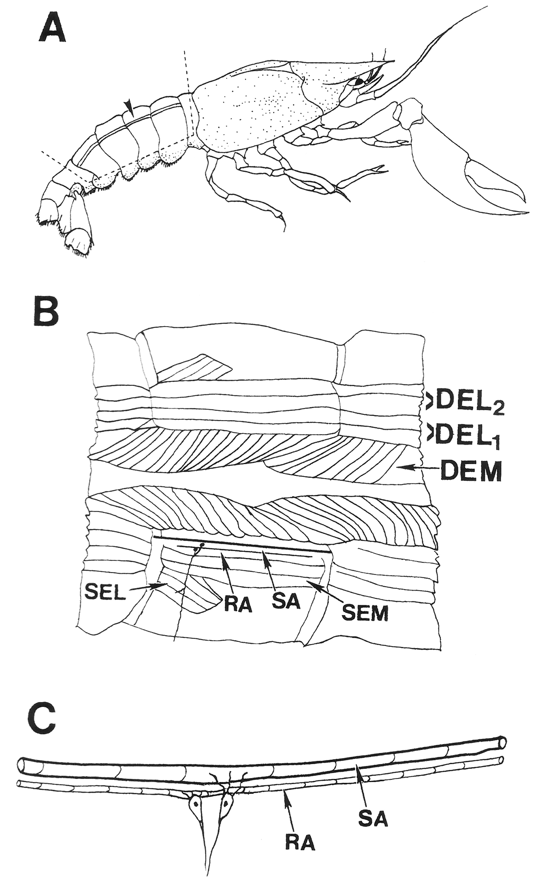

Appendix Figure 1:The layout of the muscle receptor organs (MROs) in relation to the superficial and deep extensor muscles of the crayfish abdomen. A: The MROs are located on the dorsal aspect of the abdomen and monitor the position and movements of the abdominal segments. B: A schematic of the superficial and deep extensor muscles with the particular muscles identified. The most deep extensor medial (DEM) muscles have a spiral fiber pattern. In the top half, the deep extensors muscles are shown. DEL1 is the first lateral group followed by the DEL2 muscles. In the bottom half, the DEL1 and DEL2 musculature was removed to show the more dorsal superficial extensor muscles. The superficial extensor medial muscle (SEM) lies directly dorsal to DEL1 and DEL2 . The most lateral bundle of fibers is the superficial extensor lateral muscle (SEL). The two MRO muscles are just medial to the SEM muscle. C: The anatomical arrangement of the rapidly-adapting (RA) and slowly-adapting (SA) sensory neurons to the muscle fibers which they monitor (after Purali, 1997). The motor innervation is not shown (Taken from Cooper et al., 2003).

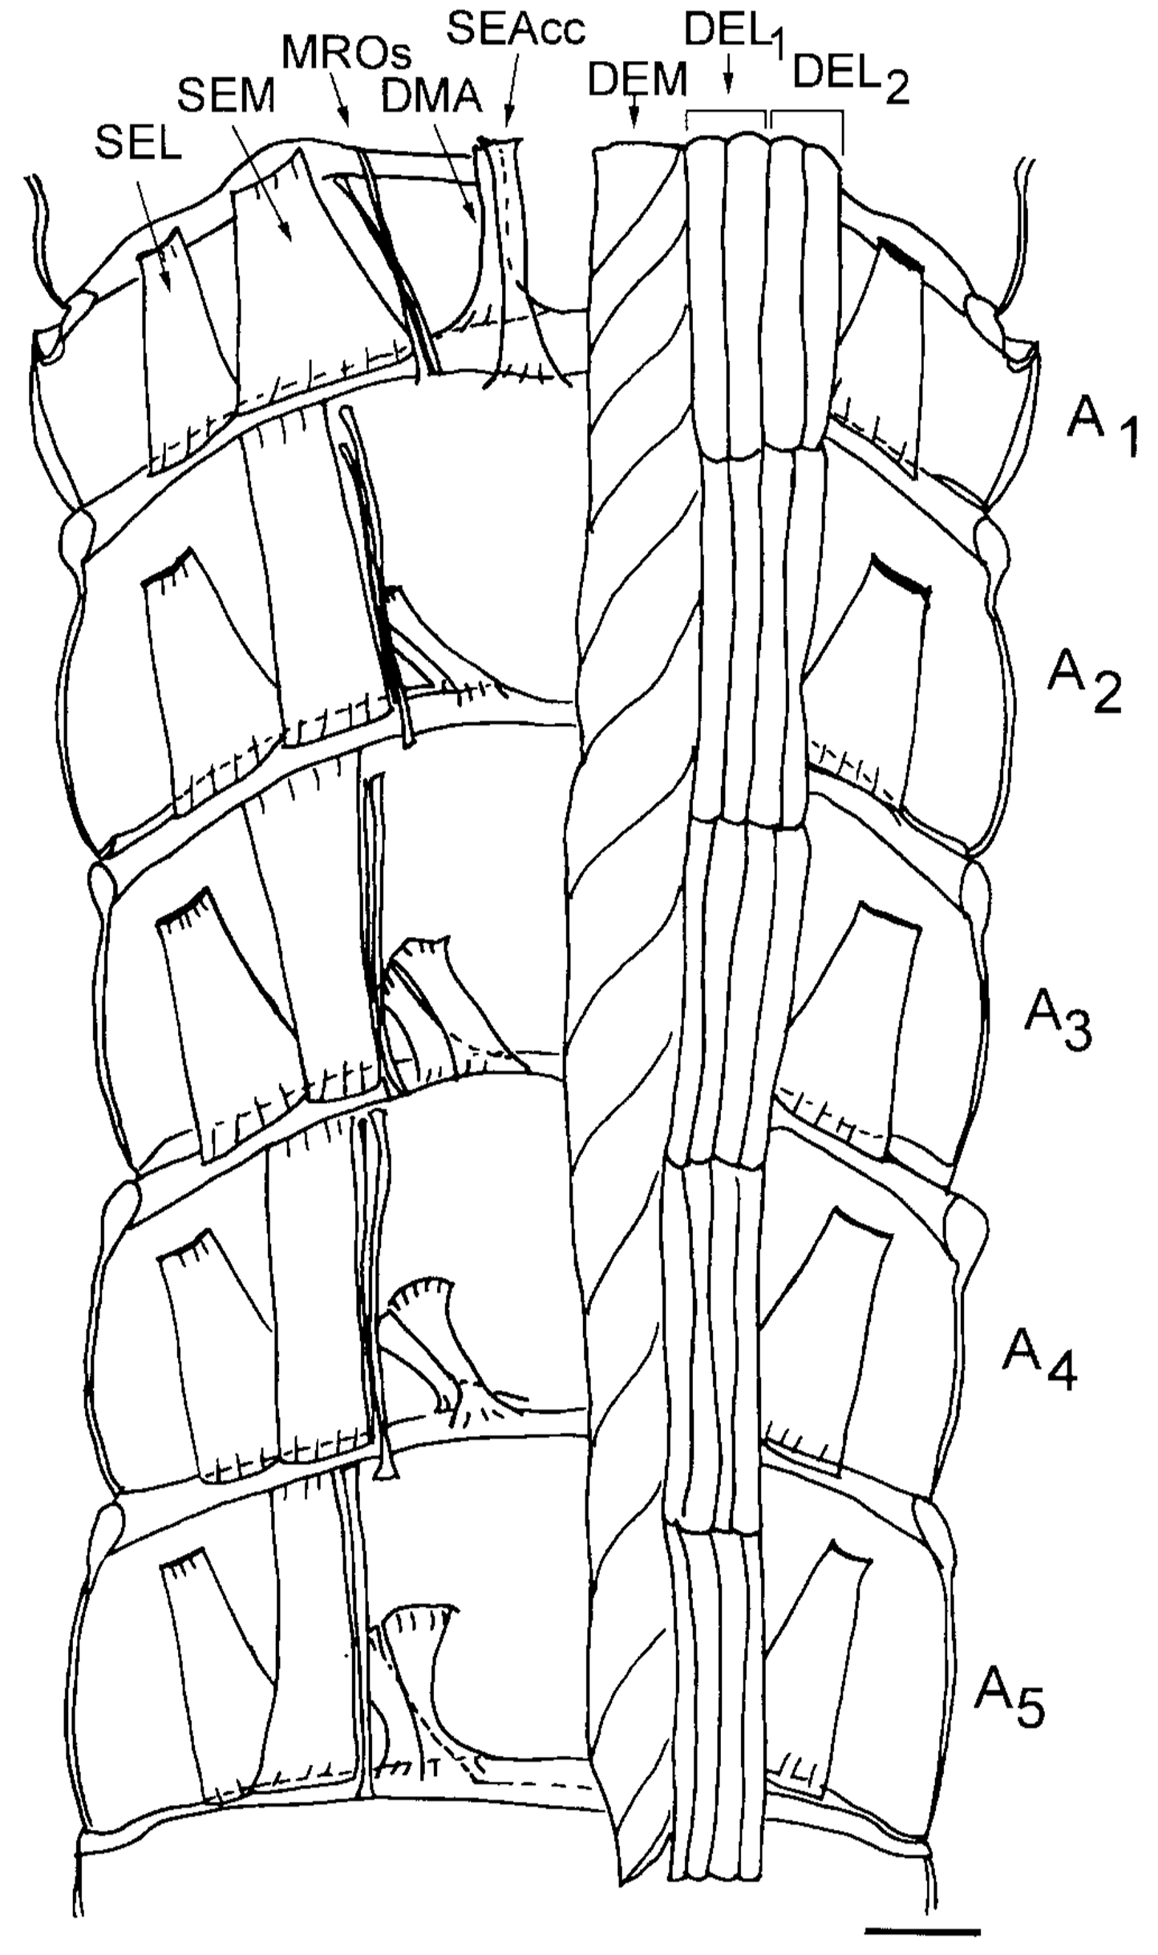
Appendix Figure 2: Schematic drawing from a ventral view of the dorsal part of the crayfish abdomen showing the extensor musculature of each segment. The dorsal membrane abdomen muscle (DMA) and the superficial extensor accessory head muscle (SEAcc) occur in segments 1 through 5 of the abdomen with a different orientation for each segment. With the exception of segment 1, these muscles have their attachment sites at their anterior end to the calcified tergite and at the posterior end in the articular membrane. In segment 1, the homologous muscles have their anterior attachment sites to the articular membrane located between the thorax and abdomen. The illustration was based upon photographic montages of methylene blue stained preparations. On the left side of the figure all the deep extensor muscles have been removed to show the dorsal superficial extensor muscles. Scale = 2.35 mm (Taken from Sohn et al. 2000).

