Measuring electrical signals in axons: Student laboratory exercises
by
Jonathan M. Martin¹, Martha M. Robinson¹, ‎ Harold L. Atwood², Rachel C. Holsinger¹, and R. L . Cooper¹
¹Department of Biology, University of KY, Lexington, KY
²Department of Physiology, University of Toronto, Canada

ABSTRACT

This is a demonstration in properties of recording compound action potentials from the ventral nerve cord of the crayfish for student-orientated laboratories. The same equipment is used in the membrane model as on these live preparations. Some properties of an isolated nerve cord are investigated: nerve actions potentials, recruitment of neurons, and responsiveness of the nerve cord to environmental factors.

Pre-lab Questions
- What is the purpose of lab 3? How does it relate to information you are covering through lecture?
- What are the basic components of a typical action potential graph? What causes the different components to occur?
- What is the difference between a single action potential and a compound action potential?
- How might the recordings of an action potential change if someone ingested tetrodotoxin from a puffer fish? Or fell into an icy lake?
- Where is the ventral nerve cord in a crayfish? What is the equivalent structure in humans?
- What is the difference between transduction and conduction of an action potential? How does conduction change with myelination or axon diameter?
- From basic physics, how does one measure the velocity of an object in motion?
- How could you apply that physics law to measure the conduction velocity of a compound action potential?
- What type of electrodes are we using to measure the compound action potential?
- On the recording of a compound action potential shown below, why are there multiple waves? What do they represent?

Time (ms)
CONDUCTION PROPERTIES OF NERVE CELLS

From a bread board to living cells
The passive properties demonstrated in the circuit board exercises are also measurable in living cells; however, these passive properties can be complicated to tease out when accompanied with action potentials in nerve cells. The active properties of the neuron are its ability to maintain a resting membrane potential, generate action potentials, and regenerate them along a length of membrane.

Electrical flow along a nerve cord can also be regenerative within individual neurons and from one neuron to the next. In the crayfish ventral nerve cord (VNC), some neurons communicate via septate (i.e. gap) junctions. As demonstrated in the earlier exercises with the breadboard, altering the resistance can impede conduction of electrical signals. This is analogous to altering the flow of current through gap junctions within the ventral nerve cord.

The conduction velocity and other properties of the compound action potential in the VNC are examined in the next series of experiments. We will demonstrate how to obtain the VNC for experimentation and how to elicit and measure the responses using standard equipment designed for teaching student laboratories.

Background on conduction in a nerve
The crayfish ventral nerve cord functions in transmitting signals that initiate escape responses such as the tail flip reaction. For this experiment, recordings will be taken from the entire intact nerve cord. The individual potentials from each neuron within the nerve cord sum together to give rise to the compound action potential, which provides the measurable electrical pulses shown by the recording software. Erlanger, Gasser, and Bishop (1924) are some of the pioneers who described compound action potentials. Characteristics of the refractory period, conduction velocity and the neural effects of the gap junction inhibitor 1-heptanol or temperature are shown. Learning the basic principles of nerve cell signals contributes to a better understanding of neurological function in general (Bennett, et al., 1991; Furshpan et al., 1959; Watanabe and Grundfest, 1961).

The crayfish preparation
The crayfish ventral nerve cord is best suited for this experiment. The nerve is easily dissected, and a variety of protocols that effect conduction can be used with this preparation. Before starting this experiment, become familiar with the crayfish anatomy terms below:

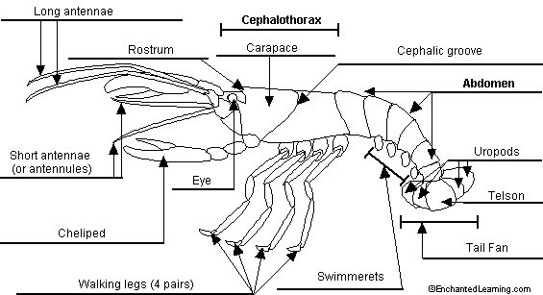
Figure 8. General crayfish anatomy diagram. Source: <http://www.enchantedlearning.com/
subjects/invertebrates/crustacean/label/crayfish/labelanswers.shtml>

Materials
Item | Quantity per group
Large Crayfish (Procambarus clarkii) | 1
Precision Dissecting Scissors | 1
Forceps | 1
MLT016/X Nerve Chamber | 1
Laptop w/Scope software | 1
PowerLab | 1
PowerLab Amplifier | 1
Stimulator output cable for PowerLab | 1
USB PowerLab/Computer Connector | 1
Manipulator Stand with Suction Electrode | 1
Glass Pipette w/bulb | 1
Beaker of Crayfish Saline | 1
Flexible metric ruler | 1

Methods
- 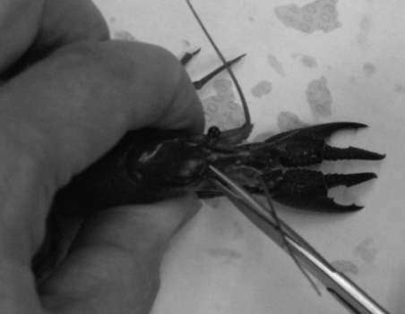Safety Precaution: If you have an allergy to shellfish (i.e. shrimp) you probably will have an allergy to crayfish. Please wear gloves when handling these animals.
Figure 1
- Ensure that the nerve chamber, various instruments, and solutions are prepared before dissecting a crayfish.
- Wrap crayfish in moist paper towel to hold or just hold crayfish in one hand with claws (chelipeds) between thumb and forefinger.
- Using a tremendous amount of force quickly cut the head off the crayfish by cutting through the rostrum between eye sockets. See figure 1.

- Remove the chelipeds and walking legs. Turn the crayfish over and make an incision at base of cephalothorax above the abdomen; remove the tail. See figures 2 and 3.
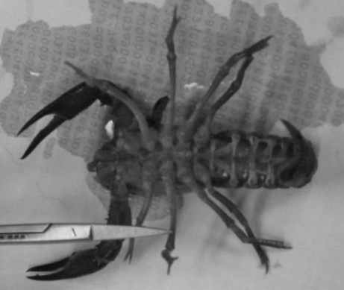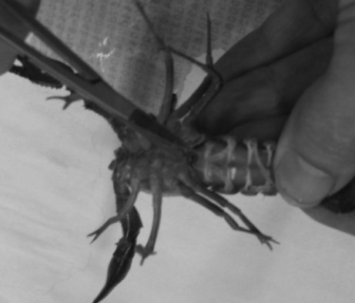
Figure 2
Figure 3

- Throw away the body of the crayfish and its legs. Then remove the swimmerets off the tail with a scissors.
- Make a cut with scissors along both sides of the ventral side of the abdomen. Be careful to not damage deeper tissue. See figure 4.

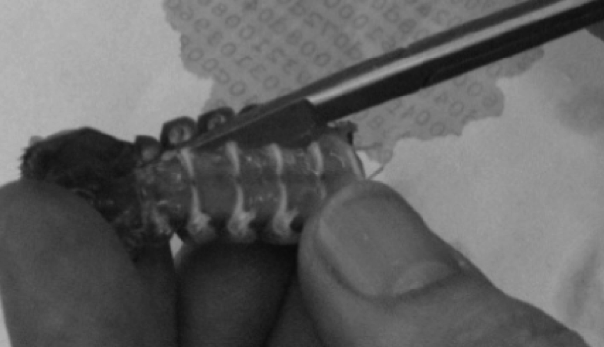
Figure 4
- Peel back the freed section of exoskeleton to the base of the tail fan in order to expose the ventral nerve cord.
- Using the edge of the forceps, carefully remove the ventral nerve cord by the tip. Be careful not to stretch or crush the nerve cord. Cut the nerve cord distil (after) to the 6 abdominal ganglia. See figure 5.

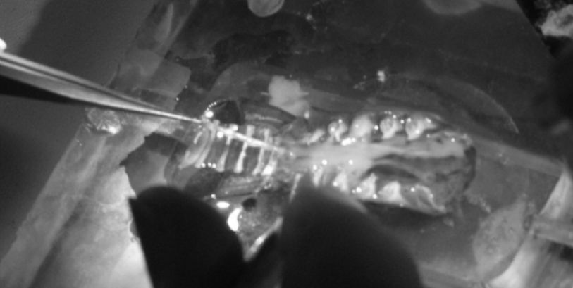
Figure 5

- It is imperative to keep the ventral nerve cord moist. To accomplish this, place the nerve cord in the nerve chamber and add enough crayfish saline solution to the nerve chamber to cover the tissue.
- Once the nerve is in place, position the suction electrode within the manipulator near the nerve chamber. Use a suction recording electrode to suck up the main ventral nerve cord by the thoracic abdomen section for stimulating. See figure 6.
Figure 6
Suck this end into recording electrode

Suck end into stimulating electrode

Recording
- Once the tip of the nerve cord is suctioned into the recording electrode, ensure that the electrode is attached to the probe and that the probe is sufficiently grounded. This can be accomplished by simply attaching the ground cable to the faraday cage. The positive and negative suction electrode wires should also be attached to the corresponding locations on the probe. The probe should be attached to the differential amplifier, which, in turn, is connected to the PowerLab.

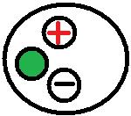
- Connect the electrical wires from the suction electrode to the head stage. The wires should be connected with the red (positive) at the top left, green (ground) in the middle, black (negative at the bottom. This is indicated in figure for the head stage below. The ground wire can just be put in the saline bath. Thus, one wire from the suction electrode to the + and the other to the – input. It does not matter which wires from the suction electrode goes to the + or – inputs.

The settings for the amplifier are as follows:

CONTROL | SETTING
High Pass | DC
Notch Filter | OFF
Low Pass | 20kHz
Capacity Comp. | Counterclockwise
DC Offset Fine and Course knob | Counterclockwise
DC Offset (+OFF) | OFF
Gain knob | 50
Input (DIFF MONO GND) | DIF
MODE(STIM-GATE-REC) | GATE
ΩTEST | OFF

- Connect the provided USB cable to the back of the PowerLab and to the computer outlet. Open the Scope software on the computer desktop. On the top right of the screen, select “Channel 1” for “Input A.” Next, click on the “Setting” tab on the top of the screen; select “Input Amplifier.” On the screen that appears for Input Amplifier options, select the following:

CONTROL | SETTING
RANGE | 500 mV
AC | CHECKED
LOW PASS | OFF
Differential | CHECKED
INVERT | CHECKED

On right hand side:
Turn off Input B
Time base: 4kHz
Sample: 1024
Time: 200msec

- Next, again under “Settings,” click “Sampling.” In the box entitled “Sweep” on the screen that appears, select the following:

CONTROL | SETTING
MODE | MULTIPLE
SAMPLE | 100 SWEEPS
SOURCE | USER
DELAY | 0 msec

- Finally, under the “Settings” tab, select “Stimulator;” choose the following settings:
Click off the isolated stimulator box

CONTROL | SETTING
MODE | MULTIPLE
DELAY | 10 ms
DURATION | 1.5 ms
PULSE(S) | 2
INTERVAL | 50 ms
RANGE | 10 V
AMPLITUDE | 0.5 V

Exercise 1.
Select the “Start” button at the lower left of the screen. Given the above settings, a clearly defined action potential should appear on the Scope data collection box. Sketch the general shape of the action potential below:
Time (ms)
Voltage (mV)
Slowly decrease the voltage using the tab at the top left of the screen. The action potential should become smaller in magnitude until its characteristic wave pattern likewise disappears. Decreasing the voltage reduces the number of neurons that are recruited to fire the compound action potential. The larger axons are likely the recruited at the lower voltages and are the faster conducting ones which would tend to appear first in the compound action potential. Incrementally increase the voltage to observe the opposite effect; as more neurons are recruited, the compound action potential wave grows larger. This exercise illustrates the fact that individual neurons have different thresholds for action potential production. When the compound action potential does not increase any further with increasing stimulating voltage, all the neurons have been recruited; two distinct peaks in the action potential wave on the computer screen should be visible.

Exercise 2.
After examining neuron recruitment and the resulting compound action potential, observe the effect of the refractory period. This can be done by giving two stimuli close together in time and varying the interstimulus interval, then observing at what interstimulus interval the compound action potential, elicited by the second stimulus, is reduced in amplitude compared to the first compound action potential. Change the interval between pulses using the tab in the top left corner of the screen (THIS IS THE INTERVAL FUNCTION). Keep shortening the interval until the second compound action potential cannot be elicited. The time between pulses at which a second action potential is no longer elicited is the absolute refractory period. The time between the end of the absolute refractory period to the time when a second stimulus generates an action potential of full amplitude is termed the relative refractory period. Give an estimate of the absolute and relative refractory periods in the spaces provided.

Absolute Refractory Period: ___________________

Relative Refractory Period: ___________________

Measuring conduction velocity

With a millimeter ruler, measure the distance between the stimulating wire closest to the recording electrode, and the recording electrode. From the recorded trace, measure the time to the various peaks of events in the compound potential so that you can record conduction velocity of the various electrical signals. Convert the mm distance to meters and the msec time to sec for meters/second as units.

1st wave-form conduction velocity: __________________

2nd wave-form conduction velocity: __________________

3rd wave-form conduction velocity: __________________

4th wave-form conduction velocity: __________________
Manipulation of the gap junctions and/or conduction velocity
Next, investigate the properties of a neuronal inhibitor. The uncoupling effect of heptanol was first described in crayfish septate axons (i.e., gap junctions) by Johnston et al. (1980). This effect related to electrical communication was soon confirmed in various vertebrate and invertebrate systems (Bernardini et al., 1984; Meda et al., 1986). To understand the role of electrical communication in this ventral nerve cord, a saline with (1mM) 1-heptanol can be used to uncouple gap junctions. With a glass pipette, wash over the over the entire nerve cord a solution of heptanol. Observe the change that is recorded by the Scope recording software, and summarize it. (Note the change in the wave-form, and whether conduction velocity of the wave-forms has changed). Alternatively, instead of using 1-heptanol, ice-cold saline could be exchanged for the bathing saline and any change in the wave-form or conduction velocity of the wave-forms could be monitored.

Discussion
Our goal in the on-line video presentation and this paper is to demonstrate that the biophysical properties of cells can, in part, be modeled as electrical circuits. In addition, with live neural tissue that is relatively easily obtained, fundamental principles of conduction velocity, refractory periods and electrophysiological recording techniques are possible for undergraduate student laboratories with modest investment of equipment. The themes and fundamental paradigms presented can be readily modified for the requirements of different courses.

Maintenance of crayfish and their abundance makes them attractive models for student-driven experimentation. Crustacean ventral nerve cords are generally robust and retain physiological integrity in a minimal saline for hours, which is adequate for a 3 hour student laboratory.

Given that some of the large axons in the VNC of the crayfish are connected via gap junctions, additional experimentation on their contribution can be conducted, and different properties than found in the standard frog sciatic nerve preparation can be demonstrated. The sciatic nerve is a classic model for addressing compound action potentials and conduction properties. It might even be an interesting comparative experiment for students to compare conduction properties, axon recruitment, and refractory periods between these two preparations.

Acknowledgments
These experiments were modified from a laboratory manual that has been used in a course, orchestrated by Dr. H.L. Atwood, at the Department of Zoology, University of Toronto. The exercises were also used and modified from a manual that was produced for “6th INTENSIVE IBRO WORKSHOP ON BASIC NEUROSCIENCE” and was held at Korea University, Seoul, South Korea in 1993 (Cooper et al., 1993). The current modifications were required to use equipment common to present day student directed laboratories at various universities.

REFERENCES
Bennett, M. V. L., Barrio, L. C., Bargiello, T. A., Spray, D. C., Hertzberg, E. and Sdez, J. C. (1991). Gap junctions: new tools, new answers, new questions. Neuron. 6: 305-320.

Bernardini, G., Peracchia, C., and Peracchia, L.L. (1984) Reversible effects of heptanol on gap junction structure and cell-to-cell electrical coupling. European Journal of Cell Biology. 34(2):307-312.

Cooper, R.L., Chang, J.J., and Ito, M. (1993) A report on the, "SIXTH INTENSIVE IBRO WORKSHOP ON BASIC NEUROSCIENCE", held in July 1993, Seoul, South Korea. Abstracts, Society for Neuroscience 19:116.3

Cragg, B.G. and Thomas, P.K. (1957). The relationship between conduction velocity and the diameter and internodal length of peripheral nerve fibers. Journal of Physiology. 136: 606-614.

Erlanger, J. Gasser, H.S. and Bishop, G.H. (1924). The compound nature of the action current of nerves as disclosed by the cathode ray oscillograph. American Journal of Physiology 70: 624-666.

Furshpan, E. J. and Potter, D. D. (1959). Transmission at the giant motor synapses of the crayfish. Journal of Physiology. 145(2): 289-325.

Johnston, M. F., Simon, S.A., and Ramrn, F. (1980) Interaction of anesthetics with electrical synapses. Nature (Lond.). 286:498-500.

Loewenstein, W. R. (1966). Permeability of membrane junctions. Annual NY Academy of Sciences 137: 441–472.

Meda, P., Bruzzone, R., Knodel, S. and Orci, L. (1986) Blockage of cell-to-cell communication within pancreatic acini is associated with increased basal release of amylase. Journal of Cell Biology. 103(2):475-483.

Peracchia, C. (1990). Increase in gap junction resistance with acidification in crayfish septate axons is closely related to changes in intracellular calcium but not hydrogen ion concentration Journal of Membrane Biology. 113 (1): 75-92.

Peracchia, C. and Dulhunty, A. F. (1976). Low resistance junctions in crayfish: structural changes with functional uncoupling. Journal of Cell Biology. 70: 419-439.

Peracchia, C., Bernardini, G., and Peracchia, L. L. (1983). Is calmodulin involved in the regulation of gap junction permeability? Pfügers Arch 399: 152–154.

Peracchia, C., Lazrak, A. and Peracchia. L. L. (1994). Molecular models of channel interaction and gating in gap junctions. In Handbook of Membrane Channels. Molecular and Cellular Physiology. C. Peracchia, editor. Academic Press, San Diego. 361-377.

Spray, D. C., Harris, A. L. and Bennett, M. V. L. (1981). Gap junctional conductance is a simple and sensitive function of intracellular pH. Sciences NY 211: 712-715.

Spray, D.C., Harris, L.L. and Bennett, M.V.L. (1982). Comparison of pH and Ca dependence of gap junctional conductance. In Intracellular pH: Its Measurement, Regulation, and Utilization in Cellular Functions, R. Nuccitelli and D. Deamer, eds., pp. 445-461, Alan R. Liss, New York. pp. 445-461.

Spray, D.C., White, R., De Carvalho, C., Harris, A.L. and Bennett, M.L.V. (1984). Gating of gap junction channels. Journal of Biophysics 45: 219-230.

Watanabe, A., and Grundfest, H. (1961). Impulse propagation at the septal and commissural junctions of crayfish lateral giant axons. Journal of General Physiology 45: 267-308.

Wiersma, C.A.G and Hughes, G.M. (1961). On the functional anatomy of neuronal units in the abdominal cord of the crayfish, Procambarus clarkii. Journal of Comparative Neurology 116: 209-228.

