Human ECG Laboratory Experiment
By

Brittany Baierlein, Alison L., Thurow, Rachel Holsinger and Robin L. Cooper
Department of Biology, University of KY, Lexington, KY 40506-0225, USA.
(Some text taken directly from ADInstruments protocol guide)
ABSTRACT:
The purpose of these experiments is to understand the function and importance of an electrocardiogram (ECG) and finger pulse reading as well as see how they relate to one another. This lab will demonstrate how changes in the environment and stress levels affect human heart rate. Furthermore, the equipment used in the lab will demonstrate the anatomical function of the ulnar, radial, and brachial artery in the arm as well as the QRS complex and the waves associated with an ECG. Finally, the lab will serve as a way to learn how to use an ECG to record and calculate heart rate.
1) INTRODUCTION:
1a) The Electrocardiogram:
An ECG can be used to record activity during the cardiac process of pumping and returning blood to the body and heart because of the electric current that spreads through the tissue of the heart and to the surface of the body. By using three electrodes: one on each wrist around the radial artery and one that is grounded on the upper, left foot, we are able to record these electrical potentials produced by the heart.
The first part of the lab involves reading an ECG and calculating heart rate by analyzing the waves associated with an ECG recording. Each portion of an ECG reading is divided into five waves or collectively three sections. The first part of an ECG is a small peak that is called the P wave. The P wave is produced by the depolarization of the atria before the heart contracts.
The QRS complex, which consists of the Q, R, and S wave, occurs because of the depolarization of the ventricles before contraction. As a result, the P, Q, R, and S wave represent the depolarization of the heart. In contrast, the T wave occurs as a result of repolarization of the ventricles (recovery from depolarization). It is important to note that the P wave occurs immediately before the contraction of the atria and the QRS complex occurs immediately before the contraction of the ventricles. The ventricles remain contracted until the end of repolarization or until the end of the T wave. The atrial T wave is not usually distinguishable on the ECG because atria depolarization occurs 0.1-0.2 seconds after depolarization occurs. As a result, the atrial T wave is often over shadowed by the QRS complex. On the other hand, the ventricular T wave is noticeable on the ECG because repolarization of the ventricles occurs over a longer period of time and is seen after the QRS complex occurs. The voltage recorded on an ECG is usually very small as compared to a normal action potential. The voltage reached by the QRS complex is approximately 1 mV (from the top of the R wave to the bottom of the S wave). In contrast, the P wave is much smaller and ranges between 0.1 and 0.3 mV, where as the T wave ranges from 0.2 and 0.3 mV.
Read the Waves and intervals section of the ECG Wikipedia article to fully understand the different parts of an ECG reading. Pay close attention to the animation of a normal ECG wave. http://en.wikipedia.org/wiki/Electrocardiography - Waves_and_intervals
The heart rate can be determined from a normal ECG. The time interval between two beats is the reciprocal of the heart rate. The average interval between two QRS complexes is 0.83 seconds. Therefore, to calculate heart rate, the time in one minute (60 seconds) is divided by the time interval between two QRS waves. As a result, the number of beats that can occur in one second is derived. The equation is given below.
$$Heart Rate=\frac{60}{Time Interval Between Successive QRS waves}$$
1b.) Finger Pulse Reader:
The finger pulse reader simply measures pulse and shows a wave or peak as the heart beats. As the heart beats and is recorded with the finger pulse reader, the activity can be compared to the ECG output to provide a better understanding as to what is occurring in the heart. The finger pulse waves are seen concurrently with the QRS complex. The finger pulse reader is most useful when analyzing blood flow and the ability of the equipment to record a heart beat when the radial, ulnar, or brachial artery is restricted. By analyzing the restriction of individual arteries and comparing results, the function of each artery can be determined and the qualitative amount of blood delivered to the body can also be determined.
1c.) Ulnar, Radial, and Brachial Arteries:
During experimentation, the function and role of each of the major arteries in the arm will be determined. The brachial artery is an artery that runs from the upper arm to the lower arm. The brachial artery branches into the ulnar artery and the radial artery. The ulnar artery is located on the medial portion of the lower arm, and the radial artery is located on the radial portion of the arm. It is important to understand the anatomy of each artery by restricting blood flow through each artery and observing the effects on the finger pulse reader. The pulse recorded will be modified when pressure is applied to a specific artery.
2. PRELAB QUESTIONS:
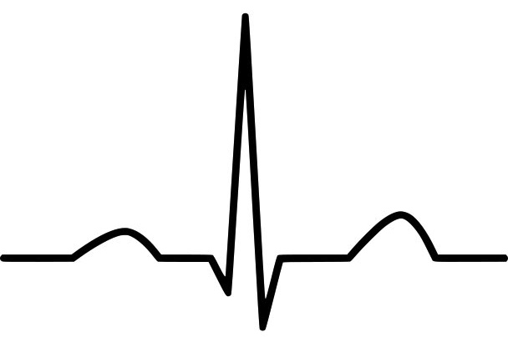
1. Label the P wave, QRS complex, T wave on the following diagram:

2. How do electrical signals on the ECG trace correlate with events in the heart?
P wave:
QRS complex:
T wave:
3. PROCEDURE:
3a.) Determine Heart Rate
- Gather all necessary equipment: finger pulse reader, black, white, and green leads, Powerlab, and laptop.
- Make sure the Powerlab is connected to the computer and open the Lab Chart file titled ECG and Pulse.
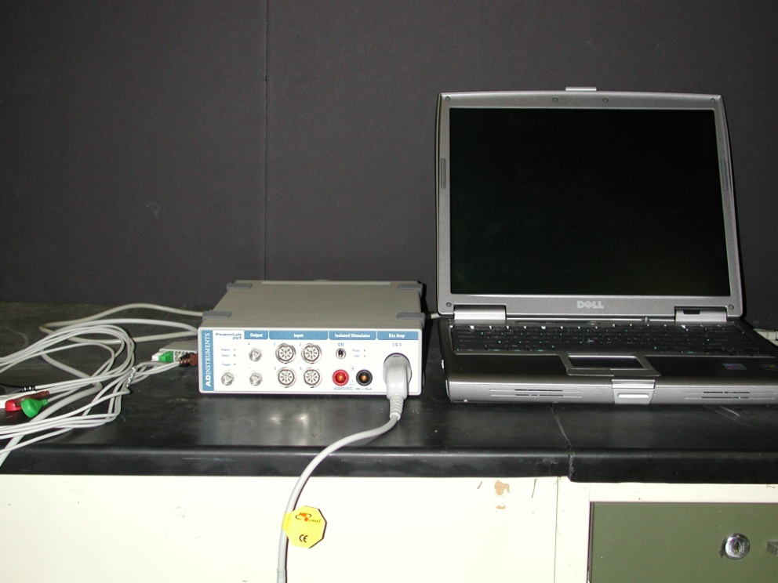
- Connect the black lead to the person’s left wrist on the same side of the wrist as the palm; connect the white lead to the right wrist, and the green lead to the lower shin of either leg.
- Connect the pulse recorder to the middle finger on the left hand.
- Have the person sit in a chair and stay as still as possible.
- Once the leads are properly attached begin recording data by pressing the start button.
- After 10 to 15 seconds have elapsed press stop.
- Channel 1 will be recording your pulse, it is very important to remain as still and quiet as possible when recording pulse, and Channel 3 is recording the ECG. Looking at the information recorded on Channel 3. Identify the P wave, QRS complex, T wave, and U wave.
- Determine the duration of one heartbeat. This is done by placing the cursor over the top of one of the R peaks. Record the time on page 6 that is displayed above where it says Channel 1. Now place your cursor over the R peak of the preceding QRS complex, and subtract this time from the time you recorded previously. The number you are left with it the value of Δt.
- Determine heart rate (beats per minute) by dividing 60 seconds by the Δt and record on page 6.
3b.) Heart Rate while exercising:
- Do another 10-15 second recording while doing one of the following things, if your TA has not assigned one to you may pick for yourself.
  - Alternate between standing and sitting
  - Run in place
  - Lay down
  - Do Jumping jacks
- Again calculate the heart rate as you did in #10 and record on page 6.
3c.) Dive response:
- Caution: Sit or lie down while doing this and have partner near by as one can faint from this activity. Hold your breath while applying a cold compress on the face particularly the upper lip area or an ice cold wet towel.
a. 1st record what happened when just holding your breath
b. Then breathe and repeat with the ice cold pack on your face.

Record the data on page 6 as an absolute change and a percent change in heart rate for holding breath and for ice cold and holding breath.

3d.) Pulse recorder
- The leads can now be removed and the pulse recorder should be applied to the middle finger.
- Record for 10-15 seconds of just sitting.
- To determine the amplitude of your pulse calculate the difference between the highest point of the waveform and the lowest point. Record this number on page 6.
- To determine the Δt of the pulse find the difference in time between two adjacent pulses using the top of each wave.
- Next the radial pulse will be measured. To do this place your middle three fingers on the underside of the wrist on the side closest to the thumb. Apply a small amount of pressure to feel the pulse. Begin recording then apply greater pressure over the radial pulse for about 5 seconds and release, notice what happens to the amplitude of the pulse. Record the differences.
- Next do the same thing with the radial ulnar pulse. This is located closer to the pinky on the underside of the wrist.
- Again, repeat the steps on the brachial pulse which is located on the inside of the elbow on the same side as the thumb.
- Do one of the following variations and after calculate and observe the change in pulse amplitude:
  - Have the person start breathing fast and notice what happens to the heart rate, if there is a change also note the time it takes for this change. Do not do this for very long and stop immediately if you feel light headed.
  - Breathing slowly
  - Stick your hand in cold water and notice what happens to the pulse amplitude.

Record observations here:
Draw an example of the initial ECG recorded and label:

Time where second R peak occurs (A):____________________
Time where initial R peak occurs (B):______________________
Δt = A –B = ___________ - ___________ =
$$heart rate= \frac{60}{∆t }=$$
Heart rate from step 12 and which variation was chosen:

Pulse amplitude:

Δt of normal pulse:
Δt of radial occluded pulse:

Δt of radial ulnar occluded pulse:

Δt of brachial occluded pulse:

Δt of step 20 and which variation was chosen:

Analysis:
Describe the relationships between the ECG, the first and second heart sounds and the finger pulse. Would the relationship be the same if you had recorded the carotid pulse? Justify your answer.

What do you conclude about the cardiac cycle from your measurements?

The P wave and the QRS complex represent depolarization of the atrial and ventricular muscle respectively. Why does the QRS complex have the larger amplitude?

Was there variability between the beats? Would you expect the interval between beats to be identical? Why or why not?

The range for a normal resting heart rate is 60 to 90 bpm. Many trained athletes have resting heart rates of 45 to 60 bpm or even lower. What physiological advantage is there in a slower resting heart rate?

Can you distinguish between the two heart sounds, lub and dub? Which is associated with the first heart sound, and which is associated with the second?

Describe the relationships between the ECG and the first and second heart sounds.

Appedix 1:
- Troubleshooting
- Ensure that the subject does not move their fingers excessively if using the MLT1010 Finger Pulse Transducer — this will introduce noise into the measurements making analysis difficult.

- If students cannot get a strong pulse signal from their finger, try placing the Finger Pulse Transducer on the thumb.

- The Range or Scale may need to be adjusted for the strength of each student’s pulse. This is especially true if the student’s pulse amplitude exceeds the default Range setting. Use the Range pop-up menu located at the right of the Chart window. Adjust the Range so that the pulse signal is 50% of a full-scale deflection on the screen. Instruct your students to refer to the Student Quick Reference Guide for help in adjusting software settings. In most cases, scaling the Y-axis will be sufficient to display the data adequately.

- Subjects in this experiment must be relaxed — have the other members of the group tap the subject on the back every ten seconds during a “dive” to help keep track of the time. In addition, a few practice runs are easy to do and will help the students get a good set of data. Tell the students that a quiet classroom will help them stay calm.

- Control data should be obtained for each student and each run.

Experiment Variations
After the basic demonstration of the dive response has been performed, ask each group to examine one or two questions relating to the dive response. This is especially useful if you want students to write an investigative lab report. A good place to start is to try to get students to think of which components of a “dive” are actually causing the response. Are these components all necessary? Are the components of the dive response additive? Examples of questions are:
- Effect of breath holding versus facial immersion
  - Allow the student to immerse their face, but allow them to breathe through a snorkel or large piece of plastic tubing.

- Effect of water temperature on the dive response
  - Is the dive response the same at warmer or cooler water temperatures?

- Effects of facial cooling and head position
  - Apply a cold compress to the forehead and have the subject hold their breath.
  - Is “wetness” important? Students can try covering their face with plastic film wrap while immersing their face in the water (takes some practice).
  - Examine the effect of head position: Compare an upright posture with placing the head between the knees, with and without a cold compress.

Other concepts to explore
- Long-term effects of the dive response
  - How long does the reduction in peripheral circulation last?
  - How long does the bradycardia last?

- Variation among students
  - Have the students express their heart rate as a percentage of their “resting” control rate.
  - Compare the percent drop in heart rate among groups or among the entire class.

Students should take care to ensure that they follow exactly the same procedures each time. Doing so will facilitate comparisons between students.

Recording from the pulse transducer

Noise
The MLT1010 Finger Pulse Transducer is a very sensitive instrument. Even slight movements by the volunteer can result in noisy recordings. Instruct the volunteer to keep their hand still during pulse recordings.

Adjusting sensitivity
Pulse strength varies between students. If the signal is weak or not visible, increase the range by selecting the Range drop-down list in the blood flow channel and choosing a lower value. A proper signal should be 1/2 to 2/3 the chart height.
If the pulse signal is too strong, you will see “Out of Range” appear in the channel window while recording. If this happens, reduce the Range by selecting a higher value from the Range drop-down list in the blood flow channel. A proper signal should be 1/2 to 2/3 the channel window height.

Analysis Tips
Students should be familiar with the use of the Marker and Waveform cursor tools. These tools can be used in both the Chart Main window and the Zoom window. If students cannot locate the marker, click in the lower left corner of the Chart main window; this will return the Marker to its “resting” location (Figure 1).
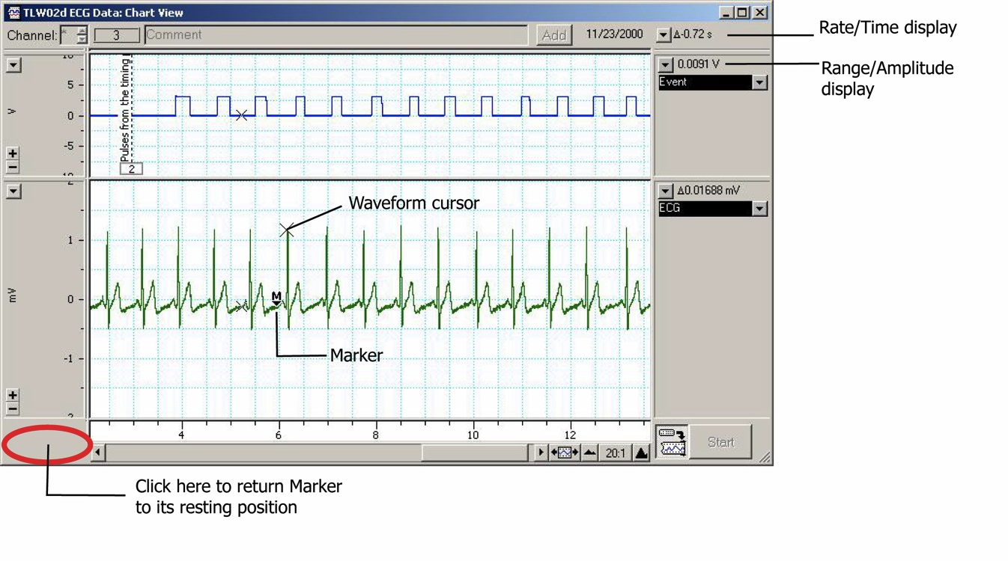
Figure 1. Use of the Marker and Waveform cursor tools.

Chart Settings
Use these settings if you do not have access to a pre-made Chart settings file for this experiment. In addition, this section may be pasted into the Word documents for student access. Chart settings files are available for download via the ADInstruments Website: http://www.adinstruments/education

ECG & Pulse Settings
Sampling rate: 200/sec
View compression: 2:1
Channel settings: Three channels displayed, of equal height.
Channel 1: Title: ‘Vol. Pulse’
Computed Input*: Left side: Raw Data Input 2
Range 200 mV
Right side: ∫(Integral) from pop-up menu at top
Range 20 mV.s
Time Const 1 s.

OR
Integral: Source channel: Ch2 Blood Flow
Integral type: Standard Integral
Reset type: Time Constant Decay 1s
Autoscale: checked

Channel 2: Title: ‘Blood Flow’
Input Amplifier: Range 200 mV
Low Pass Off
Positive checkbox: checked
Negative checkbox: unchecked
(or Single sided checked in Chart 5.1 or later)
AC Coupled checkbox: checked

Channel 3: Title: ‘ECG’
Bio Amplifier: Range 2 mV
High Pass filter: 1 Hz
Low Pass filter: 50 Hz
Notch checkbox: checked

*Computed Input can be replaced using the Integral function in the Channel Function pop-up menu (if required).

Volume Pulse Settings
Sampling rate: 200/sec
View compression: 2:1
Channel settings: Two channels displayed, of equal height.
Channel 1: Title: ‘Vol. Pulse’
Computed Input: Left side: Raw Data Input 2
Range 200 mV
Right side: ∫(Integral) from pop-up menu at top
Range 20 mV.s
Time Const 1 s.
Channel 2: Title: ‘Blood Flow’
Input Amplifier: Range 200 mV
Low Pass Off
Positive checkbox: checked
Negative checkbox: unchecked
(or Single sided checked in Chart 5.1 or later)
AC Coupled checkbox: checked

References:

LabTutor Instructor’s Guide. ECG & Peripheral Circulation. North America: 2005. Pg 1-8.

LabTutor Instructor’s Guide. Dive Response. North America: 2005. Pg 1-12.

Butch, G. E.; Winsor, T. A primer of electrocardiography. 2nd ed. Philadelphia, PA: Lea and Febiger; 1953.

Cooper, R.L., McGrath, J.J., Dooley, S. and Kopetzky, M.T. (1989) Chronic exposure to carbon monoxide at high altitude: Effects on mean electrical axis. Physiology and Behavior 46:75-79 (hot link) http://web.as.uky.edu/Biology/faculty/cooper/labWWW-PDFs/Carbon%20Monoxide%20paper.pdf

Cooper J (1986). "Electrocardiography 100 years ago. Origins, pioneers, and contributors". N Engl J Med 315 (7): 461–4. PMID 3526152.

Einthoven W. Un nouveau galvanometre. Arch Neerl Sc Ex Nat 1901; 6:625
Moises Rivera-Ruiz, Christian Cajavilca, and Joseph Varon, (2008) Einthoven's String Galvanometer: The First Electrocardiograph. Tex Heart Inst J. 2008; 35(2): 174–178. http://www.pubmedcentral.nih.gov/articlerender.fcgi?artid=2435435
Nobel lectures, physiology or medicine 1922–1941. Amsterdam: Elsevier Publishing Company; 1965. Available from: http://nobelprize.org/nobel_prizes/medicine/laureates/1924/einthoven-bio.html.

