Synaptic Responses, Neuronal Circuitry and Neuromodulation Using the Crayfish: Student Laboratory Exercises

Purpose

The purpose of this exercise is to help develop an understanding synaptic transmission. The crayfish abdominal extensor muscles are organized into functional groups: Some are tonic (slow) and others phasic (fast) in their biochemical phenotypes, and vary by structure as well as the motor neurons that innervate them. We use these muscles as well as the superficial (near the surface), tonic abdominal flexor muscle to demonstrate properties in synaptic transmission. In addition, we introduce a sensory-CNS-motor neuron-muscle circuit to demonstrate the effect of cuticular sensory stimulation as well as the influence of neromodulators on each aspect within the circuit.

Learning Objectives
Physiological Mechanisms
- Students will understand the difference between tonic and phasic neurons
- Students will understand how EPSPs and IPSP influence muscle contractions

Evaluation and Analysis of Experimental Data
- Students will understand how to obtain information from experimental recordings of nerve activities.
- Students will understand how to condense raw experimental data into descriptive/summarized statistics (averages and standard deviations).

Experimental Techniques
- Students will understand basic techniques for using electrodes to stimulate and record the electrical activity of live tissue prep using the crayfish model.

Pre-Lab Quiz
- What is an EPSP? What is an IPSP? How does each work, physiologically?
- What is a tonic-type neuron? What is a phasic-type neuron? How do they work physiologically?
- What is the excitatory neurotransmitter of the neuromuscular junction of humans? What is the inhibitory neurotransmitter of the neuromuscular junction of humans? Are the same ones commonly used in crayfish? If not, identify what is common in crayfish.
- What is the difference between a flexor muscle and an extensor muscle? What is the difference between a superficial muscle and a deep muscle?
- In each of the abdominal ganglia of the crayfish, what do the three bilateral nerve roots do? What do they communicate with?

Introduction
EPSPs, IPSPs, and the Neuromuscular Junction
The abdominal extensor muscle preparation used to demonstrate the resting membrane potential is also ideal for demonstrating synaptic responses at neuromuscular junctions. In a general motorneural pathway, action potentials exiting the central nervous system are carried along efferent motor neurons. Efferent motor neurons then synapse onto individual muscle cells at specialized synapses referred to as neuromuscular junctions, or NMJ. Depending on the type of motor neuron, the action potentials can deliver signals that are excitatory (elicit an excitatory postsynaptic potential, or EPSP) or inhibitory (elicit an inhibitory postsynaptic potential, or IPSP). In humans, NMJ’s receive only excitatory signals. In crayfish, NMJ can receive either excitatory or inhibitory signals, or both. Excitatory postsynaptic potentials cause the membrane potential of the muscle cell to move towards threshold (depolarize), whereas inhibitory postsynaptic potentials cause the membrane potential of the muscle cell to move further away from threshold (hyperpolarize).

Phasic and Tonic Neurons
In addition to delivering different types of excitation signals (excitatory or inhibitory), The motor neurons can also be phasic or tonic. Phasic-type neurons rapidly adapt and phase-out their response when the source of the stimulus (i.e. the CNS) continues the stimulation in an unchanged manner. Thus, they may fire a burst of signals initially, but quickly decrease their signals over time until no further signals are sent. In contrast, tonic-type neurons adapt slowly (if at all) and continue to fire action potentials so long as they are stimulated to do so. Abdominal flexor muscles (groups of cells) in crustacea are selectively innervated by either a phasic or a tonic motor excitatory motor neuron, although some single fibers can be innervated by both types of excitatory motor neurons (Atwood, 2008; see JOVE production id#2319-Wu and Cooper, 2010; Wiersma, 1961a). By selectively stimulating phasic and tonic motor neurons, physiological differences in the resulting EPSPs may be measured.

In experimental set-ups, phasic motor neurons produce rapid twitching of muscle fibers and evoke EPSPs on the order of 10–40 mV. The phasic response can depress rapidly with 5–10-Hz (units per second) of stimulation. The tonic motor neurons give rise to smaller EPSPs that can be facilitated in the presence of a higher frequency (10–50 Hz) of stimulation. Structurally, the presynaptic phasic and tonic terminals at the NMJs are different (Atwood and Cooper, 1996; Bradacs et al., 1997; Cooper et al., 1998).

Surprisingly the phenotype of the phasic physiological responses can undergo a transformation to a tonic-like state by electrically conditioning phasic neurons for a few hours daily over 7 days (Cooper et al., 1998; Mercier and Atwood, 1989). The sensitivity to neuromodulation of the transformed NMJs is prime for investigating the regulation of receptor expression (Griffis et al., 2000).

In this relatively robust preparation (crayfish abdominal muscles), both tonic and phasic responses are easily recorded and examined for facilitation and/or depression of the synaptic responses with varied stimulation paradigms. With these preparations, students will be able to recognize generalities of the phasic and tonic synaptic responses by stimulating a nerve bundle.

An additional NMJ preparation presented is used for monitoring intrinsic motor activity and sensory stimulus induced motor activity from the CNS. This is the superficial flexor muscle on the ventral side of the crayfish abdomen. This preparation will also be used to monitor the sensory-CNS-motor-muscle circuit and the effects of neuromodulators (Strawn et al., 2000).

Crayfish Abdomen Neuromuscular Architecture
In each of the abdominal segment (except the last) there are three functional groups of muscles: (1) those controlling pleopod (swimmerets) movement, (2) three extensor muscles and (3) three flexor muscles. The flexors and extensors are antagonistic groups of muscles. Contraction of the abdominal flexor muscles result in a decrease of the angle of the abdomen (i.e. curl and enter a tail tuck position). Contraction of the extensor muscles cause the abdomen to extend back to a 180’ angle (i.e. flatten back out from the tail tuck position). Contractions occur via rotation about the intersegmental hinges. The phasic musculature occupies most of the volume of the abdomen, while the tonic muscles comprise thin sheets of fibers that span the dorsal (extensors) and ventral (flexors) aspect of each abdominal segment.

Crayfish Neuromodulators
In crayfish, the tonic abdominal flexor muscles of crayfish are innervated in each half segment by five motoneurons and by a peripheral inhibitory neuron. The excitatory motoneurons use glutamate as a neurotransmitter. Glutamate depolarizes the muscle fibers by causing an increase in permeability primarily to sodium ions. The inhibitory neurons release gamma-amino butyric acid (GABA), which usually hyperpolarizes the muscle fibers by causing an increase in permeability to chloride ions. In some crustacean muscles (mainly in limbs), the peripheral inhibitory neurons make synaptic contacts with motor neuron terminals as well as with the muscle fibers, and reduce the amount of transmitter released by the motor neuron (presynaptic inhibition) (Dudel and Kuffler, 1961). This phenomenon is not present in the tonic flexor muscles of crayfish.

The ventral nerve cord of crayfish is a bilaterally symmetrical structure running the length of the animal. There is one ganglion per body segment. In the abdomen (6 segments), each ganglion contains several hundred neurons, and each of the two connectives consists of a few thousand axons. The nerve cell bodies form a layer several cell bodies thick on the ventral surface of each ganglion. Immediately above the cell body layer is a fine meshwork of neuronal processes, the neuropile. All synaptic interactions occur here; the cell bodies are devoid of synapses.

Abdominal Ganglia Anatomy
Each abdominal ganglion (except the last) has three roots on each side. The first root contains axons of neurons innervating the pleopod musculature and sensory axons; the second root contains axons innervating phasic and tonic extensor musculature and sensory axons; and the third root, which leaves the nerve cord several millimeters caudal to the ganglion, contains axons innervating phasic and tonic flexor musculature. There are two branches of the third root. The deep branch (IIIa) innervates only phasic flexor muscles. The superficial branch of the third root (IIIb) in each half-segment contains six axons, which innervate the tonic flexor muscles.

The neurons innervating the tonic flexor are spontaneously active, unlike the phasic efferent neurons, and in a good preparation, they will continue to fire for many hours after the abdomen has been removed from the animal. For a review of the historical nature of the discoveries made in these abdominal preparations see Atwood (2008). The cell bodies of four of the motor neurons and of the peripheral inhibitory neuron innervating the tonic flexor muscle in any half segment are located in the ganglion of that segment. The cell body of the remaining motor neuron is located in the next caudal ganglion. These neurons may be reliably distinguished from each other on the basis of extracelluarly recorded spike amplitudes. If the tonic flexor muscle from one half segment is removed along with the two ganglia containing the neurons innervating this muscle, five neurons usually show some degree of spontaneous activity. These neurons are numbered on the basis of relative extracellular spike amplitude, in ascending order. f1 to f4 are motoneurons and f5, the largest spontaneously active neuron, is the peripheral flexor inhibitor. f6, the largest motor neuron, is an excitatory motor neuron which is seldom spontaneously active.

The spontaneous nature of tonic motor neuron activity can be modulated by exogenous application of compounds or by providing a sensory stimulus to the cuticle within the same segment that is being monitored for motor nerve activity.

Specific Experiments and Questions for Today’s Laboratory Exercise

You will be one experiment investigating the intracellular activity of skeletal muscle in the abdomen of crayfish. For today’s experiment, you will collect data under three different treatment conditions: a control treatment (spontaneous activity), with stimulation (paint brush), and with exposure to the neuromodulator serotonin.

Experiment 1:
What are the average amplitudes/frequencies of the spikes amongst the three treatments and are how are they different?
Was there any evidence of IPSP activity? How was it identified?

Procedures
A video of the following lab procedure is available online at:

http://web.as.uky.edu/Biology/faculty/cooper/bio350/Bio350%20Labs/WK8-Abdomen%20EPSP%20Lab/LAB-muscle.htm

Dissection

To obtain the abdominal extensor preparation the same procedure as described above for examining the resting membrane potentials in relation to extracellular potassium. The difference is to take care of the segmental nerve bundle that runs along the side if the carapace. This nerve will be pulled into a suction electrode which will serve as the stimulating electrode. Stimulate at 1 Hz for monitoring phasic responses. Stimulate with short bursts of pulses 10Hz for 10 to 20 stimuli while monitoring the tonic responses.

The experimental procedures for caring out experiments on the crayfish tonic flexor muscles are different and one needs to leave the ventral nerve cord intact. A preparation consisting of several abdominal segments is made. This is obtained as follows:

1. A crayfish approximately 6-10 cm in body length should be obtained (or a manageable size). Obtain the crayfish by holding it from the back of the head or approximately 2 or 3 centimeters from the back of the eyes. Ensure that the claws of the crayfish or mouth cannot reach the experimenter when handling the crayfish. Dispose of the head and appendages after removing them.

2. Use the scissors to quickly remove the head. Make a clean and quick cut from behind the eyes of the crayfish.

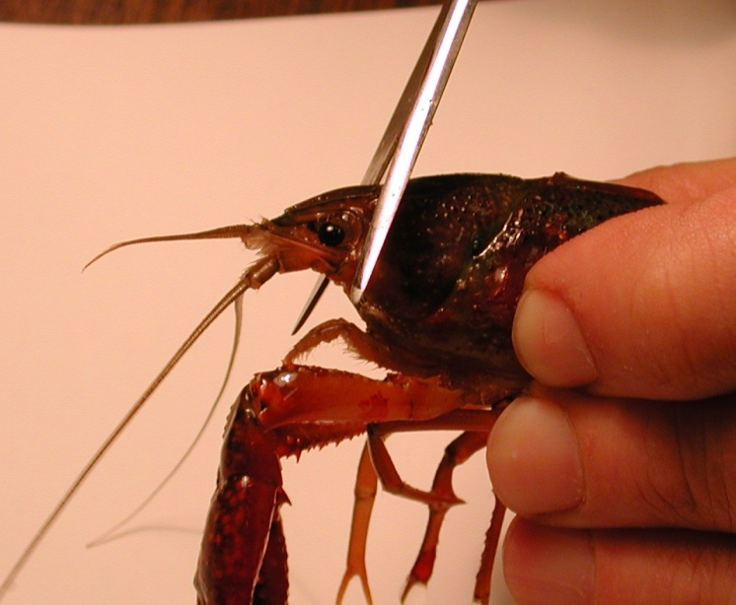
Figure 18: Image shows placement of the cut to remove the head of the crayfish.

The legs and claws of the crayfish can be removed at this point to avoid injury. Stylets on males and swimmerets on both males and females can also be removed (Figure 19 and 20). Next, separate the abdomen from the thorax. Make a cut along the articulating membrane which joins the abdomen and thorax (Figure 20).

3. Save the abdomen portion of the crayfish and dispose of the thorax.

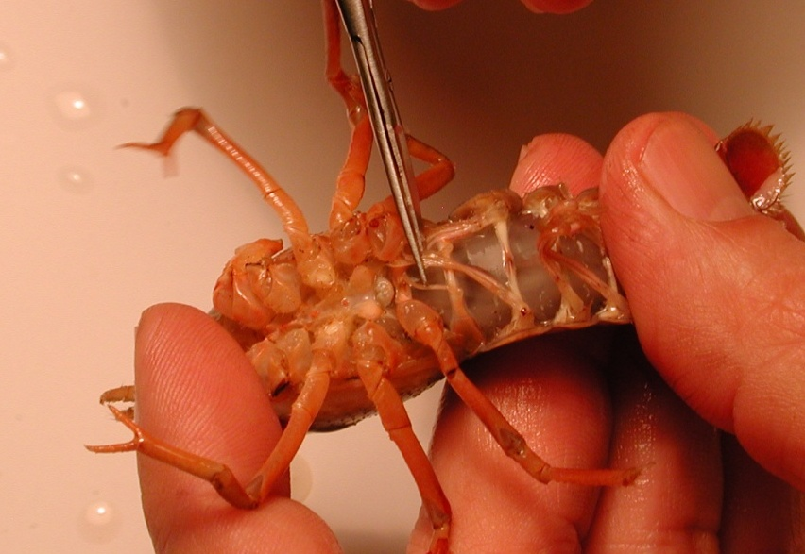
Figure 19: Image shows the placement of the stylets that can be removed from the crayfish.

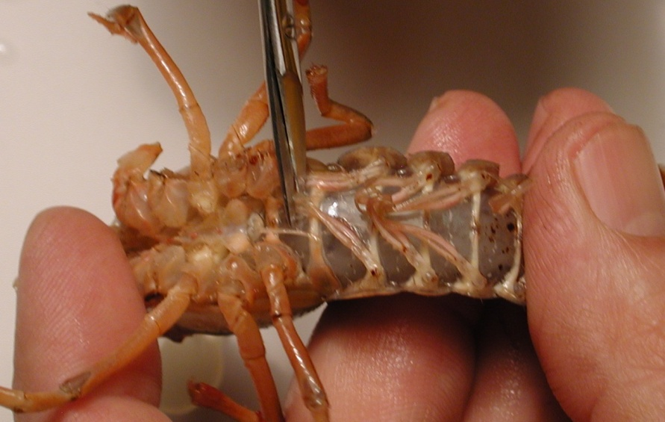
Figure 20: Image shows the placement of the cut to remove the thorax from the abdomen.
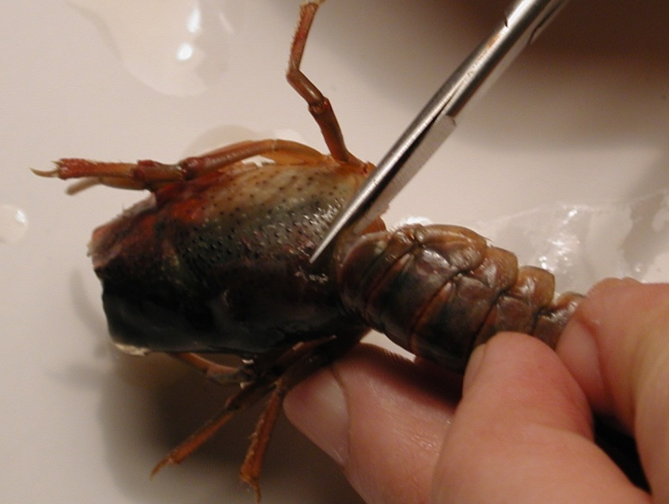
Figure 21: Removal of the thorax from the abdomen. The cut should be made in circular fashion along the line of the joining of the segments.
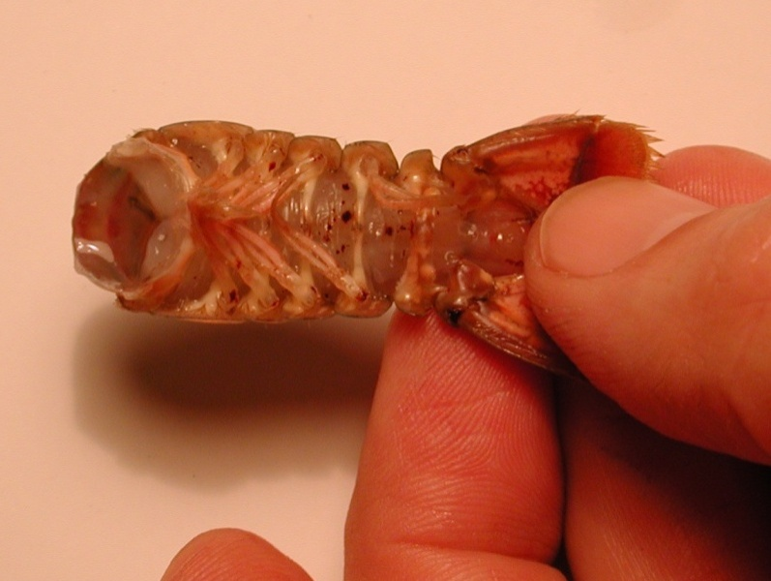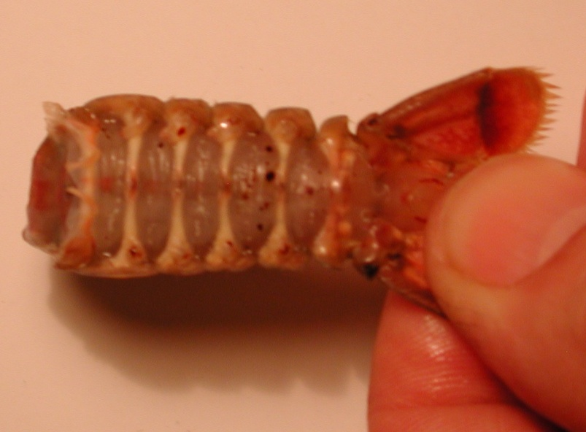
Figure 22: The top image shows the abdomen with appendages. Bottom image shows the removal of the abdominal appendages.

4. Place the isolated tail preparation in saline solution in a large Petri dish. Pin down the tail and upper portion of the preparation to the dish. Make sure the preparation is secure. Use a scalpel to remove a square portion of the ventral side of the preparation between the ribs.

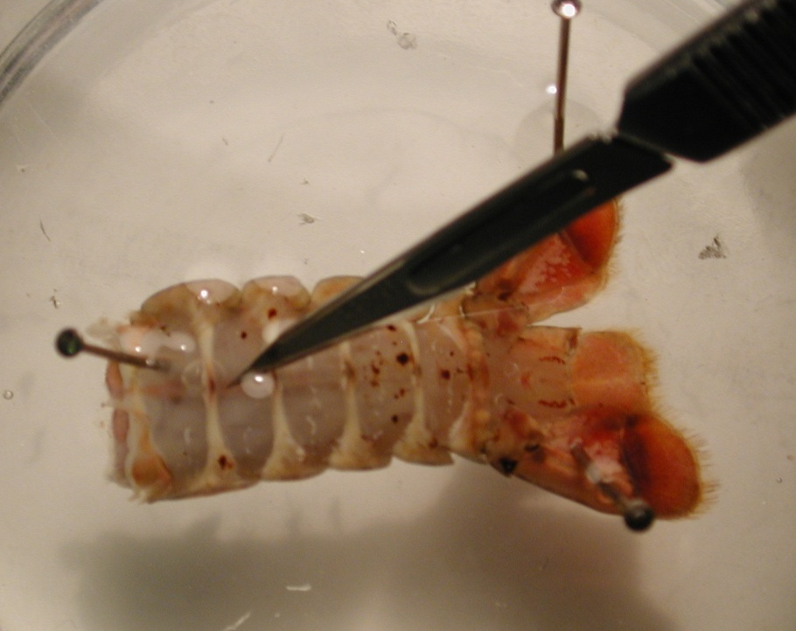
Figure 23: Shows where the cut should be made to remove the ventral potion of the preparation.

- A small cut should be made (can also be done with scissors). A flap should be cut and lifted upward. The flap can then be removed with scissors, exposing the deep flexor muscles. The microscope should be used during this process to ensure precision in removing the ventral portion of the preparation.
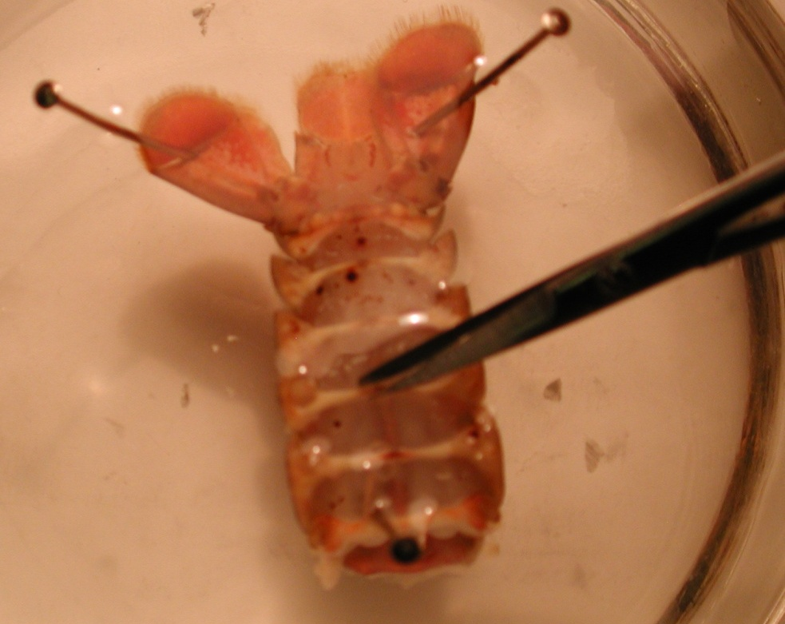
Figure 24. Cutting preparation with scissors to expose muscles.

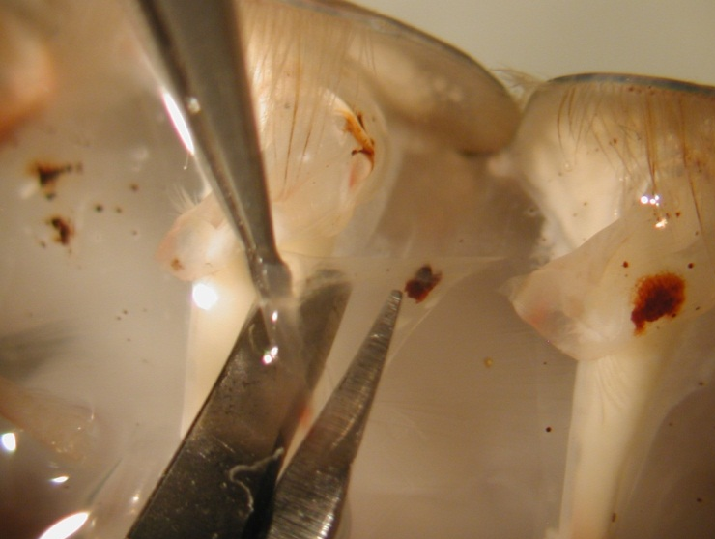
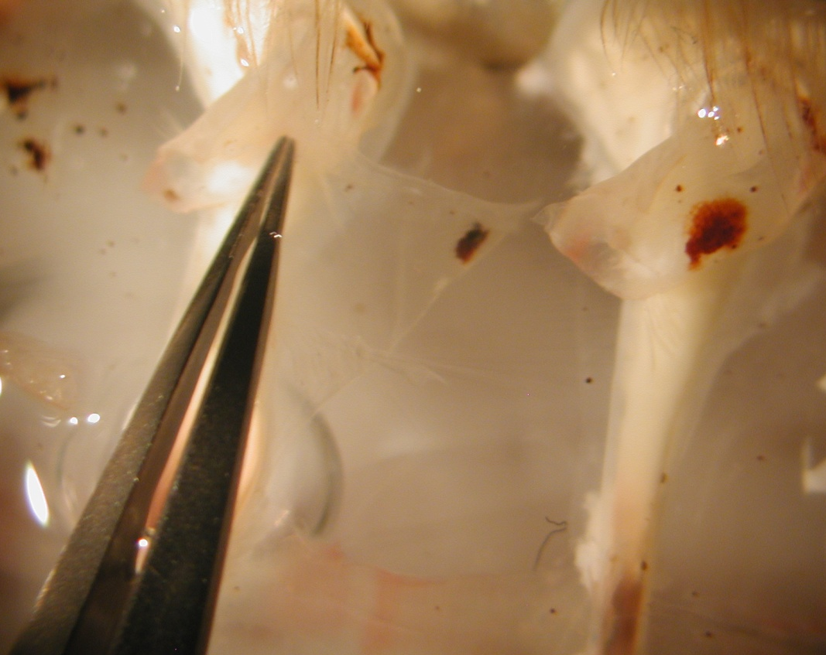
Figure 25. Left: Image shows the grasping of the flap with forceps. Right: Image shows the removal of the flap from the preparation using the microscope.

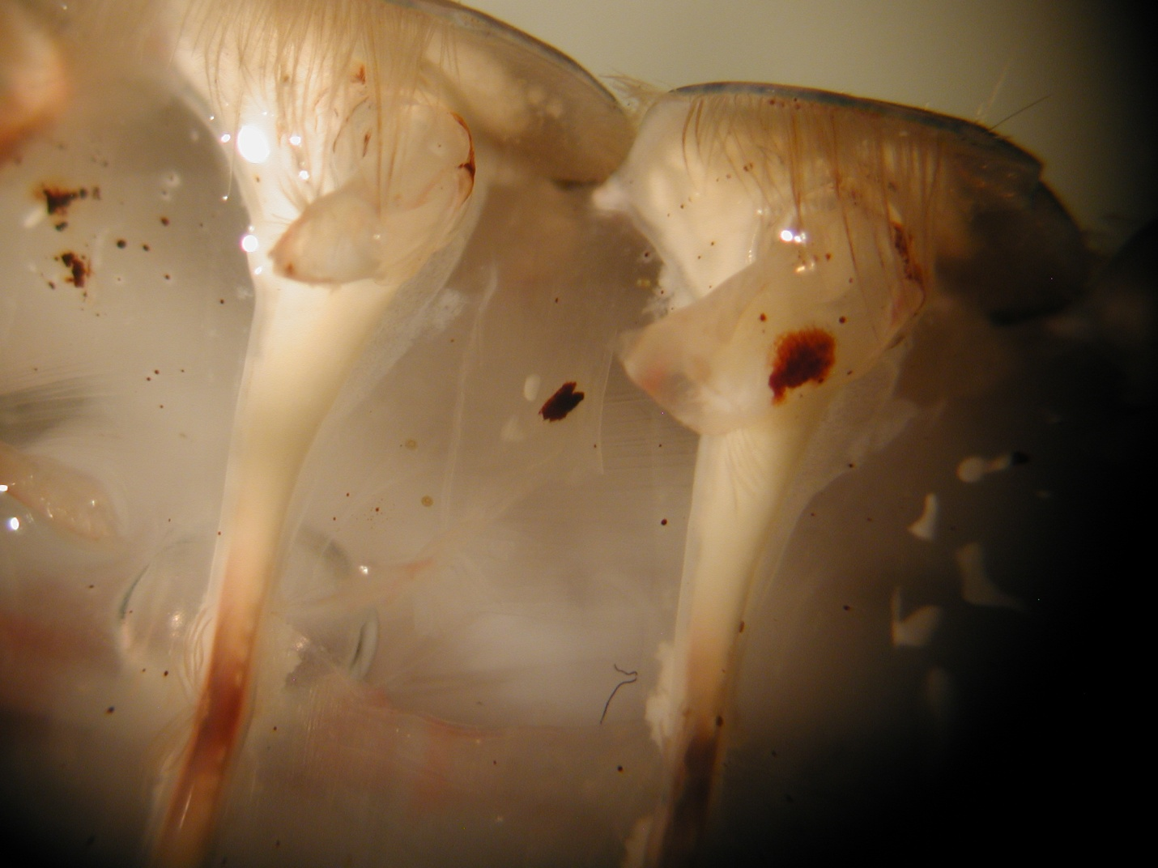
Figure 26: Exposure of the superficial flexor muscles.

5.3) Intracellular Recording:
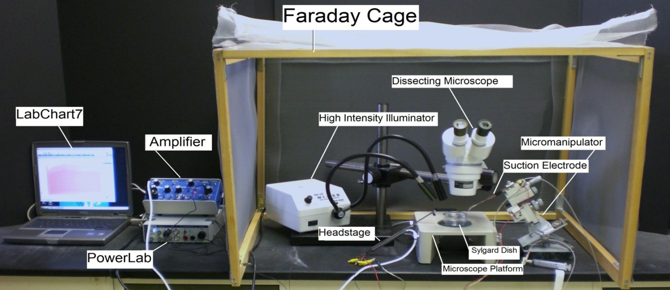
Figure 27: Overall setup of the recording equipment.
1. The Petri dish with preparation should be placed under the microscope and secured with wax at the bottom of the dish to prevent movement.

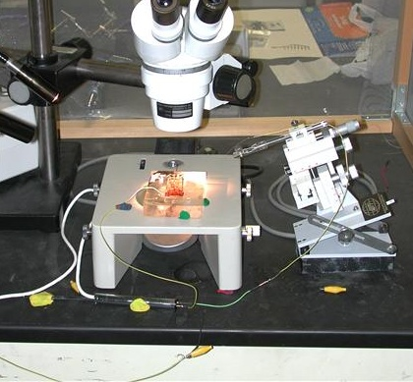
Figure 28: Shows the placement of the preparation under the microscope. Use wax to secure the Petri dish and preparation.

UPDATE 10/16/2010:
We are not using the amplifier and head stage in the movie or in this write up. You will use an upgraded version of the intracellular electrode holder and amplifier. You will be shown in lab during the introduction.

2. Two wires with short length of silver wire attached to one end should be obtained. The silver wire should be dipped into a small amount of bleach for about 20 minutes to obtain a Ag-Cl coating. Wash the wire with water before using. A glass intracellular pipette should be obtained and carefully filled with a KCl (3 M) solution. The pipette should be turned down (with the opening facing the floor) and filled with solution. The latter will ensure that any excess KCl will drip out the back of the electrode. Be sure no KCl runs along the glass pipette that will enter into the saline bath. Turn the pipette upright when finished filling with potassium chloride solution. The silver wire can then be placed into the pipette. The other end is connected to the +(positive) pole on the head stage. The pipette is then secured on the electrode probe. Care should be made not to break the electrode pipette. A third wire attached to the Faraday cage should be placed into the green pole of the head stage. Lastly the Ag wire of the remaining lead should be placed in the bath and the other end attached to the – (negative) pole shown below. A wire should also be placed from the Faraday cage to the ground portion of the AD converter Powerlab. The head stage is connected to the “input-probe” on acquisition/amplifier (Powerlab).
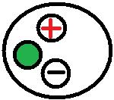
Figure 29: Head stage configuration. The wire connected to the green portion of the head stage is grounded to the amplifier or Faraday cage. The wire connected to the red portion is connected to the electrode wire. The black portion is used to connect to the bathing solution.

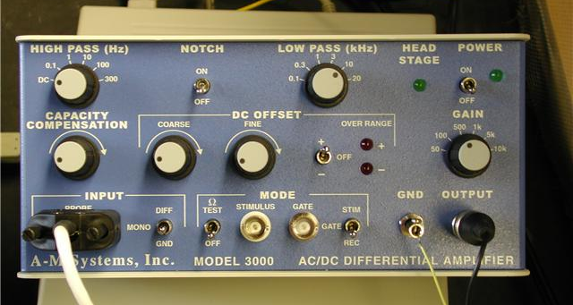
Figure 30: “Test toggle” is in the bottom row to test electrode resistance. The “coarse” knob is also found under DC offset which should be turned counter clock wise. Gain is set to 50, which amplifies signals by a factor of fifty. The ground wire from the head stage is placed in the “GND” pin jack opening.

- The LabChart software should be opened on the desktop or laptop.
- Adjust the chart to display only one channel by click “Setup”, then “Channel settings.” Under “Channel settings,” change number of channels to one. Click “OK.”
- At the top of the chart, left hand corner, cycles per second should be 2K. Set volts (y-axis) to around 200mV to 500mV.
- Click on “Channel 1” on the right hand portion of the screen. Click “Input Amplifier.” Make sure the following setting is checked:
  - Differential (checked)

The amplifier output should be in channel one. The following settings should be used with the amplifier:
  - High Pass- DC
  - Notch Filter- OFF
  - Low Pass- 20kHz
  - Capacity Comp.- counterclockwise
  - DC Offset Fine and Course knob- counterclockwise
  - DC Offset (+OFF-)- OFF
  - Gain knob- 50
  - Input (DIFF MONO GND)- Diff
  - MODE(STIM-GATE-REC)- REC
  - ΩTEST- OFF

Capillary Tip Resistance Check
- Since you did this last week, you only need to record your resistance data once today. To measure the electrode resistance, the voltage should be divided by the current, which is 2.0 nA. The resulting value is the resistance of the glass electrode. The resistance should be 20 to 60 MegaOhms.
- Place the tip of the glass electrode into the saline bath. Make sure a ground wire is also in the saline bath.
- To begin recording, press “start” at the bottom of the screen. Make sure the gain is set to 5 V/div.
- Use the course knob on the amplifier to move the line on the LabChart to zero before inserting the electrode.
- The toggle knob should be turned on and then off several times in order to test the electrode resistance.
- Next, the amplitude of the resulting values should be measured. Place one maker the steady base line and then place the second at the peak to obtain the electrode resistance.

Amplitude of response during ΩTEST _____________ (mV)

Capillary resistance _____________ (MegaOhms)

Experimental Recording
- Use the electrode probe and microscope to insert the electrode into the muscle. Do not penetrate through the muscle. Instead, use the microscope and micromanipulator to find the thin layer of muscle fiber and to insert the electrodes into the fibers. The high intensity illuminator can be used as a light source when penetrating the muscle.

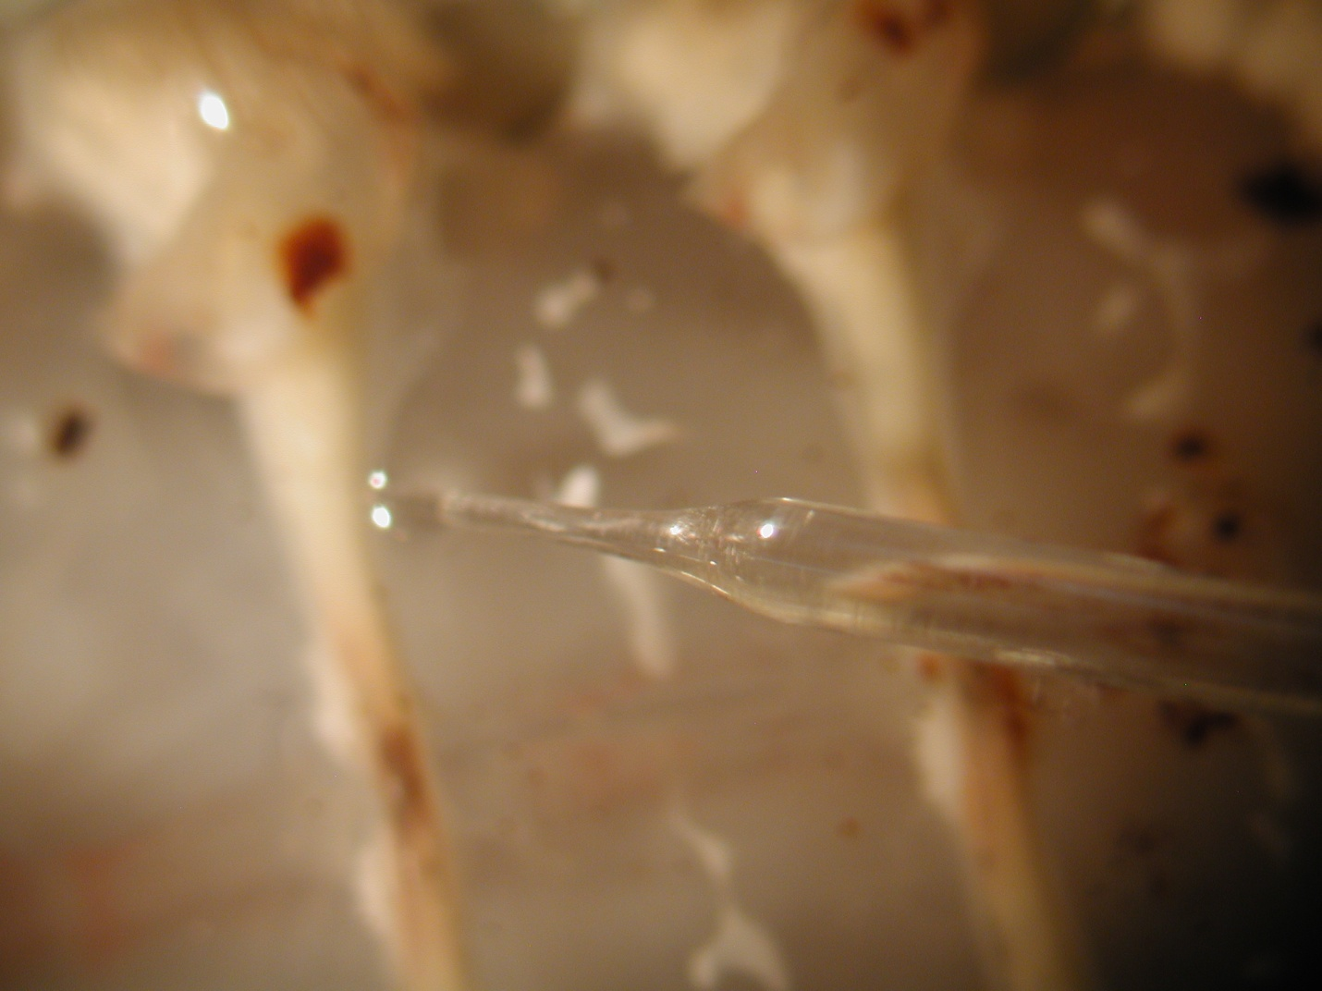
Figure 31: Insertion of electrode into the muscle.

6. Care must be taken to avoid damaging the nerve roots to the superficial muscles.

It is advisable to keep the saline bathing the preparations cool (10-15 degrees Celsius) and well oxygenated while carrying out the experimental procedures. If cooling units are not available replace the saline with fresh, cooled saline regularly. Oxygen gas, or at least air, should be bubbled through the saline.

7. Record the spontaneous activity of the EPSPs. Note the different sizes of the EPSPs and if IPSPs are present.

DATA! For each of the following, measure the frequency of spikes per 0.5 second interval.
Rep | Treatment: Spontaneous Activity
 | Frequency of EPSPs | Frequency of IPSPs
1
2
AVG

DATA! For each of the following, measure the amplitude of the 5 largest spikes per 5 second interval. Calculate the amplitude of the spike from the baseline mV.

Rep | Treatment: Spontaneous Activity
 | Amplitude of largest EPSP Spikes With Stimulation (mV)
1
2
3
4
5
AVG

2.3.2 Treatment 2: Response to Stimulation Recordings. Do this recording second!
Very carefully take a small paint bush and by hand stimulate along the cuticle edge within the same segment that one is monitoring the spontaneous activity. Note a change in frequency of the responses and if different size EPSPs appear that were not there prior to stimulating the cuticle.

DATA! For each of the following, measure the frequency of CAP spikes per 0.5 second interval.
Rep | Treatment: Activity with Stimulation
 | Frequency of EPSP Spikes With Stimulation | Frequency of IPSP Spikes with Stimulation
1
2
AVG

DATA! For each of the following, measure the amplitude (height) of the 5 largest spikes per 5 second interval. Calculate the amplitude of the spike from the baseline mV.

Rep | Treatment: Activity with Stimulation
 | Amplitude of largest Spikes With Stimulation (mV)
1
2
3
4
5
AVG

Figure 32: Preparation with stimulating brush and nerve roots. (modified from Strawn et al., 2000)

2.3.2 Treatment 3: Response to Neuromodulator Exposure. Do this recording last!
Cauton: Wear gloves when handling the serotonin solution. Serotonin is a potent neuromodulator in humans!

The stimulation procedure can be repeated after carefully exchanging the saline bath with one containing a neuromodulator such as serotonin (1 microM) or saline bubbled with CO₂. Note the effect on the activity profile for a given stimulus. Also note if exchanging the saline back to fresh saline returns the activity to its initial condition.

DATA! For each of the following, measure the frequency of CAP spikes per 0.5 second interval.
Rep | Treatment: Activity with Stimulation
 | Frequency of EPSP Spikes With Stimulation | Frequency of IPSP Spikes with Stimulation
1
2
AVG

DATA! For each of the following, measure the amplitude (height) of the 5 largest spikes per 5 second interval. Calculate the amplitude of the spike from the baseline mV.

Rep | Treatment: Activity with Stimulation
 | Amplitude of largest Spikes With Stimulation (mV)
1
2
3
4
5
AVG

You are now finished with today’s laboratory exercise. Please input your group’s data into the Excel spreadsheet on the instructor’s computer. You only need to enter data from the crayfish experiments.

Finishing up:
Please clean up your workstation before leaving the lab.
- Dispose of the crayfish abdominal prep and any remaining crayfish tissues in the trash.
- Purge/flush the crayfish saline from the electrodes. Dispose of any used crayfish saline down the sink.
- Refill your station’s crayfish saline stock solution and place on ice.
- Clean and set-out to dry any dissecting equipment and glassware used by your group during today’s activities.
- Spray with disinfectant and wipe down your work station.
- Dispose of any garbage (used papertowels, etc.) in the trash.

Post-Laboratory Report Content and Questions to Consider
- Use the posted data to calculate and report averages and standard deviations for each of the data collected and posted. Use the averages and standard deviations to address the questions for the overall experiment (what did you find). Results may be presented in one of the following forms: text, table or bar chart. If presenting in table or figure form, be sure to summarize the results in the text and reference them (i.e. Table 1). Use inferential statistics to identify significant differences in the results (One-way ANOVA is a good choice here). Follow-up your results with a discussion (what do the results mean). Wrap up your discussion with a clear and concise summary/conclusion statement. NOTE: DO NOT FOCUS ON TECHNICAL/PROCEDURAL PROBLEMS OF THE LAB EXERCISE in your report. The purpose of the lab report is for you to demonstrate your ability to deduct information from the experimental results, and convey your understanding of the physiological topics of interest. Reports that focus on procedural problems, and do not convey a sense of physiological understanding will be severely penalized.

Below are some additional questions to assist you in your discussion of the results, if needed. You are not required to specifically address these questions in your report, however, should you need help in directing your thoughts, these questions may be of some help.

- How did the frequency of spikes differ amongst the three treatment groups? Do such changes seem reasonable? Back up your observations with a plausible explanation, and compare to those reported in outside published sources.
- How did the amplitude of spikes differ amongst the three treatment groups? Back up your observations with a plausible explanation, and compare to those reported in outside published sources.
- Was there any evidence of IPSP activity in the recordings? How was such activity identified? In other words, how could it be separated from the EPSP activity?
- Which response, frequency or amplitude, showed greater differences amongst the three treatment groups? What does this mean physiologically?

REFERENCES

Antonsen, B.L. & Edwards, D.H. Differential dye coupling reveals lateral giant escape circuit in crayfish. J. Comp. Neurol. 466(1), 1-13 (2003).

Arellano, R. O., Rivera, A. & Ramón, F. Protein phosphorylation and hydrogen ions modulate calcium-induced closure of gap junction channels. Biophys. J. 57(2), 363-367 (1990).

Atwood, H. L. γ -aminobutyric acid and crab muscle fibres. Experientia (Basel) 20, 161 163 (1964).

Atwood, H. L. Variation in physiological properties of crustacean motor synapses. Nature 215, 57 58 (1967).

Atwood, H. L. Peripheral inhibition in crustacean muscle. Experimentia 24, 753-763 (1968).

Atwood, H. L. An attempt to account for the diversity of crustacean muscles. Am. Zool. 13, 357-378 (1973).

Atwood, H. L. Organization and synaptic physiology of crustacean neuromuscular systems. Prog. Neurobiol. 7, 291-391 (1976).

Atwood, H. L. Synapses and neurotransmitters. The Biology of Crustacea, vol. 3 (ed. H. L. Atwood and D. C. Sandeman), pp. 105 150. New York: Academic Press, Inc. (1982).

Atwood, H.L. Parallel ‘phasic’ and ‘tonic’ motor systems in the crayfish abdomen.
J. Exp. Biol. 211, 2193-2195 (2008).

Atwood, H.L. & Cooper, R.L. Functional and structural parallels in crustaceans and Drosophila neuromuscular systems. Am. Zool. 35(6), 556- 565 (1995).

Atwood, H.L. & Cooper, R.L. Assessing ultrastructure of crustacean and insect neuromuscular junctions. J. Neurosci. Meth. 69, 51-58 (1996a).

Atwood, H.L. & Cooper, R.L. Synaptic diversity and differentiation: Crustacean neuromuscular junctions. Invertebrate Neurosci. 1, 291-307 (1996b)

Atwood, H.L. & Parnas, I. Recording from the crayfish abdominal extensor muscle preparation with microelectrodes. In: Experiments in physiology and biochemistry (Kerkut GA, ed), pp 307-330. London: Academic (1968).

Badre, N.H., Martin, M.E. & Cooper, R.L. The physiological and behavioral effects of carbon dioxide on Drosophila larvae. Comparative Biochemistry and Physiology A. 140, 363-376 (2005).

Bernstein, J. Untersuchungen zur Termodynamik der bioelektrischen Ströme. Pflüger Arch. ges. Physiol. 9, 521-562 (1902).

Bernstein, J. Elektrobiologie, 215 pp. Viewag, Braunschweig (1912).

Bierbower, S.M. Environmental effects on behavior and physiology in crayfish. PhD disertation under Dr. Robin L. Cooper. Department of Biology, University of Kentucky (2010).

Bierbower, S.M. & Cooper, R.L. The effects of acute carbon dioxide on behavior and physiology in Procambarus clarkii. J. Exp. Zool. In press (2010)

Boistel, J. & Fatt, P. Membrane permeability change during inhibitory transmitter action in crustacean muscle. J. Physiol. (Lond.) 144, 176-191 (1958).

Bovbjerg, R.V. Dominance order in the crayfish Orconectes 6irilis (Hagen). Physiol. Zool. 26, 173–178 (1953).

Bovbjerg, R.V. Some factors affecting aggressive behavior in crayfish. Physiol. Zool. 29, 127–136 (1956).

Bradacs, H., Cooper, R.L., Msghina, M. & Atwood, H.L. Differential physiology and morphology of phasic and tonic motor axons in a crayfish limb extensor muscle. J. Exp. Biol. 200, 677-691 (1997).

Bruski, C.A. & Dunham, D.W. The importance of vision in agonistic communication of the crayfish Orconectes rusticus, I. an analysis of bout dynamics. Behaviour 63, 83–107 (1987).

Burke, W. & Ginsborg, B. L. The electrical properties of the slow muscle fibre membrane. J. Physiol. 132, 586-598 (1956).

Cooper, A.S. & Cooper, R.L. Historical view and demonstration of physiology at the NMJ at the crayfish opener muscle. Journal of Visualized Experiments (JoVE). JoVE. 33. http://www.jove.com/index/details.stp?id=1595; doi: 10.3791/1595 (2009).

Cooper, R.L., Warren, W.M. & Ashby, H.E. Activity of phasic motor neurons partially transforms the neuronal and muscle phenotype to a tonic-like state. Muscle & Nerve 21, 921-931 (1998).

Djokaj, S., Cooper, R.L. & Rathmayer, W. Effects of octopamine, serotonin, and cocktails of the two modulators on synaptic transmission at crustacean neuromuscular junctions. J. Comp. Physiol. A 187(2),145-154 (2001).

Dudel, J. & Kuffler, S. W. Mechanism of facilitation at the crayfish neuromuscular junction. J. Physiol. (Lond.) 155, 540-542 (1961).

Eckert, R. O. Reflex relationships of the abdominal stretch receptors of the crayfish. J. Cell. Comp. Physiol. 57, 149–162 (1961).

Edwards, D.H., Yeh, S.R., Musolf, B.E., Antonsen, B.L. & Krasne, F.B. Metamodulation of the crayfish escape circuit. Brain Behav Evol. 60(6), 360-369 (2002).

Fadool, D.A., Cobb, S.J., Kass-Simon, G. & Brown, P.R. Liquid chromatographic procedures for the analysis of compounds in the serotonergic and octopamine pathways of lobster hemolymph. J. Chromatogr. 452, 491–501 (1988).

Fatt, P. & Katz, B. The electrical properties of crustacean muscle fibers. J. Physiol. 120, 171-204 (1953).

Fields, H.L. & Kennedy, D. Functional role of muscle receptor organs in crayfish. Nature. 206(990), 1235-1237 (1965). PMID: 5879785

Fisher, L. & Florey, E. Modulation of synaptic transmission and excitation-contraction coupling in the opener muscle of the crayfish, Astacus leptodactylus, by 5-hydroxytryptamine and octopamine. J. Exp. Biol. 102, 187–198 (1983).

Freud, S. Über den Bau der Nervenfasern und Nervenzellen beim Flußkrebs. In: Anzeiger Akad. Wiss. Wien (Math.-Naturwiss. Kl.), Bd. 18 (1881), Nr. 28, S. 275f (1881). (see http://artmuseum.binghamton.edu/freudbook/ )

Freud, S. Über den Bau der Nervenfasern und Nervenzellen beim Flußkrebs. In: Sitzungsber. Akad. Wiss. Wien (Math.-Naturwiss. Kl.), 3. Abt., Bd. 85 (1882), S. 9-46. {(On the Structure of the Nerve Fibers and Nerve Cells of the River Crayfish), Sitzungsberichte der Mathematisch-Naturwissenschaftlichen Classe der Kaiserlichen Akademie der Wissenschaften, LXXXV. Band 1882} (see
http://artmuseum.binghamton.edu/freudbook/ )

Goldman, D.E. Potential, impedance, and rectification in membranes. J. Gen. Physiol. 27, 37-60 (1943).

Griffis, B., Bonner, P. & Cooper, R.L. Sensitivity of transformed (phasic to tonic) motor neurons to the neuromodulator 5-HT. Comparative Biochemistry and Physiology A 127, 495-504 (2000).

Grundfest, H. & Reuben, J.P. Neuromuscular synaptic activity in lobster. In: Florey, E. (Ed.), Nervous Inhibition. Pergamon Press, Oxford, pp. 92–104 (1961).

Harris-Warrick, R.M. & Kravitz, E.A. Cellular mechanisms for modulation of posture by octopamine and serotonin in the lobster. J. Neurosci. 4, 1976–1993 (1984).

Hagiwara, S., Chichibu, S. & Naka, K.I. The effects of various ions on resting and spike potentials of barnacle muscle fibers. J. Gen. Physiol. 48, 163-79 (1964). PMID: 14212147

Hille, B. Ionic Channels of Excitable Membranes, 2nd ed., Sinauer Assoc., Sunderland, Mass (1992).

Hodgkin, A.L. & Huxley, A.F. A quantitative description of membrane current and its application to conduction and excitation in nerve. J. Physiol. (Lond.) 117, 500-544 (1952).

Hodgkin, A.L., Huxley, A.F. & Katz, B. Measurement of current-voltage relations in the membrane of the giant axon of Loligo. J. Physiol. (Lond.) 116, 424-48 (1952).

Hodgkin, A.L. & Katz, B. The effect of sodium ions on the electrical activity of the giant axon of the squid. J. Physiol. (Lond.) 108, 37-77 (1949).

Hodgkin, A. L. & Rushton, W. A. H. The electrical constants of a crustacean nerve fibre. Proc. Roy. Soc. 133, 444-479 (1946).

Hörner, M., Weiger, W.A., Edwards, D.H. & Kravitz, E.A. Excitation of identified serotonergic neurons by escape command neurons in lobsters. J. Exp. Biol. 200, 2017–2033 (1997).

Huxley, T.H. The crayfish. C. London: Kegan Paul and Co. (This is a later edition that was not revised from a large paper edition limited to 250 copies published Nov. 29, 1879. (1880). Now available from MIT Press at http://www.mitpress.com)

Johnson, G. E. Giant nerve fibers in crustaceans with special reference to Cambaus and Palaemonetes. J. Comp. Neurol. 36, 323-373 (1924).

Johnston, M. F., Simon, S. A. & Ramon, F. Interaction of anaesthetics with electrical synapses. Nature (Lond) 286, 498-500 (1980).

Katz, B. & Miledi, R. The role of calcium in neuromuscular facilitation. J. Physiol. (Lond.) 195, 481-492 (1968).

Kennedy, D. & Takeda, K. Reflex control of abdominal flexor muscles in the crayfish: the twitch system. J. Exp. Biol. 43, 211–227 (1965a).

Kennedy, D. & Takeda, K. Reflex control of the abdominal flexor in the crayfish: the tonic system. J. Exp. Biol. 43, 229–246 (1965b).

Kennedy, D., Selverston, A. I. & Remler, M.P. Analysis of restricted neural networks. science 164, 1488-1496 (1969).

Krasne, F.B. Excitation and habituation of the crayfish escape reflex: the depolarizing response in lateral giant fibres of the isolated abdomen. J. Exp. Biol. 50(1), 29-46 (1969). PMID: 4304852

Li, H., Listerman, L.R., Doshi, D. & Cooper, R.L. Heart rate measures in blind cave crayfish during environmental disturbances and social interactions. Comp. Biochem. Physiol. 127A, 55–70 (2000).

Listerman, L., Deskins, J., Bradacs, H. & Cooper, R.L. Measures of heart rate during social interactions in crayfish and effects of 5-HT. Comp. Biochem. Physiol. A 125, 251–264 (2000).

Livingstone, M.S., Harris-Warrick, R.M. & Kravitz, E.A. Serotonin and octopamine produce opposite postures in lobsters. Science 208, 76–79 (1980).

Lnenicka, G.A. Seasonal differences in motor terminals. Comp. Biochem. Physiol. 104A, 423–429 (1993).

Lnenicka, G.A. & Zhao, Y. Seasonal differences in the physiology and morphology of crayfish motor terminals. J. Neurobiol. 22, 561–569 (1993).

Ma, P.M., Beltz, B.S. & Kravitz, E.A. Serotonin containing neurons in lobsters: their role as ‘gainsetters’ in postural control mechanisms. J. Neurophysiol. 68, 36–54 (1992).

Malmivuo, J. & Plonsey, R. Bioelectromagnetism-Principles and Applications of Bioelectric and Biomagnetic Fields. New York: Oxford University Press (1995).

McRae, T. On the postural effects induced in female Cherax destructor (Clark) by serotonin and octopamine. Freshwater Crayfish 11, 293–298 (1996).

Mercier, A.J. & Atwood, H.L. Long-term adaptation of a phasic extensor motoneurone in crayfish. J. Exp. Biol. 145, 9–22 (1989).

Monaghan, D. T., Bridges, R. J. & Cotman, C. W. The excitatory amino acid receptors: their classes, pharmacology, and distinct properties in the function of the central nervous system. Annu. Rev. Pharmacol. Toxicol. 29, 365-402 (1989). PMID: 2543272

Moody, W. Gradual increase in the electrical excitability of crayfish slow muscle fibers produced by anoxia or uncouplers of oxidative phosphorylation. J. Comp. Physiol. 125, 327-334 (1978).

Nernst, W.H. Zur Kinetik der Lösung befindlichen Körper: Theorie der Diffusion. Z. Phys. Chem. 3, 613-37 (1888).

Nernst, W.H. Die elektromotorische Wirksamkeit der Ionen. Z. Phys. Chem. 4, 129-81 (1889).

Pilgrim, R.L.C. & Wiersma, C.A.G. Observations on the skeleton and somatic musculature of the abdomen and thorax of Procambarus clarkii (Girard), with notes on the thorax of Panulirus interruptus (Randall) and Astacus. J. Morphol. 113, 453–587 (1963).

Robinson, M.M., Martin, J.M., Atwood, H.L. & Cooper, R.L. Modeling biological membranes with circuit boards and measuring conduction velocity in axons: Student laboratory exercises. In press, Journal of Visualized Experiments (2010).
Schneider, H., Budhiraja, P., Walter, I., Beltz, B.S., Peckol, E. & Kravitz, E.A. Developmental expression of the octopamine phenotype in lobsters. J. Comp. Neurol. 371, 3–14 (1996).

Skou, J. C. The influence of some cations on an adenosine triphosphatase from peripheral nerves. Biochim. Biophys. Acta 1000, 439-446 (1989a). PMID 2550074.

Skou, J. C. The identification of the sodium-pump as the membrane-bound Na+/K+-ATPase: a commentary on ‘The Influence of Some Cations on an Adenosine Triphosphatase from Peripheral Nerves’. Biochim. Biophys. Acta 1000, 435-438 (1989b). PMID 2550073.

Skou, J. C. (1965) Enzymatic basis for active transport of Na+ and K+ across cell membrane. Physiol. Rev. 45, 596-617(1965).

Skou, JC. Nobel Lecture. The identification of the sodium pump. Biosci Rep. 18(4),155-69 (1998).

Sneddon, L.U., Taylor, A.C., Huntingford, F.A. & Watson, D.G. Agonistic behavior and biogenic amines in shore crabs Carcinus maenas. J. Exp. Biol. 203, 537–545 (2000).

Sohn, J., Mykles, D.L. & Cooper, R.L. The anatomical, physiological and biochemical characterization of muscles associated with the articulating membrane in the dorsal surface of the crayfish abdomen. J. Exp. Zool. 287, 353-377 (2000).

Southard, R.C., Haggard, J., Crider, M.E., Whiteheart, S.W. & Cooper, R.L. Influence of serotonin on the kinetics of vesicular release. Brain Res. 871, 16–28 (2000).

Stefani, E. & Steinbach, A. B. Resting potential and electrical properties of frog slow muscle fibers. Effect of different external solutions. J. Physiol. 203, 383-401 (1969).

Strawn, J.R., Neckameyer, W.S. & Cooper, R.L. The effects of 5-HT on sensory neurons, CNS command, and neuromuscular junctions of the crayfish abdominal superficial flexor. Comp. Biochem. Physiol B 127, 533-550 (2000).

Takeuchi, A. & Takeuchi, N. Anion permeability of the inhibitory post-synaptic membrane of the crayfish neuromuscular junction. J. Physiol. (London) 191, 575-590 (1967).

Tsunoyama, T. & Gojobori, S. Evolution of Nicotinic Acetylcholine receptor Subunits. Mol. Biol. Evol. 15(5), 518–527 (1998).

Van Harreveld, A. & Mendelson, M. Glutamate-induced contractions in crustacean muscle. J. Cell Comp. Physiol. 54, 85-94 (1959).

Van Harreveld, A. A physiological solution for freshwater crustaceans. Proc. Soc Exp. Biol. Med. 34, 428-432 (1936).

Van Harreveld, A. & Wiersma, C. A. G. The Triple Innervation of the Crayfish Muscle. Proc. Natl. Acad. Sci. USA 22 (11), 667 (1936).

Vélez, S. J. & Wayman, R. J. Synaptic connectivity in a crayfish neuromuscular system. I. Gradient of innervations and synaptic strength. J. Neurophysiol. 41, 75-84 (1978).

Watanabe, A., & Grundfest, H. Impulse propagation at the septal and commissural junctions of crayfish lateral giant axons. J. Gen. Physiol. 45, 267-308 (1961).

Watkins, J.C. L-Glutamate as a central neurotransmitter: Looking back. Biochemical Society Transactions. 28, 297-310 (2000).

Wine, J. J., Mittenthal, J. E. & Kennedy, D. The structure of tonic flexor motoneurons in crayfish abdominal ganglia. J. Comp. Physiol. 93, 315-335 (1974).

Wu, W.H. & Cooper, R.L. Physiological recordings of high and low output NMJs on the Crayfish leg extensor muscle. In Press, Journal of Visualized Experiments (2010).
Wyttenbach, R.A., Johnson, B.R. & Hoy, R.R. Crawdad. A CD-ROM Lab manual for neurophysiology. Sinauer Associates, Sunderland, MA (1999)
Zucker, R.S. Crayfish escape behavior and central synapses. 3. Electrical junctions and dendrite spikes in fast flexor motoneurons. J. Neurophysiol. 35(5), 638-651 (1972). PMID: 5054508

Zucker, R.S. Crayfish escape behavior and central synapses. II. Physiological mechanisms underlying behavioral habituation. J. Neurophysiol. 35(5), 621-637 (1972). PMID: 5054507

Zucker, R.S. Crayfish escape behavior and central synapses. I. Neural circuit exciting lateral giant fiber. J. Neurophysiol. 35(5), 599-620 (1972). PMID: 5054506

