MECHANOSENSORY INTEGRATION:
NEURAL CIRCUIT RECORDING FROM AN INTACT COCKROACH NERVOUS SYSTEM

By

Josh Titlow¹, Zana R. Majeed^{1,2}, H. Bernard Hartman³ Ellen Burns¹ and Robin L. Cooper¹

¹Department of Biology, University of Kentucky, Lexington, KY 40506, USA;
²Department of Biology, College of Sci, Univ. of Salahaddin, Erbil, Iraq.
³Oregon Institute of Marine Biology, University of Oregon, Charleston, OR 97420, USA

1. PURPOSE

To demonstrate how an organism can detect its environment through mechanosensory stimuli and how the information is integrated and transformed in higher centers of the central nervous system.

2. PREPARATION

The cockroach Periplaneta americana.

3. INTRODUCTION

There are more than 4000 cockroach species of which only about 30 are household pests. Perhaps the most recognized is the misnamed American cockroach Periplaneta americana which originated in Africa, and is now found nearly everywhere on the planet. In addition to its rapid running speed (Full and Tu, 1991) and evasive behavior, in the tropics P. americana is capable of flight (Fraser, 1977; Ritzmann et al. (1980); Lieberstat and Camhi, 1988).
The predominant characteristics of the cockroach central nervous system (CNS) are its segmented nature and decentralization of control processes (Ganihar et al., 1994; Pipa & Delcomyn, 1981). The brain, thoracic and abdominal ganglia are joined together by "paired interganglionic connectives" to form the ventral nerve cord (VNC).
The outer, cortical region of the ganglion contains the cells responsible for the blood-brain permeability barrier, just beneath them, and the somata of neurons which originate in that ganglion. These somata may belong to interneurons, modulatory neurons or motor neurons. They supply axons that remain within the ganglion of origin (local interneuron), or have an axon that travels between the ganglia of the CNS (interganglionic inter neurons) or that terminates on peripheral muscle cells (motor neuron). The paired, interganglionic connectives contain only axons and no neuronal cell bodies. Most somata are positioned ventrally or ventrolaterally in the ganglionic cortex (Pipa & Delcomyn, 1981).
The neuropil contains glial cells (neuroglia), axon tracts, bundles of axons and dendrites (neurites)of neurons. The neuropil is devoid of neuronal cell bodies. This is the region within the ganglion where direct synaptic communication between nerve cells and integration of inputs occurs.
The ability of the American cockroach P. americana to detect and suddenly respond to an approaching predator (foot, hand, etc.) has been attributed to a reflex circuit that consists of the cerci and giant fiber system (Westin et al., 1977; Camhi et al., 1978). The cerci are a pair of horn-like, wind-sensitive structures located on the end of the abdomen (Figure 1). In P. americana the ventral surface of each cercus contains about 200 filiform (thread) hairs that are organized into 14 columns. Nine of these columns can be consistently identified in different animals according to the response properties of the associated receptor cell and axon. Each hair is in a socket that allows it to bend most readily in one plane that is column specific. Movement of the hair in one direction along its plane induces a depolarization in the receptor cell and a burst of action potentials (APs) in the sensory neuron. Movement in the opposite direction inhibits any ongoing spontaneous APs (Nicklaus, 1965). The preferred plane of deflection and directionality of the response is different in each column. Thus, the filiform hair-receptor complexes are responsible not only for detecting the movement of air but also for 'coding', in the form of APs, the direction from which the air current originated. Processing of this information by the CNS results in an 'appropriate' escape response (Westin et al., 1977; Camhi et al., 1978). This functional, columnar specificity of the sensory hairs is preserved from animal to animal.

Figure 1: A cockroach with intact cerci.

The receptor cell of each filiform hair is responsible for transducing the mechanical deflection of the hair into a neural event (resulting in a burst or inhibition of APs in the receptor cell's axon (Westin, 1979). The APs travel to the terminal abdominal ganglion (A6) via cercal nerve XI, where they synapse with giant axons of the (VNC). The giant axons are responsible for the transmission and subsequent excitation of motor neurons commanding escape behavior (Roeder, 1948; Westin et al., 1977; Ritzmann, 1984; Ritzmann & Pollack, 1986).
The behavioral latency of the escape response of P. americana is one of the shortest of any animal (Camhi, 1978). Behavioral latency is the time between the arrival of a stimulus at a mechanoreceptor and the initiation of an escape response. In experiments using high speed cinematography to record the attempted escape from an attacking toad, the cockroach was observed to begin its turn away from the toad in about 40 ms (time from beginning of tongue extension to cockroach movement (Camhi et al., 1978; Plummer & Camhi, 1981). Using controlled wind puffs, the behavioral latency could be reduced to 11 ms. Other experiments revealed that a minimum wind puff velocity of 12 mm.s-1 (with an acceleration of 600 mm.(s-2) can evoke an escape response, while even lower velocities (3 mm.s-1) caused slowly walking cockroaches to stop moving (Plummer & Camhi, 1981).
The strong correlation that typically exists between giant fiber systems and escape behavior has been well documented (Bullock, 1984; Pollack et al., 1995). In instances were a particular cell is necessary and sufficient to evoke a particular behavior the cell is referred to as a command neuron (Atwood and Wiersma, 1967, Olson and Krasne, 1981). Giant interneurons (GIs) in the wind escape circuit of P. americana are not necessary for the reflex. Animals that have experimentally ablated GIs still exhibit the escape behavior therefore these GIs are not considered command neurons (Comer, 1985, Comer et al., 1988). Severing cervical connectives that are rostral to the sensorimotor circuit also influences the behavior, indicating that descending input from the brain has an effect on the direction of escape (Keegan and Comer, 1993). These aspects of fine control and redundancy are paramount to the organism’s survival and are complemented by neurochemical modulation via biogenic amines (Casagrand and Ritzmann, 1992).
The P. americanus nerve cord preparation has been an elegant model system for neuroethologists over the past many decades starting with the pioneering work of Roeder (1948). It permits students to record, display and analyze primary sensory activity and the resultant responses by giant interneuron to their input. In addition to conveying the idea that identifiable neural circuits underlie behavioral responses to the environment, these exercises should instill an appreciation for the biological contributions made by this common household pest.

3. MATERIALS & METHODS
3.1 Material list
- Dissecting tools
- Sylgard coated dishes
- Insect pins
- Dissecting microscope with light source
- Glass electrodes for recording (suction electrode)
- Micromanipulator (for positioning the active electrode)
- Silver wire for active electrode (10/1000")
- Computer
- AC/DC Differential Amplifier (A-M Systems Inc. Model 3000)
- PowerLab 26T (AD Instruments)
- Head stage
- LabChart 7 (ADI Instruments, Colorado Springs, CO, USA)
- Set of electrical leads and connectors
- 2 glass tools for dissecting and manipulating nerves
- Cable and connectors
- Pipettes with bulbs and beakers
- Wax or modelling clay
- Stimulator (grass SD9 or Grass S88)

3.2 Solution
Cockroach Ringer's solution: (grams for 100ml)
210 mM NaCl (1.227g)
2.9 mM KCl (0.0216g)
1.8 mM CaCl₂ (0.0265g)
0.2 mM NaH₂PO₄ 2H₂O (0.0032g)
1.8 mM Na₂HPO₄ 7H₂O (0.0483g)
(pH 7.2 - Elia & Gardner, 1984).
Adjust pH with NaOH or HCl.

3.3 Dissection
Select a male cockroach from the holding tank that has intact robust cerci (Figure 1). The last segments of the male are narrow compared to the female, and containing no ovaries and
egg mass, are easier to dissect. Cut off the wings, legs and head and pin the body, ventral side up, to a Sylgard-coated dish. With forceps pick up the ventral plates and cut them off, with fine scissors, starting at the posterior end and working anteriorly (Figure 2). Always keep the internal organs moist with Ringer's while trying to keep the cerci dry. One can use wax or pieces of Sylgard to position the abdomen upwards to prevent the saline from wetting the cerci. If they do get wet, dry them with a pointed piece of Kimwipe. Push to the side the internal organs and the white matter (fat body). The VNC is in the center of the field, runs the length of the abdomen and should be visible between the shiny trachea. The nerve cord is translucent and may initially be difficult to see until the lighting is adjusted properly (Figure 3). DO NOT handle the VNC with forceps or insect pins, rather manipulate it using glass probes. Next, clear away the animal’s tracheae system from the nerve cord with forceps and with a pair of fine glass needles; very carefully split the VNC connectives longitudinally between A6 and A5 ganglia. (Figures 4 and 5). Cradle the cerci and abdomen upwards out of the saline bath with shortened insect pins (Figure 6). Be extra careful in the last abdominal segment not to damage the cercal nerves that project into the ganglion (Figure 7).

Figure 2: Ventral view of cockroach indicating where to cut the legs off (red bars) and region to open the abdomen.

Figure 3: Ventral view of cockroach nerve cord as seen with the ventral cuticle removed (A). A enlarged view of the segment outlined by arrows is seen in B. In C the connectives were spilt between A4 and A3 with a glass probe. The 6th abdominal ganglion is shown in D with the two cercal nerves leaving at the caudal end. Black paper was placed under the VNC for aiding in contrast for the photographs in C and D.

Figure 3: Ventral view of cockroach nerve cord with trachea running along the sides.

Figure 4: Schematic ventral view of cockroach nerve cord.

Figure 5: Splitting of the connectives. Black paper is under the VNC to aid in contrast.

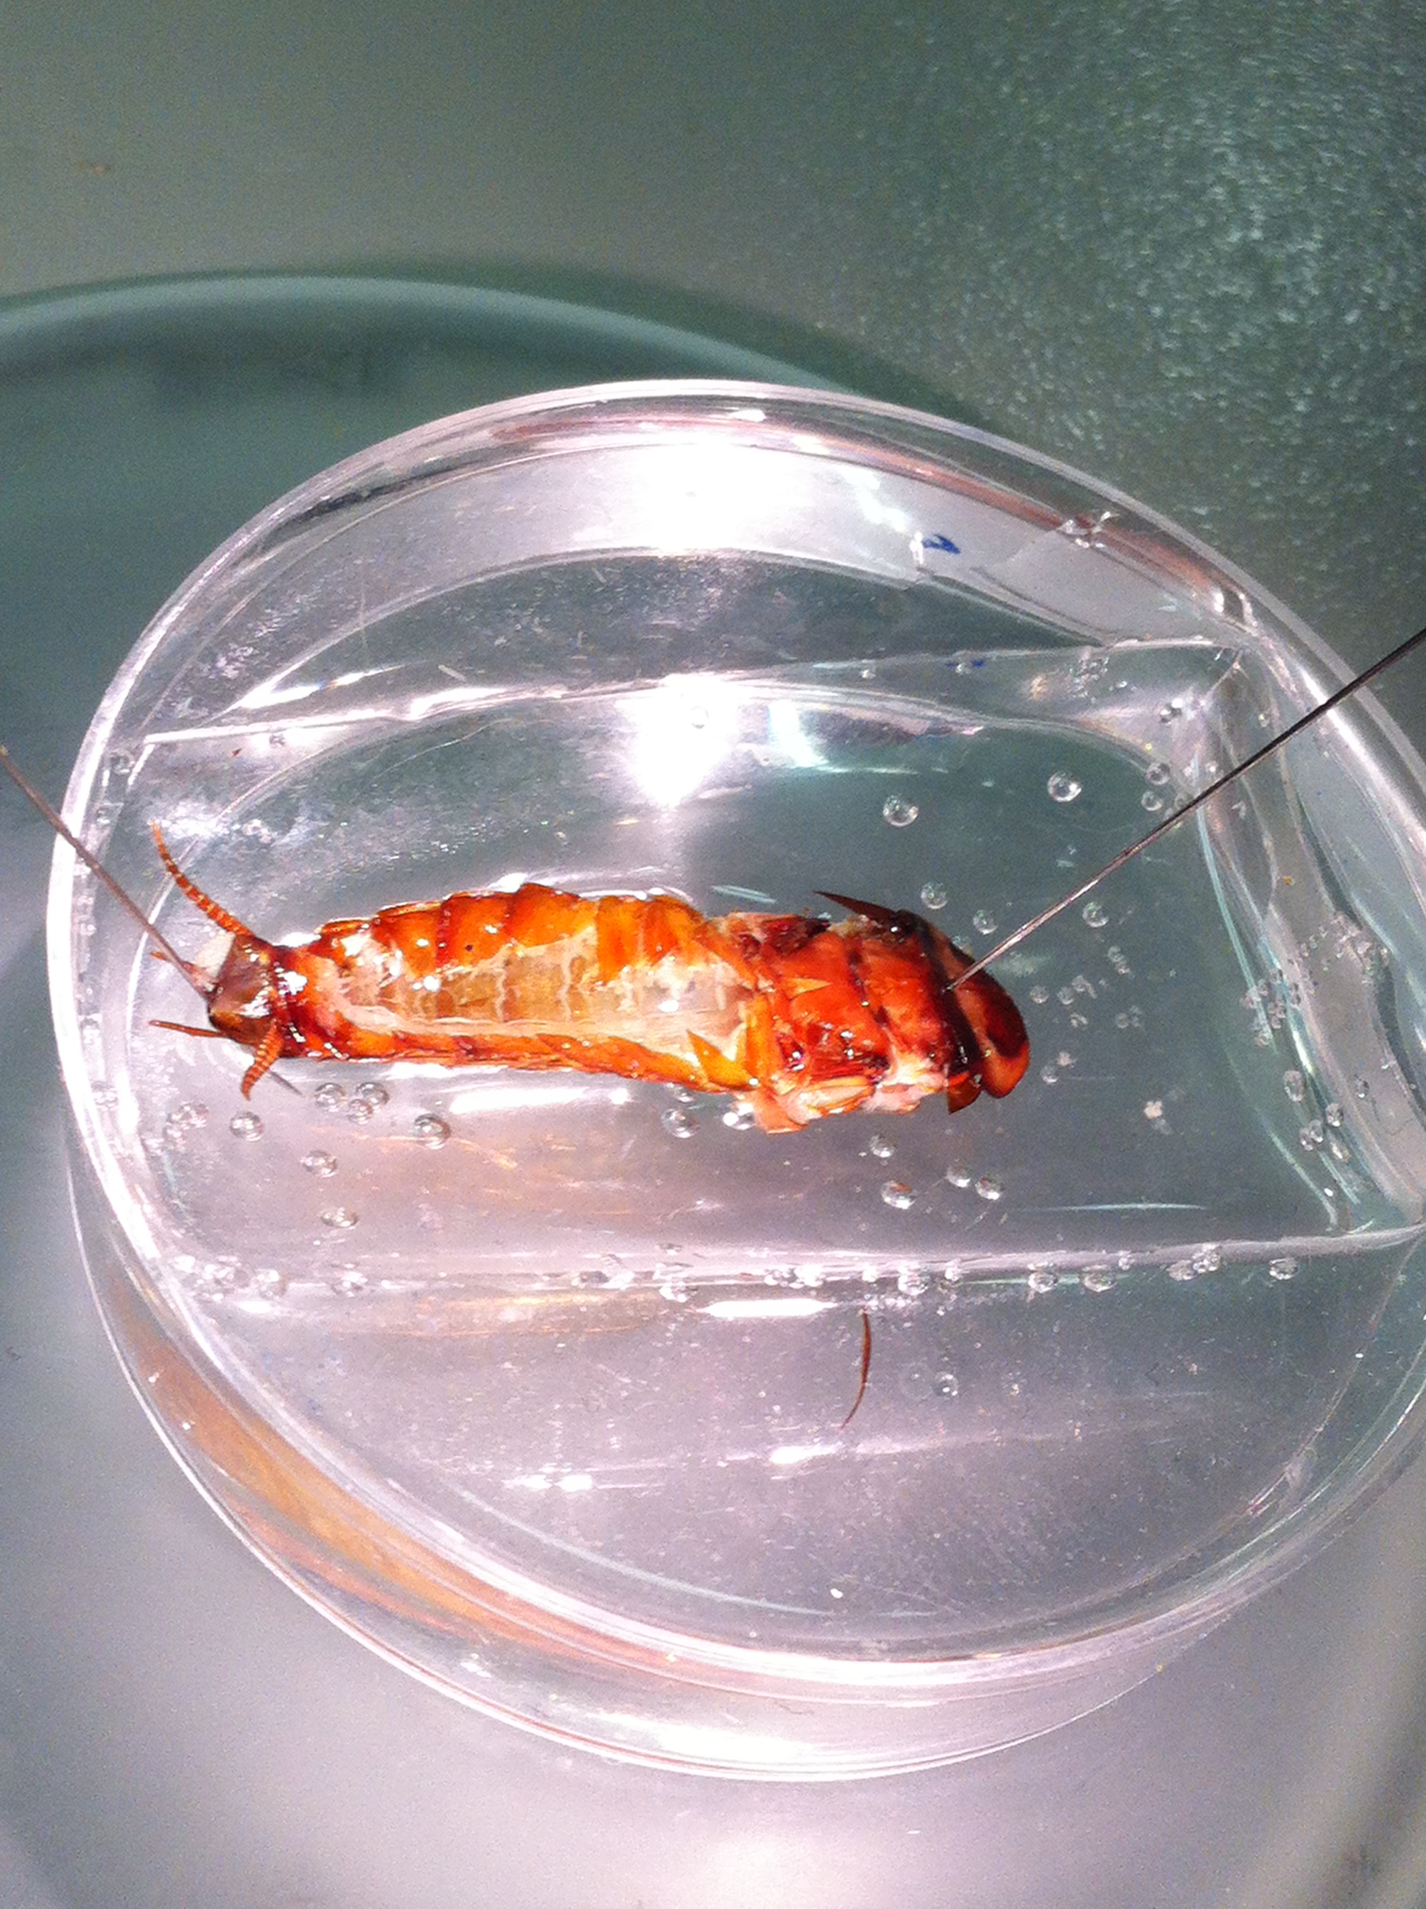
Figure 6: The cerci and are positioned upwards out of the saline bath. It can help to use Surgident Periphery Wax atop the Sylgard to elevate the cerci.

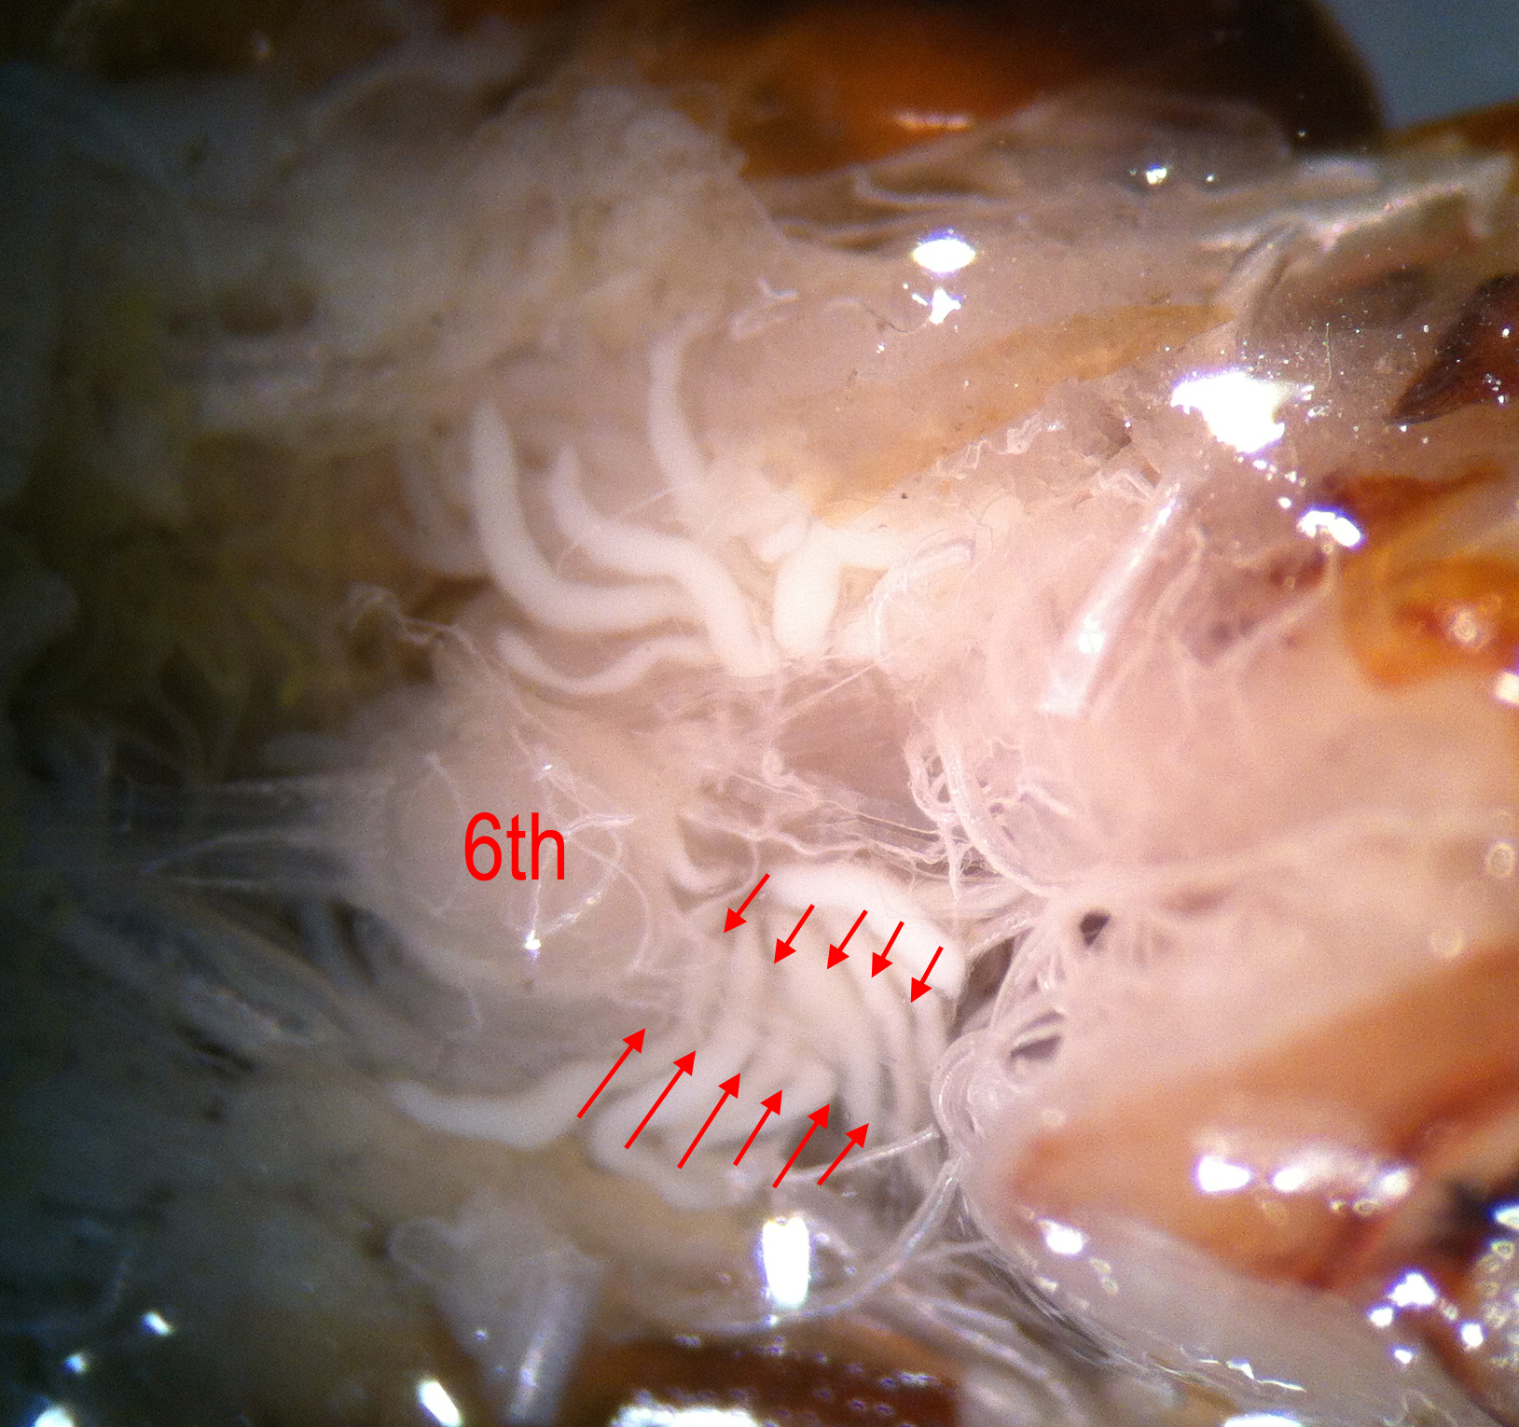

Figure 7: The6th abdominal ganglion with the cercal nerves (indicated by arrows is one of the cercal nerves).

3.4 Recording
Stimulation of hairs on the cerci causes discharges of primary sensory neurons in the cercal
nerve. En passant recordings from this nerve can be obtained with a suction electrode.
Recordings can also be made from giant fibers in the VNC connectives between the 5th and 6th abdominal ganglia or higher up the ventral cord 3rd and 4th (Figure 8).

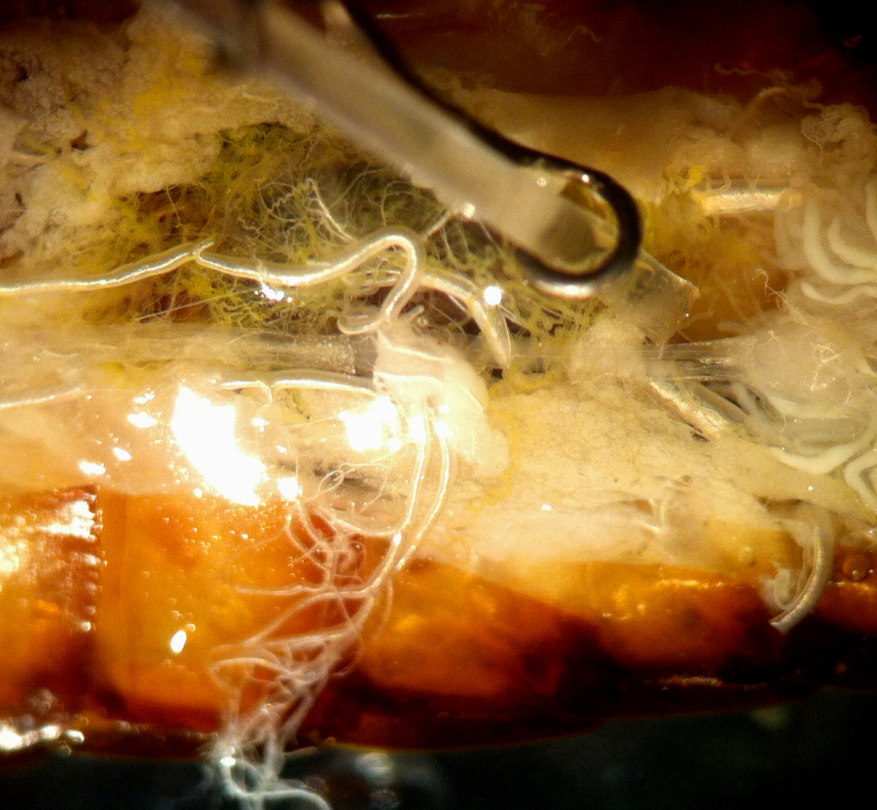
Figure 8: Suction electrode placed next to the connective prior to pulling the connective into the lumen.

The frequency of impulses at this location can be compared to the size and frequency of impulses in the cerci nerve (Figure 9). Some of the advantages of using the suction electrode described below include: (a) it can be used to record from very fine nerves; (b) the form of the recorded AP is very sharp and of short duration, thus allowing a more precise calculation of high frequency events; (c) the nerves will survive for an extended time.

Figure 9: Extracellular recording from cercal nerve (top) and connective between A4 and A5 (bottom) with a similar air puff stimulation.

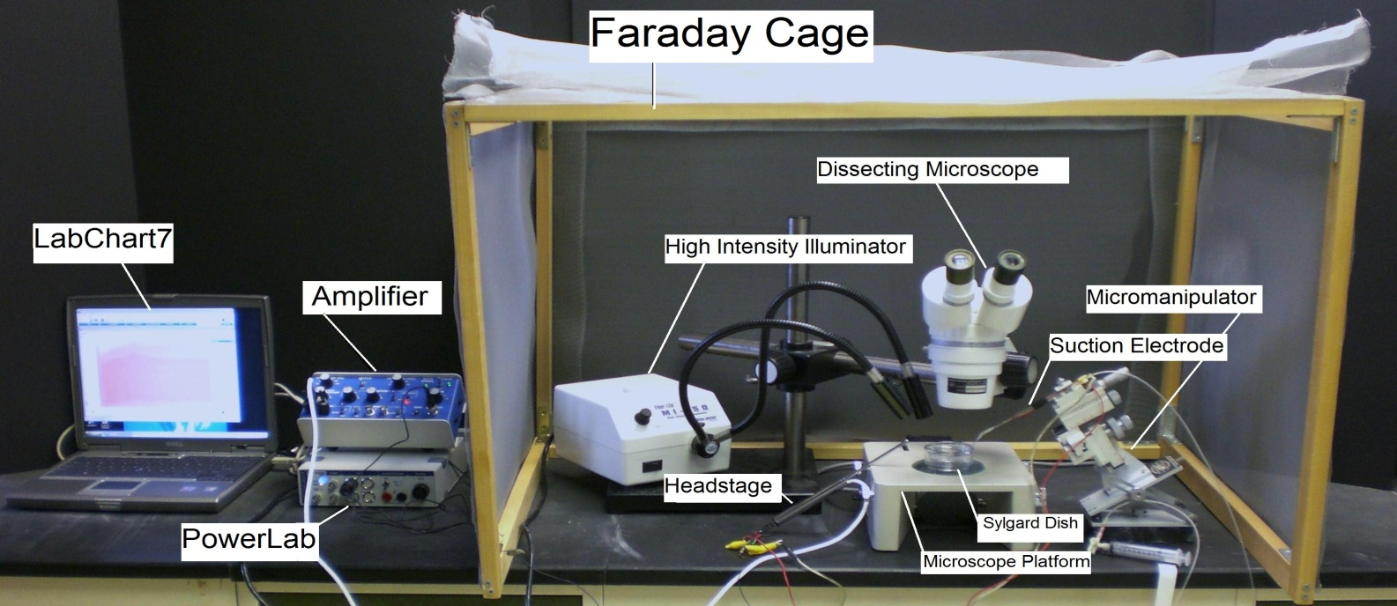
Figure 10: The equipment set up

Setup up the Faraday cage. The microscope, high intensity illuminator, micromanipulator, and the saline bath will all be set up inside the cage (the Faraday cage is used to block external electric fields that could interfere with the electrical recording, Figure 10).

Setup the Faraday cage which is used to block external, particularly AC, electric fields that could override signals from neurons. The microscope, high intensity illuminator, micromanipulator, and the saline bath will all be set up inside the cage (Figure 10).

Position the microscope so that it is overlooking the microscope stage. Once it placed on the stage, you will need to adjust the position of the high intensity illuminator beam to best visualize the preparation.

Prepare a Sylgard dish and place it under the microscope (this is where the dissected preparation will be placed).

Position the micromanipulator so the attached suction electrode assembly will have easy access to the saline bath and preparation.

Connect the AC/ DC Differential Amplifier (amplifier) to the Power Lab 26T. Do this by connecting the proper cord from Input 1 on the PowerLab 26T to the output on the amplifier (Figure 11).

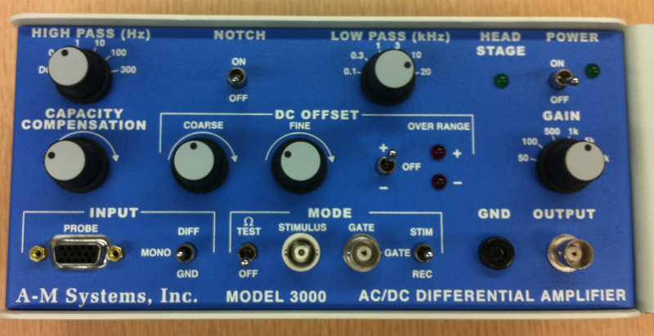
Figure 11: Extracellular amplifier used for this lab.

The settings for the amplifier are as follows:

CONTROL | SETTING
High Pass | DC
Notch Filter | OFF
Low Pass | 20kHz
Capacity Comp. | Counterclockwise
DC Offset Fine and Course knob | Counterclockwise
DC Offset (+OFF) | OFF
Gain knob | 50
Input (DIFF MONO GND) | DIF
MODE(STIM-GATE-REC) | GATE
ΩTEST | OFF

Connect the head stage to the ‘input- probe’ on the amplifier.

Connect the head stage to the input- probe on the amplifier. Next connect the electrical wires from the suction electrode to the head stage with the red (positive) at the top left, green (ground) in the middle, black (negative at the bottom). This is indicated in Figure 12. The ground wire can be inserted into the abdomen in a convenient out-of-the-way spot.

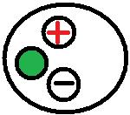
Figure 12: Head stage Configuration

Now connect the USB cord from the PowerLab 26T to the laptop. Ensure that both the amplifier and PowerLab26T are plugged in and turned on before opening LabChart7 on the computer.

Open LabChart7.

- The LabChart Welcome Center box will pop open. Close it.
    - Click on Setup
    - Click on channel settings. Change the number of channels to 1 (bottom left of box) push OK.
    - At the top right of the chart set the cycles per second to about 4 kHz. Set the volts (y-axis) to about 500 or 200mv.
    - Click on Channel 1 on the right of the chart. Click on Input Amplifier. Ensure that the settings: differential, ac coupled, and invert (inverts the signal if needed), anti-alias are checked.
    - To begin recording press start.

Cut one of the cVNC onnectives close to A5 and place the cut end attached to A6 into a suction electrode. Be sure to pull some Ringer's into the suction electrode to cover the silver wire inside it before sucking in the nerve. Make sure a ground wire is placed in the fluid held in the abdomen, preferably near A3. With a dry pipette blow air on to the hairs located on each cercus. See if stimulating the hairs on the cercus ipsilateral to the recorded connective gives a different response than the contralateral one. Take note in the amplitude of the responses and the number of spikes in a given time interval during the stimulation. Pharmacological experiments can also be conducted with this preparation by dissolving neuroactive chemicals (e.g. nicotine, dopamine, and serotonin) into the Ringer’s saline. After exchanging this solution with the normal bathing medium changes in responsive or spontaneous activity may be observed while recording from connectives or a motor nerve. Would the cercal nerve show altered responses during these tests, and if so, why?

Now, move the suction electrode to a cercal nerve for recording. To get a better fit, you may have to switch to a tip with a smaller opening. Cut the cercal nerve close to A6 and then suck up the nerve leading to the cercus. Blow air onto the cercus and note the responses. Are there fewer or more spikes firing than in the recordings from the VNC connectives during the same stimulation? Do the spike amplitudes look similar? If they differ, can you account for the difference?

Electrically stimulating the sensory nerves to determine recruitment

An experimental approach to drive synaptic communication from the sensory neurons to the VNC with a consistent stimulation is to electrically stimulate the cercal nerve and record responses in the connective(s). This helps to deliver a controlled stimulus as compared to the air puffs on the hairs. One can switch to using the other cercal nerve for this procedure. If the cercal nerves are cut too short or they are damaged dissect a new preparation. This time cut the cercal nerve most distal as possible so that a long nerve root can be pulled into the stimulating suction electrode (Figure 13). The connective between A6 and A5 or another segment more anterior can be used. Now set the recording suction electrode so you can pull up a cut connective into the electrode. Be sure to pull some Ringer's into the suction electrodes to cover the silver wire inside it before sucking in the nerves. Make sure a ground wire is placed in the fluid, preferably around A3. Next set the parameters on the stimulator to recruit cercal neurons so that the synaptic responses can be recorded in the VNC connectives. One should make a record of the minimal stimulating voltage and duration to recruit a response. Then incrementally increase the stimulating voltage to determine if a maximum response is recorded.

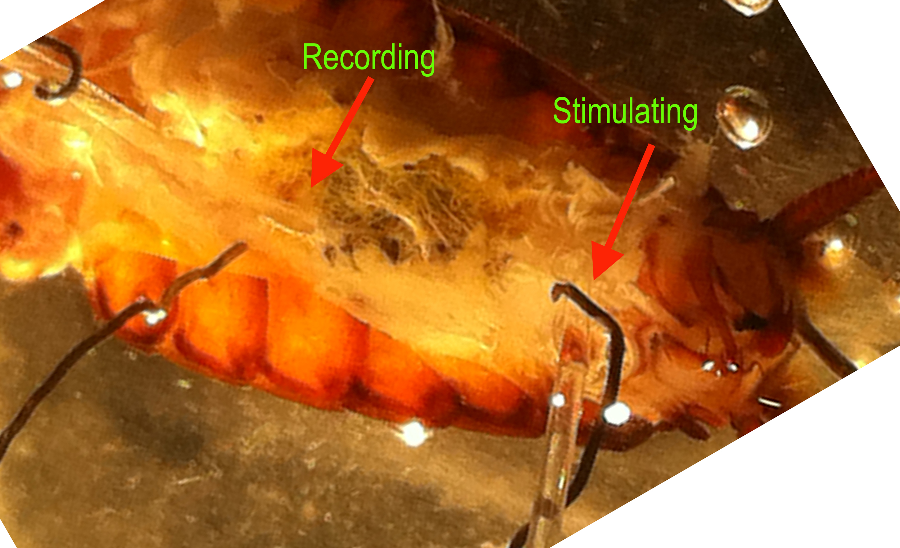

Figure 13: Stimulating and recording electrode set up

Stop the Chart 7 recording. Save your file and give it a descriptive title that can recall later. Close out of the Chart software. Open the Scope software on the computer desktop. On the top right of the screen, select “Channel 1” for “Input A.” Next, select “Input Amplifier” under Channel A tab. On the screen that appears for Input Amplifier options, select the following:

CONTROL | SETTING
RANGE | 500 mV
AC | CHECKED
LOW PASS | OFF
Differential | CHECKED
INVERT | CHECKED or not

On right hand side:
Turn off Input B
Time base: 4kHz
Sample: 1024 select this setting to make time base of 4 KHz
Time: 500msec

On the right side is a black bar, in the center of the screen. Click on it and drag to the bottom of the screen to enlarge the channel 1 display.

Under “Settings,” click “Sampling.” In the box entitled “Sweep” on the screen that appears, select the following:

CONTROL | SETTING
MODE | MULTIPLE
SAMPLE | 100 SWEEPS
SOURCE | External
DELAY | 0 msec

Connect the stimulating electrode to the output of the SD9 stimulator (Figure 14)

Adjust the stimulator to the following settings:
Duration 0.3 to 0.5 sec
Delay 10 msec
Frequency 1 Hz
Adjust the voltage as needed to obtain a signal in the recordings

Connect the stimulator cable with the two mini-hook leads or clips. Connect the BNC trigger output from stimulator to the trigger input on the Powerlab.

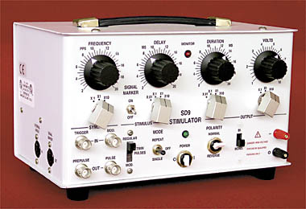

Figure 14: Stimulator SD9

Next, it might be necessary to change the voltage on the stimulator but you must be careful not to damage the nerve with a voltage stimulation that is too high.

Select the “Start” button at the lower left of the screen. Given the above settings, a clearly defined action potential should appear on the Scope data collection box. Sketch the general shape of the action potential. Be sure to turn off the stimulator when done collecting the responses of choice.

Deliver a series of single stimuli of increasing voltage from the software until an action potential appears on the screen. Increase the intensity until a synaptic response in the connectives is observed (Figure 15). The large spike (extracellular APs) from the giant axons appears first, then other smaller AP’s may also be observed. Adjust the Time base for optimum resolution of the responses. Note that the potentials do not grow in response to greater stimulus intensity. Use the single pulse to deliver single stimuli at subthreshold and increasing voltages. Save your records and make notes on “Comments” within the chart software and in your notebook.

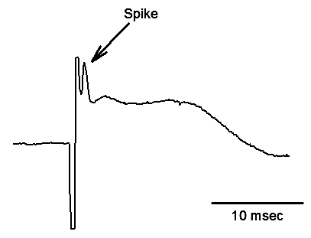
Figure 15: Stimulated cercal nerve produces a spike in the connective. Note the large stimulus artifact preceding the spike.

Some questions to consider: Are these axons capable of conducting synaptic communication in both directions? Swap the recording and stimulating leads (not the electrodes) and repeat the experiment. What is your final answer? Explain your results.

This paradigm of electrically stimulating the sensory nerve can also be used to examine pharmacological agents. Exchange the bathing medium with a solution of neuroactive chemicals (as described above) while recording either from a motor nerve or a connective; then note the responses. Observe responses while recording from connectives and stimulating the cercal nerve. Pharmacological experiments can also be conducted with this preparation by dissolving neuroactive chemicals (e.g. nicotine, dopamine, serotonin) into the Ringer’s saline. After exchanging this solution with the normal bathing medium changes in responsive or spontaneous activity may be observed while recording from connectives or a motor nerve. Would the cercal nerve show altered responses during these tests, and if so, why?

4. RESULTS

For the laboratory write up report your findings and your interpretations of the findings from cercal and connective recordings, i.e. describe the neurophysiological phenomena associated with these experiments. Describe the action potential waveforms you observed at different levels of the nervous system. Describe the sensitivity of the hairs with respect to air movements.

5. DISCUSSION

The purpose of these experiments was to demonstrate the fundamental principles of
extracellular recording from primary and secondary order neurons of an identified neural
circuit. Students should gain an appreciation of identified neurons and their close association
with behavioral responses to environmental stimuli. Other questions to consider are: (1) Why
is the cercal nerve activity so different from the that of the VNC? (2) If the respective neurons were dye filled, how would the anatomy correlate with the physiological parameters that were measured?

Finally, it should be appreciated from your modest experiments, that here is a rich history of investigations using the cockroach cerci system for neurophysiological and pharmacological investigations. As well, the cerci system in other insects has been and still is an active area of research in addressing questions of the development of neural circuitry as well as questions regarding synaptic repair and regeneration (Bacon and Blagburn, 1992; Blagburn 2007; Blagburn et al., 1995; Booth et al., 2009; Schrader et al., 2002; Stern et al., 1997).

6. REFERENCES
Atwood HL, Wiersma CA (1967) Command interneurons in the crayfish central nervous system. The Journal of experimental biology 46:249-261.
Bacon, J.P., and Blagburn, J.M. (1992). Ectopic sensory neurons in mutant cockroaches compete with normal cells for central targets. Development 115(3):773-784.
Booth, D., Marie, B., Domenici, P., Blagburn, J.M., and Bacon, J.P. (2009). Transcriptional control of behavior: Engrailed knockout changes cockroach escape trajectories. J Neurosci. 29(22): 7181–7190.
Blagburn, J.M. (2007). Co-factors and co-repressors of Engrailed: expression in the central nervous system and cerci of the cockroach, Periplaneta americana. Cell Tissue Res. 327(1):177-187.
Blagburn, J.M., Gibbon, C.R., and Bacon, J.P. (1995). Expression of engrailed in an array of identified sensory neurons: comparison with position, axonal arborization, and synaptic connectivity. J Neurobiol. 28(4):493-505.
Bullock, T.H. (1984) Comparative neuroethology of startle, rapid escape, and giant fiber-mediated responses. In: "Neural Mechanisms of Startle Behavior" Plenum press, N.Y., pp 1-14.
Burrows, M. (1980) Principals of organisation of insect central nervous system. In: "Insect Neurobiology and Pesticide action (Neurotox '79)" Society of Chemical Industry, London, pp 5-16.
Casagrand JL, Ritzmann RE (1992) Biogenic amines modulate synaptic transmission between identified giant interneurons and thoracic interneurons in the escape system of the cockroach. Journal of neurobiology 23:644-655.
Camhi, J.M. (1980) The escape system of the cockroach. Scientific American 243:158-172.
Camhi, J.M., Tom, W. and Volman , S. (1978) The escape behavior of the cockroach Periplaneta americana. II. Detection of natural predators by air displacement. J. Comp. Physiol. A. 128:203-212.
Comer CM (1985) Analyzing cockroach escape behavior with lesions of individual giant interneurons. Brain research 335:342-346.
Comer CM, Dowd JP, Stubblefield GT (1988) Escape responses following elimination of the giant interneuron pathway in the cockroach, Periplaneta americana. Brain research 445:370-375.
Elia, A.J. and Gardner, D.R. (1984) Long-term effects of DDT on the behavior and central nervous system activity in Periplaneta americana. Pestic. Biochem. Physiol. 21:326-335.
Fourtner, C.R. and Pearson, K.G. (1977) Morphological and physiological properties of motor neurons innervating insect leg muscles. In:" Identified Neurons and Behavior of Arthropods" (ed. G. Hoyle) Plenum Press, N.Y. pp87-99.
Full, R.J. and Tu, M.S. (1991) Mechanics of rapid running insect: two-, four- and six-legged locomotion. J. Exp. Biol. 156:215-231.
Ganihar, D., Libersat, F., Wendler, G., and Cambi, J.M. (1994). Wind-evoked evasive responses in flying cockroaches. J. Comp. Physiol. A. 175(1):49-65.
Keegan AP, Comer CM (1993) The wind-elicited escape response of cockroaches (Periplaneta americana) is influenced by lesions rostral to the escape circuit. Brain research 620:310-316.
Lieberstat, F., and Camhi, J. (1988) Control of sensory feedback by movement during flight in the cockroach. J. Exp. Biol. 136: 483-488.
Olson GC, Krasne FB (1981) The crayfish lateral giants as command neurons for escape behavior. Brain research 214:89-100.
Pipa, R., and Delcomyn, F. (1981) Nervous System. In:" The American Cockroach" (Eds. W.J. Bell and K.G. Adiyodi) Chapman and Hall, London. pp 175-216.
Pitman, R.M., Tweedle, C.D. and Cohen, M.J. (1972) Branching of central neuron. Intracellular cobalt injection for light and electron microscopy. Science 176:412-414.
Plummer, M.R. and Camhi, J.M. (1981) Discrimination of sensory signals from noise in the escape system of the cockroach: The role of wind acceleration. J. Comp. Physiol. A: 142:347-357.
Pollack, A.J., Ritzmann, R.E., and Watson, J.T. (1995). Dual pathways for tactile sensory information to thoracic interneurons in the cockroach. J Neurobiol. 26(1):33-46.
Ritzmann, R.E. (1984) The cockroach escape response. In:" Neural Mechanisms of Startle Behavior" Plenum Press, N.Y. pp 93-131.
Ritzmann, R.E. and Camhi, J. (1978) Excitation of leg motor neurons by giant interneurons in the cockroach. J. Comp. Physiol. A. 125:305-316.
Ritzmann, R.E. and Pollack, A.J. (1986) Identification of thoracic interneurons that mediate giant interneuron-to-motor pathways in the cockroach. J. Comp. Physiol. A: 159:639-654.
Ritzmann, R. E., Tobias, M. L., and Fourtner, C. R. (1980). Flight activity initiated via giant Interneurons of the cockroach: evidence for bifunctional trigger interneurons. Science 210, 443-445.
Roeder, K.D. (1948) Organization of the ascending giant fiber system in the cockroach (Periplaneta americana L.). J. Exp. Zool. 108: 243-262.
Schrader, S., Horseman, G., Cokl, A. (2002). Directional sensitivity of wind-sensitive giant interneurons in the cave cricket Troglophilus neglectus. J. Exp. Zool. 292(1):73-81.
Stern, M., Ediger, V.L., Gibbon, C.R., Blagburn, J.M., and Bacon, J.P. (1997). Regeneration of cercal filiform hair sensory neurons in the first-instar cockroach restores escape behavior. J Neurobiol. 33(4):439-458.
Tobe, S.S. and Stay, B. (1981). Neurosecretions and Neurohormones. In:"The American Cockroach" (eds. W.J. Bell and K.G. Adiyodi) Chapman Hall, N.Y. pp 305-342.
Westin, J. (1979) Responses to wind recorded from the cercal nerve of the cockroach Periplaneta americana. I. Response properties of single neurons. J. Comp. Physiol. A 133:97-102.
Westin, J., Langberg, J.J. and Camhi, J.M. (1977) Responses of giant interneurons of the cockroach Periplaneta americana to wind puffs of different directions and velocities. J. Comp. Physiol. A. 121:307-324.

