TENSION RECEPTION OF A SKELETAL MUSCLE IN A CRAB LEG
By
Zana R. Majeed^{1,2}, Josh Titlow¹, H. Bernard Hartman³, Ellen Burns¹ and Robin L. Cooper¹
¹Department of Biology, University of Kentucky, Lexington, KY 40506, USA;
²Department of Biology, College of Sci, Univ. of Salahaddin, Erbil, Iraq;
³Oregon Institute of Marine Biology, University of Oregon, Charleston, OR 97420, USA

1. Purpose

To understand how primary sensory neurons convey force information that is generated by a skeletal muscle of an animal. In addition, one will learn some gross and fine anatomy by dissecting and viewing alive neurons under the microscope. The electrical activity from a joint receptor organ will be recorded by using basic neurophysiological equipment.

2. Preparation

Opener muscle and leg from the blue crab Callinectes sapidus.

3. Introduction

Monitoring the force skeletal muscles exert is an intricate and complicated task as there are unique morphological arrangements, such as, various pinnate and fusiform structures of muscle fibers. Also, muscles in different developmental stages generate various force and some are capable of producing a wide range of forces after maturation. Vertebrates use Golgi tendon organs (GTO) that are strategically placed in attachment points of tendons and muscles to monitor factions as well as whole muscle force (Hill, 1970; Stuart et al., 1972). Generally, it is assumed that these sensory structures act to protect muscles and tendons from overuse and damage (Hill, 1970; Jami, 1992; Mileusnic and Loeb 2006). Although it is clear that the animal monitors the force of muscles not just for the extreme forces but throughout a range (Houk and Henneman 1967; Houk and Simon, 1967). This is indicative the animals need to use this information for more than just protecting the muscle or tendons from the damage that could occur with extreme development of force. Perhaps the responses from tension reception aids in proprioception of the limbs. However, it is a daunting task to monitor each GTO in a mammalian muscle and related the forces exerted on each sensory neuron in relation to regional and total muscle tension. Perhaps less sophisticated skeletal muscular systems offer an advantage for such discrete measurements. In fact, studies in which one can ablate different types of skeletal muscle fibers in a mixed muscle (glycolytic or oxidative) or by reducing various regions through removing tissue would be an asset to future understanding of GTO physiology and functional significance in their arrangements within muscle-tendon units.
As in the vertebrates, invertebrates also have a need to measure the force that a muscle can generate to avoid muscle or cuticular structural damage. In arthropods, receptors that mimicked GTOs were first described by Macmillian and Dando (1972). This early study in invertebrates was performed in a leg of a crab (Cancer magister) and subsequent studies have reported skeletal muscle tension receptors analogous to GTOs in several invertebrates including insects (Carcinus meanas- Parsons, 1980, 1982; Callinectes sapidus-Hartman, 1985; Tryba and Hartman 1997; Limulus-Eagles and Hartman, 1975;Gregg and Eagles, 1984; Locust legs-Theophilides and Burns, 1979).
Arthropods do not have an internal skeleton for skeletal muscle attachment. Instead they have developed an interesting means of making internal attachment points from invaginated exoskeleton that can form a tendon like structure for skeletal muscles to attach. These structures are referred to as apodemes. The sensory ending of the tension neurons are embedded within the layers of the apodeme that appear to monitor the shearing between the layers within the cuticle of the apodeme (Parsons, 1980). Skeletal muscle fibers are attached to the apodeme and then span a region and attach to the internal side of the exoskeleton. Thus, when the skeletal muscle contracts, it will pull apodeme in relation to the exoskeleton. The apodeme association with the exoskeleton occurs across a joint in which the skeletal muscle resides. Thus, joints are moved by the pulling on the apodemes via the skeletal muscle. In the apodemes examined to date within the walking leg of the crab C. magister, it appears that each has a set of associated tension receptors (Cooper and Hartman,1994). At least in the crab leg, the tension receptors always appear to be most distally associated within the apodeme. In addition, the tension sensory nerve bundle is observed generally close to where the chordotonal nerve joins the main leg nerve bundle (Cooper and Hartman,1994).
In this exercise, one should think about what physiological criteria are used to describe tension receptor and how to obtain the measures to prove if the neurons you will record from are monitoring the forces from skeletal muscles (Hartman, 1985).

4. Methods
4.1 Materials
1. Faraday Cage
2. Micromanipulator
3. Suction Electrode
4. Dissecting Microscope
5. High Intensity Illuminator (light source)
6. Microscope Platform
7. AC/DC Differential Amplifier (A-M Systems Inc. Model 3000)
8. PowerLab 26T (AD Instruments)
9. Head stage
10. LabChart 7 (ADI Instruments, Colorado Springs, CO, USA)
11. Crab saline (see Table 1)
12. Methylene blue: This is made in crab saline at a concentration of 0.25%
13. Sylgard coated dishes (Dow Corning, SYLGARD® 184 silicone elastomer kit; Dow Corning Corporation, Midland, MI. USA)
14. Dissecting tools
15. Big and small insect pins
16. Glass rod/tools for dissecting and manipulating nerves
17. Pipettes and beakers
18. Force transducer

4.2 Setup

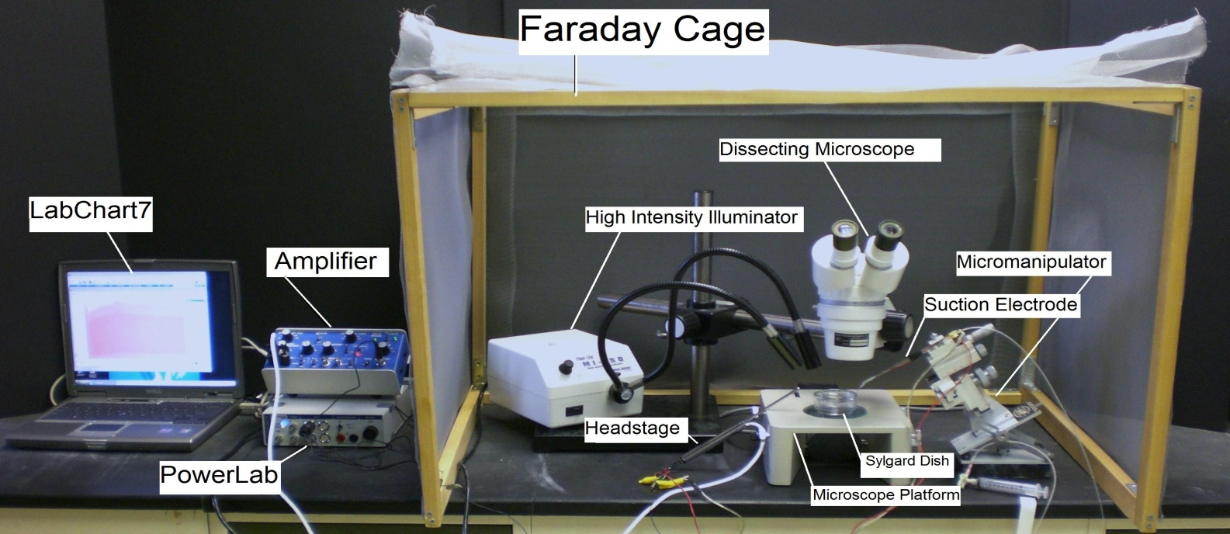

Figure 2: The equipment set up

1. Setup up the Faraday cage. The microscope, high intensity illuminator, micromanipulator, and the saline bath will all be set up inside the cage (The Faraday cage is used to block external electric fields that could interfere with the electrical recording).

2. Setup the microscope in a position where it is overlooking the microscope stage.

3. Position the high intensity illuminator in a convenient position.

4. Prepare a saline bath using crab saline in a Sylgard dish and place it under the microscope (this is where the dissected leg will be placed).

5. Position the micromanipulator in a position where the suction electrode has easy access to the saline bath.

6. Suction up saline until it is in contact with the chloride coated silver wire inside the suction electrode. Arrange the other wire on the cut-side of suction electrode close to the tip of electrode, so both wires will be in contact with the saline bath.

7. Connect the AC/ DC Differential Amplifier (amplifier) to the Power Lab 26T. Do this by connecting the proper cord from Input 1 on the PowerLab 26T to the output on the amplifier.
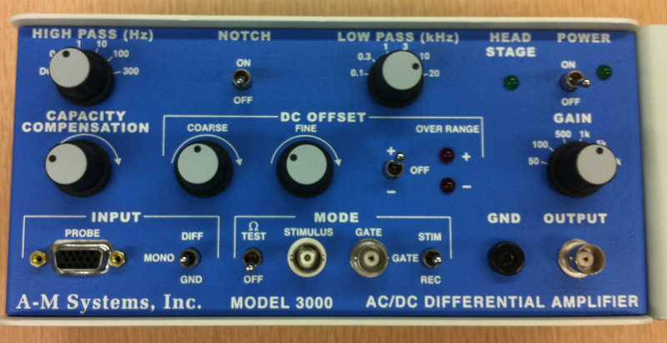

Figure 3: Extracellular amplifier

The settings for the amplifier are as follows:

CONTROL | SETTING
High Pass | DC
Notch Filter | OFF
Low Pass | 20kHz
Capacity Comp. | Counterclockwise
DC Offset Fine and Course knob | Counterclockwise
DC Offset (+OFF) | OFF
Gain knob | 50 (to start with)
Input (DIFF MONO GND) | DIF
MODE(STIM-GATE-REC) | GATE
ΩTEST | OFF

8. Connect the head stage to the ‘input- probe’ on the amplifier.

9. Connect the electrical wires from the suction electrode to the head stage. The wires should be connected with the red (positive) at the top left, green (ground) in the middle, black (negative at the bottom. This is indicated in Figure 4. The ground wire can just be put in the saline bath.

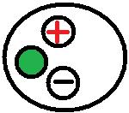
Figure 4: Head stage Configuration

10. Now connect the USB cord from the PowerLab 26T to the laptop. Ensure that both the amplifier and PowerLab26T are plugged in and turned on before opening LabChart7 on the computer.

11. Open LabChart7.

-The LabChart Welcome Center box will open. Close it.
- Click on Setup
- Click on channel settings. Change the number of channels to 1 (bottom left of box) push OK.
-At the top right of the chart set the cycles per second to about 4 KHz. Set the volts (y-axis) to about 500 or 200mv.
-Click on Channel 1 on the right of the chart. Click on Input Amplifier. Ensure that the settings: differential, ac coupled, and invert (inverts the signal if needed), anti-alias, and differential are checked.
- To begin recording press start.

12. Force transducer

Recording forces of contraction in excised preparations

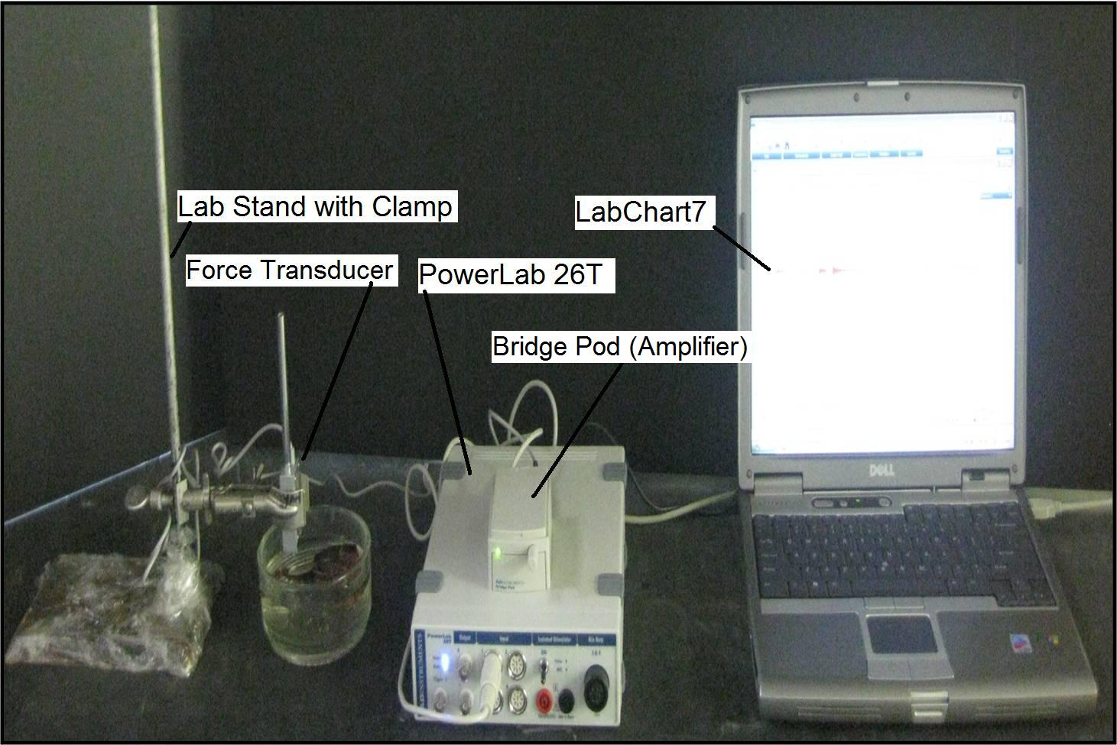
Figure 4: Setup

12.1. Attach the transducer to the bridge pod.

12.2 Attach the bridge pod to the PowerLab 26T.

12.3. Attach the PowerLab 26T to the USB port on the computer.

12.4. Open LabChart7, by clicking on the labchart7 icon on the desktop.
- The LabChart Welcome Center box will pop open. Close it.
- Click on Setup
- Click on channel settings. Change the number of channels to 1 (bottom left of box) push OK.
-At the top left of the chart set the cycles per second to about 4KHz. Set the volts (y-axis) to about 500 or 200 mV.
-Click on Channel 1 (or what ever port the transducer is plugged into) on the right of the chart. Click on Input Amplifier. Ensure that the settings: single-ended, ac coupled, and invert (inverts the signal if needed), and anti-alias, are checked.
- To begin recording press start.

12.5. Gently move the force transducer pin to see that the movements are detected in the recording

12.6. Place the force transducer in the clamp near the dissected crab leg

12.7. Hook the force transducer in the leg as shown in Figure 5.

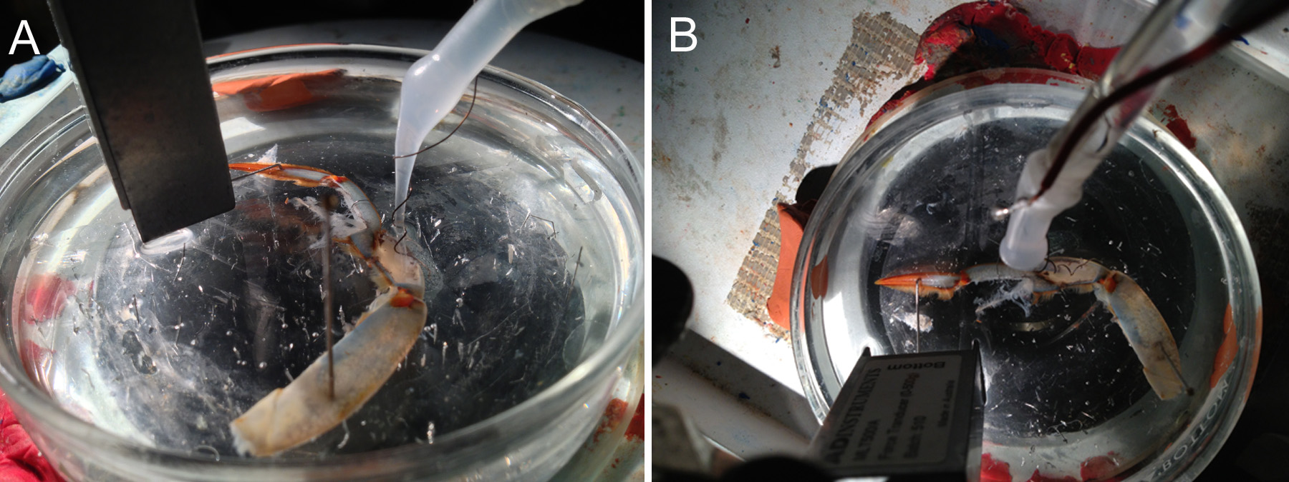
Figure 5: The wire hook on the end of the transducer is positioned with the tip placed within the hole in the dactylopodite. The transducer is positioned in a 90 degree, along with the pin, to the development of force on the dactylopodite. Side view (A) and top view (B).

4.3 Dissection
The procedures described by Tryba and Hartman (1997) are being followed for the anatomical dissection and electrical stimulation. The equipment for the electrophysiological recordings is different so we have provided a detailed description of this laboratory manual.
In brief, Tryba and Hartman (1997) obtained a walking leg of the swimming crab Callinectes sapidus. A good place to obtain blue crabs is :http://www.crabplace.com/crabs.asp. Using a net obtain a crab from a holding tank and place into an empty bucket. While holding the crab with the net or an object across the carapace from behind, and avoiding the claws, cut across the merus of a walking leg with a stout pair of scissors. The animal will autotomize the remaining basal portion of that limb. If the crab does not break the leg off, help it by inserting the scissor tips into the wound and twisting the stump but be careful not to damage the leg. Return the animal to its aquarium.
Put the leg in the Sylgard-lined dissecting dish and cover it with the species correct cooled (12-19ºC) crab saline (Table 1).

Table 1: Solution for C. sapidus saline (Blundon, 1989)

SALT g/l g/3l g/2l
NaCl 27.47 82.41 54.94
KCl 0.59 1.77 1.18
MgCl₂ 6H₂0 1.421 4.269 2.842
CaCl₂ 2H₂0 2.205 6.615 4.41
Dextrose 1.982 5.945 3.964
HEPES acid (5mM) 1.19 3.57 2.38
HEPES salt (5mM) 1.30 3.90 2.60
Adjust to pH 7.5 with NaOH (2N) or HCl (1M). The osmotic pressure should be 1000 mm/l.

The lateral and medial side of the leg should be determined. The medial side has a soft texture that can be felt by pinching gently in the merus region with a fingernail. Face this soft cuticle side up in the dish. The excitor motor nerve that innervates the opener muscle also innervates the stretcher muscle in the carpus. In order to stimulate the opener muscle, the stretcher motor nerve should be isolated in the carpus region and then stimulated. With a pair of scissors, make an incision through the merus. Discard the leg proximal to the cut. Pin the preparation in the proximal part of the carpus and in the dactylus. Remove a section of the cuticle in the carpus region on the inner side (medial side, Figure 6A). Then cut the apodeme of the bender muscle and remove the muscle carefully as not to pull the main leg nerve out of the leg cavity (Figure 6B, C- note the arrows where to bender apodeme). Then the main leg nerve and a branch to the stretcher muscle can be observed (Figure 6D). Find the nerve branching from the main nerve bundle to the stretcher muscle (Figure 6E) and this can be cut close to the muscle and pulled into a suction electrode to stimulate (Figure 6F&G).
Figure 6: Dissection steps for exposing the motor neuron for stimulating the opener muscle.

Tease a section of the nerve that projects towards the opener without pinching the nerve. The streatcher/opener motor nerve is transected to pull it into the suction electrode and then stimulated. Make sure that the saline is up to the wire that is located inside the suction electrode; otherwise, electrical activity cannot be obtained.

Use the series of steps in Figure 7 to guide you through the rest of this dissection for exposing the opener muscle. Cut off the closer muscle with a scalpel with a #11 blade in the propus. (Note: Do not cut deeply in the proximal region because it might damage the opener motor nerve).

Figure 7: The series of dissection steps A-E illustrates a method to remove tissues to expose the ventral surface of the opener muscle for recording from the tension nerve.

The saline should be exchanged with fresh cooled saline throughout the dissection process to keep the neurons alive. For further dissection, place the preparation dish under a dissecting microscope and use fiber-optic illumination.
In the next step, carefully cut the closer tendon from its attachment to the dactyl using sharp-pointed medium-size scissors. Be very careful not to disturb the branches to the opener muscle from the main leg nerve which should be clearly visible, remove and discard the closer muscle and tendon. This will require minimal cutting and trimming. Make a hole in the dactylus with a dissection pin. This hole will be used later to hook the metal pin on the tension transducer, but it is necessary to make it while the leg is in this position.
Locate the nerve branch that projects to the opener muscle and apodeme in the distal region of the opener muscle. Carefully probe the nerve with the glass tool. Ask for help if you cannot find the nerve bundle. Now pin the main nerve so that the ventral view of the opener muscle is facing upward toward the observer (see Figure 8). Be cautious not to damage the opener muscle fibers.

Figure 8: Exposed tension nerve will run very close to the opener apodeme and joining the motor neurons. Here the motor neurons to the opener muscle can be seen branching to the various muscle fibers. The main leg nerve is pinned to one side prior to cutting it away as to insure not to cut the motor nerve. In this figure the preparation is stained with methylene blue.

One may first want to learn the preparation with methylene blue staining to make observations so that when the physiology is to be recorded one can make the dissection without the stain. The tension nerve is very small as it only contains a few axons. It can be observed arising from the distal end of the apodeme and proceeding to the motor nerve bundle (Figure 9).
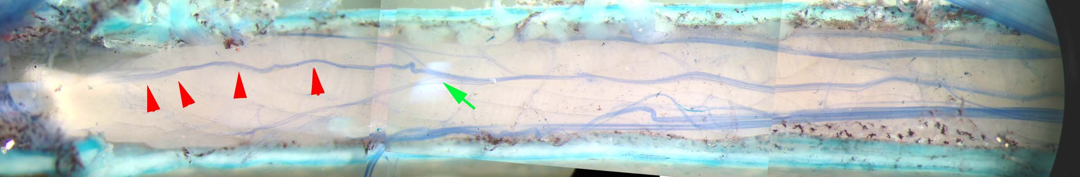
Figure 9: The tension nerve arising from distal end (red arrows) and joining the motor nerve (green arrow).

4.4 Recording
One is now ready to determine if the preparation is still alive. Electrically ground the bath. Change the saline often with saline that has been kept on ice. Turn on Lab chart recording software. To detect neural activity, draw the cut end of the opener tension nerve into the recording suction electrode.

The first set of experiments is to examine for passive tension on the opener apodeme.

(i) Is there a patterned and consistent response to the opening and closing movements of the dactyl with passive movement?

Next we will test for active force development related to stimulation frequency.

(ii) Firmly attach a metal hook so that the tip of the hook goes through a small hole in the dactylus. The other end should be attached to the force transducer (Figure 5). The metal rod should be strong enough that it does not bend easily. Pull the hook and dactylus so that it is about a 45 degree angle of the opener joint. Now stimulate the motor nerve at 100 Hz for 250 msec and measure the force as well as the firing frequency of the tension nerve. Repeat this process twice. Next extend the joint 0 degrees (joint is fully extended, opener muscle fibers are flaccid). Now stimulate the motor nerve at 100 Hz for 250 msec and measure the force as well as the firing frequency of the tension nerve. Repeat this two times. Next bend/flex the joint so that it is fully flexed (~90 degrees). In this position the muscle fibers of the opener are fully stretched. There may be some force measured by the transducer due to this passive stretch of the muscle. Now stimulate the motor nerve at 100 Hz for 250 msec and measure the force as well as the firing frequency of the tension nerve. Repeat this two times. NOTE: Make sure the transducer is at a 90 degree angle each time so that the pin is perpendicular to the transducer for maximal detection of the force generated. Now that you are able to measure a force, proceed in a series of 20, 40, 60, 80 and 100 Hz for a 8 to 10 seconds in each joint position. Allow the muscle to relax for a few seconds between stimulus pulses.

(ii) What types of responses are evoked by pinning the dactyl at various fixed positions?

(iii) Is that response consistent when repeated?

By filling in Table 2 with values the observations will be easier to make into quantitative statements.

Table 2: Static position. Firing frequency measures
Angle($°)$ | Time in recording before activity appeared after stimulation started | # of Action Potentials in stimulation period | # of different sized action potentials in stimulation period
0$°$ Joint
(extended)
45$°$ Joint
90$°$ Joint
(flexed)

(iv) Now measure the response with a quick tension release. Arrange the preparation so that the hook on the tension transduce can easily be pushed out of the hole in the dactylus. Bend/flex the joint so that it is fully flexed (~90 degrees). Now stimulate the motor nerve at 100 Hz with a continuous stimulation of 5 seconds. After the first second or less, as tension has built up on the opener muscle, push the pin out of the hole in the dactylus. Examine the tension nerve recording before and after release of the pin holding the dactylus. Write down your observations.

Make careful notes of the kinds of responses observed. After you are satisfied with your observations save the chart file and take a photo with your phones of the preparation.
You may wish to determine if the neuromodulators octopamine, serotonin, and proctolin alter the output of the tension neurons by adding these compounds to the bathing media over the exposed opener muscle and repeating the experiments. Use a pipette and just drip over the preparation (range 10µM to 0.5mM).

5. Results

Representative anatomical morphology is illustrated in the Methods in hopes of helping to provide an understanding of the anatomy so that physiological recordings can be made without the use of stains or dyes. Sometimes, one can observe the tension nerve better when moving the light at various angles and intensity to obtain the best contrast. Tracking the tension nerve close to the muscle fibers, at the distal of the opener apodeme, maybe help one to observe the branch from the main leg nerve. Figure 9 illustrates the tension nerve separated from the main leg nerve.
The forces measured can readily be compared by graphing them superimposed on top of each other (Figure 10). The can also be performed for each joint position for each given stimulation frequency.
Figure 10: The relative forces that are developed with the joint fully flexed and stimulated at the various frequencies.
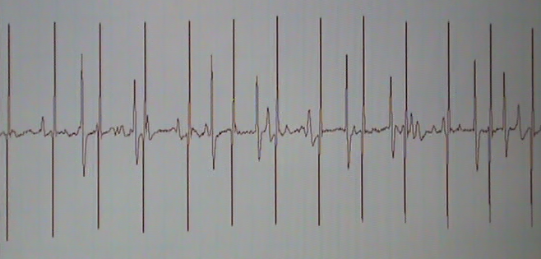
The activity of the tension nerve can correlated with the amount of relative force generated at each stimulation frequency and for each joint position from the measures obtained from the raw traces (Figure 11) that were analyzed in Table 2.

Figure 11: Raw trace recorded from the tension nerve when the motor nerve was stimulated at 80 Hz. Note the regular pattern of the stimulus artifacts as compared to the neural activity. Also, note the various amplitudes of the neural responses.
6. Discussion
In this experiment we have learned the physiological importance of tension neurons. The tension that is generated by the contraction of muscle fibers is monitored by tension receptors in the apodeme. These neurons detect force at various levels and recruit additional neurons as the force increases. The frequency in activity is related to the stimulation frequency of the motor neuron until saturation in reception is reached. A quick release protocol, of a flexed dactylus joint, the tension activity disappears for a while but then returns upon force returns in a fully extended joint. Various neuromodulators, for instance 5-HT, can be applied to the preparation to see how it effects the development of force and neuronal response. One of the important aspects is how the neural responses are processed and integrated in the central nervous system and their impact on activity of motor neurons. What kind of approaches can one use to obtain more information about the tension nerve-CNS-motor neuron circuitry in an intact leg to the thorax and ganglion?

REFERENCES:

Cooper, R.L. and Hartman, H.B. (1994) Responses of the bender apodeme tension receptors in the Dungeness crab, Cancer magister. J. Comp. Biochem. Physiol.109A:479-486
Eagles D. A. and Hartman H. B. (1975) Tensionreceptors associated with the tailspine muscles of the horseshoe crab, Limulus polyphemus. J. Comp. Physiol. 101, 289-307.
Gregg R. A. and Eagles D. A. (1984) The relationship between sensory activity and muscle tension in the anterior flexor muscle of the horseshoe crab walking legs. Mar. Behav. Physiol. 10, 283-301.
Hartman, H.B. (1985) Tension receptors on the closer muscle apodeme in the walking legs of the blue crab Callinectes sapidus. J Comp Physiol 157:355-362
Hill A. V. (1970) First and Last Experiments in Muscle Mechanics. Cambridge University Press, Cambridge, U.K.
Houk JC and Henneman E. Responses of Golgi tendon organs to active contraction of the soleus muscle of the cat. J Neurophysiol 30: 466–481, 1967.
Houk JC and Simon W. Responses of Golgi tendon organs to forces applied to muscle tendon. J Neurophysiol 30: 1466–1481, 1967.
Jami L. Golgi tendon organs in mammalian skeletal muscle: functional properties and central action. Physiol Rev 72: 623–661, 1992.
Macmillan, D. L. & M. R. Dando, 1972. Tension receptors on the apodemes of muscles in the walking legs of the crab, Cancer magister. Mar. Behav. Physiol., 1: 185-208.
Mileusnic MP, Loeb GE.Mathematical models of proprioceptors. II. Structure and function of the Golgi tendon organ. J Neurophysiol. 2006 Oct;96(4):1789-802. Epub 2006 May 3.PMID: 16672300
Parsons D. W. (1980) The morphology and ultrastructure of tension receptors in the walking legs of the crab, Carcinus maenas. Cell Tiss. Res. 211, 139-149.
Parsons D. W. (1982) Responses and central interactions of tension receptors in the leg muscle of Carcinus. Comp. Biochem. Physiol. 72A, 391-399.
Stuart DG, Mosher CC, Gerlach RL, and Reinking RM. Mechanical arrangement and transducing properties of Golgi tendon organs. Exp Brain Res 14: 274–292, 1972
Theophilidis G, Burns MD (1979) A muscle tension receptor in the locust leg. J Comp Physiol 131:247-254
Tryba AK, Hartman HB. Dynamic responses of series force receptors innervating the opener muscle apodeme in the blue crab, Callinectes sapidus. J Comp Physiol A. 1997;180(3):215-21.

