Synaptic Transmission: Quantal measures and analysis exercises
Sarah Kenney and Robin L. Cooper
Department of Biology, University of Kentucky, Lexington, KY 40506, USA;

1.0 Purpose: The purpose of this laboratory is to observe and measure quantal synaptic vesicular release of neurotransmitter at the crayfish neuromuscular junction. Students will electrically stimulate a crayfish motor nerve in order to measure evoked and spontaneous vesicular events through direct counts, amplitude measurements, and charge measurements to quantify synaptic transmission.

2.0 Preparation: The crayfish abdominal extensor muscles are in groups with some being tonic (slow) and others phasic (fast) in their synaptic phenotypes. The neuromuscular junctions (NMJ) of the abdominal extensors will be used to investigate quantal properties in synaptic transmission. Also, one can examine the influence of neuromodulators and various concentrations of Ca²⁺ in the extracellular fluid on synaptic transmission in these preparations. Synaptic transmission can be assessed over regions of the various nerve terminals with a loose patch electrode (focal macropatch). Thus, a subset of the terminal will be monitored for synaptic transmission by recording spontaneous and evoked quantal events. This laboratory exercise parallels, to an extent, an earlier one in the semester in which one recorded with an intracellular electrode and monitoring the entire muscle responses from motor nerve stimulation.

3.0 Background:
During signal transmission throughout the nervous system, neurotransmitters are released into the synapses in order to transmit signals to targets. Neurotransmitters are released from the pre-synaptic terminal in a quantal manner, meaning that transmitter is released in packets of neurotransmitter from a single vesicle at a time. The fusion of presynaptic vesicles in quantal transmitter packets relays the signal to the receptors on the postsynaptic membrane, where a graded current and potential can be measured as a result. The quantal vesicular responses can be measured either as spontaneous or evoked events. The evoked events occur when the nerve is stimulated in order to provide a measurable response within a defined period of time. The spontaneous events are random in nature and are generally y seen as events induced by the fusion of a single vesicle. It is important to index quantal vesicular release in order to further understand the mechanisms underlying the process of synaptic transmission and to note changes with alterations in physiological and pathological processes.
There are a variety of methods for indexing synaptic transmission by quantal events. One such method is the direct counting of evoked quantal events. This method is the most useful when the evoked events are of a low probability of occurrence so multi-quantal events are low in occurrence. This allows a better accuracy in distinguishing the evoked quanta. Two other methods to quantify synaptic transmission is to estimate mean quantal content for a given stimulation paradigm. One approach is measuring the amplitude of both evoked and spontaneous responses and estimate a mean quantal content. The other method is to measure the charge, or area in the recorded traces, of both spontaneous and evoked response events. The method of using charge to measure quantal synaptic responses is the preferred method for mammalian synapses or high output synapses because it appears have less error associated with the measurements. Overall, using the three methods to index quantal transmission allows for comparison among the different approaches in order to determine which are the most useful. Quantifying the quantal synaptic output at the crayfish neuromuscular junctions is helpful for this exercise as high output and low output terminals can be examined in one preparation and various conditions (frequency of stimulation, environmental changes such as temperature or alterations in ionic composition of the bathing solution). In addition, predictions and inquiry into where alterations occur in the presynaptic or postsynaptic components of transmission can be investigated. Discussion into what potentially gives rise to the variation in the single quantal events observed in spontaneous events is a topic that addresses the pre- and post-synaptic contributions to the quantal response.
The NMJs of the crayfish are easily accessed and they remain healthy for hours in a minimal saline solution, which allows them to be ideal for investigations into synaptic transmission. Many of the crayfish NMJs are non-spiking excitatory postsynaptic potentials (EPSP) such as the graded postsynaptic signals in dendrites within the mammalian CNS or the subthreshold potentials in vertebrate NMJs (Wiersma & Van Harreveld, 1938; Katz & Kuffler, 1946). The NMJs of crayfish have served as fundamental model for synaptic transmission for a number of years (Atwood, 1982; Cooper & Cooper, 2009; Fatt & Katz, 1953; Wu & Cooper, 2010).
The differences in synaptic structural complexity for phasic and tonic NMJ can in part account for the differences in synaptic efficacy. The number active zones on synapses and differences in Ca²⁺ influx can account for some of the presynaptic differences between the types of terminals (Bradacs et al., 1997; Johnstone et al., 2008; King et al., 1996; Lancaster et al., 2007; Miller et al, 2002; Viele et al., 2003, 2006). The vesicles pools between phasic and tonic nerve terminals appear to be regulated differentially in kinetics and in their susceptibility to the neuromodulator serotonin (Cooper et al., 2003; Logsdon et al., 2006; Sparks and Cooper, 2004; Wu & Cooper, 2012, 2013).
As for postsynaptic differences in the receptor density and glutamate receptor subtypes of phasic and tonic NMJs, these topics have not been fully addressed in the crayfish synaptic models. To gain an understanding of pre- and post-synaptic contributions to synaptic efficacy one approach is to investigate the quantal unit and the quantal characteristics in various experimental conditions. Understanding of the fundamental differences in the physiology of different types of synapses on a comparative base enriches our understanding in the diversity of synaptic responses as well as commonalities.
The description of quantal events, in terms of synaptic transmission, comes from the seminal work of Katz, Fatt and del Castillo in the 1950s when they coined the term quanta. They demonstrated at the frog NMJ that ACh can be released in packets as miniature endplate potentials (MEPPs or mini’s). These individual packets were referred to as the smallest amounts of transmitter that could be released from nerve terminals (Fatt and Katz, 1952). To index the occurrences of the quantal events with evoked nerve stimulation, the probability and number of the quantal events needed to be quantified. The index that developed is the “mean quantal content” (ie., m) to described the synaptic efficacy or strength. Del Castillo and Katz characterized the specific sites or places a packet of transmitter could be released as n. Each site then has a probability in the potential release of transmitter (p) with each stimulation of the nerve terminal. This approach aided in understanding how single quantal events could add to multi-quantal events that then gave rise to graded excitatory postsynaptic potentials (EPSPs) of various amplitudes and shapes. Combining the structure of the terminals with the physiological responses, it was then postulated the vesicles was the structure that held a packet of transmitter that gave rise to the postsynaptic quantal events. An estimate in the number of transmitter molecules within a vesicle depends on the synapse. There appears to be about 7000 molecules for the frog NMJ that uses ACh as a transmitter and about 4000 for synapses that release glutamate (Kuffler and Yoshikami, 1975, Villanueva et al., 1990).
The skeletal muscles in the limbs of crayfish have been used for many years for addressing the quantal nature of synaptic transmission at this NMJ (Dudel and Kuffler 1961a,b; Dudel, 1963, 1965a). However, the walking legs are a bit tedious in dissection for a class room teaching exercise in obtaining quantal responses. For this reason, the abdominal extensor muscles are used since in this course the students have already learned this dissection and are familiar with identifying the segmental nerve for stimulation.

4. METHODS

4.1 Materials
- Scissors (1)
- Forceps (1)
- Silver Wire for ground wire (1)
- Microscope (1)
- Electrode Probe (1)
- Petri Dish with Sylgard on the bottom (1)
- Crayfish Saline Solution (1)
- Bleach (Small Amount, Use for the tip of the silver wire to build Ag-Cl)
- Glass Pipette (1), to remove and add solutions
- Syringe (1)
- Amplifier/Acquisition System (1)
- Faraday Cage (1)
- Desktop/Laptop (1)
- Dissection pins (4)
- Crayfish
- Fire polished glass focal electrodes

4.2 Preparation/Dissection
To obtain the abdominal extensor preparation the same procedure as described above for examining the resting membrane potentials in relation to extracellular potassium. The difference is to take care of the segmental nerve bundle that runs along the side if the carapace. This nerve will be pulled into a suction electrode which will serve as the stimulating electrode. Stimulate at 1 Hz for monitoring synaptic responses

The experimental procedures for caring out experiments on the crayfish tonic flexor muscles are as follows:

1. A crayfish approximately 6-10 cm in body length should be obtained (or a manageable size). Obtain the crayfish by holding it from the back of the head or approximately 2 or 3 centimeters from the back of the eyes (The crayfish may be placed in crushed ice for 5 minutes to anesthetize it prior to cutting off the head). Ensure that the claws of the crayfish or mouth cannot reach the experimenter when handling the crayfish. Dispose of the head and appendages after removing them.

2. Use the scissors to quickly remove the head. Make a clean and quick cut from behind the eyes of the crayfish.

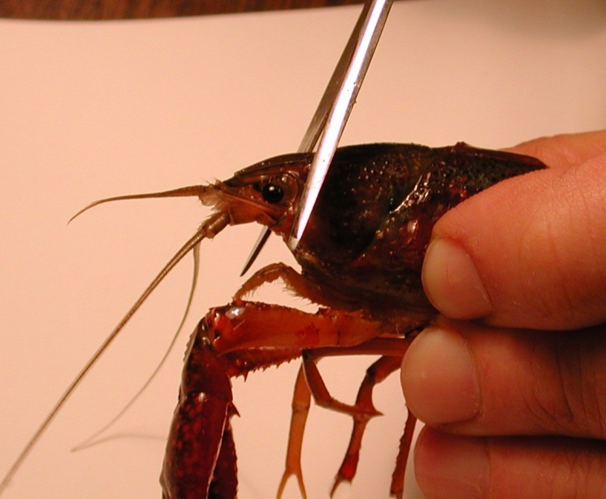
Figure 1: Image shows placement of the cut to remove the head of the crayfish.

The legs and claws of the crayfish can be removed at this point to avoid injury. Stylets on males and swimmerets on both males and females can also be removed (Figure 1 and 2). Next, separate the abdomen from the thorax. Make a cut along the articulating membrane which joins the abdomen and thorax (Figure 3).

3. Save the abdomen portion of the crayfish and dispose of the thorax.

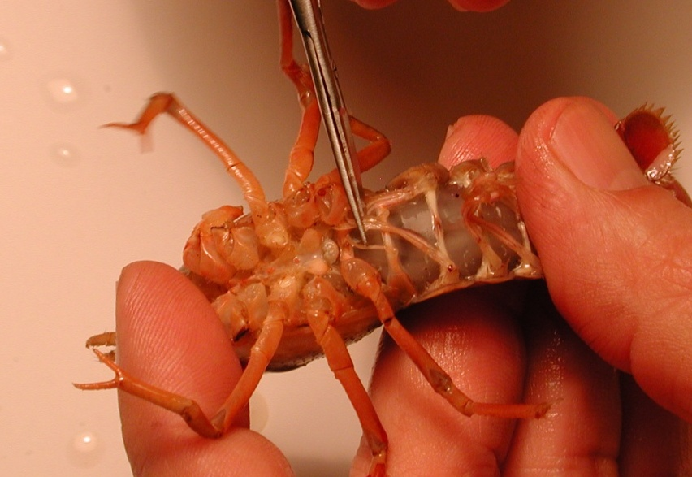
Figure 2: Image shows the placement of the stylets that can be removed from the crayfish.

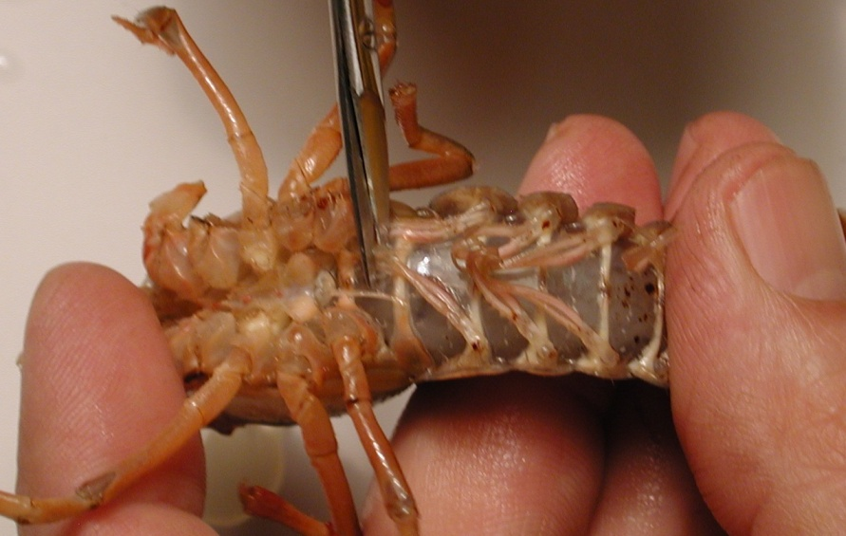
Figure 3: Image shows the placement of the cut to remove the thorax from the abdomen.
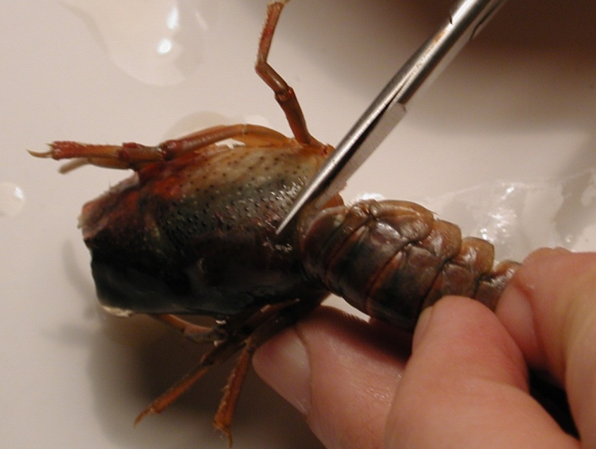
Figure 4: Removal of the thorax from the abdomen. The cut should be made in circular fashion along the line of the joining of the segments.

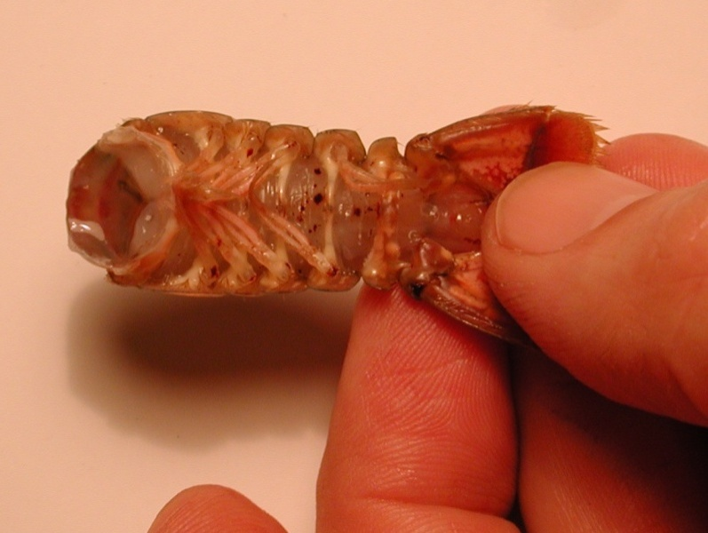
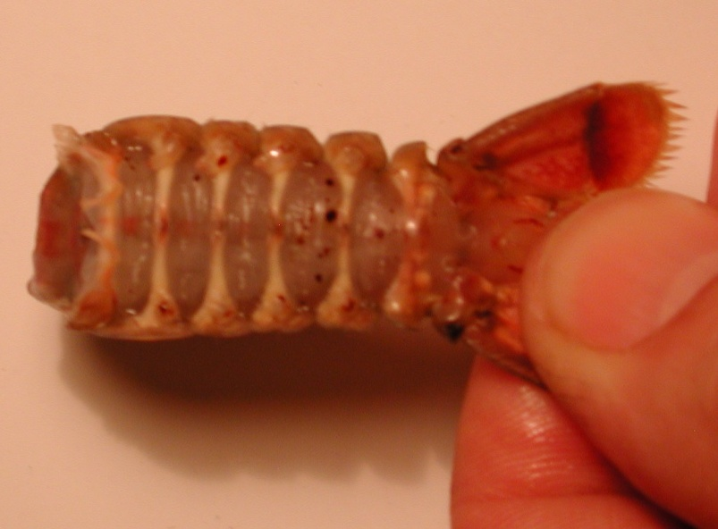
Figure 5: The top image (A) shows the abdomen with swimmeret appendages. Bottom image (B) shows the abdomen without the swimmeret appendages.

4. With the abdomen, a cut should be made in the shell along the lower, lateral border of each side of the abdomen. Care should be taken not to cut too deeply into the crayfish. To help in the process of cutting the shell, the cut should be made with the scissors pointing slighting down towards the ventral side and at an angle. Follow the natural shell pattern of lines of the crayfish that run the length of each segment (Figure
6).
Figure 6: Scissors are placed at an angle and follow the natural alignment of the shell. Do not cut too deep and destroy the preparation. The arrowheads point to the natural line along each segment that should be followed for the cuts.

5. Remove the ventral portion of the shell. Take care not to destroy the abdominal muscles. Use forceps to remove the ventral portion. When the ventral portion of the shell is removed, a white mass of tissue can be seen on top of the deep flexor muscles. This tissue can be removed carefully with forceps.
Figure 7: Removing the ventral portion of the shell with forceps. Pull up and back on the ventral portion to remove. Do not destroy muscles under the ventral shell.

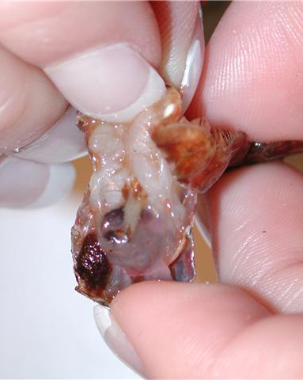
Figure 8: Pulling back on the ventral portion of the shell, which is to be discarded.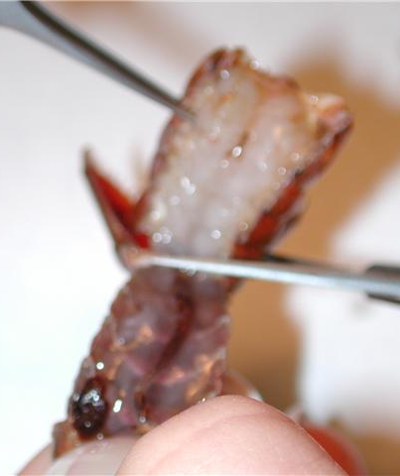
Figure 9: Cut the ventral portion of the preparation with scissors and discard.

6. The GI tract, a small tube running along the midline of the deep flexor muscles, can be removed from the crayfish. Pinch the top of the tract with the forceps and pull away from the abdomen. Cut the bottom of the tract – at the end of the tail. Rinse the dissection with saline to ensure the fecal waste does not interfere with the preparation.
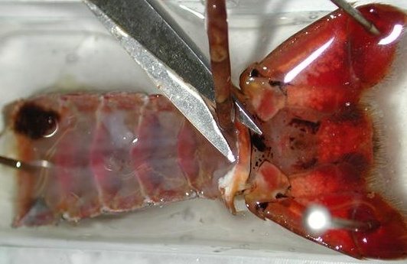
Figure 10: Image shows the removal of the GI tract from the preparation.

7. Use dissection pins to secure the preparation to the Petri dish. The top and bottom corners of the preparation should be pinned down to the dish. Saline solution should be poured into the Petri dish and cover the preparation completely until intracellular recordings are performed.

This dissection dish should have a Sylgard (Dow Corning) coating on the bottom (1cm thick) so that insect pins can be stuck into it.

Dissected preparations are bathed in standard crayfish saline, modified from Van Harreveld’s solution (1936), which is made with 205 NaCl; 5.3KCl; 13.5 CaCl₂; 2H₂O; 2.45 MgCl₂; 6H₂O; 5 HEPES and adjusted to pH 7.4 (in mM).

4.3 Stimulating the segmental nerve and obtaining extracellular focal recordings:

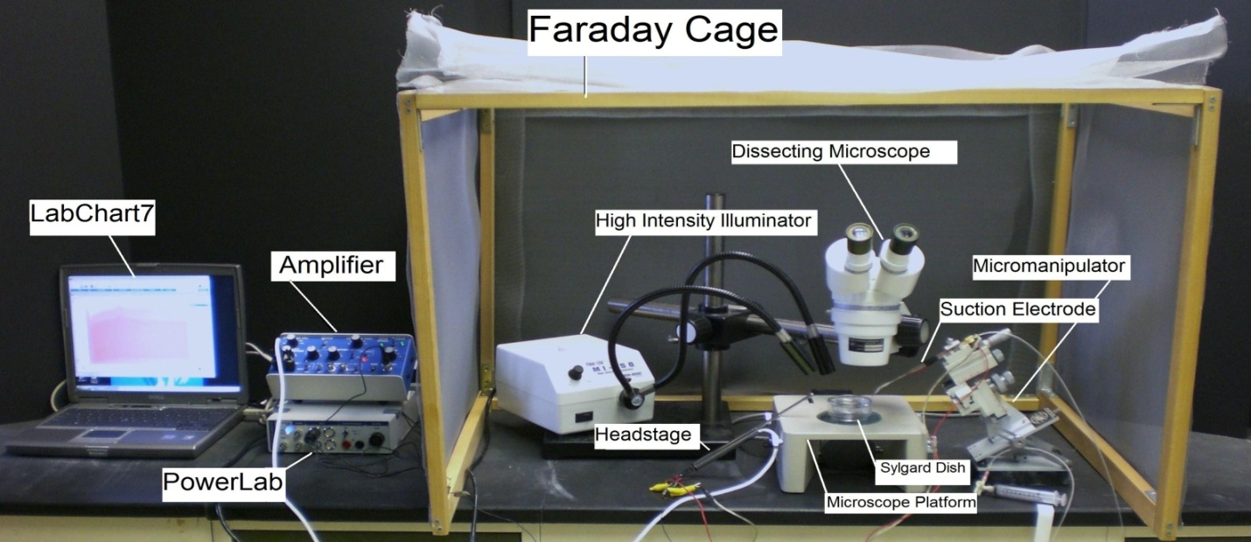
Figure 11: Overall setup of the recording equipment

1. The Petri dish with preparation should be placed under the microscope and secured with wax at the bottom of the dish to prevent movement.

2. The specimen dish with preparation should be placed under the microscope and secured with wax or clay on the sides of the dish to prevent movement.

Figure 12: Placement of the preparation under the microscope.

3. Two wires each with a short length of silver wire attached to one end should be obtained. The silver wire should be dipped into a small amount of bleach for about 20 minutes to obtain an Ag-Cl₂ coating. Wash the wire with distilled water before using. A glass intracellular pipette should be obtained and carefully backfilled with a long needle attached to a syringe filled with a saline solution (Figure ?). The silver wire can then be placed into the pipette (Figure 13). Care should be made not to break the electrode tip. Another wire is attached to the Faraday cage or into ground directly on the intracellular amplifier A wire should also be placed from the Faraday cage to the ground portion of the AD converter Powerlab. The head stage is connected to the “input-probe” on acquisition/amplifier (Powerlab).

Figure 13: Filling the focal electrode with crayfish saline

Figure 14 : Focal electrode and holder

This experiment requires a very clean recording with little noise in the signal. The 60Hz noise has to be grounded and eliminated in order to measure the extracellular quantal events that are in the 1 or 0.5 mV amplitude range.
Glass electrodes are to be pull pulled with an electrode puller and the ones used for making patch electrodes will be broken off and fire polished to an inner diameter of about 10 micrometers. Kimax glass (outer diameter: 1.5 mm) is used to make the focal electrode. One can place the focal electrode in the saline bath for now.
4. Setting up the stimulating electrode
Use the microscope to find the nerve to be recorded. Note: Look for the segment with the most accessible nerve. The nerve is white, and can be seen by using the pipette to spray saline around the nerve or by lightly blowing on the preparation. This causes the nerve to move around and makes it easier to identify. See figure 15 for details.
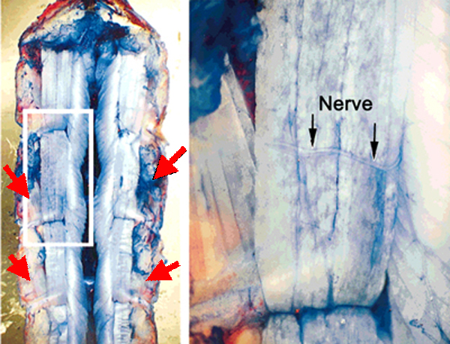
Figure 15: In this methylene blue stained preparation. The segmental nerve approached the extensor muscle from the lateral-caudal aspect of each segment. The nerve is close to the SEL muscle. The red arrows depict the approximant locations where the segmental nerve can be located.

Now that the nerve has been identified place the suction electrode from the micromanipulator directly over the nerve (Figure 16). Gently pull on the syringe to draw the nerve into the electrode (one can see the nerve being sucked into the electrode with the use of the microscope).
Figure 16: The nerve bundle to be sucked up into the recording electrode. (A) The free nerve is shown floating over the dissected abdomen. (B) Outlines the nerve bundle and the plastic suction electrode close by the nerve. (C) The segmental nerve is pulled into the suction electrode, which is outlined in blue.

5. Stimulate the segmental nerve and see phasic muscles twitch

The PowerLab system (PowerLab interface from AD Instruments, Australia) will serve as the stimulating voltage source in this experiment.
(i) Attach the PowerLab’s USB cable to the computer. Make sure PowerLab is on and open the LabChart program from the desktop.
(ii) Select “New File.”
(iii) A window will appear with multiple recording channels. Select “Setup” at the top and click on “Channel Settings.” In the bottom left corner of the window, decrease the Number of Channels to 1; on Channel 1, change the Range to 5 V.
(iv) Connect the Stimulator cable with the two mini-hook leads to the Output portals on the PowerLab as follows: attach the red connector cable to the positive Output portal and the black connector cable to the negative Output portal.
(v) Next, it is necessary to change the power output, frequency, and pulse duration of the PowerLab. In order to do this, select “Setup,” and then “Stimulator Panel.” Short pulses and small voltages to start off with are required for the first portion of the experiment, so adjust the amplitude to 0.5 V; this will give a range of 1.0 V (the PowerLab will emit a voltage fluctuating between positive and negative 0.5 V). Set the frequency (1 Hz) and pulse duration (0.3s).
While one person watches the muscles through the microscope for twitching behavior another person will adjust the stimulating setting to higher voltages. When muscle twitches occur, stop stimulating and now get ready to record the electrical signal over the muscle fibers.
6. Obtaining Quantal Responses
A procedure similar to that described for the opener muscle of the crayfish (Cooper and Cooper, 2009) is used in this preparation. The quantal EPSPs of the nerve terminal are recorded by placing the lumen of a macro-patch recording electrode over the nerve terminals. Since one can not see the nerve terminals this is considered a blind placement. The spontaneous as well as evoked quantal responses can be recorded when over a nerve terminal that is being stimulated (Dudel, 1981; Wojtowicz et al.,1991; Mallart, 1993).

The focal electrode will look something like that shown in Figure 17 under high magnification.

Figure 17: The lumen of a macro-patch recording electrode..

The amplifier is the same as that used for extracellular nerve recordings.

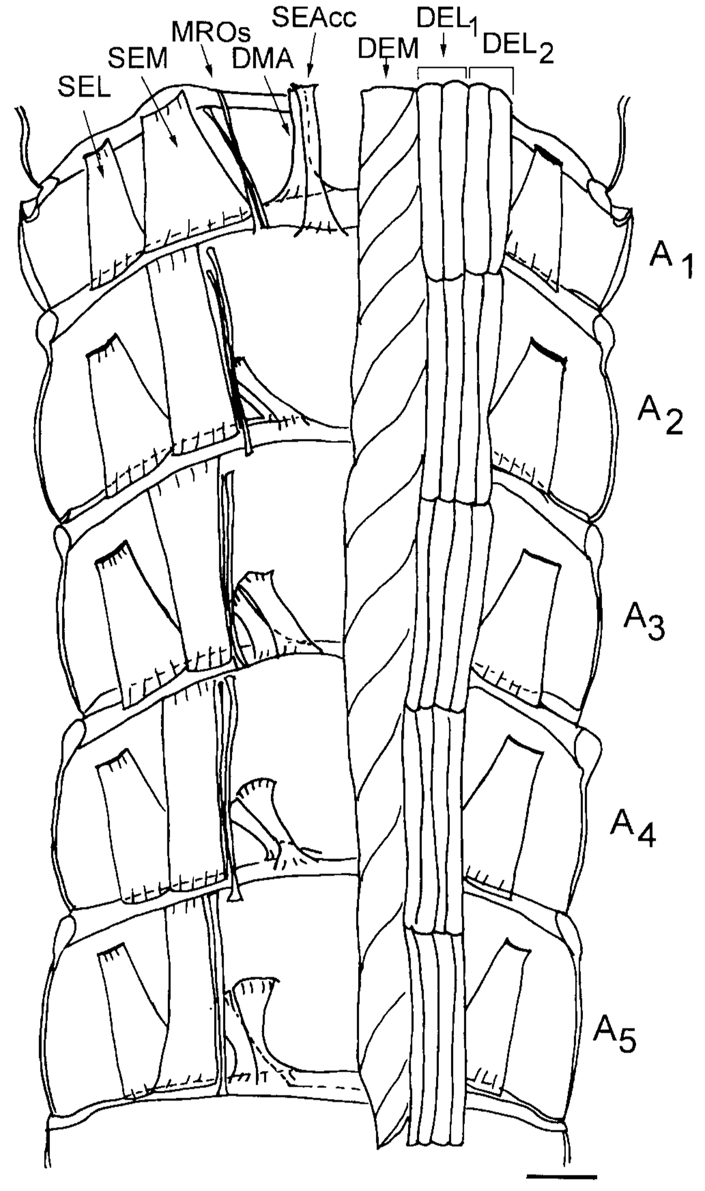
Figure 18. Schematic drawing from a ventral view of the dorsal part of the crayfish abdomen showing the extensor musculature of each segment. The dorsal membrane abdomen muscle (DMA) and the superficial extensor accessory muscle head (SEAcc) are under the deep extensor medial (DEM) muscle. The superficial extensor medial (SEM) muscle is under the deep extensor lateral (DEL2 and DEL1) muscles. For this lab one will record over the DEL1or DEL2 for obtaining synaptic events from phasic terminals and superficial extensor lateral (SEL) for the tonic terminals. On the left side of the figure all the deep extensor muscles have been removed to show the dorsal superficial extensor muscles. Scale = 2.35 mm. (Taken from Sohn et al. 2004).

Use the micromanipulator and dissecting scope to place the focal electrode tip on top of the SEM tonic muscle of the preparation (see Figure 18 for muscle names and locations). The electrode should barely be touching the surface of the muscle. You will likely see the muscle dimple as the electrode touches. Do not penetrate the muscle. The high intensity illuminator should be adjusted to clearly see the muscle as the electrode is being placed.

Examples of recording made with a focal electrode over tonic and phasic terminals is shown in Figure 19 which is reproduced from a study (Bradacs et al., 1997) of the leg extensor muscle in crayfish that is innervated by both phasic and tonic terminals. In this particular recording instrumentation the current was measured. For the instrumentation used in the protocol described herein you will be measuring the synaptic potentials in volts.

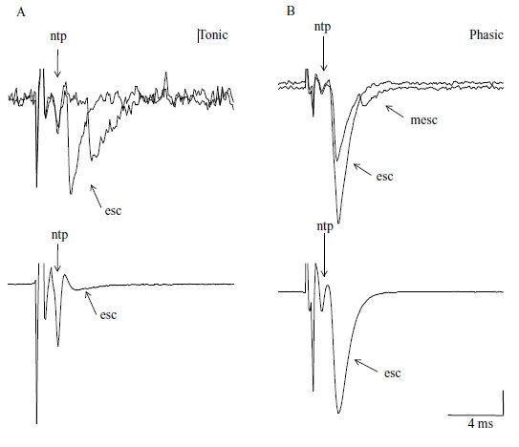
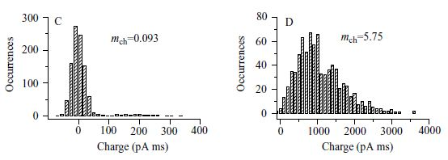
Figure 19. (A,B) Focal recording of extracellular synaptic currents (esc) at visualized terminals of tonic (A, left) and phasic (B, right) endings. Top traces are superimposed single sweeps containing evoked responses; a spontaneous miniature extracellular synaptic current or quantal event (mesc) appears in the phasic record. Bottom traces are the averages of 1000 evoked events. Vertical arrows mark the nerve terminal potential (ntp); diagonal arrows mark evoked release. Scale bars: top panel, A, 54 pA; B, 200 pA; bottom panel, A and B, 80 pA. (C,D) Quantal events (integrated charge measurements) of paired tonic (C) and phasic (D) endings, recorded with the same macro-patch electrode, showing the typical difference in quantal content (mch, quantal content determined from charge measurements). In this example, the phasic:tonic ratio of quantal contents was 62. All recordings (A–D) were obtained while stimulating at 1 Hz. Reproduced from Bradacs et al., 1997.

7. Analyzing the quantal recordings

Direct counting of quantal events is possible with low stimulation frequencies. For each evoked response, the number of quantal events can be readily determined for the low output terminals (Figure 20). These direct counts can help estimate the mean quantal content (Del Castillo & Katz, 1954; Cooper et al., 1995). Since the evoked high output NMJs produce multi-quantal evoked events, the mean amplitude or area of the deflections, along with the average peak amplitude or area of the spontaneous events can be used to approximate the mean quantal content (Cooper et al., 1995).

Figure 20. Focal traces recorded from a phasic and a tonic NMJ.

Area measurements

Peak measurements

5. References

Atwood, H. L. Synapses and neurotransmitters. The Biology of Crustacea, vol. 3 (ed. H. L. Atwood and D. C. Sandeman), pp. 105 150. New York: Academic Press, Inc. (1982).

Bradacs, H., Cooper, R.L., Msghina, M., and Atwood, H.L. (1997) Differential physiology and morphology of phasic and tonic motor axons in a crayfish limb extensor muscle. Journal of Experimental Biology 200:677-691.

Cooper, A.S. & Cooper, R.L. Historical view and demonstration of physiology at the NMJ at the crayfish opener muscle. Journal of Visualized Experiments (JoVE). JoVE. 33. http://www.jove.com/index/details.stp?id=1595; doi: 10.3791/1595 (2009).

Cooper, R. L., Marin, L. & Atwood, H. L. Synaptic differentiation of a single motor neuron: Conjoint definition of transmitter release, presynaptic calcium signals and ultrastructure. J. Neurosci. 15, 4209–4222 (1995).

Cooper, R. L., Stewart, B. A., Wojtowicz, J. M., Wang, S. & Atwood, H. L. Quantal measurement and analysis methods compared for crayfish and Drosophila neuromuscular junctions and rat hippocampus. J. Neurosci. Meth. 61, 67–79 (1995).

Cooper, R.L., Donmezer, A., & Shearer, J. Intrinsic differences in sensitivity to 5-HT between high- and low-output terminals innervating the same target. Neuroscience Research 45,163-172 (2003).

Del Castillo, J. & Katz, B. Quantal components of the end-plate potential. J. Physiol. (Lond.) 124, 560-573 (1954).

Dudel, J. Presynaptic inhibition of the excitatory nerve terminal in the neuromuscular junction of the crayfish. Pflügers Arch. ges. Physiol. 277, 537–557 (1963).

Dudel, J. The mechanism of presynaptic inhibition at the crayfish neuromuscular junction. Pflügers Arch. 284,66–80 (1965a).

Dudel, J. The effect of reduced calcium on quantal unit current and release at the crayfish neuromuscular junction. Pflügers Arch. 391, 35-40 (1981).

Dudel, J. & Kuffler, S.W. The quantal nature of transmission and spontaneous miniature potentials at the crayfish neuromuscular junction. J. Physiol. (Lond.) 155, 514-529 (1961).

Fatt, P. and B. Katz, The electric activity of the motor end-plate. Proc R Soc Lond B Biol Sci, 1952. 140(899): p. 183-6.
Fatt, P. & Katz, B. The electrical properties of crustacean muscle fibers. J. Physiol. 120, 171-204 (1953).

Johnstone, A.F.M., Kellie, S. & Cooper, R.L. Presynaptic depression in phasic motor nerve terminals and influence of 5-HT on docked vesicles. The Open Neuroscience Journal 2, 16-23 (2008).

Katz, B. & Kuffler, S.W. Excitation of the nerve-muscle system in crustacea. Proc. R. Soc. Lond. B 133, 374-389 (1946).

King, M.J.R., Atwood, H.L. & Govind, C.K. Structural features of crayfish phasic and tonic neuromuscular junctions. J. Comp. Neurol. 372, 618–626 (1996).

Kuffler, S.W. and D. Yoshikami, The number of transmitter molecules in a quantum: an estimate from iontophoretic application of acetylcholine at the neuromuscular synapse. J Physiol, 1975. 251(2): p. 465-82.

Lancaster, M., Viele, K., Johnstone, A.F.M., & Cooper, R.L. Automated classification of evoked quantal events. J. Neurosci. Meth. 159, 325-336 (2007)

Logsdon, S., A.F. Johnstone, K. Viele, and R.L. Cooper, Regulation of synaptic vesicles pools within motor nerve terminals during short-term facilitation and neuromodulation. J Appl Physiol, 2006. 100(2): p. 662-71.

Mallart, A. Calcium dependent modulation of the facilitation of transmitter release at neuromuscular junctions of Drosophila. J. Physiol. (Paris) 87, 83-88 (1993).

Millar, A.G., Bradacs, H., Charlton, M.P. & Atwood, H. L. Inverse relationship between release probability and readily releasable vesicles in depressing and facilitating synapses. J. Neurosci. 22, 9661–9667 (2002).

Sohn, J., Mykles, D.L., & Cooper, R.L. The anatomical, physiological and biochemical characterization of muscles associated with the articulating membrane in the dorsal surface of the crayfish abdomen. J. Exp. Zool. 287, 353-377 (2004).

Sparks, G., & Cooper, R.L. 5-HT offsets homeostasis of synaptic transmission during short-term facilitation. J. Applied Physiol. 96,1681-1690 (2004).

Wiersma, C.A.G. & Van Harreveld, A. The influence of the frequency of stimulation on the slow and fast contraction in crustacean muscle. Physiol. Zool.11, 75-81 (1938).

Wojtowicz, J.M., Smith, B.R. & Atwood, H.L. Activity-dependent recruitment of silent synapses. Ann. NY Acad. Sci. 627, 169-179 (1991).

Van Harreveld, A. A physiological solution for freshwater crustaceans. Proc. Soc Exp. Biol. Med. 34, 428-432 (1936).

Viele, K., Lancaster, M. & Cooper, R.L. The self-modeling structure of evoked post-synaptic potentials. Synapse 60, 32-44 (2006).

Viele, K., Stromberg, A. & Cooper, R.L. Determining the number of release sites within the nerve terminal by statistical analysis of synaptic current characteristics. Synapse 47, 15-25 (2003).

Villanueva, S., J. Fiedler, and F. Orrego, A study in rat brain cortex synaptic vesicles of endogenous ligands for N-methyl-D-aspartate receptors. Neuroscience, 1990. 37(1): p. 23-30.

Wu, W.H. and Cooper, R.L. (2010) Physiological recordings of high and low output NMJs on the Crayfish leg extensor muscle. Journal of Visualized Experiments (JoVE). Jove 45: http://www.jove.com/index/details.stp?id=2319 , doi:10.3791/2319

Wu, W.-H. and Cooper, R.L. (2012) The regulation and packaging of synaptic vesicles as related to recruitment within glutamatergic synapses. Neuroscience 225:185–198.

Wu, W.-H. and Cooper, R.L. (2013) Physiological separation of vesicle pools in low- and high-output nerve terminals. (In Review)

