**THE EFFECTS OF K+ AND Na+ ON RESTING MEMBRANE POTENTIALS USING THE CRAYFISH: STUDENT LABORATORY EXERCISES**

**PURPOSE**

To understand the properties of excitable membranes, the ionic basis of the resting membrane potential, and methods used to measure the membrane potential. The purpose is also to learn how to stain the neuromuscular preparations and to examine the histology of different muscle fiber phenotypes.

**1) INTRODUCTION**

The goals of these laboratory exercises are to understand the properties of excitable membranes, the ionic basis of the resting membrane potential, and methods to measure the membrane potential. In addition, staining and histology of muscle is presented, which can be used to teach muscle structure. Also, two different types of dissected preparations are used to demonstrate properties of synaptic transmission in various muscle groups. A complete sensory-central nervous system (CNS)-motor neuron-muscle circuit in the crayfish abdomen is also used to present a preparation to examine sensory stimulation and the influence of neromodulators and neurotransmitters on aspects of a circuit.

The first part of this report presents the approaches used to measure resting membrane potential and the influence of extracellular K+ on membrane potential. We will also introduce muscle structure. In the second part of this exercise, we present various means of measuring synaptic responses from different types of neuromuscular junctions (NMJs). The first exercise uses the crayfish abdominal extensor muscles and the second uses the abdominal superficial flexor muscles. In addition, we present a neural circuit (the ventral nerve cord of the crayfish with sensory inputs and motor outputs) that is easy to maintain, and which can to be used for teaching as well as for research in various aspects of a sensory-CNS-motor neuron-muscle circuit. After completing the explanation of the initial exercises, we present the physiology of NMJs and CNS circuit.

The ion gradient across a biological membrane can result in a potential difference. For a cell at rest, this difference in electrical charge across the cell membrane is known as the cell’s **resting membrane potential**. There are two main factors we will address that influence a cell’s membrane potential. The first is the ion concentration on either side of the membrane. The second is the ionic permeability of the membrane. It is important to keep in mind that in a living cell there are a number of different ions with varying concentrations inside and outside the cell. The key ions we will address are sodium (Na+), potassium (K+) and chloride (Cl-). The quantities and movement of these ions across a muscle membrane determines the membrane potential. From this foundation, we can address electrical potentials observed during electrical excitation and inhibition of a membrane from synaptic responses and examine the effects of pharmacological agents. We can also build biophysical models to represent these processes to experimental test concepts (Robinson et al., 2010).

The use of glass capillary microelectrodes permits recording of membrane potentials. The electrode can be inserted through the cell membrane without damage, providing the tip is small enough and an accurate measure of the transmembrane potential can be obtained. The technique is particularly applicable to large cells, which are less likely to be damaged by the insertion of the intracellular electrode. This is one of the essential techniques in physiology.

The balance of Na+ and K+ across the membrane is maintained by the Na-K ATPase pump under physiological conditions. Under normal conditions the pump moves, on average, three Na+ out of the cell and two K+ into the cell. As a side note, a Nobel Prize in chemistry was awarded in 1997 for this discovery made back in the late 1950’s. The fundamentals of the discovery were obtained from research using axons from a crab (Skou, 1965, 1998).

This pump is also considered electrogenic as it has a greater ability to pump when the membrane is depolarized (Skou, 1989a,b). In many cells, the pump speeds up when a cell is electrically activated by depolarization.

Potassium can also move through potassium “leak” channels while a cell is in a resting state. Due to these potassium leak channels, the cell membrane at rest is more permeable to potassium than to other ions. Thus, the cell’s resting membrane potential is closer to the equilibrium potential for potassium than that for sodium. The resting membrane potential can then be examined to see if it depends upon the potassium equilibrium potential.

**1.1)** Muscle variability

Crustacean muscle fibers show greater variability of structural features, membrane electrical properties and contractile properties than do vertebrate muscle fibers. Phasic muscle fibers in crustaceans are modified for twitch-type contractions. They are characterized by short sarcomere lengths (2-4 microns), thin, straight Z-lines, a low ratio of thin to thick myofilaments, and well developed systems of T-tubules and sarcoplasmic reticulum. Phasic muscle fiber membranes may generate graded or all-or-none action potentials. Tonic muscle fibers, on the other hand, are modified for prolonged maintenance of tension. They often have sarcomere lengths of 10 to 15 microns, thick, wavy Z-lines, a high ratio of thin to thick myofilaments, and less well developed systems of T-tubules and sarcoplasmic reticulum. Tonic muscle fiber membranes are often electrically unexcitable, or they may produce graded electrical responses (“graded spikes”). A wide range of intermediate fiber types is found in crustacean muscles.

**1.2)** Equations

Equations that are commonly used to determine the equilibrium potential of an ion and resting membrane potential are the Nernst equation and the Goldman-Hodgkin-Katz (G-H-K) equation respectively. An important distinction between the two equations is that the Nernst equation is used only for one specific ion to determine the equilibrium potential for that ion, whereas the G-H-K equation is used to determine the resting potential by considering the permeability of multiple ions and their gradients across a cell membrane (Nernst, 1888, 1889; Goldman, 1943; Hodgkin and Huxley, 1952; Hodgkin *et al.,* 1952 ; Hodgkin and Katz,1949; see Hille, 1992).

The Nernst equation is generally considered for ions across a membrane generating an electromotive force as commonly shown as:

$$V=\frac{RT}{zF} ∙ln\frac{⁡{[X]}_{out}}{{[X]}_{in}}$$

X = ion of interest

V = equilibrium voltage for the X ion across the membrane

R = gas constant [8.314 J/(mol•K)]

T = absolute temperature [Kelvin]

Z = valence of the ion

F = Faraday's constant [9.649 × 104 C/mol]

For the K+ ion at 20oC and transformation of ln to log10 along with filling in the constants, one arrives at:

$$Potential=58 log\frac{{[K]}_{out}}{{[K]}_{in}}$$

Let us assume that only K+ is permeant by diffusion. [Kin] is the K+ concentration on the inside of the cell and [Kout] is the K+ concentration on the outside of the cell.

As an exercise estimate [Kin]. ______________

Assume for this calculation, membrane potential is only dependent on the K+ equilibrium potential.

Given the [Kout]= for the saline used is 5.4 mM. Also, assume membrane potential is -70mV.

$$Potential=58\log{\frac{5.4}{{[K]}_{in}}}$$

In the experiment we will measure a cell’s resting membrane potential and determine how it is influenced by altering [Kout]. The slope of the hypothetical line relating membrane potential and [Kout] is 58. After collecting data on the resting membrane potential at various [Kout] (range from 5.4 mM to 100 mM) we will plot the observed values to determine if there is a match with the hypothetical line. We will use the average resting membrane potential obtained at 5.4 mM [Kout] for initiating the hypothetical and observed lines for comparison.

Considering that a membrane can be permeable to more than one ion at rest, as well as at various depolarized states, one uses the G-H-K equation to take into account the permeability (P in the equation) for various ions. The G-H-K equation will reduce to the Nernst equation if a membrane is permeable to only one ion.

Here is a generalized G-H-K equation for Na+, K+, and Cl- ions:

$${Em}_{K, Na, Cl}=\frac{RT}{F}\ln{\frac{P_{{Na}^{+}}{\left[{Na}^{+}\right]}_{out}+P_{K^{+}}{\left[K^{+}\right]}_{out}}{P_{{Na}^{+}}{\left[{Na}^{+}\right]}_{in}+P_{K^{+}}{\left[K^{+}\right]}_{in}}}$$

Since Cl- has a negative charge, the concentration term is inverted in this equation for the inside and outside. This allows the Z (ion charge) to be left off.

**1.3)** Aims of this exercise

In this experiment we will measure the membrane potential of a crayfish muscle cell and apply the principles discussed above to address:

1. How to measure a cell membrane potential with appropriate instrumentation and technique.

2. Ion permeability of the muscle cell membrane and how it contributes to the membrane potential.

In addition, we will make a preliminary study of muscle structure:

3. Use stains to highlight the anatomy of the muscles in the dorsal aspect of the crayfish abdomen, which is used for conducting these electrophysiological experiments.

4. Examine the histology of different muscle fiber types.

In this laboratory exercise, we will use the crayfish abdominal extensor muscles. This preparation has been used in the past to teach these principles in physiology and anatomy (Atwood and Parnas, 1968). We have used many of the procedures from this source and modified others to accommodate current instrumentation and to complete the goals in a single 3 hour student laboratory period. These exercises are a foundation for other experiments used in the Animal Physiology course in the Department of Biology at the University of Kentucky (Instructor Dr. R.L. Cooper, 2010).

**1.4)** Why this model animal

There are several good reasons for using the crayfish abdominal extensor muscles in this experiment:

1. Crayfish are commonly available and are relatively cheap and easy to maintain in laboratory conditions.

2. The dissection is relatively easy for students learning dissection techniques for live preparations.

3. The muscle is stable for several hours in a minimal normal saline, which serves well for students learning electrophysiological techniques. The muscle preparation is fairly robust when external [K+] is altered for short time periods.

4. Various synaptic responses can be readily obtained by stimulating motor neurons.

5. The anatomical arrangement of the extensor muscles is easy to discern, and due to their large size it is relatively easy to obtain stable intracellular recordings.

6. The muscles and the innervation pattern can be observed easily with methylene blue staining. In addition, particular muscle fiber types can be readily processed for histology to observe the sarcomere structure.

7. No animal protocols are needed at this time for invertebrate animal preparations in laboratory experimentation in many institutions within the USA.

**2) METHODS**

**2.1)** Materials

* Scissors (1)
* Forceps (1)
* Silver Wire for ground wire (1)
* Microscope (1)
* Electrode Probe (1)
* Petri Dish with Sylgard on the bottom (1)
* Saline Solution (1)
* Potassium Solutions: 5.4mM (normal saline), 10, 20, 40, 80, 100 mM
* Bleach (Small Amount, Use for the tip of the silver wire to build Ag-Cl)
* Glass Pipette (1), to remove and add solutions
* Syringe (1)
* Amplifier/Acquisition System (1)
* Faraday Cage (1)
* Desktop/Laptop (1)
* Dissection pins (4)
* Crayfish

**2.2)** Methods

**2.2.1)** Preparation/Dissection:

1. A crayfish approximately 6-10 cm in body length should be obtained (or a manageable size). Hold the crayfish at the back of the head or approximately a centimeter from the back of the eyes. Ensure that the claws of the crayfish or its mouth cannot reach the individual handling the crayfish. (The crayfish may be placed in crushed ice for 5 minutes to anesthetize it prior to cutting off the head.)

2. Use the large scissors to quickly remove the head. Make a clean and quick cut from behind the eyes of the crayfish. Dispose of the head and appendages.

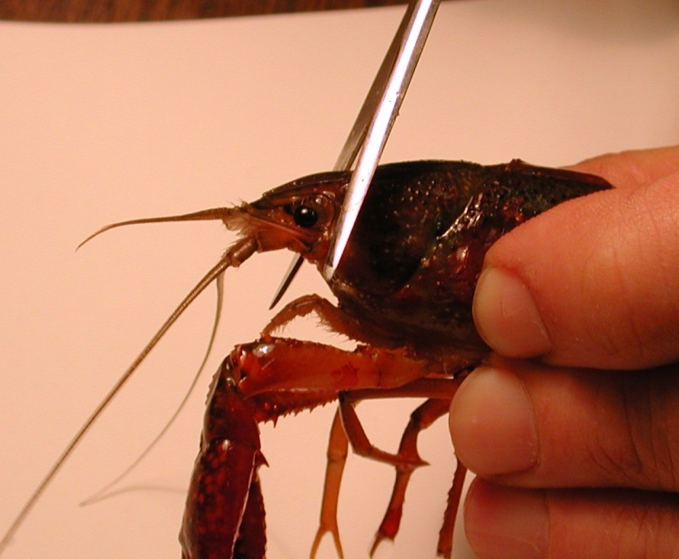

*Figure 1: Image shows placement of the cut to remove the head of the crayfish.*

3. The legs and claws of the crayfish can be removed at this point to avoid injury. Stylets on males and swimmerets on both males and females can also be removed (Figure 2). Next, separate the abdomen from the thorax. Make a cut along the articulating membrane, which joins the abdomen and thorax (Figure 3). Save the abdomen portion of the crayfish and dispose of the thorax.

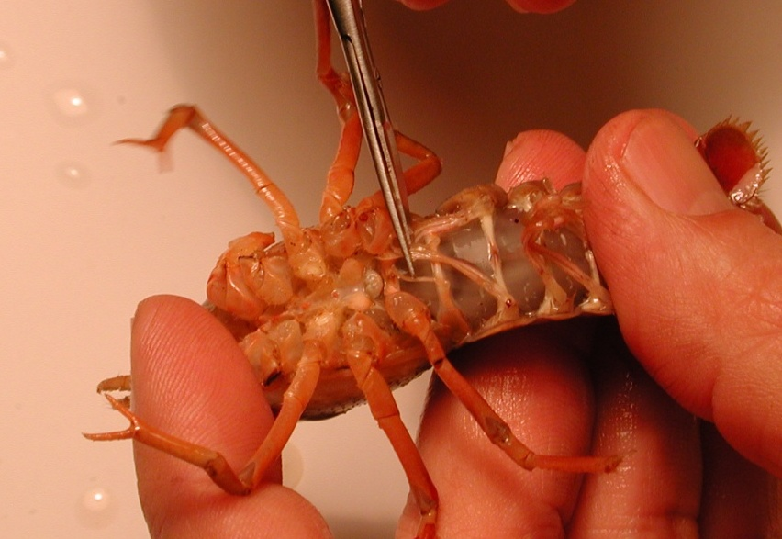

*Figure 2: The scissors are cutting the stylets. These can be removed from the crayfish.*

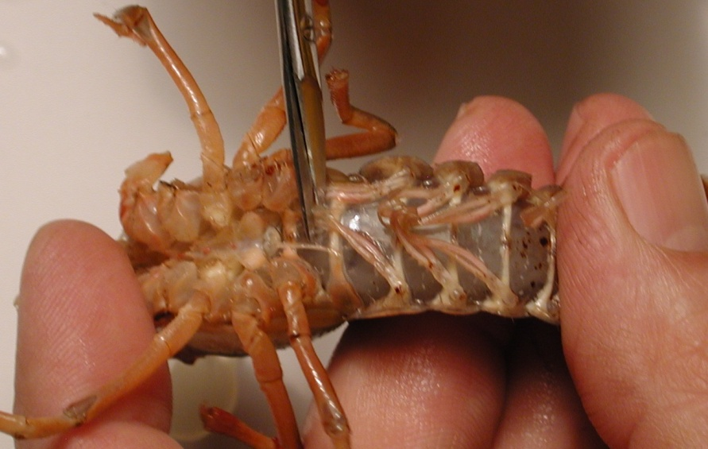

*Figure 3: Image shows the placement of the cut to remove the thorax from the abdomen.*

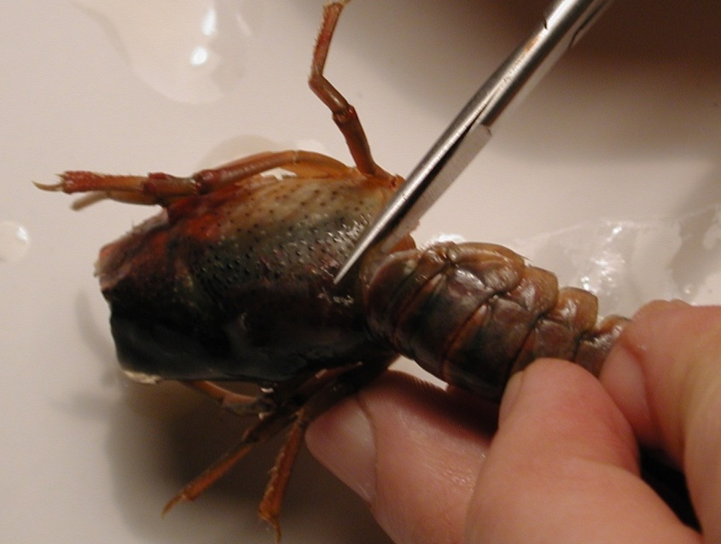

*Figure 4: Removal of the thorax from the abdomen. The cut should be made in circular fashion along the line in the joining of the segments.*

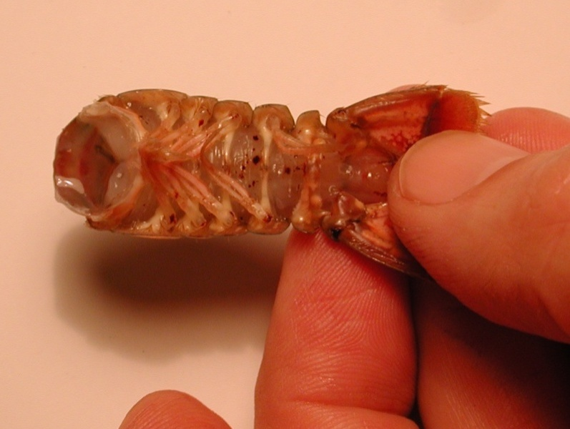

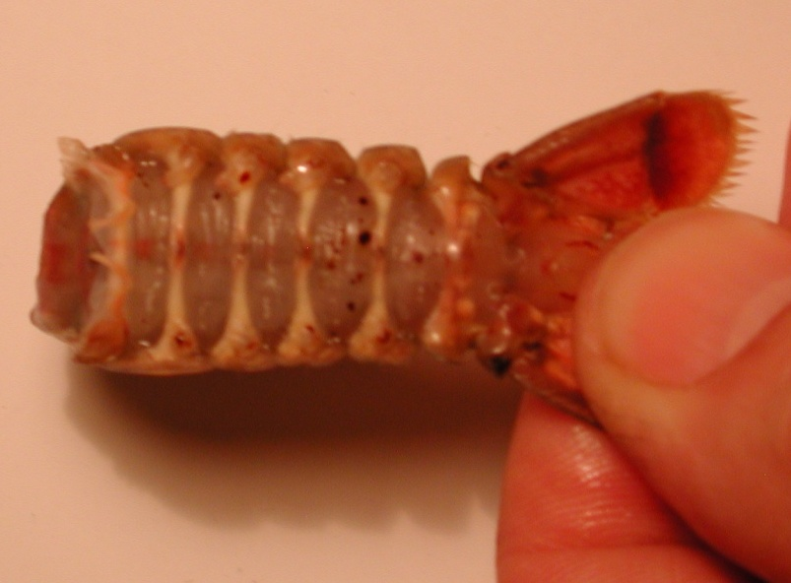

*Figure 5: The top image shows the abdomen with swimmeret appendages. Bottom image shows the abdomen without the swimmeret appendages.*

4. With the abdomen, a cut should be made in the shell along the lower, lateral border of each side of the abdomen. Care should be taken not to cut too deeply into the crayfish. To help in the process of cutting the shell, the cut should be made with the scissors pointing slighting down towards the ventral side and at an angle. Follow the natural shell pattern of lines of the crayfish that run the length of each segment (Figure

6).

line of cuts crayfish.tif

*Figure 6: Scissors are placed at an angle and follow the natural alignment of the shell. Do not cut too deep and destroy the preparation. The arrowheads point to the natural line along each segment that should be followed for the cuts.*

5. Remove the ventral portion of the shell. Take care not to destroy the abdominal muscles. Use forceps to remove the ventral portion. When the ventral portion of the shell is removed, a white mass of tissue can be seen on top of the deep flexor muscles. This tissue can be removed carefully with forceps.

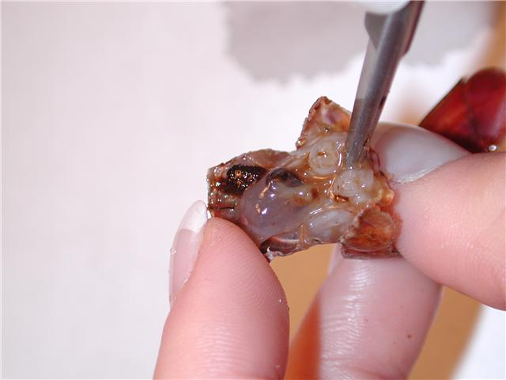

*Figure 7: Removing the ventral portion of the shell with forceps. Pull up and back on the ventral portion to remove. Do not destroy muscles under the ventral shell.*

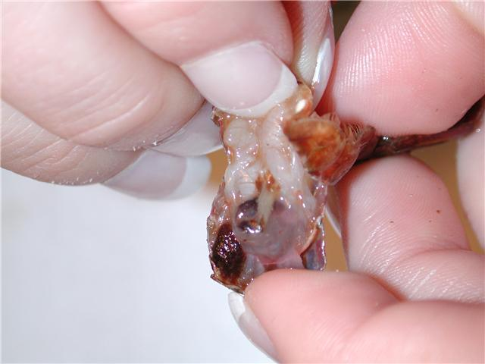

*Figure 8: Pulling back on the ventral portion of the shell, which is to be discarded.*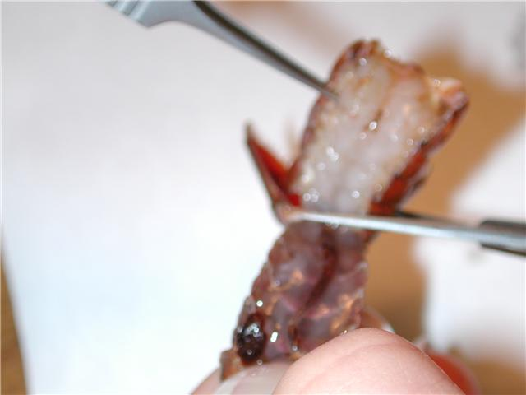

*Figure 9: Cut the ventral portion of the preparation with scissors and discard.*

6. The GI tract, a small tube running along the midline of the deep flexor muscles, can be removed from the crayfish. Pinch the top of the tract with the forceps and pull away from the abdomen. Cut the bottom of the tract – at the end of the tail. Rinse the dissection with saline to ensure the fecal waste does not interfere with the preparation.

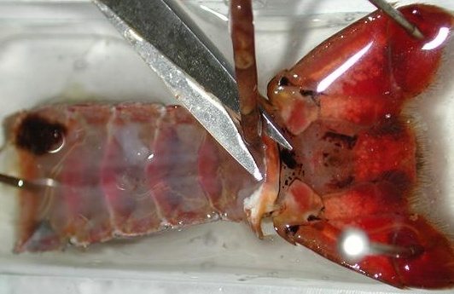

*Figure 10: Image shows the removal of the GI tract from the preparation.*

7. Use dissection pins to secure the preparation to the Petri dish. The top and bottom corners of the preparation should be pinned down to the dish. Saline solution should be poured into the Petri dish and cover the preparation completely until intracellular recordings are performed.

This dissection dish should have a Sylgard (Dow Corning) coating on the bottom (1cm thick) so that insect pins can be stuck into it.

Dissected preparations are bathed in standard crayfish saline, modified from Van Harreveld’s solution (1936), which is made with 205 NaCl; 5.3KCl; 13.5 CaCl2; 2H2O; 2.45 MgCl2; 6H2O; 5 HEPES and adjusted to pH 7.4 (in mM).

**2.2.2)** Intracellular Recording

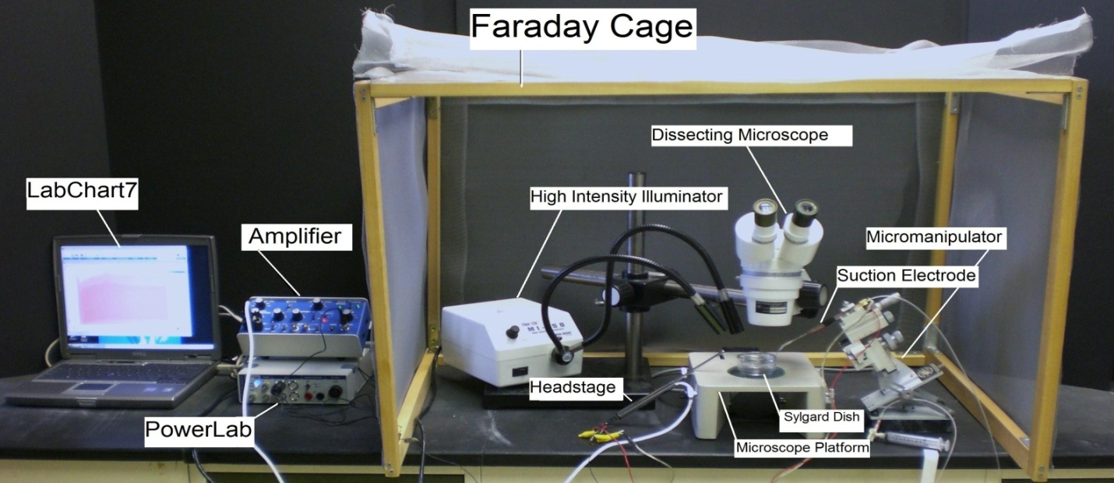

*Figure 11: General setup of the recording equipment from. Specific set-ups may vary with different electrodes.*

8. The specimen dish with preparation should be placed under the microscope and secured with poster tack beneath the dish to prevent movement.

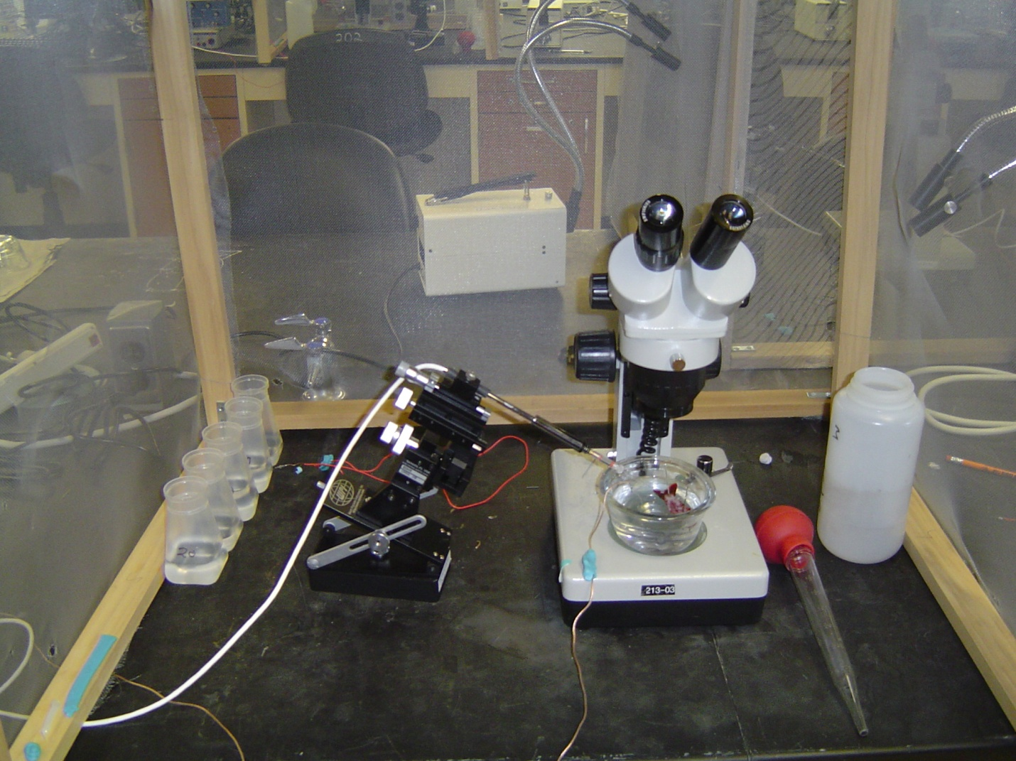

*Figure 12: Placement of the preparation under the microscope. Use poster tack (shown in blue) to secure the specimen dish and ground wire to the stage of the dissecting scope.*

9. Two wires each with a short length of silver wire attached to one end should be obtained. The silver wire should be dipped into a small amount of bleach for about 20 minutes to obtain an Ag-Cl coating. Wash the wire with distilled water before using. A glass intracellular pipette should be obtained and carefully backfilled with a long needle attached to a syringe filled with a 3M KCl solution. The pipette should be turned down (with the opening facing the floor) and filled with solution. This will ensure that any excess KCl will drip out the back of the electrode. Be sure no KCl runs along the glass pipette that will enter the saline bath. Turn the pipette upright when finished filling with potassium chloride solution. The silver wire can then be placed into the pipette. The other end is connected to the +(positive) pole on the amplifier head stage. The pipette is then secured on the electrode probe. Care should be made not to break the electrode tip. A third wire attached to the Faraday cage should be placed into the green pole of the head stage. Lastly the Ag wire of the remaining lead should be placed in the bath and the other end attached to the – (negative) pole shown below. A wire should also be placed from the Faraday cage to the ground portion of the AD converter Powerlab. The head stage is connected to the “input-probe” on acquisition/amplifier (Powerlab).

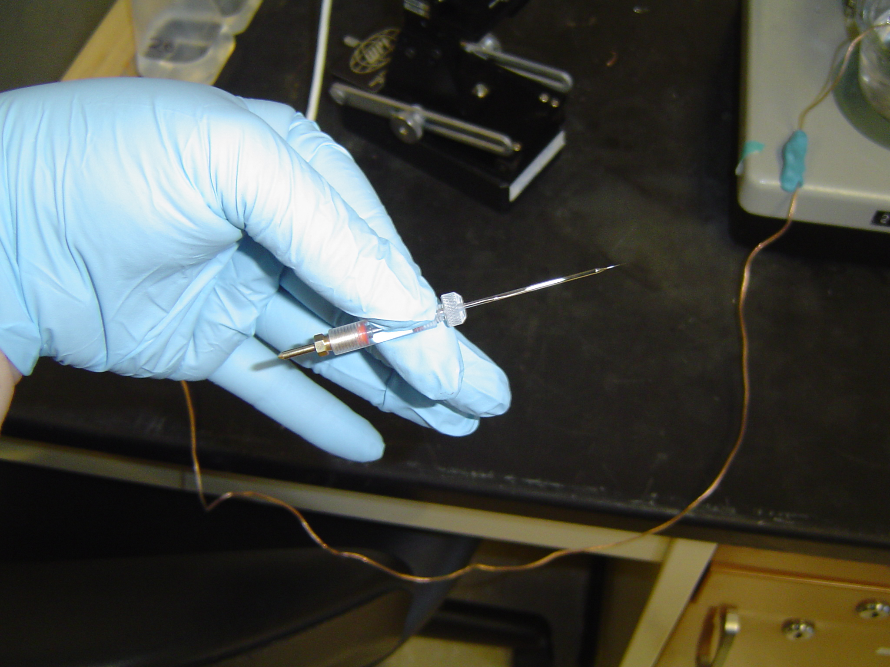

*Figure 13: Microelectrode assembly with glass capillary in place.*

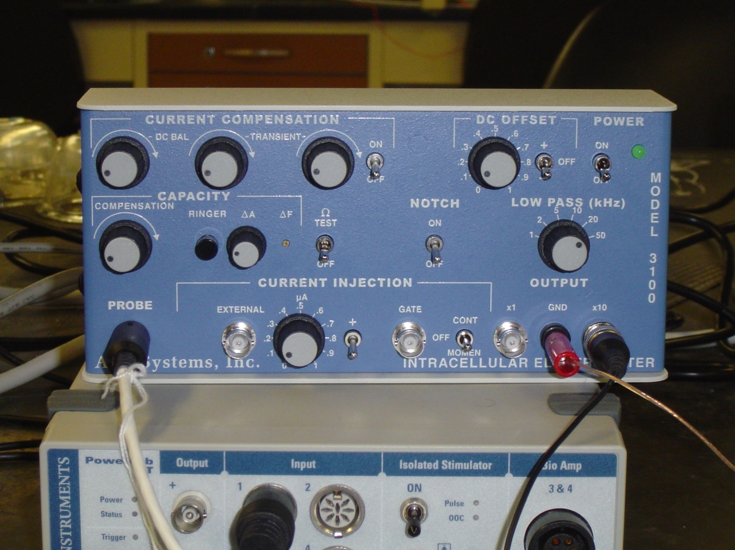

Figure 14: Front face of the intracellular amplifier used during the intracellular membrane potential recordings. The “Ω TEST” switch used to test electrode resistance is center left. The DC offset knob is in the upper right corner, and should be turned counter clockwise to start. The Low Pass (gain) is set to 50 kHz, which amplifies signals by a factor of fifty. The ground wire is placed in the “GND” pin jack opening. The amplifier in this set-up amplifies the signal by 10X, so all measurements should be adjusted to account for this.

Software Set-up

10. Be sure your amplifier and PowerLab units are on before opening the software!

11. Open the LabChart software. Adjust the chart to display only one channel by clicking “Setup”, then “Channel settings.” Under “Channel settings,” change number of channels to one. Click “OK.”

12. At the top of the chart, left hand corner, cycles per second should be 2K. Set volts (y-axis) to around 1V.

13. Click on “Channel 1” on the right hand portion of the screen. Click “Input Amplifier” and that the following settings are selected:

|  |  |
| --- | --- |
| Single ended | OFF |
| Differential | Checked |
| AC-Coupled | OFF |
| Anti-alias | Checked |
| Invert | OFF |

Amplifier Set-up

14. The amplifier output cable should be plugged into channel one. The following settings should be used with the intracellular amplifier (see Figure 14 for reference):

|  |  |
| --- | --- |
| Current Comp.(3 knobs) | counter clockwise |
| Capacity Comp. | counter clockwise, OFF |
| Capacity Amp (A) | counter clockwise |
| DC Offset knob | Varies (see part 16 below) |
| Low Pass knob | 50 kHz |
| Notch | OFF |
| Current Injection | 0 A |
| ΩTEST | OFF |

15. CHECK THE RESISTANCE OF YOUR ELECTRODE.

To measure the resistance, place the tip of the glass electrode into the saline bath. Make sure a ground wire is also in the saline bath. While recording, the Ω TEST switch should be turned on and then off several times. The amplitude (mV) of the resulting changes should be measured. To measure the amplitude changes in the trace, place the marker on the steady base line and then move the cursor to the peak amplitude.

As a measure of the electrode resistance, the voltage should be divided by the current, which is 2.0 nA (ie., R=V/I, or Ohm’s law). The resulting value is the resistance of your glass electrode.

|  |  |  |
| --- | --- | --- |
| Trial (Replicate) | Voltage change (mV) | Resistance (MΩ) |
|  |  |  |
|  |  |  |
|  |  |  |

Average Resistance (MΩ) = ____________________

The resistance should be within 20 to 60 MegaOhms. Low (<20) and high resistance (>100) are not acceptable. Troubleshoot as necessary to bring your electrode’s resistance within the acceptable range.

16. NEXT, SET YOUR EXTRACELLULAR VOLTAGE TO ZERO. Set the gain in your software to 1 or 5 V/div. Begin recording by pressing “start” at the bottom of the screen. Use the DC offset knob on the amplifier to adjust the recording trace to zero before inserting the electrode into the tissue. This sets your extracellular voltage to zero.

17. Use the micromanipulator and dissecting scope to insert the microelectrode tip into the longitudinal muscles (DEM or DEL1 or DEL2) of the preparation (see Figure 16). The electrode should barely be inserted into the muscle. You will likely see the muscle dimple as the electrode penetrates. Do not penetrate completely ***through*** the muscle. The high intensity illuminator should be adjusted to clearly see the muscle as the electrode is being inserted. When poking muscle fibers in this preparation one can commonly run into spaces and clefts within the muscle. This is the reason why the membrane potential can appear, then disappear, and then reappear.

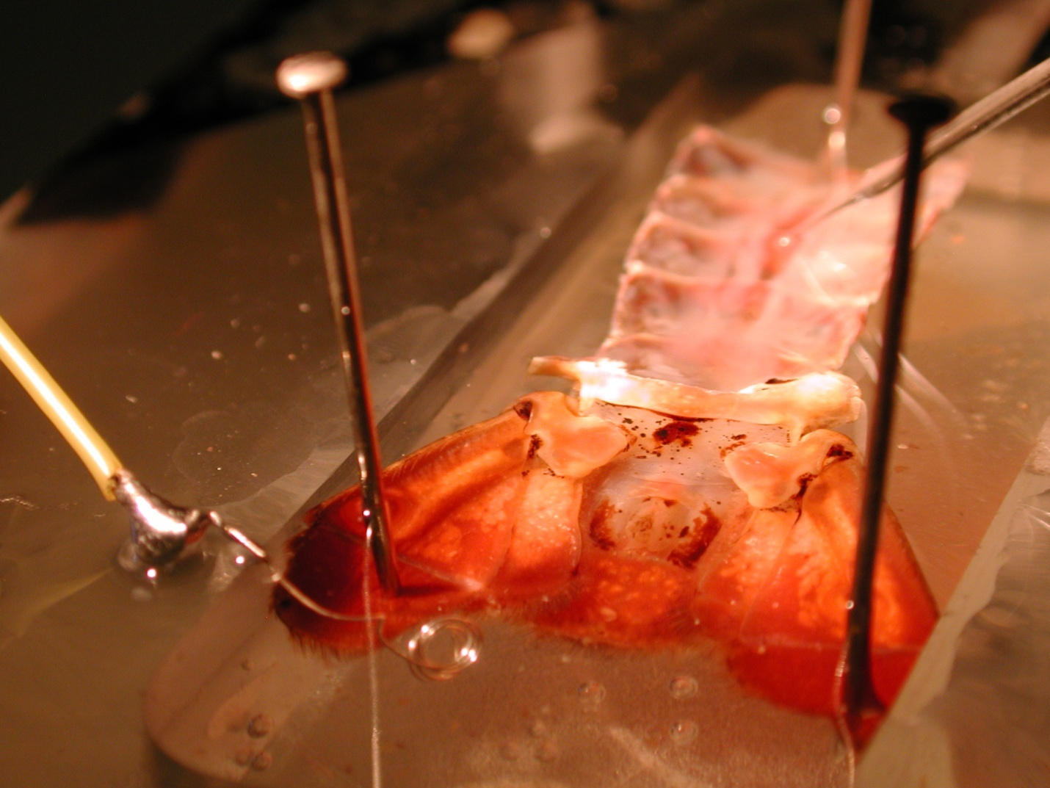

Electrode tip

*Figure 15: Insertion of electrode into the muscle.*

13. To measure the membrane potential, use the coarse knob on the amplifier to move the line on the LabChart to zero before inserting the electrode. Poke a muscle fiber. Next, measure the amplitude of the resulting values. Place a marker on the steady base line and record the value.

The difference in the marker and the active cursor is displayed on the right side of the screen. The value is gives the voltage. The recorded voltage might need to be adjusted to account for any amplification used on the amplifier (i.e. 10X amplification). The voltage should be converted to millivolts if the values are reported on the software as volts (1 V = 1,000mV).

14. Carefully use the dissecting scope and micromanipulator to withdraw the electrode from the muscle. Reposition the electrode, and insert the tip into another muscle fiber. Record the resting membrane potential. One should collect several recordings and be comfortable with measures as well as directing the intercellular electrode into the muscle fiber of interest before moving onto the next step.

**15. Effects of [Na+]o on RP.**

As you read about [K+]o having an impact of RP did you also wonder about the impact of Na+ ? Think about a cell at rest and the concentration/electrical gradients of the ions. If a cell is slightly permeable to Na+ at rest would the cell resting membrane potential (RP) be further from EK and closer to ENa? What if now the [Na+]o was reduced? Would there be any impact on the driving gradient of Na+ and if the cell was slightly permeable to Na+ how would this impact the RP? Let’s do an experiment and find out the answer.

Dissected preparations are to be maintained in crayfish saline, a modified Van Harreveld’s solution (in mM: 205 NaCl; 5.3 KCl; 13.5 CaCl22H2O; 2.45 MgCl26H2O; USE TRIZMA BASE and bring pH down to pH7.4 with HCl. If one uses HEPES here then the pH is to low and needs to be adjusted to 7.4. A common mistake is that one would use NaOH to adjust pH thus messing up the Na+ concentration in the saline. One could also use CsOH to adjust pH instead of NaOH as Cs+ is less permeable to Na leak channels). Start off with obtaining an intracellular recording with using the above saline solution. Record the RP and then move to another muscle fiber and record another RP. Try this for a 3rd time. One can gently remove the saline, or if you feel you can not do this gently enough, remove the electrode from the fiber and exchange the saline. The saline to exchange to is one with a lower NaCl. When NaCl is reduced, the osmolarity needs to be maintained by replacing with the same molarity of with choline chloride. The two different salines with the amounts of NaCl and choline chloride to be used are for each are as follows:

**Composition of Saline with Reduced Na+ and Compensated with Choline Chloride**

|  |  |  |  |
| --- | --- | --- | --- |
|  | **100% Na+**  **(Normal Saline)** | **66.66% Na+** | **33.33% Na+** |
| **NaCl** | 205 mM | 136.65 mM | 68.32 mM |
| **Choline Chloride** | NA | 68.3 mM | 136.53 mM |

An agar bridge (1.5% agar in normal crayfish saline) is to be used to keep the potentials from fluctuating when the saline is exchanged.

Plot or graph the results of your findings:

|  |  |  |
| --- | --- | --- |
| [Na+]out  (mM) | Replicate | Membrane potential (mV) |
| 205 | 1 |  |
| 205 | 2 |  |
| 205 | 3 |  |
| 136.65 | 1 |  |
| 136.65 | 2 |  |
| 136.65 | 3 |  |
| 68.32 | 1 |  |
| 68.32 | 2 |  |
| 68.32 | 3 |  |

One might wish to utilize this equation to explain the measures that were obtained in this part of the exercise.

E= (RT/nF) ln (PNa[Na+]o + PK [K+]o ) / ( PNa[Na+]i + PK [K+]i)

16. The electrode probably will not stay in one muscle fiber during the changing of all the different altered [K+]out solutions. It is best to withdraw the electrode, change the solution (see below), then penetrate a new muscle fiber again to avoid damaging the muscle or electrode tip. Collect data from at least three recordings per solution. Each recording should be collected from a separate muscle fiber. Use an average of the replicates to avoid any spurious readings.

17. To change the bathing solution, use a large syringe (turkey baster) to remove and discard the saline solution from the Petri dish. If you just completed the low [Na+]out experiments exchange the saline back to the normal crayfish saline with [Na+]out equal to 205 mM. The Petri dish should be filled with the next higher concentration of potassium chloride saline solution, covering the preparation completely. The same process should be repeated with each potassium solution and the changes in voltage/potential should be noted and recorded. The series of [K+]out crayfish saline solutions we use are: 5.4 (control), 20, 60, and 80 mM.

|  |  |  |
| --- | --- | --- |
| [K+]out  (mM) | Replicate | Membrane potential (mV) |
| 5.4 | 1 |  |
| 5.4 | 2 |  |
| 5.4 | 3 |  |
| 20 | 1 |  |
| 20 | 2 |  |
| 20 | 3 |  |
| 60 | 1 |  |
| 60 | 2 |  |
| 60 | 3 |  |
| 80 | 1 |  |
| 80 | 2 |  |
| 80 | 3 |  |

**2.2.3)** Anatomy

Now that the physiology is completed, we can examine the associated anatomy of the muscle fibers and innervation pattern. Transfer the preparation to the staining dish and add the **COLD** methylene blue (1 gram of methylene blue mixed with 100 ml of crayfish saline). Let the saline bathe the preparation for 5 minutes and then remove and add fresh crayfish saline without the stain. The anatomy of these muscles has been described in detail over the years (Huxley, 1880; Pilgrim and Wiersma,1963). Only recently have some of the muscles been described anatomically, physiologically and biochemically (Cooper *et al.,* 1998; Griffis *et al.,* 2000; Sohn *et al.,* 2000).

The general anatomical layout of the muscles is depicted in Figure 17 (right side of figure for this purpose). Look for the main nerve that innervates primarily the muscles within a segment. Sketch the innervation pattern to the SEM, DEL2, DEL1 and DEM muscles in a segment. The abdomen needs to be stretched out fully by pinning the preparation in the dish firmly. Next remove the saline and add the fixative solution. The fix solution is a Bouin’s solution (Prepared with saturated picric acid, formaldehyde and acetic acid; Sigma-Aldrich Co.).

**CAUTION. Do not get this solution on your skin or in your eyes. Avoid the vapors of the solution by working under the fume hood. If your eyes start to burn wash your eyes out immediately at the eye wash station.**

Let the Bouin’s solution remain on the preparation for about 10 minutes and then use a pipette and exchange the solution for saline. Cut a thin piece of DEL1 or DEL2 muscle out and place on a glass slide. Label the slide. Repeat the procedure for the SEM muscle. View the sarcomere banding pattern in both tissue preparations. You can use the compound microscope and adjust the objectives accordingly to see the banding patterns. If possible take a digital photo through the eyepiece of the microscope (note: some cell phone cameras work well for this procedure).

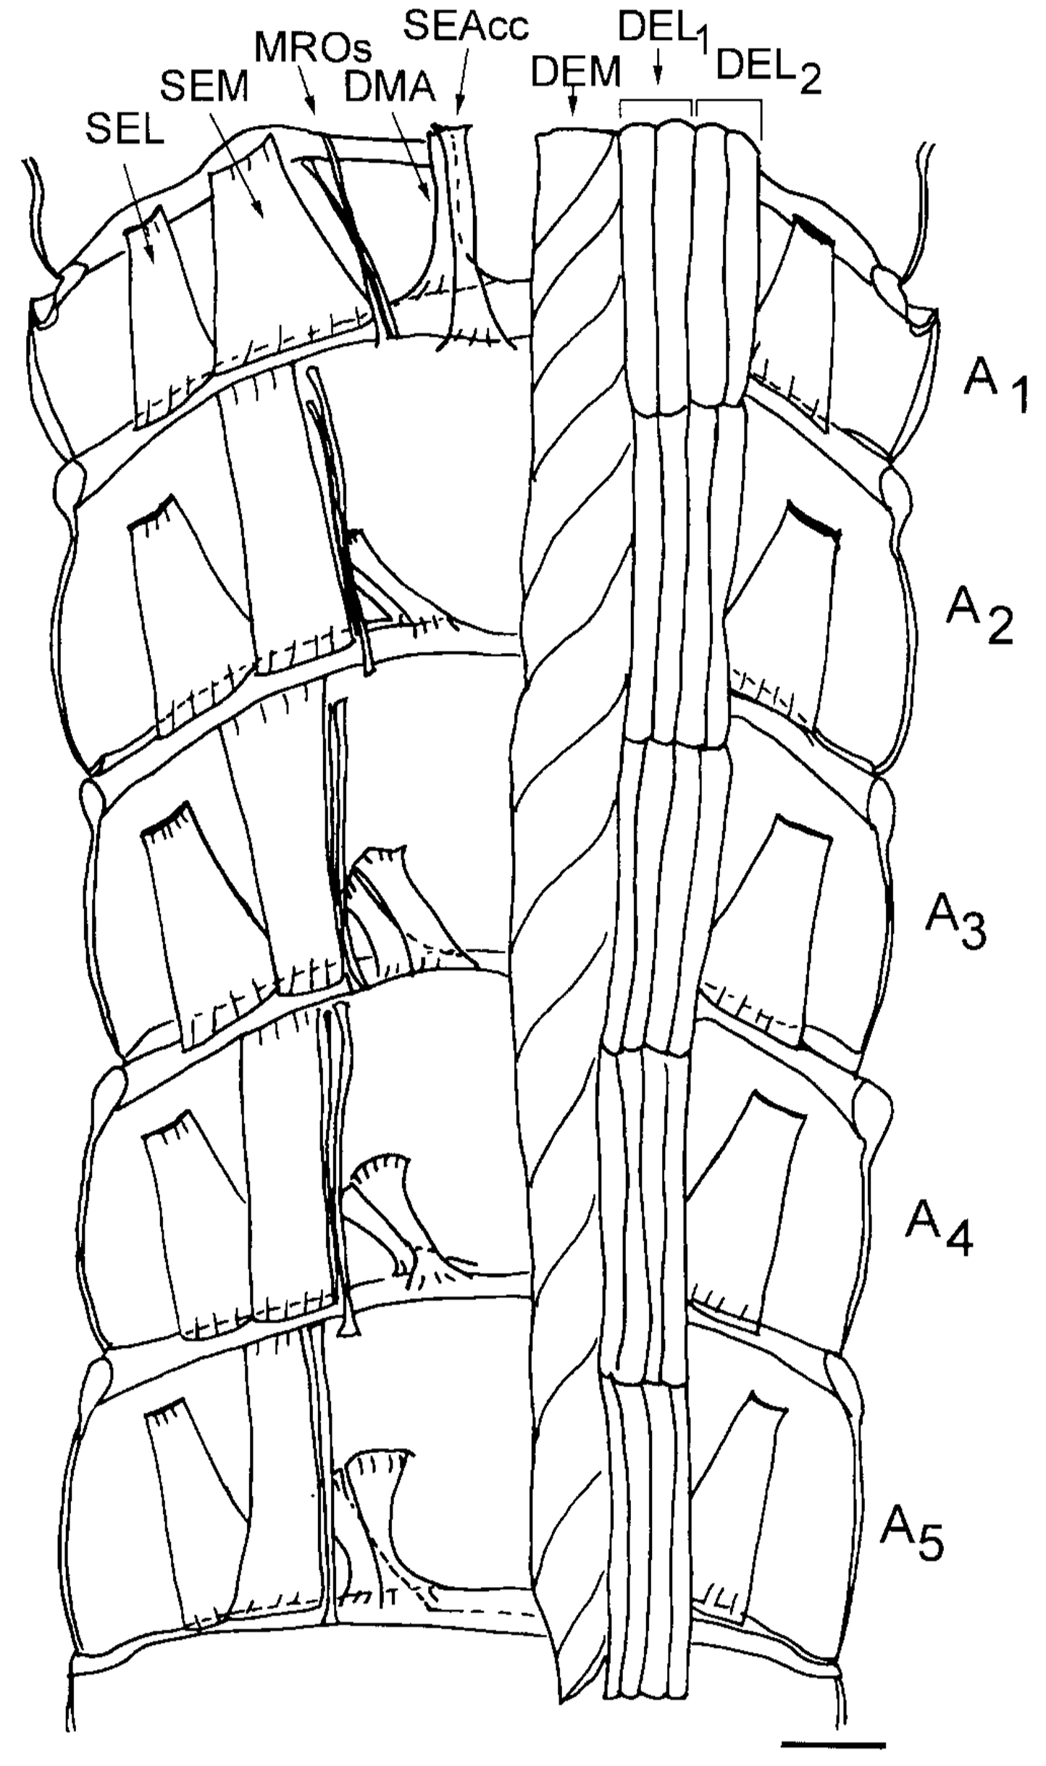

*Figure 17. Schematic drawing from a ventral view of the dorsal part of the crayfish abdomen showing the extensor musculature of each segment. The dorsal membrane abdomen muscle (DMA) and the superficial extensor accessory muscle head (SEAcc) occur in segments 1 through 5 of the abdomen with a different orientation for each segment. With the exception of segment 1, these muscles have their attachment sites at their anterior end to the calcified tergite and at the posterior end in the articular membrane. In segment 1, the homologous muscles have their anterior attachment sites to the articular membrane located between the thorax and abdomen. The illustration was based upon photographic montages of methylene blue stained preparations. On the left side of the figure all the deep extensor muscles have been removed to show the dorsal superficial extensor muscles. Scale = 2.35 mm. (Taken from Sohn et al. 2000).*

**3) RESULTS**

The following questions and data processing illustrate the main principles and objectives for this laboratory procedure.

**3.1)** Plot the measures obtained for the resting membrane potentials at each [Na+]out used.

**3.2)** Plot the measures obtained for the resting membrane potentials at each [K+]out used using Excel. See if the observed and hypothetical lines are matched in their slope. To plot the values use a semi-log plot with the x-axis of varied [K+]out as a log and the y-axis of the membrane potentials (as shown below; Figure 18). (Download free graph paper if needed <http://incompetech.com/graphpaper/logarithmic/>)

graph.tif*Figure 18: Log scale graph paper*

Use the average resting membrane potential obtained at 5.4 mM [K+]out for initiating the hypothetical and observed lines for comparison.

If the lines do not match discuss why this might be.

**3.2)** In altering the external level of Na+ ions, did you expect the same type of alterations as observed for changing the external level K+ concentration to lower levels?

**3.3)** How well did methylene blue stain the muscles as compared to the nerves? Why might there be differences? Is methylene blue used today for identification of tissue or contrast in live human cells? What relationship is there with Sigmund Freud and stains used in crayfish?

**3.4)** Note any differences in the sarcomere patterns between the DEL and SEM muscles. If so, what might be the reason? Do all muscles have the same resting sarcomere distances? Draw the muscle-banding pattern you observed with the microscope and label as much of the figure as possible (in relation to known sarcomere muscle anatomy).

**4) DISCUSSION**

As early as 1902, Bernstein was dealing with the issues of a resting potential in the axon of a squid. It is intriguing to consider how these early ideas and observations of Berstein (1902) and Nernst (1888) later influenced research in membrane physiology. (See review by Malmivuo and Plonsey, 1995; also available on the www <http://www.bem.fi/book/> ). There are still, to this day, breakthroughs being made about ion channel function and properties of biological membranes that are very significant in understanding the cellular physiology which relates to the function of tissues, organs and systems.

The comparison of the experimental and theoretically derived effects of external [K+] on the resting membrane potential indicates the influence of ions on the membrane potential. Additional experiments using this same preparation remain to be performed to address fundamental physiological questions. Some were highlighted back in 1968 by Atwood and Parnas and have yet to be fully tackled. With the techniques obtained in this exercise, one can proceed to answer many questions remaining in other experimental preparations as well as in physiological applications related to medicine and health. We have demonstrated the usefulness of a model invertebrate preparation to address fundamental questions pertinent to all animals.

With the knowledge gained on the electrochemical gradients of ions in this above exercise, you can now advance to the excitability of membranes by examining synaptic transmission at neuromuscular preparations in the crayfish.

**5) REFERENCES**

Atwood HL. Membrane physiology of crustacean neurons. In Podesta RB, Ed. Membrane physiology of invertebrates; New York, Marcel Dekker, Inc. 1982; pp.341–407.

Atwood, H.L. and Parnas, I. (1968). Recording from the crayfish abdominal extensor muscle preparation with microelectrodes. In: Experiments in physiology and biochemistry (Kerkut GA, ed), pp 307-330. London: Academic.

Bernstein J (1902): Untersuchungen zur Termodynamik der bioelektrischen Ströme. *Pflüger Arch. ges. Physiol*. 9: 521-62.

Bernstein J (1912): *Elektrobiologie*, 215 pp. Viewag, Braunschweig.

Cooper RL, Warren WM, Ashby HE. 1998. Activity of phasic motor neurons partially transforms the neuronal and muscle phenotype to a tonic-like state. Muscle Nerve 21:921–931.

Desai-Shah, M. and Cooper, R.L. (2010) Actions of NCX, PMCA and SERCA on short-term facilitation and maintenance of transmission in nerve terminals The Open Physiology Journal 3:37-50.

Freud, S. (1881) Über den Bau der Nervenfasern und Nervenzellen beim Flußkrebs. In: Anzeiger Akad. Wiss. Wien (Math.-Naturwiss. Kl.), Bd. 18 (1881), Nr. 28, S. 275f. (see <http://artmuseum.binghamton.edu/freudbook/> )

Freud, S. (1882) Über den Bau der Nervenfasern und Nervenzellen beim Flußkrebs. In: Sitzungsber. Akad. Wiss. Wien (Math.-Naturwiss. Kl.), 3. Abt., Bd. 85 (1882), S. 9-46. {(On the Structure of the Nerve Fibers and Nerve Cells of the River Crayfish), Sitzungsberichte der Mathematisch-Naturwis­senschaftlichen Classe der Kaiserlichen Akademie der Wissenschaften, LXXXV. Band **1882}**(see <http://artmuseum.binghamton.edu/freudbook/> )

Griffis, B., Bonner, P. and Cooper, R.L. (2000) Sensitivity of transformed (phasic to tonic) motor neurons to the neuromodulator 5-HT. Comparative Biochemistry and Physiology A 127: 495-504.

Goldman DE (1943): Potential, impedance, and rectification in membranes. *J. Gen. Physiol.* 27: 37-60.

Hagiwara, S., Chichibu, S., and Naka, K.I. (1964). The effects of various ions on resting and spike potentials of barnacle muscle fibers. J Gen Physiol. 48:163-79. PMID: 14212147

Hille B (1992): *Ionic Channels of Excitable Membranes*, 2nd ed., Sinauer Assoc., Sunderland, Mass.

Hodgkin AL, Huxley AF (1952): A quantitative description of membrane current and its application to conduction and excitation in nerve. *J. Physiol. (Lond.)* 117: 500-44.

Hodgkin AL, Huxley AF, Katz B (1952): Measurement of current-voltage relations in the membrane of the giant axon of Loligo. *J. Physiol. (Lond.)* 116: 424-48.

Hodgkin AL, Katz B (1949): The effect of sodium ions on the electrical activity of the giant axon of the squid. *J. Physiol. (Lond.)* 108: 37-77.

Huxley TH. 1880. The crayfish. C. London: Kegan Paul and Co. (This is a later edition that was not revised from a large paper edition limited to 250 copies published Nov. 29, 1879. Now available from MIT Press at <http://www.mitpress.com>)

Nernst WH (1888): Zur Kinetik der Lösung befindlichen Körper: Theorie der Diffusion. *Z. Phys. Chem.* 3: 613-37.

Nernst WH (1889): Die elektromotorische Wirksamkeit der Ionen. *Z. Phys. Chem.* 4: 129-81.

Malmivuo, J. and  Plonsey, R. (1995) *Bioelectromagnetism- Principles and Applications of Bioelectric and Biomagnetic Fields*. New York: Oxford University Press

Pilgrim RLC, Wiersma CAG. 1963. Observations on the skeleton and somatic musculature of the abdomen and thorax of *Procambarus clarkii* (Girard), with notes on the thorax of *Panulirus interruptus* (Randall) and Astacus. J Morphol 113:453–587.

Skou, J C (1989). The influence of some cations on an adenosine triphosphatase from peripheral nerves. [*Biochim. Biophys. Acta*](http://en.wikipedia.org/wiki/Biochim._Biophys._Acta) 1000: 439–46. [PMID](http://en.wikipedia.org/wiki/PubMed_Identifier) [2550074](http://www.ncbi.nlm.nih.gov/pubmed/2550074).

Skou, J C (1989). The identification of the sodium-pump as the membrane-bound Na+/K+-ATPase: a commentary on ‘The Influence of Some Cations on an Adenosine Triphosphatase from Peripheral Nerves’. [*Biochim. Biophys. Acta*](http://en.wikipedia.org/wiki/Biochim._Biophys._Acta) 1000: 435–8. [PMID](http://en.wikipedia.org/wiki/PubMed_Identifier) [2550073](http://www.ncbi.nlm.nih.gov/pubmed/2550073).

Skou, J. C. (1965) Enzymatic basis for active transport of Na+ and K+ across cell membrane. *Physiol. Rev.* 45:596-617.

[Skou JC](http://www.ncbi.nlm.nih.gov/pubmed?term=%22Skou%20JC%22%5BAuthor%5D). (1998) Nobel Lecture. The identification of the sodium pump. [Biosci Rep.](javascript:AL_get(this,%20'jour',%20'Biosci%20Rep.');) 18(4):155-69.)

Sohn, J., Mykles, D.L., and Cooper, R.L. (2000). The anatomical, physiological and biochemical characterization of muscles associated with the articulating membrane in the dorsal surface of the crayfish abdomen. Journal of Experimental Zoology 287:353-377.