PROPERTIES OF ANNELID GIANT AXONS
By

H.B. Hartman¹, Ellen Burns² & R.L. Cooper²
¹Oregon Institute of Marine Biology, University of Oregon, Charleston, OR 97420, USA
and
²Department of Biology, University of Kentucky, Lexington, KY 40506, USA

1. PURPOSE

The purpose of these experiments is to learn how to stimulate and record from a nerve bundle as well as measure conduction velocity. In addition, one is to learn by experimentation how to measure single action potentials and compound action potentials and understand the difference. Through experimentation one will examine refractory periods and determine absolute and relative refractory periods.

2. PREPARATION

Common earthworm Lumbricus terrestris

3. INTRODUCTION

Many invertebrate animals have giant axons with rapid conduction velocities mediating escape responses. Some of these axons such as those in the squid have been of great importance in the study of the fundamental mechanisms of excitation and conduction. Such axons in the squid may be greater than 1 mm in diameter. Arthropods including cockroaches as well as many segmented worms also have giant axons. Upon receiving input from sensory neurons detecting a potential predator, the giant interneurons quickly conduct action potentials to motor neurons that synapse upon muscles, evoking coordinated, rapid, withdrawal or swimming responses.

The common earthworm Lumbricus terrestris has a strong escape response and is an excellent animal for the study of giant axon properties. It has 150 well-marked segments with #32 - 37 forming the structure that secretes a cocoon around eggs. As may be seen in a typical cross section of a segment, the anatomy is elegantly simple. Immediately beneath the cuticle are circular muscles which when they contract elongate the worm. Next, there is a well-developed layer of longitudinal muscles that shorten it when they contract. Paired nephridia (kidneys) reside in the coelom. Dorsally, there is a large blood vessel, and beneath it, the large gastrointestinal tract or gut. A ventral blood vessel is positioned just above the large ventral nerve cord (VNC) (Figure 1).
Figure 1: Earth worm with a cross section and the ventral nerve cord enlarged to highlight medial and lateral giant axons.

A dorsal view of a portion of the nerve cord with nerve roots (rami) projecting to muscles and from the cuticle (Figure 2).

Figure 2: Ventral nerve cord (VNC) with nerve roots (arrows show rami) projecting to muscles. The ventral blood vessel runs along the VNC and sends branches along the rami.

A cross section of the nerve cord reveals three giant axons near the dorsal surface. The medial giant axon (MGA) measures 50 - 90 µm and two electrically-coupled lateral giant axons (LGA) range from 40 to 60 µm. The giant axons are ensheathed by multilamellar myelin-like membranes. The sheath is formed by multiple spirals of tightly compacted glial wrappings containing little cytoplasm. Tactile stimulation of receptors of the head region provides input to the MGA whose action potentials acting via motor neurons to muscles produce rapid, coordinated, reflexive, retraction of the head. Input to receptors of the posterior end furnishes input to the LGA’s whose action potentials evoke reflexive retraction of the tail.

Earthworms are cheap and easy to maintain. They are easily dissected to expose the nerve cord and to record the responses of the giant axons, providing the dissection is carried out quickly and without injury to the VNC.

4. OBJECTIVES

1. Using controlled tactile stimulation of a partially dissected worm, determine which areas of the body provide sensory input to the medial and the lateral giant axons.

2. Determine the time between touching the cuticle and the arrival of action potentials at the recording site.

3. Observe habituation by repeatedly touching the skin in the same area.

4. Electrically stimulate and record from the ventral nerve cord of the to observe action potentials of the MGA and LGA, measure their conduction velocities, and their respective relative and absolute refractory periods.

5. Measure temperature effects on the conduction velocity and refractory periods of the giant axons.

Note: Sections #3 and 4 never fail with the earthworm; sections #1 and 2 are problemmatic. Marine worms may work better.

5. METHODS
5.1 Materials
1. Faraday Cage
2. Two micromanipulators
3. Two suction Electrode
4. Dissecting Microscope
5. High Intensity Illuminator (light source)
6. Microscope Platform
7. AC/DC Differential Amplifier (A-M Systems Inc. Model 3000)
8. PowerLab 26T (AD Instruments)
9. Head stage
10. LabChart 7 (ADI Instruments, Colorado Springs, CO, USA)
11. Earthworm Saline (see Table 3 in Appendix) with beaker and pipettes for squirting saline over preparation.
12. Methylene blue: This is made of crayfish saline at a concentration of 0.25%
13. Sylgard coated dishes (Dow Corning, SYLGARD® 184 silicone elastomer kit; Dow Corning Corporation, Midland, MI. USA)
14. Dissecting tools
15. Insect pins
16. Glass rod/tools for dissecting and manipulating nerves
17. Pipettes and beakers
18. Make saline containing 10% ethanol for anesthesia

5.2 Setup

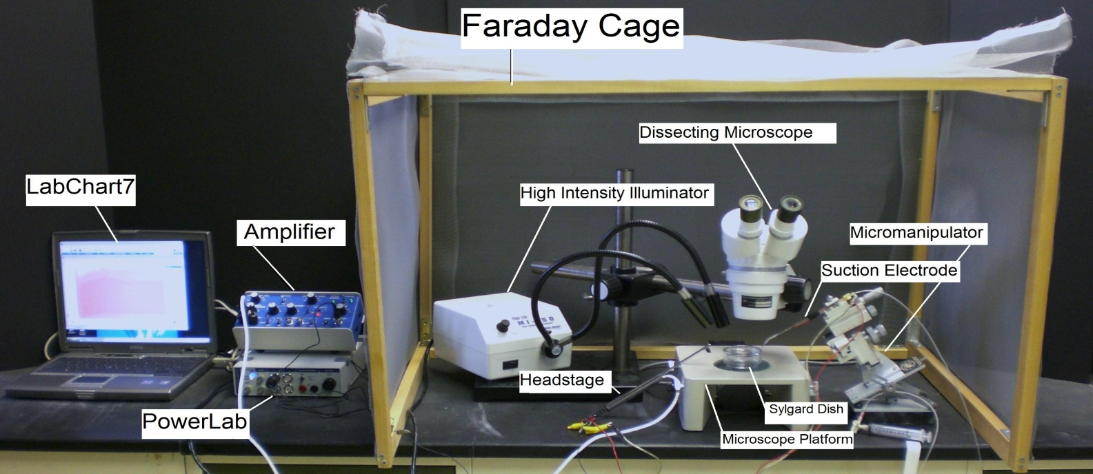
Figure 3: The equipment set up

1. Setup up the Faraday cage. The microscope, high intensity illuminator, micromanipulator, and the saline bath will all be set up inside the cage (The Faraday cage is used to block external electric fields that could interfere with the electrical recording, Figure 3).

2. Setup the microscope in a position where it is overlooking the microscope stage.

3. Position the high intensity illuminator in a convenient position.

4. Prepare a saline bath using Earthworm saline in a Sylgard dish and place it under the microscope.

5. Position the micromanipulator in a position where the suction electrode has easy access to the saline bath.

6. Suction up saline until it is in contact with the chloride coated silver wire inside the suction electrode. Arrange the other wire on the cut-side of suction electrode close to the tip of electrode, so both wires will be in contact with the saline bath. Place ground wire in dissected region by intestine.

7. Connect the AC/ DC Differential Amplifier (amplifier, Figure 4) to the Power Lab 26T. Do this by connecting the proper cord from Input 1 on the PowerLab 26T to the output on the amplifier.
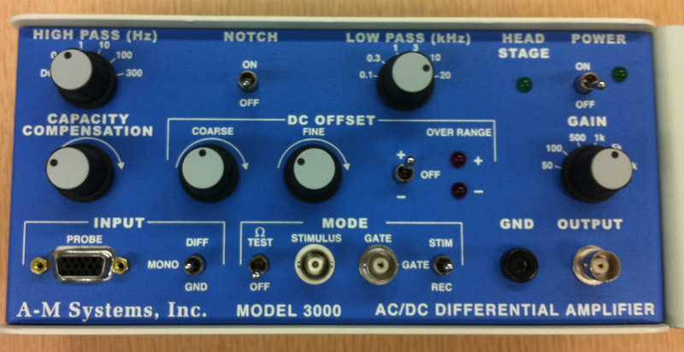

Figure 4: Extracellular amplifier

The settings for the amplifier are as follows:

CONTROL | SETTING
High Pass | 10 Hz
Notch Filter | OFF
Low Pass | 10kHz
Capacity Comp. | Counterclockwise
DC Offset Fine and Course knob | Counterclockwise
DC Offset (+OFF) | OFF
Gain knob | 50 (to start with)
Input (DIFF MONO GND) | DIF
MODE(STIM-GATE-REC) | GATE
ΩTEST | OFF

8. Connect the head stage to the ‘input- probe’ on the amplifier.

9. Connect the electrical wires from the suction electrode to the head stage. The wires should be connected with the red (positive) at the top left, green (ground) in the middle, black (negative) at the bottom. This is indicated in Figure 5. The ground wire can just be put in the saline bath.

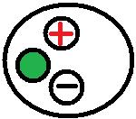
Figure 5: Head stage Configuration

10. Now connect the USB cord from the PowerLab 26T to the laptop. Ensure that both the amplifier and PowerLab26T are plugged in and turned on before opening LabChart7 on the computer.

11. Open LabChart7.

-The LabChart Welcome Center box will open. Close it.
- Click on Setup
- Click on channel settings. Change the number of channels to 1 (bottom left of box) push OK.
-At the top right of the chart set the cycles per second to about 4 KHz. Set the volts (y-axis) to about 500 or 200mv.
-Click on Channel 1 on the right of the chart. Click on Input Amplifier. Ensure that the settings: differential, ac coupled, and invert (inverts the signal if needed), anti-alias, and differential are checked.
- To begin recording press start.

5.1 Dissection

Place the earthworm in a dish containing a small quantity of 10% ethanol until it is narcotized. This may take 5-10 minutes; the worm will not struggle when touched if anesthetized. Wash the ethanol solution from the earthworm and transfer it to a Sygard-lined dissecting dish. Because the worm is so long, pin it around the periphery of the dish, inserting the pins at its lateral margins with the dorsal side (dark) facing you. Avoid pinning the ventral midline where the VNC resides. Using fine scissors, make a longitudinal mid-dorsal incision in the body wall about 4 - 5 cm long at a point just behind the clitellum. Expose the gut and go along the edge of the intestine cutting the ligaments attaching the cuticle to the intestine. Push the intestine to one side and pin it, with the insect pins) to expose the VNC being very careful not to injure the white nerve cord lying below (Figure 6). If the intestine becomes nicked and leaks, remove the contents with a pipette and replace the saline in the region. Make certain to change the saline periodically, and do not allow the nerve to dry out.
Figure 6: The flap of skin is pinned to one side (A). The ligaments on the sides of the intestine (as seen by the arrows in B) need to be cut so that the intestine can be pinned to the side exposing the ventral nerve cord (as seen between the arrows in C).

5.2 Recordings

5.2.1 Mechanical Stimulation: Initial recordings, habituation, measurements

The first experiment is an effort to evoke and observe action potentials in the VNC. Probing the cuticle stimulates touch receptors which synapse on the giant axons.

Insert the GROUND wire from the preamplifier into the animal near the incision. Using a micromanipulator, position the tip of the suction electrode in the pool of saline and against the nerve cord. Gently pull on the plunger to form a snug connection between the electrode and VNC (there must be saline in the tip of the electrode to complete the circuit) (Figure 7).

Before beginning to use a glass probe to touch the worm and evoke giant fiber responses, be aware that the giant fibers habituate and successive stimuli will not necessarily yield action potentials with each touch. Habituation is the decline in response to repeatedly applied stimuli. Therefore, you must be patient when applying stimuli, and not apply them too often to the same spot or habituation will occur rapidly. Apply stimuli at a fixed interval, say every 30 sec, and save your records in the Chart file.

First probe the anterior end of the worm to evoke action potentials from the MGF. In a systematic manner touch successive segments at the anterior end, noting the change in latency of arrival of the action potentials at the recording electrode; make a map in your notebook of the areas driven by the MGA. Collect a series of responses (10 - 20) to touch at spots at the head end, making “Comments” (top panel in Chart 7 menu) for each time you touch as appropriate. Explain your results (see Appendix 1). When the response has habituated, attempt to dishabituate by giving a strong poke to the posterior end of the worm, and repeating the stimuli to the head as before. Does the response return? Accurately measure the distances between the stimulus and recording sites.

Next, repeat the above probing sequence at the posterior end, this time evoking LGF action potentials. As you did at the anterior end, systematically touch successive segments, noting the change in latency of action potentials. Measure the distance between the stimulus points and recording sites for correlation with the responses. Map the areas driven by the LGFs.

In the experiments above, stimuli were applied to the cuticle and the touch receptors residing there. The receptors conducted action potentials along their axons before synapsing on the giant interneurons producing the large action potentials that you recorded. Conduction takes time; transmission takes time.

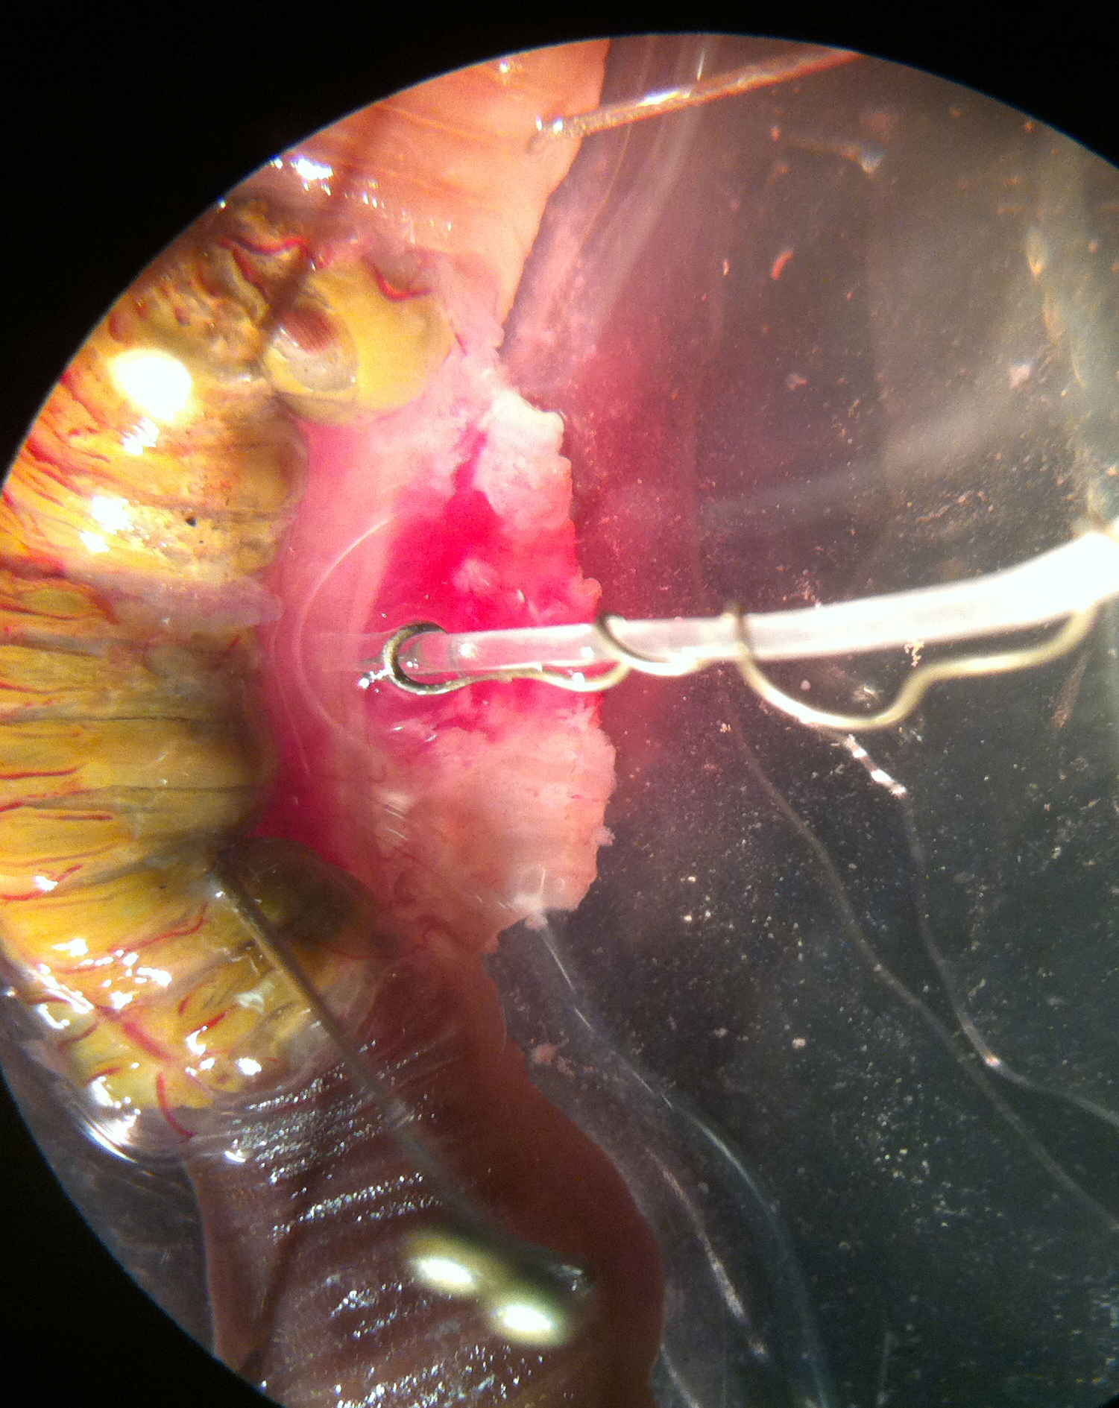

Figure 7: Suction electrode on the VNC in exposed region. Intestine pushed to left side.

To begin electrical recording press “start” (bottom right) on the Chart 7 menu screen.

Using a blunt glass rod or a stiff brush, probe the head then the tail end of the worm.

Stop the Chart 7 recording and examine if there is a difference in the amplitude of the action potentials (Figure 8). Use comment marker to add comments on to the recordings.

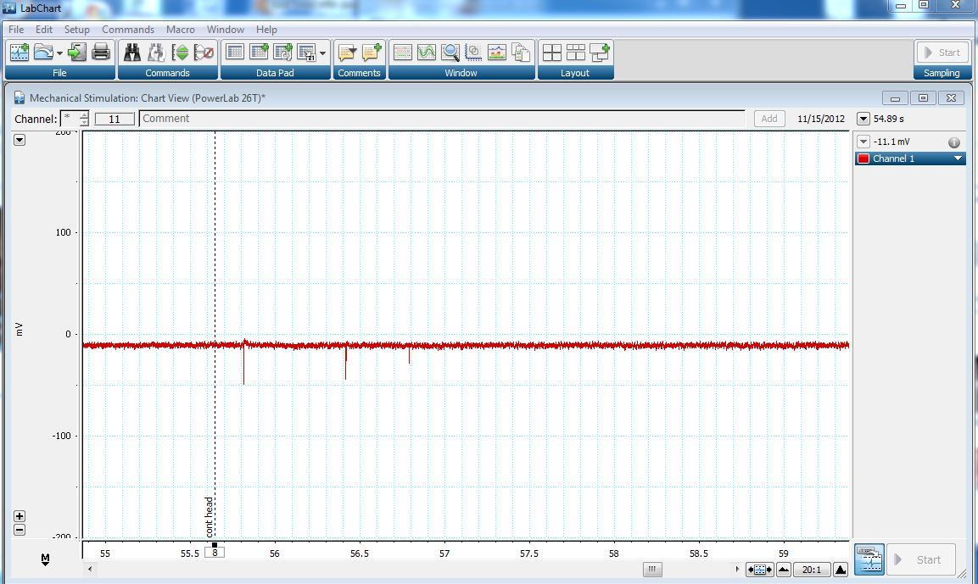

Figure 8: Screen capture of the window in Chart with three spikes seen when touching the head of the worm.

Which axon is discharging when you touch the head end, and which is responding to touch of the tail end?

In a systematic manner touch successive segments of the worm, note which axon is responding, and make a crude map on a piece of paper that you can scan in or take a photo of for your lab report of the areas driving MGA and LGA.

5.2.2. Electrical stimulation: Conduction velocities and refractory periods

The next experiment will allow you to determine the conduction velocity of action potentials moving along the MGA and LGA’s.

Stop the Chart 7 recording. Save your file with a name that can recall what the experiment was. Close out of the Chart software. Remove the glass probe and the recording electrodes from the immediate preparation area area.

Using fine scissors, make a longitudinal mid-dorsal incision in the body wall about 4 - 8 cm long at a point at the posterior end of the worm. Pin the gut as before without injuring the underlying nerve cord. Using fine scissors, free about 1 mm of nerve cord at the anterior end, and do the same at the anterior end where the VNC was first exposed (Figure 9). Next, measure the length of the VNC between the cut ends or remember to do this after your experimentation is completed. Draw the anterior end of the nerve cord about 1 mm into a suction electrode and the other end about 1 mm into the another suction electrode (Figure 10 and 11). Insert the tip of the ground electrode into the preparation by the intestine at one of the exposed regions. The leads of the electrode at the posterior end are to be used for recording.

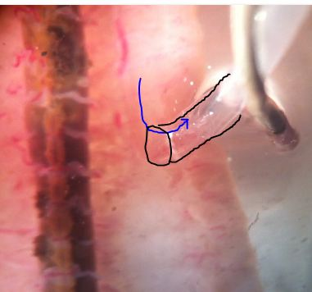
Figure 9: VNC pulled into the lumen of the electrode.

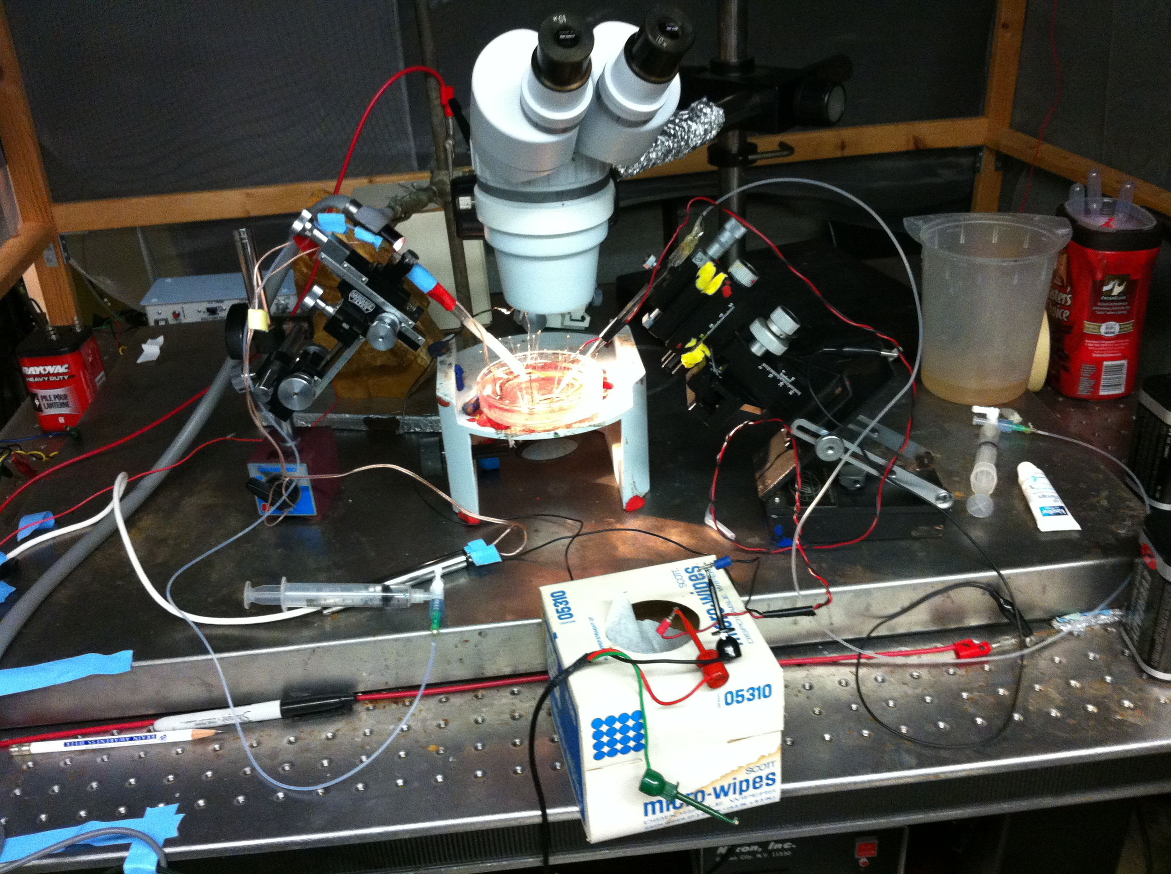
Figure 10: Two suction electrodes in place. One electrode is for stimulating and one for recording.

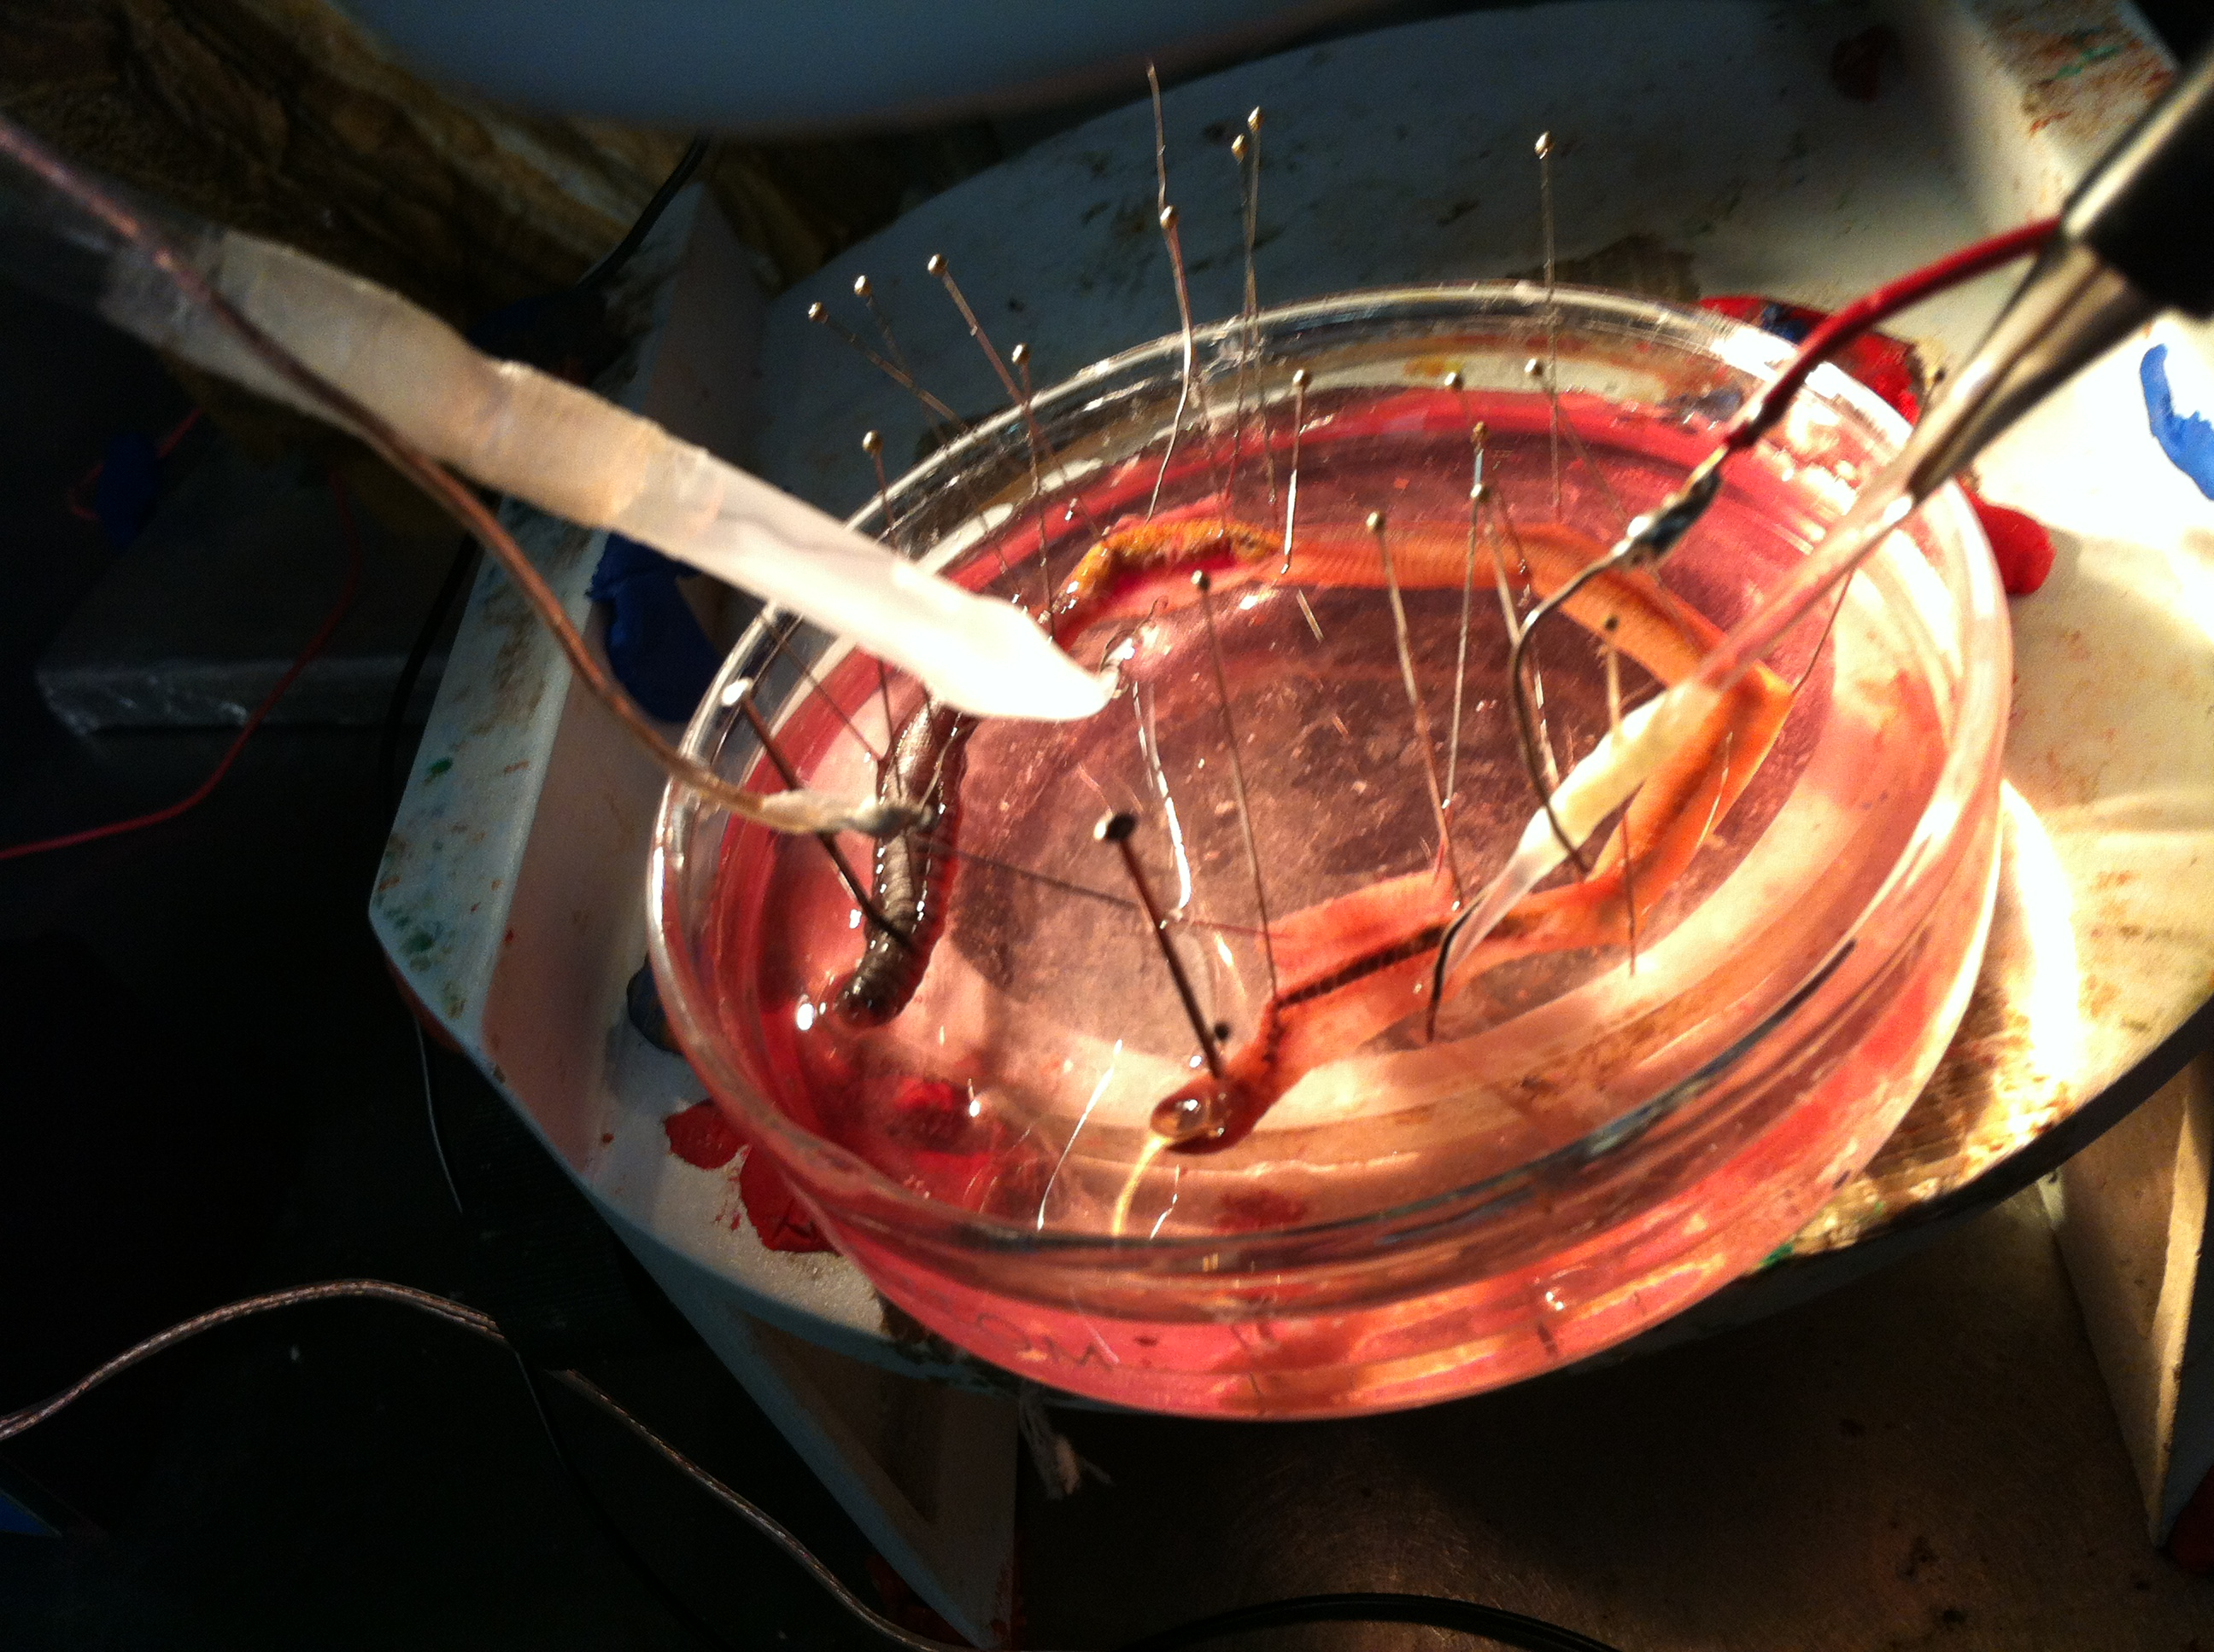
Figure 11: The two suction electrodes in place with cut end of the VNC.

Once the tip of the nerve cord is suctioned into the recording electrode, ensure that the electrode is attached to the probe and that the probe is sufficiently grounded. This can be accomplished by simply attaching the ground cable to the faraday cage. The positive and negative suction electrode wires should also be attached to the corresponding locations on the probe. The probe should be attached to the differential amplifier, which, in turn, is connected to the PowerLab.

Use the recording setting that was used above when recording from the axons on the side of the VNC. Use the same settings on the extracellular amplifier as well.

Connect the provided USB cable to the back of the PowerLab and to the computer outlet. Open the Scope software on the computer desktop. On the top right of the screen, select “Channel 1” for “Input A.” Next, click on the “Input Amplifier.” On the screen that appears for Input Amplifier options, select the following:

CONTROL | SETTING
RANGE | 500 mV
AC | CHECKED
LOW PASS | OFF
Differential | CHECKED
INVERT | CHECKED or not

On right hand side:
Turn off Input B
Time base: 20kHz
Sample: 1280
Time: 50msec

Next, again under “Set up,” click “Sampling.” In the box entitled “Sweep” on the screen that appears, select the following: (Note: be sure to that the “isolated stimulator box” is unchecked in this window)

CONTROL | SETTING
MODE | MULTIPLE
SAMPLE | 100 SWEEPS
SOURCE | USER
DELAY | 0 msec

Finally, under the “Settings” tab, select “Stimulator;” choose the following settings:
Click off the isolated stimulator box

CONTROL | SETTING
MODE | MULTIPLE
DELAY | 10 ms
DURATION | 0.5 ms
PULSE(S) | 1
INTERVAL | 0 ms
RANGE | 2.0V
AMPLITUDE | 0.5 V

Connect the Stimulator cable with the two mini-hook leads to the Output portal on the PowerLab.

Next, it might be necessary to change the power output, frequency, and pulse duration of the PowerLab. In order to do this, select “Setup,” and then “Stimulator Panel.” Short pulses and small voltages to start off with are required for the first portion of the experiment, so adjust the amplitude to 0.5 V; this will give a range of 1.0 V (the PowerLab will emit a voltage fluctuating between positive and negative 0.5 V). Set the frequency (0.5 Hz) and pulse duration (0.3s).

Select the “Start” button at the lower left of the screen. Given the above settings, a clearly defined action potential should appear on the Scope data collection box. Sketch the general shape of the action potential below:

Deliver a series of single stimuli of increasing voltage from the software until an action potential appears on the screen. Increase the intensity until both the MGA and LGA are responding. The MGA action potential appears first, then the summed action potentials of the LGA. Adjust the Time base for optimum resolution of the MGA and LGA’s. Note that the potentials do not grow in response to greater stimulus intensity. Use the single pulse to deliver single stimuli at subthreshold and increasing voltages. Save your records and make notes on “Comments” within the chart software and in your notebook.

To determine the relative and absolute refractory periods of the giants, by using double pulse protocol.
CONTROL | SETTING
MODE | MULTIPLE
DELAY | 10 ms
DURATION | 0.5 ms
PULSE(S) | 2
INTERVAL | 50 ms
RANGE | 2.0V
AMPLITUDE | 0.5 V

After that, run one series by overlaying the responses on the screen.
Alter the interval time to lower and higher values

INTERVAL | 5 to 100 ms

From these collected data pages you will be able to measure the absolute and relative refractory periods of the MGA and LGA. By knowing the distance between the electrodes and the time between the stimulus and responses, you can calculate the conduction velocity (m/s) of each axon. The recording will look something like those shown in Figure 12 with the stimulus artifacts and the responses. One needs to keep notes on which pages of the Scope software is the interval between stimuli so when the pages are superimposed one will be able to obtain each interval of choice.

Are these axons (they are interneurons) capable of conducting action potentials in both directions? Swap the recording and stimulating leads (not the electrodes) and repeat the experiment. What is your final answer? Explain your results (see Appendix 1).
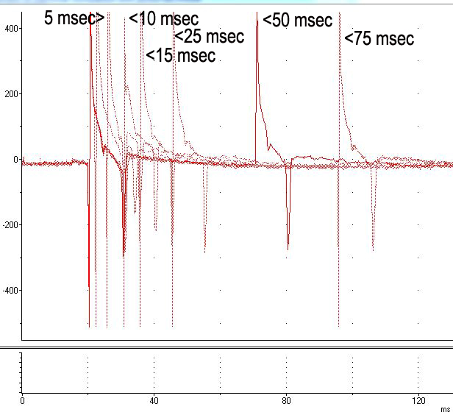

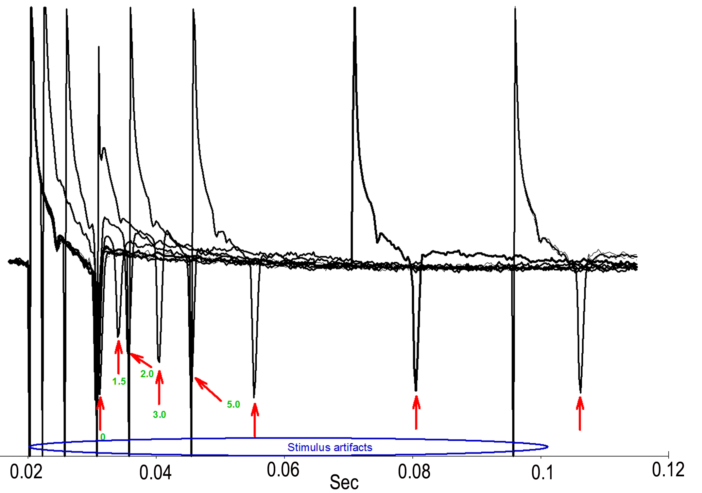

Figure 12: Responses obtained with various intervals between stimuli to obtain absolute and relative refractory periods (top). One has to be able to determine the artifacts from the responses of the nerves. The red arrows indicate the spikes (bottom).

5.2.3. Temperature effects on conduction velocity and refractory period

Using the same preparation and setup as in 5.2.2 position the suction electrodes, to stimulate the nerve at one end and record from the other. Record a response at room temperature. Exchange the bath with very cold saline (~4oC) in the dish, and measure the temperature. Record the temperature of the saline as it rises (~ 15oC) while stimulating the VNC and recording the MGA and LGA responses; note the temperature on each recording with the comment command in the software and in your Tables 1 & 2. Replace the warmed saline with cold saline and repeat the warming sequence using your double-pulse series to measure the refractory periods as the temperature rises. Explain your results (see Appendix 1). The change in conduction velocity with temperature maybe very pronounced as shown in Figure 13.

Table 1: Absolute Refractory Period at Various Temperatures
 | Temp 21C (room temp) | Temp ? C | Temp ? C | Temp ? C
LGA
MGA

Table 2: Relative Refractory Period at Various Temperatures
 | Temp 21C (room temp) | Temp ? C | Temp ? C | Temp ? C
LGA
MGA

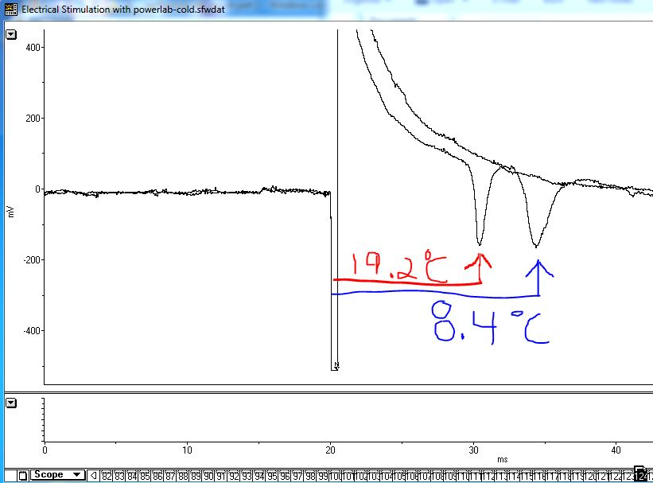

Figure 13: Illustrating a change in conduction velocity with temperature. (Screen capture with windows “Snip” and comments of temperature drawn on image)

6. REFERENCES

Bullock, T.H. (1945) Functional organization of the giant fiber system in Lumbricus. J. Neurophysiol. 8: 55-72

Cardone, B. and Roots, B.I. (1996) Monoclonal antibodies to proteins of the myelin-like sheath of earthworm giant axons: an immunogold electron microscopy study. Neurochem. Res. 21: 505-510

Cragg, B.G. and Thomas, P.K. (1957). The relationship between conduction velocity and the diameter and internodal length of peripheral nerve fibers. J. Physiol. 136: 606-614.

Drewes, C.D., Landa, K.B. and McFall, J.L. (1978) Giant nerve fiber activity in intact, freely moving earthworms. J. Exp. Biol. 72: 217-227.

Drewes, C.D. and Pax, R.A. (1972). Electrophysiological studies of earthworm longitudinal muscle. Am. Zool. 12, xlii. (abstract).

Erlanger, J., Gasser, H.S. and Bishop, G.H. (1924). The compound nature of the action current of nerves as disclosed by the cathode ray oscillograph. Amer. J. Physiol. 70: 624-666.

Furshpan, E. J. and Potter, D.D. (1959). Transmission at the giant motor synapses of the crayfish. J. Physiol. 145(2): 289-325.

Mulloney, B. (1970) Structure of giant fibers of the earthworm. Science: 168: 994-996

Roberts, M.B.V. (1966) Facilitation in the rapid response of the earthworm, Lumbricus terrestris. J. Exp. Biol. 45: 141-150

Wilson, D. M. (1961) Connections between the lateral giant fibers of earthworms. Comp. Biochem. Physiol. 3: 274-284

Table 3: Earthworm saline
grams per 2 L (mM)
NaCl 14.26 (122)
KCl 0.59 (3.956)
NaHCO3 3.02 (17.97)
NaH2PO4 1.104 (3.538)
CaCl2 0.444 (1.981)
MgCl2 0.406 (2.1099)
Tris acid 0.63 (2.0)
Sucrose 5.144 (5)
Adjust pH to 7.3 with NaOH or HCl
Modified from {Staff of ADInstruments (2012). Action potentials in earthworm giant nerve fibers. Teaching Experiment. Pp. 1-11.} along with adjustments from data in Drewes and Pax (1974).

As an additional reference to a worm saline:
C. elgans saline (Eisenmann, D. M., Wnt signaling (June 25, 2005), WormBook, ed. The C. elegans Research Community, WormBook, doi/10.1895/wormbook.1.7.1, http://www.wormbook.org. ) The extracellular solution consists of (in mM): NaCl 150; KCl 5; CaCl₂ 5; MgCl₂ 1; glucose 10; sucrose 5; HEPES 15 (pH 7.3, ~330mOsm).

Earthworm saline shown not to be good for NMJ: Pantin (1948) consisting of 135.0 mM NaCI, 2.7 mM KCl, 1.8 mM CaC12, 0.4 mM MgC12, 0.4 mM Na2S04, and 1.0 meq Na2HP04 at pH 7.4.
Pantin, C. F. A. 1948. Notes on microscopical technique for zoologists. University Press, Cambridge

Appendix 1: Lab report

WRITE A LABORATORY REPORT THAT INCLUDES THE FOLLOWING:

TITLE- Select one THAT IS INSTRUCTIVE to the reader

INTRODUCTION
1. Rationale - What reasons dictate why we selected the earthworm for these experiments?

2. Describe in words (not figures) the functional organization of the giant fiber system and how it generates behavior.

METHODS
1. Briefly describe the dissection
2. Briefly describe the experimental arrangement for recording from and stimulating the nerve cord. You should use a drawing to help describe the procedure.

RESULTS
1. Show a typical record of the responses of the median and lateral giant axons. Make certain that you label the items in the figure. Describe but do not interpret your results
2. What were the conduction velocities of the axons at normal temperature? What were their conduction velocities at colder temperature? Show the labeled figures.
5. Show a labeled record of the refractory period results. Do you know the meaning of the term refractory period in terms of channels and gates if asked?

DISCUSSION
How do your results compare with published results? How do you explain the temperature results?

