Synaptic Responses, Neuronal Circuitry and Neuromodulation Using the Crayfish: Student Laboratory Exercises

ABSTRACT

The purpose of this exercise is to help develop an understanding synaptic transmission. The crayfish abdominal extensor muscles are in groupings with some being tonic (slow) and others phasic (fast) in their biochemical phenotypes, structure as well as the motor neurons that innervate them. We use these muscles to demonstrate properties in synaptic transmission. Also we will examine the influence of neromodulators on synaptic transmission. With the techniques obtained in this exercise, one can utilize them to answer and address questions remaining in other experimental preparations as well as in physiological applications related to medicine and health. This exercise will also help to demonstrate the usefulness of a model invertebrate preparation to address fundamental questions pertinent to all animals.

1. INTRODUCTION

The abdominal extensor muscle preparation used to demonstrate the resting membrane potential is also ideal for demonstrating induction of synaptic responses at the NMJs from the various muscles. Some muscles in crustaceans are selectively innervated by either a phasic or a tonic motor neuron, although some single fibers can be innervated by both phasic and tonic excitatory motor neurons, such as for extensor muscle in the crayfish walking legs (Atwood, 2008; Wu and Cooper, 2010, 2012a,b) and most other limb muscles (Wiersma, 1961a). By selectively stimulating phasic and tonic motor neurons, physiological differences in the EPSPs may be measured. Phasic motor neurons produce rapid twitching of muscle fibers and evoke EPSPs on the order of 10–40 mV. The phasic response can depress rapidly with 5–10-Hz trains of stimulation. The tonic motor neurons give rise to smaller EPSPs that can be facilitated in the presence of a higher frequency (10–50 Hz) of stimulation. Structurally, the presynaptic phasic and tonic terminals at the NMJs are different (Atwood and Cooper, 1996; Bradacs et al., 1997; Cooper et al., 1998).

Surprisingly the phenotype of the phasic physiological responses can undergo a transformation to a tonic-like state by electrically conditioning phasic neurons for a few hours daily over 7 days (Cooper et al., 1998; Mercier and Atwood, 1989). Also the sensitivity to neuromodulation of the transformed NMJs is prime for investigating the regulation of receptor expression (Griffis et al., 2000).

In this relatively robust preparation (crayfish abdominal muscles), both tonic and phasic responses are easily recorded and examined for facilitation and/or depression of the synaptic responses with varied stimulation paradigms. With these preparations, students will be able to recognize generalities of the phasic and tonic synaptic responses by stimulating a nerve bundle. These preparations will also be used to monitor the effects of neuromodulators (Strawn et al., 2000; Wu and Cooper 2012a,b).

In each of the abdominal segment (except the last) there are three functional groups of muscles: (1) those controlling pleopod (swimmerets) movement, (2) three extensor muscles and (3) three flexor muscles. The flexors and extensors are antagonistic groups of muscles which bring about either abdominal flexion or extension by causing rotation about the intersegmental hinges. The phasic musculature occupies most of the volume of the abdomen, while the tonic muscles comprise thin sheets of fibers that span the dorsal (extensors) and ventral (flexors) aspect of each abdominal segment.

These are the same muscles that were used in an earlier exercise to examine the effects of alterations in extracellular Na+ and K+ on the resting membrane potential. Please refer to the previous protocols and references utilized in the earlier experiments for this course.

2. METHODS

2.1 Materials

- Scissors (1)
- Forceps (1)
- Silver Wire for ground wire (1)
- Microscope (1)
- Electrode Probe (1)
- Petri Dish with Sylgard on the bottom (1)
- Saline Solution (1)
- Potassium Solutions: 5.4mM (normal saline), 10, 20, 40, 80, 100 mM
- Bleach (Small Amount, Use for the tip of the silver wire to build Ag-Cl)
- Glass Pipette (1), to remove and add solutions
- Syringe (1)
- Amplifier/Acquisition System (1)
- Faraday Cage (1)
- Desktop/Laptop (1)
- Dissection pins (4)
- Crayfish

2.2 Preparation/Dissection:

Dissection

To obtain the abdominal extensor preparation the same procedure as described above for examining the resting membrane potentials in relation to extracellular potassium. The difference is to take care of the segmental nerve bundle that runs along the side if the carapace. This nerve will be pulled into a suction electrode which will serve as the stimulating electrode. Stimulate at 1 Hz for monitoring phasic responses. Stimulate with short bursts of pulses 10Hz for 10 to 20 stimuli while monitoring the tonic responses.

The experimental procedures for caring out experiments on the crayfish tonic flexor muscles are different and one needs to leave the ventral nerve cord intact. A preparation consisting of several abdominal segments is made. This is obtained as follows:

1. A crayfish approximately 6-10 cm in body length should be obtained (or a manageable size). Obtain the crayfish by holding it from the back of the head or approximately 2 or 3 centimeters from the back of the eyes (The crayfish may be placed in crushed ice for 5 minutes to anesthetize it prior to cutting off the head). Ensure that the claws of the crayfish or mouth cannot reach the experimenter when handling the crayfish. Dispose of the head and appendages after removing them.

2. Use the scissors to quickly remove the head. Make a clean and quick cut from behind the eyes of the crayfish.

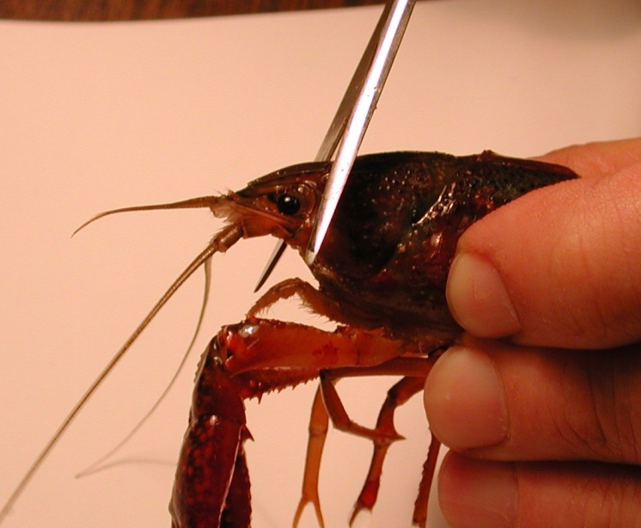
Figure 1: Image shows placement of the cut to remove the head of the crayfish.

The legs and claws of the crayfish can be removed at this point to avoid injury. Stylets on males and swimmerets on both males and females can also be removed (Figure 1 and 2). Next, separate the abdomen from the thorax. Make a cut along the articulating membrane which joins the abdomen and thorax (Figure 3).

3. Save the abdomen portion of the crayfish and dispose of the thorax.

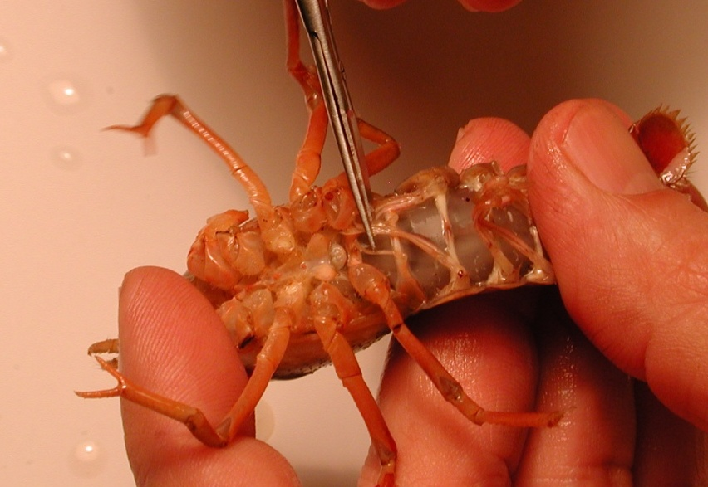
Figure 2: Image shows the placement of the stylets that can be removed from the crayfish.

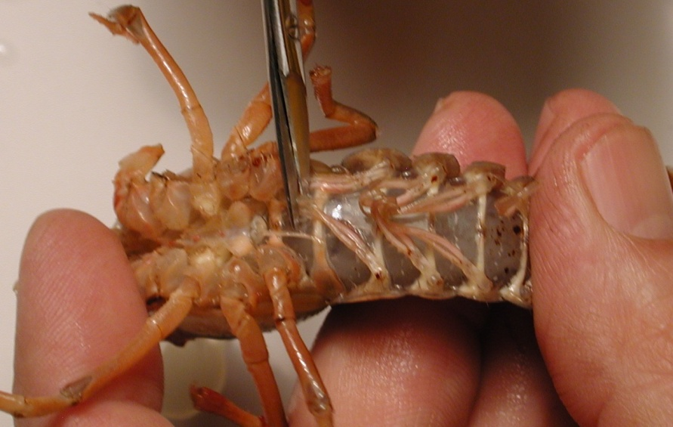
Figure 3: Image shows the placement of the cut to remove the thorax from the abdomen.
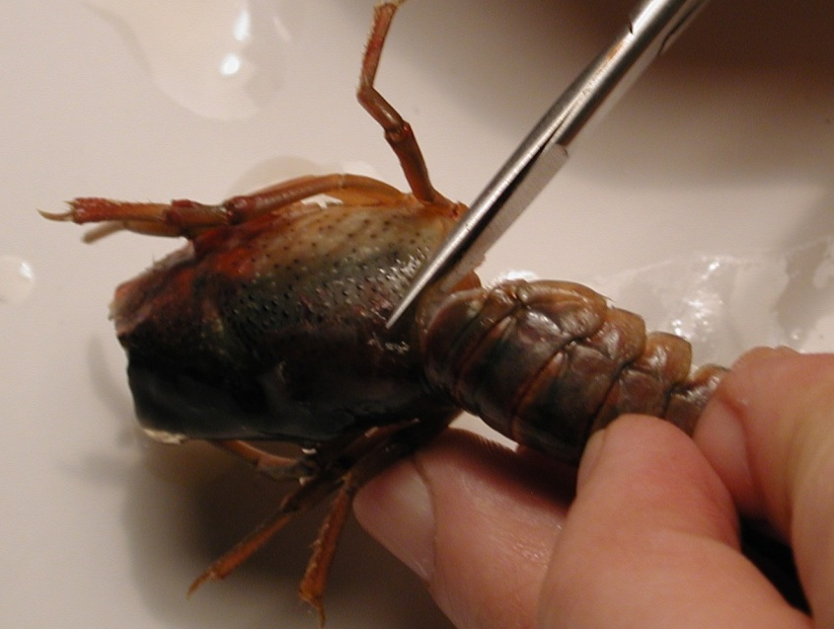
Figure 4: Removal of the thorax from the abdomen. The cut should be made in circular fashion along the line of the joining of the segments.

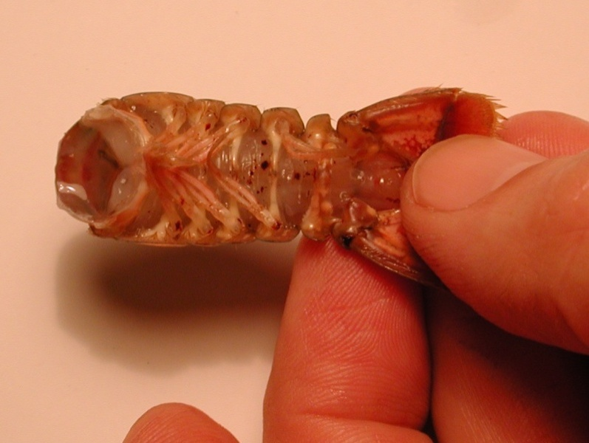
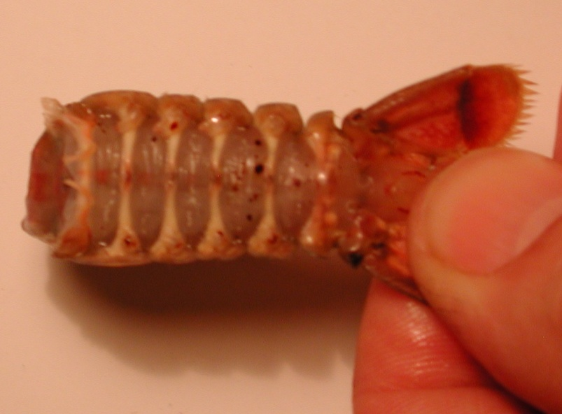
Figure 5: The top image (A) shows the abdomen with swimmeret appendages. Bottom image (B) shows the abdomen without the swimmeret appendages.

4. With the abdomen, a cut should be made in the shell along the lower, lateral border of each side of the abdomen. Care should be taken not to cut too deeply into the crayfish. To help in the process of cutting the shell, the cut should be made with the scissors pointing slighting down towards the ventral side and at an angle. Follow the natural shell pattern of lines of the crayfish that run the length of each segment (Figure
6).
Figure 6: Scissors are placed at an angle and follow the natural alignment of the shell. Do not cut too deep and destroy the preparation. The arrowheads point to the natural line along each segment that should be followed for the cuts.

5. Remove the ventral portion of the shell. Take care not to destroy the abdominal muscles. Use forceps to remove the ventral portion. When the ventral portion of the shell is removed, a white mass of tissue can be seen on top of the deep flexor muscles. This tissue can be removed carefully with forceps.
Figure 7: Removing the ventral portion of the shell with forceps. Pull up and back on the ventral portion to remove. Do not destroy muscles under the ventral shell.

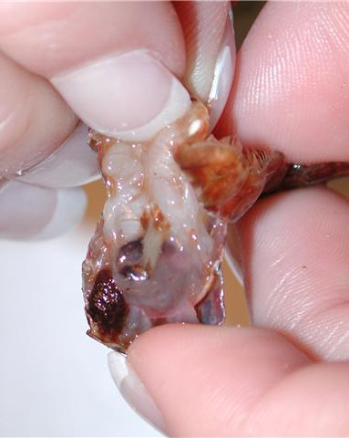
Figure 8: Pulling back on the ventral portion of the shell, which is to be discarded.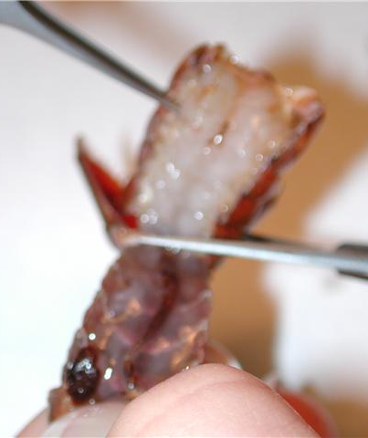
Figure 9: Cut the ventral portion of the preparation with scissors and discard.

6. The GI tract, a small tube running along the midline of the deep flexor muscles, can be removed from the crayfish. Pinch the top of the tract with the forceps and pull away from the abdomen. Cut the bottom of the tract – at the end of the tail. Rinse the dissection with saline to ensure the fecal waste does not interfere with the preparation.
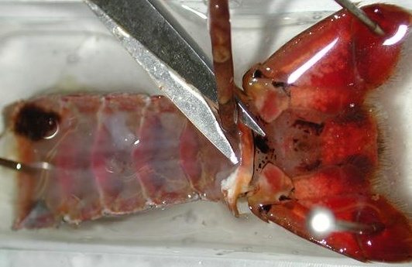
Figure 10: Image shows the removal of the GI tract from the preparation.

7. Use dissection pins to secure the preparation to the Petri dish. The top and bottom corners of the preparation should be pinned down to the dish. Saline solution should be poured into the Petri dish and cover the preparation completely until intracellular recordings are performed.

This dissection dish should have a Sylgard (Dow Corning) coating on the bottom (1cm thick) so that insect pins can be stuck into it.

Dissected preparations are bathed in standard crayfish saline, modified from Van Harreveld’s solution (1936), which is made with 205 NaCl; 5.3KCl; 13.5 CaCl₂; 2H₂O; 2.45 MgCl₂; 6H₂O; 5 HEPES and adjusted to pH 7.4 (in mM).

2.3 Stimulating the segmental nerve and obtaining intracellular recordings:

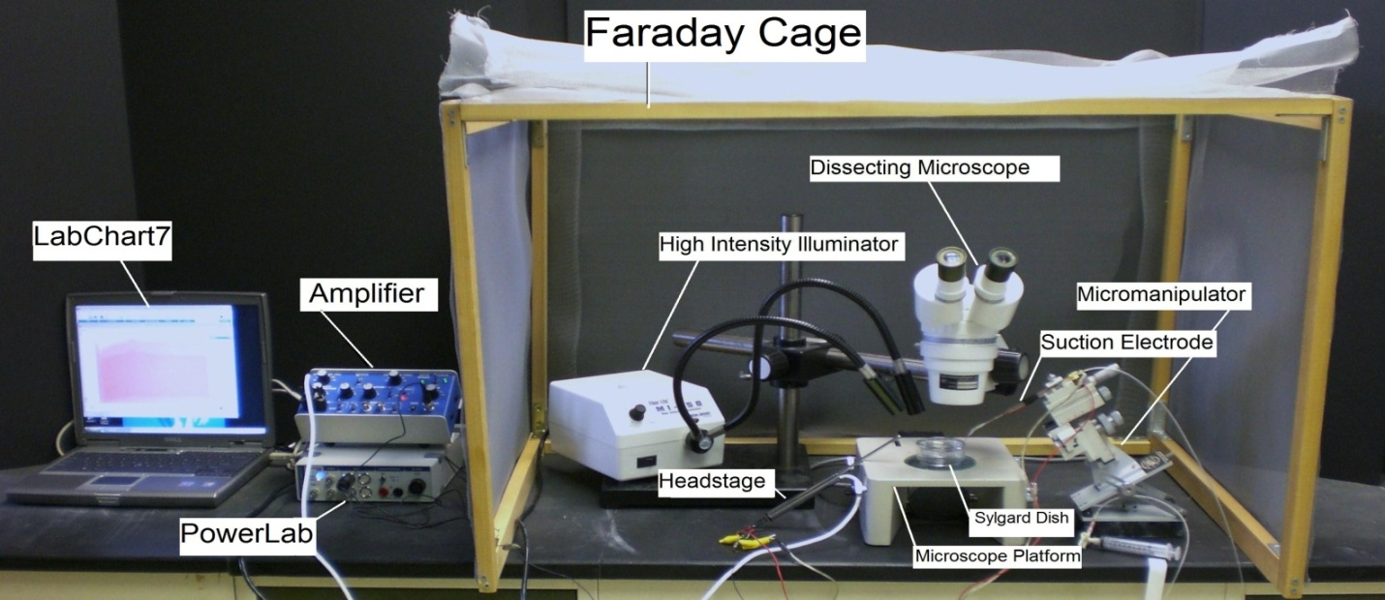
Figure 11: Overall setup of the recording equipment.

1. The Petri dish with preparation should be placed under the microscope and secured with wax at the bottom of the dish to prevent movement.

2. The specimen dish with preparation should be placed under the microscope and secured with wax or clay on the sides of the dish to prevent movement.

NEED NEW PHOTO with suction and intracellular with correct amp

Figure 12: Placement of the preparation under the microscope.

3. Two wires each with a short length of silver wire attached to one end should be obtained. The silver wire should be dipped into a small amount of bleach for about 20 minutes to obtain an Ag-Cl coating. Wash the wire with distilled water before using. A glass intracellular pipette should be obtained and carefully backfilled with a long needle attached to a syringe filled with a 3M KCl solution (Figure ?). The pipette should be turned down (with the opening facing the floor) and filled with solution. This will ensure that any excess KCl will drip out the back of the electrode. Be sure no KCl runs along the glass pipette that will enter the saline bath. Turn the pipette upright when finished filling with potassium chloride solution. The silver wire can then be placed into the pipette (Figure 13). Care should be made not to break the electrode tip. Another wire is attached to the Faraday cage or into ground directly on the intracellular amplifier A wire should also be placed from the Faraday cage to the ground portion of the AD converter Powerlab. The head stage is connected to the “input-probe” on acquisition/amplifier (Powerlab).

Figure 13: Filling the microelectrode with 3 M KCl

Figure 14 : Microelectrode and holder

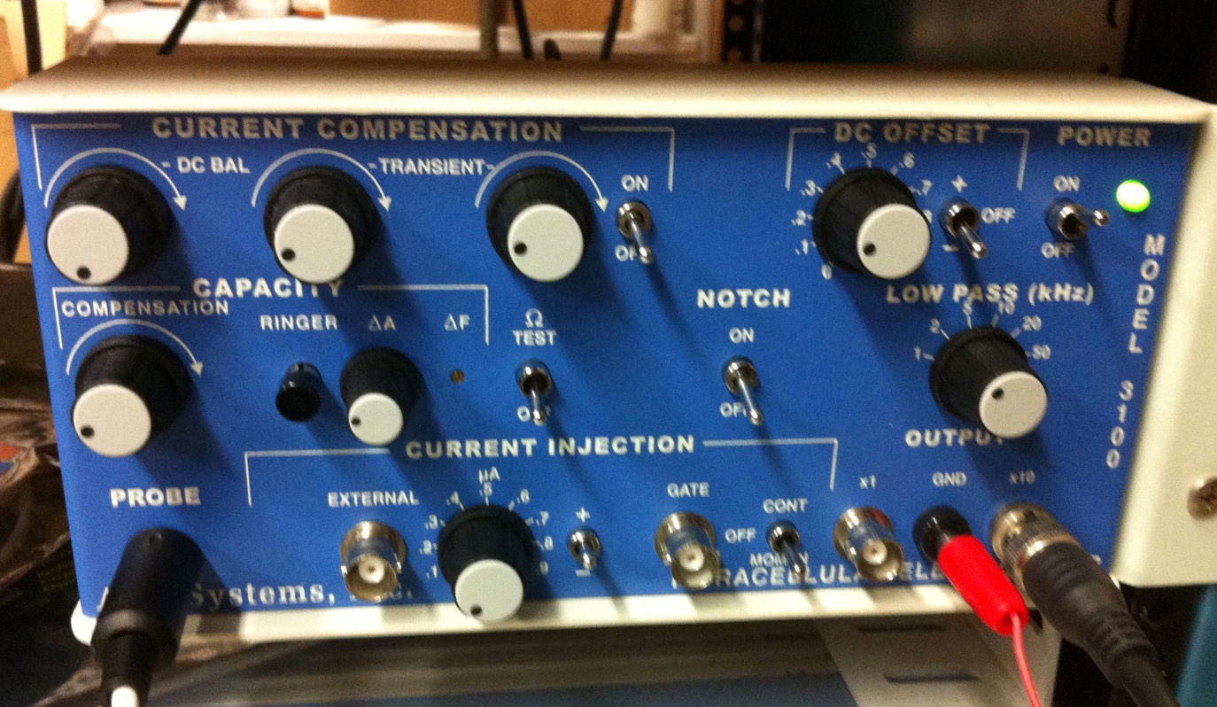
Figure 15: Front face of the intracellular amplifier used during the intracellular membrane potential recordings. The “Ω TEST” switch used to test electrode resistance is center left. The DC offset knob is in the upper right corner, and should be turned counter clockwise to start. The ground wire is placed in the “GND” pin jack opening. The amplifier in this set-up amplifies the signal by 10X.

Software Set-up
4. Be sure your amplifier and PowerLab units are on before opening the software!
5. Open the LabChart software. Adjust the chart to display only one channel by clicking “Setup”, then “Channel settings.” Under “Channel settings,” change number of channels to one. Click “OK.”
6. At the top of the chart, left hand corner, cycles per second should be 2K. Set volts (y-axis) to around 1V.
7. Click on “Channel 1” on the right hand portion of the screen. Click “Input Amplifier” and that the following settings are selected:

Single ended | OFF
Differential | Checked
AC-Coupled | OFF
Anti-alias | Checked
Invert | OFF

Amplifier Set-up
8. The amplifier output cable should be plugged into channel one. The following settings should be used with the intracellular amplifier (see Figure 14 for reference):

Current Comp.(3 knobs) | counter clockwise
Capacity Comp. | counter clockwise, OFF
Capacity Amp (ΔA) | counter clockwise
DC Offset knob | Varies (see part 16 below)
Low Pass knob | 50 kHz
Notch | OFF
Current Injection | 0 μA
ΩTEST | OFF

9. CHECK THE RESISTANCE OF YOUR ELECTRODE.

To measure the resistance, place the tip of the glass electrode into the saline bath. Make sure a ground wire is also in the saline bath. While recording, the Ω TEST switch should be turned on and then off several times (Figure 16).

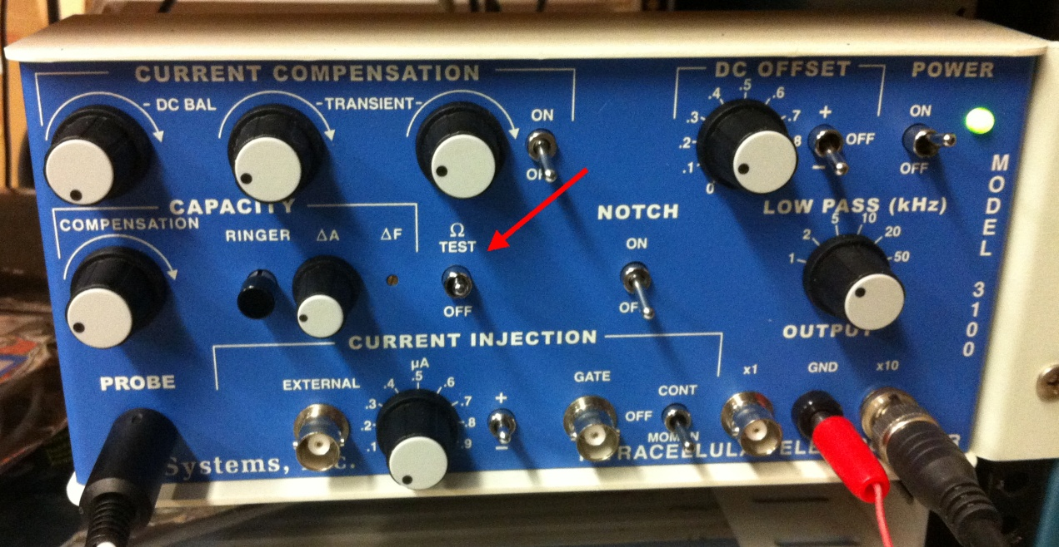

Figure 16: Front face of the intracellular amplifier with the “Ω TEST” switch in the on position.

The amplitude (mV) of the resulting changes should be measured. To measure the amplitude changes in the trace, place the marker on the steady base line and then move the cursor to the peak amplitude. The trace might be condensed so use the “zoom function” under the “window” menu. Then move the “M” at the bottom left to base line and the cursor over the peak response (Figure 17). Then the delta value will display at the top in mV. In the figure it is 222.7 mV.
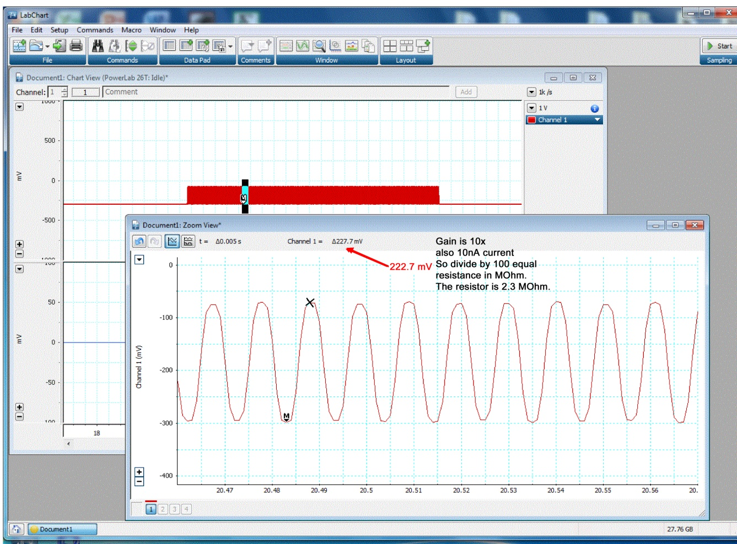

Figure 17: Use the cursor to the peak amplitude for obtaining electrode resistance.

As a measure of the electrode resistance, the voltage should be divided by the current, which is 2 nA (ie., R=V/I, or Ohm’s law). The resulting value is the resistance of your glass electrode. Recall the BNC output of the intracellular amplifier is connected to the 10X output. Thus, divide by 100 to obtain the correct electrode resistance.

Electrode Resistance (MΩ) = ____________________

The resistance should be within 20 to 60 MegaOhms. Low (<20) and high resistance (>100) are not acceptable. Troubleshoot as necessary to bring your electrode’s resistance within the acceptable range.

Set the gain in your software to 1 or 5 V/div. Begin recording by pressing “start” at the bottom of the screen. Use the DC offset knob on the amplifier to adjust the recording trace to zero before inserting the electrode into the tissue. This sets your extracellular voltage to zero. This is the difference from the glass microelectrode to the ground wire which should be both in the saline.

10. NEXT, SET YOUR EXTRACELLULAR VOLTAGE TO ZERO. Set the gain in your software to 1 or 5 V/div. Begin recording by pressing “start” at the bottom of the screen. Use the DC offset knob on the amplifier to adjust the recording trace to zero before inserting the electrode into the tissue. This sets your extracellular voltage to zero.

Leave the electrode in the bath over the side of the dish away from preparation.

11. Setting up the stimulating electrode

Use the microscope to find the nerve to be recorded. Note: Look for the segment with the most accessible nerve. The nerve is white, and can be seen by using the pipette to spray saline around the nerve or by lightly blowing on the preparation. This causes the nerve to move around and makes it easier to identify. See figure 18 for details.
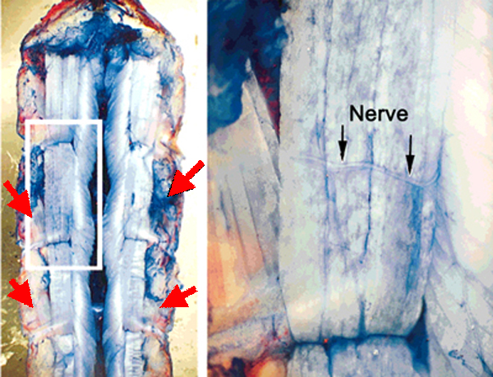
Figure 18: In this methylene blue stained preparation. The segmental nerve approached the extensor muscle from the lateral-caudal aspect of each segment. The nerve is close to the SEL muscle. The red arrows depict the approximant locations where the segmental nerve can be located.

Now that the nerve has been identified place the suction electrode from the micromanipulator directly over the nerve (Figure 19). Gently pull on the syringe to draw the nerve into the electrode (one can see the nerve being sucked into the electrode with the use of the microscope).

Figure 19: The nerve bundle to be sucked up into the recording electrode. (A) The free nerve is shown floating over the dissected abdomen. (B) Outlines the nerve bundle and the plastic suction electrode close by the nerve. (C) The segmental nerve is pulled into the suction electrode, which is outlined in blue.

12. Stimulate the segmental nerve and see phasic muscles twitch

The PowerLab system (PowerLab interface from AD Instruments, Australia) will serve as the stimulating voltage source in this experiment.
(i) Attach the PowerLab’s USB cable to the computer. Make sure PowerLab is on and open the LabChart program from the desktop.
(ii) Select “New File.”
(iii) A window will appear with multiple recording channels. Select “Setup” at the top and click on “Channel Settings.” In the bottom left corner of the window, decrease the Number of Channels to 1; on Channel 1, change the Range to 5 V.
(iv) Connect the Stimulator cable with the two mini-hook leads to the Output portals on the PowerLab as follows: attach the red connector cable to the positive Output portal and the black connector cable to the negative Output portal.
(v) Next, it is necessary to change the power output, frequency, and pulse duration of the PowerLab. In order to do this, select “Setup,” and then “Stimulator Panel.” Short pulses and small voltages to start off with are required for the first portion of the experiment, so adjust the amplitude to 0.5 V; this will give a range of 1.0 V (the PowerLab will emit a voltage fluctuating between positive and negative 0.5 V). Set the frequency (0.5 Hz) and pulse duration (0.3s).
While one person watches the muscles through the microscope for twitching behavior another person will adjust the stimulating setting to higher voltages. When muscle twitches occur stop stimulating and now get ready to record the electrical signal in the muscle fibers.

2.4 Intracellular recording

Electrically ground the bath by placing a silver-chloride ground wire in the bath and the other end to a common ground. Note: sometimes this can cause electrical noise during the recording. If this happens do not ground the bath.
1. Use the micromanipulator and dissecting scope to insert the microelectrode tip into the SEM tonic muscle of the preparation (see Figure 20 for muscle names and locations). The electrode should barely be inserted into the muscle. You will likely see the muscle dimple as the electrode penetrates. Do not penetrate completely through the muscle. The high intensity illuminator should be adjusted to clearly see the muscle as the electrode is being inserted. When poking muscle fibers in this preparation, one can commonly run into spaces and clefts within the muscle. This is the reason why the membrane potential can appear, then disappear, and then reappear.

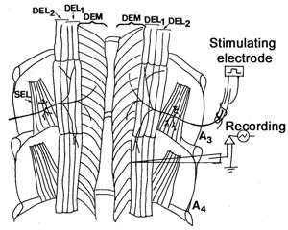

Figure 20: Schematic presentation of crayfish abdomen extensor musculature. Each side of each segment contains deep extensor medial muscle (DEM), deep extensor lateral muscle 1 (DEL1), deep extensor lateral muscle 2 (DEL2), superficial extensor lateral muscle (SEL), superficial extensor medial muscle (SEM). On the left side of the figure, dorsal SEL, SEM is viewed by removing DEM, DEL1, and DEL2. DEM, DEL1 and DEL2 are phasic muscles whereas SEM and SEL are tonic in nature. A1-A5 means abdomen segments. Scale bar = 2.35 mm. The figure is from Wu and Cooper, 2012c.

2. To measure the membrane potential, use the coarse knob on the amplifier to move the line on the LabChart to zero before inserting the electrode. Poke a muscle fiber. Next, measure the amplitude of the resulting values. Place a marker on the steady base line and record the value.

The difference in the marker and the active cursor is displayed on the right side of the screen. The value is gives the voltage. The recorded voltage might need to be adjusted to account for any amplification used on the amplifier (i.e. 10X amplification). The voltage should be converted to millivolts if the values are reported on the software as volts (1 V = 1,000mV).

3. Once a good RP is measured in a SEL muscle fiber, start the stimulator and look for the appearances of EPSPs on the screen after each stimulation artifact. One may have to increase the voltage, but if the DEL1,2 and DEM muscles are twitching then likely the SEL is being stimulated as well. One can then increase the stimulation frequency form 0.5Hz to 1.0 Hz, then 2 Hz, then 3Hz and 4Hz and 5Hz. Then stop stimulating and zoom in on the recorded file to see if the EPSPs are present. Also take a quick look over the amplitude differences in the EPSP during the various stimulation frequencies given. Later one can record the amplitudes of the various EPSPs at each stimulation frequency. SAVE THIS FILE on the computer and then start a new file with the same settings.

4. Now one is to record from the phasic muscles. If the phasic muscles could still twitch and the phasic responses do not appear decreased extensively then one might be able to stay in the same segment and record from them. If they appear too depressed then move the stimulating electrode to another segment and stimulate just enough to obtain some twitch response. Use 0.5 Hz as a stimulating frequency. Look for a region of the stimulating muscle that is not moving as much for obtaining an intracellular recording. Stop the stimulation and obtain a good RP in one of the longitudinal muscles (DEM or DEL1 or DEL2) of the preparation (see Figure 17). Then turn on the stimulator and hope the electrode remaining in the muscle fiber. SAVE THIS FILE on the computer.

5. Measure the EPSP amplitudes from the tonic muscle at the different frequencies and phasic muscle fibers. One can make a graph of the responses. Think how you might represent the data.

6. One can also apply exogenous compounds such as serotonin (Strawn et al., 2000) or glutamate while recording from the phasic or tonic muscles. Record a base line then add concentrated 5-HT (1 mM or 500 nM) by a pipette aimed at the muscles one is recording from. Mark the file in the chart software when the compound is added. Now measure, in the chart file, the EPSP amplitudes before and after the compound was added.

3. DISCUSSION

The details provided in the associated movie and text has provided key steps in order to sufficiently record membrane potentials and investigate muscle structure as discussed in the first part of this report. In the second part, the demonstration of how to dissect and record synaptic transmission at the NMJs of phasic and tonic motor units provided an exposure to the potential for these preparations in student run investigative laboratories to teach fundamental concepts in physiology.

These preparations can be used to investigate synaptic facilitation, depression and long-term plasticity. Even within some species of crayfish they show neuronal plasticity depending on the experimental stimulation conditions (Mercier and Atwood, 1989; Cooper et al., 1998) as well as their natural environment. To what extent the ability to alter synaptic efficacy and muscle dynamics serves the animal remains to be investigated. Since crayfish do alter their behavior in relation to seasonal variation and the molt cycle, there are relatively long-term activity differences in their neuromuscular systems. It has been shown that the phasic motor nerve terminals of claw closer muscles exhibit the classic phasic morphology during the winter, but swell and become more varicose along the length of the terminal during the summer months (Lnenicka 1993; Lnenicka and Zhao, 1991).

The action of various neuromodulators is also readily studied at the various types of NMJs (Cooper and Cooper, 2009; Griffis et al., 2000; Southard et al., 2000; Strawn et al., 2000) presented in addition to the influences on various aspects of the CNS circuitry. It has been suggested that the 5-HT and octopaminergic neurons may function as ‘gain-setters’ in altering the output of neuronal circuits (Ma et al., 1992; Schneider et al., 1996; Hörner et al., 1997; Edwards et al., 2002). Much work remains to be done before we can fully understand the effects of neuromodulators on individual target cells. Given that different neuromodulators may work in concert with one another, analysis of their mixed action is an area for future research (Djokaj et al., 2001). In addition, few studies, particularly in the vertebrates, address the effects of neuromodulators on entire pathways which can regulate a specific behavior. In this sensory-CNS-motor unit preparation one can examine the influence of both sensory input and neuromodulators on the activity of the motor neurons (Kennedy et al., 1969).

Since it has been postulated that 5-HT plays a role in regulating the behavioral state of the crayfish, lobsters, and crabs (Livingstone et al.,1980; Sneddon et al., 2000), several attempts have been made to determine its concentration in the VNC, the hemolymph, and in isolated ganglia of lobsters (Livingstone et al., 1980; Harris-Warrick and Kravitz 1984; Fadool et al., 1988). However, there has been considerable variation in the recorded measurements which eludes a specific dosage and effect relationship to account for behavioral actions. See a review on 5-HT’s action on a variety of invertebrate NMJs (Wu and Cooper, 2012b)

A crayfish with the claws held in a raised position with the tail tucked under its abdomen was touted as a dominate posture (Livingstone et al., 1980). The state of abdominal flexion in crayfish does not appear to be the posture that dominant crayfish, within a pair, exhibit during the social interactions or while maintaining a dominant hierarchical status (Listerman et al., 2000). Submissive crayfish will even tuck their abdomens under themselves as they cower to an opponent. Such tail tucking is also seen as a defense posture (Listerman et al., 2000). These behaviors have been readily observed in the field and in laboratory settings (Bovbjerg, 1953, 1956; Bruski and Dunham, 1987; Li et al., 2000; Listerman et al., 2000). Interestingly, the behavioral postures noted in lobsters (Livingstone et al., 1980) are reversed for 5-HT and octopamine injections in the Australian crayfish, Cherax destructor (McRae, 1996). Possibly, entirely different responses would be observed in the muscle preparations in the Australian crayfish. In addition, since dominance is generally size related among crayfish, one would expect a very plastic response system for rapidly altered social conditions (Strawn et al., 2000). The plasticity in responsiveness to neuromodulators in invertebrates is an open area of investigation.

4. REFERENCES

Antonsen, B.L. & Edwards, D.H. Differential dye coupling reveals lateral giant escape circuit in crayfish. J. Comp. Neurol. 466(1), 1-13 (2003).

Arellano, R. O., Rivera, A. & Ramón, F. Protein phosphorylation and hydrogen ions modulate calcium-induced closure of gap junction channels. Biophys. J. 57(2), 363-367 (1990).

Atwood, H. L. γ -aminobutyric acid and crab muscle fibres. Experientia (Basel) 20, 161 163 (1964).

Atwood, H. L. Variation in physiological properties of crustacean motor synapses. Nature 215, 57 58 (1967).

Atwood, H. L. Peripheral inhibition in crustacean muscle. Experimentia 24, 753-763 (1968).

Atwood, H. L. An attempt to account for the diversity of crustacean muscles. Am. Zool. 13, 357-378 (1973).

Atwood, H. L. Organization and synaptic physiology of crustacean neuromuscular systems. Prog. Neurobiol. 7, 291-391 (1976).

Atwood, H. L. Synapses and neurotransmitters. The Biology of Crustacea, vol. 3 (ed. H. L. Atwood and D. C. Sandeman), pp. 105 150. New York: Academic Press, Inc. (1982).

Atwood, H.L. Parallel ‘phasic’ and ‘tonic’ motor systems in the crayfish abdomen.
J. Exp. Biol. 211, 2193-2195 (2008).

Atwood, H.L. & Cooper, R.L. Functional and structural parallels in crustaceans and Drosophila neuromuscular systems. Am. Zool. 35(6), 556- 565 (1995).

Atwood, H.L. & Cooper, R.L. Assessing ultrastructure of crustacean and insect neuromuscular junctions. J. Neurosci. Meth. 69, 51-58 (1996a).

Atwood, H.L. & Cooper, R.L. Synaptic diversity and differentiation: Crustacean neuromuscular junctions. Invertebrate Neurosci. 1, 291-307 (1996b)

Atwood, H.L. & Parnas, I. Recording from the crayfish abdominal extensor muscle preparation with microelectrodes. In: Experiments in physiology and biochemistry (Kerkut GA, ed), pp 307-330. London: Academic (1968).

Badre, N.H., Martin, M.E. & Cooper, R.L. The physiological and behavioral effects of carbon dioxide on Drosophila larvae. Comparative Biochemistry and Physiology A. 140, 363-376 (2005).

Bernstein, J. Untersuchungen zur Termodynamik der bioelektrischen Ströme. Pflüger Arch. ges. Physiol. 9, 521-562 (1902).

Bernstein, J. Elektrobiologie, 215 pp. Viewag, Braunschweig (1912).

Bierbower, S.M. Environmental effects on behavior and physiology in crayfish. PhD disertation under Dr. Robin L. Cooper. Department of Biology, University of Kentucky (2010).

Bierbower, S.M. & Cooper, R.L. The effects of acute carbon dioxide on behavior and physiology in Procambarus clarkii. J. Exp. Zool. In press (2010)

Boistel, J. & Fatt, P. Membrane permeability change during inhibitory transmitter action in crustacean muscle. J. Physiol. (Lond.) 144, 176-191 (1958).

Bovbjerg, R.V. Dominance order in the crayfish Orconectes 6irilis (Hagen). Physiol. Zool. 26, 173–178 (1953).

Bovbjerg, R.V. Some factors affecting aggressive behavior in crayfish. Physiol. Zool. 29, 127–136 (1956).

Bradacs, H., Cooper, R.L., Msghina, M. & Atwood, H.L. Differential physiology and morphology of phasic and tonic motor axons in a crayfish limb extensor muscle. J. Exp. Biol. 200, 677-691 (1997).

Bruski, C.A. & Dunham, D.W. The importance of vision in agonistic communication of the crayfish Orconectes rusticus, I. an analysis of bout dynamics. Behaviour 63, 83–107 (1987).

Burke, W. & Ginsborg, B. L. The electrical properties of the slow muscle fibre membrane. J. Physiol. 132, 586-598 (1956).

Cooper, A.S. & Cooper, R.L. Historical view and demonstration of physiology at the NMJ at the crayfish opener muscle. Journal of Visualized Experiments (JoVE). JoVE. 33. http://www.jove.com/index/details.stp?id=1595; doi: 10.3791/1595 (2009).

Cooper, R.L., Warren, W.M. & Ashby, H.E. Activity of phasic motor neurons partially transforms the neuronal and muscle phenotype to a tonic-like state. Muscle & Nerve 21, 921-931 (1998).

Djokaj, S., Cooper, R.L. & Rathmayer, W. Effects of octopamine, serotonin, and cocktails of the two modulators on synaptic transmission at crustacean neuromuscular junctions. J. Comp. Physiol. A 187(2),145-154 (2001).

Dudel, J. & Kuffler, S. W. Mechanism of facilitation at the crayfish neuromuscular junction. J. Physiol. (Lond.) 155, 540-542 (1961).

Eckert, R. O. Reflex relationships of the abdominal stretch receptors of the crayfish. J. Cell. Comp. Physiol. 57, 149–162 (1961).

Edwards, D.H., Yeh, S.R., Musolf, B.E., Antonsen, B.L. & Krasne, F.B. Metamodulation of the crayfish escape circuit. Brain Behav Evol. 60(6), 360-369 (2002).

Fadool, D.A., Cobb, S.J., Kass-Simon, G. & Brown, P.R. Liquid chromatographic procedures for the analysis of compounds in the serotonergic and octopamine pathways of lobster hemolymph. J. Chromatogr. 452, 491–501 (1988).

Fatt, P. & Katz, B. The electrical properties of crustacean muscle fibers. J. Physiol. 120, 171-204 (1953).

Fields, H.L. & Kennedy, D. Functional role of muscle receptor organs in crayfish. Nature. 206(990), 1235-1237 (1965). PMID: 5879785

Fisher, L. & Florey, E. Modulation of synaptic transmission and excitation-contraction coupling in the opener muscle of the crayfish, Astacus leptodactylus, by 5-hydroxytryptamine and octopamine. J. Exp. Biol. 102, 187–198 (1983).

Freud, S. Über den Bau der Nervenfasern und Nervenzellen beim Flußkrebs. In: Anzeiger Akad. Wiss. Wien (Math.-Naturwiss. Kl.), Bd. 18 (1881), Nr. 28, S. 275f (1881). (see http://artmuseum.binghamton.edu/freudbook/ )

Freud, S. Über den Bau der Nervenfasern und Nervenzellen beim Flußkrebs. In: Sitzungsber. Akad. Wiss. Wien (Math.-Naturwiss. Kl.), 3. Abt., Bd. 85 (1882), S. 9-46. {(On the Structure of the Nerve Fibers and Nerve Cells of the River Crayfish), Sitzungsberichte der Mathematisch-Naturwissenschaftlichen Classe der Kaiserlichen Akademie der Wissenschaften, LXXXV. Band 1882} (see
http://artmuseum.binghamton.edu/freudbook/ )

Goldman, D.E. Potential, impedance, and rectification in membranes. J. Gen. Physiol. 27, 37-60 (1943).

Griffis, B., Bonner, P. & Cooper, R.L. Sensitivity of transformed (phasic to tonic) motor neurons to the neuromodulator 5-HT. Comparative Biochemistry and Physiology A 127, 495-504 (2000).

Grundfest, H. & Reuben, J.P. Neuromuscular synaptic activity in lobster. In: Florey, E. (Ed.), Nervous Inhibition. Pergamon Press, Oxford, pp. 92–104 (1961).

Harris-Warrick, R.M. & Kravitz, E.A. Cellular mechanisms for modulation of posture by octopamine and serotonin in the lobster. J. Neurosci. 4, 1976–1993 (1984).

Hagiwara, S., Chichibu, S. & Naka, K.I. The effects of various ions on resting and spike potentials of barnacle muscle fibers. J. Gen. Physiol. 48, 163-79 (1964). PMID: 14212147

Hille, B. Ionic Channels of Excitable Membranes, 2nd ed., Sinauer Assoc., Sunderland, Mass (1992).

Hodgkin, A.L. & Huxley, A.F. A quantitative description of membrane current and its application to conduction and excitation in nerve. J. Physiol. (Lond.) 117, 500-544 (1952).

Hodgkin, A.L., Huxley, A.F. & Katz, B. Measurement of current-voltage relations in the membrane of the giant axon of Loligo. J. Physiol. (Lond.) 116, 424-48 (1952).

Hodgkin, A.L. & Katz, B. The effect of sodium ions on the electrical activity of the giant axon of the squid. J. Physiol. (Lond.) 108, 37-77 (1949).

Hodgkin, A. L. & Rushton, W. A. H. The electrical constants of a crustacean nerve fibre. Proc. Roy. Soc. 133, 444-479 (1946).

Hörner, M., Weiger, W.A., Edwards, D.H. & Kravitz, E.A. Excitation of identified serotonergic neurons by escape command neurons in lobsters. J. Exp. Biol. 200, 2017–2033 (1997).

Huxley, T.H. The crayfish. C. London: Kegan Paul and Co. (This is a later edition that was not revised from a large paper edition limited to 250 copies published Nov. 29, 1879. (1880). Now available from MIT Press at http://www.mitpress.com)

Johnson, G. E. Giant nerve fibers in crustaceans with special reference to Cambaus and Palaemonetes. J. Comp. Neurol. 36, 323-373 (1924).

Johnston, M. F., Simon, S. A. & Ramon, F. Interaction of anaesthetics with electrical synapses. Nature (Lond) 286, 498-500 (1980).

Katz, B. & Miledi, R. The role of calcium in neuromuscular facilitation. J. Physiol. (Lond.) 195, 481-492 (1968).

Kennedy, D. & Takeda, K. Reflex control of abdominal flexor muscles in the crayfish: the twitch system. J. Exp. Biol. 43, 211–227 (1965a).

Kennedy, D. & Takeda, K. Reflex control of the abdominal flexor in the crayfish: the tonic system. J. Exp. Biol. 43, 229–246 (1965b).

Kennedy, D., Selverston, A. I. & Remler, M.P. Analysis of restricted neural networks. science 164, 1488-1496 (1969).

Krasne, F.B. Excitation and habituation of the crayfish escape reflex: the depolarizing response in lateral giant fibres of the isolated abdomen. J. Exp. Biol. 50(1), 29-46 (1969). PMID: 4304852

Li, H., Listerman, L.R., Doshi, D. & Cooper, R.L. Heart rate measures in blind cave crayfish during environmental disturbances and social interactions. Comp. Biochem. Physiol. 127A, 55–70 (2000).

Listerman, L., Deskins, J., Bradacs, H. & Cooper, R.L. Measures of heart rate during social interactions in crayfish and effects of 5-HT. Comp. Biochem. Physiol. A 125, 251–264 (2000).

Livingstone, M.S., Harris-Warrick, R.M. & Kravitz, E.A. Serotonin and octopamine produce opposite postures in lobsters. Science 208, 76–79 (1980).

Lnenicka, G.A. Seasonal differences in motor terminals. Comp. Biochem. Physiol. 104A, 423–429 (1993).

Lnenicka, G.A. & Zhao, Y. Seasonal differences in the physiology and morphology of crayfish motor terminals. J. Neurobiol. 22, 561–569 (1993).

Ma, P.M., Beltz, B.S. & Kravitz, E.A. Serotonin containing neurons in lobsters: their role as ‘gainsetters’ in postural control mechanisms. J. Neurophysiol. 68, 36–54 (1992).

Malmivuo, J. & Plonsey, R. Bioelectromagnetism-Principles and Applications of Bioelectric and Biomagnetic Fields. New York: Oxford University Press (1995).

McRae, T. On the postural effects induced in female Cherax destructor (Clark) by serotonin and octopamine. Freshwater Crayfish 11, 293–298 (1996).

Mercier, A.J. & Atwood, H.L. Long-term adaptation of a phasic extensor motoneurone in crayfish. J. Exp. Biol. 145, 9–22 (1989).

Monaghan, D. T., Bridges, R. J. & Cotman, C. W. The excitatory amino acid receptors: their classes, pharmacology, and distinct properties in the function of the central nervous system. Annu. Rev. Pharmacol. Toxicol. 29, 365-402 (1989). PMID: 2543272

Moody, W. Gradual increase in the electrical excitability of crayfish slow muscle fibers produced by anoxia or uncouplers of oxidative phosphorylation. J. Comp. Physiol. 125, 327-334 (1978).

Nernst, W.H. Zur Kinetik der Lösung befindlichen Körper: Theorie der Diffusion. Z. Phys. Chem. 3, 613-37 (1888).

Nernst, W.H. Die elektromotorische Wirksamkeit der Ionen. Z. Phys. Chem. 4, 129-81 (1889).

Pilgrim, R.L.C. & Wiersma, C.A.G. Observations on the skeleton and somatic musculature of the abdomen and thorax of Procambarus clarkii (Girard), with notes on the thorax of Panulirus interruptus (Randall) and Astacus. J. Morphol. 113, 453–587 (1963).

Robinson, M.M., Martin, J.M., Atwood, H.L. & Cooper, R.L. Modeling biological membranes with circuit boards and measuring conduction velocity in axons: Student laboratory exercises. In press, Journal of Visualized Experiments (2010).
Schneider, H., Budhiraja, P., Walter, I., Beltz, B.S., Peckol, E. & Kravitz, E.A. Developmental expression of the octopamine phenotype in lobsters. J. Comp. Neurol. 371, 3–14 (1996).

Skou, J. C. The influence of some cations on an adenosine triphosphatase from peripheral nerves. Biochim. Biophys. Acta 1000, 439-446 (1989a). PMID 2550074.

Skou, J. C. The identification of the sodium-pump as the membrane-bound Na+/K+-ATPase: a commentary on ‘The Influence of Some Cations on an Adenosine Triphosphatase from Peripheral Nerves’. Biochim. Biophys. Acta 1000, 435-438 (1989b). PMID 2550073.

Skou, J. C. (1965) Enzymatic basis for active transport of Na+ and K+ across cell membrane. Physiol. Rev. 45, 596-617(1965).

Skou, JC. Nobel Lecture. The identification of the sodium pump. Biosci Rep. 18(4),155-69 (1998).

Sneddon, L.U., Taylor, A.C., Huntingford, F.A. & Watson, D.G. Agonistic behavior and biogenic amines in shore crabs Carcinus maenas. J. Exp. Biol. 203, 537–545 (2000).

Sohn, J., Mykles, D.L. & Cooper, R.L. The anatomical, physiological and biochemical characterization of muscles associated with the articulating membrane in the dorsal surface of the crayfish abdomen. J. Exp. Zool. 287, 353-377 (2000).

Southard, R.C., Haggard, J., Crider, M.E., Whiteheart, S.W. & Cooper, R.L. Influence of serotonin on the kinetics of vesicular release. Brain Res. 871, 16–28 (2000).

Stefani, E. & Steinbach, A. B. Resting potential and electrical properties of frog slow muscle fibers. Effect of different external solutions. J. Physiol. 203, 383-401 (1969).

Strawn, J.R., Neckameyer, W.S. & Cooper, R.L. The effects of 5-HT on sensory neurons, CNS command, and neuromuscular junctions of the crayfish abdominal superficial flexor. Comp. Biochem. Physiol B 127, 533-550 (2000).

Takeuchi, A. & Takeuchi, N. Anion permeability of the inhibitory post-synaptic membrane of the crayfish neuromuscular junction. J. Physiol. (London) 191, 575-590 (1967).

Tsunoyama, T. & Gojobori, S. Evolution of Nicotinic Acetylcholine receptor Subunits. Mol. Biol. Evol. 15(5), 518–527 (1998).

Van Harreveld, A. & Mendelson, M. Glutamate-induced contractions in crustacean muscle. J. Cell Comp. Physiol. 54, 85-94 (1959).

Van Harreveld, A. A physiological solution for freshwater crustaceans. Proc. Soc Exp. Biol. Med. 34, 428-432 (1936).

Van Harreveld, A. & Wiersma, C. A. G. The Triple Innervation of the Crayfish Muscle. Proc. Natl. Acad. Sci. USA 22 (11), 667 (1936).

Vélez, S. J. & Wayman, R. J. Synaptic connectivity in a crayfish neuromuscular system. I. Gradient of innervations and synaptic strength. J. Neurophysiol. 41, 75-84 (1978).

Watanabe, A., & Grundfest, H. Impulse propagation at the septal and commissural junctions of crayfish lateral giant axons. J. Gen. Physiol. 45, 267-308 (1961).

Watkins, J.C. L-Glutamate as a central neurotransmitter: Looking back. Biochemical Society Transactions. 28, 297-310 (2000).

Wine, J. J., Mittenthal, J. E. & Kennedy, D. The structure of tonic flexor motoneurons in crayfish abdominal ganglia. J. Comp. Physiol. 93, 315-335 (1974).

Wu, W.H. and Cooper, R.L. (2010) Physiological recordings of high and low output NMJs on the Crayfish leg extensor muscle. Journal of Visualized Experiments (JoVE). Jove. 45: http://www.jove.com/index/details.stp?id=2319 doi:10.3791/2319.
Wu, W.-H. and Cooper, R.L. (2012a) The regulation and packaging of synaptic vesicles as related to recruitment within glutamatergic synapses. (In Press, Neuroscience).

Wu, W.-H. and Cooper, R.L. (2012b) Role of serotonin in the regulation of synaptic transmission in invertebrate NMJs. (In Press, Experimental Neurobiology, Sept. issue.).

Wu, W.-H. and Cooper, R.L. (2012) Physiological separation of vesicle pools in low- and high-output nerve terminals. (In Review).

Wyttenbach, R.A., Johnson, B.R. & Hoy, R.R. Crawdad. A CD-ROM Lab manual for neurophysiology. Sinauer Associates, Sunderland, MA (1999)

Zucker, R.S. Crayfish escape behavior and central synapses. 3. Electrical junctions and dendrite spikes in fast flexor motoneurons. J. Neurophysiol. 35(5), 638-651 (1972). PMID: 5054508

Zucker, R.S. Crayfish escape behavior and central synapses. II. Physiological mechanisms underlying behavioral habituation. J. Neurophysiol. 35(5), 621-637 (1972). PMID: 5054507

Zucker, R.S. Crayfish escape behavior and central synapses. I. Neural circuit exciting lateral giant fiber. J. Neurophysiol. 35(5), 599-620 (1972). PMID: 5054506

