HEART RATE RESPONSE TO INDUCED STIMULI IN FRESHWATER SHRIMP
Jonathan M. Martin, Martha M. Robinson‎ and R. L . Cooper
Department of Biology, University of KY, Lexington, KY 40506-0225, USA.

Purpose
To investigate the effect of various environmental cues upon the heart rate of the transparent ghost shrimp, Palaemonetes kadakensis. There are many factors that affect the heart rate response including temperature and chemical stimulants or depressants. For the purposes of this experiment, cold water and nicotine will serve as the temperature and chemical stimuli.
Preparation
The ghost shrimp is an ideal experimental model for monitoring heart rate, due to the organism’s transparent exoskeleton and low maintenance. In addition, the animals are easily acquired, making them well suited for use in the classroom. Before starting this experiment, become familiar with the shrimp anatomy terms below:
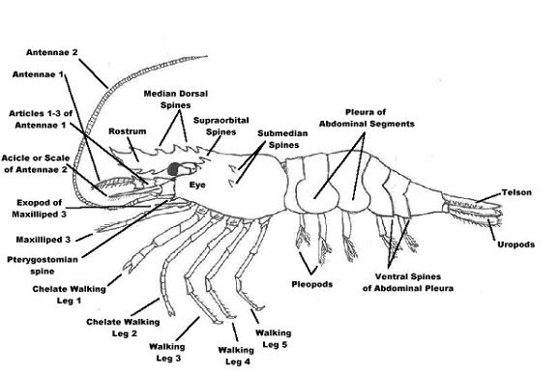
FIG 1. General shrimp anatomy diagram. Source: <http://www.geog.ubc.ca/biodiversity/efauna/
CaridaeShrimpsandPrawnsofBC.html>

Introduction
Heart rate in crustaceans can be altered under many conditions. Neurotransmitters, temperature, and chemicals such as stimulants can all have an effect. Neurotransmitters act on the organism’s heart rate through the nervous system in a parasympathetic-like or sympathetic-like manner. This can either cause an increase or decrease in overall heart rate based on the properties of the neurotransmitter in question. The effects of temperature on heart rate are also variable. Lower temperatures tend to decrease the heart rate. Conversely, high temperatures tend to cause an increase in heart rate due to the increase in metabolic activity and higher rate of chemical reactions within the body. Chemical stimulants also increase the heart rate and blood flow. In this experiment, students will become familiar with these effects by subjecting a species of freshwater shrimp to varying environmental conditions.

Materials
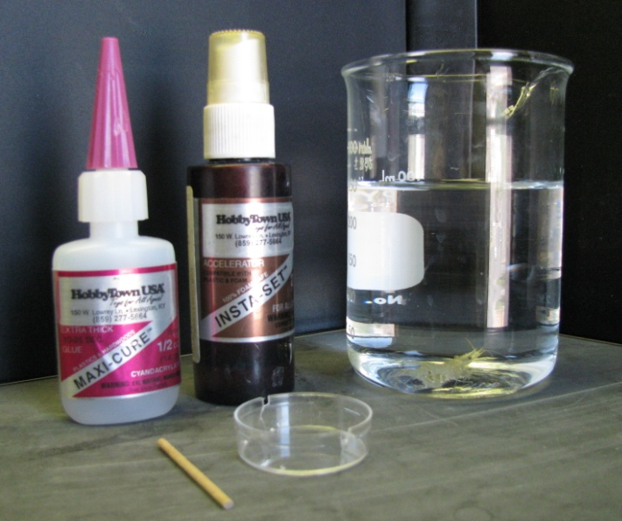
Item | Quantity
Ghost Shrimp (Palaemonetes kadakensis) | 1
Small Wooden Rod (Toothpick) | 1
Grooved Petri Dish | 1
Light Microscope | 1
Pins with Curled Ends | 2
Paper Towels | 2
Beaker of Distilled, Aerated Water | 2
Beaker of Ice | 1
10 μM Nicotine Solution | 1 Bath
10 μM GABA Solution | 1 Bath
10 μM Glutamate Solution | 1 Bath
Set of Microscope Lights | 1
Drop of Super Glue (Maxi-Cure) | 1
Drop of Quick Dry (Insta-Set) | 1
FIG 2. Materials for shrimp preparation.
Methods
- Dampen a paper towel with distilled water as this species of freshwater shrimp are highly sensitive to small amounts of copper or nickel.
- Place the shrimp in the damp paper towel so that the anterior region is wrapped and the animal’s back and tail are free.
- With a second, dry paper towel gently dab the back of the animal in order to dry it for the glue.
- Place a small drop of the glue onto the wooden rod and then adhere it to the animal. Ensure that the stick is glued slightly below the back on the tail so that the heart is not hidden by the apparatus.
- While holding the rod in place, place a dab of the quick dry compound over the glue to complete the bonding.
- Hold the stick in place for approximately five more seconds or until the rod is sufficiently affixed to the shrimp.
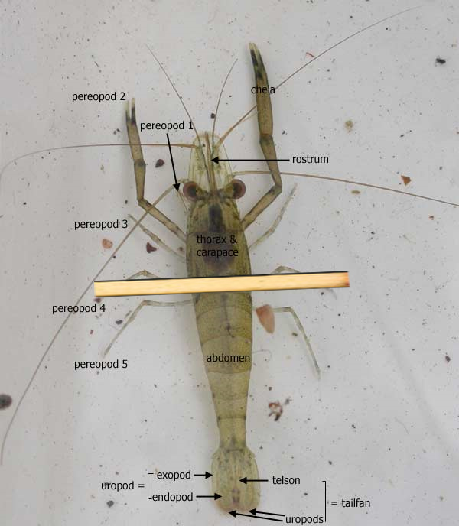
FIG 3. Diagram of wooden rod placement on dorsal side of shrimp. Source: <www.mdfrc.org.au/BugGuide/diagrams/decapoda.htm>
>

- Rinse the shrimp and rod of any excess chemicals by dipping it once or twice into the beaker of distilled water.
- Place the shrimp in the grooved Petri dish; ensure that the rod fits securely into both grooves on either side of the dish. This will limit the animal’s movement and will allow for it to be monitored through the microscope. Fill the dish with aerated water and be sure that the level is over the back of the shrimp so that it survives the experiment.
Exercise 1.
Monitor the heart rate of the shrimp to gain a baseline. To do this, place the shrimp setup under the microscope so that the heart is visible on the back of the animal. Count the number of beats in ten seconds and multiply this number by six to get the beats per minute. To obtain an experimental baseline, do this three times and take the average of the three values. Note: It may be beneficial to allow the shrimp to acclimate for approximately five to ten minutes before taking a baseline reading to account for the agitation of the animal.
Heart Rate
- __________beats/minute
- __________beats/minute
- __________beats/minute
__________average beats/minute (BASELINE)

Exercise 2.
Note: Your TA will instruct your group to perform either Part A. or Part B. of Exercise 2 (NOT both). You will then exchange recorded data with a group that used a different chemical stimulus.
A. Carefully transport the dish containing the shrimp to the sink and gently pour the contents of the bath out. Make sure that the shrimp is secure and does not fall into the sink. While monitoring the shrimp heart rate through the microscope, fill the bath with the prepared glutamate solution. Take note of the immediate response. After approximately thirty seconds, take note of the number of heart beats in a ten second period. Again, multiply this number by six in order to calculate beats per minute. As in Exercise 1, repeat this process for a total of three times; generate an average beats per minute reading.
Heart Rate
- __________beats/minute
- __________beats/minute
- __________beats/minute
__________average beats/minute
B. Carefully transport the dish containing the shrimp to the sink and gently pour the contents of the bath out. Make sure that the shrimp is secure and does not fall into the sink. While monitoring the shrimp heart rate through the microscope, fill the bath with the prepared GABA solution. Take note of the immediate response. After approximately thirty seconds, take note of the number of heart beats in a ten second period. Again, multiply this number by six in order to calculate beats per minute. As in Exercise 1, repeat this process for a total of three times; generate an average beats per minute reading.
Heart Rate
- __________beats/minute
- __________beats/minute
- __________beats/minute
__________average beats/minute

Exercise 3.
Carefully transport the dish containing the shrimp to the collection beaker in the classroom. Gently pour out the solution containing either GABA or glutamate. Make sure that the shrimp is secure. Rinse the beaker and the shrimp with aerated water to ensure that all of the chemicals have been removed. While monitoring the shrimp heart rate through the microscope, fill the bath with chilled aerated water from the beaker containing the ice. Observe the immediate change. After approximately thirty seconds, take note of the number of heart beats in a ten second period. Again, multiply this number by six in order to calculate beats per minute. As in the previous exercises, repeat this process for a total of three times; generate an average beats per minute reading.
Heart Rate
- __________beats/minute
- __________beats/minute
- __________beats/minute
__________average beats/minute

Exercise 4.
Nicotine will be applied to the bath last, as it is expected induce a significantly stronger change in heart rate than the stimuli used in Exercises 2 and 3. In order to isolate the effects of nicotine from experimental stress, a chilled solution of nicotine will be used. Carefully transport the dish containing the shrimp to the sink and gently pour the contents of the bath out. Make sure that the shrimp is secure and does not fall into the sink. While monitoring the shrimp heart rate through the microscope, fill the bath with chilled nicotine solution from the beaker indicated by the TA. Observe the immediate change. After approximately thirty seconds, take note of the number of heart beats in a ten second period. Again, multiply this number by six in order to calculate beats per minute. As in the previous exercises, repeat this process for a total of three times; generate an average beats per minute reading.
Heart Rate
- __________beats/minute
- __________beats/minute
- __________beats/minute
__________average beats/minute

Exercise 5.
In order to compare the effects upon heart rate of the various conditions observed above, graph the average beats/minute of each stimulus below:
Heart Rate (Beats/Min)
Control GABA Glutamate Cold Nicotine
Exercise 6.
To account for the effects of non-target variable conditions such as experimenter noise or changes in the amount of light over the shrimp with passing shadows, it is important to calculate the percent difference from baseline for each of the stimuli observed before drawing any conclusions about generalized reaction trends. The formula for percent difference is as follows:
$$\% Difference= \frac{Absolute differnce (intial-experimental)}{intial}x100$$
For the conditions GABA, glutamate, and cold water, the baseline used will be the average beats/min for the room temperature water (control) from Exercise 1. For the nicotine trial, the baseline used will be the average beats/min for the chilled water from Exercise 3.
Percent Differences:
GABA: _____________
Glutamate: ___________
Cold Water: __________
Nicotine: ____________

References
Alexandrowicz, J. S. 1932. The innervation of the heart of Crustacea. I. Decapoda. Wuart. J. Microsc. Sci., 75: 181-249.
Bethe, A. 1897. Vergleichende Untersuchungen uber die Funtionen des Zentrainervensystems der Arthropoden. Pfluger’s Arch. Ges. Physiol., 68: 449-545.
Bierbower SM and Cooper RL. 2009. Measures of Heart and Ventilatory Rates in Freely Moving Crayfish. JoVE. 32. http://www.jove.com/index/details.stp?id=1594
Bierbower, S.M. and Cooper, R.L. (2010) The effects of acute carbon dioxide on behavior and physiology in Procambarus clarkii. Journal of Experimental Zoology {In press}.
Burmistrov, Y. M. and Z. P. Shuranova. 1996. Individual features in invertebrate behavior: Crustacea. In: Abramson Cl, Shuranova ZP, Burmistrov YM (eds) Russian Contributions to Invertebrate Behavior. Praeger, Westport, Connecticut. Pp. 111-144.
Carpenter, M. B., 1976. The autonomic nervous system. Human Neuroanatomy, 7th ed. The William & Wilkins Co, Baltimore, MD, pp. 191-212.
Cooper, A.S., Rymond, K.E., Ward, M.A., Bocook, E.L. and Cooper, R.L. (2009) Monitoring heart function in larval Drosophila melanogaster for physiological studies. Journal of Visualized Experiments (JoVE) 32: http://www.jove.com/index/details.stp?id=1596
Cuadras, J., 1979. Heart rate and agonistic behavior in unrestrained crabs. Mar. Behav. Physiol., 6: 189-196.
Cuadras, J., 1980. Cardiac responses to visual detection of movement, mechanostimulation and cheliped improsed movement in hermit crabs. Comp. Biochem. Physiol. A, 66: 113-1171.
Huxley, T.H., 1880. The Crayfish: An introduction to the study of zoology, New York: D. Appleton and Company, 1880, v. XXVIII of the international Scientific Series. Reprinted 1973, 1974, 1977, MIT Press, Cambridge, MA.
Li, H., L.R. Listerman, D. Doshi, and R. L. Cooper, 2000. Use of heart rate to measure intrinsic state of blind cave crayfish during social interactions. Comp. Bichem. Physiol., 127A: 55-70.
Listerman, L.R., J. Deskins, H. Bradacs, and R.L. Cooper, 2000. Heart rate within male crayfish: Social interactions and effects of 5-HT. Comp. Biochem. Physiol., 125A: 251-263.
McMahon, B.R., and J.L. Wilkens, 1983. Ventilation, perfusion and oxygen uptake. In: Mantel, L., Bliss, D. (eds), Biology of Crustacea, 6. Academic Press, New York, pp. 289-372.
Mendelson, M., 1971. Oscillator neurons in crustacean ganglia. Science, 171: 1170-1173.
Nicholls, J.G., A.R., Martin, B.G. Wallace, and P.A. Fuchs, 200. From Neuron to Brain. Sinauer Assoc., Sunderland, MA, USA. pp. 315-317.
Orlov, Y., 1927. Das Magenganglion des Fluβkrebses, Ein Beitrag zur vergleichenden Histologis des sympathischen Nervensystem. Z. Mikrosk. Anat. Forschung 8 (1), 67-102.
Pasztor, V.M., 1968. The neurophysiology of respiration in decapod Crustacea: The motor system. Can. J. Zool., 46: 585-596.
Schapker, H., T. Breithaupt, Z. Shuranova, Y. Burmistrov, and R.L. Cooper, 2002. Heart rate and ventilatory correlative measures in crayfish during environmental disturbances and social interactions. Comp. Biochem. Physiol., A 131: 397-407.
Shuranova, Z.P., A.V. Vekhov, and Y.M. Burmistrov, 1993. The behavioral reactions of fresh-water crayfish to sensory exposures: the autonomic components. Zh. Vyssh Nerv. Deiat Im I P Pavlova, 43: 1159-1169.
Shuranova, Z.P. and Y.M. Burmistrov, 2002. Ventilatory activity in free moving crayfish is indicative of its functional state and perceiving external stimuli. In: The Crustacean Nervous System (K. Wiese, ed.). Springer, Berlin. Pp. 526-535.
Shuranova, Z.P., Y.M. Burmistrov, J.R. Strawn, and R.L. Cooper, 2006. Evidence for an autonomic nervous system in decapod crustaceans. Inter. J. Zool. Res. 2 (3): 242-283.
Wiersma, C.A.G., 1961. Reflexes and the central nervous system. In: Waterman, T.H., (ed). The physiology of Crustacea, vol II, Sense organs, integration, and behavior. Academic Press: New York. Pp. 241-279.
Wilkens, J.L., 1976. Neuronal control of respiration in decapod Crustacea. Fed. Proc. 35, 2000-2006.
Wilkens, J.L., and L.A. Wilkens, 1974. Central control of cardiac and scaphognathite pacemakers in the crab Cancer magister. J. Comp. Physiol. 90, 89-104.
Wilkens, J.L., 1999. The control of cardiac rhythmicity and of blood distribution in crustaceans. Comp. Biochem. Physiol. A, 124: 531-538.
Wilkens JL, Mercier AJ, Evans J. 1985. Cardiac and ventilatory responses to stress and to neurohormonal modulators by the shore crab Carcinus maenas. Comp Biochem Physiol C 82:337-343.
Yamagishi, H., H. Ando, and T. Makioka, 1997. Myogenic heartbeat in the primitive crustacean Triops longicaudatus. Biol. Bull., 193: 350-358.
Yazawa, T. and T. Katsuyama, 2001. Spontaneous and repetitive cardiac slowdown in the freely moving spiny lobster, Panulirus japonicas. J. Comp. Physiol., 187 A: 817-824.

