Instructor Notes
This module highlights the relationship between diet, development and behavior using Drosophila melanogaster (fruit flies) as a model. Fruit flies are a commonly used model organism in research to understand biological principles and became well recognized as a model for studying genetics (Rubin and Lewis 2000; Morgan 1910). Using a project-based learning approach and building on the tremendous amount of knowledge about the life cycle, physiology, genetics and behavior of Drosophila, this module provides students the opportunity to investigate questions concerning chronic health of their interest.

The module was developed to allow for flexibility in content investigated by building on the same two foundational modules: (1) the influence of diet on development and (2) the effects of diet on behavior. Therefore, the module can be implemented as consecutive units, as it’s presented here, or as stand-alone single units. Additional concepts can be explored using these two modules as building blocks. These concepts include survival of the adults and population dynamics (Oh and Oh 2011, Potter et al. 2016, Pulver et al. 2011); the effects of a ketogenic diet on behavior and function related to treatment of epilepsy (Boison 2017); and using heart rate as a bioassay for health of the larvae exposed to various diets (Spindler 2005, Potter et al. 2019). Additional information on integrating these additional activities can also be found at the module’s website.

Materials & Supplies

Our goal is for college level programs of all budget types to be able to use this model. We have provided information on all necessary materials and supplies including where to materials can be purchased and alternative options in both the Appendix and on the course website. This includes information on starting and maintaining a fly colony, conducting various behavioral measures, how to measure developmental time from larva to pupa, and how to build a microscope.

Food Preparation & Fly Diets – To maintain adult flies for breeding and rearing, a cornmeal-molasses-agar media can be made. A complete ingredient list and instructions can be found for the media in the Appendix. Various additions can be included to this standard media to investigate the effects of different diet types. For example, if one wants to examine essential amino acids in a diets various amounts of amino acids could be used and in combinations. Different Drosophila lines with mutations are available to investigate defects in amino acid transport and enzymes used in metabolism (St Clair et al., 2017; Sasamura et al, 2013). Flies can also be requested from one of the authors (Robin Cooper).

To focus on diets related to human health one, or more, of three different diets can be used for this activity: (1) high fructose, (2) high protein (soybean extract), and (3) high fat (coconut oil). These additions can be included in the standard media in 5%, 10%, 20%, 40% per weight of diet. A higher fat diet than 40% is difficult to use as the fat does not mix well with the food. Standard fly media food can be used and mixed to these percentages based on wet weight of the readymade food. This is the easiest approach in our experience.

Fly Growth
The two activities presented here are set up sequentially, therefore setting up a duplicate vial will allow one to fully pupate and the other to be tested for behavioral differences. Eggs, 1st instar, or 2nd instar larvae can be used to set up the experiments. Growth from egg to third instar larva takes approximately five days (Figure 1), and larval stage can be determined by anatomical and behavioral differences. Adult flies can be exposed to each food type allowing them to lay eggs, then eggs can be moved to hatch on different food types. This would require a minimum of a four-hour time window. This approach is difficult to know the number of viable larvae one is stating out with. However, one could use control food and compare relative to the controls. For more precise measures of survival (experiment one), we strongly suggest moving 1st or 2nd instars into various types of food. It is easy to damage the larvae, so care is required when transferring them. We suggest having a fly colony started on traditional media to make it easier to set up the activity and provide flexibility in timing. A procedural outline for establishing a fly colony and preparing individual vials for the activities can be found outlined in the Appendix.
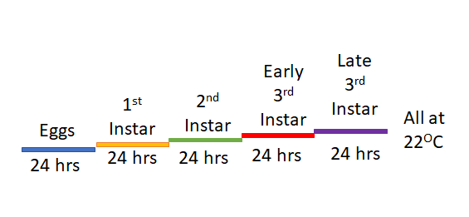

Figure 1. Developmental timeline of Drosophila at 22 degrees Celsius.

Additional Student Engagement

For additional engagement regarding the context of the activity, a pre-lab assignment where students investigate the health status of their local community could be implemented. Using the CDC website, students can examine the rates of cardiovascular disease for example. This can spark interest in the topic and help provide more specific background for students to help frame the concepts for students.
Student Handout
Learning Objectives
- To explore the role of diet in physiological and developmental processes
- Generate informed hypotheses regarding the effects of diet on the development and behavior of Drosophila melanogaster
- Design and conduct an experiment to test the hypotheses
Background Information
Diet and Health
The general notion is the balance of "energy in" with the "energy out" for the developmental and adult life requirements of organisms for being in a healthy state. Excess "energy in" can led to storage of the energy in the form of fat or surplus circulating levels of substances which can have harmful consequences, such has high lipids and sugar content in the cardiovascular circulation. Therefore, metabolism and diet type are keys factors in the energy homeostatic balance. And we use different diet types for both medical treatments for purely cosmetic reasons. For example, body builders commonly use a high protein – low carbohydrate diet to build and maintain lean muscle mass. Yet diet can also be used to control our cholesterol or blood sugar levels, and a ketogenic diet (high-fat, adequate-protein, low-carbohydrate diet) is also being used to treat epilepsy. We can investigate the effects of diet on physiological processes, mimicking the different factors observed in human conditions, but altering the diets of Drosophila.
Life cycle of Drosophila
After males fertilize the eggs and the female lays them on a substrate in 1 day the larvae will emerge at room temperature (21ºC or 70ºF). Larvae develop through three stages which are easily identified by morphological changes in their mouth hooks used for feeding (Figure 1). In the late 3rd instar stage the larvae crawl out of the food and find a place to become a pupa. After about 7 days the pupa emerge as adult fruit flies. The adults typically live for 2 to 3 weeks depending on the crowding and environmental conditions.

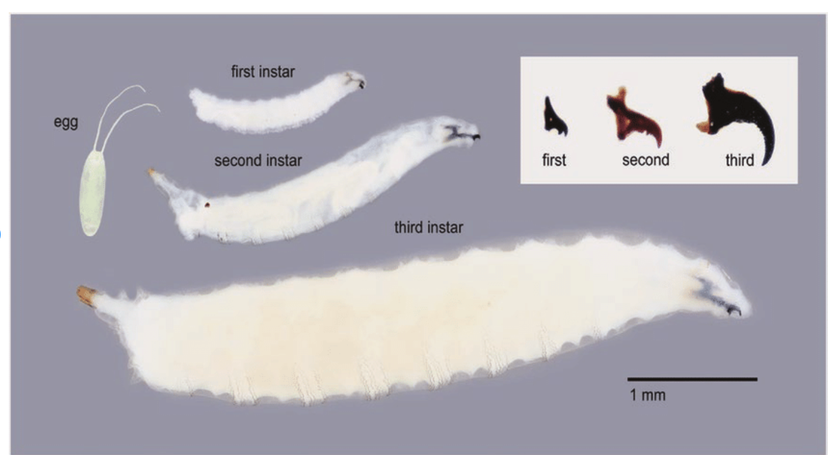
Figure 1. Development life stages of Drosophila. (Adapted from Timmeren et al. 2017)
Diet Options
- High Fructose - A condition which is of increasing prevalence in the USA and other industrial nations is that of metabolic syndrome. This condition results in an increased blood pressure, high blood sugar, excess body fat around the waist, and abnormal cholesterol or triglyceride levels, increasing the risk for heart disease, diabetes, and stroke. To mimic some of these factors in Drosophila we can use a high sugar diet with alpha-fructose, a simple sugar.
- High Fat (Ketogenic) - A diet high in fat can also result in metabolic syndrome. Therefore, to mimic these factors in Drosophila we can use a high fat diet by using various amounts of 100% coconut oil.
- High Protein – To mimic a diet high in protein, like what a body builder may use, we can use synthetic soybean extract as a protein source.
Choose a diet from the list above and develop a hypothesis regarding how that diet may affect the development of Drosophila. State your hypothesis:
How might the diet influence the behavior of the larva? State your hypothesis:
Now let’s set up the experiment to test your hypotheses.

Experiment One – Influence of Diet on the development of Drosophila
To test the effects of diet on larval development, we will compare larvae grown on a high fat and high sugar diet. Here we will set up replicates of each tube. We can use a one of the replicates to investigate the effects of diet on behavior (experiment two).

Materials
- 2 tubes of 10% high fat larval diet
- 2 tubes of 10% high sugar larval diet
- 2 tubes of standard fly media
- 1 dish of 2nd or 3rd instar larvae
- Paint brush/forceps (to move flies)
- Permanent marker

Procedure
- Place 10 larvae (1st or 2nd instar larvae) into each of the high fat and high sugar larval tubes
- Be sure to note what instar they are and how many of each you include in the tube
- Allow larvae to burrow into food (~ 30 minutes)
- Mark and index the location of all larvae using a sharpie as shown in Figure 2 (right). Note date and time pupa form in notebook.
- Place tubes in a light-controlled environment at 22 degrees Celsius for 24 hours
Figure 2: Marked and indexed larvae in different diet types. Diets were labeled using a lettering system, and all larvae were circled and marked using a permanent marker.
- Check every 24 hours to determine number of individuals that pupate
- Note any changes in pupation and survival in your notebook.
What is our dependent and independent variable? What is our control?

What is the percent survival based on diet type? Do you accept or reject your hypothesis?

Experiment Two – Effects of Diet on Behavior
Next let’s investigate the effects of diet on behavior. But first we need to understand different behaviors of Drosophila larvae. Larvae respond to external stimuli in a variety of ways. These behavioral responses are adaptive and act as an anti-predator defense (Robertson et al. 2013). Prior to proceeding review the different behaviors that larvae can exhibit (see Appendix).

Develop a hypothesis to explain how each diet might influence larval behavior:
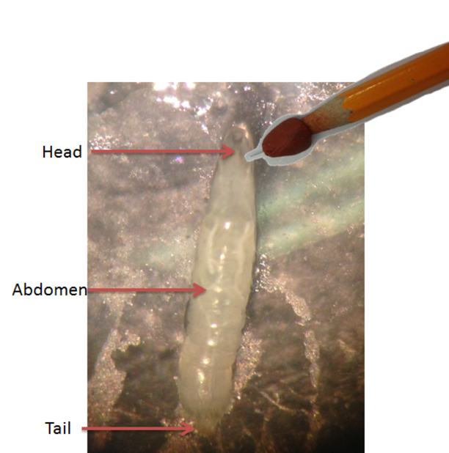
Materials
From experiment one:
- 1 tube of 10% high fat larval diet from experiment one
- 1 tube of 10% high sugar larval diet
- 1 tube of standard fly media
- Tweezers or forceps to move larva
- Petri dish
- Pencil
- Stopwatch

Procedure
- Using tweezers or a small paint brush remove a single larva and place it on a petri dish
Figure 3. Illustration of body segments on larvae and points of contact.
- Identify the stage of the larva
- Allow larvae to acclimate for 15 secs prior to beginning the trial
- Count the number of peristaltic waves for 15 seconds
- Stimulate the larvae at the abdomen on the right side on the larva’s body segment as shown in Figure 3
- Record the behavioral response
- Wait 15 seconds
- Repeat steps 5-6 for each additional body segment
- Conduct stimulus test on a minimum of 10 larvae per diet type and control

When all stimulus tests are finished, calculate the fraction of each behavioral response by diet type. Do you accept or reject your hypothesis?

Citations
Boison, D. (2017). New insights into the mechanisms of the ketogenic diet. Current Opinions in Neurology. 30:187-192.

Morgan, T. H. Chromosomes and heredity. The American Naturalist. 44 (1910):449–96. http://www.jstor.org/stable/pdf/2455783.pdf (Accessed March 25, 2017).

Oh, P.S. & Oh, S.J. (2011). What teachers of science need to know about models: an overview. International Journal of Science Education. 33:1109–1130.

Potter, S., Krall, R.M., Mayo, S. Johnson, D., Zeidler-Watters, K., and Cooper, R.L. (2016). Population dynamics based on resource availability and founding effects: Live and computational models. The American Biology Teacher. 78(5): 396-403, ISSN 0002-7685,

Potter, S., Sifers, J., Yocom, E., Blümich, S.L.E., Potter, R., Nadolski, J., Harrison, D.A. & Cooper, R.L. (2019) Effects of inhibiting mTOR with rapamycin on behavior, development, neuromuscular physiology and cardiac function in larval Drosophila. Biol. Open 2019, 8.

Pulver, S.R., Cognigni, P., Denholm, B., Fabre, C., Gu, W.X.W., Linneweber, G. et al. (2011). Why flies? Inexpensive public engagement exercises to explain the value of basic biomedical research on Drosophila melanogaster. Advances in Physiology Education. 35:384–392.

Sasamura, T., Matsuno, K., & Fortini, M.E. (2013) Disruption of Drosophila melanogaster Lipid metabolism genes causes tissue overgrowth associated with altered developmental signaling. PLoS Genet 9(11): e1003917. https://doi.org/10.1371/journal.pgen.1003917

Spindler SR. (2005) Rapid and reversible induction of the longevity, anticancer and genomic effects of caloric restriction. Mech Ageing Dev. 126(9):960-966. doi: 10.1016/j.mad.2005.03.016. PMID: 15927235.

St Clair, S. L., Li, H., Ashraf, U., Karty, J. A., & Tennessen, J. M. (2017). Metabolomic analysis reveals that the Drosophila melanogaster gene lysine influences diverse aspects of metabolism. Genetics. 207(4): 1255–1261. https://doi.org/10.1534/genetics.117.300201

Robertson, J. L., Tsubouchi, A., & Tracey, W. D. (2013). Larval defense against attack from parasitoid wasps requires nociceptive neurons. PloS one, 8(10): e78704. https://doi.org/10.1371/journal.pone.0078704

Rubin, G.M. & Lewis, E.B. (2000) A brief history of drosophila's contributions to genome research. Science. 287 (5461): 2216-2218. DOI: 10.1126/science.287.5461.2216

Appendix

Standard Fly Media
All items can be purchased from Sigma Aldrich and fly media can be purchased ready to use from Archon Scientific. Additional information on where to purchase ingredients and for making your own fly media can also be found at the Indiana University Bloomington Drosophila Stock Center website: https://bdsc.indiana.edu/information/recipes/bloomfood.html

Ingredients:
- 420 mL water
- 4.5 gm agar
- 60 mL of unsulfured molasses
- 49 gm cornmeal (any kind)
- 6.5 gm brewer’s yeast
- 145 mL cold water
- 3.4 mL of propionic acid (acts as a mold inhibitor)

Mix 420 mL of water and agar, bringing the mixture to a boil for about 3–5 minutes. Add unsulfured molasses and heat to boiling again. Mix together cornmeal, brewer’s yeast, and cold water in a separate container until all lumps are removed. Add cornmeal-yeast mixture to molasses-agar mixture. Boil mixture for 5 minutes, stirring constantly. Cool mixture to 60°C. Add propionic acid. Pour culture medium 1-inch deep into sterile culture jars with sterile plugs. Add a sprinkle of active baker’s yeast (from a saltshaker) to each jar before adding flies.

Additional Diet Options
To create additional diet options including high fructose, high protein, or high fat diets, soybean extract or coconut oil can be used. These additions can be purchased online or at your local grocery store. These diets can be created using standard media in 5%, 10%, 20%, 40% per weight of diet. Standard fly media food can be used and mixed to these percentages based on wet weight of the readymade food. This is the easiest approach in our experience. It should be noted that to use a higher fat diet than 40% is difficult and can result in suffocation of larvae.

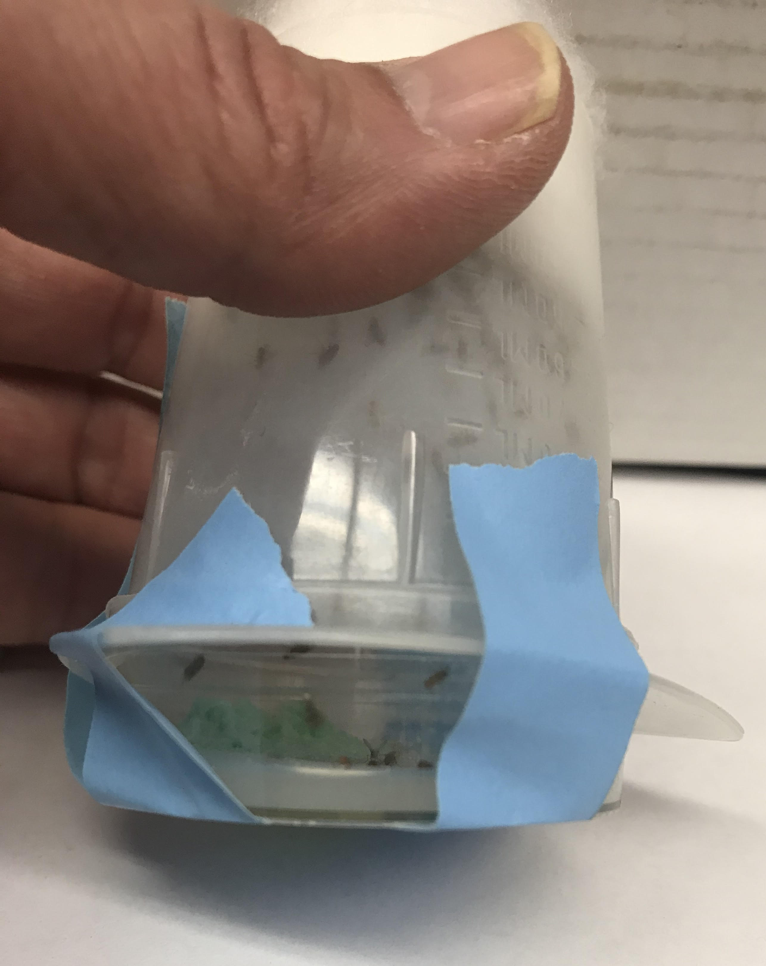
Fly Colony
Figure 1. Example fly colony with additional plate on bottom.
Drosophila can be housed in vials partially filled with fly media. The larvae of D. melanogaster can be grown in the laboratory within a plastic cage. A plastic beaker and petri dish can be used to create the cage (see movie). Petri dishes wish 1% apple juice agar (1/2 filled) bottom with some standard food pressed against one side of the dish to hold it in place so it will not be dislodged when turned over when switching out the dishes. A small hole is cut in the bottom of the plastic beaker small enough that cotton plug can cover the hole. (Note: Use of a soldering iron makes it easy to cut out a hole without the plastic cracking. Don’t breathe the fumes from the melting plastic).

A colony can be started by including 50 males and females. Flies can also be ordered through the Indiana University Blooming Stock Center (https://bdsc.indiana.edu) or can be requested from one of the authors (Robin Cooper). Having adults in this container for 3 days prior to egg pulse will ensure a good amount of freshly collected eggs. Each day for 3 days, preferable first thing in the morning, replace the apple juice agar dish with a fresh dish. On 3rd day replace the dish for a fresh one and allow the adults to lay eggs for 4 hours. Remove this dish and mark 4-hour egg pulse with time of collection. Repeat again for another 4 hours and label "hours of collection time on the dish and 4- hour egg pulse".

Use a dish with food to keep the adults alive for the next day so collections can be repeated. The dishes with the eggs cannot have a petri dish lid as the CO₂ will build up and the embryos and larvae will die. We use lids with fine netting glued to the lids and then place the lids on the dishes. The dish can be left for a day like this if one is collecting 1st instars. If one wants to collect 2nd or 3rd instars, then the agar and food will dry out if left without checking for moisture. What works is using a larger petri dish with paper around the smaller dish and a lid placed to the side as not to trap the CO₂. For additional information on how to knock out flies see movie.
After 24 hours at 22-24 degree Celsius the egg dish will start to show the hatching and 1st instars can be collected. These larvae if allowed to continue to develop will yield 2nd instars (day 2), and 3rd instars (day 3). Early 3rd instars will remain in the food and late 3rd instar (day 4) will be wandering and stop eating as they find a place to pupate. Depending on the time to dedicate to this exercise instars can be removed at the desired stage and placed in the food of choice. Once the colony has started, you can transfer the instars into a long tube containing the experimental food. Continue to repeat this procedure for the different foods to be examined.

Apple juice plates: Used for colony growth and crawling behaviors
Ingredients:
10.1 g Agar (general lab agar)
330 mL of water
11.1 g of table sugar
111 mL of Apple juice (juice, not drink flavor)
0.66 g p-Hydroxybenzoic acid methyl ester, Methyl paraben, NIPAGIN - (SIGMA, catalog # H3647-100G, CAS Number 99-76-3)

Mix agar with water and bring to a boil. Be sure bubbles are occurring to dissolve all the agar.
Turn off heat but keep on stirrer. Add sugar and apple juice to mix fully. If going to keep for a few weeks add preservative. Pour into the plastic Petrie dish and cover. Then place in zip lock bag and put in refrigerator.

Microscope

Watching the larvae crawl and responses to touch, one can use a stereomicroscope (a standard dissecting microscope) with at total 20× magnification (such as using an eye piece 5 x and zoom at 4 x). An observer can then record all behavioral responses to touch or number of inch worm movements in a set time period. If one does not have a dissecting scope, one can use simple and inexpensive approaches to magnify the larvae. We made a movie to show various approaches one can use
https://www.youtube.com/watch?v=wTSynwmyHBQ

Larval Behaviors

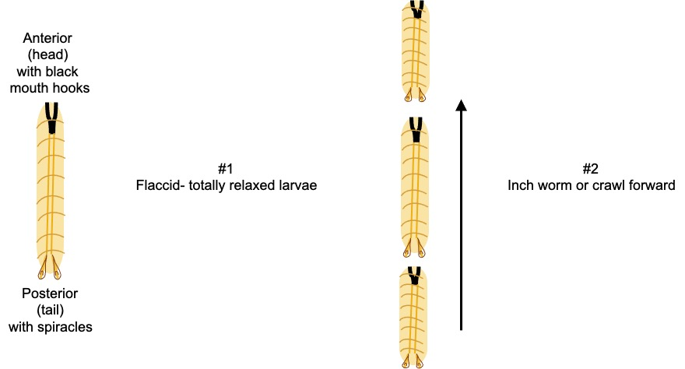

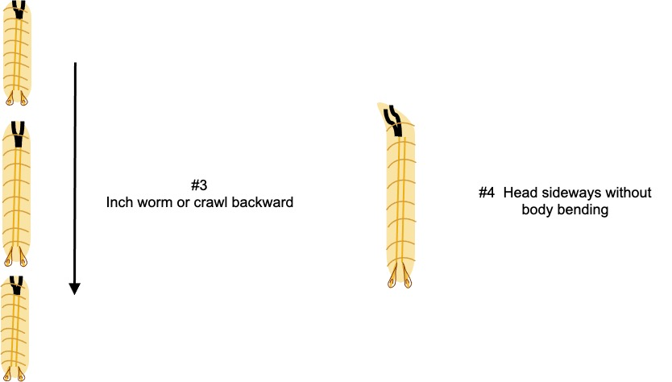

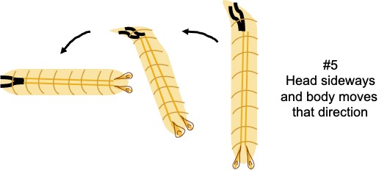

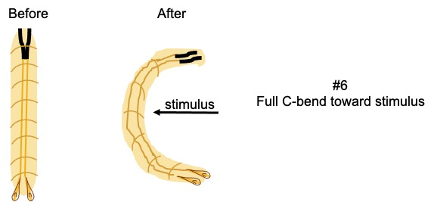

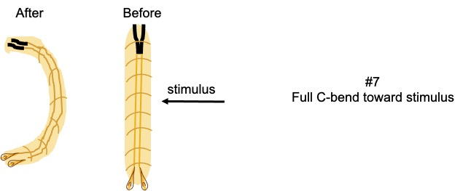

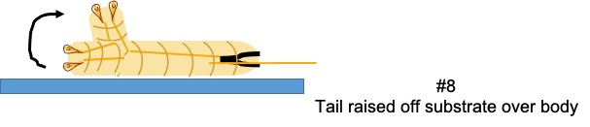

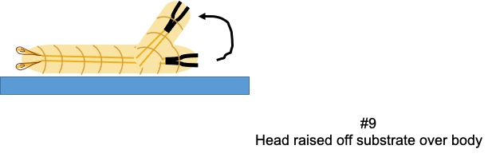

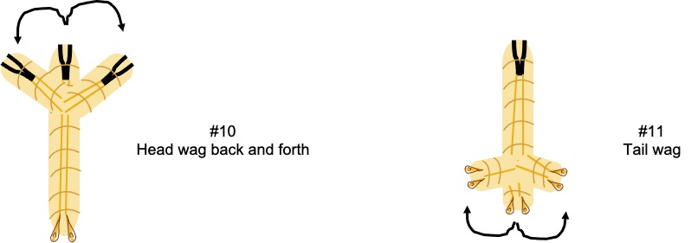

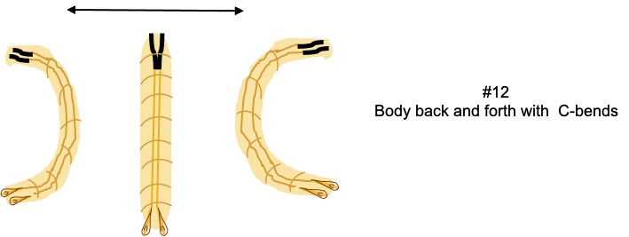

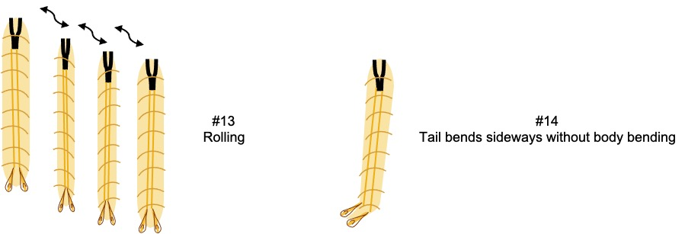

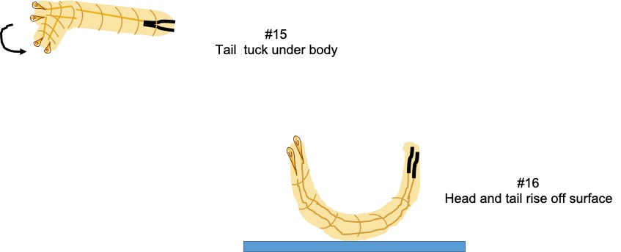

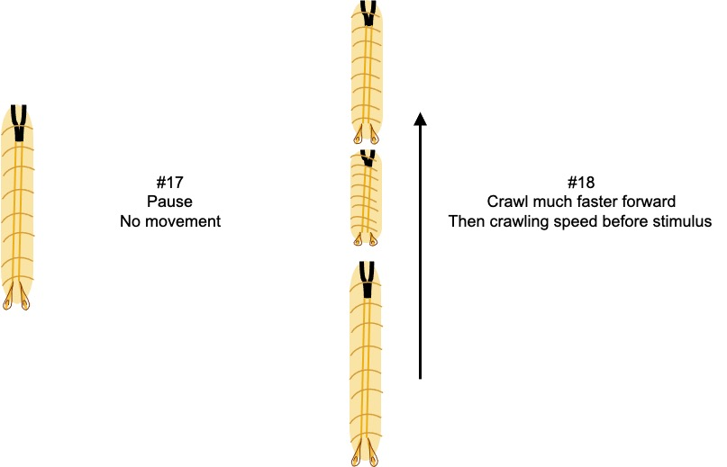

Be careful to not breath this in! Use proper PPE when handling.

